

**Amendment_V2.11**

**For**

**Re-KYC Portal**

**Abhyudaya Bank**

**(Work Order no. IT/PO-105/ 2022-23 dated 27th February 2003.)**

[Version 1.0]

***Prepared by***:

**Chic InfoTech Pvt. Ltd.**

457,’D’ Wing, 2nd Floor,

Vashi Plaza, Sector 17,

Vashi, Navi

Mumbai 400705

Tel 2789 8996 / 97

Web site: - www.chicinfotech.com

Email: - [chicinfotech@gmail.com](mailto:chicinfotech@gmail.com)

Date: 06/11/2013

**Note:** This Document is the property of CHIC InfoTech Pvt. Ltd and has been developed by us as per requirement of Abhyudaya Bank. On receipt of this document through any media by it is implied that the Bank will not share this document with any third party without written permission from us.

Amendment for Re-KYC

A few point given by bank,

1. Provide access to the customer when they leaves the portal without completing the process.

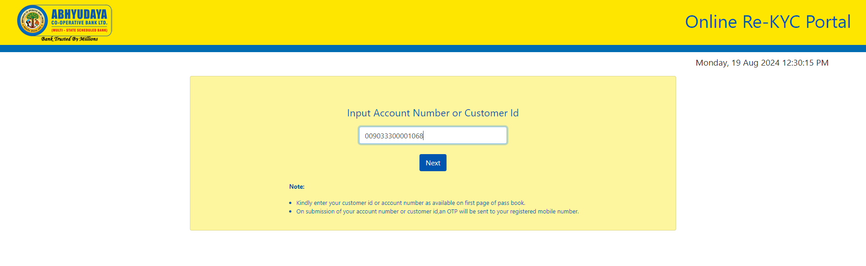

Screen 1

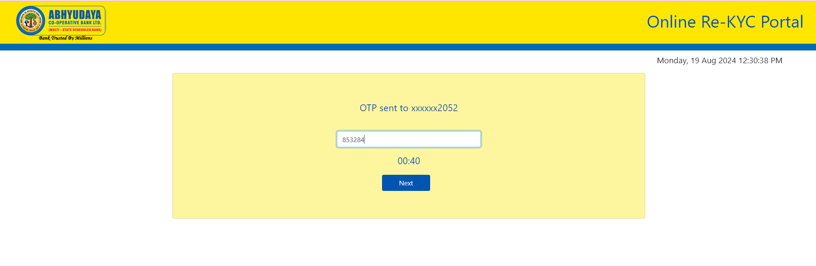

Screen 2

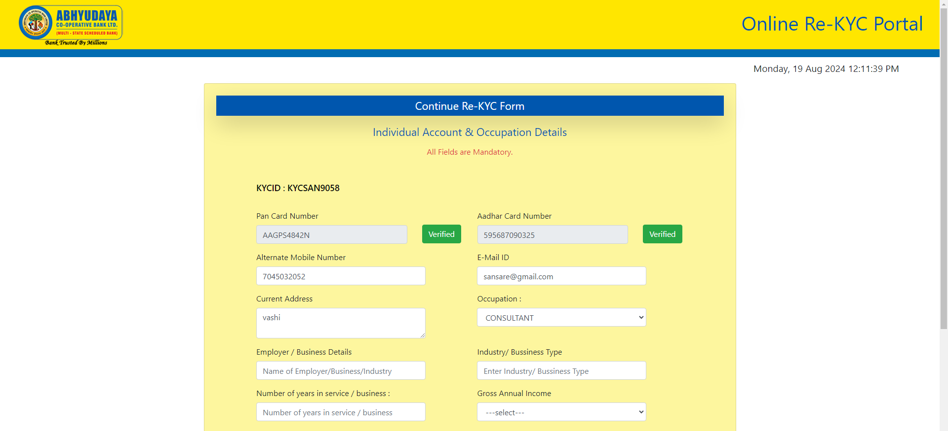



Screen 3

1. Risk coverage (High, Medium and Low)
2. High Risk (2 YEAR)

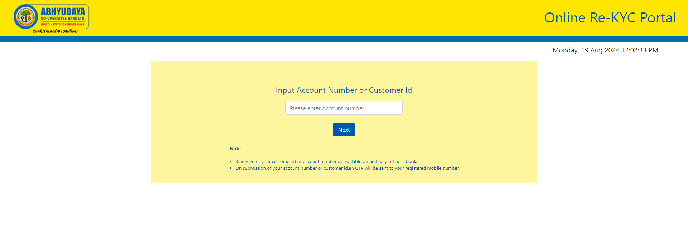

Screen 4

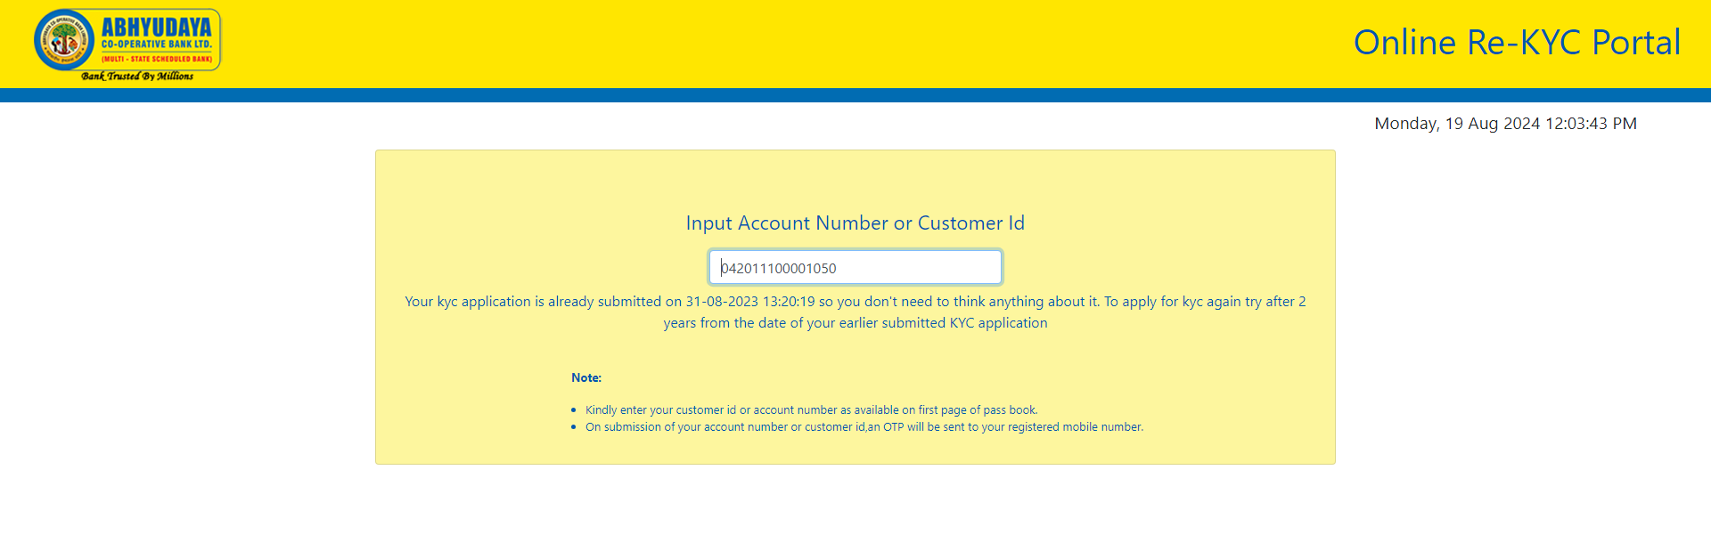

Screen 5

1. Medium Risk (8 YEAR)

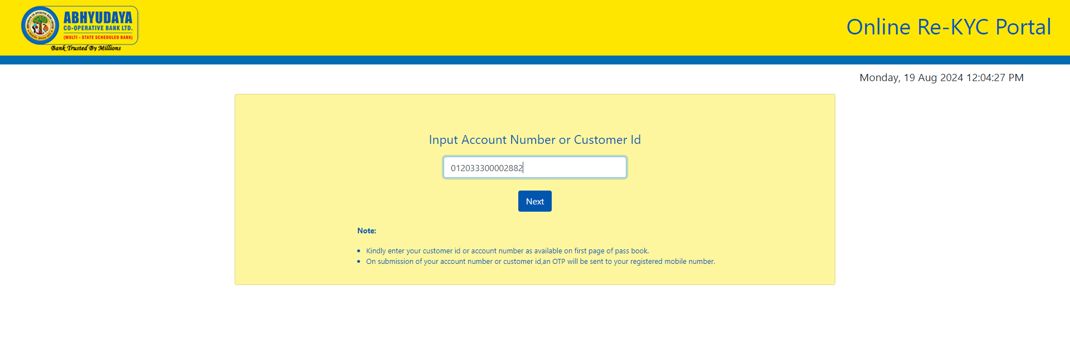

Screen 6

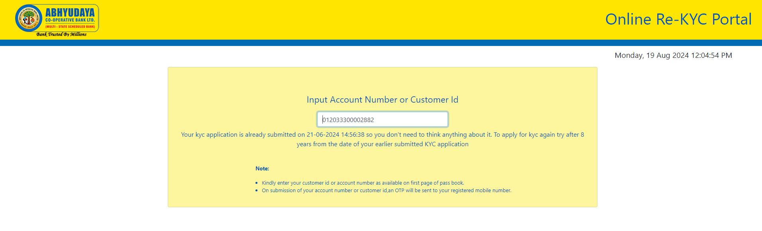

Screen 7

1. Low Risk (10 YEAR)

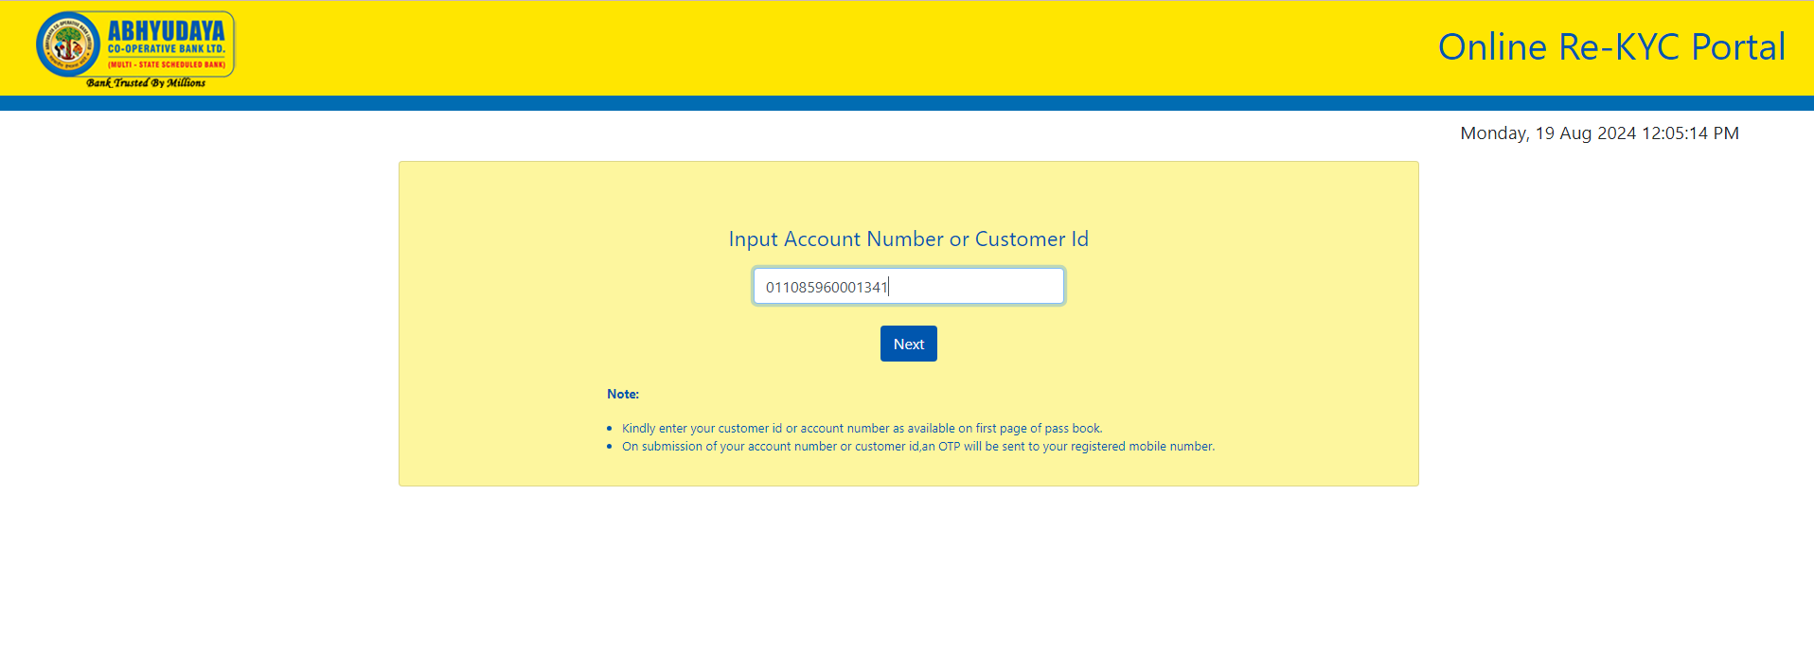

Screen 8

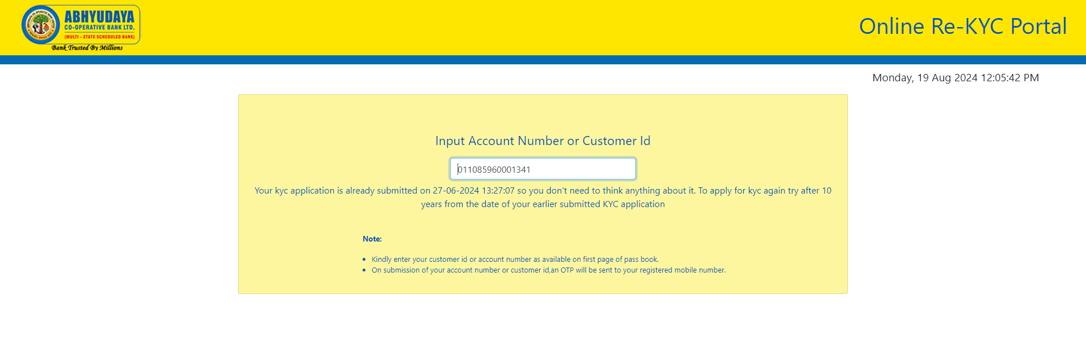

Screen 9

1. Customer should allowed to attach document of pan card and adhar card that attachment sent directly bank email id.

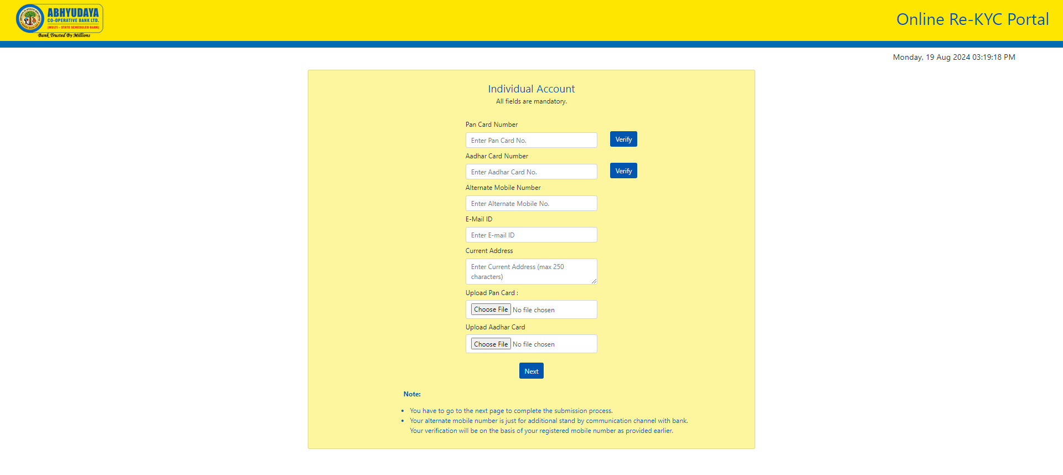

Screen 8

4) OTP resend option should be provide.

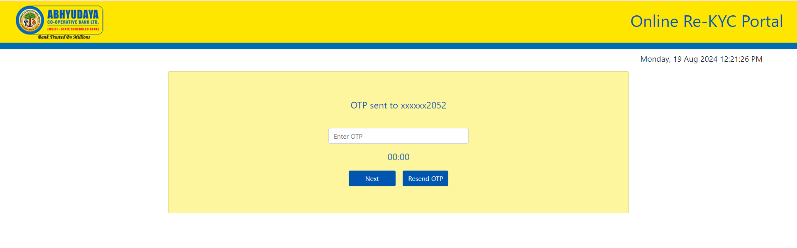

Screen 9

1. After Approved status sent SMS to the customer.