**Re-KYC Application test case**

**User Section:**

Here, users have to put a 15-digit account number as per bank detail (screen 1).

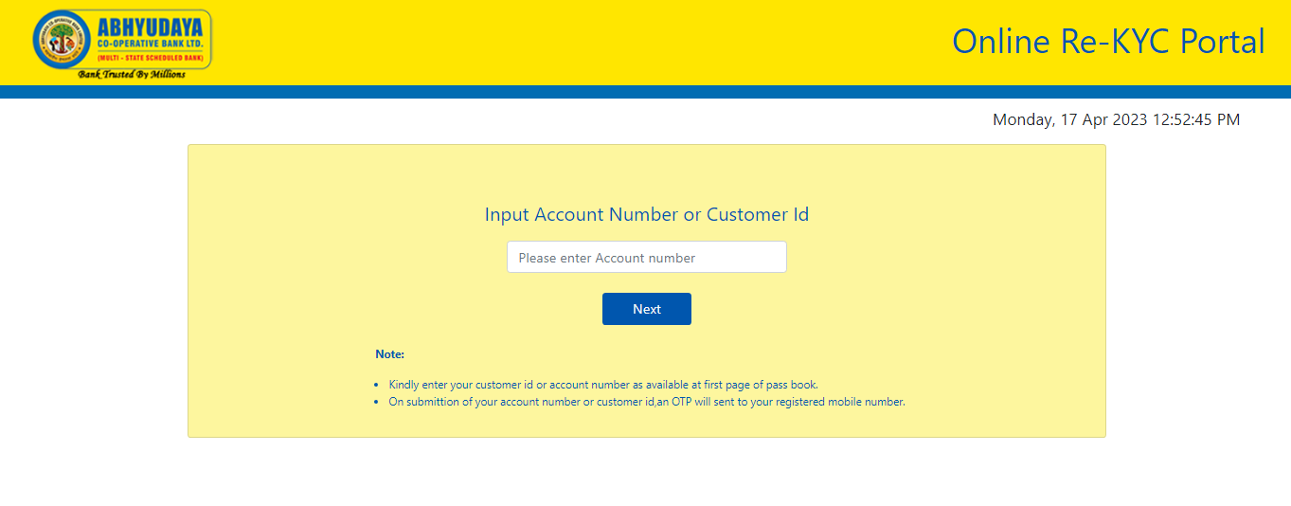

Screen 1

If an user puts a less than 15-digit account number after that, a message in red will be displayed as per screen 2

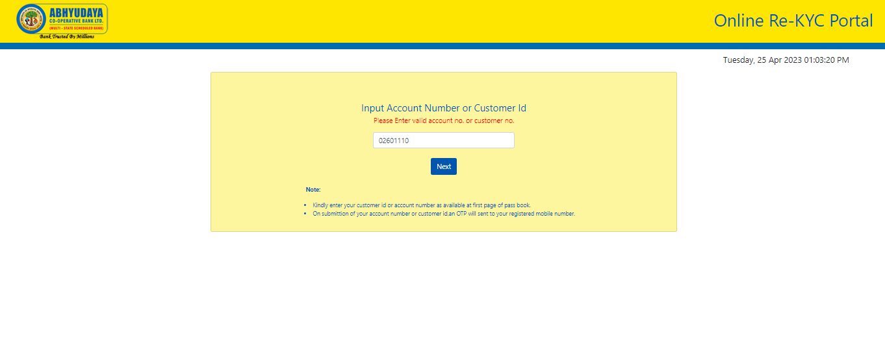

Screen 2

Also here, if any special character is fed then following message will appear in red as per screen 3.

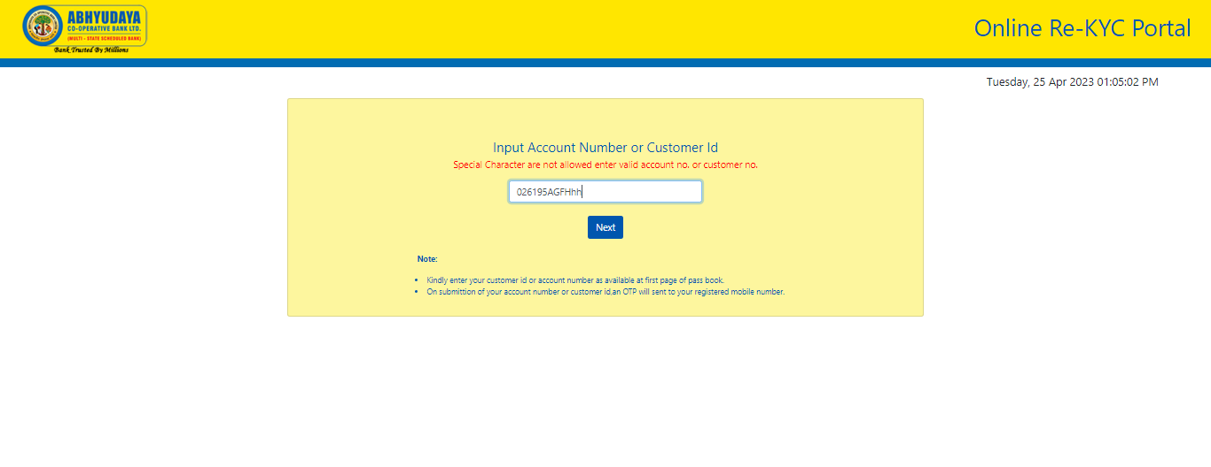

Screen 3

Once you have done the Re-KYC process, and after checking, the bank gives remark as valid, then after that you cannot apply again.

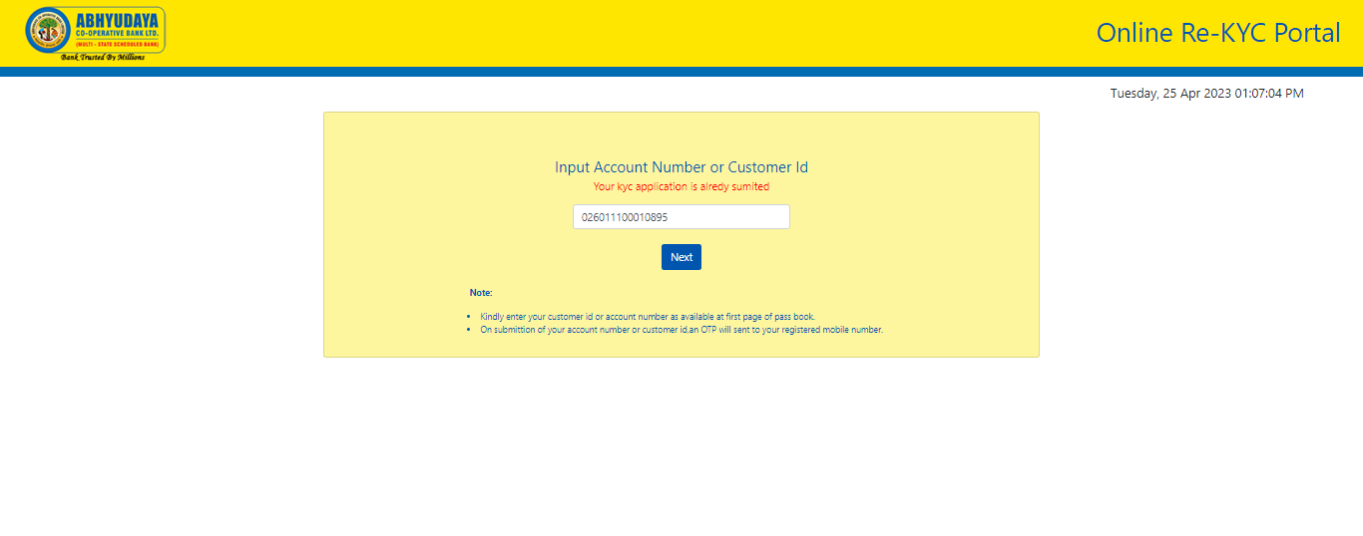

Screen 4

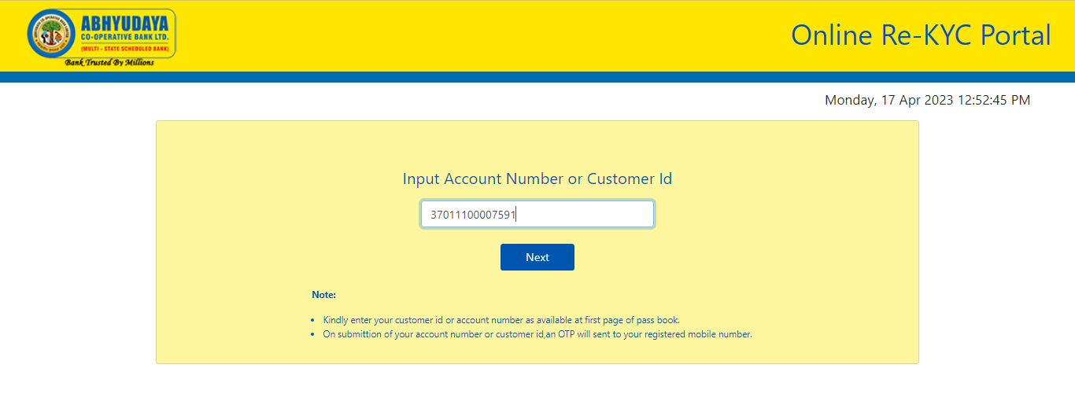

Screen 5

On submitting correct Account Number or Customer id in screen 5 an OTP will be sent to registered mobile number as provided to bank.

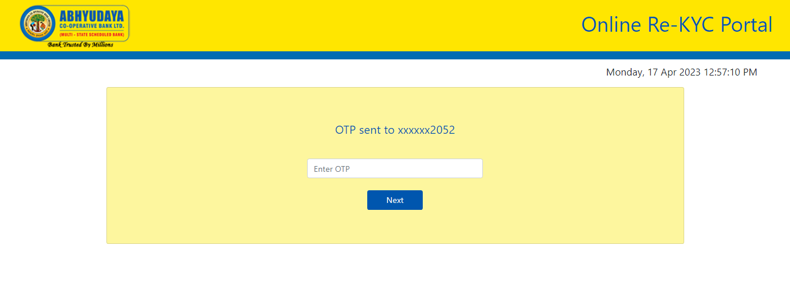

Screen 6

The OTP so generated will have to be filled in screen 6.

If users put the wrong OTP, there will be the message displayed as per screen 7.

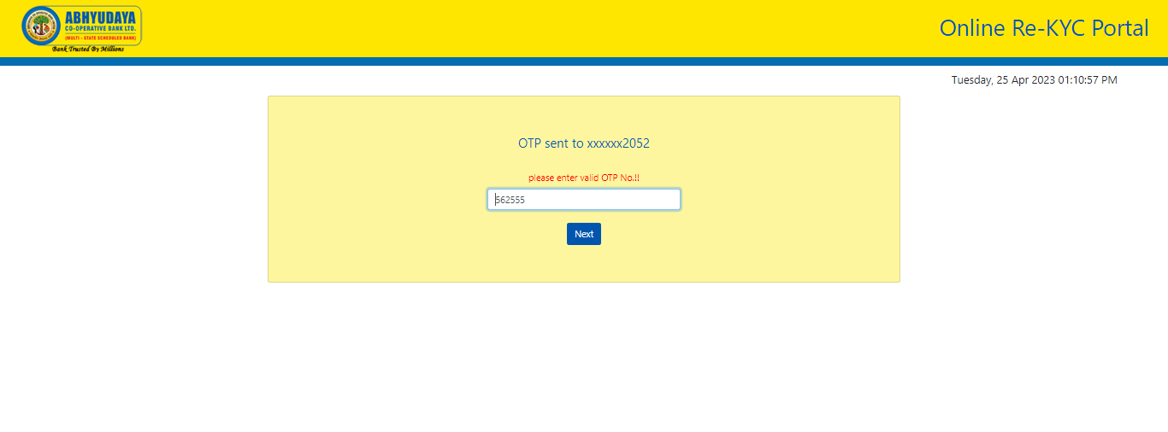Screen 7

Following message will reach the registered mobile number.

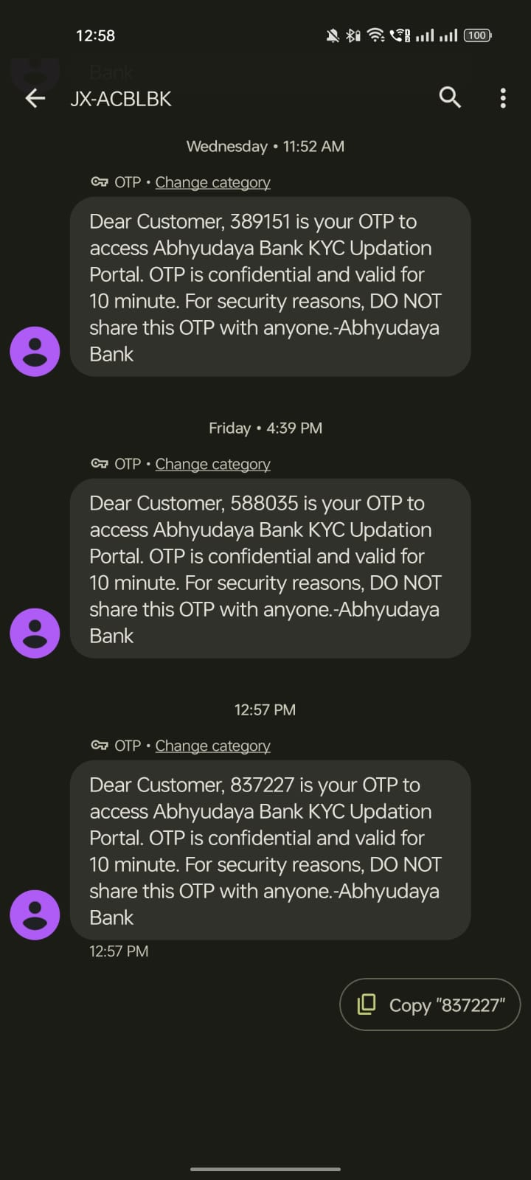

Screen 8

Enter below the OTP as received as above and click on “next” button as per screen 9.

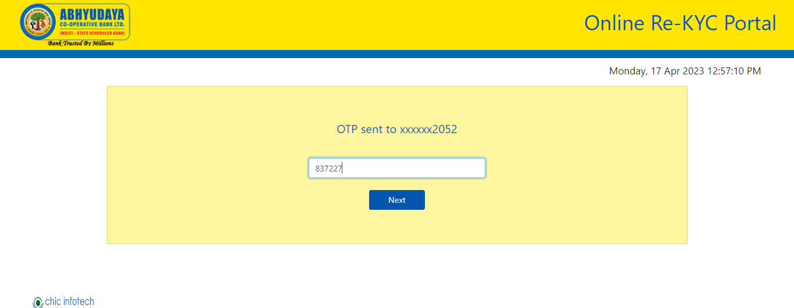Screen 9

Following message will appear on your screen after submitting OTP as above.

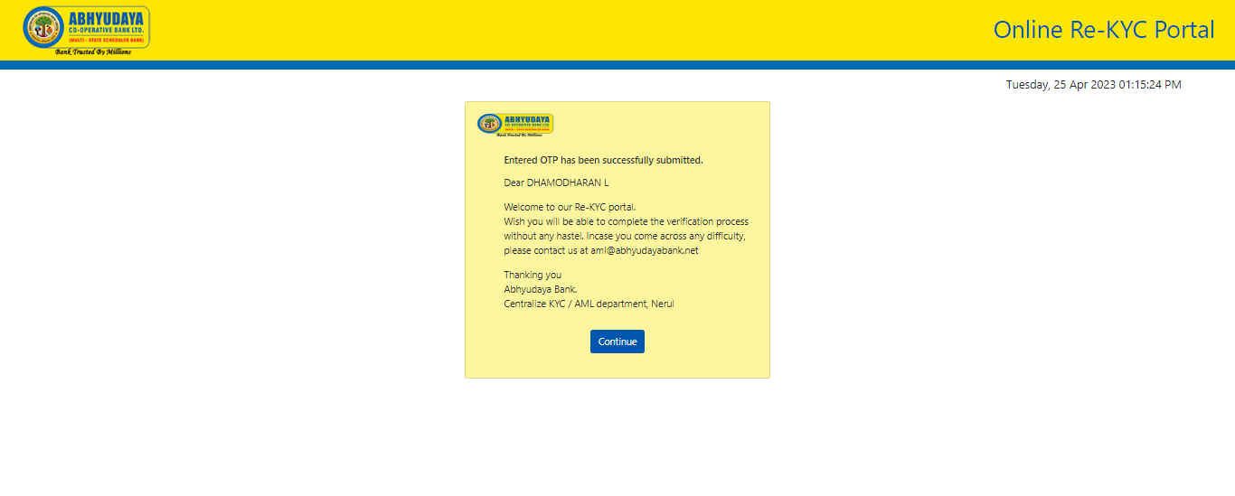

Screen 10

Here, users have to select an account type as per screen 11.

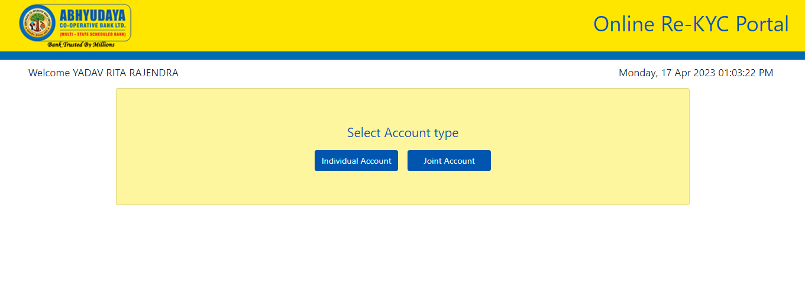

Screen 11

Now, you will be redirected to following page. On selecting “Individual Account” you will get the page as per Screen no.12 below.

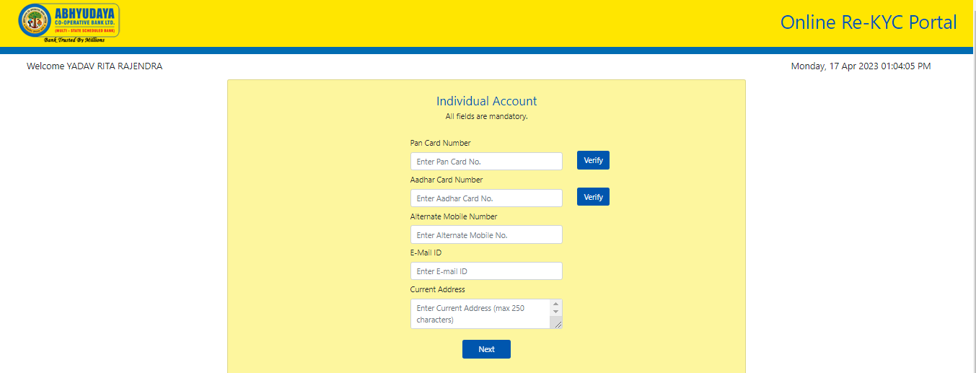

Screen 12

Users have to fill out all details (all mandatory) as per screen 12.

Here, users have to put his correct Pan Card number. If the Pan Card number or format is wrong, then following message in red will appear as per screen 13.

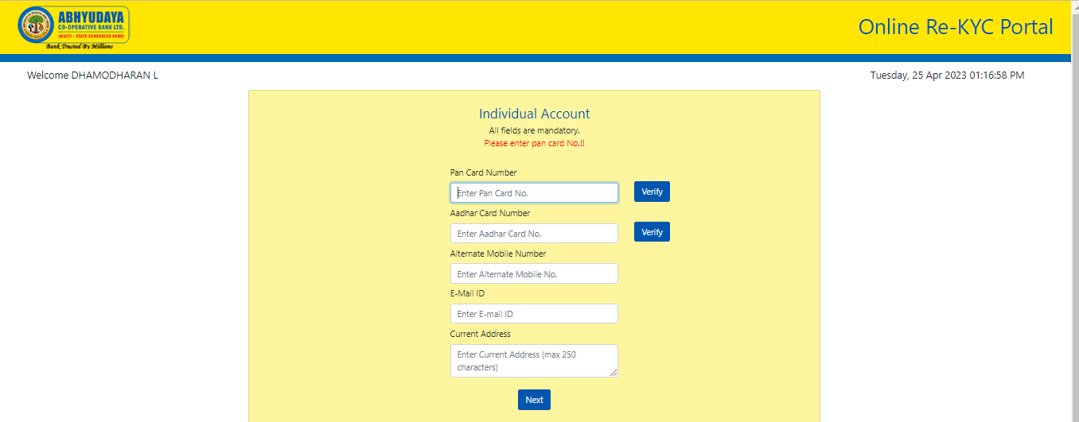

Screen 13

Here, your Pan Card and Aadhar Card will get verified online. On filling up Pan Card number you have to click “verify” button and now, the verification result will come online after some time. If the verification is successful, blue “verify” button will change to green button called “verified” and the name of the Pan Card holder will appear above input textbox (refer screen no. 14 below).

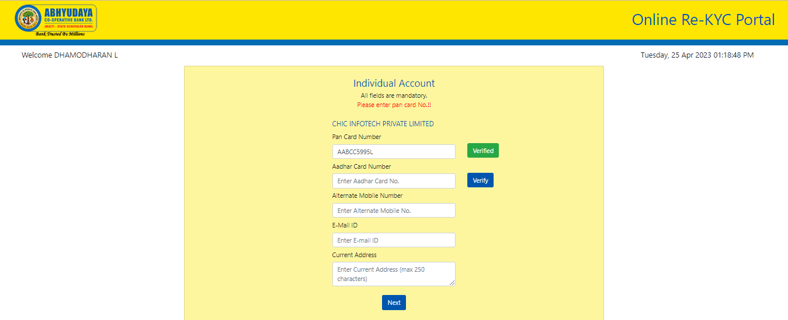

Screen 14

Similar function is available for Aadhar Card verification also with the exception that after filling Aadhar Card number and OTP will be sent to registered mobile number from Aadhar Portal (https://uidai.gov.in/en/ ) (refer screen no. 15 below).

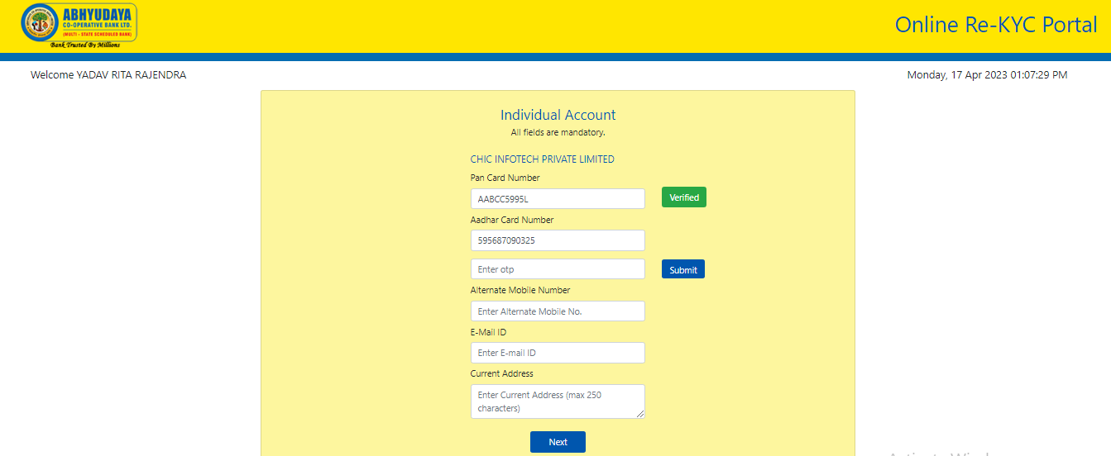

Screen 15

Following message will reach the registered mobile number for verification from Aadhar Portal (https://uidai.gov.in/en/).

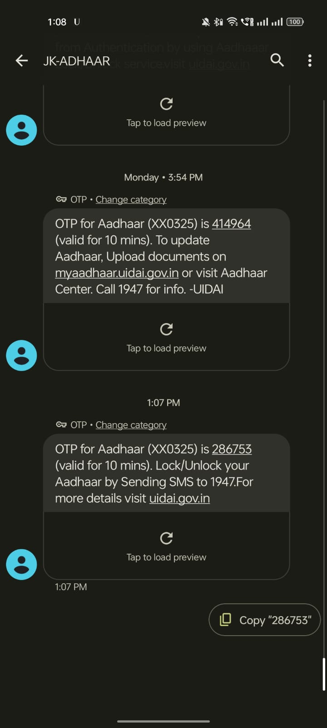

Screen 16

If the verification is successful, blue “verify” button will change to green button called “verified” (refer screen no. 17 below).

Few more details, though not mandatory, may be filled in like alternate mobile number, email id and current address.

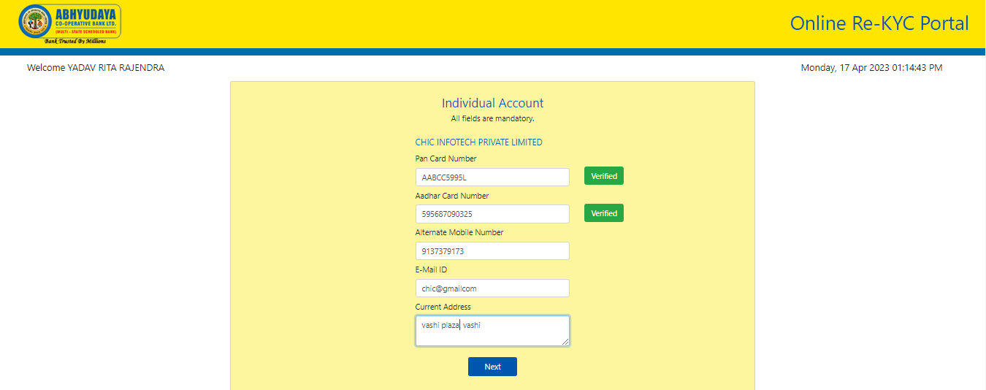

Screen 17

After that, the user will be able to select the source of income from the salary and business account (refer screen 18). After filling in the following details like industry /business type and annual income range, the applicant can submit their application by clicking on “submit” button.

All fields are mandatory here. (refer screen 18 to 22).

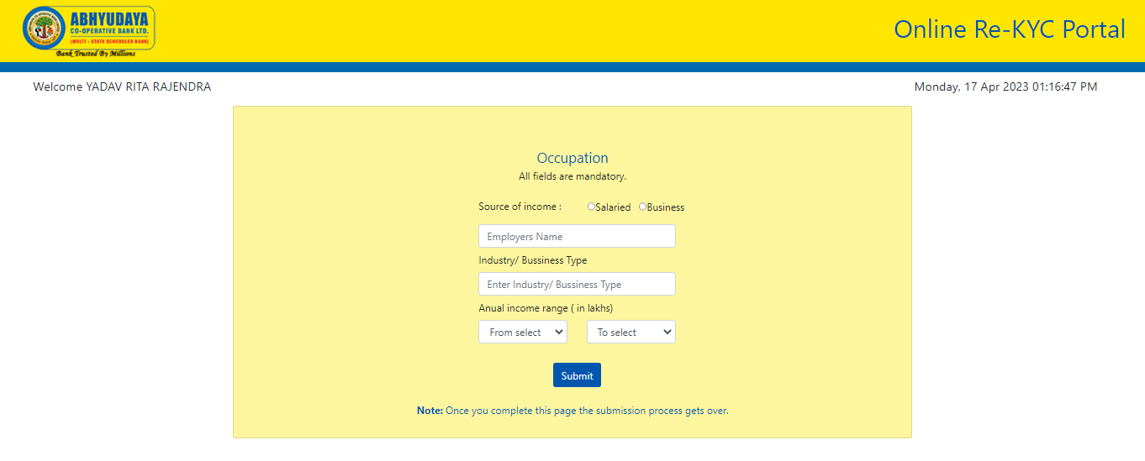

Screen 18

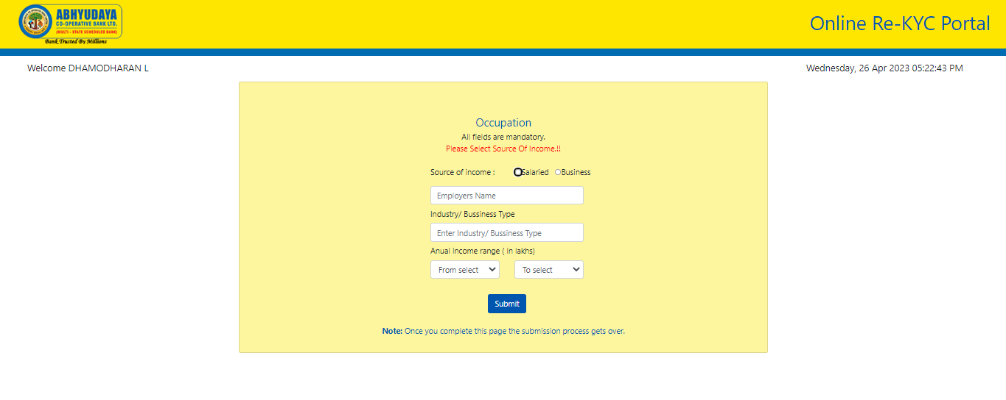

Screen 19

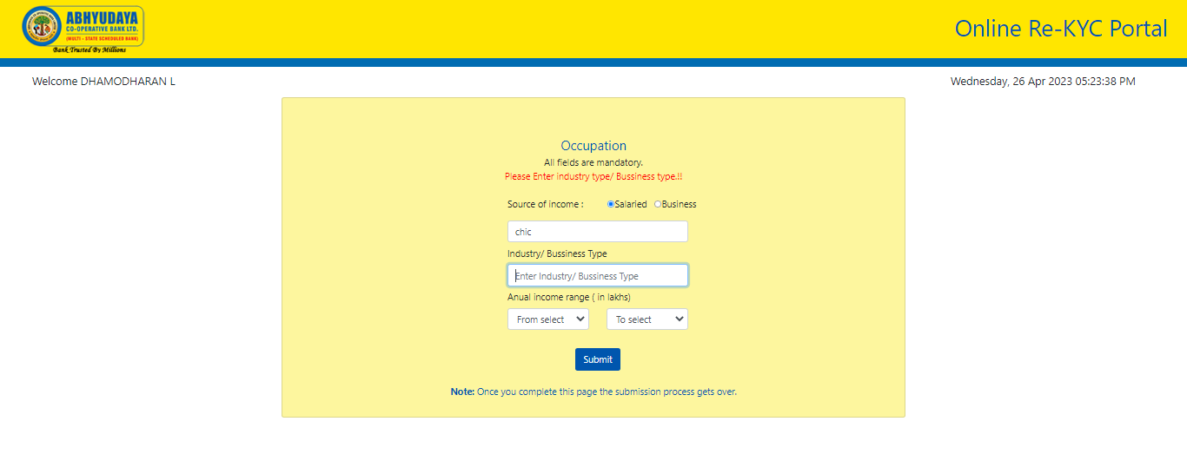

Screen 20

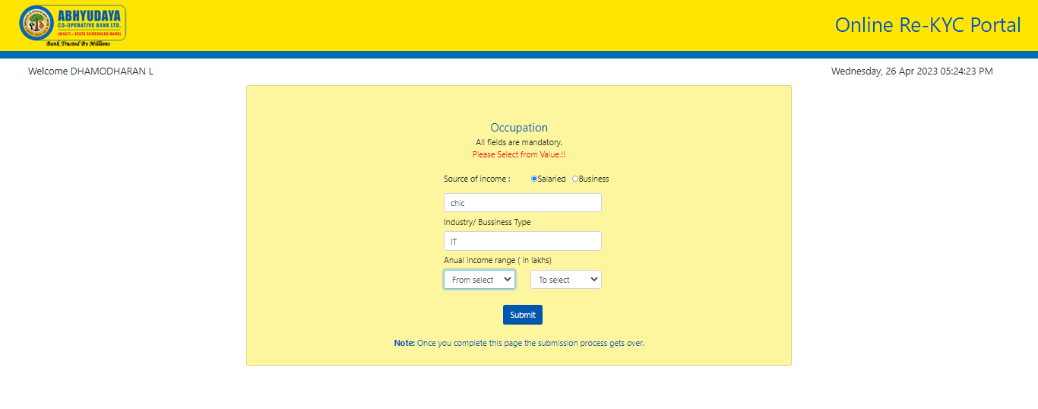

Screen 21

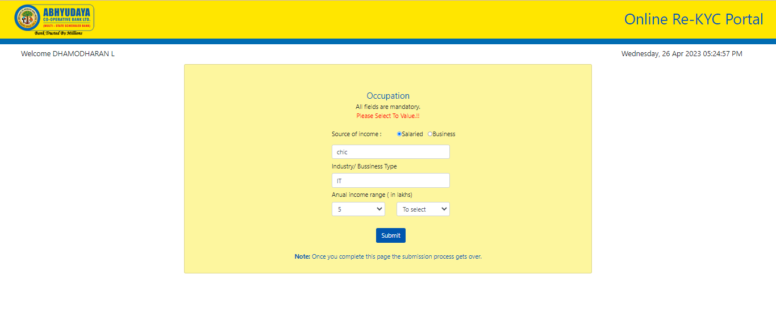

Screen 22

After filling all the fields click on “submit” button for redirect the acknowledgement page.

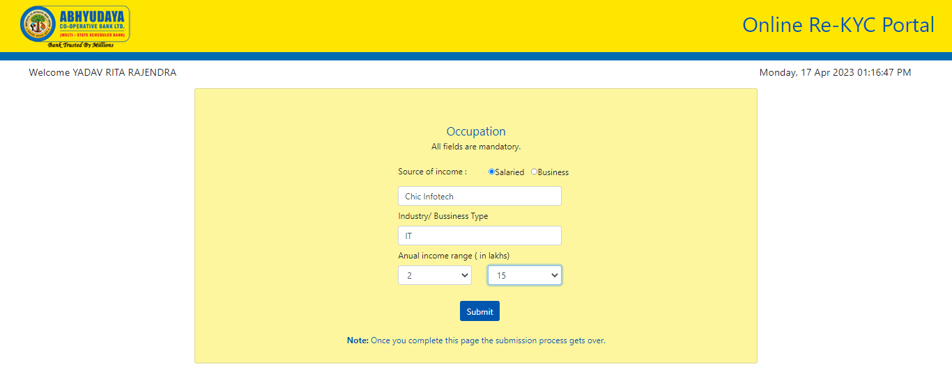

Screen 23

An acknowledgement message will appear as follows (screen 24). The applicant should preserve the KYC ID for future reference.

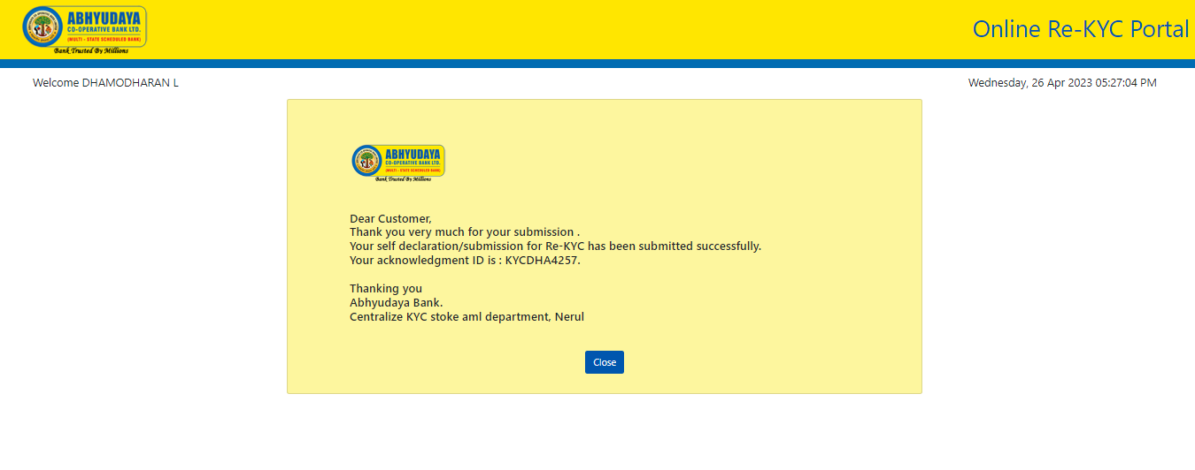

Screen 24

By clicking on “close” button your submission process gets completed.

……end of user section…..

Admin Section (Only meant for owner of the module at bank):

All authorized users will have the access to “Admin Module”. The bank officials can login with their login credentials to perform the administrative functions as shown below.

Under admin section there are two types of users, “SuperAdmin” and “Ordinary Admin User”.

A SuperAdmin user will be able to add, edit or delete admin user. Whereas, the admin user will not have this authority.

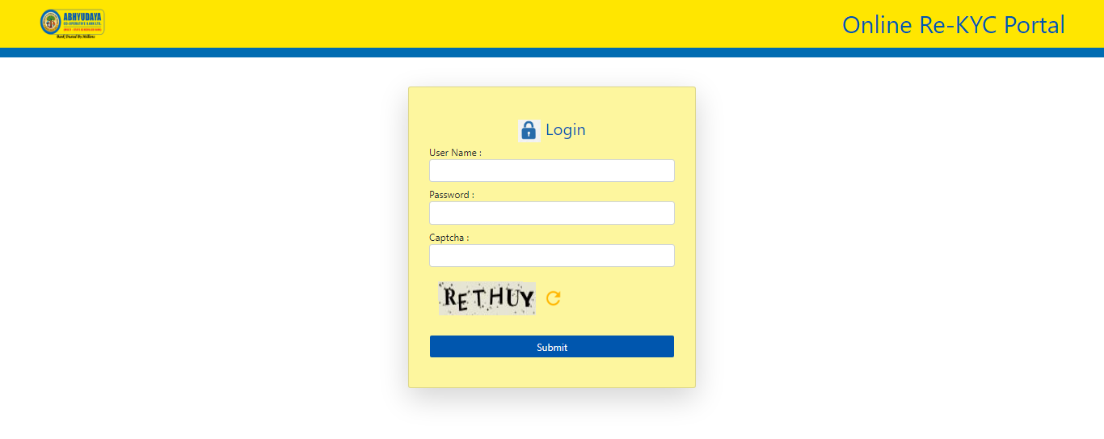

Screen 25

Here, enter a username without a special character and a username length is a maximum of 10 characters.

password length is a maximum of 11 characters. Also, alpha and numeric are both allowed.

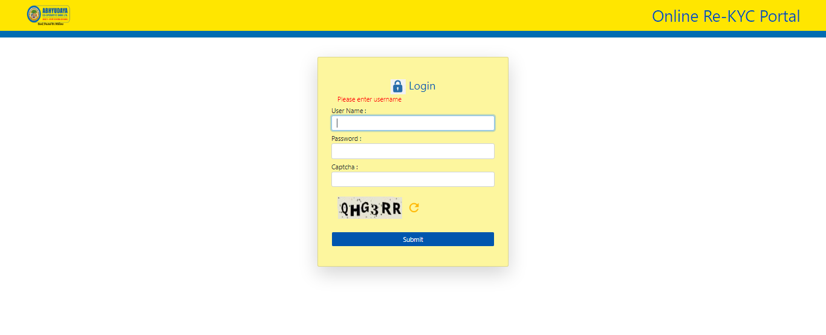

Screen 26

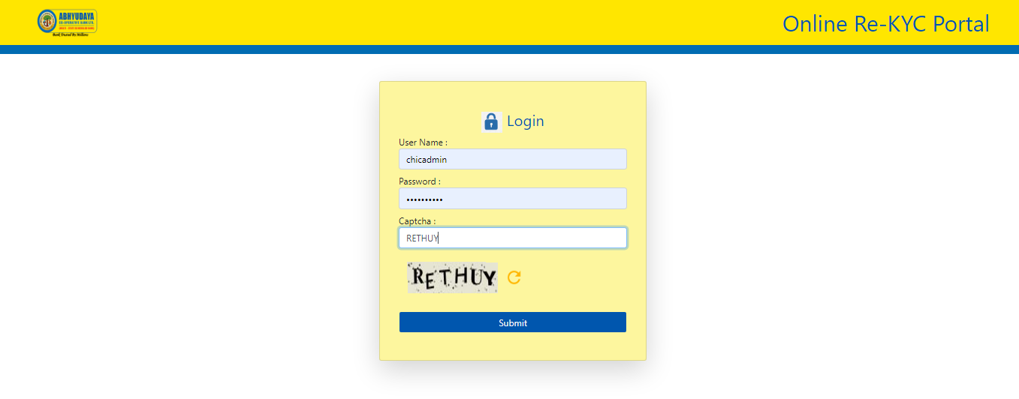

Screen 27

After filling the correct credentials and captcha in screen 27 you will get the admin home page (screen 28).

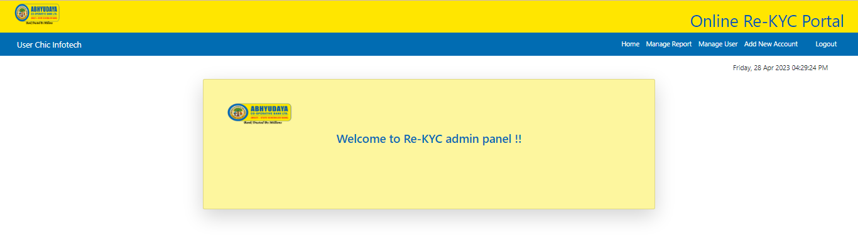

Screen 28

For creating various reports, click on “Manage Report” button on the top-right side in screen 28. You will receive screen as follows (screen 29) for the multiple types of search report options.

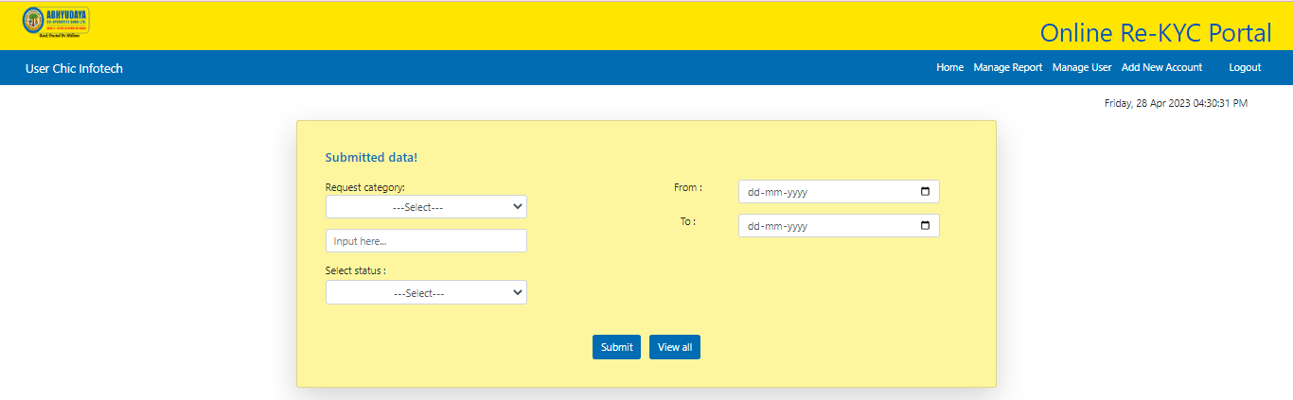

Screen 29

Using the features in screen 29 you will have the following search options:

1. Search by KYC id.
2. Search by Name.
3. Search by Account number.
4. Search by from-to date.
5. Search by valid status.
6. Search by Invalid status.
7. Search by Replied status.
8. Search by Not-replied status.
9. Search by KYC id and from-to date.
10. Search by Name and from-to date.
11. Search by Account number and from-to date.
12. Search by valid status and from-to date.
13. Search by valid status and from-to date.
14. Search by Replied status and from-to date.
15. Search by Replied status and from-to date.
16. View all data.

For example: If the search is for “name” request category (screen 30) then you will get the results as per screen 31.

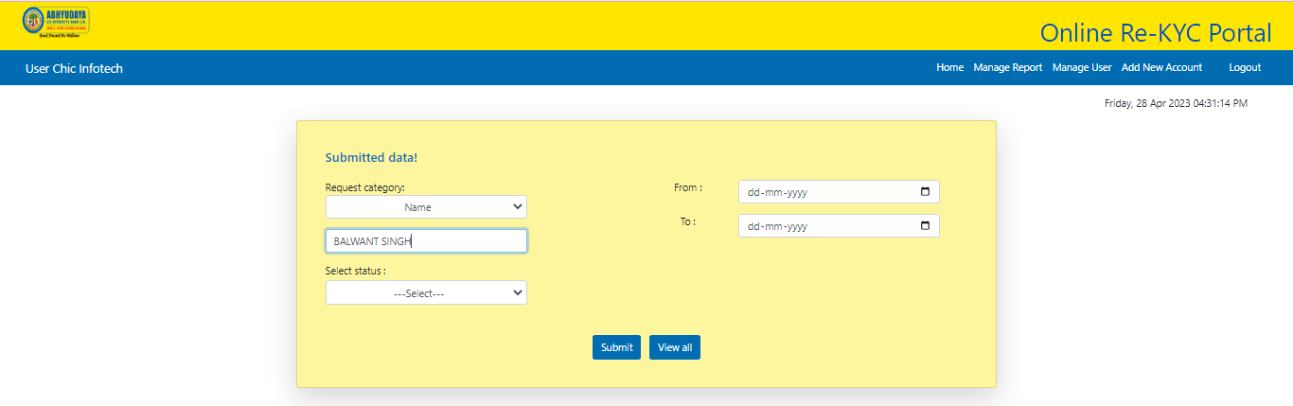

Screen 30

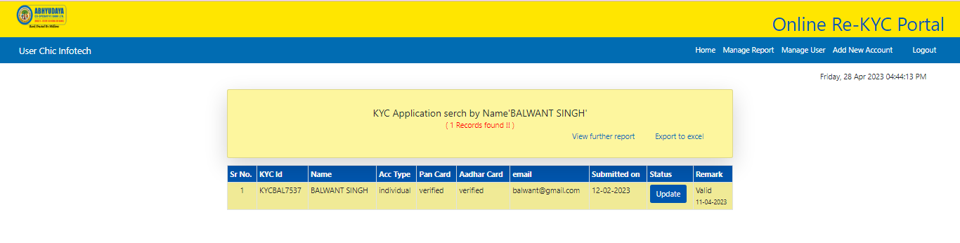

Screen 31

Again, if the search is for “Account Number” request category (screen 32) then you will get the results as per screen 33.

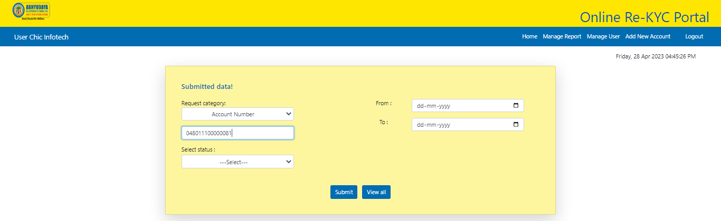

Screen 32

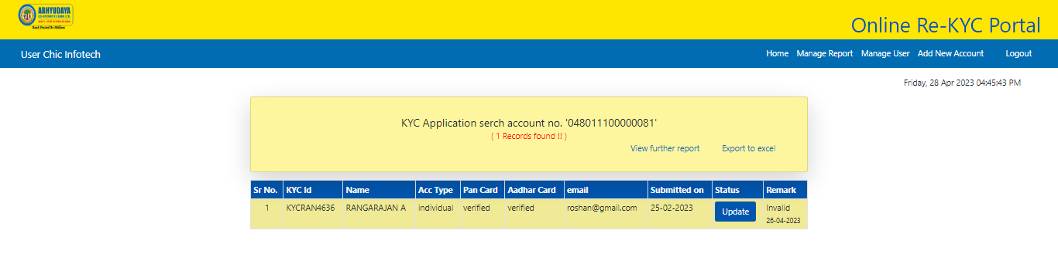

Screen 33

Search through Kyc-ID (screen 35)

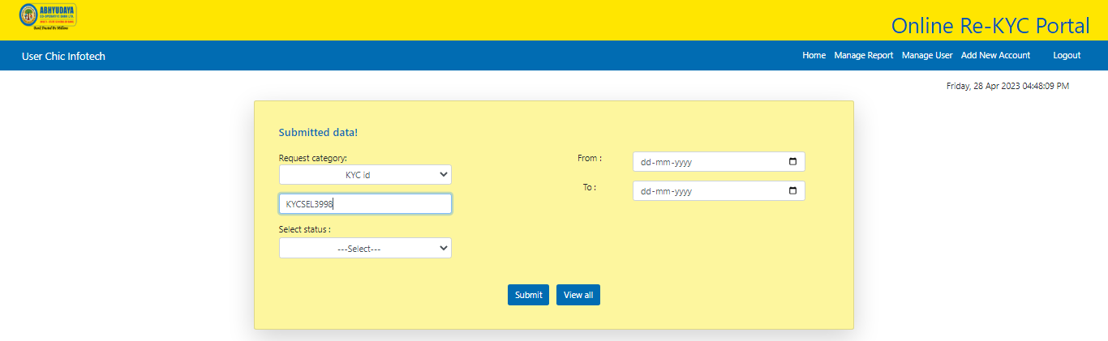

Screen 34

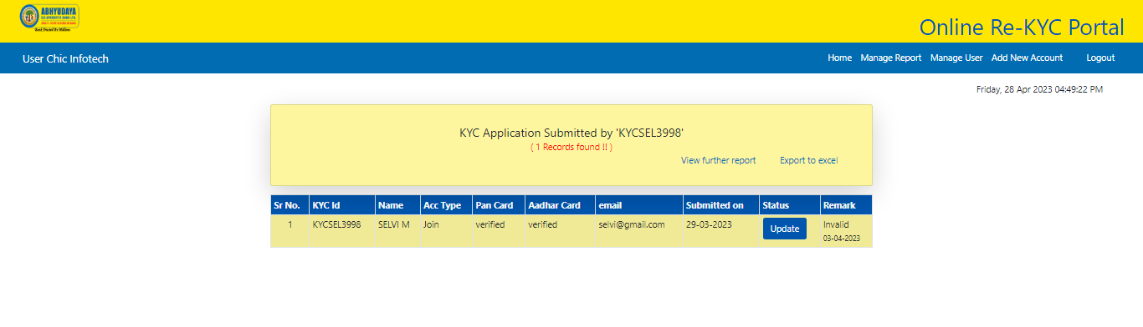

Screen 35

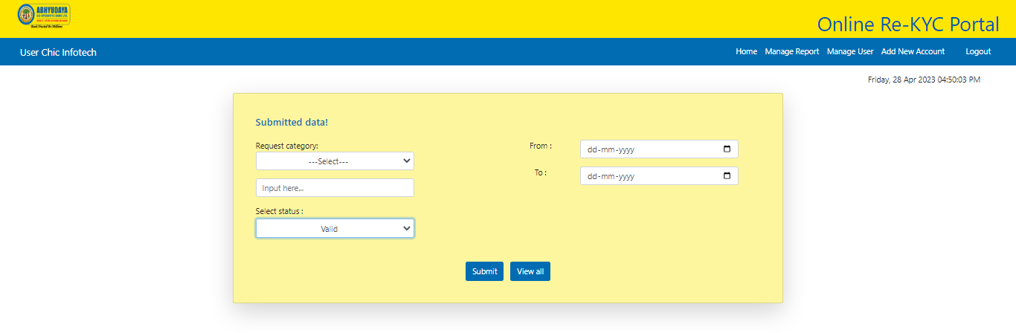

Screen 36

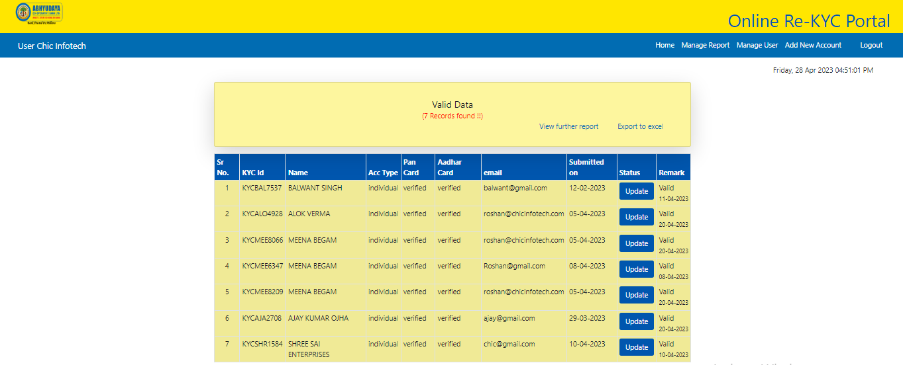

Screen 37

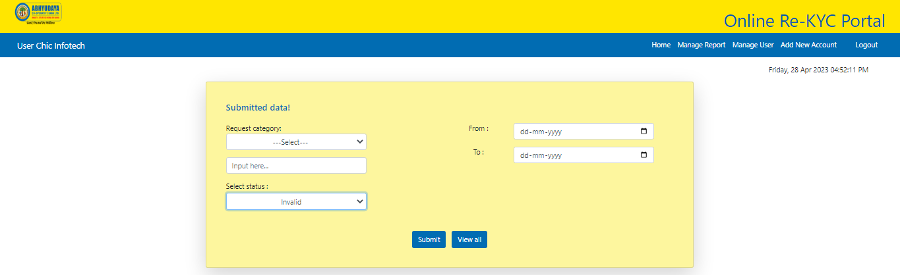

Screen 38

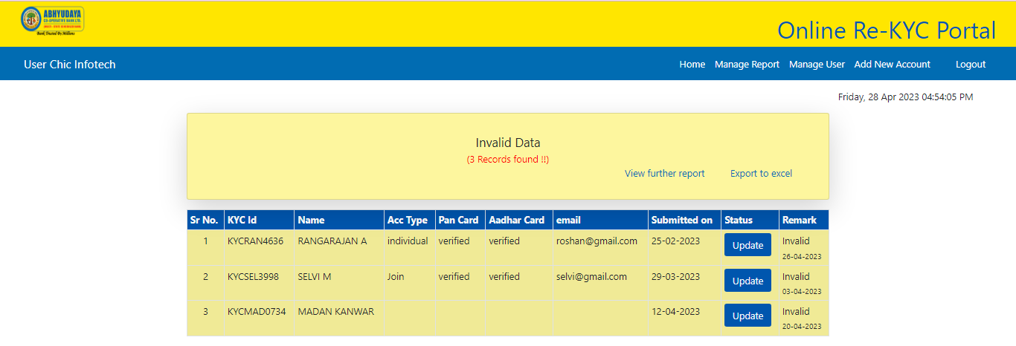

Screen 39

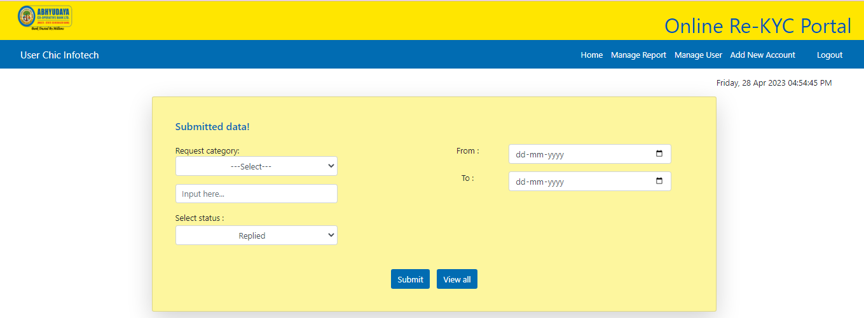

Screen 40

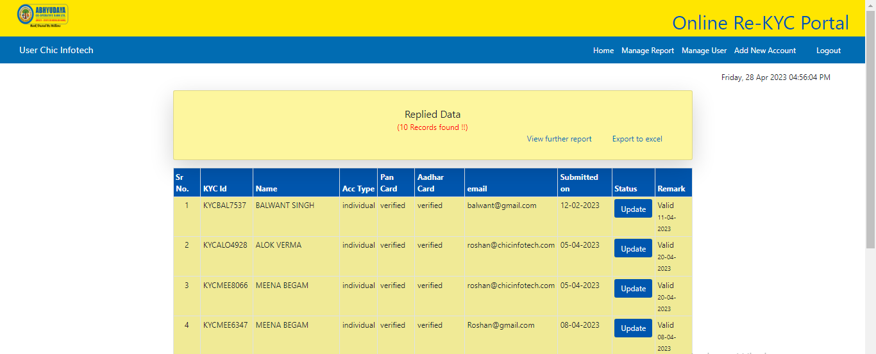

Screen 41

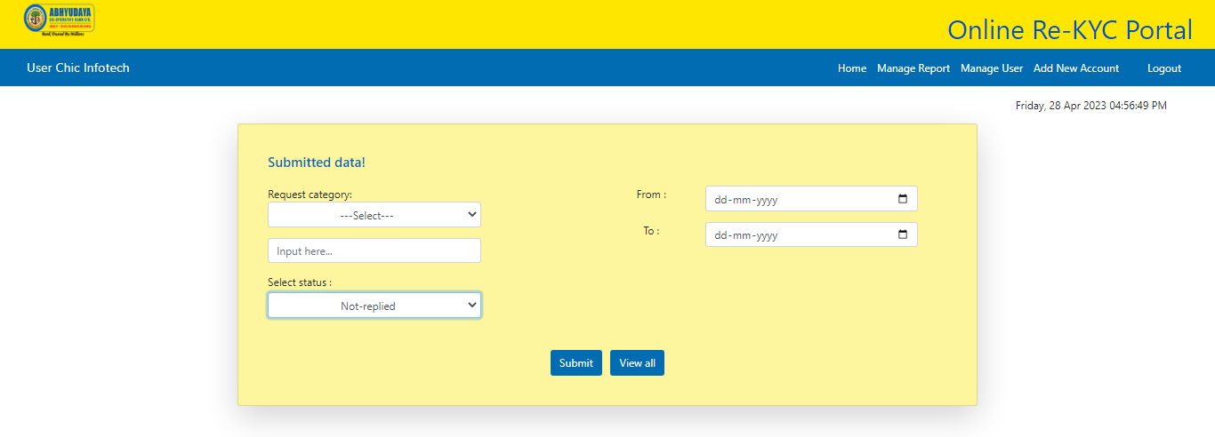

Screen 42

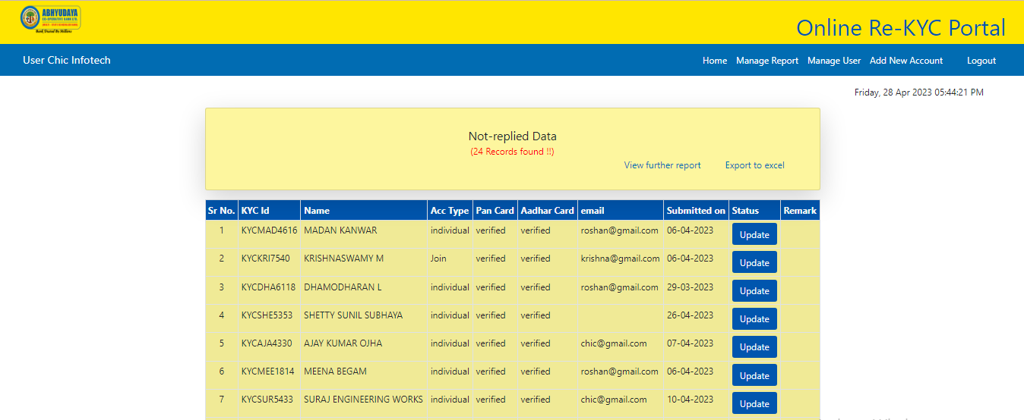

Screen 43

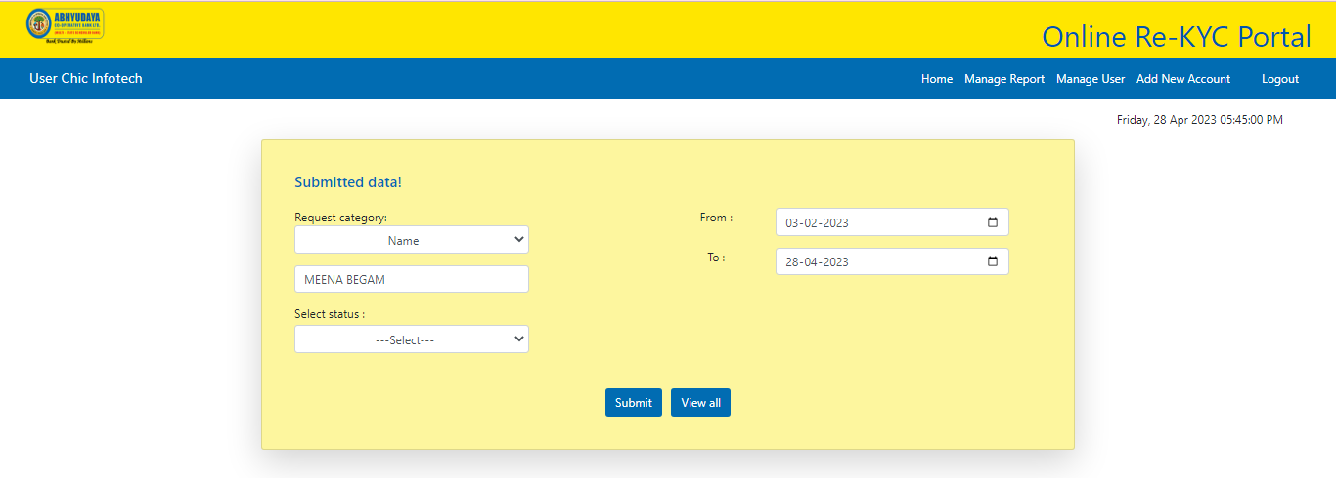

Screen 44

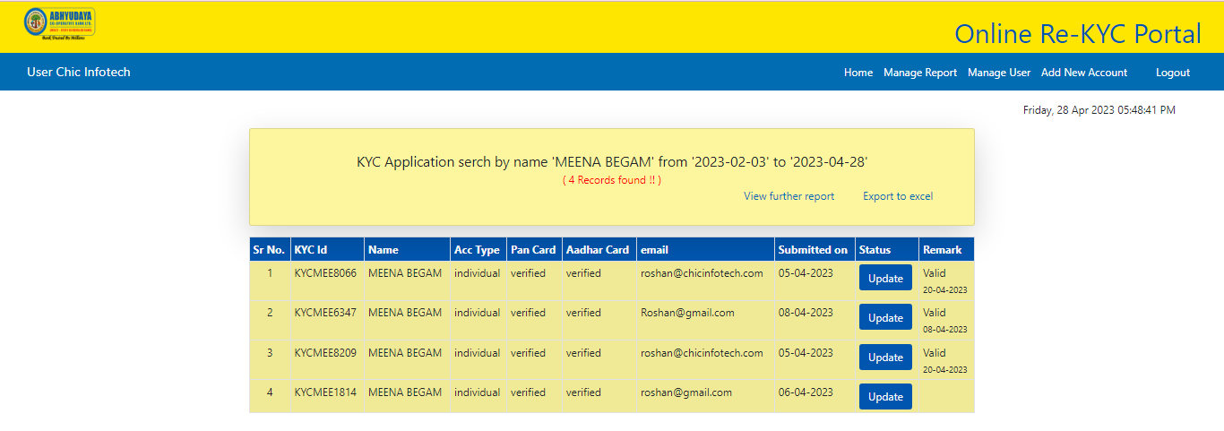

Screen 45

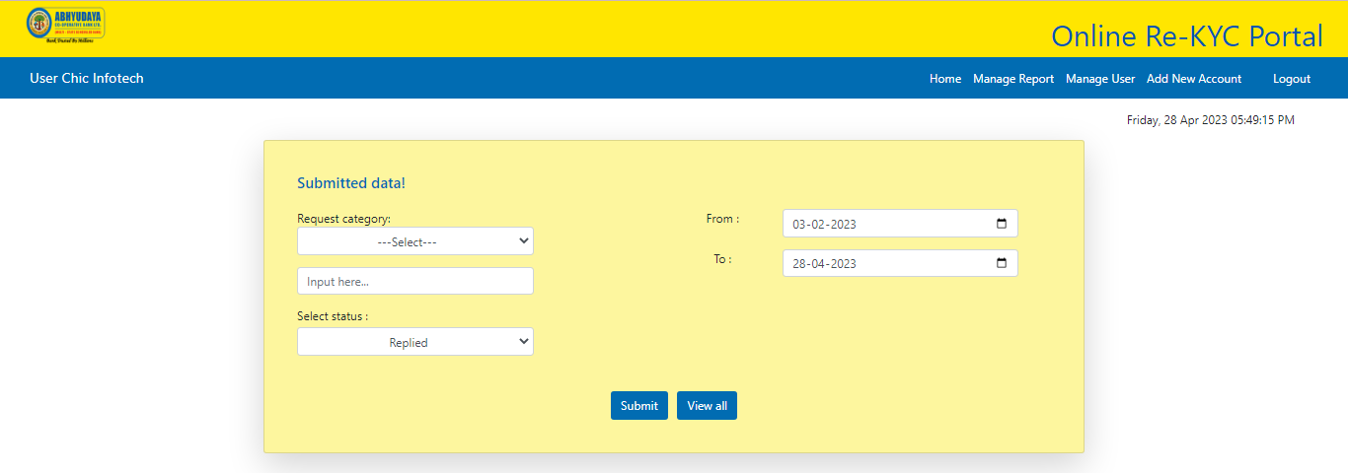

Screen 46

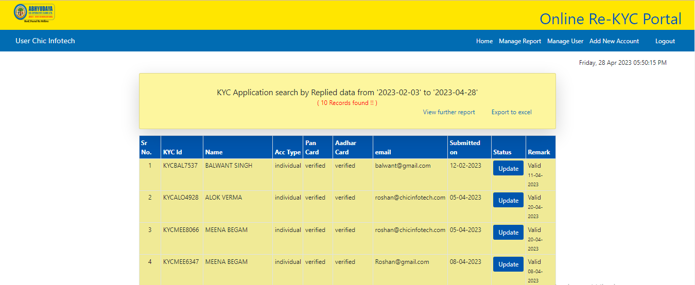

Screen 47

The above examples are for various search results from serial number 1 to 7 as per screen 29 above.

For rest search results, similar process may be followed.

Now, the admin can update the status after generating report by selecting search option, “from-to date” option (serial no. 4 ) to view the records and click on “update” button under status column to get a partially field in form as will appear as per screen 50 below.

Status to be updated through field provided for “Remarks” at the bottom of the form.

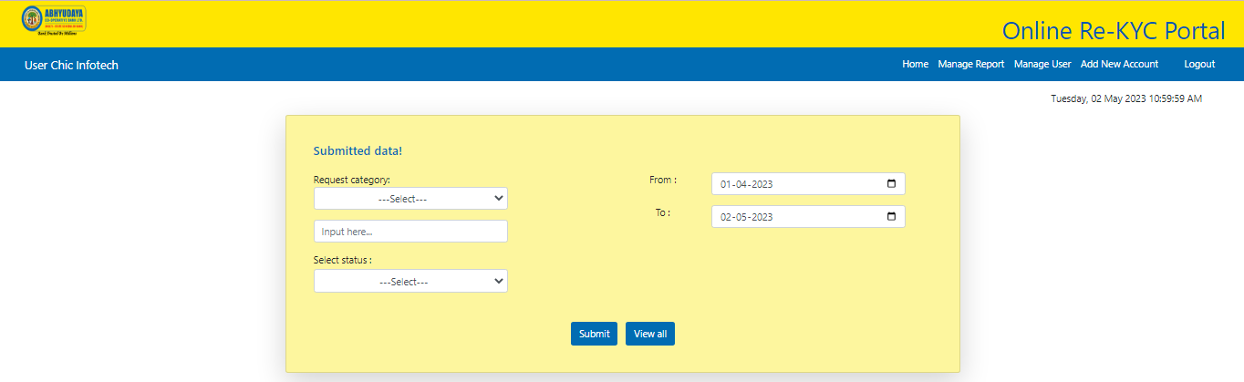

Screen 48

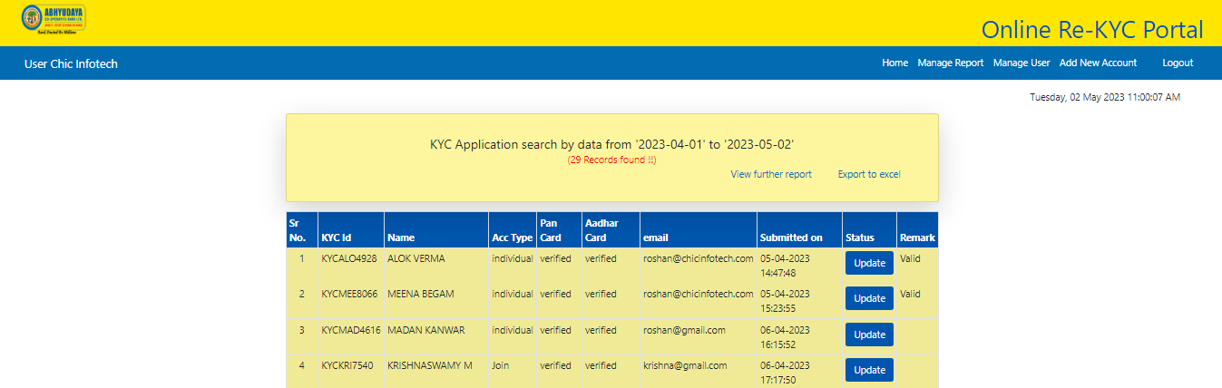

Screen 49

For updating status Now, Admin wants to update the status as per screen 49 above you will get the following page where you can update status through dropdown under “remarks” option.

Please note that admin can update only through “remarks” option (screen 50).

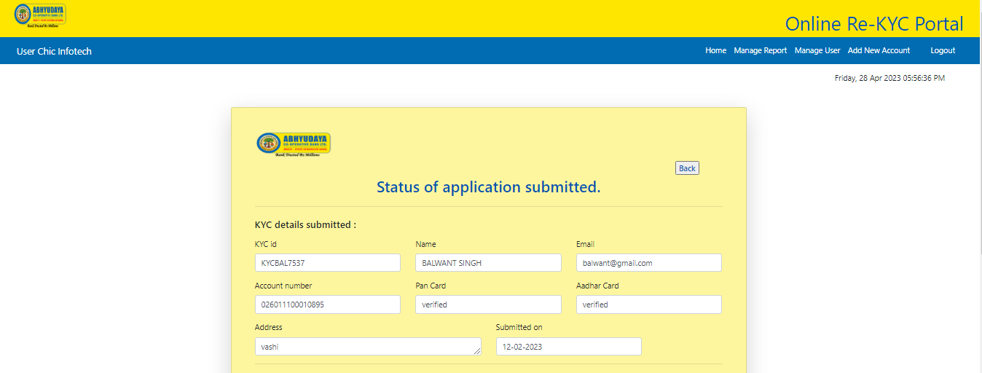

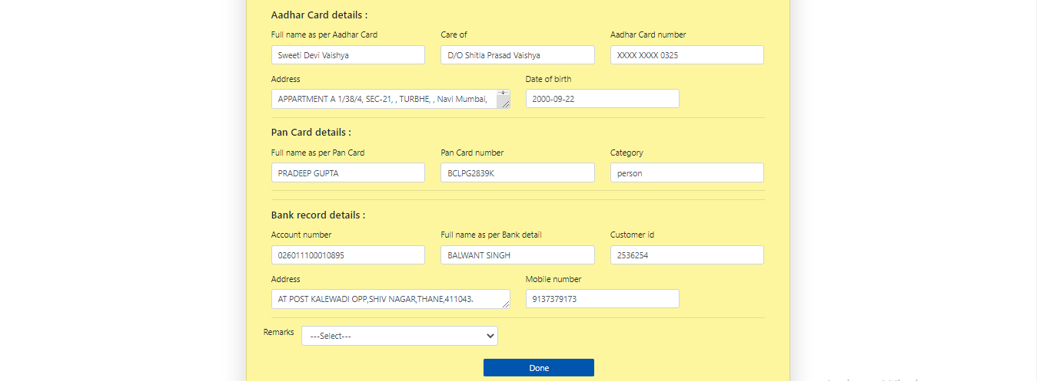

Screen 50

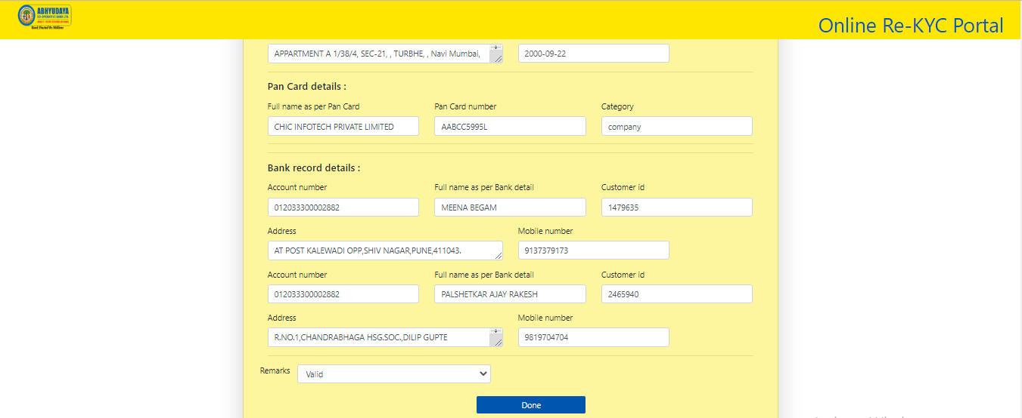

Screen 51

Now, this section gives facility to only upload data of customers in predetermined format in excel

(Screen 52).

Following process is to be followed while updating uploading data for new customers.

1. Click on “Add new Account” button to add the new account data.
2. Select “excel file” in predetermined format and click on “insert” button.
3. A message will be displayed as per screen 52(for successful upload message will be displayed as “Inserted data successfully” and if not successful then “Please select a file to upload.” will appear.)

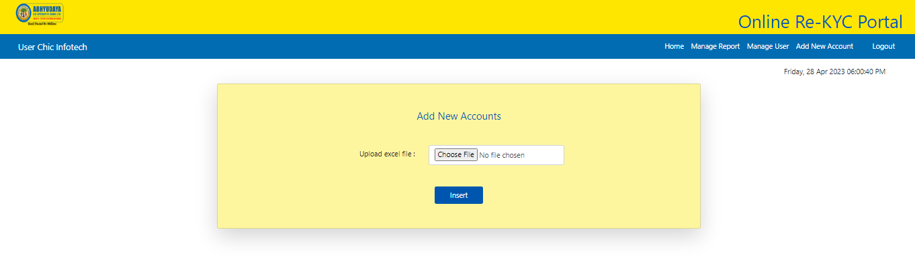

Screen 52

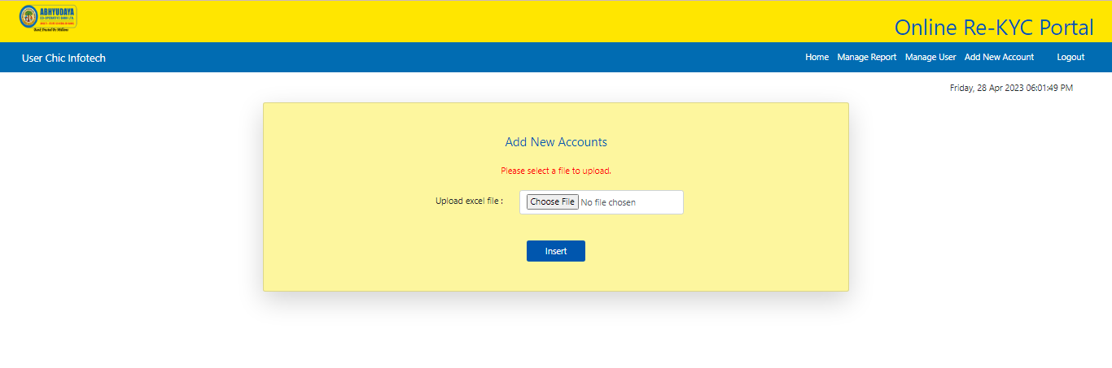

Screen 53

Here, Super Admin can change users (Admin) to clicking on “Manage User”. This access provide only for Super Admin.

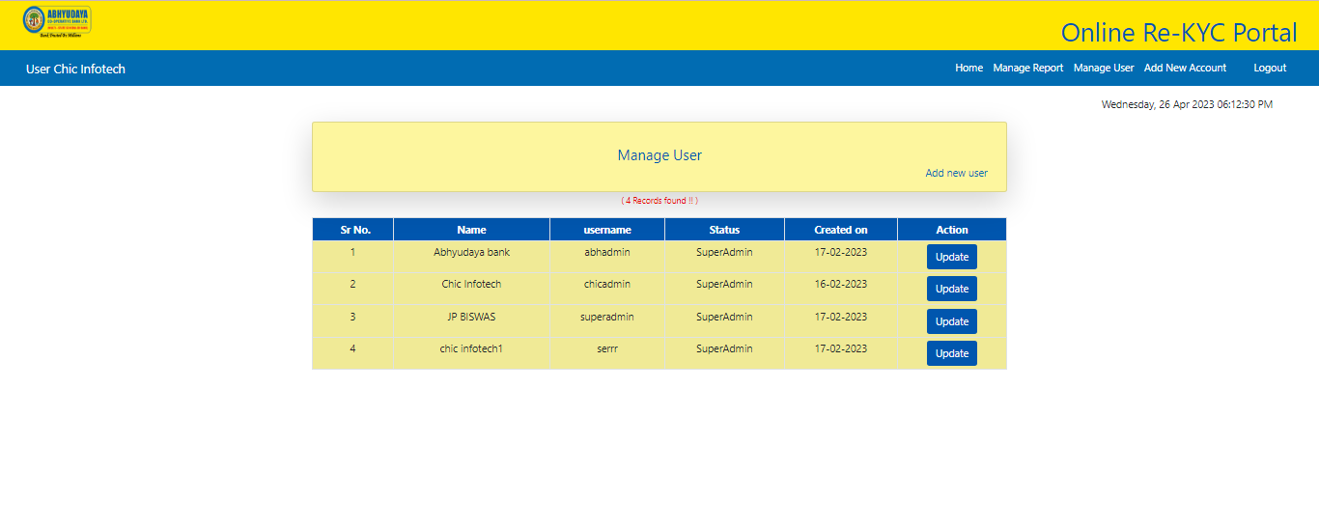

Screen 54



Screen 55

Super Admin can add users (Admin), update users profile and also delete users.

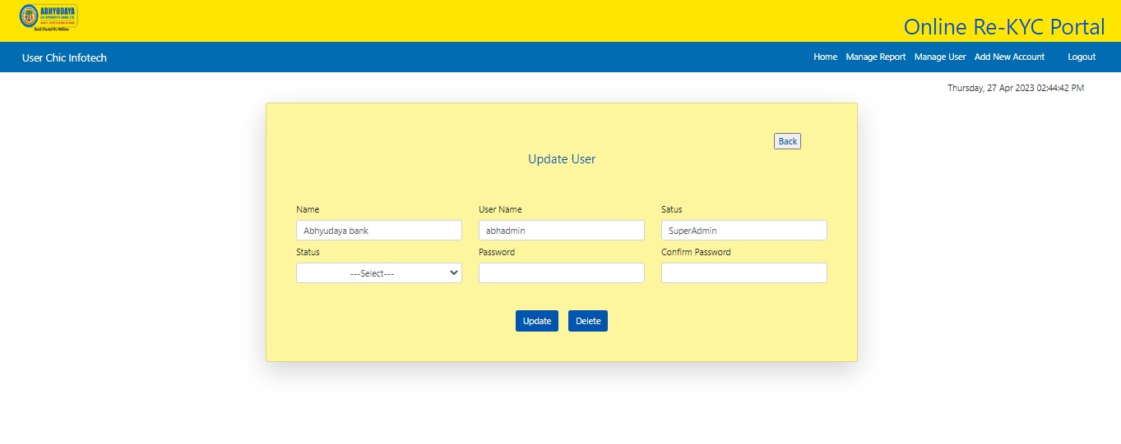

Screen 56

Admin screen:

In this admin section, admin cannot access the “Manage User” model. That access is only for SuperAdmin.

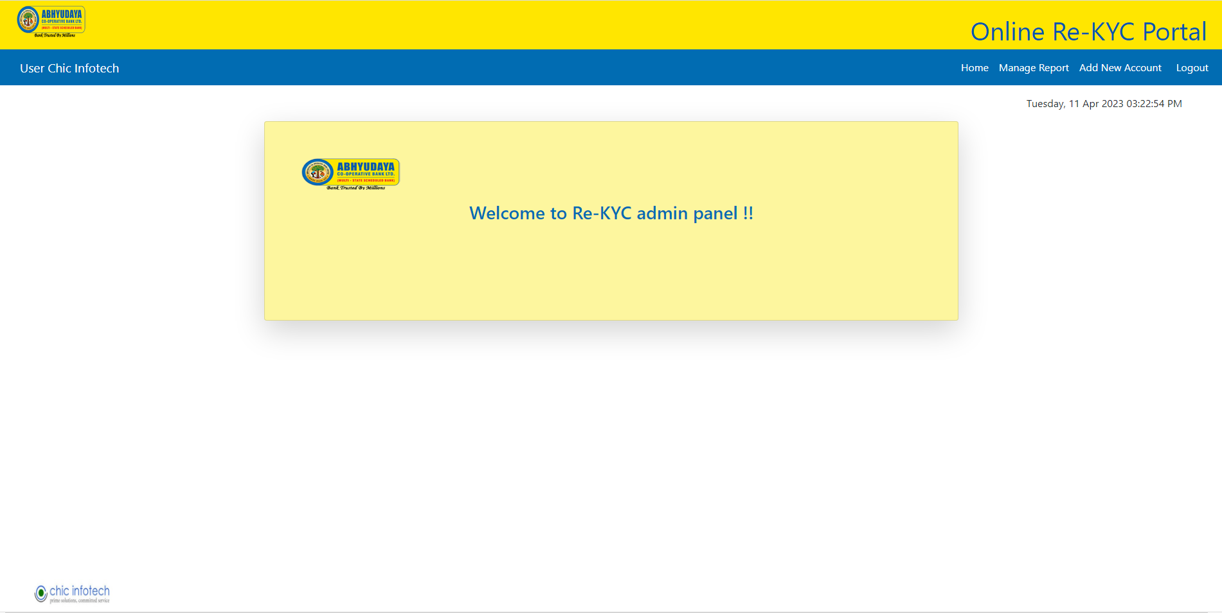

Screen 57

………end of admin section………