**o**



**User manual**

**For**

**Re-KYC Portal**

**Abhyudaya Bank**

**(Work Order no. IT/PO-105/ 2022-23 dated 27th February 2003.)**

[Version 1.0]

***Prepared by***:

**Chic InfoTech Pvt. Ltd.**

457,’D’ Wing, 2nd Floor,

Vashi Plaza, Sector 17,

Vashi, Navi

Mumbai 400705

Tel 2789 8996 / 97

Web site: - www.chicinfotech.com

Email: - [chicinfotech@gmail.com](mailto:chicinfotech@gmail.com)

Date: 06/11/2013

**Note:** This Document is the property of CHIC InfoTech Pvt. Ltd and has been developed by us as per requirement of Abhyudaya Bank. On receipt of this document through any media by it is implied that the Bank will not share this document with any third party without written permission from us.

**User Section :**

Website(<https://www.abhyudayabank.co.in/english/home.aspx> ) visitors can view the online Re-KYC Portal by clicking on the link “Online Re-KYC Portal” and browser will be redirected to the below web dynamic form (screen shot 2).

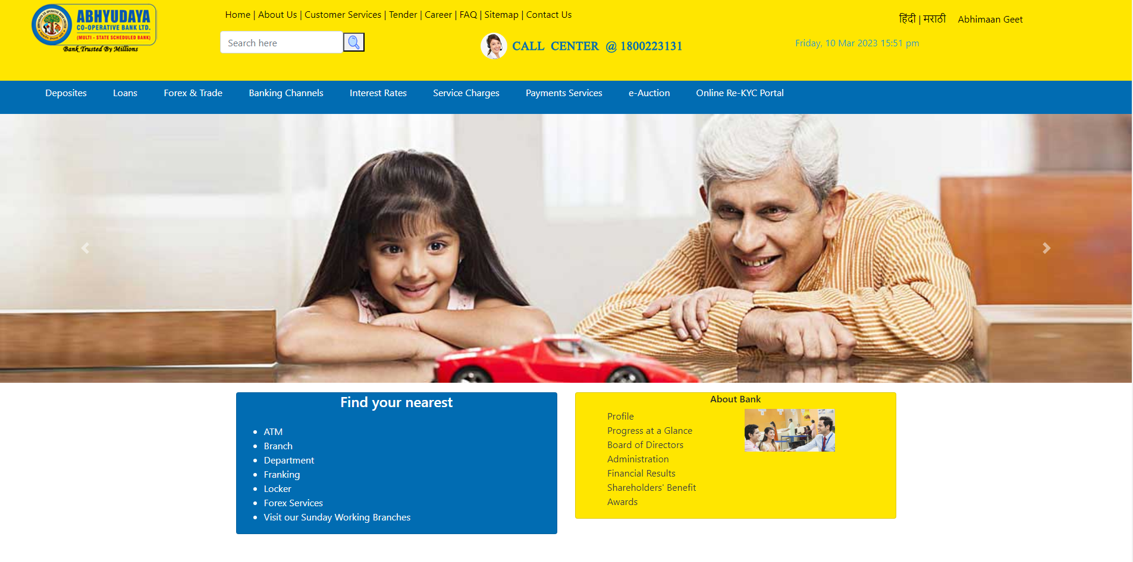

Screen1

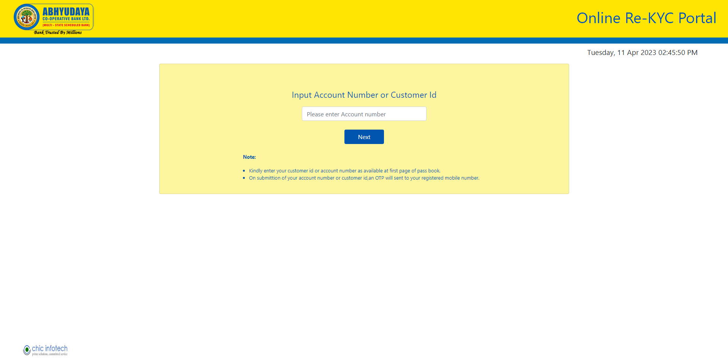

Screen 2

On Filling Account Number or Customer id and Clicking on submit button an OTP will be sent to registered mobile number as provided to bank.

Enter below the OTP as received as above and click on “next” button.

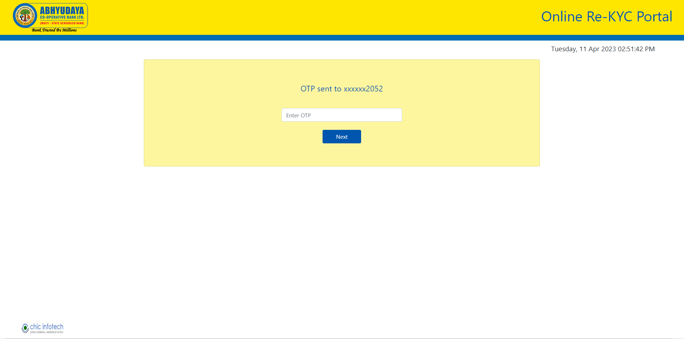

Screen 3

Following message will appear on your screen after submitting OTP.

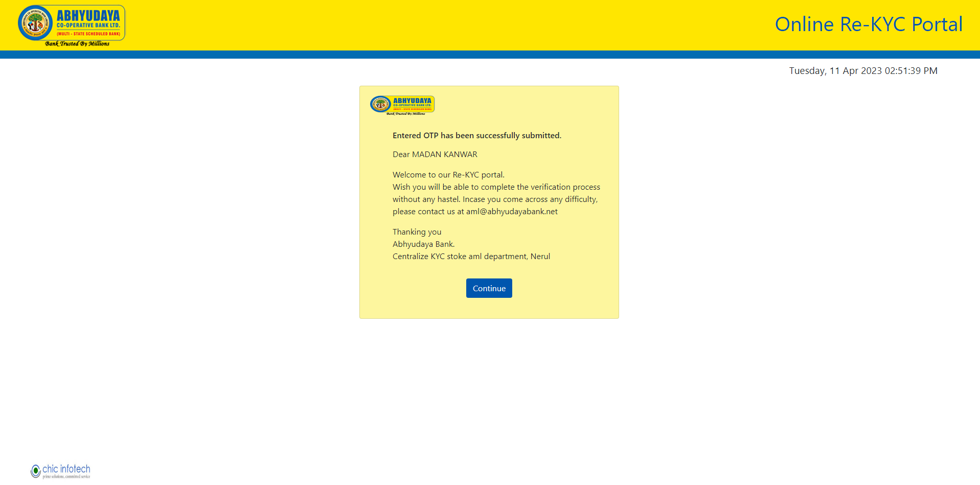

Screen 4

On click on “continue” as above you will be directed to screen no.5 as follows:

Now, you will be redirected to following page. On selecting “Individual Account” you will get the page as per Screen no.6 below.

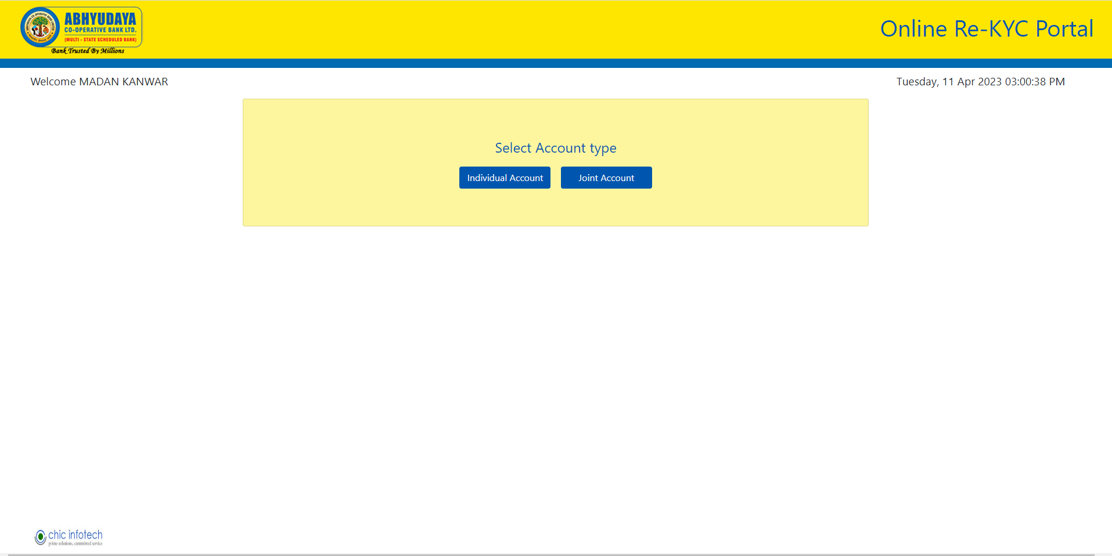

Screen 5

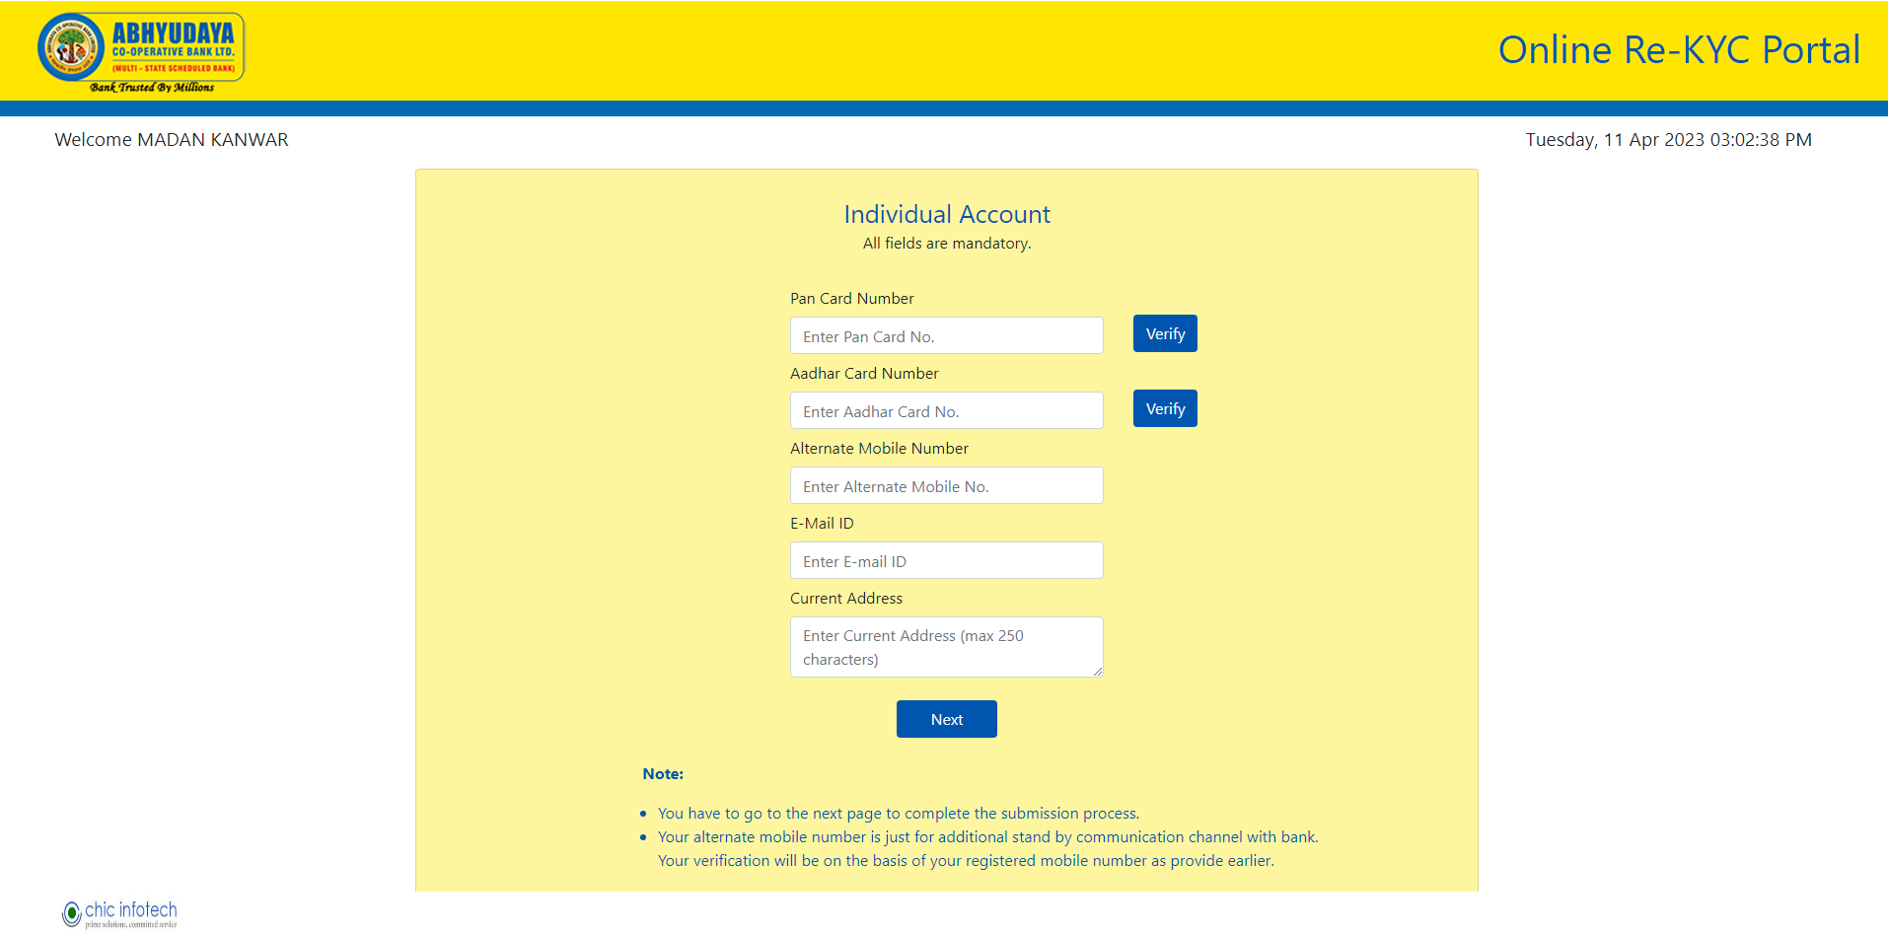

Screen 6

Here, your Pan Card and Aadhar Card will get verified online. On filling up Pan Card number you have to click “verify” button and now, the verification result will come online after some time. If the verification is successful, blue “verify” button will change to green button called “verified” and the name of the Pan Card holder will appear above input textbox (refer screen no. 7 below).

Similar function is available for Aadhar Card verification also with the exception that after filling Aadhar Card number and OTP will be sent to registered mobile number with Aadhar Portal (refer screen no. 8 below).

Here, name of the Aadhar Card holder will not appear on the screen as it happens in case of Pan Card holder.

If the verification is successful, “verify” button in blue will change to “verified” button in green (refer screen no. 9 below).

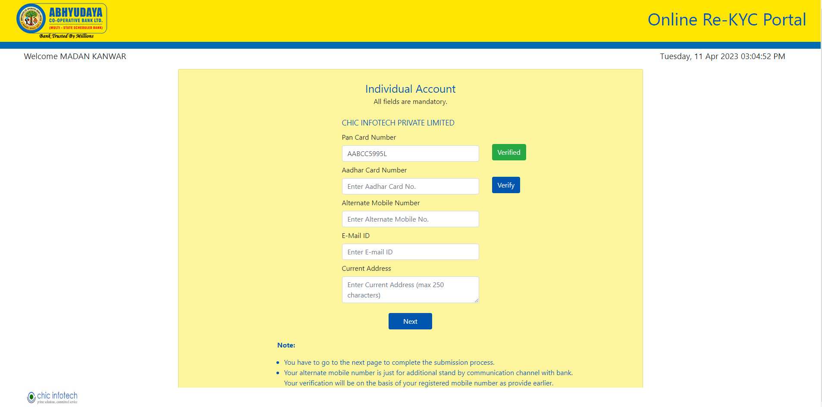

Screen 7

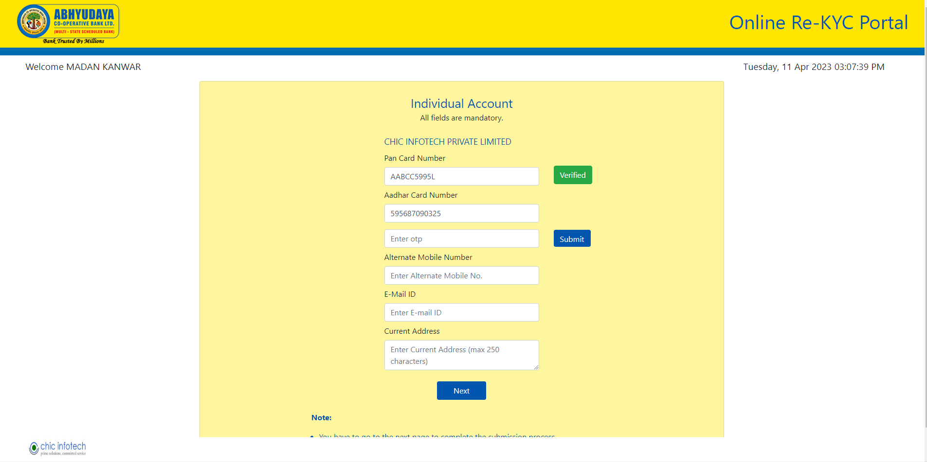

Screen 8

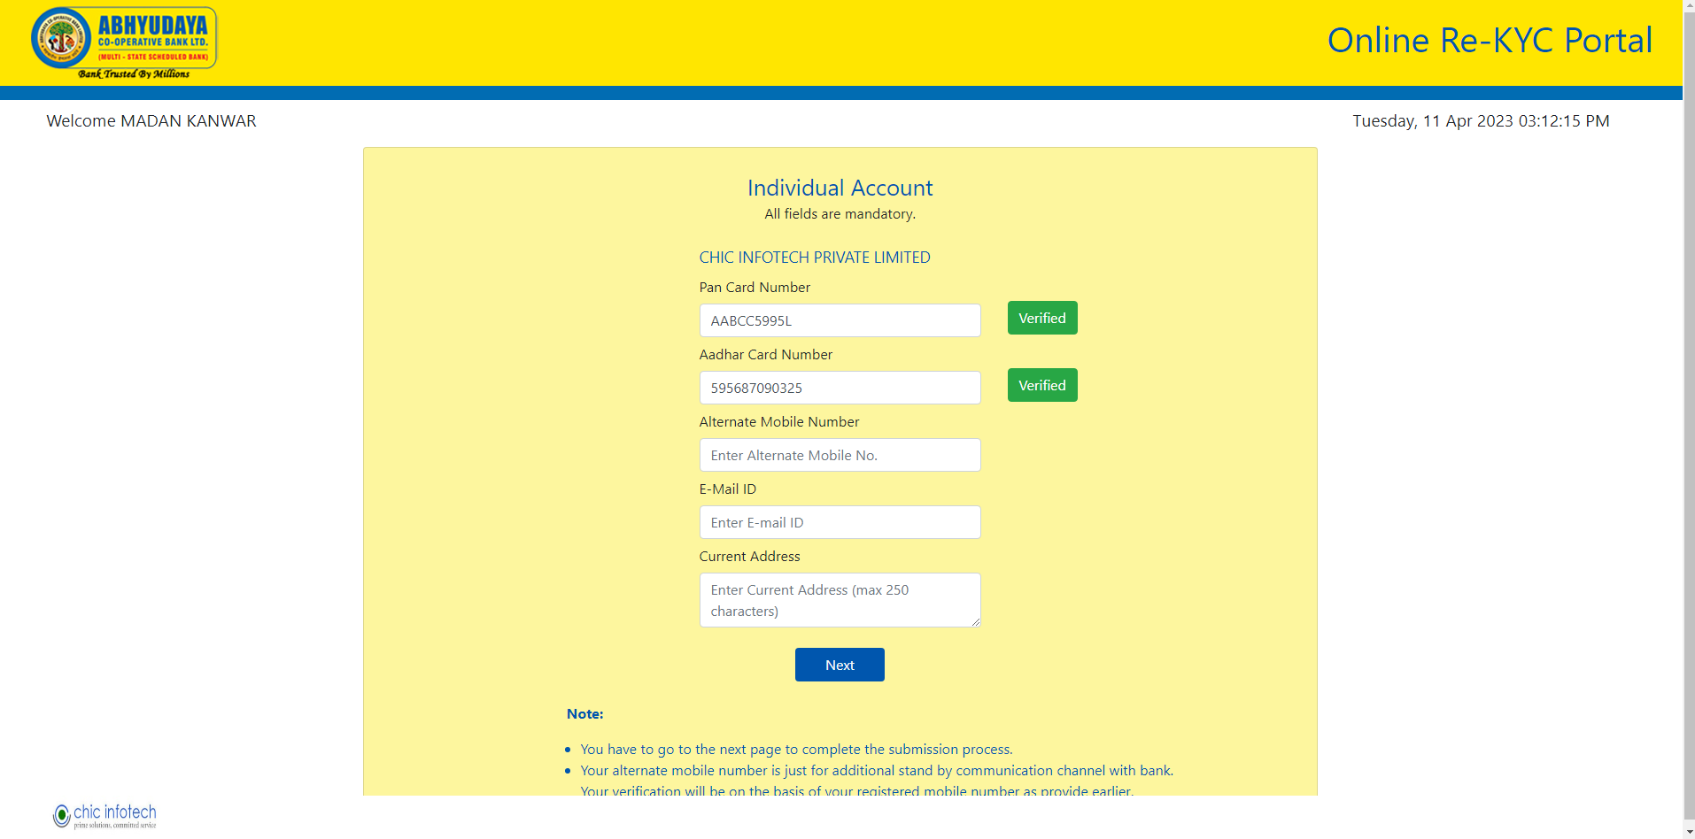

Screen 9

Now, enter the alternate mobile number and valid email id and also current address.

Then click on “Next” button (refer screen no. 10 below).

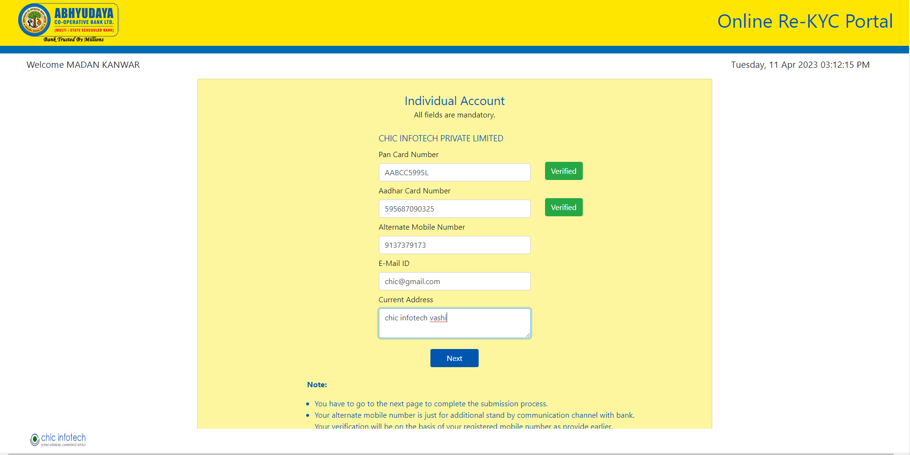

Screen 10

After that, the user will be able to select the source of income from the salary and business account (refer screen no. 11). After filling in the following details like industry /business type and annual income range, the applicant can submit their application by clicking on “submit” button.

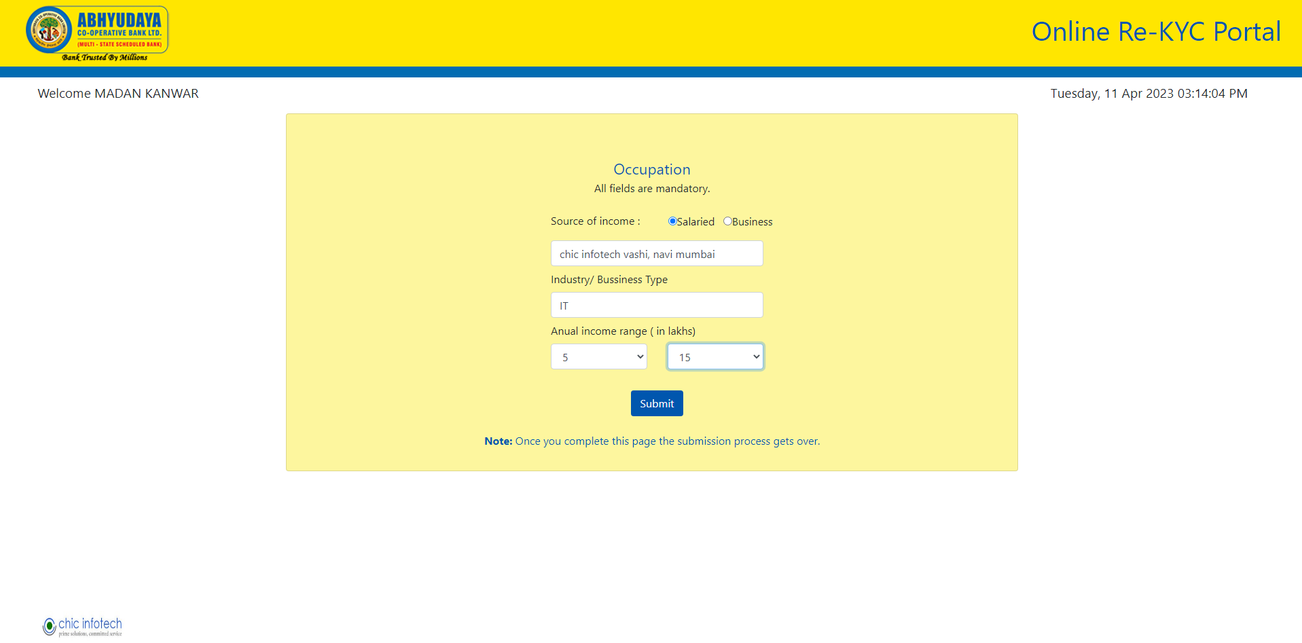

Screen11

An acknowledgement message will appear as follows (screen no. 12). The applicant should preserve the KYC ID for future reference.

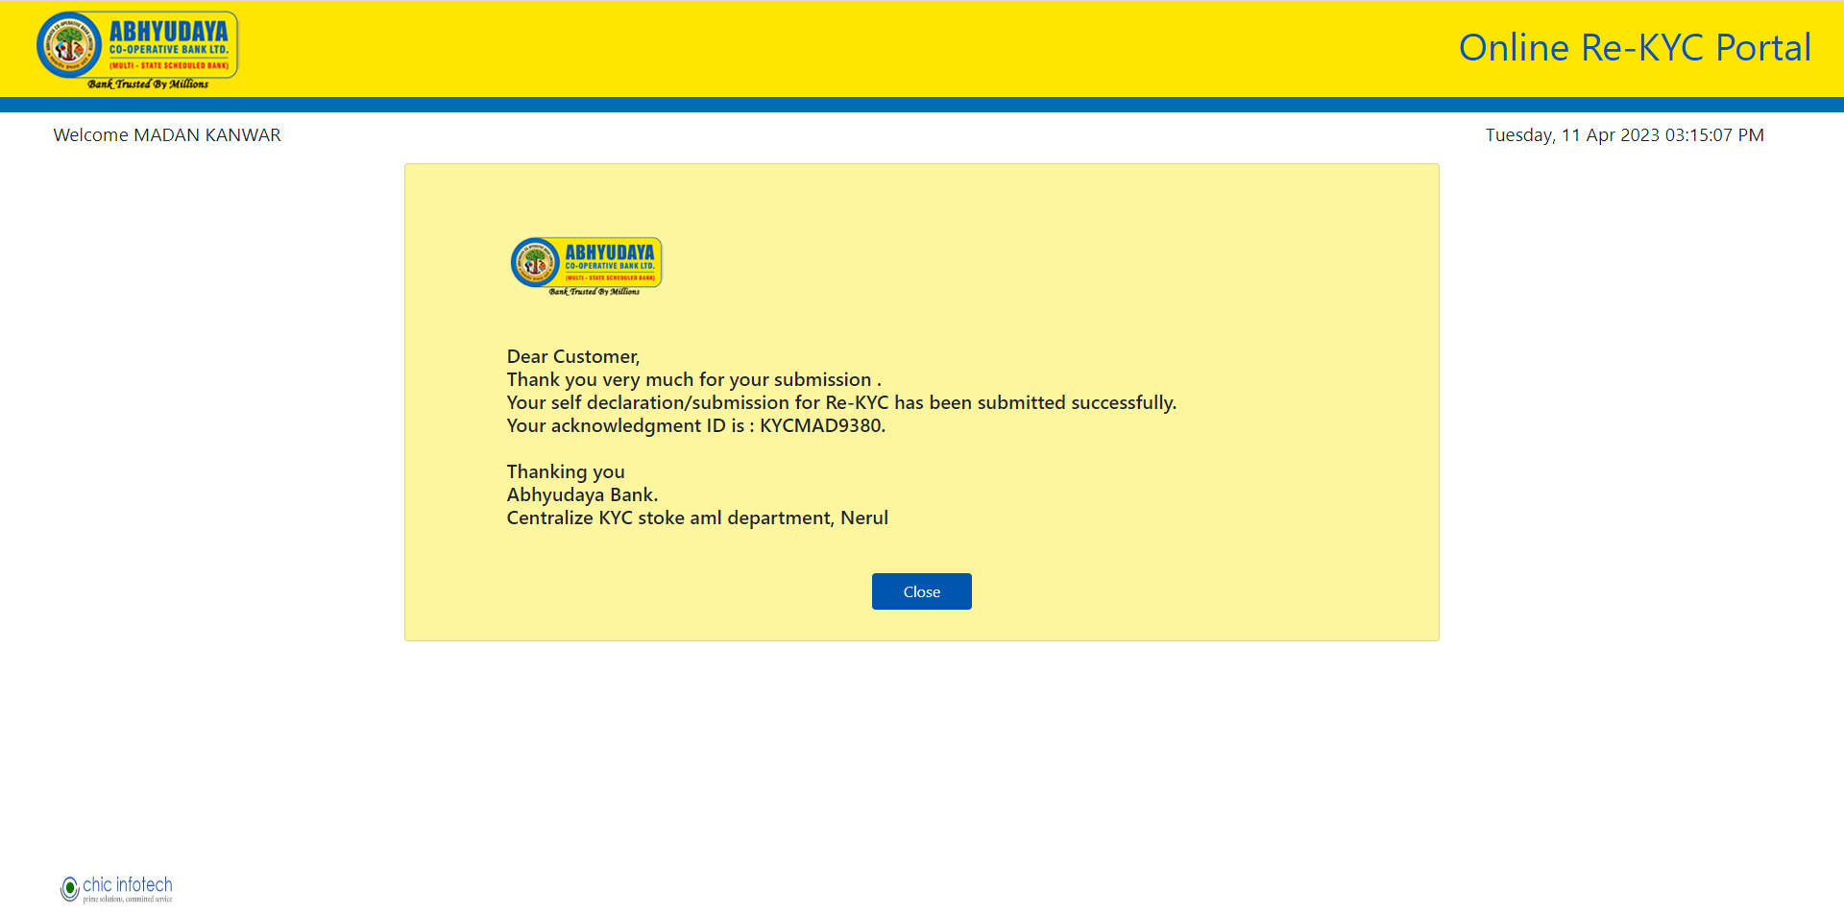

Screen 12

By clicking on “close” button your submission process gets completed.

If a user encounters a technical issue preventing them from completing the form, they can enter their account number and OTP to be directly redirected to the continue Re-KYC form.

In this form, the previously filled data will also be displayed, showing the information the user has already submitted – refer screen 12.1.

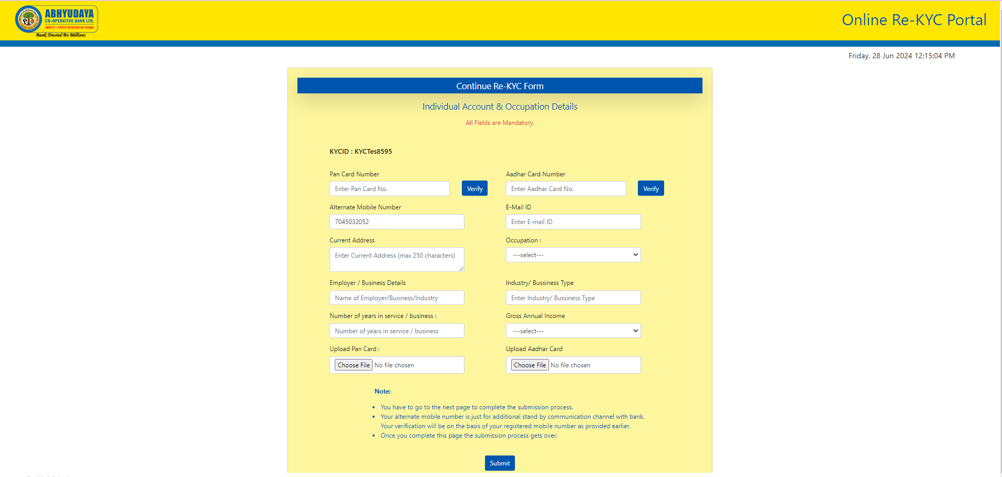

Screen 12.1

After filling out the form, the user will receive an acknowledgment message with their KYC ID.refere screen – refer screen 12.2 & 12.3

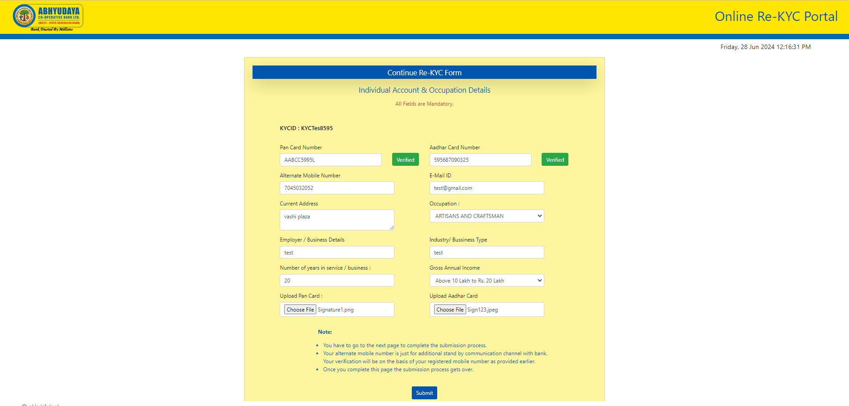

Screen 12.2

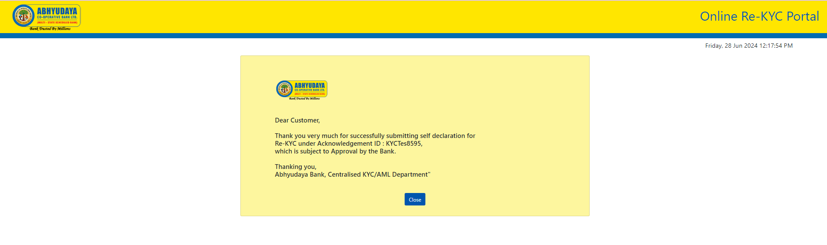

Screen 12.3

……end of user section…..

**Admin Section:**

All authorized Bank’s users will have the access to “Admin Module”. The bank officials can login with their login credentials to perform the administrative functions as shown below.

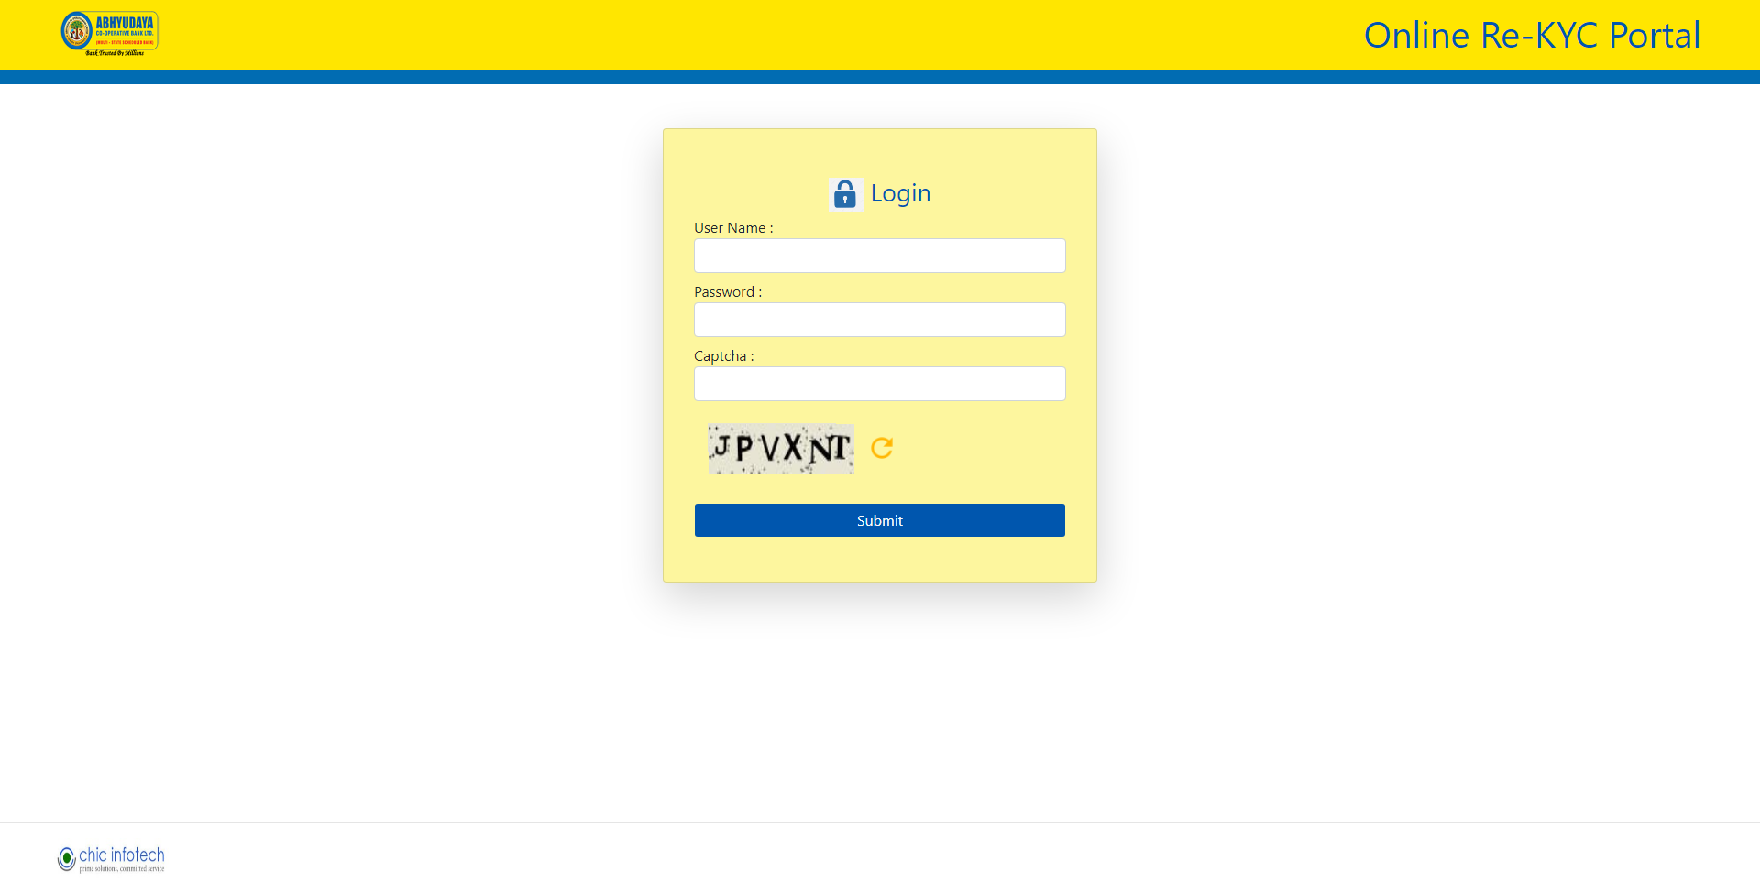

Screen 13

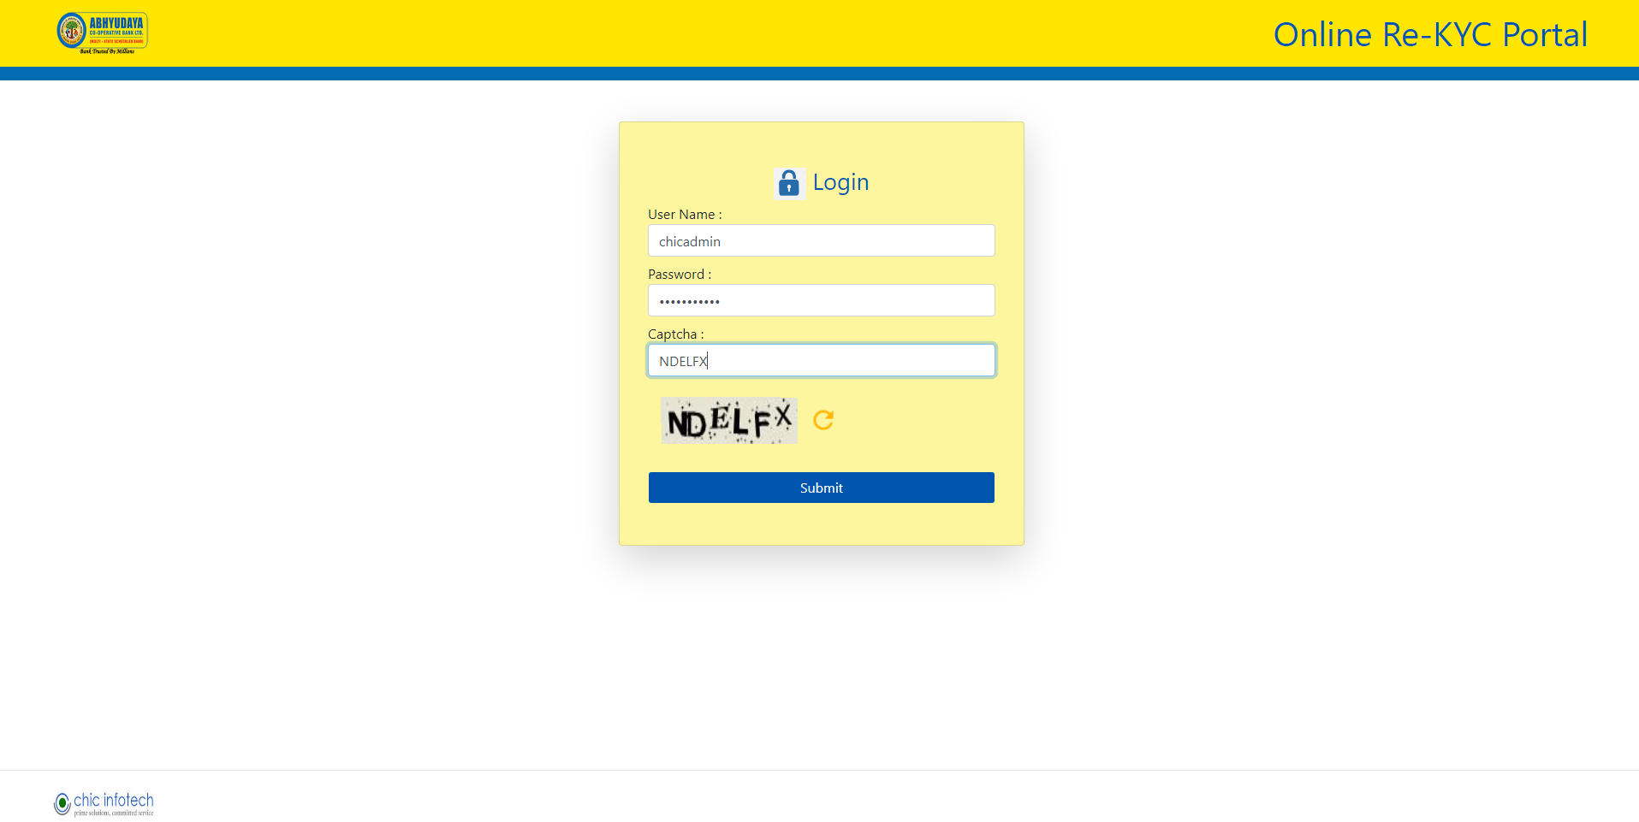

Screen 14

After entering the correct credentials like username, password   and captcha in screen no. 14 you will get the admin home page (screen no. 15).

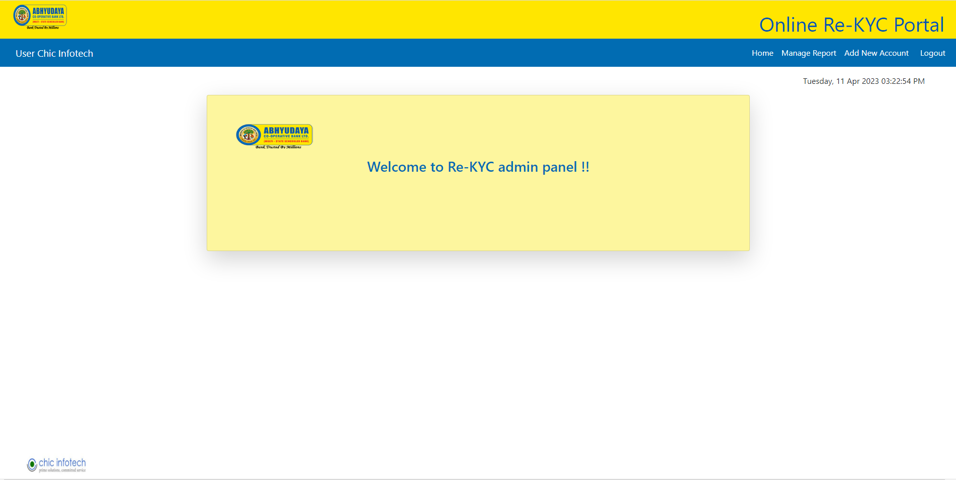

Screen 15

Now click on “Manage Report” button on the top-right side in screen no. 15 you will receive screen as follows (screen no. 16) for the multiple types of search report options.

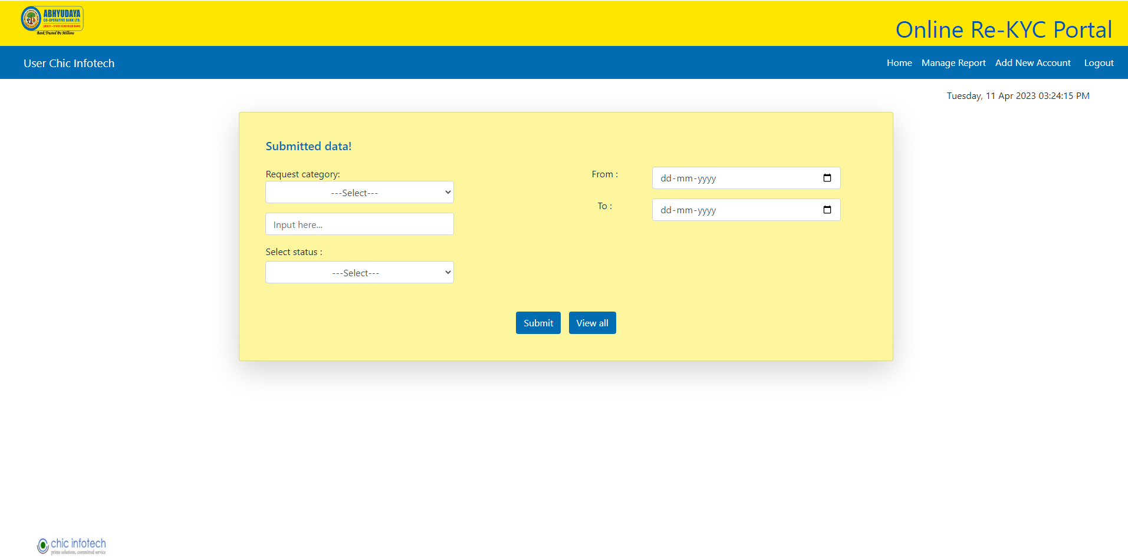

Screen16

Using the features in screen no. 16 you will get the following search options:

1. Search by KYC id.
2. Search by Name.
3. Search by Account number.
4. Search by from-to date.
5. Search by valid status.
6. Search by Invalid status.
7. Search by Replied status.
8. Search by Not-replied status.
9. Search by KYC id and from-to date.
10. Search by Name and from-to date.
11. Search by Account number and from-to date.
12. Search by valid status and from-to date.
13. Search by valid status and from-to date.
14. Search by Replied status and from-to date.
15. Search by Replied status and from-to date.
16. View all data

For example: If the search is for “valid” status then you will get the following results (screen no. 17).

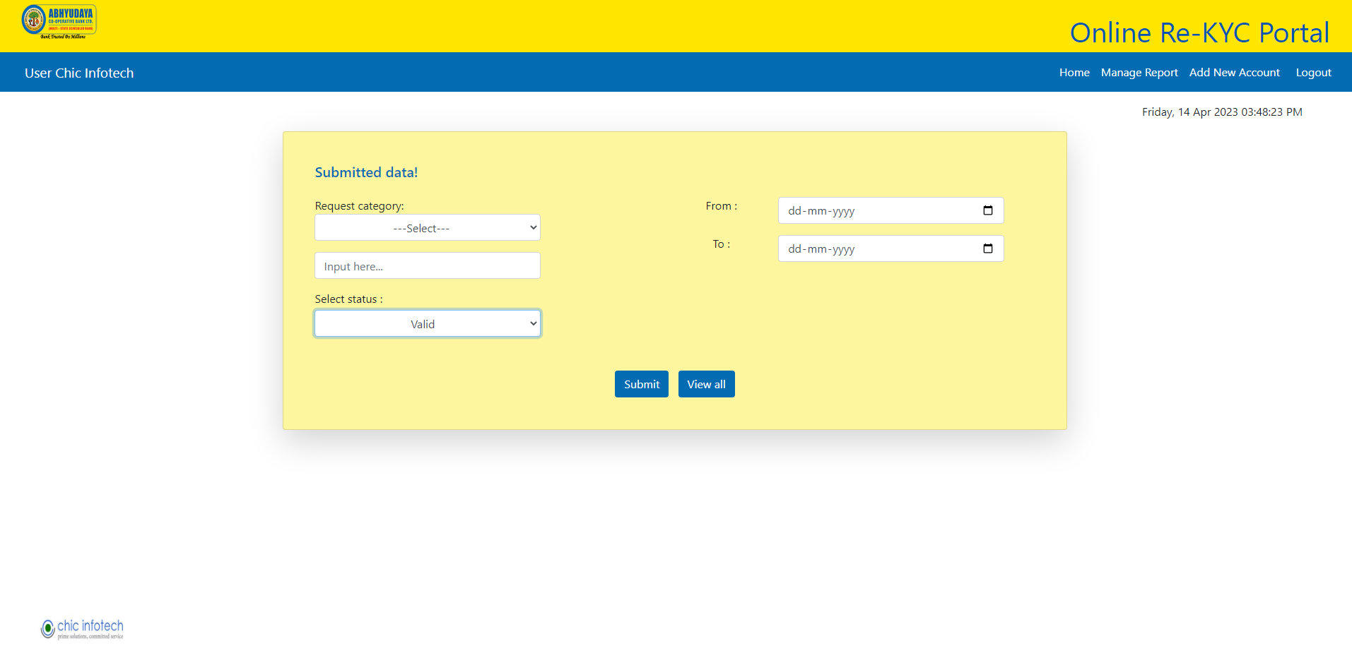

Screen 17

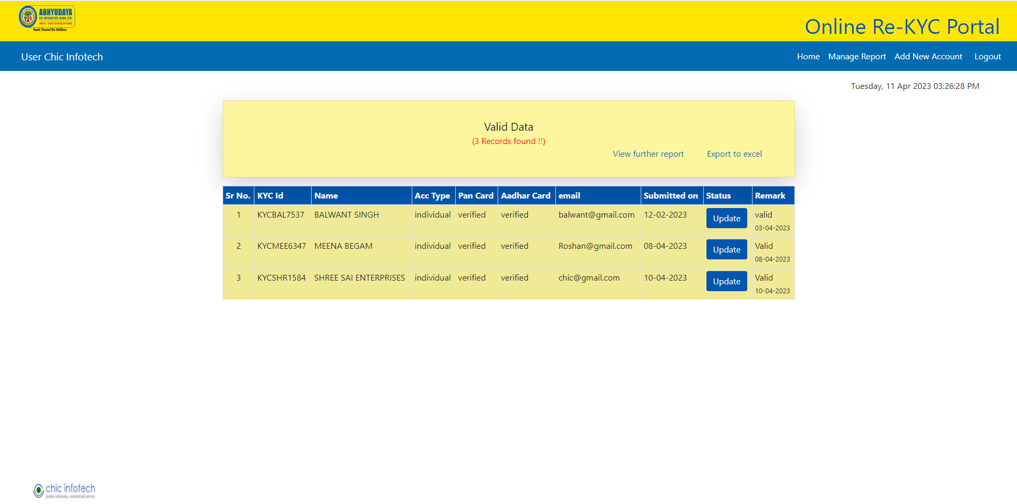

Screen 18

Again if you select search option (1) Not-replied and (2) from-to date then you will get the following report.

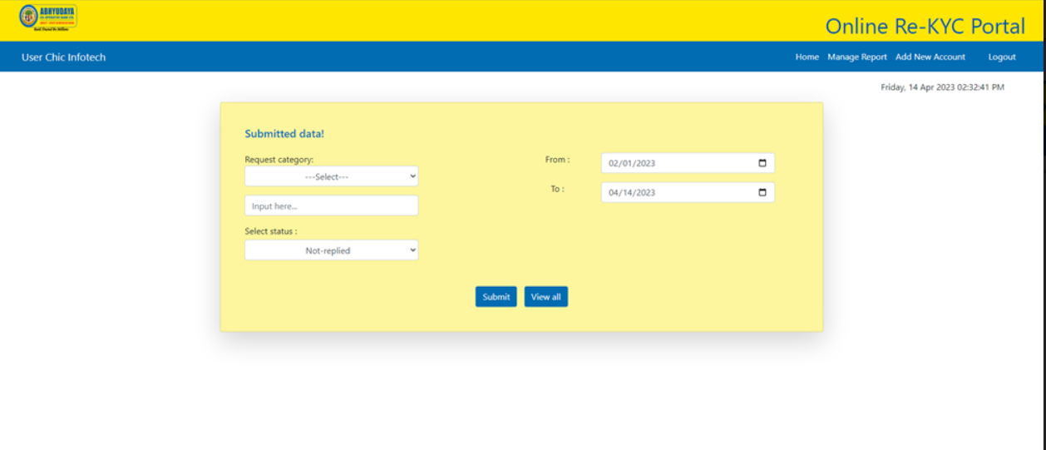

Screen 19

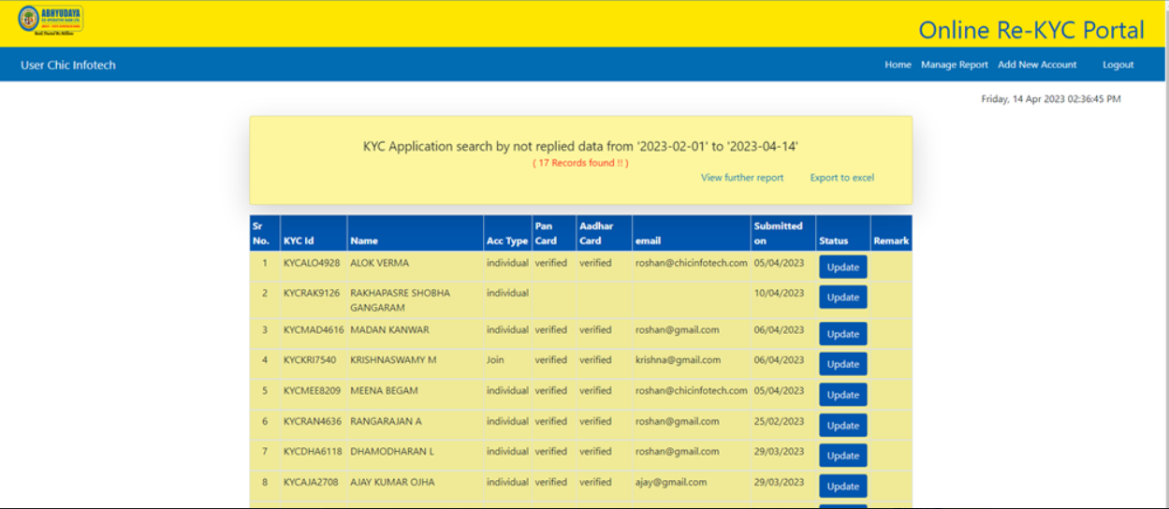

Screen 20

Now, bank wants to update the status as per screen no. 19 above you will get the following page where you can update status through dropdown under “remarks” option.

Please note that admin can update only through “remarks” option (screen no.20).

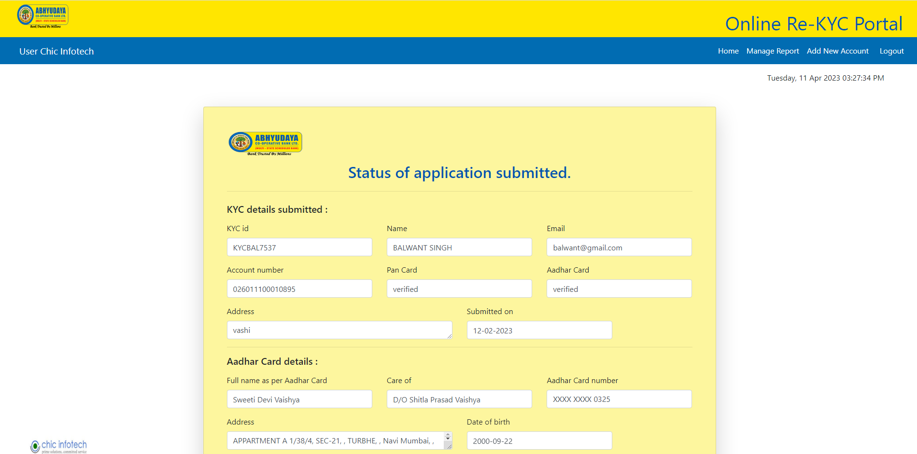

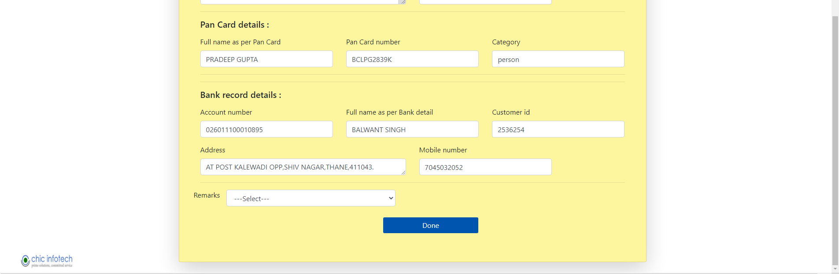

Screen 21

After updating the status under “remarks” following screen will appear (screen no. 21).

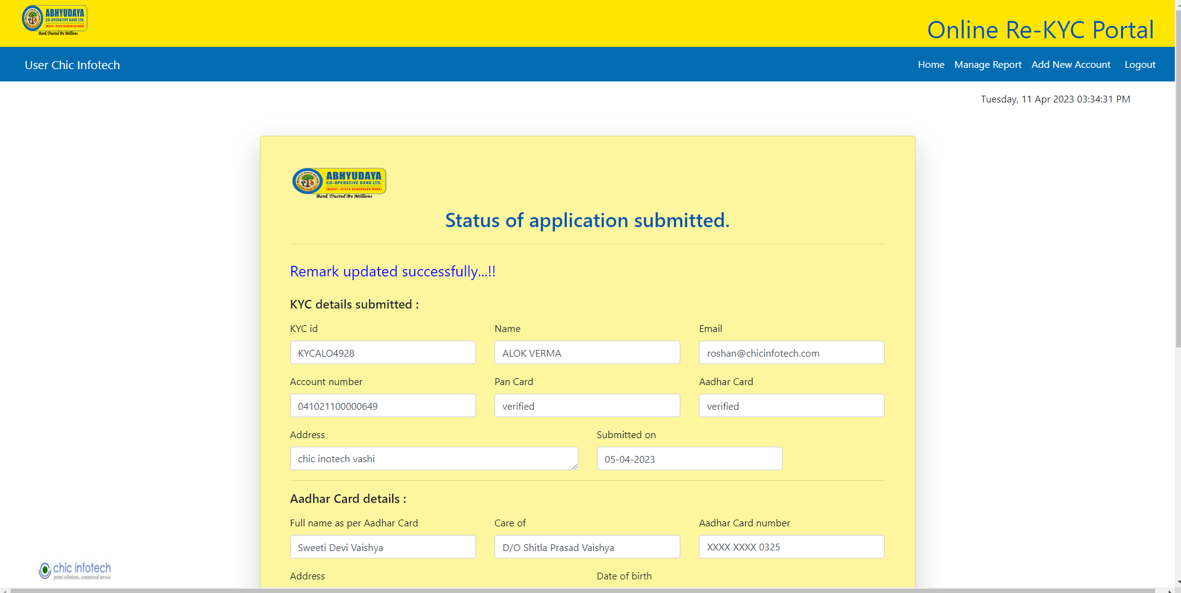

Screen 22

This section gives facility to only upload data of customers in predetermined format in excel

(Screen no. 22).

Following process is to be followed while updating uploading data for new customers.

1. Click on “Add new Account” button to add the new account data.
2. Select “excel file” in predetermined format and click on “insert” button.
3. A message will be displayed as per screen no. 23 (for successful upload message will be displayed as “Inserted data successfully” and if not successful then “Please select a file to upload.” will appear.)

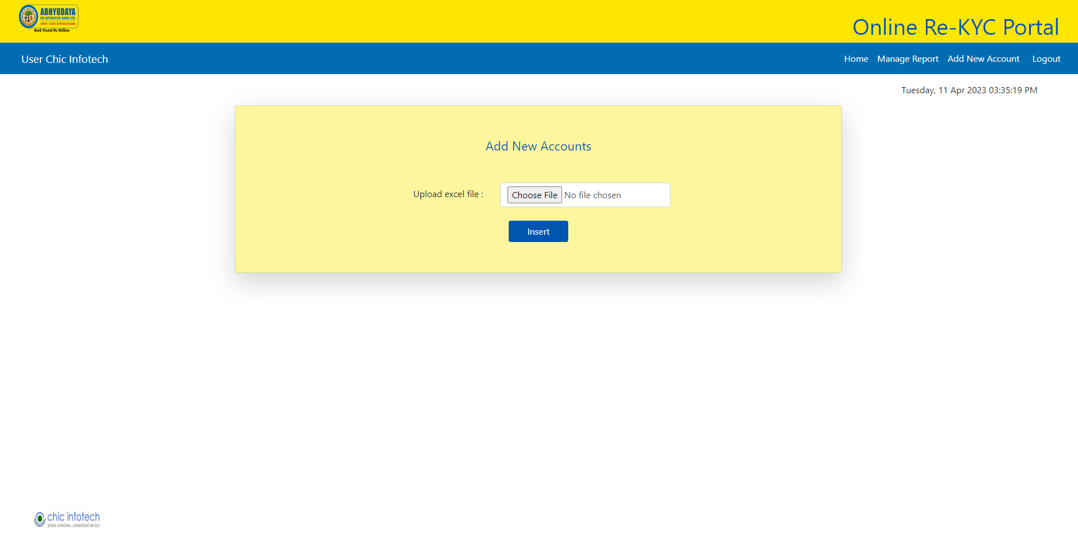

Screen 23

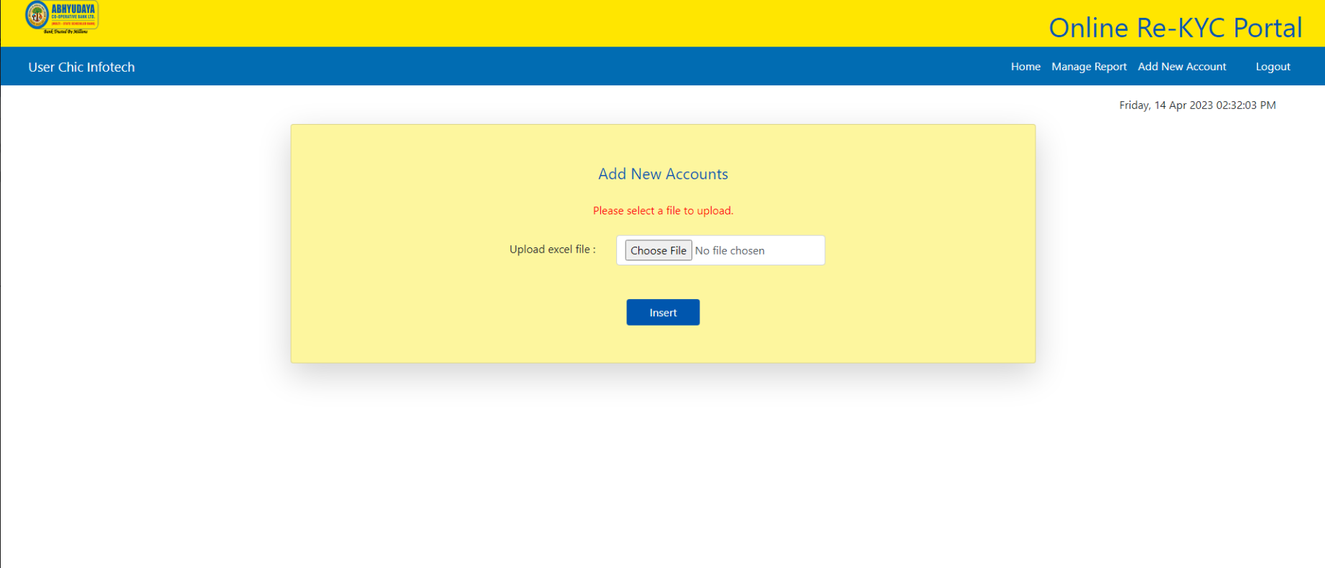

Screen 24

(Note: The excel file data format it’s fixed.)