# DIR-V Hackathon Proposal

## 1. Proposal Title

“IoT based Real Time Automobile Dashboard using I2C Protocol”

## 2. Problem Statement

Ensuring optimal tire pressure is vital for safety, efficiency, and sustainability, yet traditional TPMS solutions are often bulky and inefficient. This proposal leverages I2C communication standards.

1. Continuous monitoring of tire pressure through I2C compatible sensors.
2. Simplify the system architecture I2C protocol, 2 wired designs, reducing wiring complexity and making it scalable for integrating into various automobile.
3. Provides a real time TPMS enabling vehicle safety, improves fuel efficiency and reduces maintenance cost.

The proposal is a real-time TPMS leveraging the I2C protocol for seamless, low-power communication between sensors and vehicle systems. By simplifying hardware, enabling multi-device integration, and ensuring precise, real-time data transmission, this solution redefines TPMS for modern, connected vehicles.

## 3. Proposed Solution

Our solution is a real time Tire Pressure Monitoring System to control the performance matrix of automobile with respect to air pressure in tires, wheel alignment and wheel balancing.

* Real time monitoring
* Simplified communication
* User friendly interface

## Goals and Objectives

**Goal**

Develop an efficient TPMS for Indian automobile industry.

Ensuring vehicle safety, performance and driver convenience

**Objective**

To increases the performance of TPMS for vehicles to improve its safety and efficiency.

* Sensor integration
* Real time data processing
* Scalable architecture

## 5. Target Audience

The primary users of this solution are automobile industry and general public who uses vehicles who wishes to reduce the maintenance bill and who take cares the eco system.

## 6. Key Features

- Real-time data monitoring.  
- Data analysis and visualization.  
- Automated alerts for dash board.

## 7. Technical Approach

A RISC-V architecture is used for complete functioning of the system.

- **Hardware**: Sensor for measuring pressure (BMP180), VSD Squadron Mini, LCD Display, ESP32 (Wi-Fi module)  
- **Software**: VS Code, Platform IO, CH32V platform  
- **Communication:** I2C for data transmission  
- **Interface:** I2C interface to connect to display, Thingspeak IoT cloud platform to aggregate, visualize and analyze live data stream in the cloud.

## 8. Expected Outcomes

Pressure sensor output is used for real time data display, accurate monitoring, low power consumption. Our solution is to significantly

* increase safety like reduced risk of tire blowouts, accidents,
* increases fuel efficiency,
* extended tire lifespan,
* enhanced performance like stability and braking system of the vehicle
* reduced maintenance cost

## 9. Block diagram

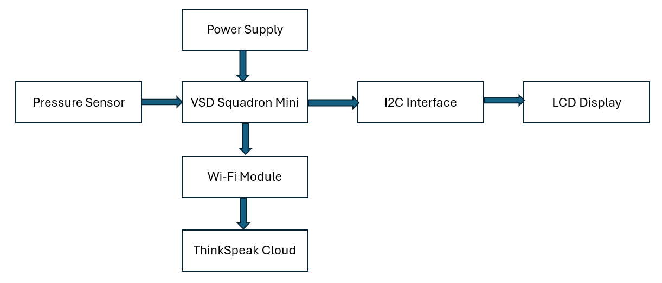

## 10. Circuit connections

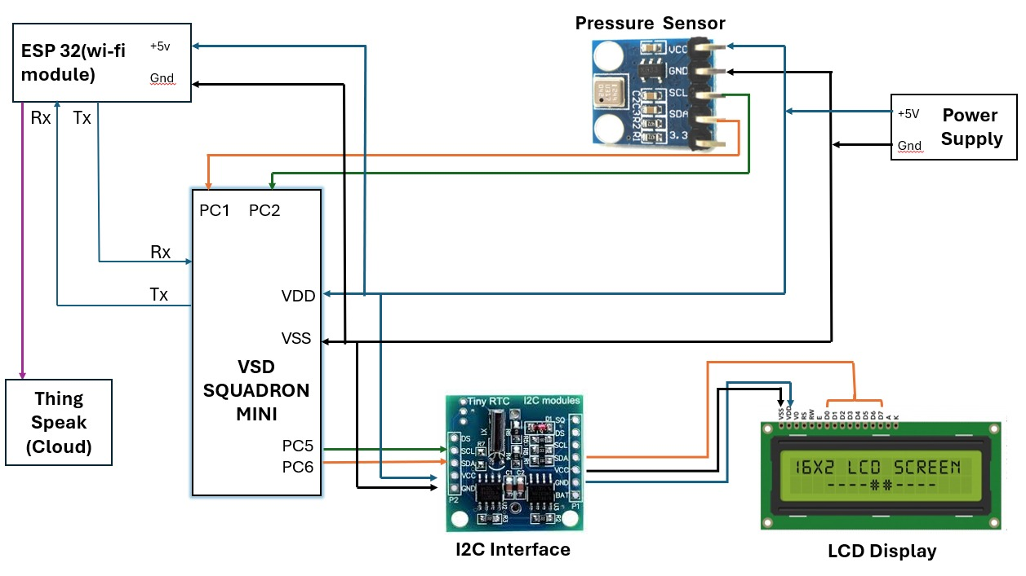

## 11. Budget and Resources

|  |  |  |
| --- | --- | --- |
| **S. No** | **COMPONENTS** | **COST** |
| 1 | RTC DS130 (I2C interface) | INR.149 |
| 2 | BMP 180 Pressure Sensor | INR.118 |
| 3 | LCD Display | INR.97 |
| 4 | VSD Squadron mini board | INR.1200 |
| 5 | ESP32(Wi-Fi Module) | INR 342 |
| **TOTAL COST** | | **INR. 1,906** |

## 12. Conclusion

The system designed and developed as part of this project provides a comprehensive solution for monitoring and maintaining optimal tire pressure which leads to wheel balancing and wheel alignment. This project demonstrates the potential for technology to improve vehicle safety, efficiency, and performance. Its successful implementation can have a significant impact on the automotive industry.