**Background**

[SAP Lumira](http://go.sap.com/solution/analytics/lumira.html) is a self-service Business Intelligence tool that helps business users to acquire and analyze data, visualize that data as charts, combine charts to form a story and then share that story with others.

SAP Lumira ships with a lot of charts, but sometimes you need a custom chart to help tell your story, that is where extensions come in.

You can find more about to develop these extensions on our web [page](http://saplumira.com/developers/). We started building the discussed developer community for SAP Lumira on the [SAP Community Network](http://scn.sap.com/docs/DOC-57319) (SCN).

**Challenge**

Create the following % of Net Sales chart using JavaScript and CSS.

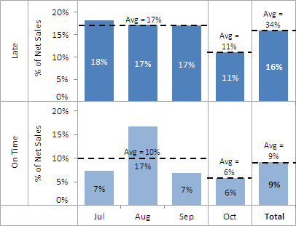

The goal of the challenge is not necessarily to complete the full chart, but to demonstrate your skills and approach. Get as far as you can and stick as close as you can to the above screen shot.

In the interview walk us through what you have done, how you structured the data, describe any assumptions that you made and if you had more time how you would finish or improve on what you have done.

Ideally the chart extension will be based upon [D3.js](http://d3js.org/) but if that is not possible, focus on the chart itself using JavaScript and any other JavaScript libraries that you need for the challenge.

Feel free to contact us if you have any questions about this challenge.

I have attached a CSV file that you can use for the data in this chart screen shot.

The CSV file has three columns, the values could change but you will always have these three columns:

1. **Shipment status** – create one chart per shipment status.
2. **Date** – used for the X Axis values.  
   The date CSV format is M/D/YYYY.  
   Display the date as a short month in the chart, for example Jun.  
   The dates in the X Axis are grouped into quarters: Jan-Mar, Apr-Jun, Jul-Sep, Oct-Dec.
3. **Net Sales** – the Y Axis values  
   The Y Axis shows the % distribution of Net Sales by quarter and not the Net Sales amount itself, you will need to calculate the % as that is not in the CSV file.  
   The average % Net Sales per quarter is also shown as a dashed line on the chart.

Good luck and we look forward to seeing what you have done!