**USBzDXL, RS485 and Half-Duplex TTL connection to USB**

**Quick Start**

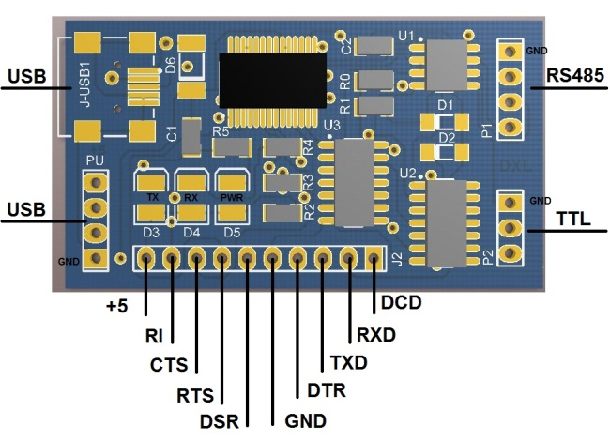

The USBzDXL is a device used to directly drive the dynamixel on a PC. The USBzDXL is used by connecting to a USB port of a PC, and is equipped with 3pin and 4pin connectors to be connected with a variety of dynamixels. Both of 4pin (RS485) and 3Pin (TTL Half-Duplex) can be used in same time without changing Switch.

In addition, the USBzDXL can be used to transform a USB port into a serial port for a PC without a serial port such as a lap-top computer. This function can be used effectively when dynamixel exclusive controllers such as the CM-2, CM-2+ and CM-5 are connected to an UBS port or when the ZIG2Serial is connected to an USB port to control a robot by radio.

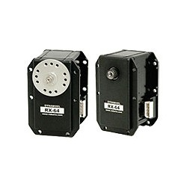Following pictures show how to use the USBzDXL:

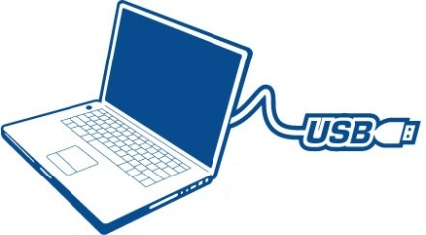

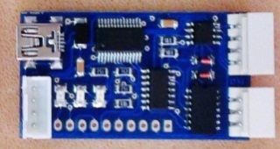

Power

4Pin (RS485)

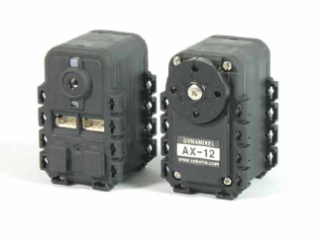

3Pin (TTL)

**Pin Description:**

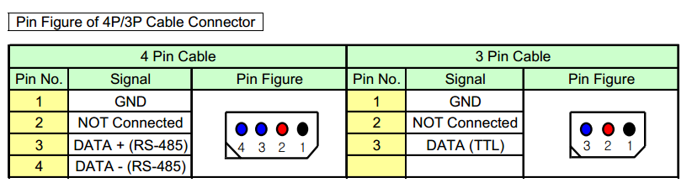

***This report is published on (May, 14, 2014) from AUTMan Humanoid Team by M.Karimi.***

 

**Mojtaba Karimi.**

Robotics Engineering,Controller System designer.

[AmirKabir University of Technology (Tehran Polytechnic](http://www.aut.ac.ir/))

**Web:**  <http://mojtaba.info.se/>

<http://www.facebook.com/mojtaba.mk>

**Mail:**   [mojtaba.k@aut.ac.ir](http://mojtaba%2Ek@aut.ac.ir/)

[mojtaba_k@live.com](http://mojtaba_k@live.com/)

[mojtaba.mk1989@gmail.com](http://mojtaba%2Emk1989@gmail.com/)

**Tell:**    +98 912 740 8587 (IR)