Consider the system below

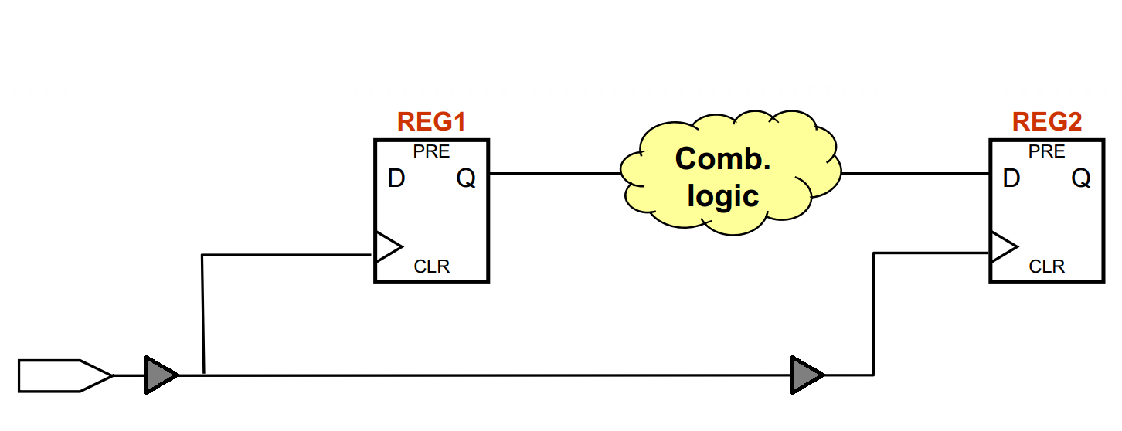Tdata,Min = 3 ns TSU = 2 ns  
 TCO = 2ns Tdata,Max = 5 ns TH = 1.5 ns

1 ns 1 ns

1. **Calculate the setup and hold slack if the clock runs at 100 MHz. Does the system meet timing requirements?**

$$T_{clk}=10ns$$

$$Setup Slack=Minimum Data Required Time-Maximum Data Arrival Time$$

$$Minimum Data Required Time=T_{clk2}-t_{su}=(12ns)-2ns=10ns$$

$$Maximum Data Arrival Time=T_{clk1}+t_{co}+T_{data}\left(max\right)=(1ns)+2ns+5ns=8ns$$

$$Setup Slack=10ns-8ns=2ns$$

$$Hold Slack=Minimum Data Arrival Time-Maximum Data Required Time$$

$$Minimum Data Arrival Time=T_{clk2}+t_{h}+Hold Uncertainty=1.5ns=1.5ns$$

$$Maximum Data Required Time=T_{clk1}+T_{co}+T_{data}(\min{)}=\left(-1ns\right)+2ns+3ns=4ns$$

$$Hold Slack=4ns-1.5ns=2.5ns$$

Does meet timing requirements.

1. **Calculate the setup and hold slack if the clock runs at 150 MHz. Does the system meet timing requirements?**

$$T_{clk}=\frac{1}{f}=\frac{1}{150MHz}=6.67ns$$

$$Setup Slack=Minimum Data Required Time-Maximum Data Arrival Time$$

$$Minimum Data Required Time=T_{clk2}-t_{su}=(8.87ns)-2ns=6.67ns$$

$$Maximum Data Arrival Time=T_{clk1}+t_{co}+T_{data}\left(max\right)=(1ns)+2ns+5ns=8ns$$

$$Setup Slack=6.67ns-8ns=-1.33ns$$

$$Hold Slack=Minimum Data Arrival Time-Maximum Data Required Time$$

$$Minimum Data Arrival Time=T_{clk2}+t_{h}+Hold Uncertainty=1.5ns=1.5ns$$

$$Maximum Data Required Time=T_{clk1}+T_{co}+T_{data}(\min{)}=\left(-1ns\right)+2ns+3ns=4ns$$

$$Hold Slack=4ns-1.5ns=2.5ns$$

Does not meet timing requirements.