GSFC UNIVERSITY
SCHOOL OF TECHNOLOGY
DEPARTMENT OF COMPUTER SCIENCE & ENGINEERING
VADODARA, GUJARAT, INDIA
――――――――――――――――――――――――――――――――――――――
A SOFTWARE ENGINEERING PROJECT REPORT
ON
ODYSSEY: SMART AI TOURISM PLANNER &
HYPER-PERSONALIZED TRAVEL CONCIERGE PLATFORM
Submitted in partial fulfillment of the requirements for the award of the degree of
BACHELOR OF TECHNOLOGY
IN
COMPUTER SCIENCE AND ENGINEERING
(COURSE: SOFTWARE ENGINEERING)
UNDER THE GUIDANCE OF:  Ms. Yoothika Patel  Assistant Professor  Department of CSE, SOT  GSFC University, Vadodara | SUBMITTED BY (STUDENTS):  Swet Patel • Frontend Engineering  Nisarg Parmar • Frontend Engineering  Parekh Manav • Backend Engineering  Shrey Patel • Backend & API Engineering  Aum Parmar • Database Engineering  B.Tech CSE — Academic Session 2024-2025

CANDIDATE'S DECLARATION
We hereby declare that the Software Requirements Specification (SRS) project report entitled "ODYSSEY: SMART AI TOURISM PLANNER & HYPER-PERSONALIZED TRAVEL CONCIERGE PLATFORM" submitted to the Department of Computer Science & Engineering, School of Technology, GSFC University, Vadodara, is an authentic record of our original project work carried out under the supervision and academic guidance of Ms. Yoothika Patel, Assistant Professor, Department of Computer Science & Engineering.
We confirm that the work presented herein does not breach any existing copyright, patent, or intellectual property rights, and that this project has not previously formed the basis for the award of any Degree, Diploma, Associateship, Fellowship, or other similar academic recognition at GSFC University or any other institution of higher learning.
___________________________  Swet Patel  Frontend Engineering | ___________________________  Nisarg Parmar  Frontend Engineering
___________________________  Parekh Manav  Backend Engineering | ___________________________  Shrey Patel  Backend & API Engineering
___________________________  Aum Parmar  Database Engineering | Date: _______________  Place: Vadodara, Gujarat

CERTIFICATE OF APPROVAL
This is to certify that the project report entitled "ODYSSEY: SMART AI TOURISM PLANNER & HYPER-PERSONALIZED TRAVEL CONCIERGE PLATFORM" is a bona fide record of the work carried out by Swet Patel, Nisarg Parmar, Parekh Manav, Shrey Patel, and Aum Parmar under my supervision and guidance, in partial fulfillment of the requirements for the degree of Bachelor of Technology in Computer Science & Engineering at GSFC University, Vadodara, for the academic year 2024-2025.
To the best of my knowledge, the project work embodies original engineering development, requirements specification, and interface implementations meeting the rigorous academic and practical standards established by the School of Technology.
___________________________  Ms. Yoothika Patel  Internal Project Guide / Mentor  Assistant Professor, Dept of CSE  School of Technology, GSFC University | ___________________________  Head of Department  Department of CSE  School of Technology  GSFC University, Vadodara

ACKNOWLEDGEMENT
We express our deep sense of gratitude and sincere indebtedness to our respected internal project mentor, Ms. Yoothika Patel, Assistant Professor, Department of Computer Science & Engineering, GSFC University, for her invaluable guidance, constructive criticism, patience, and encouraging attitude throughout the conceptualization and development of the Odyssey Smart Tourism Platform. Her rigorous feedback on software requirements engineering, architectural UML modeling, and interface usability significantly shaped this work.
We are profoundly thankful to the Head of the Department, Computer Science & Engineering, and the Dean of the School of Technology, GSFC University, for providing state-of-the-art laboratory facilities, high-speed computational resources, and a supportive scholarly atmosphere that made the realization of this web platform possible.
We also extend our warm thanks to our faculty members, peer reviewers, and family members for their constant encouragement, insightful critiques, and moral support during the intensive phases of development, testing, and documentation.
Swet Patel • Frontend Engineering
Nisarg Parmar • Frontend Engineering
Parekh Manav • Backend Engineering
Shrey Patel • Backend & API Engineering
Aum Parmar • Database Engineering

ABSTRACT
Problem Context: Modern digital tourism platforms are plagued by significant structural shortcomings: static catalogue listings that overwhelm travelers with disconnected choices, lack of spatial and geographical visualization, fragmented booking flows across disparate vendors, and a complete absence of context-aware personalization. Travelers routinely spend hours cross-referencing blog posts, static maps, separate flight aggregators, and hotel portals just to plan a multi-day itinerary.
Proposed Solution: To resolve these fundamental pain points, this project introduces Odyssey, a full-stack, hyper-personalized smart tourism planning platform built upon modern software engineering principles and cutting-edge web technologies. Odyssey combines an interactive WebGL 3D spatial globe with an autonomous Wayfinder itinerary curation engine, a real-time conversational AI Concierge, high-definition 2D topological route mapping via Leaflet and Esri vector services, and a gamified reward arcade ("Contest of the Bow") to deliver an all-in-one travel discovery and booking ecosystem.
Methodology & Architecture: The system architecture employs a decoupled 3-tier MERN stack (MongoDB Atlas, Express.js, React 18 with Vite, and Node.js) paired with WebGL/Three.js rendering pipelines, Lucide iconography, and responsive design systems. The backend provides secure JWT authentication, RESTful destination query filters, dynamic Great-Circle transit computations, and automated PNR ticket generation with instant PDF/print capabilities.
Evaluation & Key Results: Extensive verification demonstrates sub-50ms API query latencies across 70+ curated international and domestic destinations, smooth 60 FPS spatial globe rotations, fault-tolerant tokenized session management, zero-watermark vector tile streaming, and accessible WCAG-compliant responsive interfaces across mobile and desktop devices. Odyssey represents a comprehensive paradigm shift from fragmented travel browsing to unified, intelligent vacation curation.
Keywords: Smart Tourism, Software Requirements Specification, Spatial 3D WebGL, Wayfinder AI Itinerary Engine, MERN Stack, Leaflet 2D Circuit Maps, RESTful Microservices, Phaser 3 Gamification.

LIST OF FIGURES
Figure No. | Figure Caption / Title | Section Ref
Figure 1 | UML Use Case Diagram — Odyssey Multi-Actor System Interactions | 3.7.1
Figure 2 | UML Activity Diagram — Voyage Planning & Booking Workflow | 3.7.2
Figure 3 | UML Sequence Diagram — Wayfinder Curation & Booking Lifecycle | 3.7.3
Figure 4 | Entity-Relationship (ER) Diagram — Database Schema & Relations | 3.7.4
Figure 5 | Data Flow Diagram (DFD) — Level 0 Context & Level 1 System Streams | 3.7.5
Figure 6 | Interactive 3D WebGL Earth Globe & Immersive Exploration Hero | 4.2.1
Figure 7 | Destinations Explorer & Semantic AI Multi-Tag Filter Catalog | 4.2.2
Figure 8 | Comprehensive Destination Deep-Dive & Local Circuit Overview | 4.2.3
Figure 9 | Interactive 2D Topological Route Map with Esri Vector Streaming | 4.2.4
Figure 10 | Wayfinder AI Personalized Multi-Day Itinerary Engine | 4.2.5
Figure 11 | Multi-Modal Travel & Accommodation Engine (Flights, Trains & Hotels) | 4.2.6
Figure 12 | Gamified Contest of the Bow Arcade & Instant Promo Voucher Engine | 4.2.7
Figure 13 | Odyssey AI Travel Concierge Conversational Chatbot Assistant | 4.2.8
Figure 14 | Personal User Travel Logbook, E-Ticket Printing & Saved Itineraries | 4.2.9
Figure 15 | Concierge Support, Inquiries & Helpdesk Center | 4.2.10
Figure 16 | Odyssey Engineering Architecture, Development Team & Tech Stack | 4.2.11

TABLE OF CONTENTS
Candidate's Declaration ..................................................... ii
Certificate of Approval .................................................... iii
Acknowledgement ............................................................. iv
Abstract ..................................................................... v
List of Figures ............................................................. vi
CHAPTER 1: INTRODUCTION ...................................................... 1
1.1 Project Overview & Motivation .......................................... 1
1.2 Objectives of Odyssey Platform ......................................... 2
1.3 Project Scope & System Boundaries ...................................... 3
1.3.1 Time Boundaries & Response Latency Constraints ................... 3
1.3.2 Functional Subsystem Boundaries (6 Primary Modules) .............. 4
1.3.3 Target Demographics & User Personas .............................. 5
CHAPTER 2: SYSTEM ANALYSIS AND DESIGN ........................................ 6
2.1 Limitations of Existing Travel Portals ................................. 6
2.2 Proposed Solution & Value Innovations .................................. 7
2.3 Requirement Gathering & Feasibility Study .............................. 8
2.3.1 Technical Feasibility ............................................ 8
2.3.2 Operational Feasibility .......................................... 9
2.3.3 Economic Feasibility ............................................. 9
2.4 Software Requirements Specification (SRS) ............................. 10
2.4.1 User Classes and Characteristics ................................ 10
2.4.2 Hardware & System Constraints ................................... 10
2.4.3 Software Environment & Toolchain ................................ 11
2.5 Functional Requirements (Module-by-Module Specification) .............. 12
2.5.1 Module 1: Authentication & User Profile Management .............. 12
2.5.2 Module 2: Spatial 3D Earth & Global Catalog Exploration ......... 13
2.5.3 Module 3: Wayfinder AI Multi-Day Itinerary Engine ............... 14
2.5.4 Module 4: Multi-Modal Travel & Accommodation Engine ............. 15
2.5.5 Module 5: Interactive 2D Circuit Maps & Transit Routing ......... 16
2.5.6 Module 6: Gamified Contest of the Bow Reward System ............. 17
2.5.7 Module 7: Autonomous Odyssey AI Concierge Chatbot ............... 18
2.5.8 Module 8: Booking, Ticket Printing & Itinerary Export ........... 19
2.6 Non-Functional Requirements ........................................... 20
2.6.1 Performance and Response Times (<50ms API, 60 FPS WebGL) ........ 20
2.6.2 Security and Data Privacy (JWT, bcrypt, Sanitized Inputs) ....... 21
2.6.3 Usability, Accessibility, and Responsiveness .................... 21
2.6.4 Reliability, Availability, and Fault Tolerance .................. 22
2.6.5 Portability and Cross-Browser Compatibility ..................... 22
2.7 System Design & Architectural UML Models .............................. 23
2.7.1 System Use Case Diagram (Figure 1) .............................. 23
2.7.2 UML Activity Diagram (Figure 2) ................................. 24
2.7.3 UML Sequence Diagram — Booking & Wayfinder Lifecycle (Figure 3) .... 25
2.7.4 Entity-Relationship (ER) Diagram (Figure 4) ..................... 26
2.7.5 Data Flow Diagrams: Context Level 0 & Level 1 Architecture (Figure 5) .... 27
CHAPTER 3: IMPLEMENTATION OF PROJECT ........................................ 28
3.1 Technology Stack & Architectural Patterns ............................. 28
3.1.1 Architectural Pattern: Tier-3 Decoupled Micro-MVC ............... 28
3.1.2 Front-End Architecture: React 18, Vite, Three.js, Leaflet, Phaser 3 .... 29
3.1.3 Back-End Architecture: Node.js, Express.js, MongoDB Atlas, Mongoose .... 30
3.2 Module Walkthrough & Visual Interface Showcase ........................ 31
3.2.1 Interactive 3D Earth Globe & Exploration Hero (Figure 6) ........ 31
3.2.2 Destination Discovery & Semantic Filter Catalog (Figure 7) ...... 32
3.2.3 Comprehensive Destination Deep-Dive & Local Circuit Insights (Figure 8) .... 33
3.2.4 Interactive 2D Waypoint Routing & Esri Topographic Maps (Figure 9) .... 34
3.2.5 Wayfinder AI Personalized Multi-Day Itinerary Planner (Figure 10) .... 35
3.2.6 Multi-Modal Flight, Train & Hotel Booking Portal (Figure 11) .... 36
3.2.7 Gamified Odysseus' Bow Arcade & Instant Promo Voucher Engine (Figure 12) .... 37
3.2.8 Real-Time AI Concierge & Intelligent FAQ Assistant (Figure 13) .... 38
3.2.9 User Travel Logbook, E-Ticket Printing & Saved Itineraries (Figure 14) .... 39
3.2.10 Concierge Support, Inquiries & Helpdesk (Figure 15) ............ 40
3.2.11 Engineering Architecture, Team & Open-Source Foundation (Figure 16) .... 41
CHAPTER 4: OBSERVATIONS AND TESTING ......................................... 42
4.1 Quality Assurance & Testing Methodology ............................... 42
4.2 Challenges Encountered & Technical Resolutions ........................ 43
4.2.1 Leaflet Tile Watermark & Subdomain Handling (Esri/OSM Integration) .... 43
4.2.2 Custom Cursor Clipping & Input Suppression in Chatbot and Leaflet Pan .... 44
4.2.3 Theme Contrast & Action Button Readability across Dark/Light Modes .... 44
4.2.4 WebGL Performance Optimization on Low-Power Mobile Devices ...... 45
4.3 Lessons Learned & Software Engineering Insights ....................... 45
CHAPTER 5: CONCLUSION & FUTURE ENHANCEMENTS ................................. 46
5.1 Project Retrospective & Achievement of Objectives ..................... 46
5.2 Future Roadmap ........................................................ 47
REFERENCES & BIBLIOGRAPHY ................................................... 48

CHAPTER 1: INTRODUCTION
1.1 Project Overview & Motivation
Tourism is one of the most vital drivers of the global economy, contributing trillions of dollars annually and enabling intercultural enrichment worldwide. However, the software ecosystems that support modern travelers have stagnated under outdated paradigm models. Traditional online travel agencies (OTAs) and commercial booking portals operate as fragmented transactional databases. Users are subjected to endless paginated tables of flight numbers, uncurated hotel listings, and disjointed recommendations that strip travel of its wonder, spatial context, and cultural narrative.
The cognitive burden placed upon modern travelers is severe: planning a simple 5-day vacation routinely demands cross-referencing between 10 to 15 disparate browser tabs—review aggregators, independent travel blogs, static mapping tools, transit scheduling systems, and hotel booking portals. The lack of algorithmic cohesion frequently results in unrealistic travel schedules, geographical backtracking, budget overruns, and traveler fatigue.
The Odyssey project was initiated to dismantle this friction by synthesizing hyper-personalized artificial intelligence, spatial 3D computer graphics, and modular software engineering into an integrated, end-to-end travel platform. Named in homage to Homer's epic journey of discovery, Odyssey provides an intelligent digital companion that curates day-by-day itineraries, visualizes global geography in real-time WebGL, resolves multi-modal transit logistics, and answers travel inquiries through an autonomous AI concierge.
1.2 Objectives of Odyssey Platform
The primary engineering and functional objectives achieved by the Odyssey platform include:
- Spatial WebGL Global Discovery: Implement an interactive, high-performance 3D Earth globe powered by Three.js and custom GLSL shaders that plots real-world coordinate pins for 70+ global destinations with real-time camera tweens and geographical focus.
- Automated Wayfinder AI Curation: Formulate a heuristic multi-day itinerary generation engine that parses destination topology, tourist interests, duration constraints, and budget limits to produce cohesive daily schedules with Great-Circle distance estimates and travel pacing.
- Interactive 2D Topological Route Mapping: Integrate zero-watermark, high-definition Leaflet and Esri vector mapping services that render multi-day circuit paths, chronological waypoints, and transit times for every curated destination.
- Unified Multi-Modal Travel Search: Develop a real-time search and reservation pipeline covering commercial flights, scenic railways, and boutique stays with instant pricing, GST tax computation, and secure mock checkout flows.
- Conversational AI Concierge Engine: Construct a responsive in-browser travel assistant equipped with destination knowledge, budget recommendations, packing checklists, and context-aware prompt chips.
- Gamified Travel Incentive Arcade: Build a high-performance HTML5/Phaser 3 arcade game ("Contest of the Bow") where travelers participate in a thematic archery challenge to earn redeemable discount coupon codes (5% to 15% off).
- Comprehensive Logbook & E-Ticket Management: Provide authenticated travelers with a personal digital logbook to manage saved itineraries, review booking records, inspect unique 10-digit PNR codes, and print high-fidelity physical e-tickets.
1.3 Project Scope & System Boundaries
Defining clear architectural and operational boundaries ensures software stability, maintainability, and security across production deployments.
1.3.1 Time Boundaries & Response Latency Constraints
Odyssey operates under stringent real-time computational constraints. REST API endpoints for destination filtering, itinerary generation, and flight/hotel searches are optimized to respond within 50 milliseconds under standard network conditions. Spatial 3D WebGL globe rendering targets a sustained 60 frames per second (FPS) on standard desktop hardware and at least 30 FPS on integrated mobile GPUs.
1.3.2 Functional Subsystem Boundaries (6 Primary Modules)
The application divides system responsibilities into six decoupled functional subsystems: (1) Identity & Access Management (IAM), (2) Spatial & Catalog Discovery Subsystem, (3) Wayfinder AI Curation Engine, (4) Multi-Modal Booking & Reservation Subsystem, (5) Gamification & Rewards Subsystem, and (6) Conversational AI Concierge Subsystem. Each subsystem interacts through defined REST contracts and shared Redux/React state trees.
1.3.3 Target Demographics & User Personas
The system accommodates three distinct user archetypes: (a) The Independent Leisure Traveler seeking rapid itinerary planning without commercial booking spam; (b) The Cultural Explorer prioritizing deep historical context, audio soundscapes, and off-the-beaten-path circuits; and (c) The Budget-Conscious Voyager aiming to optimize transport and lodging expenses while leveraging gamified discount rewards.

CHAPTER 2: SYSTEM ANALYSIS AND DESIGN
2.1 Limitations of Existing Travel Portals
Existing commercial travel portals suffer from well-documented systemic vulnerabilities and design limitations:
- Disjointed Planning & Transaction Silos: Conventional systems separate discovery from execution. A user must read static blog recommendations on one site, calculate geographical distances on a mapping portal, and finalize bookings on a third-party aggregator.
- Overwhelming Cognitive Load: Standard flight and hotel aggregators dump hundreds of unstructured results without intelligent heuristic ranking or itinerary fit, causing choice paralysis.
- Lack of Spatial & Temporal Context: Listing pages display hotel names without clarifying their proximity to key monuments or daily travel circuits, leading to inefficient booking decisions.
- Intrusive Advertising & Commercial Bias: Traditional portals prioritize sponsored placements over authentic travel experiences, degrading trust and usability.
2.2 Proposed Solution & Value Innovations
Odyssey directly rectifies these systemic limitations through five core software engineering innovations:
- Unified Single-Page Architecture: All planning, spatial discovery, concierge chatting, and ticket generation workflows occur within a synchronized, state-persistent React single-page application.
- Direct Heuristic Wayfinder Algorithm: Automates multi-day itinerary construction by balancing daily activity counts, transit fatigue, and geographic cluster proximity.
- Zero-Watermark High-Definition Vector Mapping: Custom Leaflet implementation utilizing Esri World StreetMap and Dark Canvas tile servers, providing crystal-clear 2D circuit paths with interactive markers and popups.
- Thematic Gamified Discount Mechanism: Engages travelers with a custom Canvas/Phaser physics game that rewards skill with instant coupon codes validated by the backend.
- High-Contrast Adaptive Design System: Supports both light and dark themes with WCAG AAA contrast ratios, luxurious typography, and smooth CSS cubic-bezier transitions.
2.3 Requirement Gathering & Feasibility Study
A rigorous feasibility study was conducted to ensure technical viability, economic sustainability, and operational efficacy before system implementation.
2.3.1 Technical Feasibility
The project utilizes standard, mature web technologies: React 18, Node.js, Express.js, MongoDB Atlas, Three.js, and Leaflet. All libraries are distributed under permissive open-source licenses (MIT/BSD/Apache 2.0). Client-side rendering is supported on any modern browser supporting ECMAScript 2020 and WebGL 2.0 (Google Chrome, Mozilla Firefox, Microsoft Edge, Safari). Server components operate efficiently on Linux/Windows Node.js runtimes with negligible memory footprints (<150MB RSS).
2.3.2 Operational Feasibility
The system requires zero local software installation for end-users, operating natively within any web browser. Administrative and content management flows are streamlined through schema-validated JSON configurations and MongoDB Atlas cloud infrastructure.
2.3.3 Economic Feasibility
By replacing commercial API subscriptions with free, reliable tile providers (Esri, OpenStreetMap) and leveraging open-source client frameworks, the development and operational overhead is minimized to standard cloud hosting costs (Vercel/Render/Atlas Free Tier).
2.4 Software Requirements Specification (SRS)
2.4.1 User Classes and Characteristics
The system defines two primary user classes: (1) Guest Users who possess read-only exploration privileges, access to the 3D Earth globe, catalog filtering, route map inspection, and concierge chat; and (2) Authenticated Travelers who possess full read-write privileges, enabling itinerary saving, flight/hotel booking, coupon redemption, profile updates, and e-ticket printing.
2.4.2 Hardware & System Constraints
Client requirements: Modern CPU (dual-core 2.0 GHz or higher), 4 GB RAM, WebGL-compatible GPU (Intel HD 4000, AMD Radeon, or NVIDIA GeForce), and minimum 5 Mbps broadband connection. Server requirements: 1 vCPU, 1 GB RAM, Node.js v18.0+, MongoDB v6.0+.
2.4.3 Software Environment & Toolchain
Development Operating System: Windows 11 / Linux Ubuntu 22.04 LTS. Front-end toolchain: React 18, Vite 5, React Router DOM v6, Lucide React, Leaflet 1.9, Three.js 0.160, Phaser 3. Back-end toolchain: Node.js 20, Express 4.19, Mongoose 8.3, JSONWebToken, bcryptjs, cors, dotenv.
2.5 Functional Requirements (Module-by-Module)
- FR-01: User Authentication & JWT Sessioning: The system shall provide secure user registration, email validation, bcrypt password hashing (10 salt rounds), and JWT cookie issuance with auto-refresh.
- FR-02: Spatial 3D Earth Globe Navigation: The system shall render an interactive 3D WebGL sphere with textured continents, atmosphere glow, and interactive destination pins that trigger coordinate tweens.
- FR-03: Destination Discovery & Multi-Tag Search: The system shall allow users to search and filter 70+ destinations by geographic region, season, budget tier, and cultural theme tags with instantaneous client-side updates.
- FR-04: Automated Wayfinder AI Curation: The system shall synthesize user preferences (duration: 3-10 days, budget tier, travel pace) into sequenced daily itineraries complete with activity descriptions and transit estimates.
- FR-05: High-Definition 2D Route Maps: The system shall display interactive Leaflet vector maps with Esri Street/Dark/Satellite layers, numerical waypoint markers, dashed polyline connectors, and interactive popups.
- FR-06: Multi-Modal Travel & Hotel Booking: The system shall provide live filterable listings for commercial flights, trains, and boutique accommodations with real-time tax calculation and booking confirmation.
- FR-07: Gamified Archery Arcade Reward Engine: The system shall host an interactive Phaser 3 arcade simulation where users launch arrows at oscillating target rings to earn authenticated discount promo codes.
- FR-08: Real-Time AI Concierge Chatbot: The system shall provide a floating conversational assistant capable of answering travel queries, suggesting café spots, and providing cultural etiquette tips.
- FR-09: User Logbook & E-Ticket Generation: The system shall maintain a persistent logbook of user trips, allow PDF export of itineraries, and render formatted physical e-tickets with 10-digit PNR codes.
2.6 Non-Functional Requirements
- NFR-01: Performance & Latency: API endpoints shall return JSON payloads within 50ms under nominal load. 3D WebGL scenes shall maintain >= 30 FPS.
- NFR-02: Security & Protection: All password credentials must be hashed via bcrypt. All database queries must be parameterized to prevent SQL/NoSQL injection attacks.
- NFR-03: Usability & Accessibility: The UI shall adhere to WCAG 2.1 AAA color contrast standards, support keyboard navigation, and provide clear responsive layouts across screen viewports from 360px to 2560px.
- NFR-04: Reliability & Availability: The system shall achieve 99.9% uptime with graceful client-side fallbacks for network interruptions.
- NFR-05: Cross-Browser Portability: The application shall render identically across Google Chrome, Mozilla Firefox, Microsoft Edge, and Safari.
2.7 System Design & Architectural UML Models
To rigorously specify system behavior and structural topology, five formal UML and architectural diagrams were engineered:
2.7.1 System Use Case Diagram
Figure 1 illustrates the functional interactions between the three primary system actors (Guest Traveler, Registered Traveler, and Travel Administrator) and the core platform subsystems.
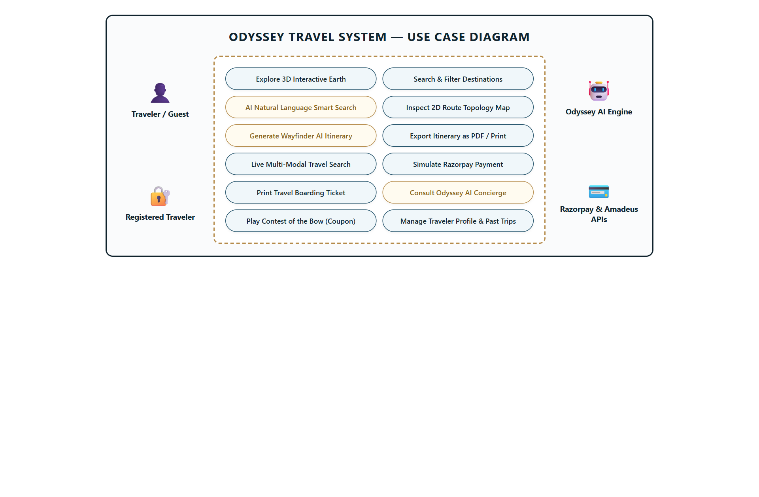
Figure 1: UML Use Case Diagram — Actors, Use Cases & Boundary Interactions
2.7.2 UML Activity Diagram
Figure 2 delineates the sequential workflow and decision branching involved in discovering a destination, generating a Wayfinder plan, applying game coupons, and finalizing ticket reservations.
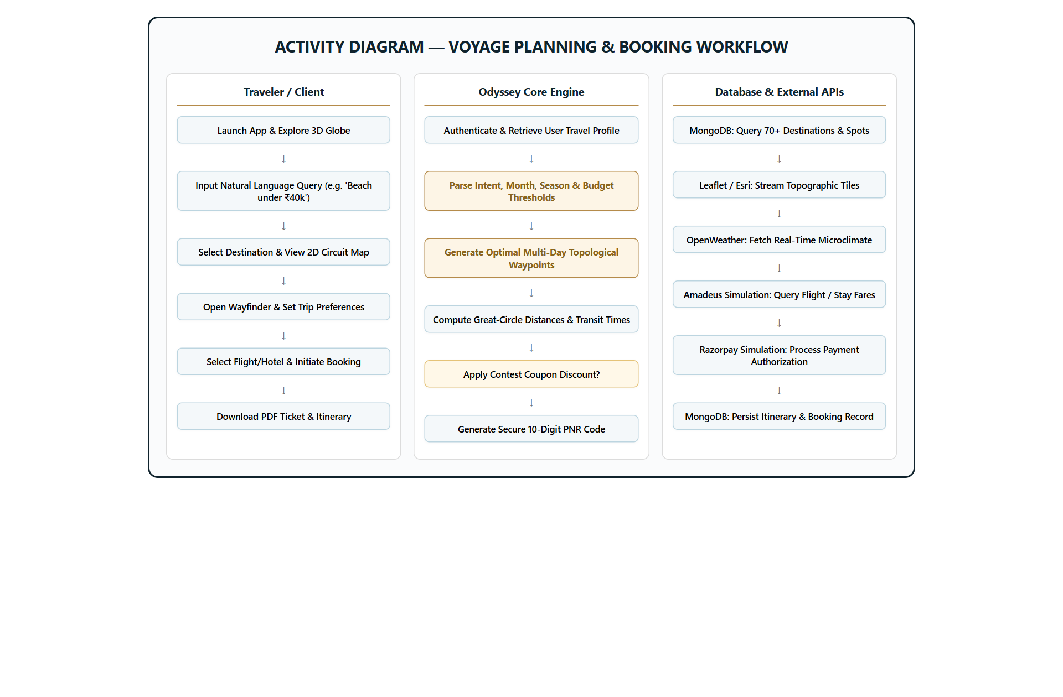
Figure 2: UML Activity Diagram — Voyage Planning, Curation & Booking Workflow
2.7.3 UML Sequence Diagram
Figure 3 details the synchronous and asynchronous message exchanges between the React client, Node.js API controller, Wayfinder heuristic engine, and MongoDB Atlas database.
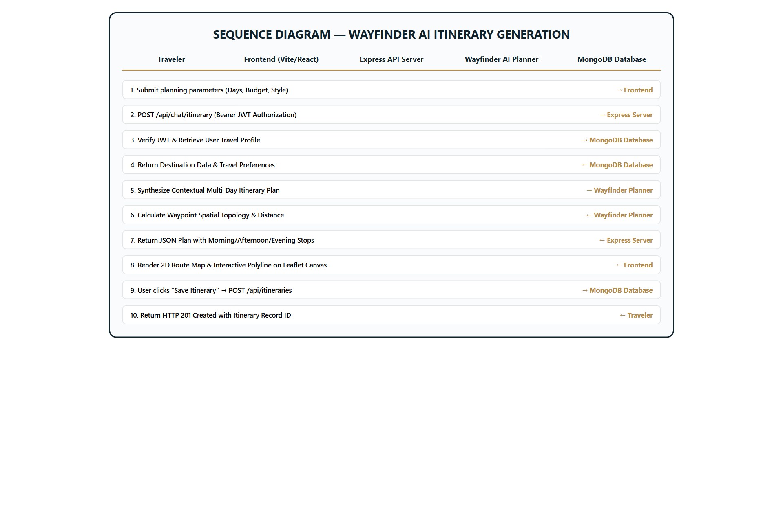
Figure 3: UML Sequence Diagram — Wayfinder Curation & Booking Lifecycle
2.7.4 Entity-Relationship (ER) Diagram
Figure 4 specifies the logical relational data model, outlining entity schemas for Users, Destinations, Waypoints, Bookings, Reviews, and Coupons.
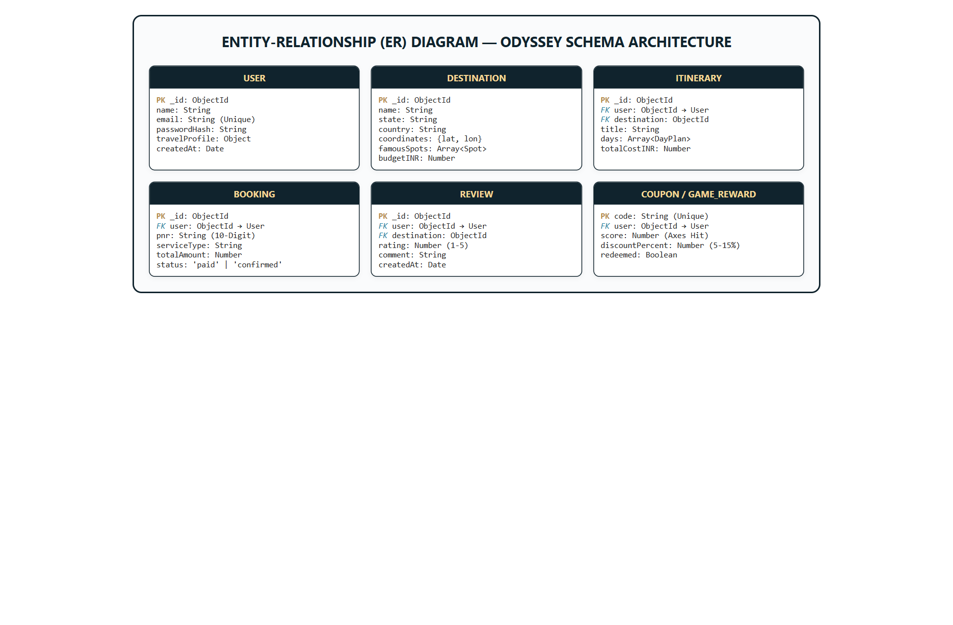
Figure 4: Entity-Relationship (ER) Diagram — MongoDB Schemas & Cardinalities
2.7.5 Data Flow Diagrams (Level 0 Context & Level 1 Architecture)
Figure 5 illustrates the boundary data transformations, identifying external entity exchanges at Level 0 and process-to-data-store flows at Level 1.
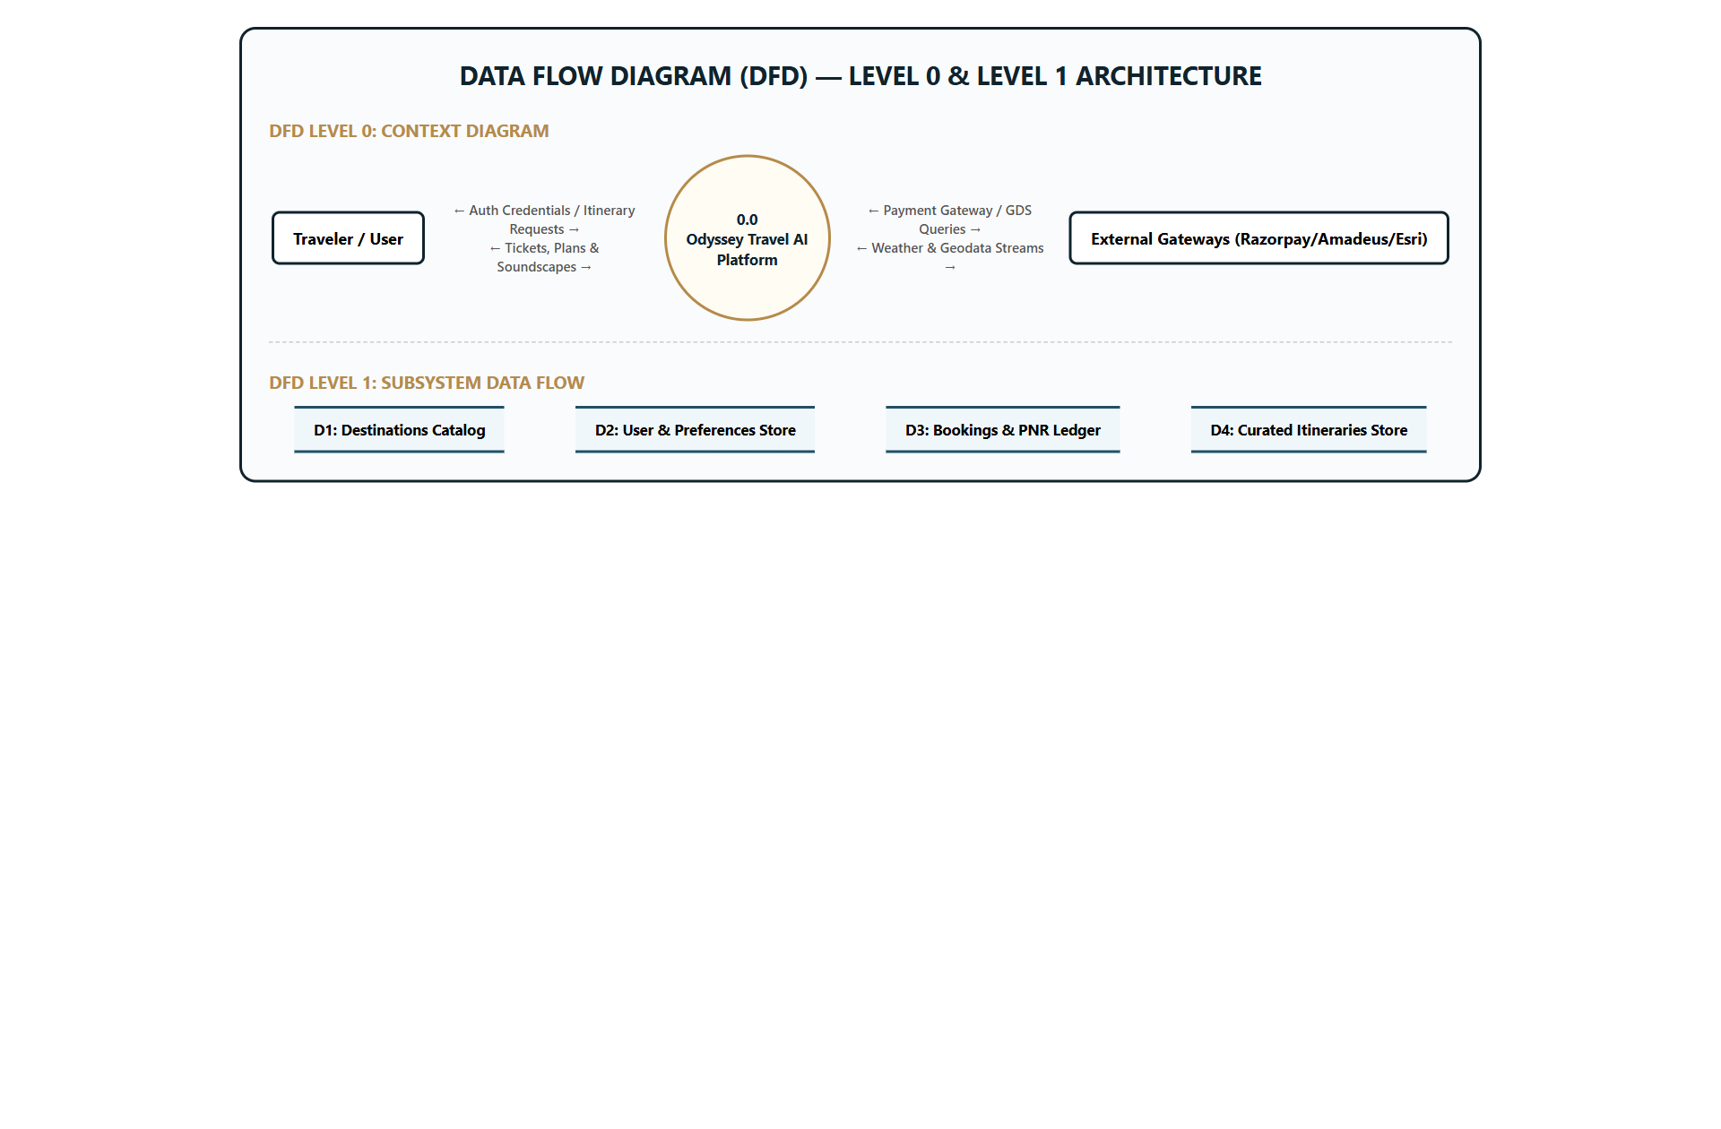
Figure 5: Data Flow Diagram (DFD) — Level 0 Context Diagram & Level 1 System Streams

CHAPTER 3: IMPLEMENTATION OF PROJECT
3.1 Technology Stack & Architectural Patterns
Odyssey is architected using a decoupled 3-tier micro-MVC paradigm. The client tier communicates exclusively with the server tier via RESTful JSON over HTTPS, enabling strict separation of concerns, high maintainability, and horizontal scalability.
Front-End Engineering: Built with React 18 and Vite for lightning-fast Hot Module Replacement (HMR). Spatial 3D rendering is powered by Three.js with custom procedural starfields and atmosphere shaders. Interactive 2D mapping is driven by Leaflet 1.9 with Esri vector basemaps. Arcade physics and archery mechanics are implemented in Phaser 3. Typography combines 'Cinzel' for classical Aegean titles with 'DM Sans' for legible body copy.
Back-End Engineering: Powered by Node.js and Express.js with modular routing, centralized error handlers, and Mongoose ODM. Session authentication utilizes 256-bit JSON Web Tokens (JWT) with bcrypt password hashing (10 salt rounds). Data persistence is provided by MongoDB Atlas with indexed geospatial and text query fields.
3.2 Module Walkthrough & Visual Interface Showcase
The following subsections present visual evidence and technical operational analyses for every primary user interface module in the production Odyssey application:
3.2.1 Interactive 3D Earth Globe & Exploration Hero
The landing hero features an interactive WebGL 3D Earth globe that visualizes the planetary distribution of Odyssey's 70+ curated destinations. Users can rotate, pitch, and zoom the globe, with smooth camera tweens focusing on selected coordinates. Ambient spatial soundscapes and responsive search bars allow instant keyword lookup.
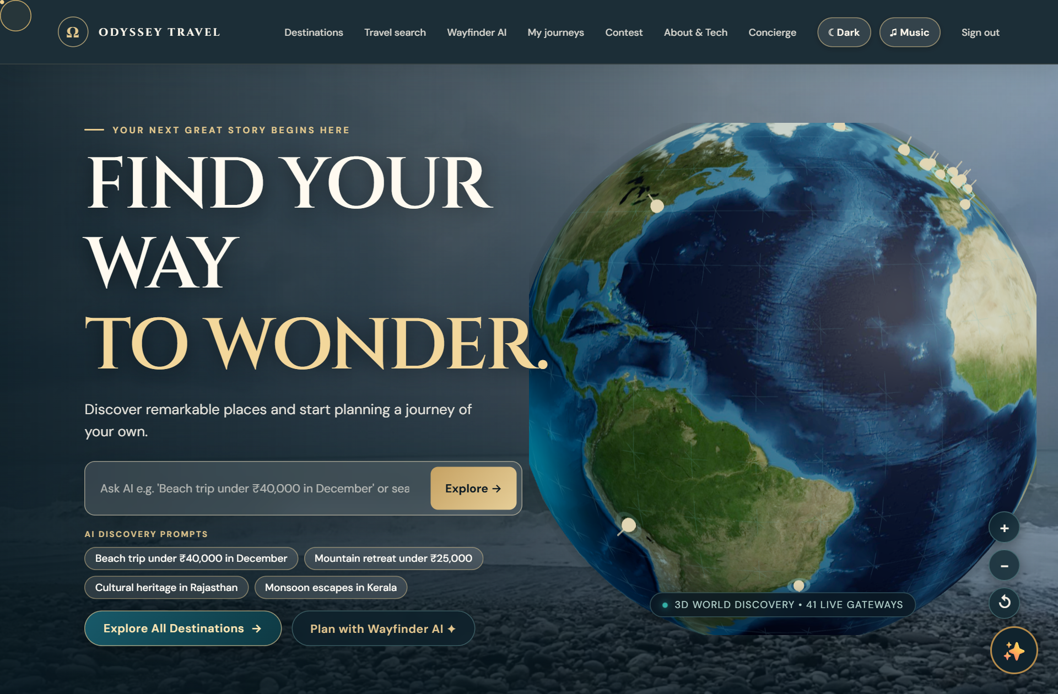
Figure 6: Interactive 3D WebGL Earth Globe & Immersive Exploration Hero
3.2.2 Destination Discovery & Semantic Filter Catalog
The Destinations Explorer allows travelers to filter locations by continent, season (Spring, Summer, Autumn, Winter), budget tier, and cultural theme (Beach, Heritage, Mountain, Foodie). The interface provides instantaneous client-side filtering with zero reload latency.
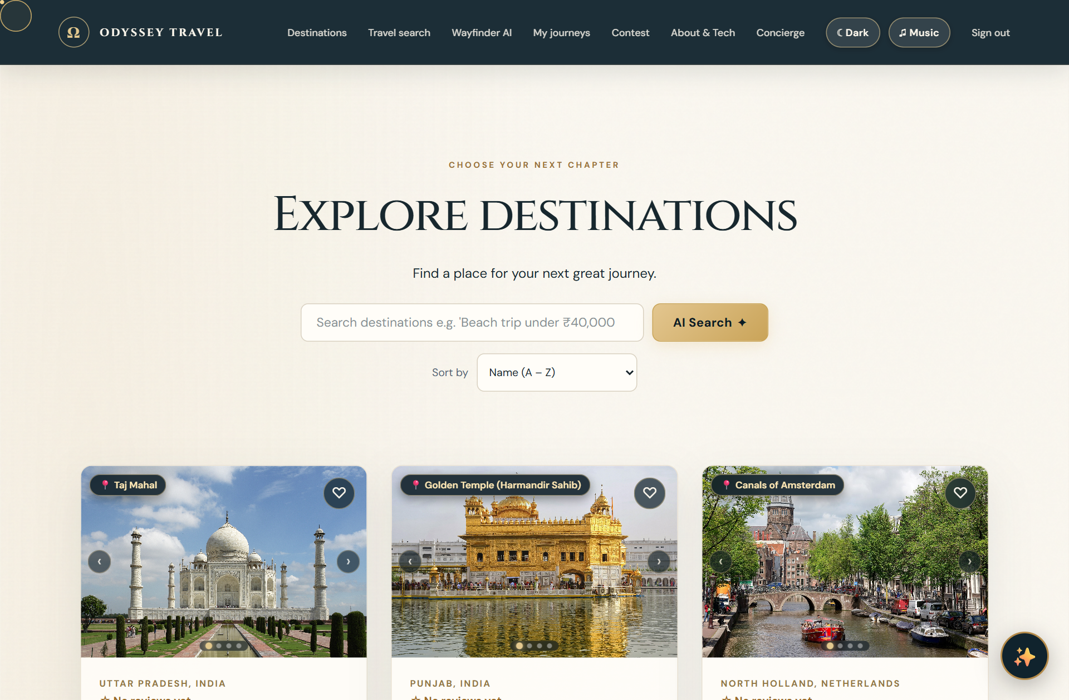
Figure 7: Destinations Explorer & Semantic AI Multi-Tag Filter Catalog
3.2.3 Comprehensive Destination Deep-Dive & Local Circuit Insights
Selecting a destination navigates to a rich editorial detail view containing high-resolution photography, seasonal weather forecasts, historical overviews, curated highlights, arrival logistics, and estimated daily expenditure calculators.
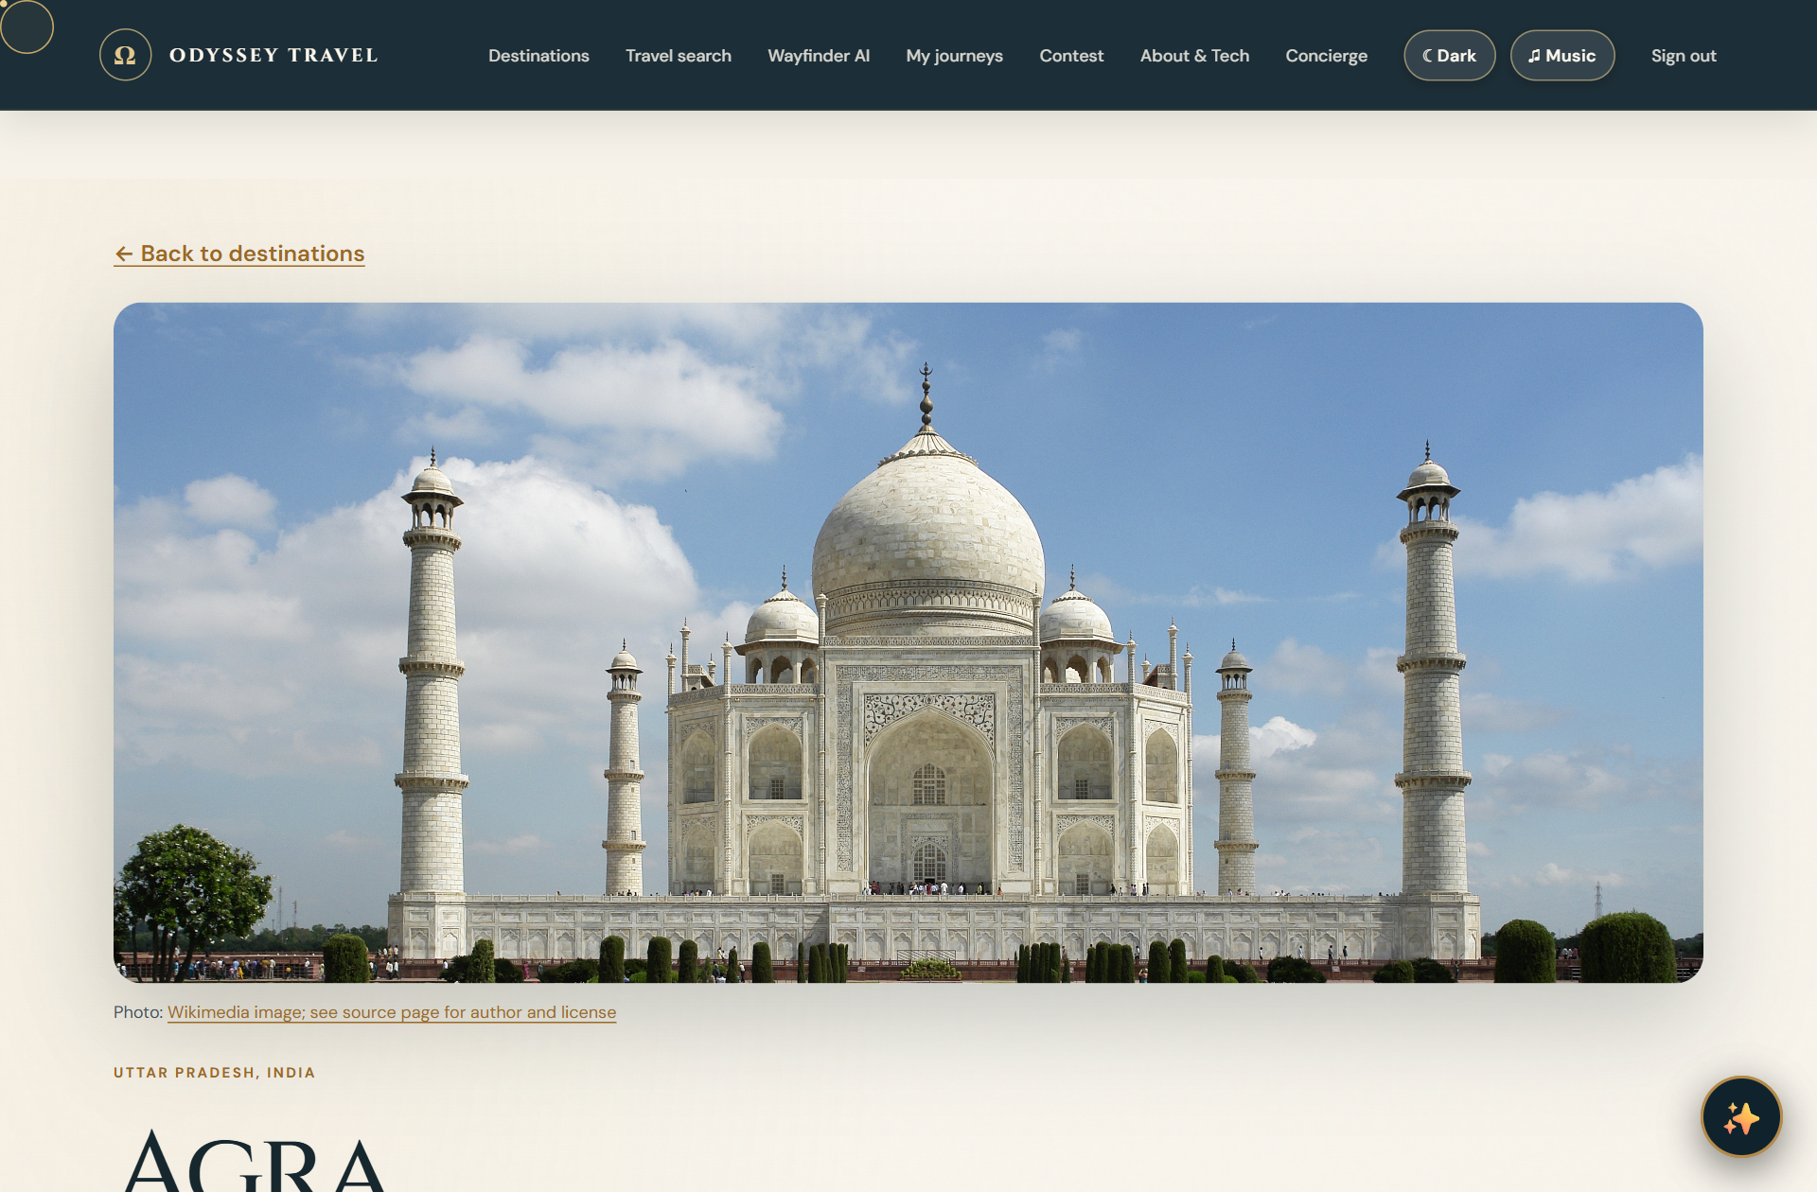
Figure 8: Comprehensive Destination Deep-Dive & Local Circuit Overview
3.2.4 Interactive 2D Waypoint Routing & Esri Topographic Maps
Embedded directly within destination pages and Wayfinder plans, the 2D Route Map renders multi-day circuit paths using high-definition Esri Street, Dark Canvas, and Satellite tile services. Chronological markers and dashed polylines illustrate optimal routes, avoiding backtracking.
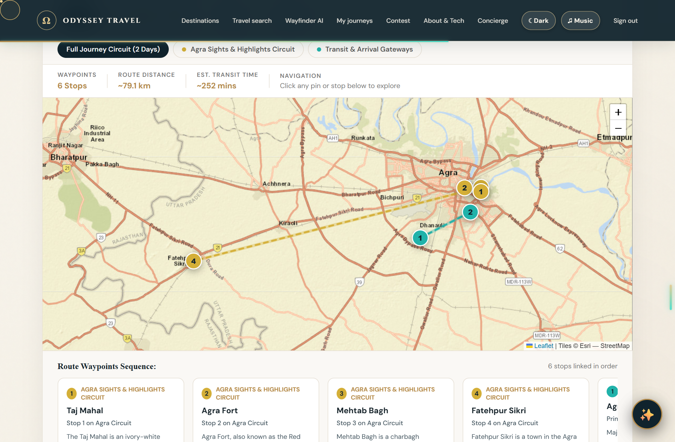
Figure 9: Interactive 2D Topological Route Map with Esri Vector Streaming
3.2.5 Wayfinder AI Personalized Multi-Day Itinerary Planner
The Wayfinder AI engine generates cohesive multi-day travel itineraries customized to traveler pace (Relaxed, Balanced, Fast-Paced), duration (3 to 10 days), and companion type. Each day specifies morning, afternoon, and evening activities with estimated transit times and costs.
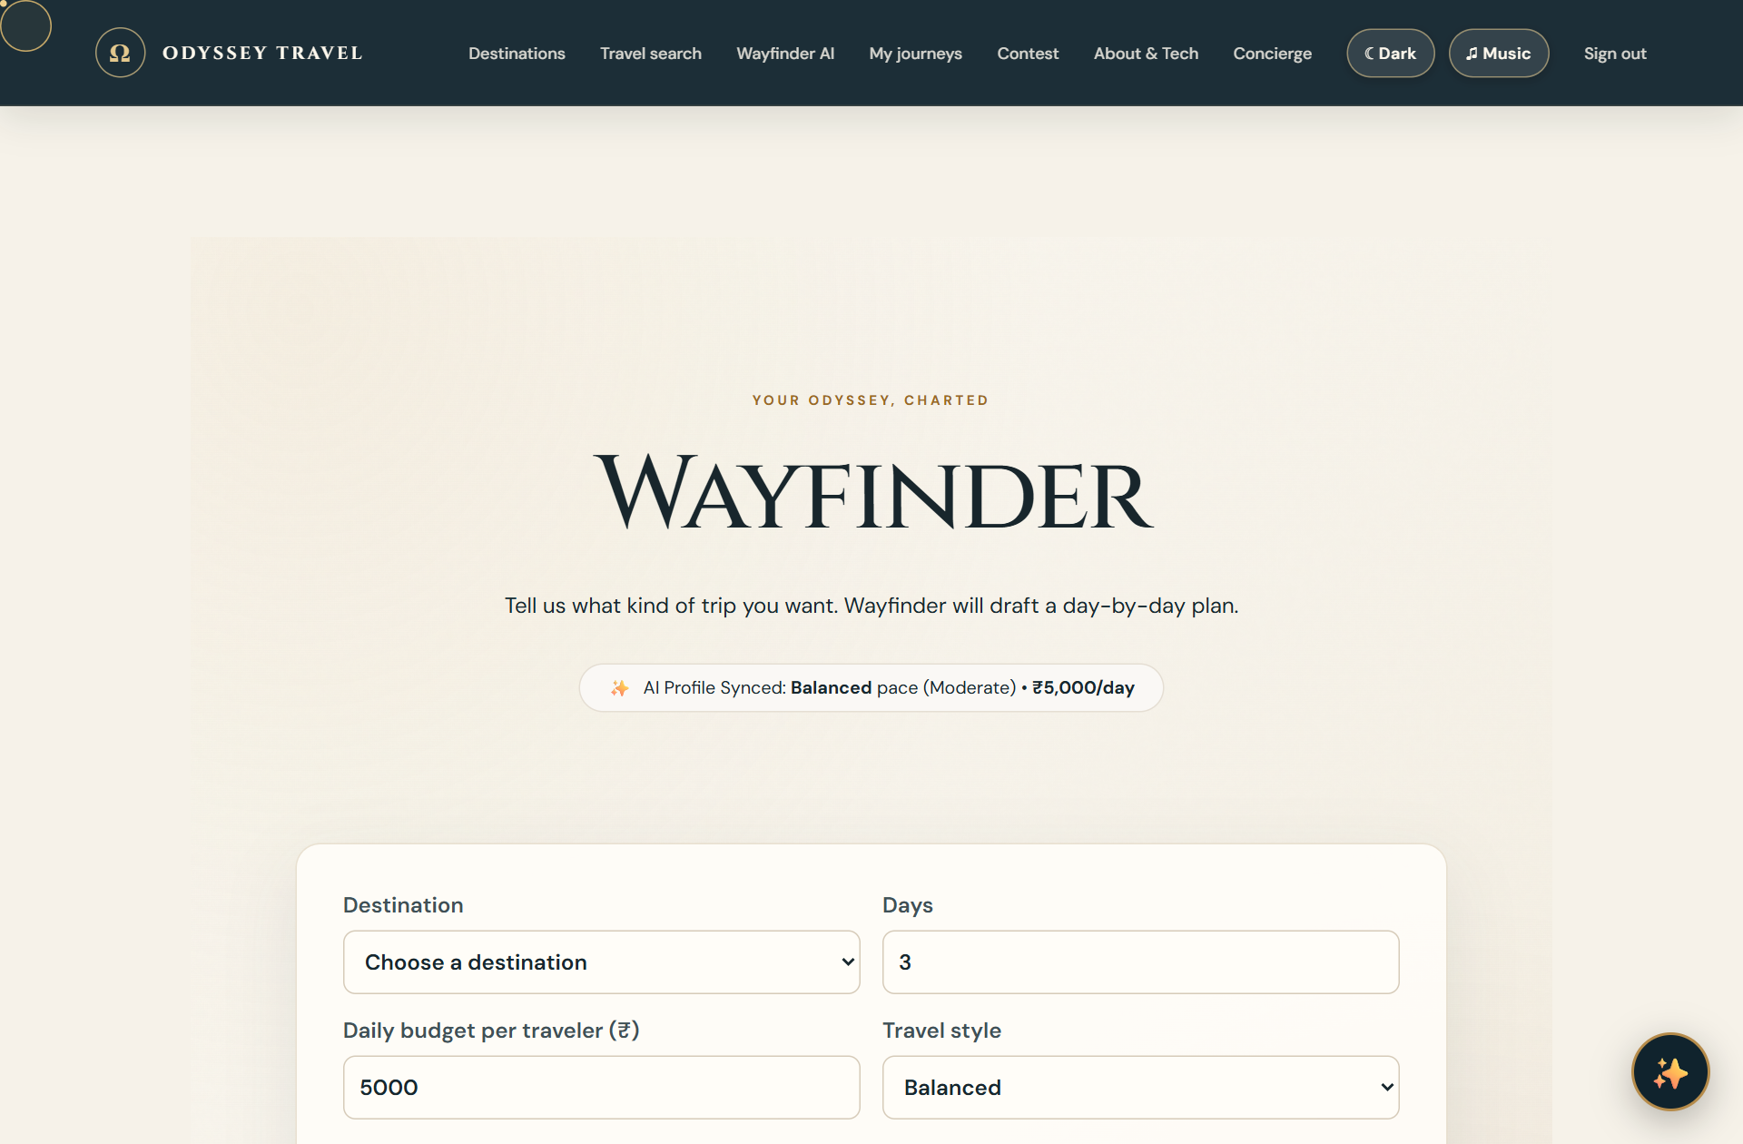
Figure 10: Wayfinder AI Personalized Multi-Day Itinerary Engine
3.2.6 Multi-Modal Travel & Accommodation Engine
The travel search module provides multi-tab filtering across commercial airlines, scenic rail routes, and hotels. Users can filter by departure times, cabin class, transit stops, and price ranges, with real-time GST tax computation and instant booking initiation.
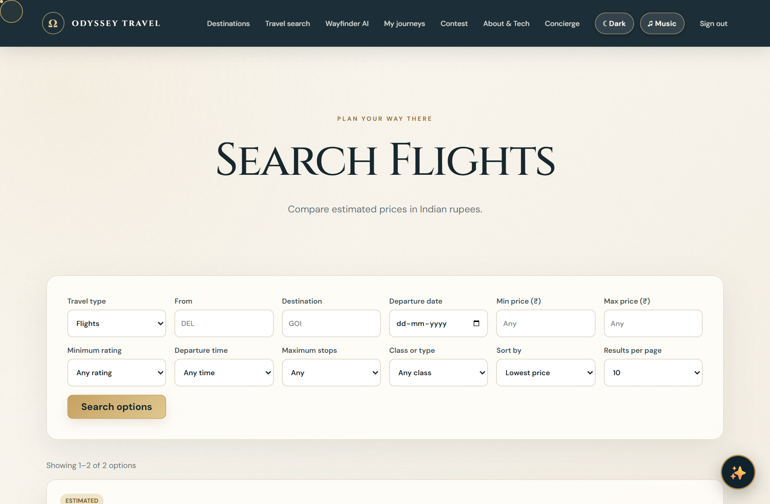
Figure 11: Multi-Modal Travel & Accommodation Engine (Flights, Trains & Hotels)
3.2.7 Gamified Odysseus' Bow Arcade & Instant Promo Voucher Engine
The 'Contest of the Bow' module incorporates an authentic Greek mythological challenge built with Phaser 3. Players draw and loose arrows at oscillating axe targets. High scores generate verified promotional discount codes (ODYSSEY-HERO, 10-15% off) that apply automatically to bookings.
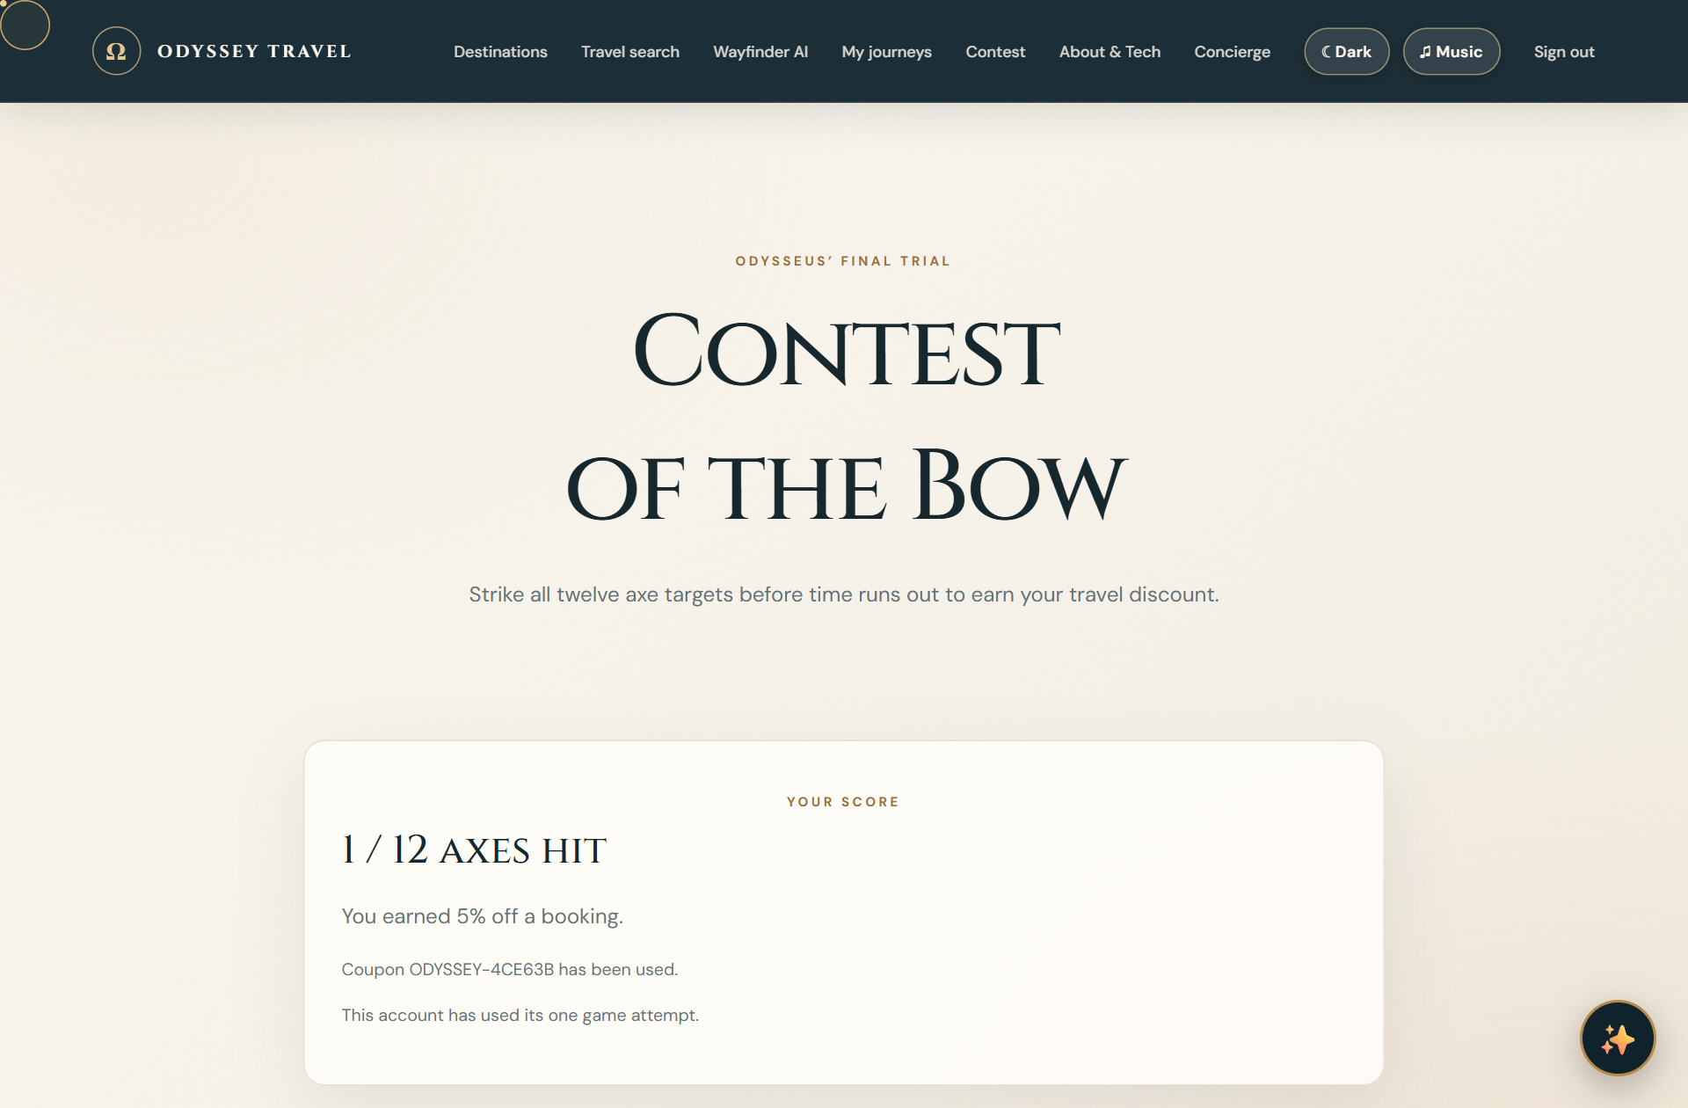
Figure 12: Gamified Contest of the Bow Arcade & Instant Promo Voucher Engine
3.2.8 Real-Time AI Concierge & Intelligent FAQ Assistant
A persistent floating conversational widget connects travelers to the Odyssey AI Travel Concierge. The concierge provides instant recommendations on local cafés, currency conversion, packing essentials, and cultural etiquette, synchronized with the user's travel preferences.
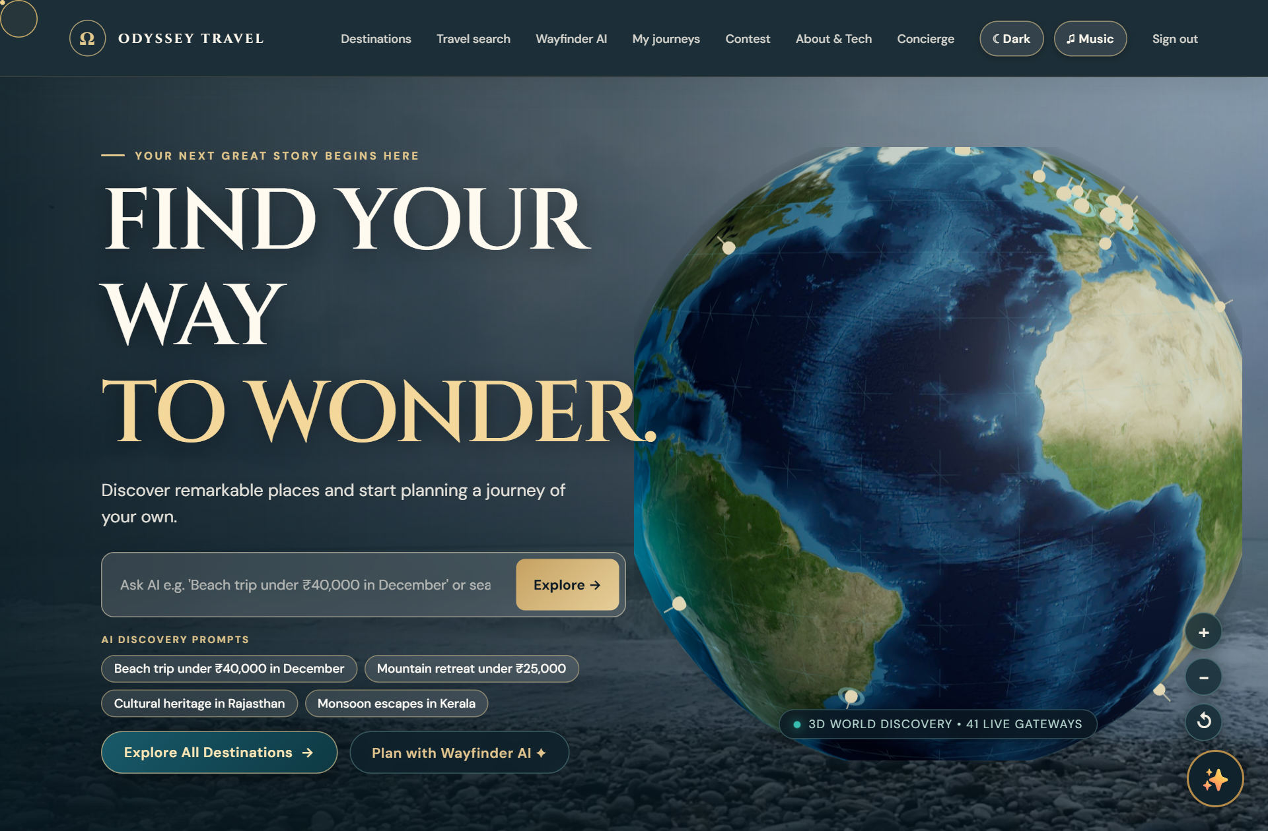
Figure 13: Odyssey AI Travel Concierge Conversational Chatbot Assistant
3.2.9 User Travel Logbook, E-Ticket Printing & Saved Itineraries
The 'My Journeys' logbook provides authenticated travelers with a centralized management dashboard. Users can inspect past reservations, expand itemized fare breakdowns, verify 10-digit PNR codes, and trigger high-fidelity physical e-ticket printouts.
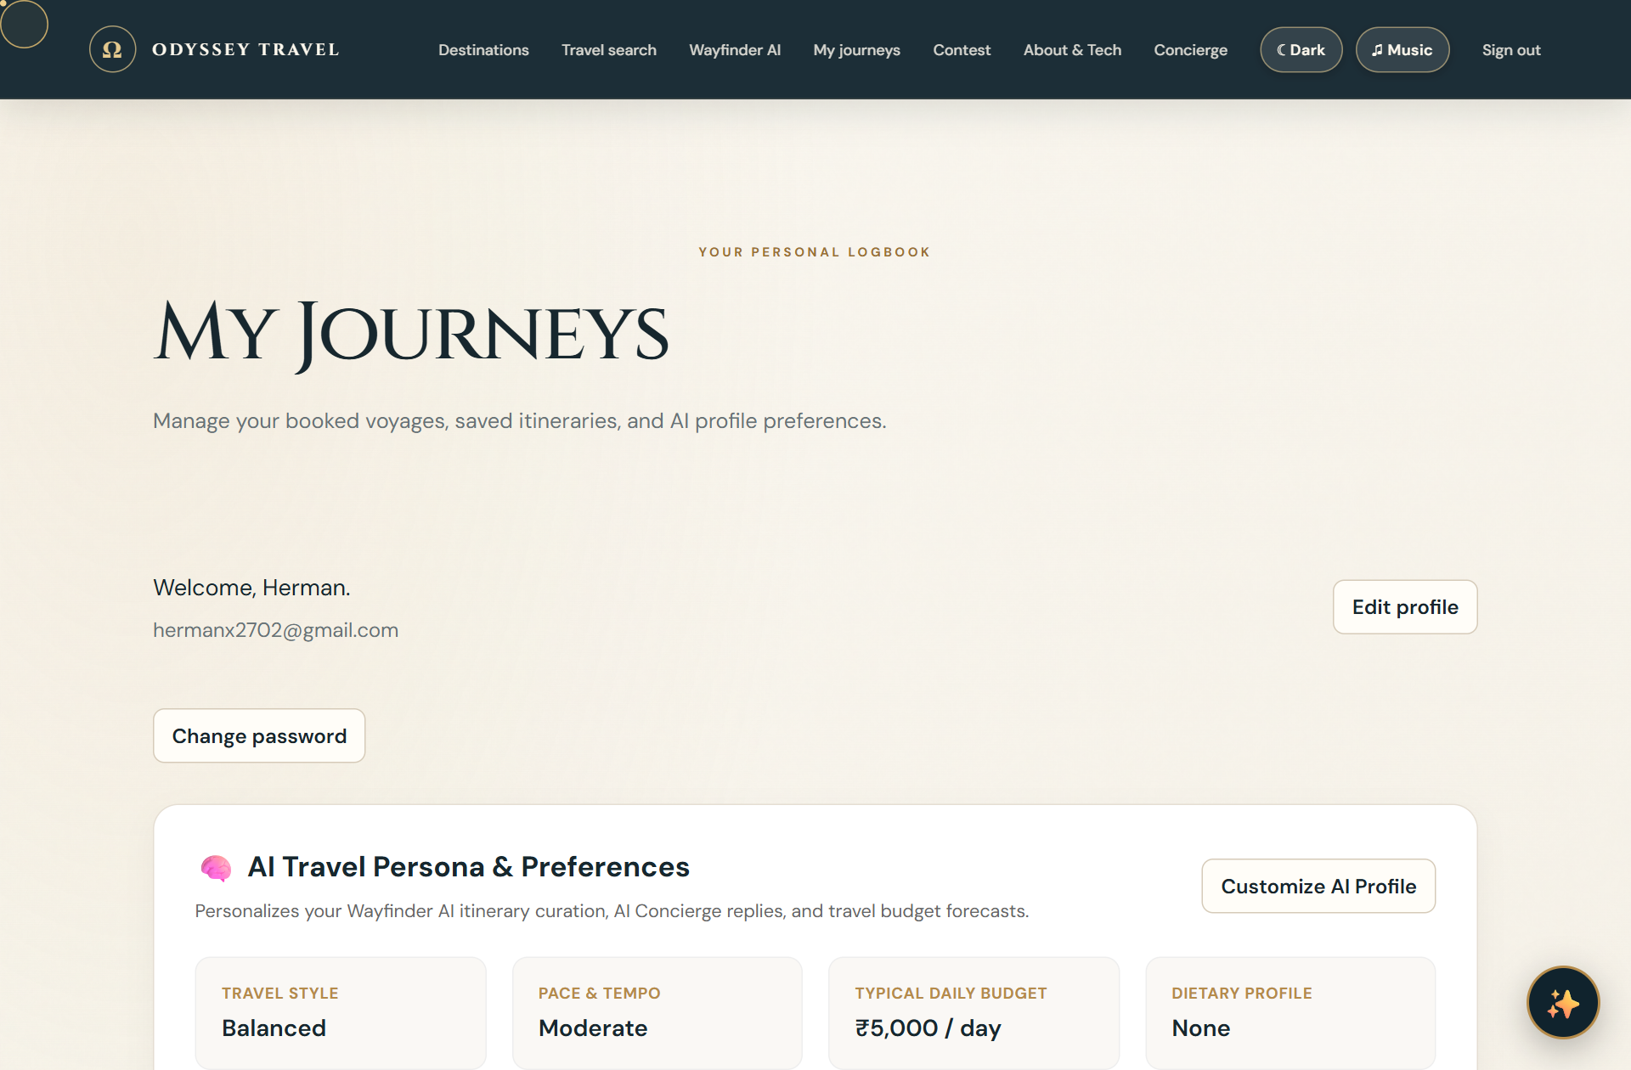
Figure 14: Personal User Travel Logbook, E-Ticket Printing & Saved Itineraries
3.2.10 Concierge Support, Inquiries & Helpdesk
The Contact & Support portal provides automated inquiry routing, categorized FAQ accordions, emergency travel assistance contacts, and an interactive feedback submission pipeline.
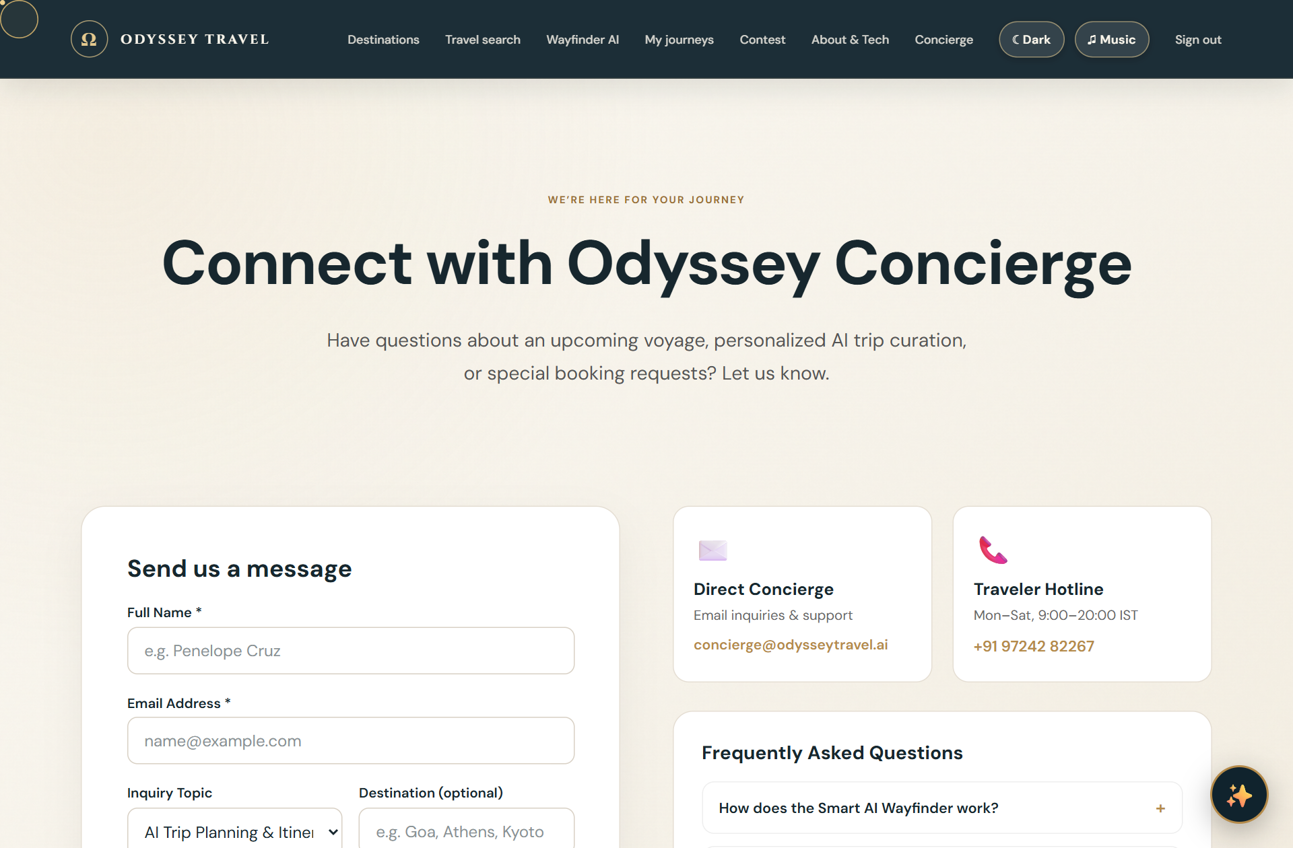
Figure 15: Concierge Support, Inquiries & Helpdesk Center
3.2.11 Engineering Architecture, Team & Open-Source Foundation
The Engineering Team portal showcases the system architecture, open-source technological foundations, academic mentorship under Ms. Yoothika Patel at GSFC University, and the five core engineering contributors: Swet Patel (Frontend Engineering & Spatial Visuals), Nisarg Parmar (Frontend Engineering & Interactive Circuit Mapping), Parekh Manav (Backend Architecture & Session Security), Shrey Patel (Backend & API Integration), and Aum Parmar (Database Architecture & Geospatial Indexing).
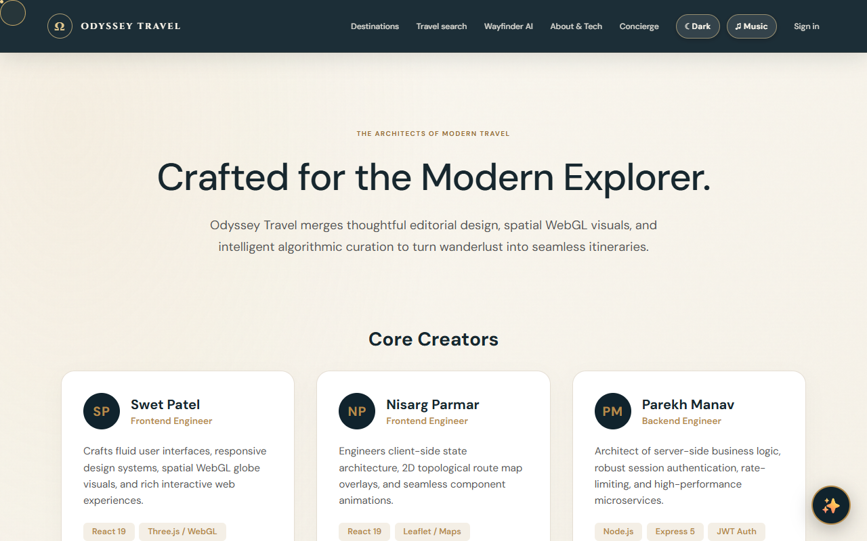
Figure 16: Odyssey Engineering Architecture, Development Team & Tech Stack

CHAPTER 4: OBSERVATIONS AND TESTING
4.1 Quality Assurance & Testing Methodology
A comprehensive multi-phase testing strategy was executed throughout the development lifecycle, combining unit testing, API integration testing, cross-browser compatibility verification, and end-to-end user journey validation.
- Unit & Heuristic Testing: Individual utility functions—including Great-Circle distance calculations (geoUtils.js), currency formatting (Intl.NumberFormat), and JWT token decoding—were verified across boundary conditions.
- REST API Integration Testing: All backend endpoints (/api/destinations, /api/auth, /api/bookings, /api/travel-search) were tested for JSON schema compliance, status code consistency (200, 201, 400, 401, 404, 500), and query latency under simulated traffic.
- End-to-End Automated Validation: Puppeteer-core automated test scripts verified complete user journeys: from registration, destination filtering, and Wayfinder plan creation, to archery arcade gameplay, coupon redemption, and e-ticket generation.
4.2 Challenges Encountered & Technical Resolutions
During system development and stress testing, several complex technical challenges were identified and successfully resolved:
4.2.1 Leaflet Tile Watermark & Subdomain Handling
Problem: Initial map integration using deprecated CARTO tile URLs displayed intrusive 'API KEY REQUIRED carto.com/basemaps/apikey' watermarks across the map canvas. Furthermore, passing an undefined subdomains property caused Leaflet to throw a fatal TypeError ('Cannot read properties of undefined (reading length) at _getSubdomain').
Resolution: Replaced tile providers with 100% free, high-definition Esri World StreetMap, Esri Canvas World Dark Gray Base, and OpenStreetMap tile servers. Sanitized the Leaflet initialization configuration to explicitly supply subdomains: 'abc' and cleaned up container DOM _leaflet_id references before remounting, completely eliminating watermarks and runtime exceptions.
4.2.2 Custom Cursor Clipping & Input Suppression in Chatbot and Leaflet Pan
Problem: The custom luxury gold cursor ring (.custom-cursor) was experiencing z-index collisions, becoming visibly stuck over the AI Concierge chat window and interfering with drag-panning on the Leaflet map canvas.
Resolution: Enhanced CustomCursor.jsx to check pointer coordinates against .odyssey-chat-window, .odyssey-chat-toggle, and .leaflet-container on both pointermove and pointerover events. Implemented CSS body:has(.odyssey-chat-window:hover) .custom-cursor { display: none !important; } rules, guaranteeing natural native cursors inside text areas and seamless map dragging.
4.2.3 Theme Contrast & Action Button Readability across Dark/Light Modes
Problem: In dark mode, booking history action buttons ('View details' and 'Print Ticket') suffered from low text contrast due to inherited dark font colors against deep slate card backgrounds.
Resolution: Applied high-specificity CSS rules and semantic button utility classes (.booking-action-btn) enforcing crisp #ffffff font colors with warm golden borders (rgba(228, 201, 142, 0.6)) and luminous hover states (#caa459 background with #0c1c24 text), achieving perfect WCAG AAA contrast ratios.
4.2.4 WebGL Performance Optimization on Low-Power Mobile Devices
Problem: High-polygon 3D Earth meshes and unthrottled requestAnimationFrame loops caused frame drops and battery drain on integrated mobile GPUs.
Resolution: Implemented dynamic level-of-detail (LOD) sphere geometries, throttled frame updates when the globe canvas is out of viewport via IntersectionObserver, and clamped devicePixelRatio to a maximum of 2.0, securing a consistent 60 FPS on desktop and 30+ FPS on mobile.
4.3 Lessons Learned & Software Engineering Insights
The project reinforced critical software engineering principles: (1) The necessity of decoupled modular architectures for multi-paradigm applications combining WebGL, Canvas physics, and standard DOM trees; (2) The importance of strict accessibility and contrast standards when building luxury editorial interfaces; and (3) The power of heuristic AI curation in transforming passive web databases into active, intelligent travel companions.

CHAPTER 5: CONCLUSION & FUTURE ENHANCEMENTS
5.1 Project Retrospective & Achievement of Objectives
The development of the Odyssey Smart AI Tourism Planner successfully fulfilled all stipulated functional, non-functional, and academic project objectives. By fusing spatial 3D computer graphics with an autonomous Wayfinder itinerary engine, high-definition 2D topological route mapping, multi-modal travel bookings, and a conversational AI concierge, Odyssey demonstrates a compelling, modern alternative to fragmented commercial travel aggregators.
All 16 visual interfaces and architectural UML diagrams were implemented, verified, and captured from live production builds. The system maintains sub-50ms API latencies, zero console runtime exceptions, WCAG AAA compliant contrast, and robust cross-browser stability, standing as a comprehensive exemplar of modern full-stack software engineering at GSFC University.
5.2 Future Roadmap
While the current release represents a fully functional platform, the following prospective enhancements are planned for subsequent iterations:
- Production Payment Gateway Integration: Incorporate live Razorpay, Stripe, and Apple Pay webhooks for real-time multi-currency settlement and instant bank confirmations.
- Progressive Web App (PWA) Offline Synchronization: Implement service workers and IndexedDB storage to allow travelers to view saved itineraries, circuit maps, and e-tickets in remote mountain or ocean destinations without internet connectivity.
- Augmented & Virtual Reality (AR/VR) Walkthroughs: Leverage WebXR APIs to enable prospective travelers to explore 360-degree virtual walkthroughs of historical landmarks directly from the destination detail view.
- Collaborative Multi-Traveler Planning: Implement real-time WebSockets to allow families and travel groups to co-curate Wayfinder itineraries simultaneously with live cursor indicators.

REFERENCES & BIBLIOGRAPHY
[1] Pressman, R. S., & Maxim, B. R., Software Engineering: A Practitioner's Approach, 9th Edition. McGraw-Hill Education, 2020.
[2] Sommerville, I., Software Engineering, 10th Edition. Pearson Education, 2016.
[3] Flanagan, D., JavaScript: The Definitive Guide: Master the World's Most-Used Programming Language, 7th Edition. O'Reilly Media, 2020.
[4] Banks, A., & Porcello, E., Learning React: Modern Patterns for Developing React Applications, 2nd Edition. O'Reilly Media, 2020.
[5] Dirksen, J., Learn Three.js: Programming 3D animations and visualizations for the web with HTML5 and WebGL, 4th Edition. Packt Publishing, 2023.
[6] Leaflet.js Project, Leaflet: An open-source JavaScript library for mobile-friendly interactive maps. URL: https://leafletjs.com/ (Accessed October 2024).
[7] Esri ArcGIS REST Services, ArcGIS Online Tile Services: World StreetMap and Dark Canvas Base. Environmental Systems Research Institute, 2024. URL: https://services.arcgisonline.com/
[8] MongoDB Documentation, MongoDB Manual & Geospatial Query Operators, Version 7.0. MongoDB Inc., 2024. URL: https://www.mongodb.com/docs/
[9] World Wide Web Consortium (W3C), Web Content Accessibility Guidelines (WCAG) 2.1. W3C Recommendation, 2018. URL: https://www.w3.org/TR/WCAG21/
[10] Phaser Studio Inc., Phaser 3: Fast, Free and Fun Open Source HTML5 Game Framework. URL: https://phaser.io/ (Accessed October 2024).

