**HR Recruitment Analytics Dashboard Report**

**Submitted by:**

Sweta Behera

Roll No.: 055051

Section: K

1. **About the Dataset**

The dataset contains **3,000 records** of job applicants and includes **15 columns** detailing their demographic information, application status, experience, salary expectations, and geographical details. The dataset can be leveraged to analyze recruitment trends, hiring efficiency, and candidate demographics.

**Key Attributes in the Dataset:**

1. **Applicant Information**
   * Applicant ID – Unique identifier for each applicant
   * First Name, Last Name, Email – Personal identification details
2. **Application Details**
   * Application Date – When the candidate applied (Useful for trend analysis)
   * Job Title – Position the candidate applied for
   * Status – Current stage in the hiring process (Applied, Interviewing, Rejected, Hired)
3. **Demographic Details**
   * Gender – Male, Female, Other
   * Date of Birth – Can be used to derive **age group distribution**
   * Education Level – High School, Bachelor's, Master's, PhD
4. **Experience & Salary Insights**
   * Years of Experience – Helps analyze hiring trends based on experience level
   * Desired Salary – Enables **salary benchmark analysis**
5. **Geographical Data**
   * City, State, Country – Useful for **regional hiring trends**
6. **Context & Objective**

TalentBridge RPO, a recruitment process outsourcing (RPO) firm specializing in multiple roles, has been facing challenges in optimizing its hiring process for client organizations. The HR team has observed inconsistencies in recruitment efficiency, gender diversity, and salary expectations, leading to delays in filling key positions for their clients. To address these concerns, the company created a **recruitment analytics dashboard** that consolidates insights from various hiring metrics.

**Objective of the Dashboard**

The recruitment dashboard was designed to:

* Assess overall recruitment performance & efficiency
* Identify trends and hiring fluctuations
* Analyze qualifications of applicants
* Examine geographical hiring trends
* Compare salary expectations across gender and experience levels
* Track efficiency in applicant progression

**Recruitment Analytics Dashboard:**

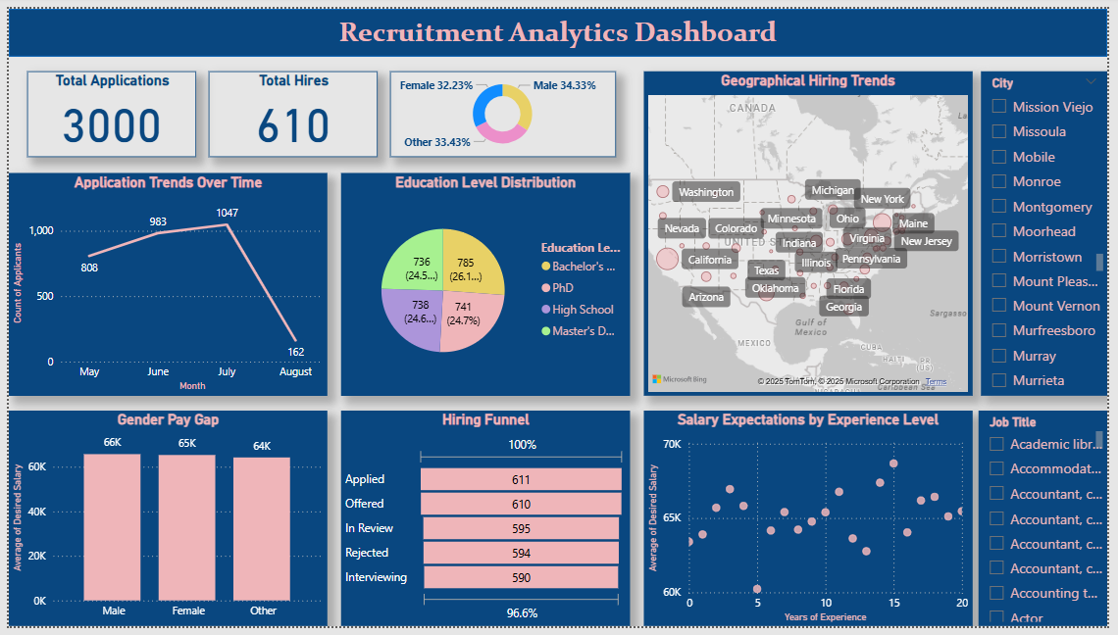

**Problem Statements:**

**Addresses overall recruitment performance & efficiency**

1. What percentage of applicants get hired?
2. How many applicants are stuck at interviewing stage?
3. Is the gender distribution balanced among applicants?

**Focuses on recruitment trends & hiring fluctuations**

1. Which month had the highest and lowest job applications?
2. Are there noticeable hiring trends over time?
3. Could changes in employer branding impact application trends?

**Examines the qualifications of applicants**

1. What is the most common education level among applicants?
2. Are there enough applicants with postgraduate qualifications?
3. Should HR prioritize degrees or skills-based hiring?

**Analyzes location-based applicant trends**

1. Which city has the highest number of applications?
2. Are applications concentrated in specific regions?
3. Should remote hiring be considered in low-application areas?
4. Are hiring efforts aligned with the highest application regions?

**Compares salary expectations across gender**

1. Is there a significant gender pay gap in salary expectations?
2. Do women expect lower salaries than men?
3. Are salary expectations consistent across all gender identities?

**Tracks efficiency in applicant progression**

1. At which hiring stage do most applicants drop off?
2. Is there a bottleneck in moving candidates forward?
3. Major indicating factor which tells that the hiring process slow?

**Benchmarks salary expectations against experience**

1. Do salary expectations increase with experience?
2. Do entry-level candidates have unrealistic salary expectations?
3. Do mid-career professionals have lower expectations than seniors?
4. **Visual Insights & Observation**
   1. **KPI Cards –**

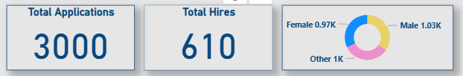

KPI cards provide an at-a-glance summary of key recruitment metrics, including:

* **Total Applications:** The total number of candidates who applied.
* **Total Hires:** The number of applicants successfully hired.
* **Gender Diversity:** The distribution of applicants by gender.

**What business insights will these KPI cards give:**

* Provides a quick assessment of the overall recruitment performance.
* Highlights hiring success rates, helping HR identify whether hiring targets are met.
* A high number of applications but low hires may indicate inefficiencies in the hiring process.
* Gender diversity metrics help track progress toward inclusive hiring goals.

**Observation:**

The report shows a total of **3000 applications**, out of which **610 candidates were hired**, with **a good gender diversity**, indicating the overall recruitment performance.

1. What percentage of applicants got hired?

20.33 % of the applicants got hired.

1. How many applicants are stuck at interviewing stage?

590 candidates are stuck at interviewing stage out of 3000 applicants.

1. Is the gender distribution balanced among applicants?

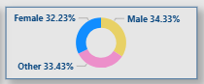

Male: **34.33%**

Female: **32.23%**

Other: **33.43%**

**Insight:** The gender distribution is fairly even, suggesting diversity in applications. HR can ensure this balance continues through inclusive hiring practices.

* 1. **Applications Over Time (Line Chart)**

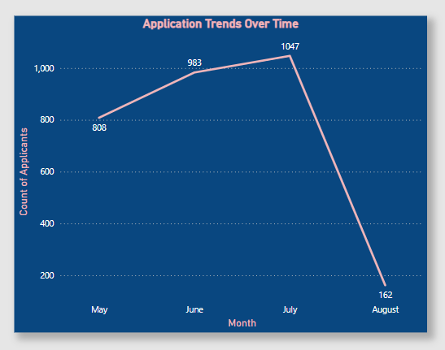

A line chart tracking monthly job application trends, showcasing peaks and dips in applicant volume.

**What business insights will this visual give:**

* Identifies hiring seasonality, helping HR teams plan recruitment efforts.
* A rise in applications may indicate strong employer branding or increased job demand.
* A sudden drop could suggest reduced job visibility, shifts in market demand, or a need to improve job descriptions and outreach strategies

**Observation:**

There was a peak in applications in **month July**, followed by a decline in **month August**, suggesting possible seasonal hiring trends or job market fluctuations.

1. Which month had the highest and lowest job applications?

**Highest:** July (**1,047 applications**)

**Lowest:** August (**162 applications**)

**Insight:** The sudden drop in August suggests reduced job visibility or fewer job openings. HR should analyze if seasonal factors influence applications.

1. Are there noticeable hiring trends over time?

Applications peaked in **June-July** and declined sharply in **August**.

**Insight:** Hiring seasonality might be a factor. HR should consider increasing job postings and recruitment efforts in low-application months.

1. Could changes in employer branding impact application trends?

Yes, a rise in applications (June-July) might indicate strong employer branding, while a drop (August) suggests reduced job visibility.

**Insight:** HR should ensure consistent branding and job visibility to maintain application flow.

* 1. **Education Level Distribution (Pie Chart)**

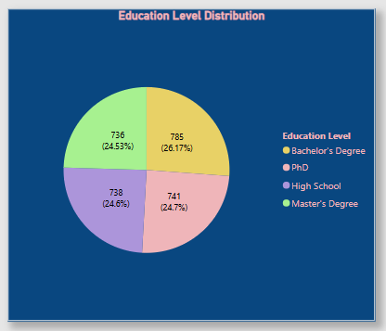

A breakdown of applicants by their highest level of education attained.

**What business insights will this visual give:**

* Helps HR understand the academic qualifications of applicants.
* Guides recruiters in determining whether job requirements align with the available talent pool.
* Assists in deciding whether skills-based hiring should be prioritized over degree requirements.

**Observation:**

The majority of applicants hold a **Bachelor’s degree (26.74%)**, while only **24.53%** have a Master’s or higher qualification.

1. What is the most common education level among applicants?

**Bachelor’s Degree (26.17%)** is the most common.

**Insight:** HR can align job requirements with this education level or introduce skills-based hiring for broader talent acquisition.

1. Are there enough applicants with postgraduate qualifications?

**PhD (24.7%)** and **Master’s Degree (24.53%)** applicants are significant.

**Insight:** This suggests a well-educated applicant pool. Jobs requiring advanced degrees may have sufficient candidates.

1. Should HR prioritize degrees or skills-based hiring?

Since **High School (24.6%)** applicants are also significant, HR should balance degree requirements with skill-based assessments.

**Insight:** A strict degree requirement may exclude capable candidates. HR can introduce skill tests to assess competencies beyond formal education.

* 1. **Geographical Hiring Trends (Map)**

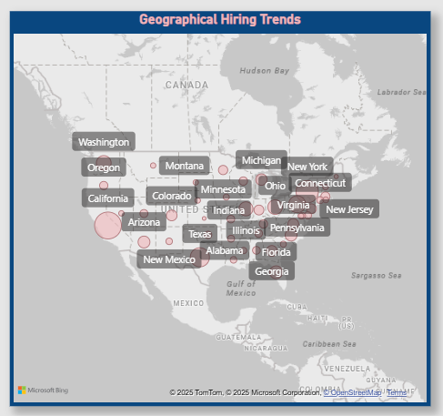

A bubble map showing the geographic distribution of applicants across different cities and states.

**What business insights will this map give:**

* Identifies where the strongest talent pools are located.
* Helps HR teams optimize hiring efforts by focusing on high-application areas.
* Assists in remote work strategy planning by identifying regions with fewer applicants.

**Observation:**

The highest number of applicants came from **California**, while **Vermont** had significantly fewer applications, indicating regional talent availability.

1. Which city has the highest number of applications?

**New York City (310 applications)**

**Insight:** HR should focus recruitment efforts here, as it has a strong talent pool.

1. Are applications concentrated in specific regions?

Yes, major cities like **Los Angeles (213), Philadelphia (183), and San Francisco (165)** have the most applications.

**Insight:** HR can optimize hiring campaigns by targeting high-application regions.

1. Should remote hiring be considered in low-application areas?

Yes, cities with fewer applicants (e.g., **Springfield (48)**) may require remote hiring strategies.

**Insight:** Expanding remote work options can attract talent from underrepresented locations.

1. A hiring efforts aligned with the highest application regions?

If **New York City (310 applications)** has no hires, there’s a **disconnect** between hiring and applicant location.

**Insight:** HR should **align recruitment resources** with high-application regions.

* 1. **Gender Pay Gap (Column Chart)**

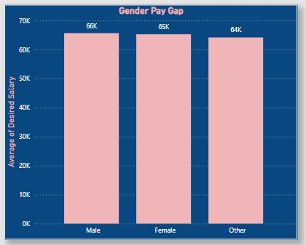

A column chart comparing the average desired salary of male, female, and other applicants.

**What business insights can this visual give:**

* Identifies potential pay disparities across different genders.
* A gender consistently expecting lower salaries may indicate broader industry gaps in salary negotiation confidence.
* Helps HR ensure equitable pay practices, making the organization more attractive to diverse talent

**Observation:**

On average, **male applicants expect $66,000**, while **female applicants expect $65,000**, highlighting a very small gap in salary expectations.

1. Is there a significant gender pay gap in salary expectations?

Female: **$65,317**

Male: **$65,698**

Other: **$64,212**

**Insight:** The gap is small, but HR should still ensure pay equity through transparent salary policies.

1. Do women expect lower salaries than men?

Yes, female applicants expect slightly lower salaries (**$381 less** than males).

**Insight:** HR should assess whether female candidates undervalue themselves and promote salary transparency.

1. Are salary expectations consistent across all gender identities?

No, **"Other" gender applicants expect the lowest salaries ($64,212)**.

**Insight:** Although the difference is not very significant, but for maintaining equity HR should ensure equitable pay practices across all gender groups.

* 1. **Hiring Funnel (Funnel Chart)**

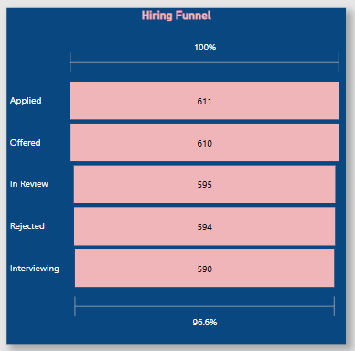

A funnel chart illustrating the number of applicants progressing through different hiring stages (Applied → Interviewing → Rejected → Hired).

**What business insights can this visual give:**

* Helps analyze conversion rates at each hiring stage.
* A high rejection rate at later stages may indicate misalignment between job descriptions and candidate expectations.
* If many candidates decline offers, it may suggest salary mismatches or stronger competition from other employers.

**Observation:**

Out of **3000 applicants**, **590 are still in interviewing stage** and **594 are still In In-Review stage.**

1. At which hiring stage do most applicants drop off?

The biggest drop is from **Interviewing (590) → Rejected (594)**.

**Insight:** High rejection rates at later stages suggest misalignment between job descriptions and candidate expectations.

1. Is there a bottleneck in moving candidates forward?

Yes, many candidates stay at **“In Review” (595)** instead of moving to offers.

**Insight:** HR should streamline the review process to avoid losing strong candidates.

1. Major indicating factor which tells that the hiring process slow?

If candidates get stuck in **In Review (595)**, delays might be turning them away.

**Insight:** HR should **streamline the selection process** keeping in mind the un-touched or under review applications to keep top talent engaged.

* 1. **Salary Expectations by Experience Level (Scatter Plot)**

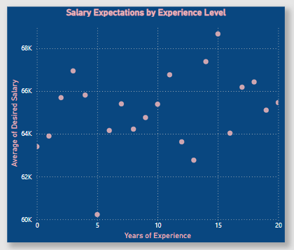

A scatter plot comparing years of experience with desired salary expectations.

**What business insights can this plot give:**

* Helps benchmark salary offers against industry expectations.
* Highlights salary expectation trends based on experience levels.
* If less experienced candidates expect higher salaries, it could indicate shifting market trends or unrealistic salary expectations.

**Observation:**

The highest average expected salary is **$68,672.99**, by candidate having **15 years of experience**.

1. Do salary expectations increase with experience?

Yes, salaries rise with experience, from **$63,405 (0 years)** to **$65,462 (20 years)**.

**Insight:** Although there’s not a significant increase in the salary expectation if we compare candidates with less than 1 year of experience with 20 years, but there are major fluctuations and reason could be qualifications or skills adopted by the candidates. HR should benchmark salaries against experience levels in consideration with other selection criteria as well to stay competitive.

1. Do entry-level candidates have unrealistic salary expectations?

Some **0-2 year** applicants expect higher salaries (**$63,405 - $65,694**).

**Insight:** HR may need to set clearer salary expectations for junior roles.

1. Do mid-career professionals have lower expectations than seniors?

Yes, **5-10 years** experience candidates expect around **$60,230 - $65,944**, slightly lower than senior levels.

**Insight:** HR should ensure competitive pay for mid-career hires to retain experienced talent.