It is Dynamic UI created for the users of a particular brand. It updates and recommends them the required services required for their previously purchased devices.

Front end contains the web pages which are linked and provide information regarding various services they can take.

Back end contains the notebook which has the "**Recommender Engine**" recommending the services that the user need to take and update their devices.

It also has the **chatbot** deployed for better communication with the user.

*It has tried to solve the problem of more customized Dell service web pages for the customer.

* Proposed Solution- We tried to present a better service recommendation to the users using various ML and DL models and using similar customer and previous experiences.

* It gives out updates and recommends the user the services for their devices such as - antivirus protection, battery life and related issues before the expiry comes.

*This model recommends as well as reminds the user for the better services to be taken for the specific device.

*This ML model works on the user's past data and adopted services using Collaborative Filtering and KNN(k-Nearest Neighbor) i.e.; the user having same past experience and activities.

It was integrated to the MYSQL which contains the database storing the relevant information of the users and their purchased services.

As the user carries out the login process, it searched its past history and it purchased device. Based on that information recommender engine recommends services and then it gets displayed in the front end and the feedback is further stored to check for better recommendation in the future.

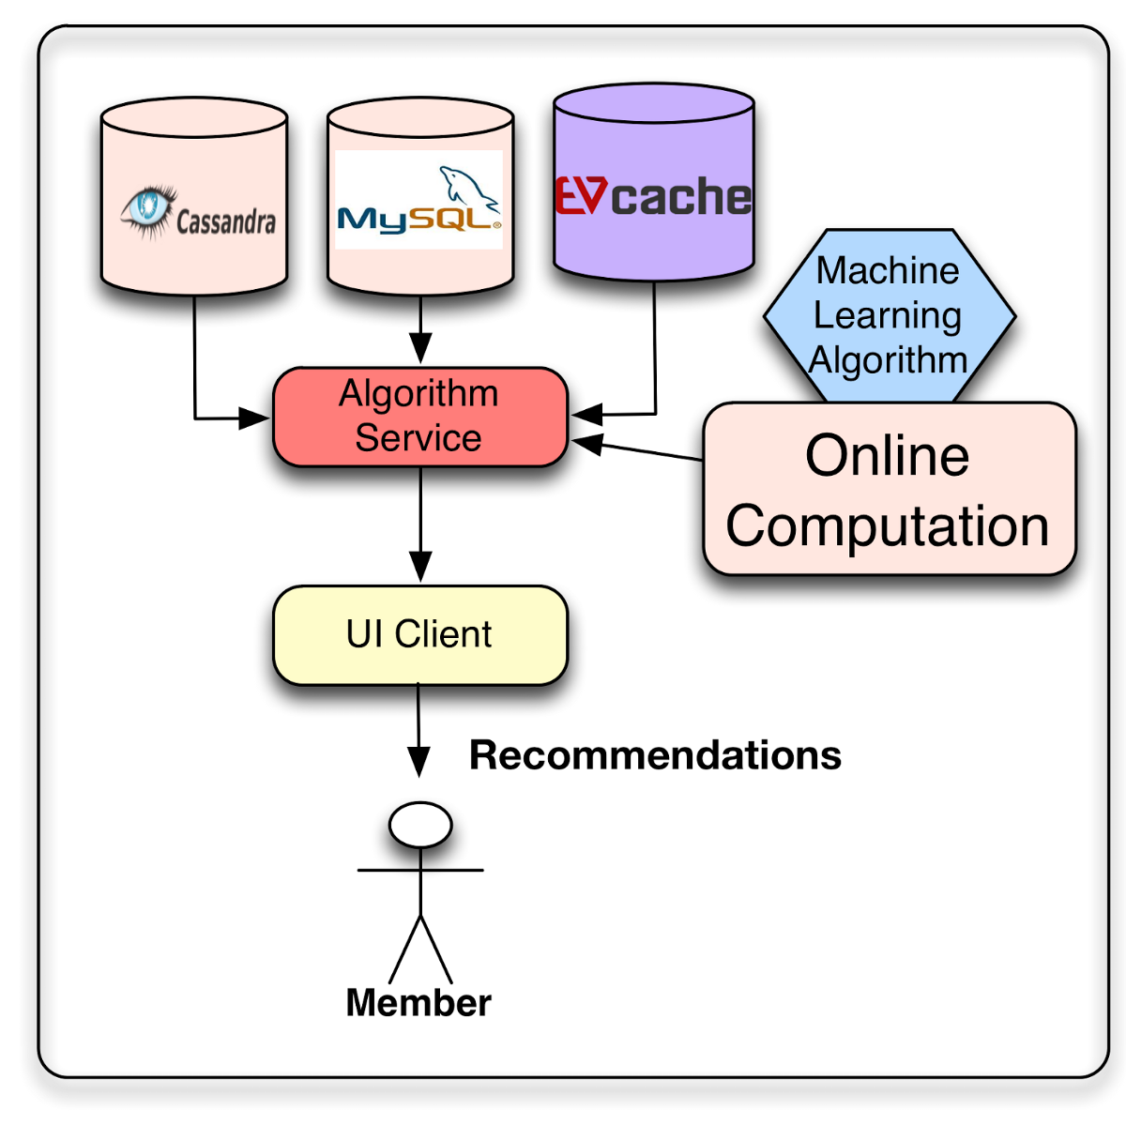

**Work-Flow**

