# eCommerce Fashion Brand

## Overview

This README provides an overview of the roles within our eCommerce fashion brand, along with their respective departments, objectives and key performance indicators (KPIs).

I have created Power BI Dashboard and Performance scorecard for each department.The pbix and excel files are uploaded.

## Roles and Responsibilities

### Chief Executive Officer (CEO)

- **Department:** Executive

- **OKRs:**

1. Increase Revenue

2. Reduce Costs

3. Increase Profits

- **KPIs:**

1. Overall revenue growth

2. Market share

3. Employee engagement

4. Customer satisfaction

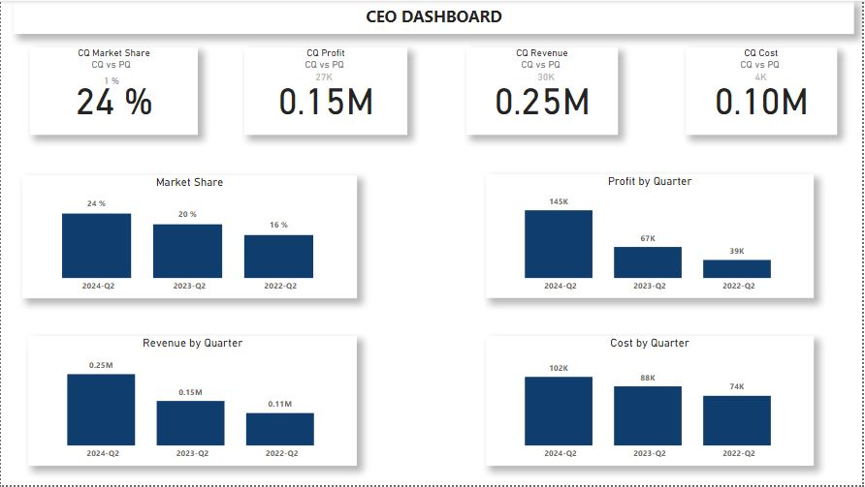

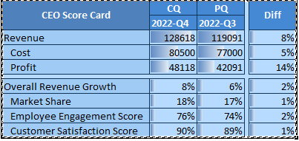

### Chief Operating Officer (COO)

- **Department:** Operations

- **OKRs:**

1. Improve operational efficiency by 20% through process optimization and automation.

2. Achieve a 95% on-time delivery rate for all orders.

- **KPIs:**

1. Order fulfillment time

2. Cost of goods sold (COGS)

3. Inventory turnover rate

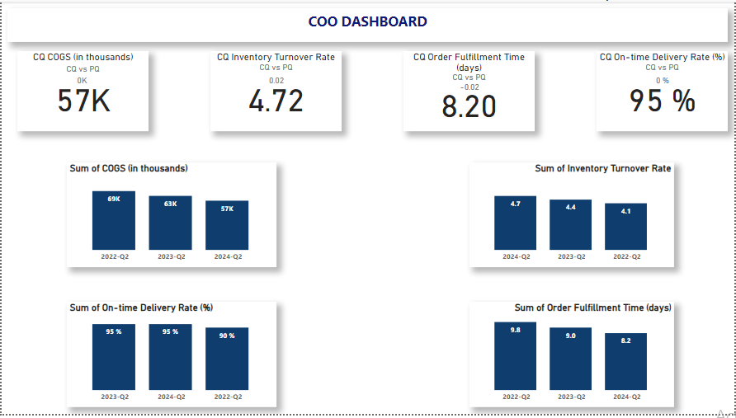

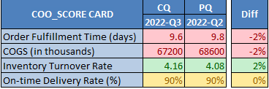

### Chief Financial Officer (CFO)

- **Department:** Finance

- **OKRs:**

1. Increase net profit margin by 10% by reducing operational costs and optimizing pricing strategies.

2. Secure funding to support expansion efforts, targeting a 30% increase in capital.

- **KPIs:**

1. Net profit margin

2. Return on Investment (ROI)

3. Cash flow management

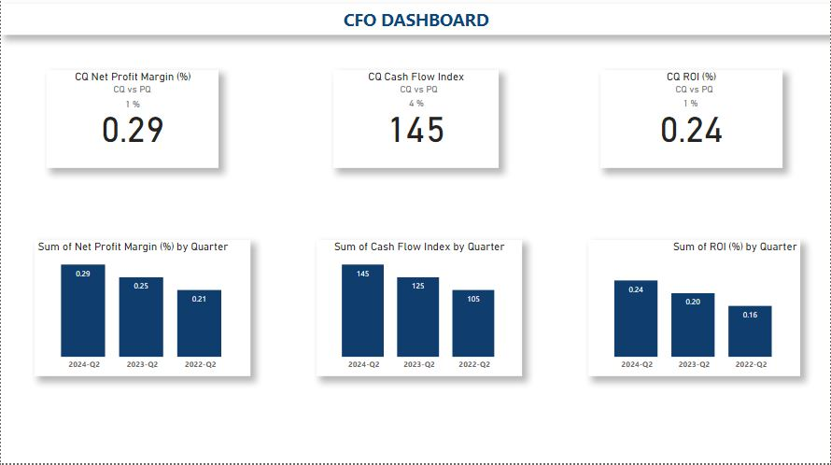

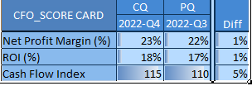

### Chief Marketing Officer (CMO)

- **Department:** Marketing

- **OKRs:**

1. Grow online traffic by 40% through SEO, content marketing, and social media engagement.

2. Increase customer acquisition by 30% while reducing acquisition costs by 15%.

- **KPIs:**

1. Customer Acquisition Cost (CAC)

2. Return on Advertising Spend (ROAS)

3. Social media engagement rates

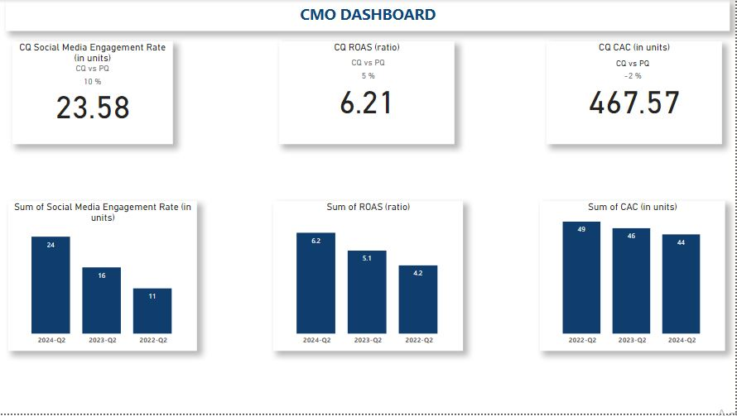

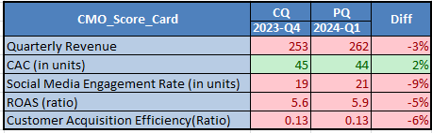

### Chief Technology Officer (CTO)

- **Department:** Technology

- **OKRs:**

1. Launch a mobile app with a 4.5+ rating on app stores within 6 months to enhance shopping experience.

2. Implement AI-driven personalization to increase average order value by 20%.

- **KPIs:**

1. App download and active user rates

2. Website uptime and speed

3. Technology stack ROI

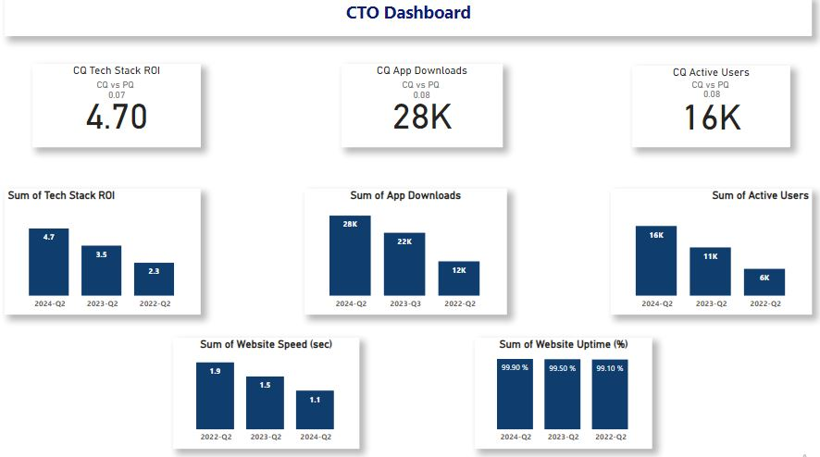

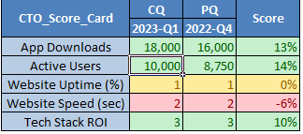

### Chief Sales Officer (CSO)

- **Department:** Sales

- **OKRs:**

1. Achieve a 25% year-over-year sales growth.

2. Expand into 2 new markets or demographics within the next fiscal year.

- **KPIs:**

1. Sales growth rate

2. Market penetration rate

3. Customer lifetime value (CLTV)

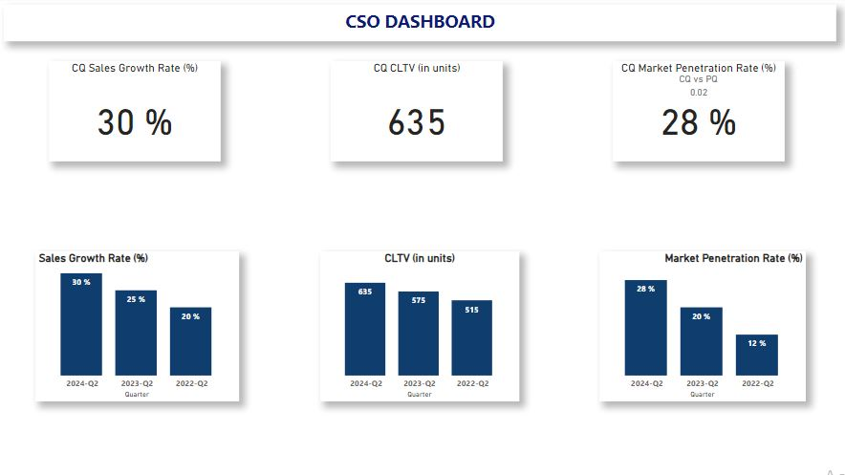

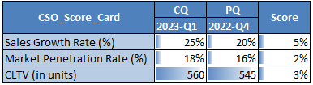

### Chief Product Officer (CPO)

- **Department:** Product Management

- **OKRs:**

1. Launch 5 new product lines with a 30% gross margin within the next year.

2. Increase product return rate to less than 2% through quality enhancement.

- **KPIs:**

1. Product development cycle time

2. Gross margin per product line

3. Product return rate

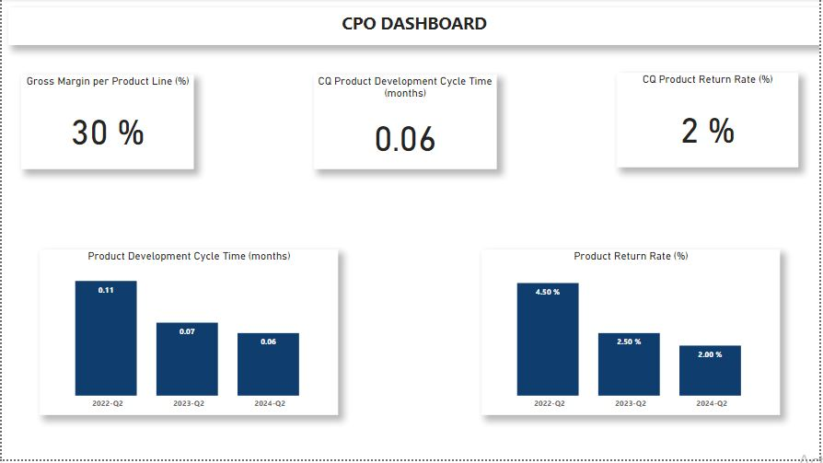

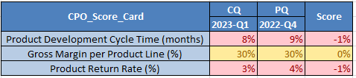

### Chief Customer Officer (CCO)

- **Department:** Customer Experience

- **OKRs:**

1. Achieve a customer satisfaction score (CSAT) of 90%.

2. Reduce average response time to customer inquiries to under 2 hours.

- **KPIs:**

1. Net Promoter Score (NPS)

2. Customer satisfaction score (CSAT)

3. Customer support response time

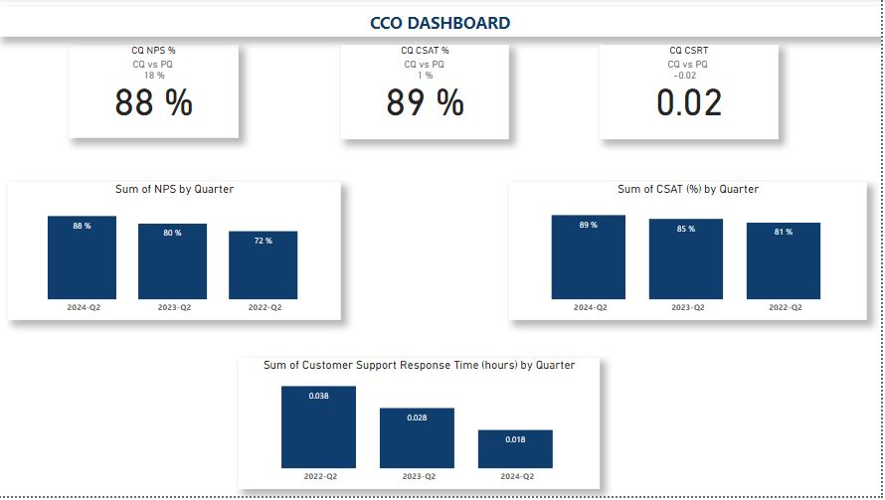

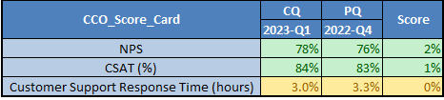

### Chief People Officer (CPO)

- **Department:** Human Resources

- **OKRs:**

1. Increase employee retention rates by 15% through improved engagement and development programs.

2. Fill critical positions within 30 days to ensure operational efficiency.

- **KPIs:**

1. Employee turnover rate

2. Time to fill positions

3. Employee satisfaction index

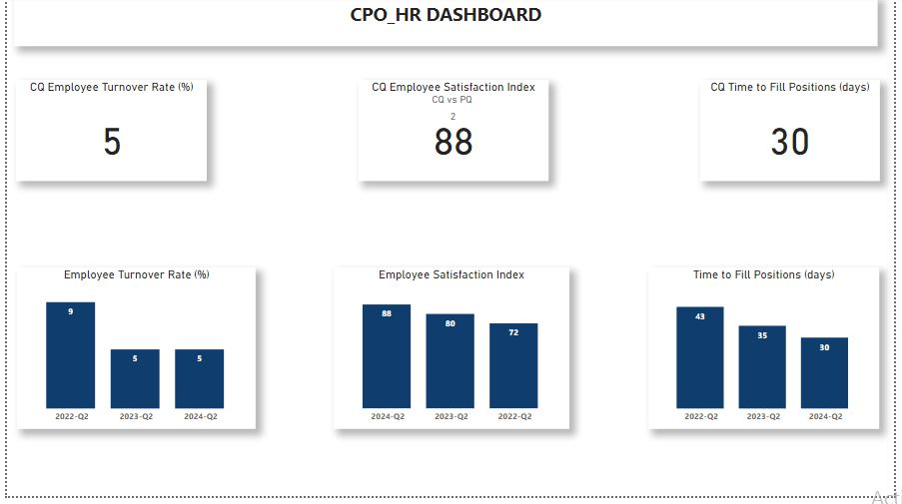

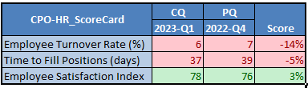

### Chief Sustainability Officer (CSO)

- **Department:** Sustainability

- **OKRs:**

1. Reduce carbon footprint by 20% within the next two years through sustainable practices.

2. Achieve 100% sustainable sourcing for all key materials within 5 years.

- **KPIs:**

1. Carbon footprint reduction

2. Percentage of sustainable materials used

3. Sustainability index score

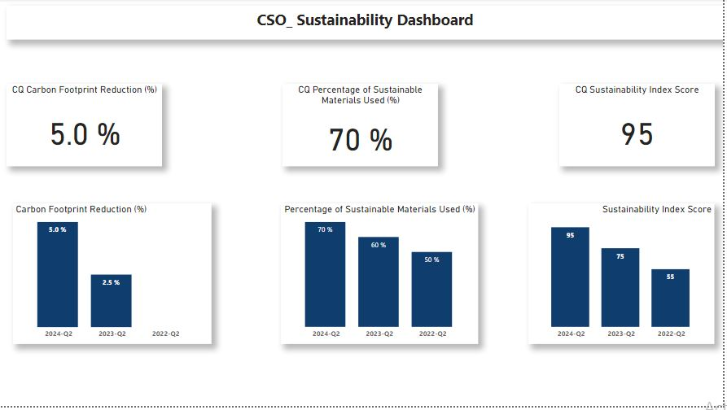

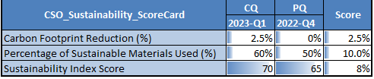

### Chief Data Officer (CDO)

- **Department:** Data Analytics

- **OKRs:**

1. Develop a predictive analytics model to forecast sales trends with 90% accuracy.

2. Implement data governance policies to ensure 100% compliance with data protection regulations.

- **KPIs:**

1. Accuracy of sales forecasts

2. Data quality score

3. Compliance rate with data protection laws

