Advanced SQL Handson

**Superset id- 6363535**

**SQL Exercise - Advanced concepts**

**Exercise 1: Ranking and Window Functions**

**Query:**

DROP TABLE IF EXISTS Products;

CREATE TABLE Products (

ProductID INT PRIMARY KEY,

ProductName VARCHAR(100),

Category VARCHAR(50),

Price DECIMAL(10, 2)

);

INSERT INTO Products VALUES

(1, 'Laptop Lenovo', 'Electronics', 950.00),

(2, 'Laptop MacBook', 'Electronics', 1250.00),

(3, 'Phone IPhone', 'Electronics', 1250.00),

(4, 'Tablet Samsung', 'Electronics', 650.00),

(5, 'Sofa Set', 'Furniture', 750.00),

(6, 'Dining Table', 'Furniture', 950.00),

(7, 'Chair', 'Furniture', 950.00),

(8, 'Bookshelf', 'Furniture', 550.00),

(9, 'T-Shirt', 'Clothing', 25.00),

(10, 'Jacket', 'Clothing', 95.00),

(11, 'Jeans', 'Clothing', 95.00),

(12, 'Shoes', 'Clothing', 60.00);

SELECT *

FROM (

SELECT *,

ROW_NUMBER() OVER (PARTITION BY Category ORDER BY Price DESC) AS RowNum

FROM Products

) AS Ranked

WHERE RowNum <= 3

ORDER BY Category, RowNum;

SELECT *

FROM (

SELECT *,

RANK() OVER (PARTITION BY Category ORDER BY Price DESC) AS RankVal

FROM Products

) AS Ranked

WHERE RankVal <= 3

ORDER BY Category, RankVal;

SELECT *

FROM (

SELECT *,

DENSE_RANK() OVER (PARTITION BY Category ORDER BY Price DESC) AS DenseRankVal

FROM Products

) AS Ranked

WHERE DenseRankVal <= 3

ORDER BY Category, DenseRankVal;

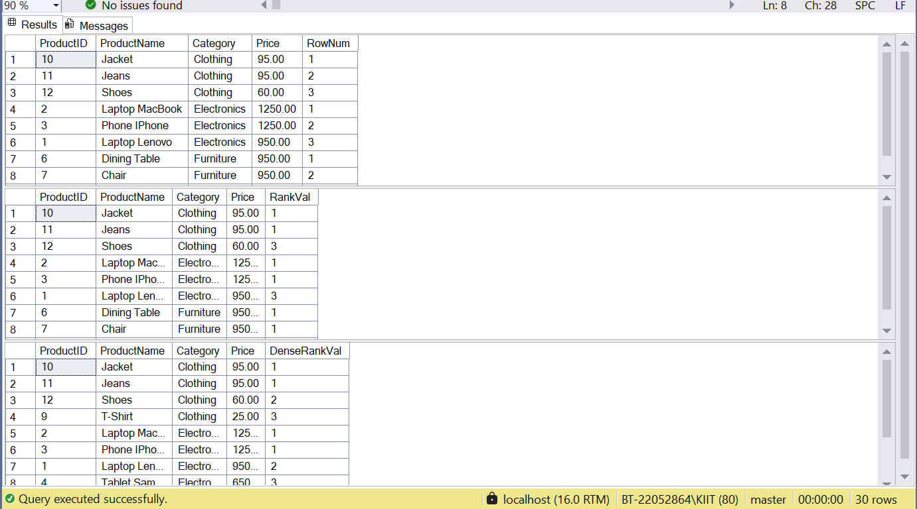

**SQL Exercise - Stored procedure**

**Exercise 1: Create a Stored Procedure**

Goal: Create a stored procedure to retrieve employee details by department.

**Query:**

IF OBJECT_ID('sp_GetEmployeesByDepartment', 'P') IS NOT NULL

DROP PROCEDURE sp_GetEmployeesByDepartment;

GO

CREATE PROCEDURE sp_GetEmployeesByDepartment

@DepartmentID INT

AS

BEGIN

SELECT

E.EmployeeID,

E.FirstName,

E.LastName,

D.DepartmentName,

E.Salary,

E.JoinDate

FROM

Employees E

INNER JOIN

Departments D ON E.DepartmentID = D.DepartmentID

WHERE

E.DepartmentID = @DepartmentID;

END;

GO

IF OBJECT_ID('sp_InsertEmployee', 'P') IS NOT NULL

DROP PROCEDURE sp_InsertEmployee;

GO

CREATE PROCEDURE sp_InsertEmployee

@FirstName VARCHAR(50),

@LastName VARCHAR(50),

@DepartmentID INT,

@Salary DECIMAL(10,2),

@JoinDate DATE

AS

BEGIN

INSERT INTO Employees (FirstName, LastName, DepartmentID, Salary, JoinDate)

VALUES (@FirstName, @LastName, @DepartmentID, @Salary, @JoinDate);

END;

GO

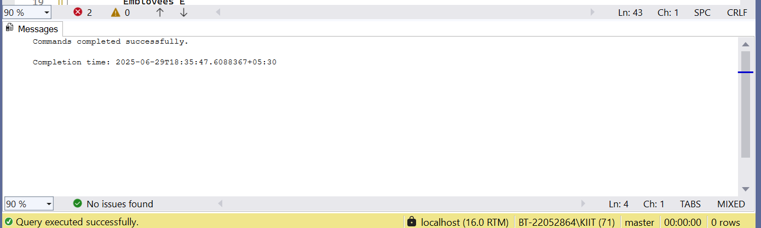

**Exercise 5: Return Data from a Stored Procedure**

**Query:**

IF OBJECT_ID('sp_CountEmployeesByDepartment', 'P') IS NOT NULL

DROP PROCEDURE sp_CountEmployeesByDepartment;

GO

CREATE PROCEDURE sp_CountEmployeesByDepartment

@DepartmentID INT

AS

BEGIN

SELECT

COUNT(*) AS TotalEmployees

FROM

Employees

WHERE

DepartmentID = @DepartmentID;

END;

GO

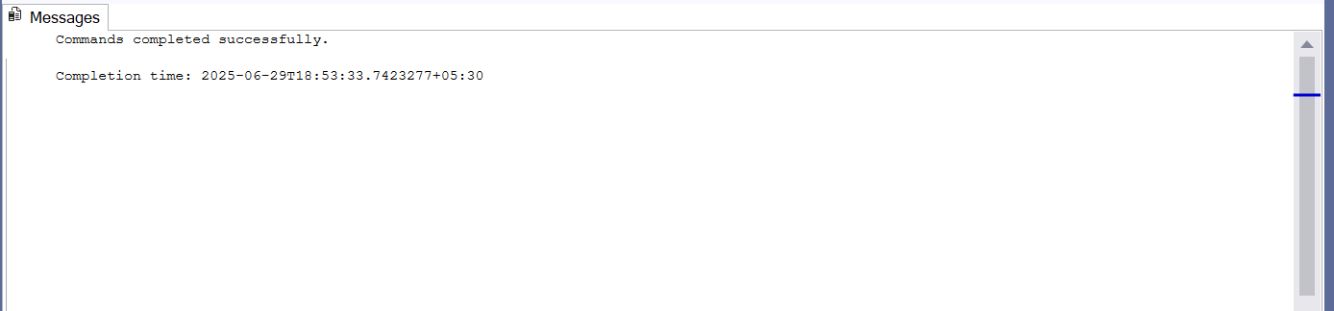

**Query:**

EXEC sp_GetEmployeesByDepartment @DepartmentID = 3;

