**Week 6: React Handsons**

Superset id: 6363535

**Handson 1**

Create a new React Application with the name “myfirstreact”, Run the application to print “welcome to the first session of React” as heading of that page.

[**App.js**](http://app.js)

import React from 'react';

function App() {

return (

<div>

<h1>Welcome to the first session of React</h1>

</div>

);

}

export default App;

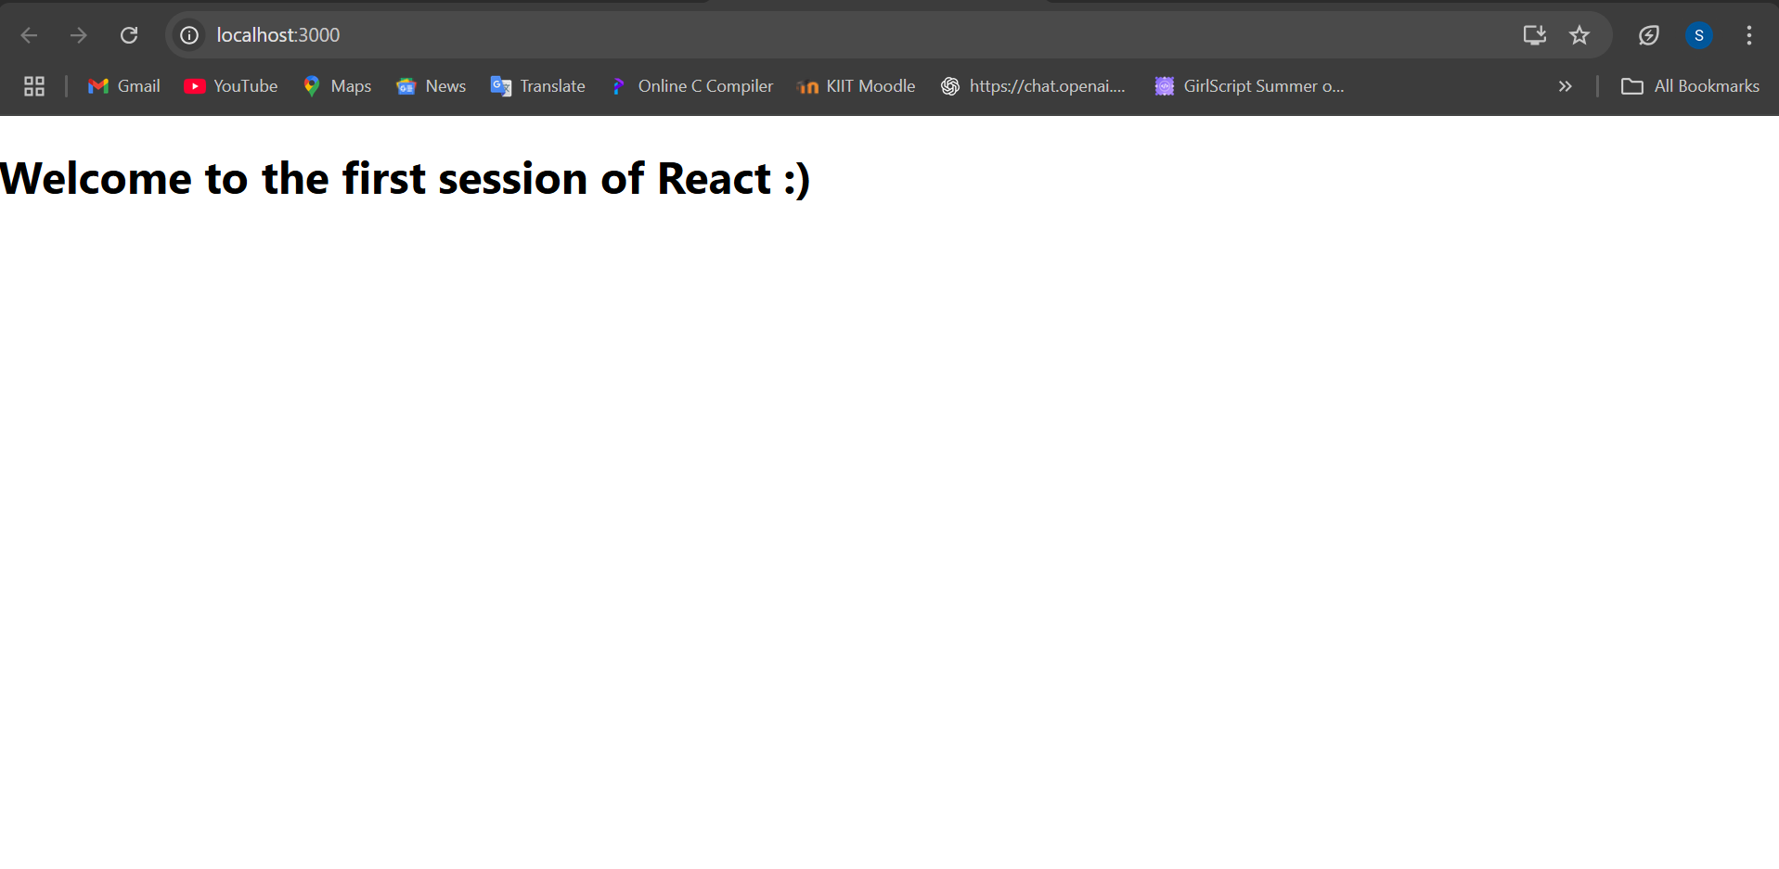

**Handson 2**

Create a react app for Student Management Portal named StudentApp and create a component named Home which will display the Message “Welcome to the Home page of Student Management Portal”. Create another component named About and display the Message “Welcome to the About page of the Student Management Portal”. Create a third component named Contact and display the Message “Welcome to the Contact page of the Student Management Portal”. Call all the three components.

[**Home.js**](http://home.js)

import React, { Component } from 'react';

class Home extends Component {

render() {

return (

<div>

<h2>Welcome to the Home page of Student Management Portal</h2>

</div>

);

}

}

export default Home;

[**About.js**](http://about.js)

import React, { Component } from 'react';

class About extends Component {

render() {

return (

<div>

<h2>Welcome to the About page of the Student Management Portal</h2>

</div>

);

}

}

export default About;

[**Contact.js**](http://contact.js)

import React, { Component } from 'react';

class Contact extends Component {

render() {

return (

<div>

<h2>Welcome to the Contact page of the Student Management Portal</h2>

</div>

);

}

}

export default Contact;

[**App.js**](http://app.js)

import React from 'react';

import Home from './Components/Home';

import About from './Components/About';

import Contact from './Components/Contact';

function App() {

return (

<div className="App">

<Home />

<About />

<Contact />

</div>

);

}

export default App;

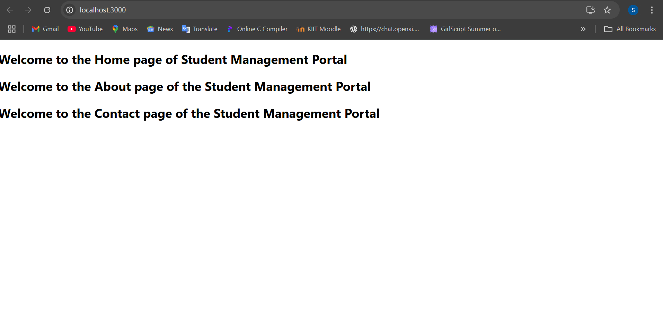

**Handson 3**

Create a react app for Student Management Portal named scorecalculatorapp and create a function component named “CalculateScore” which will accept Name, School, Total and goal in order to calculate the average score of a student and display the same.

[**CalculateScore.js**](http://calculatescore.js)

import React from 'react';

import '../Stylesheets/mystyle.css';

function CalculateScore(props) {

const average = props.total / props.goal;

return (

<div className="score-card">

<h2>Student Score Details</h2>

<p><strong>Name:</strong> {props.name}</p>

<p><strong>School:</strong> {props.school}</p>

<p><strong>Total Marks:</strong> {props.total}</p>

<p><strong>Goal:</strong> {props.goal}</p>

<p><strong>Average Score:</strong> {average}</p>

</div>

);

}

export default CalculateScore;

**mystyle.css**

.score-card {

background-color: #f0f8ff;

border: 1px solid #ccc;

padding: 20px;

margin: 30px auto;

width: 400px;

font-family: Arial, sans-serif;

box-shadow: 2px 2px 12px #aaa;

}

[**App.js**](http://app.js)

import React from 'react';

import CalculateScore from './Components/CalculateScore';

function App() {

return (

<div className="App">

<CalculateScore

name="Sweta Singh"

school="Kendriya Vidyalaya"

total={450}

goal={5}

/>

</div>

);

}

export default App;

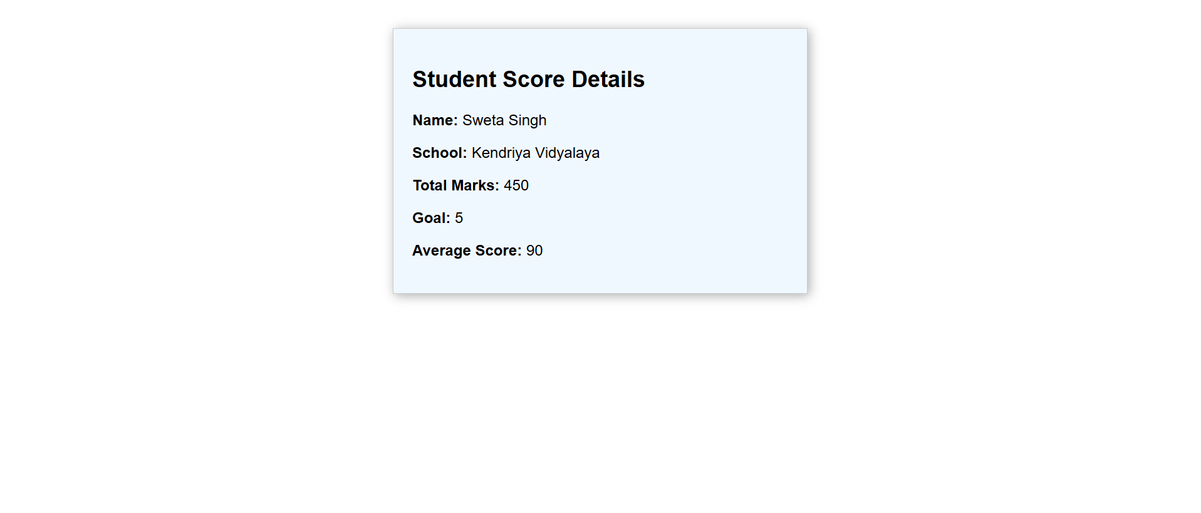

**Handson 4**

[**Post.js**](http://post.js)

import React, { Component } from 'react';

class Post extends Component {

render() {

const { title, body } = this.props;

return (

<div>

<h3>{title}</h3>

<p>{body}</p>

</div>

);

}

}

export default Post;

[**Posts.js**](http://posts.js)

import React, { Component } from 'react';

import Post from './Post';

class Posts extends Component {

constructor(props) {

super(props);

this.state = {

posts: [],

hasError: false

};

}

componentDidMount() {

this.loadPosts();

}

loadPosts() {

fetch('https://jsonplaceholder.typicode.com/posts')

.then((response) => response.json())

.then((data) => this.setState({ posts: data }))

.catch((error) => {

console.error("Error fetching posts:", error);

this.setState({ hasError: true });

});

}

componentDidCatch(error, info) {

alert("An error occurred in the Posts component.");

console.error("Caught error:", error, info);

}

render() {

if (this.state.hasError) {

return <h2>Error loading posts.</h2>;

}

return (

<div>

<h1>Blog Posts</h1>

{this.state.posts.slice(0, 10).map((post) => (

<Post key={post.id} title={post.title} body={post.body} />

))}

</div>

);

}

}

export default Posts;

[**App.js**](http://app.js)

import React from 'react';

import Posts from './Posts';

function App() {

return (

<div className="App">

<Posts />

</div>

);

}

export default App;

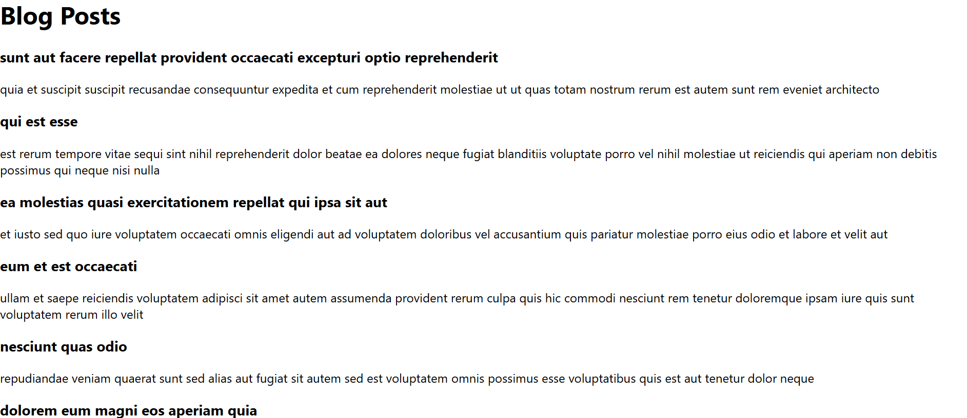

**Handson 5**

My Academy team at Cognizant want to create a dashboard containing the details of ongoing and completed cohorts. A react application is created which displays the detail of the cohorts using react component. You are assigned the task of styling these react components.

**CohortDetails.module.css**

.box {

width: 300px;

display: inline-block;

margin: 10px;

padding: 10px 20px;

border: 1px solid black;

border-radius: 10px;

}

dt {

font-weight: 500;

}

[**CohortDetails.js**](http://cohortdetails.js)

import React from 'react';

import styles from './CohortDetails.module.css';

function CohortDetails(props) {

const { cohort } = props;

const headingColor = cohort.currentStatus === 'ongoing' ? 'green' : 'blue';

return (

<div className={styles.box}>

<h3 style={{ color: headingColor }}>

{cohort.cohortCode} - <span>{cohort.technology}</span>

</h3>

<dl>

<dt>Started On</dt>

<dd>{cohort.startDate}</dd>

<dt>Current Status</dt>

<dd>{cohort.currentStatus}</dd>

<dt>Coach</dt>

<dd>{cohort.coachName}</dd>

<dt>Trainer</dt>

<dd>{cohort.trainerName}</dd>

</dl>

</div>

);

}

export default CohortDetails;

[**App.js**](http://app.js)

import React from 'react';

import CohortDetails from './CohortDetails';

function App() {

const cohort1 = {

cohortCode: 'DN-FSD-101',

technology: 'React',

startDate: '2025-07-01',

currentStatus: 'ongoing',

coachName: 'John Doe',

trainerName: 'Jane Smith'

};

const cohort2 = {

cohortCode: 'DN-FSD-102',

technology: 'Node.js',

startDate: '2025-05-15',

currentStatus: 'completed',

coachName: 'Alex Lee',

trainerName: 'Emma Davis'

};

return (

<div>

<CohortDetails cohort={cohort1} />

<CohortDetails cohort={cohort2} />

</div>

);

}

export default App;

