**Summary (**Best Scores for Sand, Silt, Clay, TOC, and CaCO3**)**

**Israel (Legacy Data)**

For:**Sand**-> [**'iqrp',** **3.12**, 'Spec:', 'none', 'bands:', 35, 'Tar:', 'none'] :**cubist**

For:Sand-> [**'r2', 0.7**, 'Spec:', 'none', 'bands:', 35, 'Tar:', 'none'] :cubist

For:**Silt**-> [**'iqrp', 1.89**, 'Spec:', 'fod', 'bands:', 25, 'Tar:', 'minmax'] :**plsr**

For:Silt-> [**'r2', 0.41,** 'Spec:', 'fod', 'bands:', 25, 'Tar:', 'minmax'] :plsr

For:**Clay**-> [**'iqrp', 3.21**, 'Spec:', 'none', 'bands:', 15, 'Tar:', 'minmax'] :**mult**

For:Clay-> [**'r2', 0.8**, 'Spec:', 'none', 'bands:', 15, 'Tar:', 'minmax'] :mult

For:**TOC**-> [**'iqrp', 2.97**, 'Spec:', 'continuum', 'bands:', 60, 'Tar:', 'none'] :**cubist**

For:TOC-> [**'r2', 0.83**, 'Spec:', 'continuum', 'bands:', 60, 'Tar:', 'none'] :cubist

For:**CaCO3**-> [**'iqrp', 2.17,** 'Spec:', 'none', 'bands:', 5, 'Tar:', 'none'] :**plsr**

For:CaCO3-> [**'r2', 0.54**, 'Spec:', 'none', 'bands:', 5, 'Tar:', 'none'] :plsr

Plots follows in upcoming pages (corresponding to the best scores):

For:**Sand**-> [**'iqrp',** **3.12**, 'Spec:', 'none', 'bands:', 35, 'Tar:', 'none'] :**cubist**

For:Sand-> [**'r2', 0.7**, 'Spec:', 'none', 'bands:', 35, 'Tar:', 'none'] :cubist

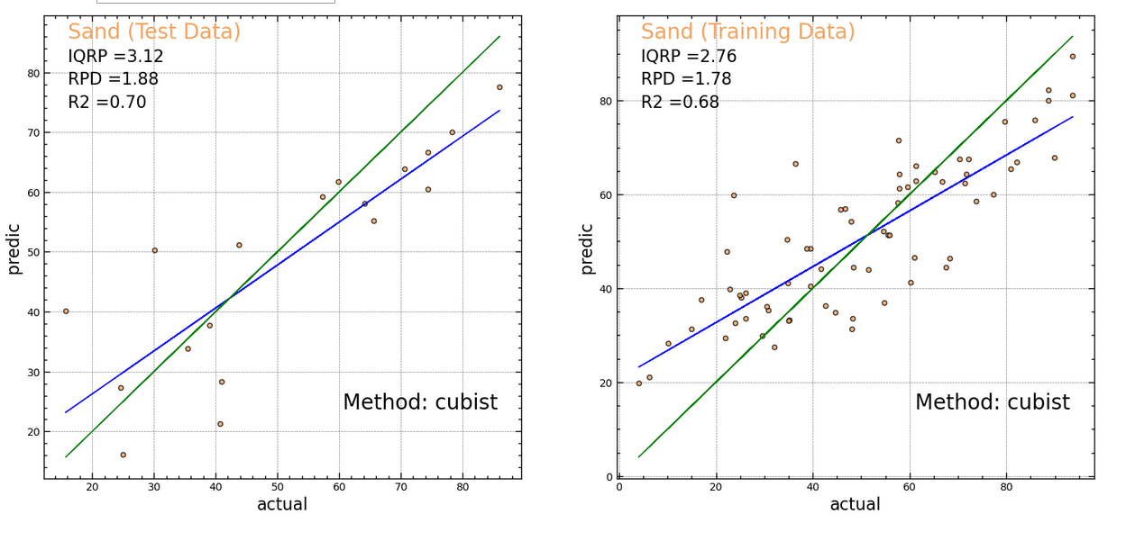

For:**Silt**-> [**'iqrp', 1.89**, 'Spec:', 'fod', 'bands:', 25, 'Tar:', 'minmax'] :**plsr**

For:Silt-> [**'r2', 0.41,** 'Spec:', 'fod', 'bands:', 25, 'Tar:', 'minmax'] :plsr

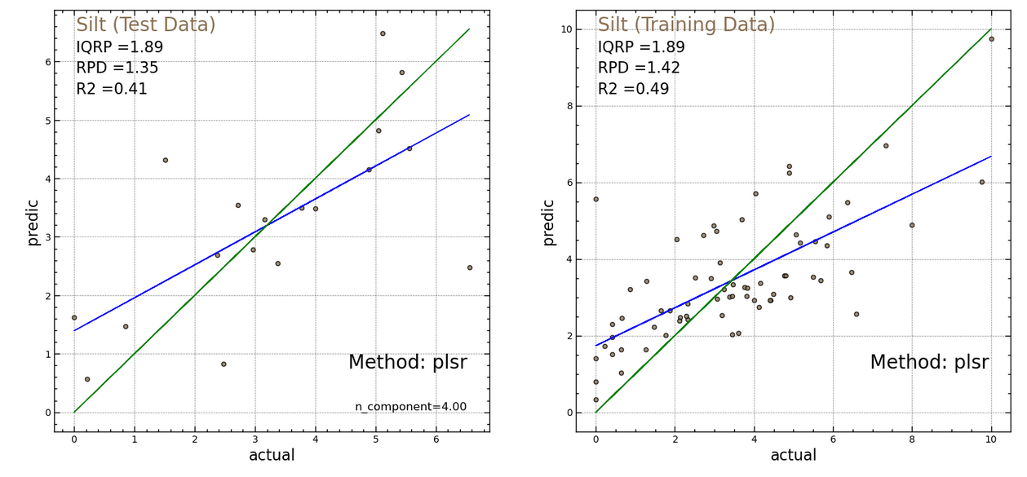

For:**Clay**-> [**'iqrp', 3.21**, 'Spec:', 'none', 'bands:', 15, 'Tar:', 'minmax'] :**mult**

For:Clay-> [**'r2', 0.8**, 'Spec:', 'none', 'bands:', 15, 'Tar:', 'minmax'] :mult

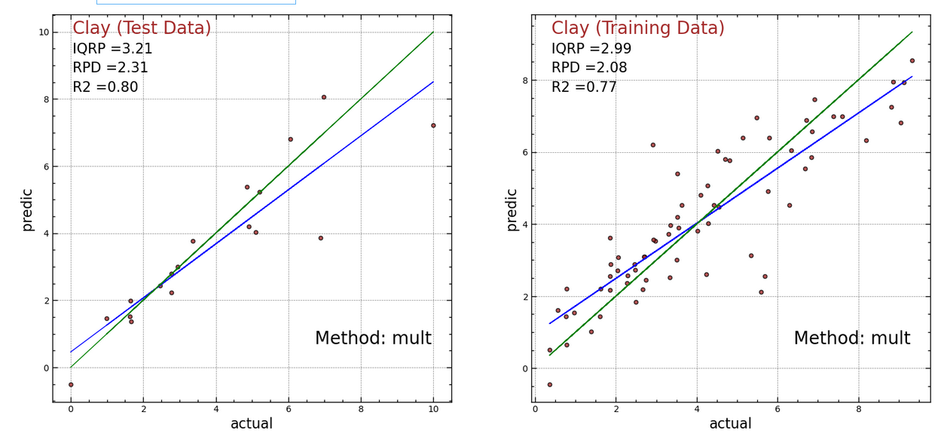

For:**TOC**-> [**'iqrp', 2.97**, 'Spec:', 'continuum', 'bands:', 60, 'Tar:', 'none'] :**cubist**

For:TOC-> [**'r2', 0.83**, 'Spec:', 'continuum', 'bands:', 60, 'Tar:', 'none'] :cubist

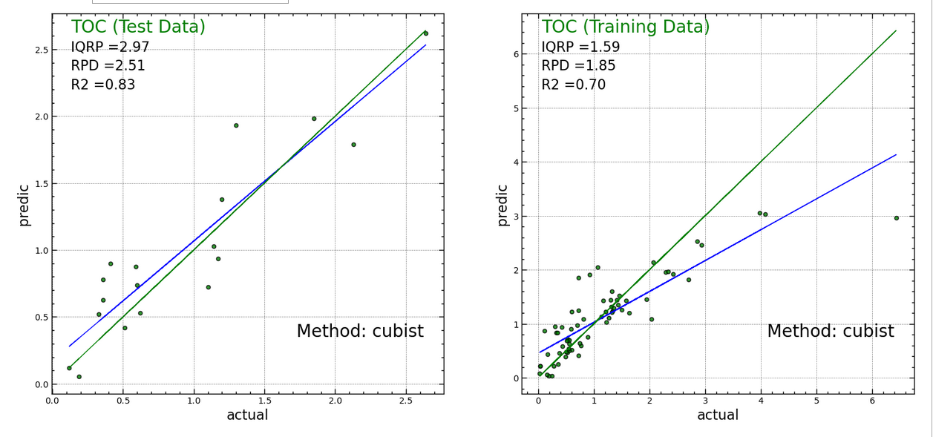

For:**CaCO3**-> [**'iqrp', 2.17,** 'Spec:', 'none', 'bands:', 5, 'Tar:', 'none'] :**plsr**

For:CaCO3-> [**'r2', 0.54**, 'Spec:', 'none', 'bands:', 5, 'Tar:', 'none'] :plsr

