Machine Learning and Applied AI Internship at BharatCares – IBM SkillsBuild
Summer Internship Report
PROJECT SUBMITTED FOR THE AWARD OF THE DEGREE OF
MASTER OF COMPUTER APPLICATION
TO THE
AMITY UNIVERSITY, MAHARASHTRA, INDIA


BY
Mr. Swetam Singh
(Enrollment No: A710145025038)

Under the Guidance of
Dr. C Kalpana
Assistant Professor

AMITY INSTITUTE OF INFORMATION TECHNOLOGY
AMITY UNIVERSITY, MAHARASHTRA, INDIA
OCTOBER 2026
TABLE OF CONTENTS
Sr. No. |  | Title | Page No.
 |  | Declaration And Certificate | i
 |  | Internship Joining Letter | ii
 |  | Internship Completion Certificate | v
 |  | Acknowledgement | vi
 |  | List of Acronyms and Abbreviations | vii
 |  | List of Figures | viii
 |  | Abstract | ix
1 |  | Introduction | 1
 | 1.1 | About the Organisations | 1
 | 1.2 | About the Role | 1
 | 1.3 | About the Work | 2
 | 1.4 | Objectives of the Internship | 3
2 |  | Technology Details | 4
 | 2.1 | IBM SkillsBuild | 4
 | 2.2 | VS Code and IBM BOB | 4
 | 2.3 | Teachable Machine | 4
 | 2.4 | IBM watsonx / Watson Studio | 5
 | 2.5 | Supervised Learning Techniques | 5
 | 2.6 | Unsupervised, Deep and Reinforcement Learning | 5
3 |  | Project Work Details | 6
 | 3.1 | Programme Structure and Learning Activities | 6
 | 3.2 | Learning Workflow | 6
 | 3.3 | Internship Timeline | 8
 | 3.4 | System Architecture and Dataset | 10
 | 3.5 | Machine Learning Model | 10
 | 3.6 | Backend API and Web Client | 11
 | 3.7 | Emissions Estimation | 11
 | 3.8 | Setup, Execution and Testing | 12
 | 3.9 | Limitations and Responsible Use | 12
4 |  | Screenshot of Work | 13
5 |  | Conclusions and Future Work | 15
 | 5.1 | Conclusion | 15
 | 5.2 | Learning Outcomes and Skillsets Developed | 15
 | 5.3 | Future Work | 16
 | 5.4 | Challenges Faced | 17
 | 5.5 | Final Project Overview and Problem Statement | 18
 |  | References | 19
 |  | Appendix | 20

DECLARATION AND CERTIFICATE
This is to certify that this Summer Internship / project report entitled: “Machine Learning and Applied AI Internship at BharatCares – IBM SkillsBuild” submitted by Mr. Swetam Singh in partial fulfillment of the requirement of the degree of Master of Computer Application in the Amity Institute of Information Technology, Amity University Maharashtra, is based on the project and research work carried under the guidance and supervision of Dr. C Kalpana. This report and any part thereof had not been submitted for any purpose to any University or Institute.
Place: Mumbai | Mr. Swetam Singh
Date: / / 2026 | Student

Guide Name:

Guide Signature:

Prof. (Dr.) Manoj Devare
Professor & HOI-AIIT
Director, Accreditation and Ranking-AUM

Internship Joining Letter
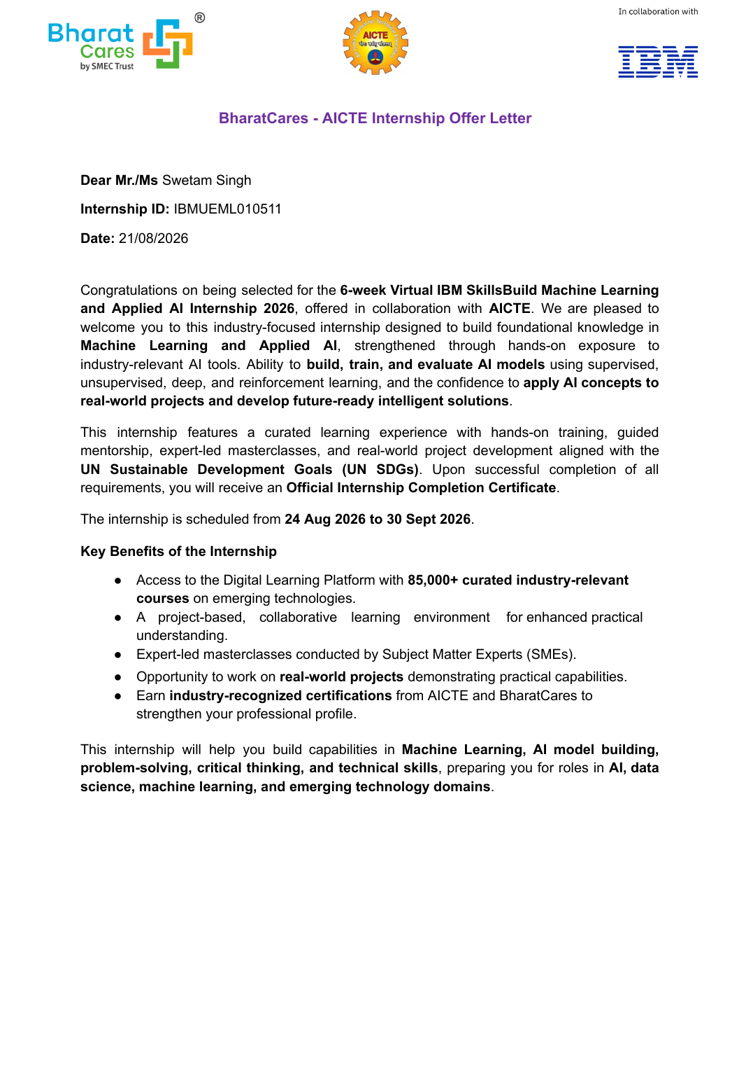
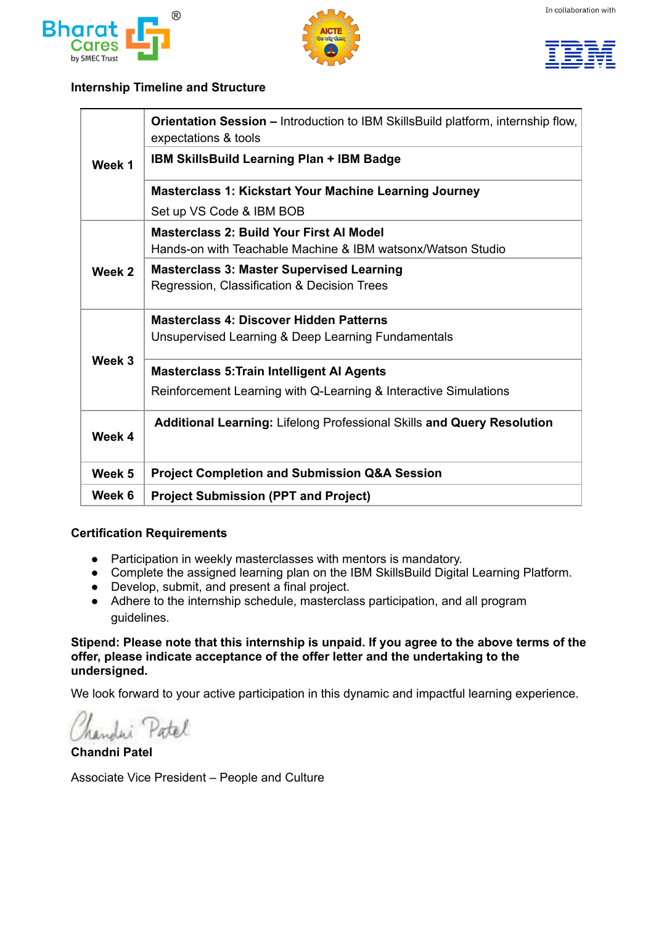

Internship Completion Certificate
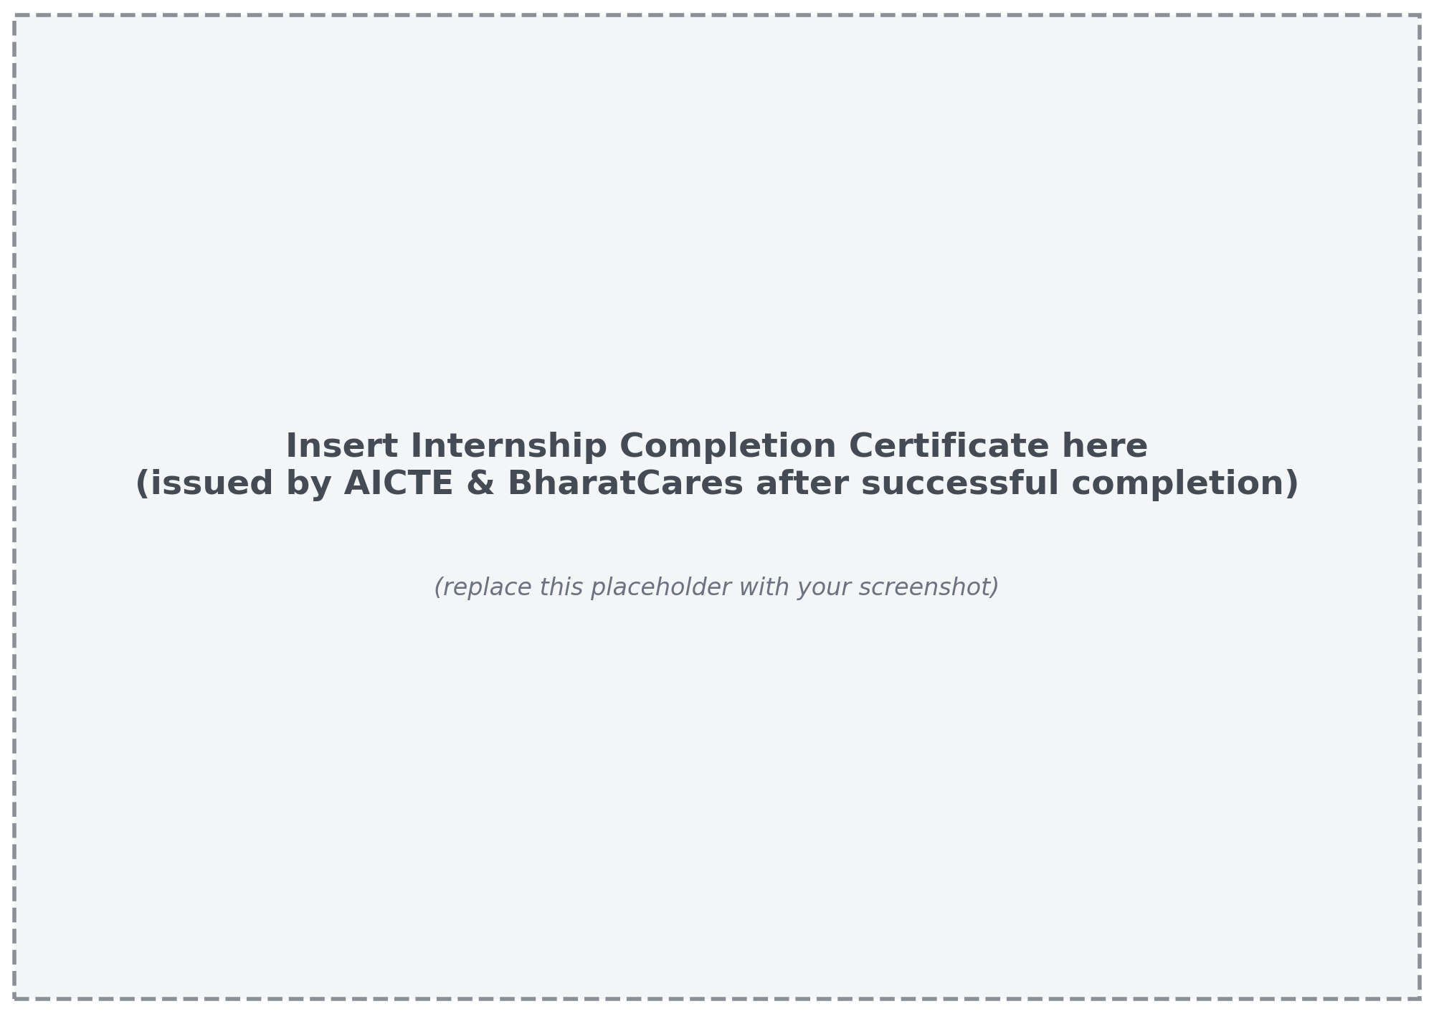

ACKNOWLEDGEMENT

I would like to formally acknowledge the support and guidance received throughout my internship as a Machine Learning and Applied AI Intern under the AICTE–BharatCares–IBM SkillsBuild Internship Program. This virtual internship gave me valuable hands-on exposure to machine learning and applied artificial intelligence, and I am sincerely grateful to everyone who made this experience productive and rewarding.

I would like to express my gratitude to Assistant Professor Dr. C Kalpana and HOI Dr. Manoj H Devare for their mentorship and guidance, which helped me stay focused and disciplined throughout this internship, and for their continuous encouragement and feedback on my technical growth.

I am also thankful to AICTE, BharatCares (by SMEC Trust), and IBM SkillsBuild for organising the internship, and to the mentors and subject matter experts who conducted the masterclasses and guided the learning plan. I especially thank Ms. Chandni Patel, Associate Vice President – People and Culture, BharatCares, for the opportunity extended through the internship offer.
I am confident that the knowledge, skills, and discipline I gained during this internship will greatly contribute to my future career in artificial intelligence, machine learning, and data science.

LIST OF ACRONYMS AND ABBREVIATIONS
Acronym | Full Form
AI | Artificial Intelligence
ML | Machine Learning
DL | Deep Learning
RL | Reinforcement Learning
AICTE | All India Council for Technical Education
IBM | International Business Machines
SDG | Sustainable Development Goal
UN | United Nations
SME | Subject Matter Expert
VS Code | Visual Studio Code
PPT | PowerPoint Presentation
Q&A | Question and Answer
API | Application Programming Interface
CORS | Cross-Origin Resource Sharing
CSV | Comma-Separated Values
HTTP | Hypertext Transfer Protocol
JSON | JavaScript Object Notation
CO₂ | Carbon Dioxide

LIST OF FIGURES
Figure | Page No.
Figure 3.1: Gantt chart of the internship timeline | 8
Figure 3.2: Architecture of the traffic speed prediction system | 10
Figure 4.1: IBM SkillsBuild learning plan and badge | 13
Figure 4.2: Teachable Machine model | 13
Figure 4.3: IBM watsonx / Watson Studio workspace | 14
Figure 4.4: Final project output | 14

ABSTRACT

This report provides an overview of my internship experience as a Machine Learning and Applied AI Intern in the 6-week Virtual IBM SkillsBuild Machine Learning and Applied AI Internship 2026, offered by BharatCares (by SMEC Trust) in collaboration with AICTE and IBM. The internship ran from 24th August 2026 to 30th September 2026 and was designed to build foundational knowledge in machine learning and applied AI through hands-on training, guided mentorship, expert-led masterclasses, and real-world project development aligned with the UN Sustainable Development Goals.

The programme progressed from an orientation to the IBM SkillsBuild platform and the setup of VS Code and IBM BOB, through building a first AI model with Teachable Machine and IBM watsonx/Watson Studio, to supervised learning (regression, classification and decision trees), unsupervised learning and deep learning fundamentals, and reinforcement learning with Q-Learning. The final weeks were devoted to additional learning in lifelong professional skills, project completion, and the submission of a final project and presentation.

This internship has been instrumental in strengthening my technical foundations and professional abilities, providing structured, industry-oriented exposure that has prepared me for roles in AI, data science, machine learning, and emerging technology domains. Participation in the weekly masterclasses, completion of the assigned learning plan, and the submission of the final project were the key requirements for the Official Internship Completion Certificate.

Chapter 1 Introduction

1.1 About the Organisations
BharatCares (by SMEC Trust) is the organisation through which the Machine Learning and Applied AI Internship 2026 was offered. The internship was run as the AICTE–BharatCares–IBM SkillsBuild Internship Program, in collaboration with the All India Council for Technical Education (AICTE) and IBM. Its purpose is to connect students with industry-relevant learning, mentorship, and project experience in emerging technologies, so that they build skills that complement their formal academic curriculum.

IBM SkillsBuild is IBM’s digital learning platform, and it formed the backbone of this internship. According to the offer letter, interns receive access to a Digital Learning Platform with more than 85,000 curated industry-relevant courses on emerging technologies, along with a project-based, collaborative learning environment and expert-led masterclasses conducted by Subject Matter Experts. Completing the assigned learning plan on the platform also earns the intern an IBM badge, which serves as a visible record of the skills acquired.

AICTE, as the national-level body for technical education in India, lends the programme academic standing, and interns who meet all requirements receive industry-recognised certifications from AICTE and BharatCares. By combining the reach of AICTE, the learning ecosystem of IBM SkillsBuild, and the programme management of BharatCares, the internship offers a structured, virtual pathway into AI, data science, machine learning, and other emerging technology domains for students who may not otherwise have access to industry-led training.

1.2 About the Role
As a Machine Learning and Applied AI Intern, I participated in the 6-week Virtual IBM SkillsBuild Machine Learning and Applied AI Internship 2026 under Internship ID IBMUEML010511. The offer letter, dated 18th August 2026 and signed by Ms. Chandni Patel, Associate Vice President – People and Culture, confirmed my selection for the programme, which was scheduled from 24th August 2026 to 30th September 2026. The internship was conducted entirely online and, as stated in the offer letter, was unpaid, with an Official Internship Completion Certificate to be awarded upon successful completion of all requirements.

The role was structured around a weekly rhythm of learning and mentorship rather than a single fixed workstream. Week 1 covered the orientation session, the IBM SkillsBuild learning plan with its badge, and Masterclass 1 on setting up VS Code and IBM BOB. Weeks 2 and 3 were built around four further masterclasses covering a first AI model, supervised learning, unsupervised and deep learning fundamentals, and reinforcement learning. Week 4 focused on additional learning in lifelong professional skills and query resolution, Week 5 on project completion and a Q&A session, and Week 6 on the submission of the project and presentation.

Participation in the weekly masterclasses with mentors was mandatory, which meant that the internship demanded regular engagement with the mentor and program team rather than purely self-paced study. Under the Undertaking Agreement, I committed to attending the scheduled virtual sessions, completing the assigned learning activities, submitting the project within the stipulated timeline, and maintaining professional conduct throughout the programme. Working in a virtual format required me to manage my own schedule carefully and to balance the platform-based learning plan with the live sessions and the project work.

1.3 About the Work
The work during the internship combined structured learning with applied practice. Through the IBM SkillsBuild learning plan and the masterclasses, I learned how to build, train, and evaluate AI models using supervised, unsupervised, deep, and reinforcement learning, which is the core capability the programme is designed to develop. Rather than treating each topic in isolation, the programme encouraged moving from concepts to hands-on exercises, for example training a first model with Teachable Machine, working with IBM watsonx/Watson Studio, and working through regression, classification, and decision tree problems.

A consistent theme was applying these concepts to real-world problems. The programme emphasised project development aligned with the UN Sustainable Development Goals, which meant thinking about how a machine learning approach could address a meaningful societal need rather than only achieving a good score on a dataset. This required framing a problem clearly, choosing a suitable learning approach, evaluating the resulting model, and presenting the outcome in a final project and PowerPoint presentation.

Beyond the technical content, the internship also contributed to professional development. The Week 4 component on lifelong professional skills, together with the query-resolution sessions and the Q&A session in Week 5, offered a chance to clarify doubts directly with mentors and to develop habits of communication, discipline, and self-directed learning that are essential in any technical career. Working in a virtual, project-based environment also strengthened my ability to plan my time and to meet submission deadlines.

1.4 Objectives of the Internship
The internship was undertaken with clear academic and professional objectives aligned to the MCA programme and to the learning outcomes defined by the AICTE–BharatCares–IBM SkillsBuild Internship Program. The primary objectives were as follows:
- To build foundational knowledge in machine learning and applied AI through the IBM SkillsBuild learning plan and expert-led masterclasses, supplementing classroom learning with industry-oriented content.
- To gain hands-on experience in setting up the development environment (VS Code and IBM BOB) and in using tools such as Teachable Machine and IBM watsonx/Watson Studio to build and train AI models.
- To understand and apply the main paradigms of machine learning — supervised learning (regression, classification, decision trees), unsupervised learning, deep learning fundamentals, and reinforcement learning with Q-Learning.
- To develop, submit, and present a final project that applies AI concepts to a real-world problem aligned with the UN Sustainable Development Goals.
- To develop professional habits of discipline, communication, and critical thinking while meeting the certification requirements of the programme, and to earn the IBM badge and the Official Internship Completion Certificate.

Chapter 2 Technology Details

During the internship, I worked with a set of learning platforms, development tools, and machine learning techniques introduced through the IBM SkillsBuild learning plan and the masterclasses. The key tools and concepts are described in detail below.

2.1 IBM SkillsBuild
IBM SkillsBuild is IBM’s digital learning platform, and it served as the primary learning environment for the internship. The assigned learning plan on the platform was a mandatory component of certification, and its successful completion earned an IBM badge. The platform provided access to curated, industry-relevant courses on emerging technologies, which I used alongside the weekly masterclasses to build a structured understanding of machine learning and applied AI.

2.2 VS Code and IBM BOB
Visual Studio Code (VS Code) is a lightweight, extensible source-code editor that is widely used for writing and debugging code across many languages. Masterclass 1, Kickstart Your Machine Learning Journey, covered setting up VS Code together with IBM BOB, so that a working development environment was ready for the hands-on exercises that followed. This setup provided the base from which later model-building and experimentation tasks were carried out.

2.3 Teachable Machine
Teachable Machine is a web-based tool that allows users to train simple machine learning models, such as image, sound, or pose classifiers, without writing code. In Masterclass 2, Build Your First AI Model, it was used to understand the end-to-end flow of an AI project: collecting and labelling training examples, training a model, testing its predictions, and judging how well it performs. This gave me an intuitive foundation before moving to more code-driven approaches.

2.4 IBM watsonx / Watson Studio
IBM watsonx and Watson Studio are IBM’s platforms for building, training, and deploying AI and machine learning models. Alongside Teachable Machine, they were introduced in Masterclass 2 as a hands-on environment for building a first AI model. Working with these tools exposed me to how an industry-grade platform organises data, experiments, and models within a project workspace.

2.5 Supervised Learning Techniques
Supervised learning trains a model on labelled data so that it can predict outcomes for new, unseen inputs. Masterclass 3, Master Supervised Learning, covered regression, which predicts continuous values; classification, which predicts categories; and decision trees, which split data using a sequence of rules and are valued for their interpretability. These techniques formed the core of the model-building work in the internship and the basis for evaluating models using appropriate performance measures.

2.6 Unsupervised, Deep and Reinforcement Learning
Masterclass 4, Discover Hidden Patterns, introduced unsupervised learning, in which models find structure such as clusters in unlabelled data, together with the fundamentals of deep learning and neural networks. Masterclass 5, Train Intelligent AI Agents, covered reinforcement learning, where an agent learns by interacting with an environment and receiving rewards, with a focus on Q-Learning and interactive simulations. Together, these topics completed the picture of the four learning paradigms named in the programme: supervised, unsupervised, deep, and reinforcement learning.

Chapter 3 Project Work Details

3.1 Programme Structure and Learning Activities
As part of the internship, I followed the structured six-week plan set out in the offer letter, which combined self-paced learning on the IBM SkillsBuild platform with live, mentor-led masterclasses. The plan included an orientation session, the IBM SkillsBuild learning plan with an IBM badge, five masterclasses spanning Weeks 1 to 3, a week of additional learning in lifelong professional skills and query resolution, a project completion and Q&A week, and a final week for project submission. The curriculum was designed to move step by step from setting up tools, to building a first model, to the major families of machine learning.

The masterclasses were the backbone of the hands-on work. Masterclass 1 prepared the development environment; Masterclass 2 introduced building a first AI model with Teachable Machine and IBM watsonx/Watson Studio; Masterclass 3 covered regression, classification, and decision trees; Masterclass 4 addressed unsupervised learning and deep learning fundamentals; and Masterclass 5 covered reinforcement learning with Q-Learning and interactive simulations. Participation in these weekly sessions was mandatory, and each one built on the concepts introduced earlier.
The final project was the culminating activity of the internship. It required applying the concepts learned across the masterclasses to a real-world problem aligned with the UN Sustainable Development Goals, and it was completed, submitted, and presented together with a PowerPoint presentation.

3.2 Learning Workflow
Throughout the internship, I followed a consistent weekly workflow. Each week began with the relevant learning-plan content on the IBM SkillsBuild platform, followed by the mentor-led masterclass in which concepts were demonstrated and discussed. I then practised the techniques hands-on using the tools set up in Week 1, and used the query-resolution and Q&A sessions to clarify any doubts before moving on to the next topic.
This workflow gave me end-to-end experience of how machine learning is learned and applied in practice — from understanding a concept, to building and training a model, to evaluating the results and communicating them in a final project and presentation.
3.3 Internship Timeline

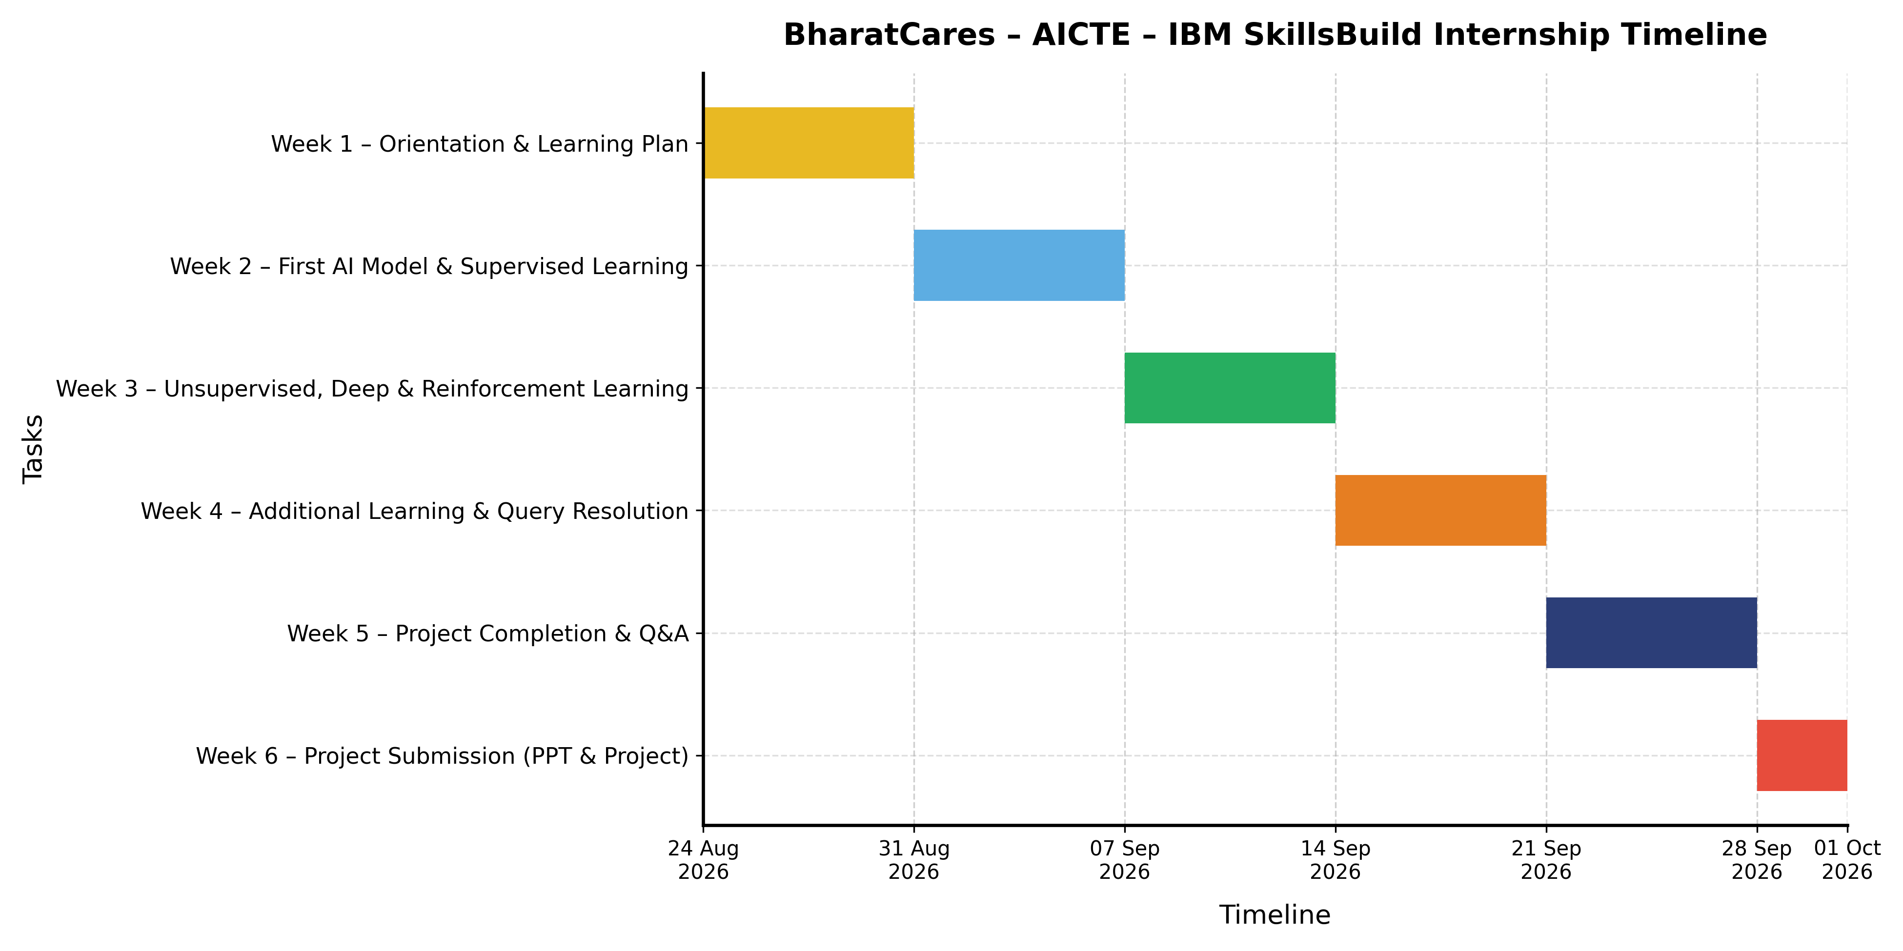
Figure 3.1: Gantt chart of the internship timeline
The Gantt chart in Figure 3.1 summarises the six weeks of the internship, from 24th August 2026 to 30th September 2026. The sections below explain the activities of each week, as laid out in the programme timeline, and how the work built toward the final project submission.

Week 1: Orientation and Setup
The internship began with an orientation session introducing the IBM SkillsBuild platform, the internship flow, expectations, and tools. I started the IBM SkillsBuild learning plan, which carries an IBM badge, and attended Masterclass 1, Kickstart Your Machine Learning Journey, in which VS Code and IBM BOB were set up for the hands-on work that followed.

Week 2: Building Your First AI Model and Supervised Learning
Week 2 featured two masterclasses. Masterclass 2, Build Your First AI Model, offered hands-on work with Teachable Machine and IBM watsonx/Watson Studio. Masterclass 3, Master Supervised Learning, covered regression, classification, and decision trees. Together, these sessions moved the learning from a first, guided model to the core techniques used to predict values and categories from labelled data.

Week 3: Unsupervised, Deep and Reinforcement Learning
Week 3 broadened the scope to other learning paradigms. Masterclass 4, Discover Hidden Patterns, introduced unsupervised learning and the fundamentals of deep learning, while Masterclass 5, Train Intelligent AI Agents, covered reinforcement learning using Q-Learning and interactive simulations. By the end of this week, all five masterclasses of the programme had been completed.

Week 4: Additional Learning and Query Resolution
Week 4 was devoted to additional learning in lifelong professional skills, along with query resolution. This week provided an opportunity to consolidate the earlier masterclasses, raise doubts with the mentors, and continue progress on the IBM SkillsBuild learning plan while preparing for the final project.

Week 5: Project Completion and Q&A Session
Week 5 focused on completing the final project and on a project completion and submission Q&A session, in which questions about the project requirements and the submission process were addressed. The emphasis was on finalising the work, making sure it applied the concepts learned and aligned with the UN Sustainable Development Goals, and preparing the presentation.

Week 6: Project Submission
The final week was reserved for the submission of the project and the accompanying PowerPoint presentation. Completing this submission, along with the weekly masterclass participation and the assigned learning plan, fulfilled the certification requirements listed in the offer letter. This phase closed the internship timeline shown in Figure 3.1.

3.4 System Architecture and Dataset
The final project is a traffic-speed prediction and monitoring system; its overview and problem statement are given in Section 5.5, and its design and implementation are described in this and the following sections.
The system has three layers, shown in Figure 3.2. The React client renders four views (overview, data exploration, prediction, and model performance) and talks to the API only over HTTP and JSON. The FastAPI application validates each request with Pydantic schemas and passes it to service modules, which use the reusable traffic_ml package for data preparation, features, training, evaluation, prediction, and emissions logic. Model files are loaded only by Python.
The checked-in sample file holds 144 synthetic rows for three illustrative road IDs covering 1 and 2 January 2024, with the timestamp, road segment ID, and the speed in km/h as the target. The inputs traffic_volume, temperature_c, and rainfall_mm may be missing and are handled by the fitted imputer; missing speed observations are never invented. All dataset and model paths, the train/validation/test fractions, and the congestion cut-offs are kept in configs/config.yaml, so the data can be replaced without editing code.
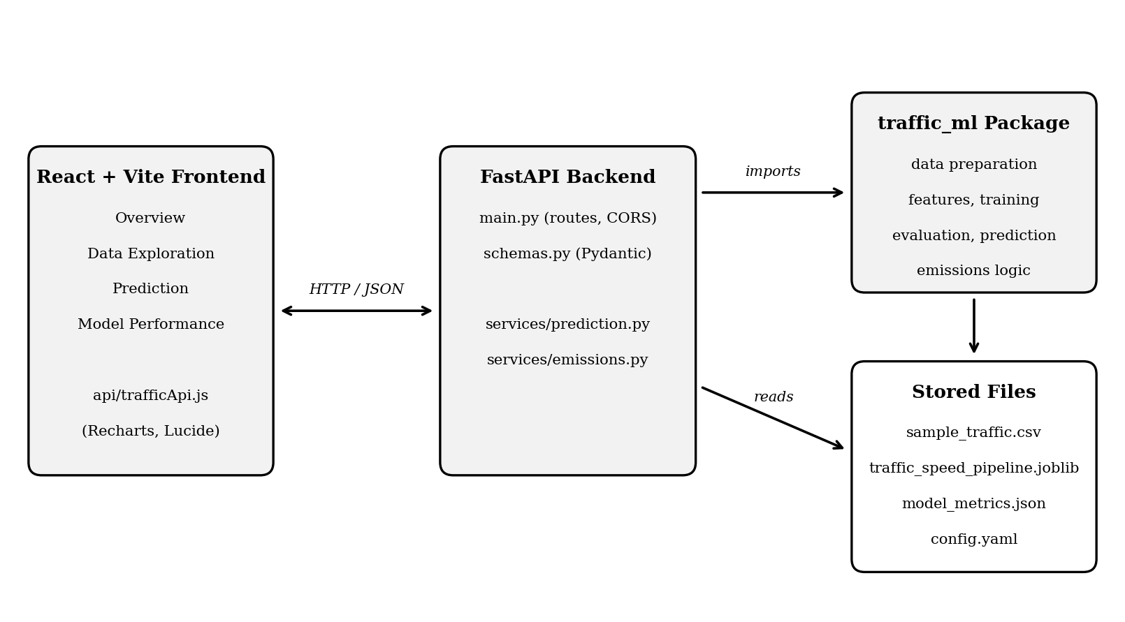
Figure 3.2: Architecture of the traffic speed prediction system

3.5 Machine Learning Model
The model is a scikit-learn pipeline ending in a RandomForestRegressor, which averages many decision trees and builds on the decision-tree concepts from Masterclass 3. The imputer and the model are saved together in one joblib artifact so that training and prediction apply identical transformations. Inputs are the timestamp, the road ID, the earlier speed history of the segment, and the optional volume, temperature, and rainfall values. Because traffic is a time series, the data is split chronologically: the final 20 per cent of distinct timestamps form the test period and a further 15 per cent form validation, so the model never sees the future during training. The saved model and baseline metrics are shown on the model-performance page. Since the data is synthetic, these scores show that the pipeline works, not accuracy on real roads, and only a one-hour horizon is validated.
The predicted speed is mapped to a congestion class using the prototype thresholds in Table 3.1, which are not official Mumbai definitions.
Table 3.1: Congestion classes used by the project
Congestion class | Predicted speed
Severe | Up to and including 15 km/h
High | Above 15 km/h and up to and including 30 km/h
Moderate | Above 30 km/h and below 45 km/h
Low | 45 km/h and above

3.6 Backend API and Web Client
The backend exposes the seven routes in Table 3.2, and FastAPI also provides interactive documentation at /docs. A prediction request names a segment and a forecast timestamp and may include the three optional inputs; omitted inputs are listed in a missing_inputs field. Errors use standard codes: 503 if the model file is missing, 404 for an unknown segment, and 422 for invalid input, for example a forecast that is not later than the latest reading. The web client uses Recharts for charts and Lucide for icons, labels the data as synthetic, and never presents it as live traffic.
Table 3.2: API routes
Method | Route | Description
GET | /health | API status and whether the dataset and model files exist.
GET | /api/summary | Dataset status, coverage dates, counts, average speeds.
GET | /api/segments | Available road IDs with a per-segment summary.
GET | /api/trends | Mean observed speed by hour and weekday.
POST | /api/predict | Model speed and congestion estimate for a segment and time.
POST | /api/emissions/estimate | CO₂ estimate from vehicle count, distance, and factor.
GET | /api/model-metrics | Saved model and baseline metrics.

3.7 Emissions Estimation
The estimator multiplies the vehicle count by the segment length to get vehicle-kilometres, and then multiplies this by an emission factor in grams per vehicle-kilometre. For 500 vehicles on a 2 km segment with a factor of 180 g, this gives 1,000 vehicle-km and 180 kg of CO₂ for that hour. The factor is illustrative and not locally sourced, so a cited value must replace it before the result is reported as a research estimate, and the output is an estimate, not measured emissions.

3.8 Setup, Execution and Testing
The project needs Python 3.10 or newer and Node.js LTS. From the repository root in PowerShell, the model is trained and the API and client are started in two terminals:
python -m traffic_ml.train
python -m uvicorn app.main:app --app-dir backend --port 8000 --reload
# second terminal: Set-Location frontend; npm run dev

The application opens at http://127.0.0.1:5173. Tests are run with python -m pytest -q, and the client is checked with npm run build.

3.9 Limitations and Responsible Use
- The three road IDs are illustrative and must not be presented as any real corridor, such as LBS Marg, and the dashboard is not live traffic.
- The congestion thresholds and emission factor are prototype values, and a real dataset should replace the sample only after its source, licence, geography, period, and units are verified.
The project can be extended with verified Mumbai data as described in Section 5.3.

Chapter 4 Screenshot of Work

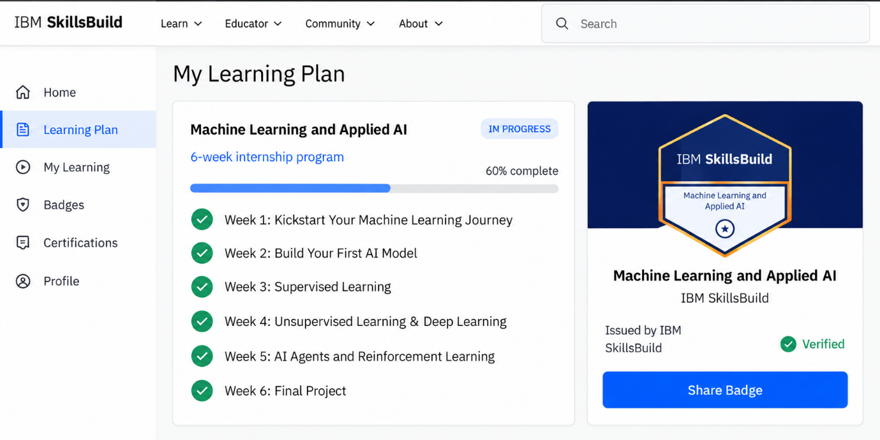
Figure 4.1: IBM SkillsBuild learning plan and badge

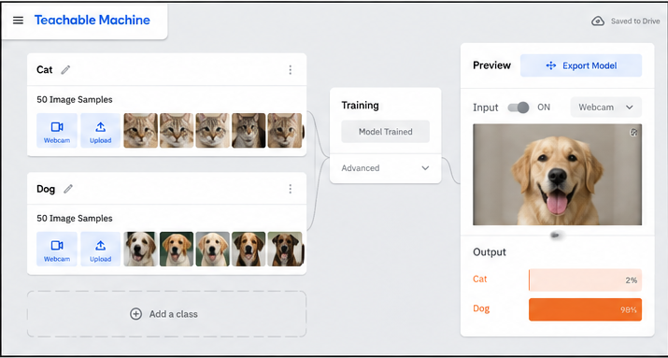
Figure 4.2: Teachable Machine model

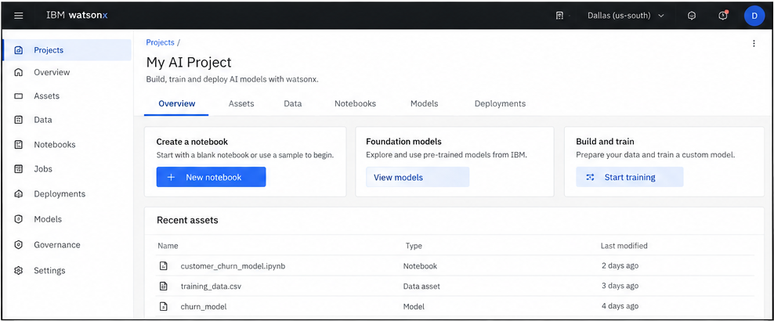
Figure 4.3: IBM watsonx / Watson Studio workspace

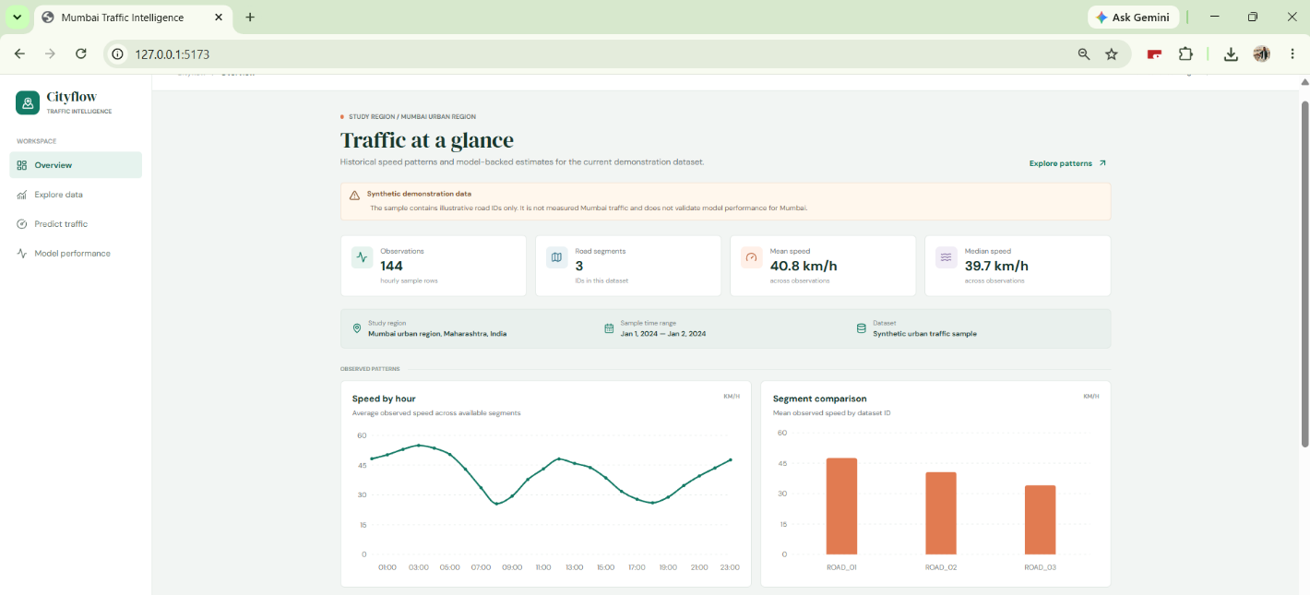

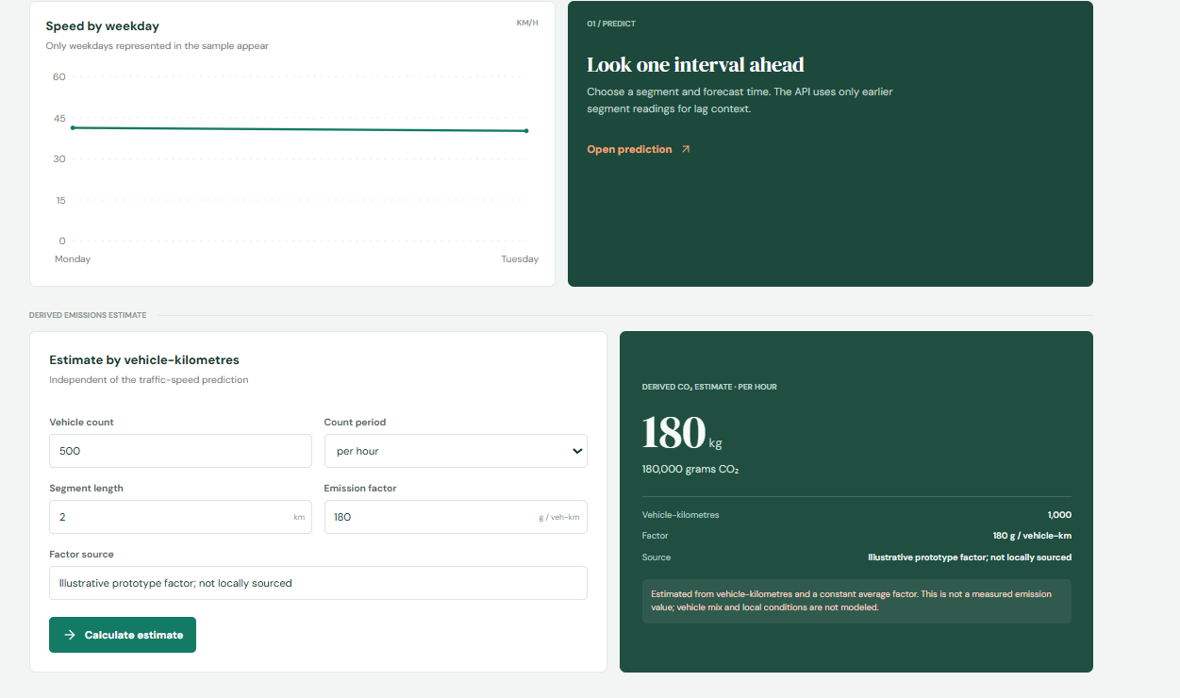
Figure 4.4: Final project output

Chapter 5 Conclusions and Future Work

5.1 Conclusion
Throughout this internship as a Machine Learning and Applied AI Intern in the AICTE–BharatCares–IBM SkillsBuild Internship Program, I gained a structured, hands-on introduction to machine learning and applied AI over six weeks. The programme moved logically from orientation and tool setup to building a first AI model, then to supervised learning, unsupervised learning, deep learning fundamentals, and reinforcement learning, and finally to a project that applied these ideas to a real-world problem. This progression allowed me to build, train, and evaluate AI models rather than only reading about them.
Participation in the weekly masterclasses with mentors, the completion of the IBM SkillsBuild learning plan, and the development, submission, and presentation of the final project gave me a clear sense of how industry-focused learning programmes are organised. The alignment of the project work with the UN Sustainable Development Goals also encouraged me to think about the social impact of AI, and not only its technical performance.
Technically, the internship exposed me to VS Code and IBM BOB for development, Teachable Machine and IBM watsonx/Watson Studio for model building, and the major families of machine learning techniques, including regression, classification, decision trees, unsupervised learning, deep learning, and Q-Learning. Beyond the specific tools, the virtual format strengthened my discipline, time management, and communication with mentors. Overall, this internship has given me a well-rounded foundation that I will carry forward into my future career in AI, data science, and machine learning.

5.2 Learning Outcomes and Skillsets Developed
By the end of the internship, the learning outcomes went beyond familiarity with individual tools. The experience developed both technical skillsets and professional working habits that are directly relevant to roles in AI, data science, and machine learning.
Learning Outcomes
- Ability to build, train, and evaluate AI models using supervised, unsupervised, deep, and reinforcement learning approaches.
- Ability to apply AI concepts to real-world problems and to frame a project around a meaningful goal such as the UN Sustainable Development Goals.
- Understanding of the end-to-end flow of an AI project, from setting up the environment and framing a problem, to training a model, evaluating it, and presenting the results.
- Improved professional judgement around discipline, communication, time management, and critical thinking when learning and working in a virtual, mentor-guided environment.
Skillsets Developed
- Machine learning fundamentals: regression, classification, and decision trees for supervised learning, along with an understanding of unsupervised learning and the discovery of patterns in unlabelled data.
- Deep learning and reinforcement learning: foundational understanding of neural-network-based deep learning and of Q-Learning for training intelligent agents through interactive simulations.
- AI tooling: practical exposure to Teachable Machine and IBM watsonx/Watson Studio for building models, and to VS Code and IBM BOB as development tools.
- Learning platforms and collaboration: using the IBM SkillsBuild Digital Learning Platform, participating in mentor-led masterclasses, and using query-resolution and Q&A sessions effectively.
- Professional skills: lifelong professional skills training, project planning, presentation preparation, and meeting submission deadlines.

5.3 Future Work
Looking ahead, both for my own growth and in terms of how the knowledge gained from this internship can be applied further, there are several clear directions worth pursuing.
On a personal level, I hope to continue building on the foundation created during this internship by moving from guided exercises to independent projects. I would like to deepen my understanding of the mathematics behind machine learning algorithms, practise on larger and more varied datasets, and become comfortable with the full lifecycle of a model, from data preparation to deployment and monitoring. I also want to keep improving my ability to explain technical results clearly, so that I can communicate findings to both technical and non-technical audiences.

From a skills perspective, one of the most significant next steps is to go deeper into the areas that were introduced only at a fundamentals level in the programme, particularly deep learning and reinforcement learning. Building and training neural networks for tasks such as image, text, or sequence data, and experimenting with more complex reinforcement learning environments beyond the introductory Q-Learning simulations, would allow me to apply these ideas to more demanding problems. Exploring IBM watsonx and Watson Studio more extensively would also help me understand how models are managed and deployed on an industry platform.

Alongside this, there is a clear opportunity to extend the final project itself. The project was aligned with the UN Sustainable Development Goals, and it could be improved by using larger real-world datasets, testing the model more rigorously, and considering responsible-AI aspects such as fairness, transparency, and privacy. Collaborating with peers or mentors on such an extension, or contributing to open-source or community projects with a social focus, would be a natural way to continue this work.

Together, deeper study of advanced techniques and the continued development of the final project represent natural next steps — and they are directions I would be glad to pursue further, building on the IBM SkillsBuild learning resources and the certifications earned through this programme.

5.4 Challenges Faced
Undertaking a fast-paced, virtual internship introduced several challenges that differed from typical classroom learning. The most significant challenges, and how they were addressed, are summarised below.
Learning a broad range of topics in a short time: Six weeks covered tools, supervised learning, unsupervised learning, deep learning, and reinforcement learning. I addressed this by following the weekly structure closely, revisiting the learning plan after each masterclass, and practising each technique hands-on before moving to the next.
Setting up the development environment: Getting VS Code, IBM BOB, and the cloud-based tools working correctly was an essential first step. I handled this by following the Masterclass 1 setup closely, testing the environment early, and using the query-resolution sessions whenever I got stuck.
Understanding abstract concepts: Ideas such as decision trees, neural networks, and Q-Learning can feel abstract at first. I addressed this by working through the interactive simulations and hands-on exercises, which made the underlying concepts more concrete.
Managing time in a virtual format: Balancing the self-paced learning plan, mandatory masterclasses, and project work required discipline. I managed this by planning each week in advance, attending every scheduled session, and breaking the project into smaller milestones.
Delivering a project to a deadline: The final project had to be completed, submitted, and presented within a fixed timeline. I handled this by starting early, using the Week 5 Q&A session to clear doubts, and reserving time to prepare the presentation before final submission.

5.5 Final Project Overview and Problem Statement
The final project is a traffic-speed prediction and monitoring system with a built-in emissions estimator. It is a full-stack application made of a React and Vite web client, a Python FastAPI backend, and a scikit-learn model that predicts the traffic speed of a road segment. Congestion in a large city such as Mumbai raises travel time and vehicle emissions, so the system lets a user explore historical speeds by hour and weekday, predict the speed of a segment at a chosen time with a congestion class, and convert a vehicle count into an approximate CO₂ figure. This connects the project to the programme requirement of aligning with the UN Sustainable Development Goals, in particular SDG 11 (Sustainable Cities and Communities) and SDG 13 (Climate Action).
Data limitation. The dataset in the repository is synthetic demonstration data with illustrative road IDs. It is not observed Mumbai traffic, its IDs do not correspond to verified Mumbai corridors, and the model scores do not demonstrate performance on Mumbai roads. Mumbai is named only as the intended study region, and the interface states this limitation. The project is therefore a tested pipeline and a foundation for future work, not a validated traffic study.

References

1. AICTE. (n.d.). All India Council for Technical Education. https://www.aicte-india.org
2. IBM. (n.d.). IBM watsonx. https://www.ibm.com/watsonx
3. IBM. (n.d.). IBM SkillsBuild. https://skillsbuild.org
4. Microsoft. (n.d.). Visual Studio Code documentation. https://code.visualstudio.com/docs
5. Sutton, R. S., & Barto, A. G. (2018). Reinforcement learning: An introduction (2nd ed.). MIT Press.
6. Teachable Machine. (n.d.). Teachable Machine. Google. https://teachablemachine.withgoogle.com

Appendix

Appendix A: Key Tools and Techniques Used
- IBM SkillsBuild — digital learning platform and learning plan with IBM badge.
- VS Code — code editor set up in Masterclass 1.
- IBM BOB — development tool set up alongside VS Code in Masterclass 1.
- Teachable Machine — no-code tool used to train a first AI model.
- IBM watsonx / Watson Studio — platform for building and training AI models.
- Q-Learning simulations — interactive reinforcement learning exercises.

