- Install Power BI Desktop and share the final screenshot of the report view page which appears when power desktop starts.
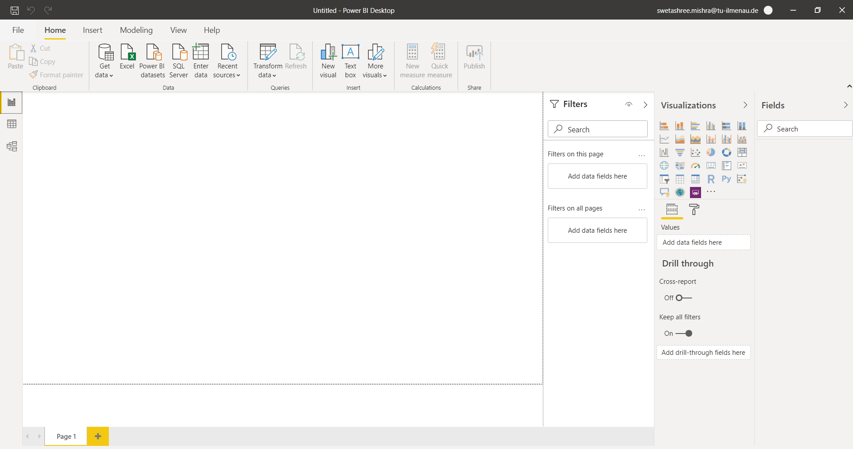
- Prepare a document and with the following screenshot
- REPORT VIEW
- DATA VIEW
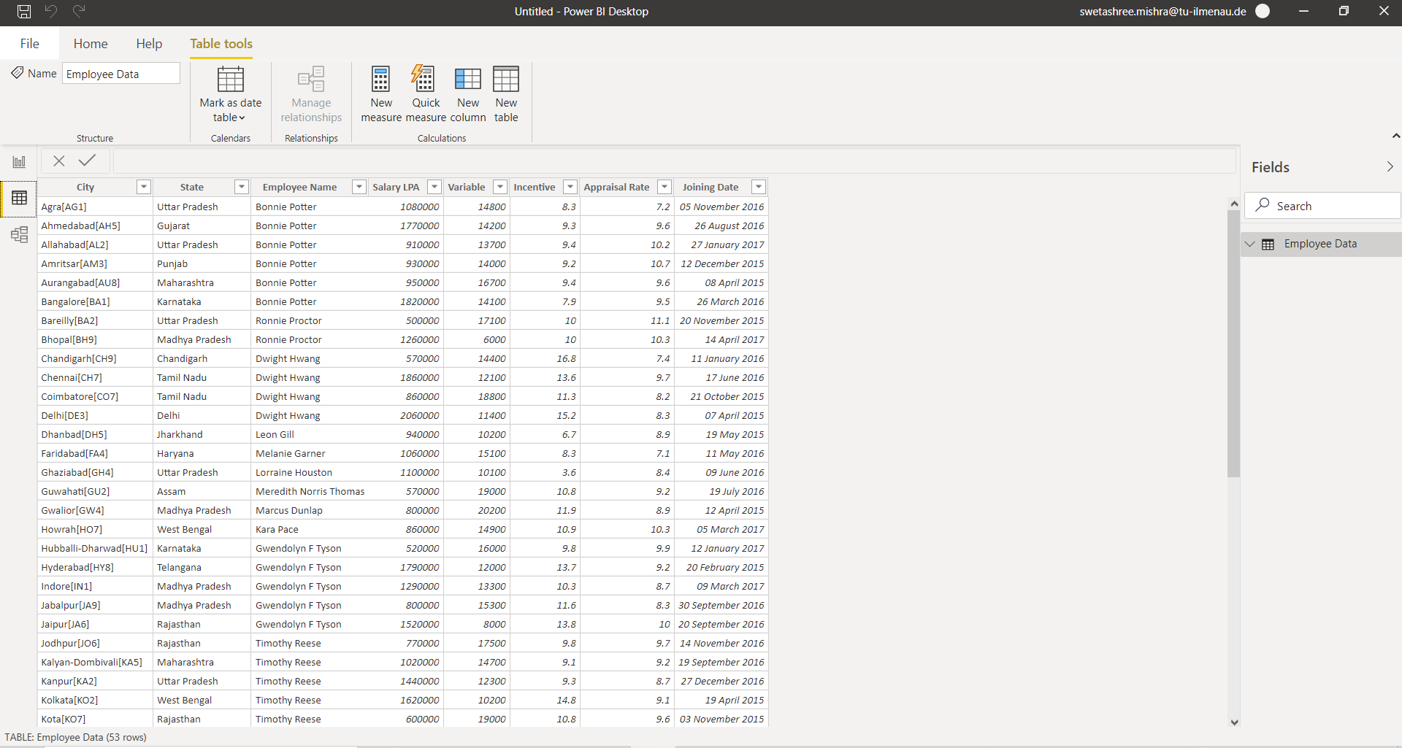
- Model View
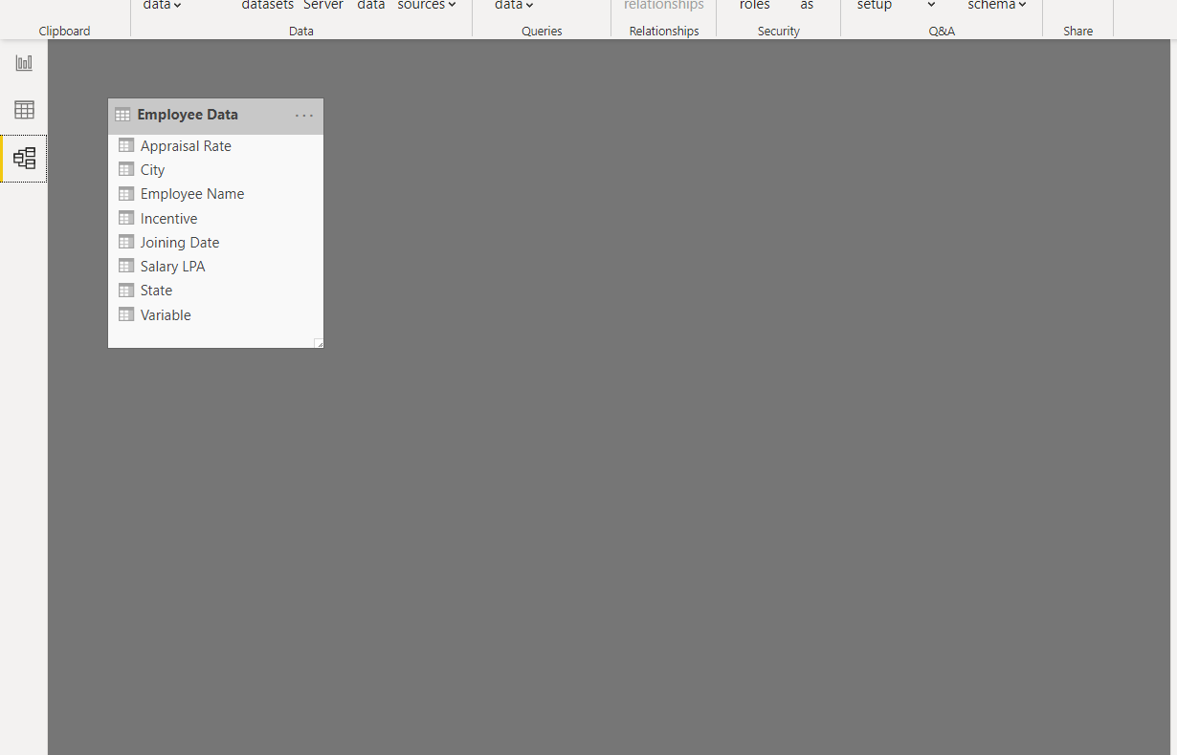
- Power Query Editor
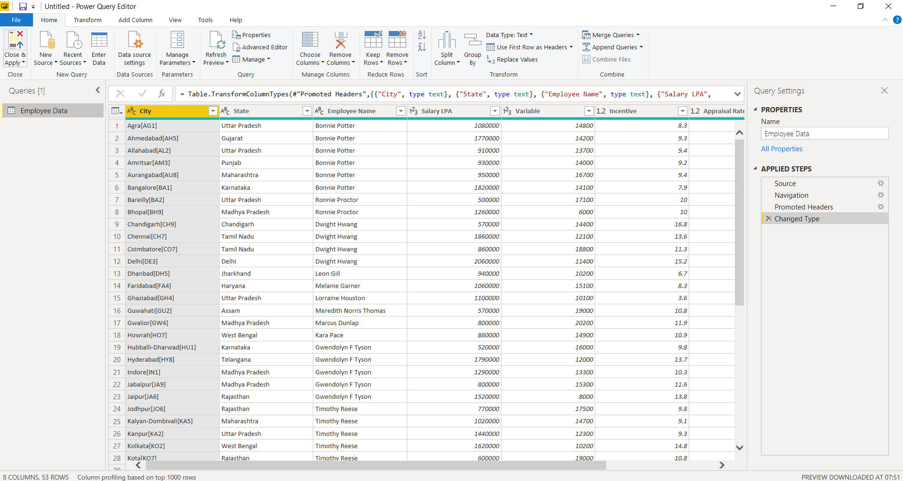
- Advanced Editor
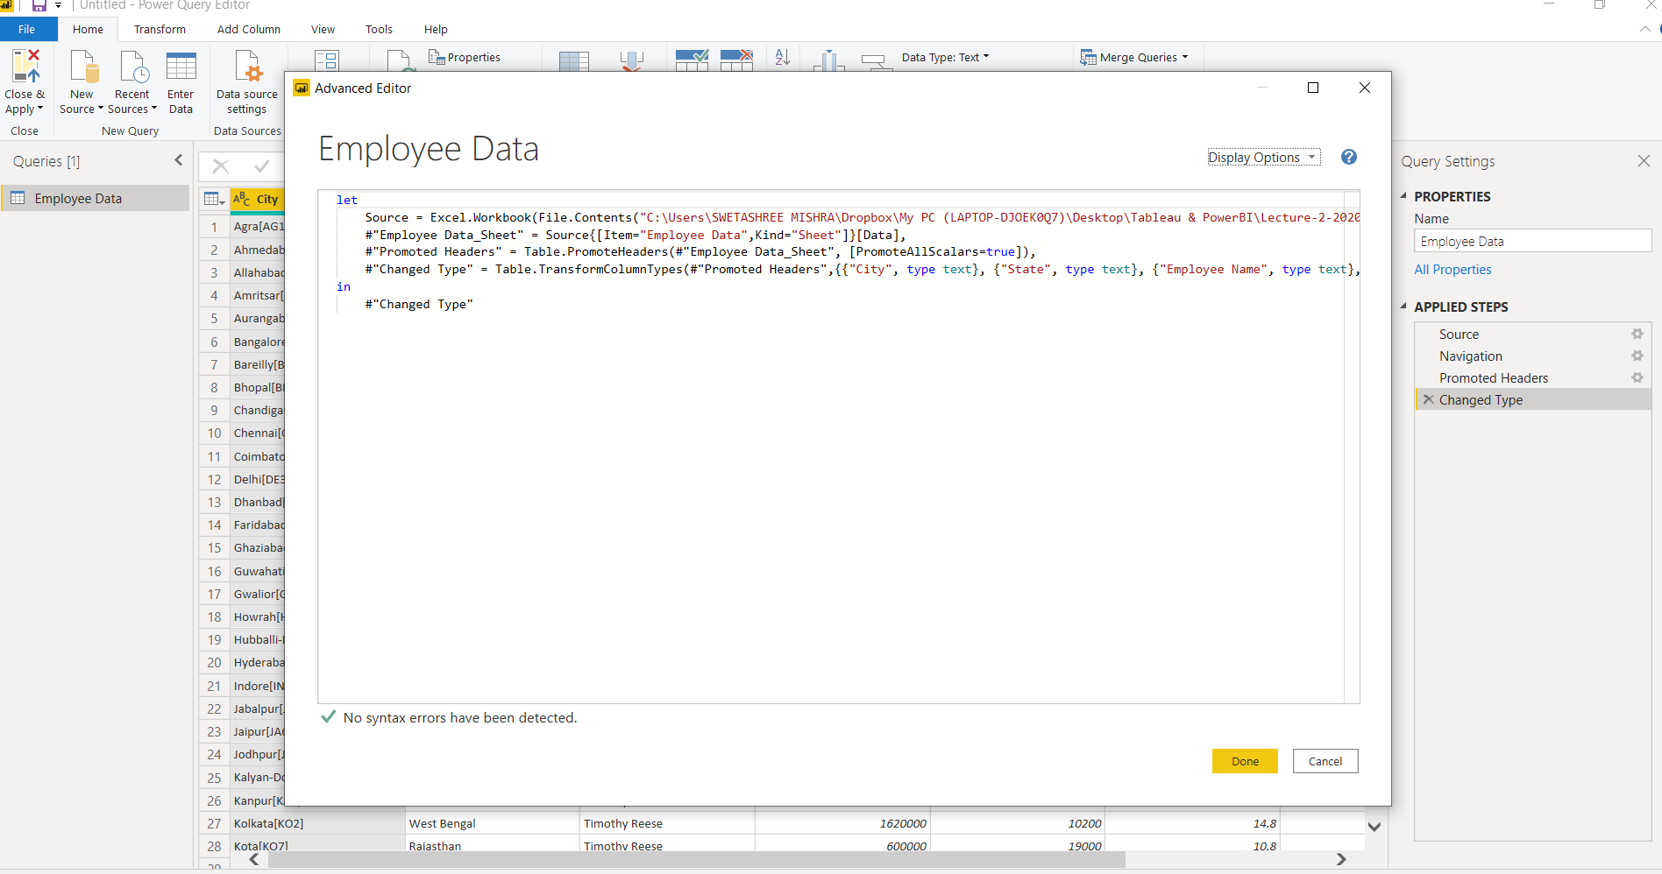
- Prepare a document with details of the following along with their price
- Power BI Desktop
- It’s the free version of Power BI that can be installed in our local computer as a program.
- It’s the prefect version to start with all the skills levels.
- Even a non-IT guy can easily play around and make interactive reports.
- The price of Power BI Desktop level is free for individual users.
- Power BI Pro
- It has the ability to use Power BI for both building dashboards and reports and unlimited viewing, sharing.
- It has the ability to embed Power BI visuals into apps.
- It can create app workspaces and peer-to-peer sharing.
- The price of Power BI Pro level costs $9.99 per user per month.

- Power BI Premium
- It’s the most expensive tier of Power BI currently available.
- It increases the data capacity limit and maximum performance.
- Has ability to embed Power BI visuals into apps like, PowerApps, SharePoint, Teams.
- Has the larger storage sizes for extended deployments.
- The Premium plan of Power BI costs $4,995 per month with a dedicated cloud compute and storage resource.

