**ADVANCED SOFTWARE ENGINEERING**

PROBLEM SET – 2

**NAME: SWETCHA REDDY VANGALA**

**CLASS ID: 41**

1. *VIDEO STORE*

UML CLASS DIAGRAM

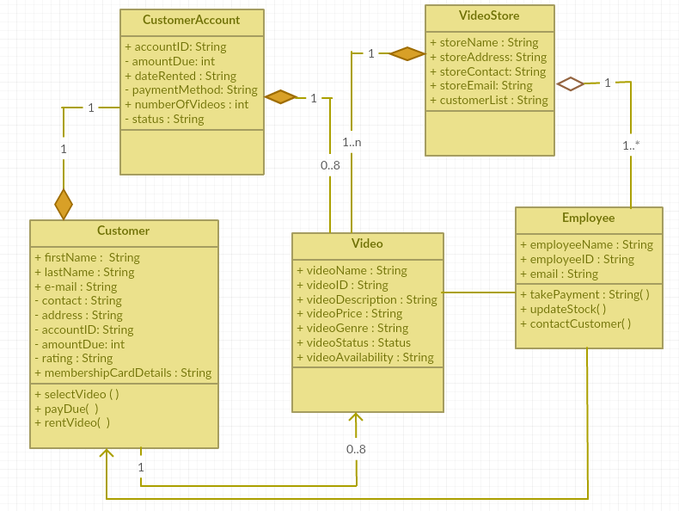

1. *DIFFERENCES BETWEEN AGGREGATION AND COMPOSITION*

* There is an Aggregation between Employee to Video Store, because employees do exist even without the Video Store.
* Without a Video store there cannot be any videos, and hence there is a Composition between Video Store and Video.
* A Customer Account do not exist without a Customer and so there is a Composition between Customer and his Account.
* Only when a customer visits a Video Store to purchase Videos, Customer Account is created. This is why Video and Customer Account has a Composition.
* Employee and Customer are just associated together because of the Video Store. There is an Association between those classes.

Hence an Aggregation links two classes in a way such that one class can exist without the other. But whereas Composition links two classes such that the child class cannot exist without the parent class.

**MULTIPLICITY**

A Video store can have one or more employees 1 -> 1..*

A Video store has many videos 1 -> 1..n

Any customer can rent none or upto 8 videos 1 -> 0..8

A customer has exactly one account 1 -> 1

1. *LIFE TIME OF A VIDEO TAPE IN A VIDEO STORE*

STATE DIAGRAM

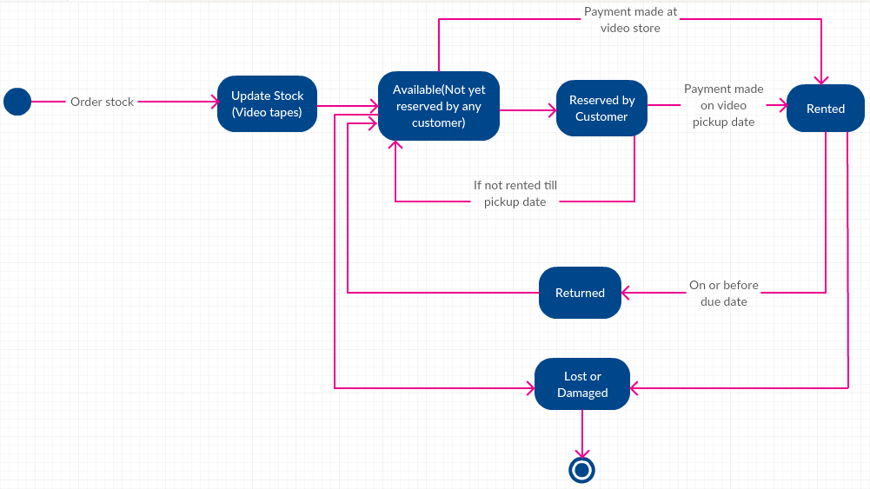

The video tape in a video store goes through the following states

* Available
* Reserved
* Rented
* Returned
* Lost or Damaged
* Terminated

A video tape is brought to store and is **available** for the customer to rent. It then can be **reserved** by any customer and can be **rented** by them by paying specified amount for that video tape. It has to be **returned** within two days of the due date. It might be **lost or damaged** either when it is in the store itself or when it is rented to customer. Once it is lost or damaged, it means it enters into **terminated** state.

1. *RENTING A MOVIE FROM VIDEO STORE*

ACTIVITY DIAGRAM

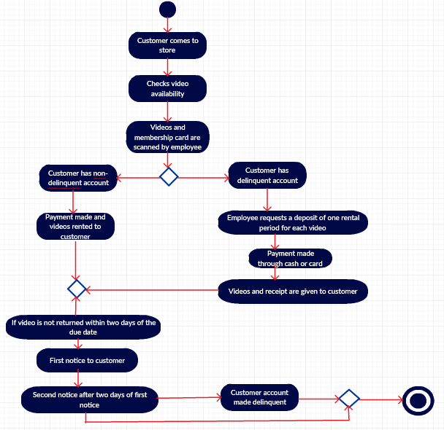

The activity diagram is self-explanatory. It gives a brief picture of how the flow goes on in a Video rental store.