**ADVANCED SOFTWARE ENGINEERING**

**PROBLEM SET-3**

**NAME: SWETCHA REDDY VANGALA**

**CLASS ID: 41**

***TAXI MOBILE SOLUTIONS***

1. **SOFTWARE ARCHITECTURE DIAGRAM**

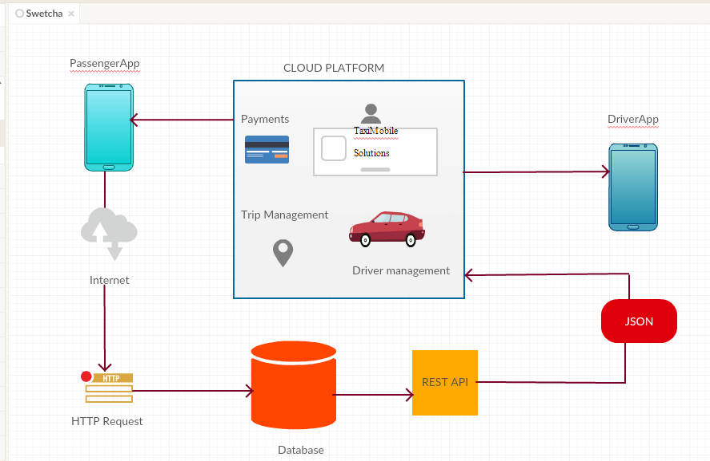

1. **MVC PATTERN**

**VIEW**

For any application or any website, view is how it is visible to users. View is the Presentation layer.

For the TaxiMobileSolutions, View is the application page. There are two different views, one is User View and the other is Driver View.

The user as well as driver can view the details like location, payment and billing details, notifications retrieved from cloud platform.

**MODEL**

Model manages the data for an application.

For the TaxiMobileSolutions, Model is the database which includes information of drivers as well as the users. Everytime any new user or driver is added, or after every ride of the driver or user, his or her details are updated in the model.

**CONTROLLER**

Controller responds to user’s changes and updates the model.

For the TaxiMobileSolutions, Controller is the REST API which takes the changes made by user or driver and updates the database.

For example, when the passenger wants a ride, he can view the nearest driver’s details in the application’s view and can book his ride. The driver gets a notification and he goes to pick up the passenger, the REST API takes the data from the database and helps the driver in picking and dropping the passenger.

1. **CALLING A TAXI SERVICE**

**SEQUENCE DIAGRAM**

