ADVANCED SOFTWARE ENGINEERING

PROBLEM SET-5

NAME: SWETCHA REDDY VANGALA

CLASS ID: 41

COMPARISION OF MAJOR CLOUD SERVICE PROVIDERS.

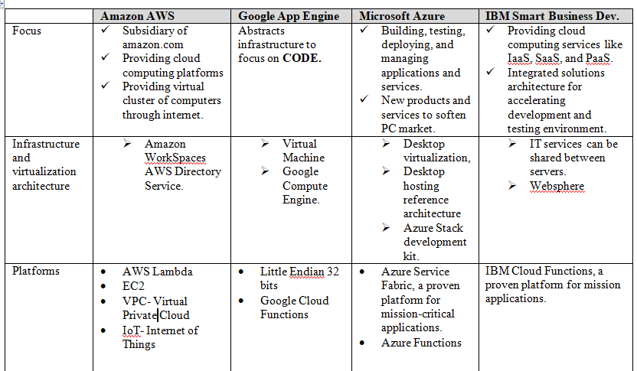

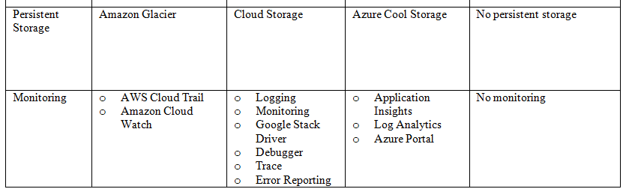

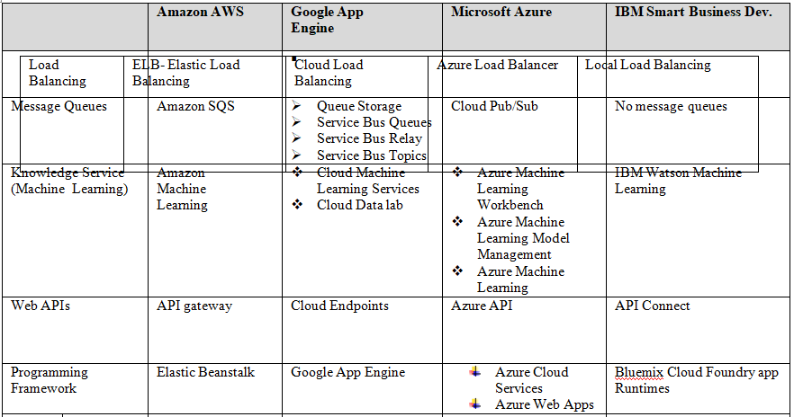

PRICING COMPARISION IN VARIOUS CLOUD SERVICE PROVIDERS

