TECHNICAL WALKTHROUGH · LANGGRAPH VOICE AGENT
Member Satisfaction Survey (MSAT) Agent
An outbound voice agent that calls Smart Step program members, runs a six-question satisfaction survey through natural conversation, and returns a structured, honest call outcome — every flow, decision, and LLM call explained end to end.
Repository: Swetha-Hariharan1810 / conversation-agent-msat-sda

Contents
- 1. What this project is
- 2. System architecture
- 3. LangGraph orchestration loop
- 4. The call, end to end
- 5. Anatomy of one turn
- 6. Guards — the safety net
- 7. The planner's precedence
- 8. Slots, answers & recording
- 9. Where the LLM gets called
- 10. State & data model
- 11. The call outcome
- 12. File-by-file map

01 — ORIENTATION

What this project is
This repo builds Ida, an automated phone caller for the Allianz Smart Step program. Ida calls a member, confirms she's speaking to the right person, asks for a couple of minutes, and — if they agree — walks through a 6-question satisfaction survey. She isn't reading a fixed script top to bottom: every turn, a planner looks at what's actually been said and answered so far and decides what to do next, so members can answer out of order, volunteer extra information, correct themselves, or ask to stop at any point.
LIKE YOU'RE FIVE
Imagine a very polite robot calling on the phone. She doesn't just read questions off a card — she actually listens. If you answer two questions in one breath, she remembers both. If you say "wait, actually…", she goes back and fixes what she wrote down. If you sound like you're in trouble, she stops the survey immediately and gets you a real person. At the end, she writes a little report of exactly what happened on the call.

It is built on the same reusable skeleton (BaseAgent + guards + slot manager + signals + dialogue manager) used across a family of similar call-center agents, sitting behind a LangGraph interrupt/resume boundary so the call can pause between turns and resume exactly where it left off.
- Python 3.11+
- LangGraph
- LangChain (Azure OpenAI / OpenAI)
- Pydantic structured output
- JSON-driven script spec (data/msat_spec.json)
02 — STRUCTURE

System architecture
The concrete agent, MsatSurveyAgent, is built by mixing four responsibility-specific mixins into an abstract BaseAgent. None of these mixins know anything about the MSAT survey itself — the survey-specific behavior lives entirely in survey_agent.py and the JSON spec it loads.
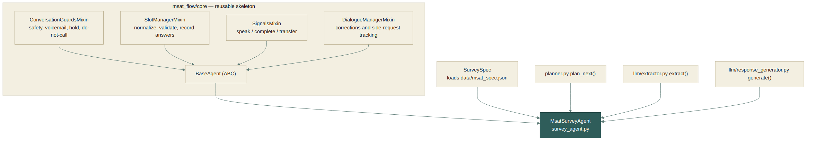
Composition of MsatSurveyAgent(ConversationGuardsMixin, SlotManagerMixin, SignalsMixin, DialogueManagerMixin, ABC) — see core/agent.py.
Mixin | Role
guards.py | Regex-based safety net that runs on the raw member text before any LLM call — safeguarding, human handoff, voicemail, do-not-call, hold.
slot_manager.py | The only path an answer can take into state: slots/pipeline.py normalizes and validates it, then it's recorded against a named slot.
signals.py | Every turn ends one of three ways: speak() (ask & wait), signal_complete() (end call), or signal_transfer() (hand to a human).
dialogue_manager.py | Tracks corrections and off-script remarks ("secondary intents") on a pending-intent ledger so nothing volunteered gets silently dropped.
03 — ORCHESTRATION

LangGraph orchestration loop
app_graph.py wires the agent into a two-node LangGraph state machine. call_workflow runs one agent turn; human_node parks the graph on interrupt() until the member's next words arrive, then resumes. All state — messages, answers, gates, phase — lives in the SurveyState TypedDict, so a checkpointer (or the hosting platform) can persist and resume a call mid-conversation.
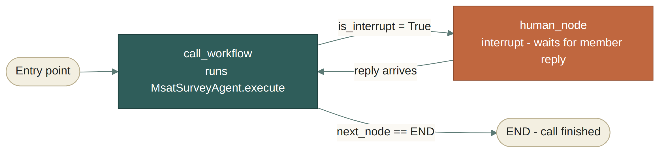
conditional_routing() reads state.is_interrupt / state.next_node to choose the edge each cycle.
Detail | Why it matters
offline flag on state | When set, call_workflow builds the agent with client = None, so the whole graph runs with zero LLM calls — scripted wording only. This is how the flow is tested end-to-end without a provider.
with_checkpointer | build_graph(with_checkpointer=True) attaches an in-memory checkpointer for local/CLI runs; the module-level graph used by the LangGraph CLI/Platform compiles without one because persistence is platform-managed there.
04 — THE CALL

The call, end to end
Stripped of edge cases, a full successful call moves through five phases in this order. The planner enforces this order as a strict precedence (§7), but within the survey phase, questions can be answered out of sequence.
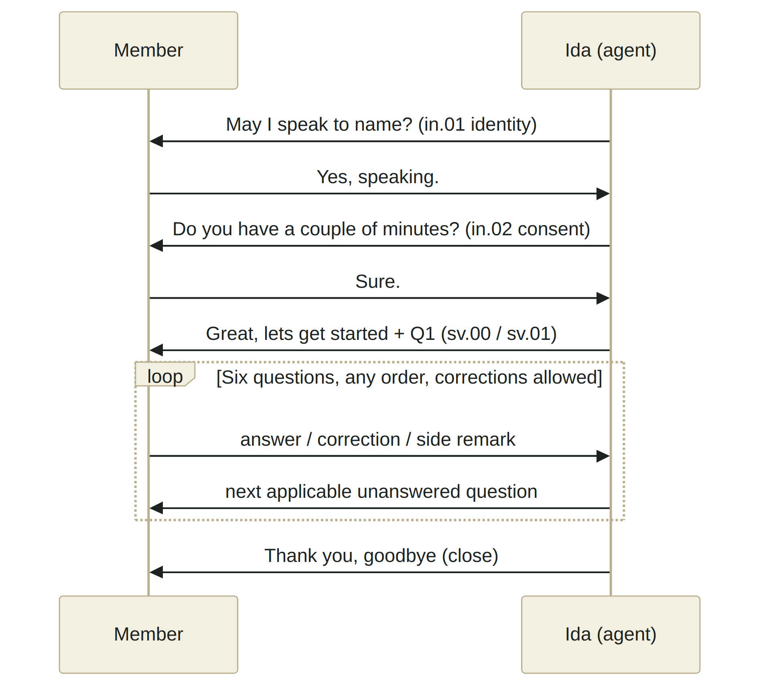
If consent is declined at in.02, the branch goes to reschedule-offer instead of the survey — see the planner diagram in §7.

The six survey questions
# | Question | Condition
1 | Reviewed any program resources? | always asked
1a | How helpful were they? | only if Q1 = yes
1b | Why not reviewed? | only if Q1 = no
2 | What would improve the program? | always asked
3 | What did you like most? | always asked
4 | Would you recommend it? | always asked
5 | Were staff helpful/knowledgeable? | only if risk_tier == "high" in the work-item payload — never inferred from the call
6 | Overall experience? | always asked

05 — PER-TURN LOGIC

Anatomy of one turn — MsatSurveyAgent.run()
This is the heart of the whole project. Every single graph invocation of call_workflow runs this method exactly once. It reads the member's last message, decides what happened, updates state, and decides what to say next.
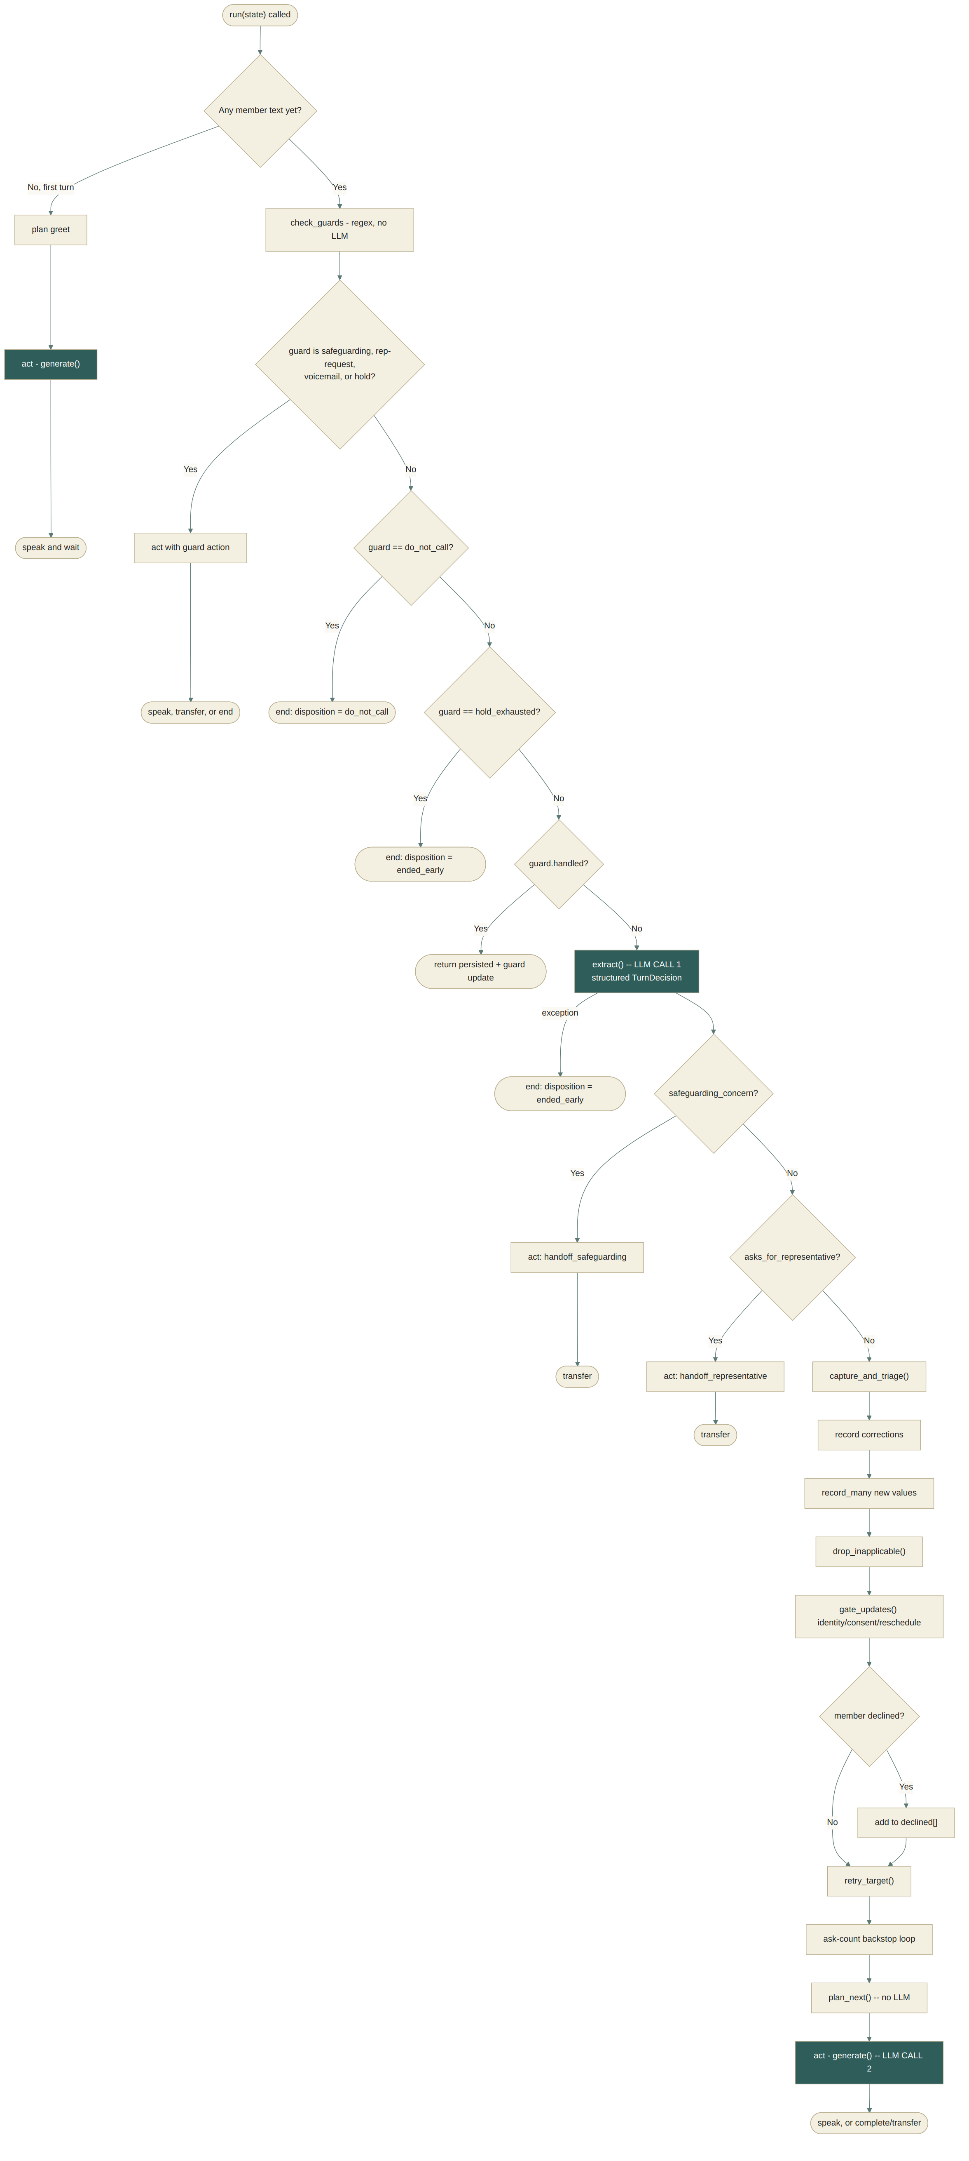
Green boxes are the two points where an LLM call can occur. Most branches (guards, gate give-up, provider errors) skip one or both.

Why corrections win over new answers
Notice the order: corrections are recorded before new values, and the retry logic explicitly treats "the member corrected an earlier answer" as a contribution rather than a failure to answer the current question. That's a small piece of code with outsized effect on how natural the conversation feels — someone revising Q3 while a totally different question is pending is never penalized for it.
msat_flow/agents/survey_agent.py — retry logic
if decision.corrections:
# They revised an earlier answer instead of answering this one. That
# is a contribution, not a failure to answer, and charging it to the
# outstanding question would spend the budget on someone being
# careful.
return None

06 — SAFETY

Guards — the safety net
core/guards.py runs before any LLM call, on the raw text, using conservative regex patterns. This means safety checks still work even if the LLM provider is down. Six guard outcomes exist, checked in strict priority order:
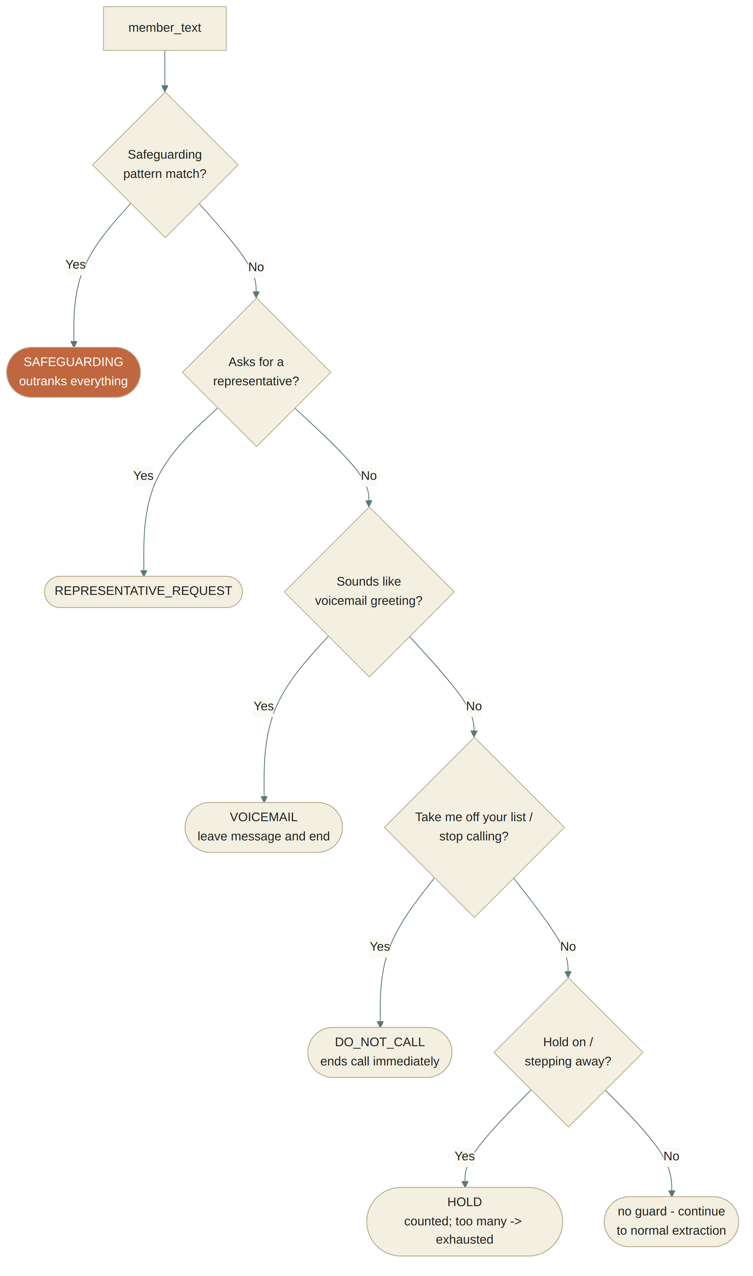
Safeguarding is deliberately the least conservative pattern — the design explicitly accepts more false positives here because the cost of a miss is unacceptable.
Two safety signals exist twice, on purpose: guards catch what's said plainly (regex, no LLM, works offline), while the extractor's TurnDecision.safeguarding_concern / asks_for_representative fields catch what's said obliquely — "I don't see much point any more" trips no regex pattern, so the LLM is explicitly instructed to lean toward raising a concern rather than away from it.

07 — DECISION LOGIC

The planner's precedence — plan_next()
planner.py is a pure function of call state — no LLM, no side effects, easy to unit test. Given the current answers, gates, and any guard that fired, it returns exactly one Plan (an action + the script node driving it).
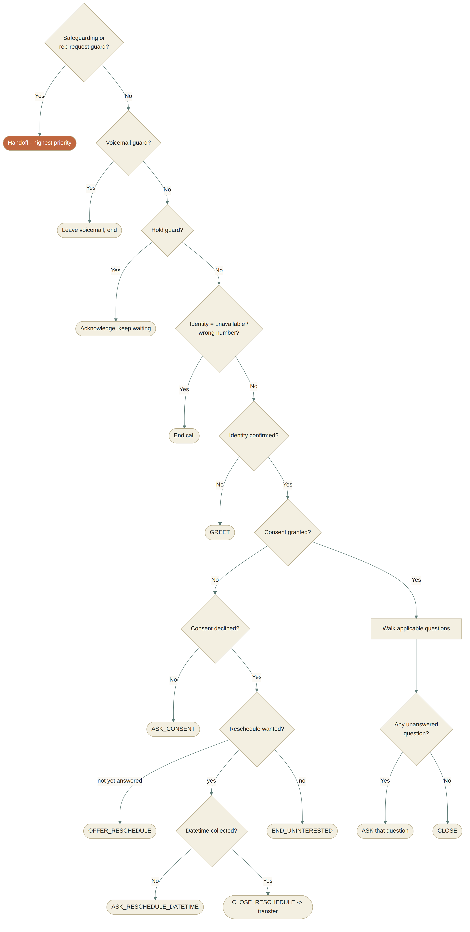
plan_next() in msat_flow/planner.py — 8 precedence levels, matching the numbered list in its own docstring.

Conditional questions — how "applicability" works
Each question in data/msat_spec.json can carry a when condition. applies() evaluates it against either an already-recorded answer (Q1a/Q1b depend on Q1) or a payload fact the work item brought (Q5 depends on risk_tier). Crucially:
- Q1a / Q1b — condition on an in-call answer. If the member later corrects Q1, _drop_inapplicable() retroactively forgets the now-invalid Q1a/Q1b answer so it doesn't leak into the outcome.
- Q5 — condition on risk_tier, a payload fact. This is never inferred from the conversation and cannot change mid-call — it's resolved once via payload.resolve().

08 — RECORDING ANSWERS

Slots, answers & recording
Every value that ends up in the outcome — whether from the member's own words or the LLM's structured extraction — passes through the same three-step pipeline before it's trusted:
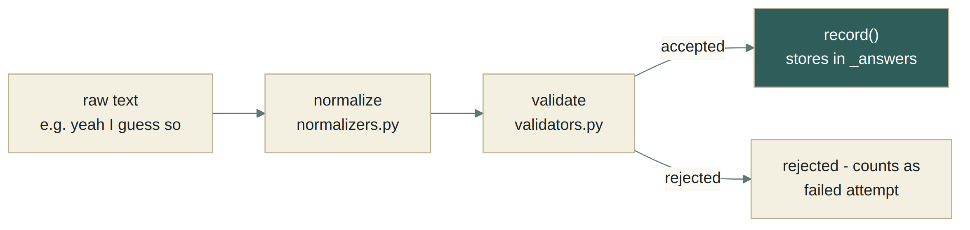
slots/pipeline.py's accept(slot, raw) is the single choke point — nothing reaches self._answers without going through it.
Guarantee | Mechanism
A rating the member never gave can't appear | Choice slots are validated against an exact allow-list of option values — an LLM hallucinating "kind of helpful" gets rejected, not silently coerced.
A question won't loop forever | Each SlotAttempt tracks attempt_count; once a slot hits its policy limit (max_asks_per_slot, or the tighter max_identity_asks / max_consent_asks for the three gates) it's either auto-declined or, for a gate, ends the call outright via _gate_gave_up().

The three gates are special
Identity, consent, and reschedule-intent are read only from the turn that asked them — _may_record() enforces this explicitly. A cheerful "sure!" volunteered before consent was ever asked cannot retroactively count as consent; it's asked anyway. This is a deliberate trade: mildly repetitive over risking a member being surveyed without having actually agreed to it.

09 — MODEL CALLS

Where the LLM gets called
There are exactly two call sites, both wrapping a single LangChain chat model (llm/client.py), and both fully documented in the flowchart in §5:
Call | Function | Mode | Purpose
#1 — Read | llm/extractor.py → extract() | client.structured(messages, TurnDecision) | Turn the member's free text into a structured TurnDecision: answer values, corrections, decline flags, safeguarding/rep-request flags, secondary intents.
#2 — Speak | llm/response_generator.py → generate() | client.text(messages) | Turn the planner's chosen action into a natural spoken line, in the agent's voice, acknowledging what was just said.

The whole questionnaire, offered every turn
The extractor doesn't just send the one outstanding question to the model — relevant_slots() offers every question slot, every turn. This is what makes multi-answer turns possible: a member who answers question 4 while question 1 is outstanding is helping, not confusing the agent.
msat_flow/llm/extractor.py
def relevant_slots(spec, asked_slots):
"""Slots the member could plausibly be answering right now.

The question that was just put comes first, then the rest of the
survey in the document's order. Payload-only slots are never
offered: the risk tier decides which questions this member gets,
and nothing said on the call may change it."""

When a call site is skipped
Situation | Read (#1) | Speak (#2)
First turn (opening greeting) | skipped — nothing to read yet | called
Guard fires (safeguarding, rep-request, voicemail, hold) | skipped — pattern-matched instead | called, unless verbatim
plan.verbatim == True (voicemail msg, reschedule offer, uninterested close, final close) | — | skipped — approved wording spoken exactly
Awaiting reschedule_datetime | skipped — free text captured directly | called
state.offline == True | skipped — rule-based fallback | skipped — scripted wording
Provider throws (rate limit / outage) | caught → call ends (ended_early) | caught → falls back to scripted wording (fallback())
Net effect: 2 LLM calls is the typical turn, dropping to 1 or 0 for the opening line, guard-driven turns, verbatim script lines, or offline/test runs. The SDK's own max_retries (6, in llm/client.py) handles transient failures underneath a single logical call rather than adding new ones.

10 — DATA MODEL

State & data model
SurveyState (in state.py) is the single TypedDict threaded through the whole LangGraph run. It groups into four concerns:
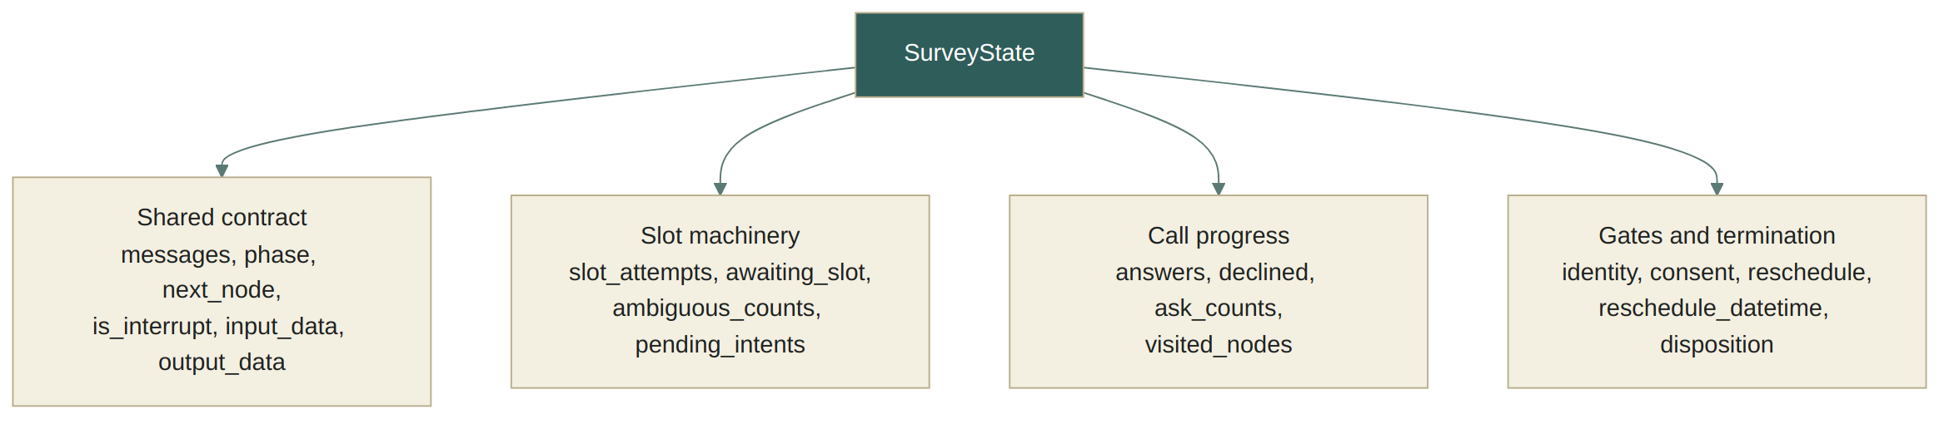
SurveyState fields, grouped by concern.
The agent itself is stateless between turns — MsatSurveyAgent.from_state(state) rebuilds its working memory (_slots, _answers, _pending_intents, _visited) fresh from the persisted state at the start of every turn, and persisted() serializes it back out at the end. This is what lets the LangGraph checkpointer suspend and resume a call across process restarts.

The two facts the work item brings
example input, validated against data/input_schema.json
{
"workflow_subtype": "MEMBER_SATISFACTION_SURVEY",
"policyholder": {
"first_name": "Margaret",
"last_name": "Ellison",
"risk_tier": "high"
}
}

risk_tier is resolved once via payload.resolve() and gates question 5. If a work item omits it, the CLI flags it before the call starts; if a call somehow runs anyway, the question is skipped, never guessed.

11 — OUTPUT

The call outcome
_outcome() builds the final {"call_outcome": ...} payload (validated against data/outcome_schema.json). Its most deliberate design choice is keeping three kinds of "no answer" apart:
Field | Meaning
declined_questions | This member was asked, and chose not to answer.
skipped_questions | This member's script never included it — with the exact condition that ruled it out (e.g. "payload risk_tier is not high").
missing_questions | Applicable, never answered — the call ended before it was reached.
disposition then tells you how the call ended — one of surveyed, partially_surveyed, uninterested, reschedule_requested, representative_requested, safeguarding_handoff, voicemail_left, policyholder_unavailable, wrong_number, do_not_call, or ended_early. Only ended_early is reported as status: "incomplete" — a member who politely declined is a correct outcome, not a fault, and the design is explicit that burying refusals in with technical failures "would make both harder to see."
example call_outcome
{
"call_outcome": {
"status": "complete",
"disposition": "surveyed",
"gating_facts": { "risk_tier": "rising" },
"answers": {
"reviewed_resources": "yes",
"resource_helpfulness": "somewhat_helpful",
"would_recommend": "yes",
"overall_experience": "extremely_helpful"
},
"declined_questions": [],
"skipped_questions": [
{ "slot": "staff_helpful", "node": "sv.05",
"reason": "payload risk_tier is not high" }
],
"missing_questions": [],
"visited_nodes": ["in.01", "in.02", "sv.00", "sv.01"],
"open_intents": []
}
}

12 — REFERENCE

File-by-file map
Path | Role
msat_flow/app_graph.py | LangGraph wiring — the two-node interrupt/resume state machine.
msat_flow/state.py | SurveyState TypedDict + initial_state().
msat_flow/agents/survey_agent.py | MsatSurveyAgent — all MSAT-specific per-turn logic.
msat_flow/core/agent.py | BaseAgent ABC that composes the four mixins.
msat_flow/core/guards.py | Regex safety/voicemail/hold/do-not-call detection, pre-LLM.
msat_flow/core/slot_manager.py | Answer bookkeeping: record, forget, payload lookups.
msat_flow/core/signals.py | speak() / signal_complete() / signal_transfer() — the three turn endings.
msat_flow/core/dialogue_manager.py | Corrections + side-request (pending intent) tracking.
msat_flow/core/pending_intents.py | Data model for the pending-intent ledger.
msat_flow/core/models.py | SlotAttempt — per-slot attempt count / exhaustion.
msat_flow/planner.py | plan_next() — the pure decision function; applicability/skip/outstanding helpers.
msat_flow/payload.py | Resolves work-item facts (name, risk tier) by declared path only.
msat_flow/script/spec.py | SurveySpec — loads & indexes data/msat_spec.json by node/kind/slot.
msat_flow/slots/*.py | normalize → validate → accept pipeline for every answer.
msat_flow/llm/client.py | Thin Azure/OpenAI chat wrapper: structured() + text().
msat_flow/llm/extractor.py | Builds the "read the turn" prompt and calls the model (LLM call #1).
msat_flow/llm/response_generator.py | Builds the "say the line" prompt and calls the model (LLM call #2).
msat_flow/llm/schema.py | TurnDecision Pydantic schema — the extractor's structured output contract.
data/msat_script.json, data/slot_map.json | Hand-authored source; compiled into data/msat_spec.json (never edited directly).
data/input_schema.json, data/outcome_schema.json | JSON Schemas validating the call's input and output payloads.
prompts/*.md | All prompt wording, kept out of Python so it can be reviewed/edited independently.

Generated from Swetha-Hariharan1810/conversation-agent-msat-sda — msat_flow/ · data/ · prompts/

