# *M-2 Lab: Data Summarization*

Problem 1: Overall Average Rating

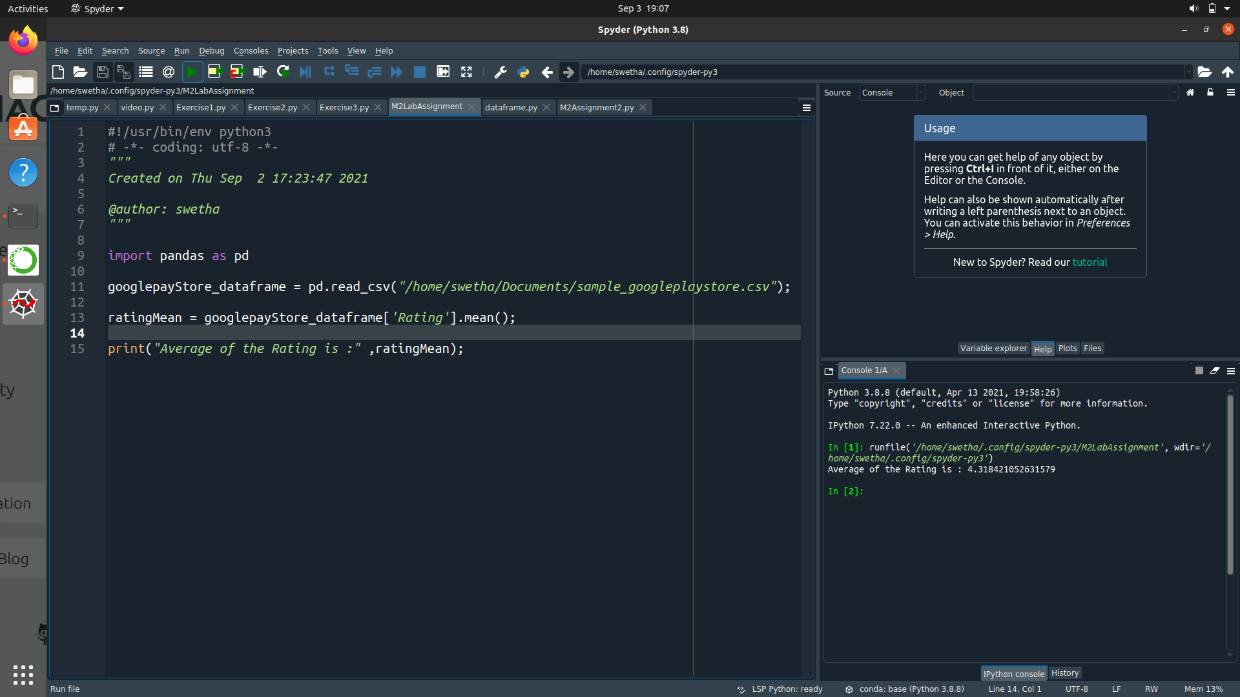

### Problem 2: Average Rating per Category

