**EX NO:1,2 Develop an application that uses GUI components, Font,Colours and DATE: 03.08.2021 use Layout Managers and event listeners.**

**AIM:** To Developan application that uses GUI components, Font and Colours and

an application that uses Layout Managers and event listeners.

**CODE:**

**Main.dart**

import 'package:flutter/material.dart';  
  
void main() => runApp(MyApp());  
  
class MyApp extends StatelessWidget {  
 @override  
 Widget build(BuildContext context) {  
 final appTitle = 'IcyRobins';  
  
 return MaterialApp(  
 title: appTitle,  
 home: Scaffold(  
 backgroundColor: Colors.*cyanAccent*,  
 appBar: AppBar(  
 title: Text(appTitle),  
 ),  
 body: AddTwoNumbers(),  
 ),  
 );  
 }  
}  
class AddTwoNumbers extends StatefulWidget {  
 @override  
 _AddTwoNumbersState createState() => _AddTwoNumbersState();  
}  
  
class _AddTwoNumbersState extends State<AddTwoNumbers> {  
 TextEditingController num1controller = new TextEditingController()..text="0";  
 TextEditingController num2controller = new TextEditingController()..text="0";  
 TextEditingController num3controller = new TextEditingController()..text="0";  
  
  
 String result = "0";  
 @override  
 Widget build(BuildContext context) {  
 return Container(  
 child: Column(  
 children: <Widget>[  
 Row(  
 children: <Widget>[  
  
 Text(" Vanilla- Rs 40 ",style:TextStyle(fontWeight: FontWeight.*bold*,fontSize: 30)),  
 Text("Enter Quantity: ",style: TextStyle(fontSize: 20),),  
 new Flexible(  
 child: new TextField(  
 keyboardType: TextInputType.*number*,  
 controller: num1controller,  
 ),  
 ),  
 ],  
 ),  
 Row(  
 children: <Widget>[  
 Text(" Chocolate- Rs 45 ",style:TextStyle(fontWeight: FontWeight.*bold*,fontSize: 30)),  
 Text("Enter Quantity: ",style: TextStyle(fontSize: 20),),  
 new Flexible(  
 child: new TextField(  
 keyboardType: TextInputType.*number*,  
 controller: num2controller,  
 ),  
 ),  
 ],  
 ),  
 Row(  
 children: <Widget>[  
 Text(" Strawberry- Rs 35 ",style:TextStyle(fontWeight: FontWeight.*bold*,fontSize: 30)),  
 Text("Enter Quantity: ",style: TextStyle(fontSize: 20),),  
 new Flexible(  
 child: new TextField(  
 keyboardType: TextInputType.*number*,  
 controller: num3controller,  
 ),  
 ),  
 ],  
 ),  
  
 Row(  
 mainAxisAlignment: MainAxisAlignment.center,  
 children: <Widget>[  
 RaisedButton(  
 child: Text("Total Price",style: TextStyle(fontSize: 25,fontWeight: FontWeight.*bold*),),  
 onPressed : () {  
 setState(() {  
 int sum = int.*parse*(num1controller.text)*40 + int.*parse*(num2controller.text)*45 +int.*parse*(num3controller.text)*35;  
 result = sum.toString();  
 });  
 },  
 )  
 ],  
 ),  
 Row(  
 mainAxisAlignment: MainAxisAlignment.center,  
 children: <Widget>[  
 Text("Amount to be paid:",  
 style: TextStyle(  
 fontSize: 30,  
 ),),  
 Text(result,  
 style: TextStyle(  
 fontSize: 30,  
 ),),  
 ],  
 ),  
 ],  
 ),  
 );  
 }

}

**OUTPUT:**

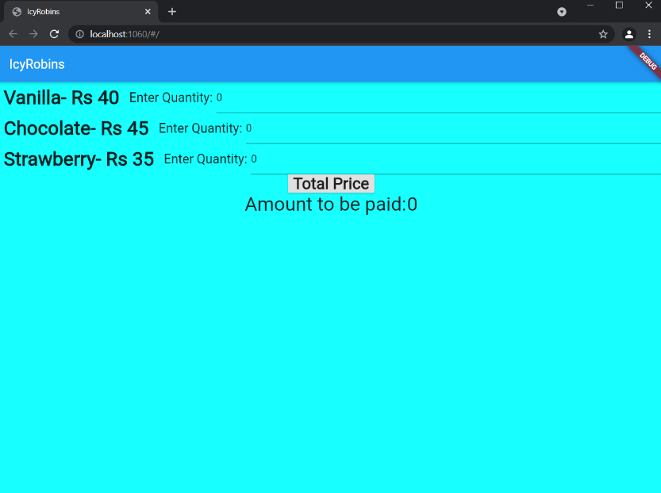

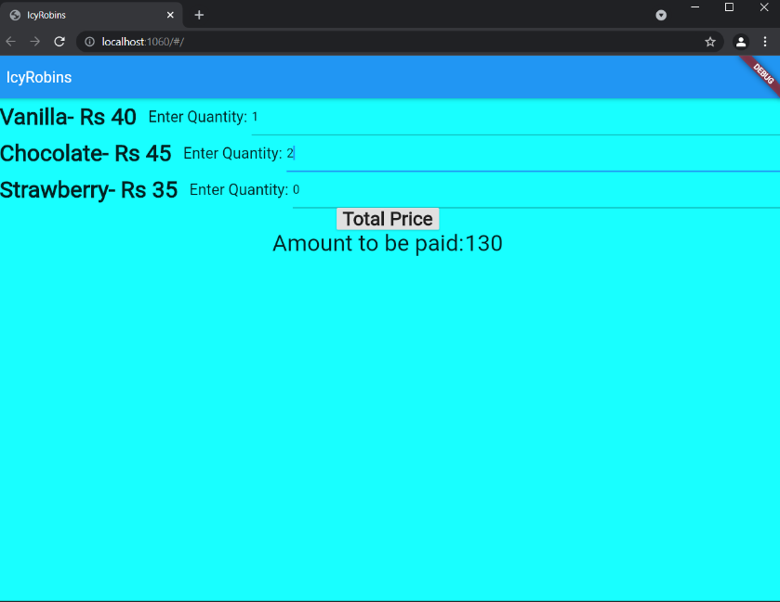

**RESULT:**

Thus the application that uses GUI components, Font and Colours and an application that uses Layout Managers and event listeners using flutter was created successfully.

**EX NO:03 Develop a Native Calculator Application**

**DATE: 17.08.2021**

**AIM:** To develop a native calculator application.

**CODE:**

**Main.dart**

import 'package:flutter/material.dart';  
import 'package:math_expressions/math_expressions.dart';  
  
void main(){  
 runApp(Calculator());  
}  
class Calculator extends StatelessWidget {  
 @override  
 Widget build(BuildContext context) {  
 return MaterialApp(  
 debugShowCheckedModeBanner: false,  
 title: 'Calculator',  
 theme: ThemeData(primarySwatch: Colors.*blue*),  
 home: SimpleCalculator(),  
 );  
 }  
}  
  
class SimpleCalculator extends StatefulWidget {  
 @override  
 _SimpleCalculatorState createState() => _SimpleCalculatorState();  
}  
  
class _SimpleCalculatorState extends State<SimpleCalculator> {  
  
 String equation = "0";  
 String result = "0";  
 String expression = "";  
 double equationFontSize = 38.0;  
 double resultFontSize = 48.0;  
  
 buttonPressed(String buttonText){  
 setState(() {  
 if(buttonText == "C"){  
 equation = "0";  
 result = "0";  
 equationFontSize = 38.0;  
 resultFontSize = 48.0;  
 }  
  
 else if(buttonText == "⌫"){  
 equationFontSize = 48.0;  
 resultFontSize = 38.0;  
 equation = equation.substring(0, equation.length - 1);  
 if(equation == ""){  
 equation = "0";  
 }  
 }  
  
 else if(buttonText == "="){  
 equationFontSize = 38.0;  
 resultFontSize = 48.0;  
  
 expression = equation;  
 expression = expression.replaceAll('×', '*');  
 expression = expression.replaceAll('÷', '/');  
  
 try{  
 Parser p = Parser();  
 Expression exp = p.parse(expression);  
  
 ContextModel cm = ContextModel();  
 result = '${exp.evaluate(EvaluationType.REAL, cm)}';  
 }catch(e){  
 result = "Error";  
 }  
  
 }  
  
 else{  
 equationFontSize = 48.0;  
 resultFontSize = 38.0;  
 if(equation == "0"){  
 equation = buttonText;  
 }else {  
 equation = equation + buttonText;  
 }  
 }  
 });  
 }  
  
 Widget buildButton(String buttonText, double buttonHeight, Color buttonColor){  
 return Container(  
 height: MediaQuery.*of*(context).size.height * 0.1 * buttonHeight,  
 color: buttonColor,  
 child: FlatButton(  
 shape: RoundedRectangleBorder(  
 borderRadius: BorderRadius.circular(0.0),  
 side: BorderSide(  
 color: Colors.*white*,  
 width: 1,  
 style: BorderStyle.solid  
 )  
 ),  
 padding: EdgeInsets.all(16.0),  
 onPressed: () => buttonPressed(buttonText),  
 child: Text(  
 buttonText,  
 style: TextStyle(  
 fontSize: 30.0,  
 fontWeight: FontWeight.*normal*,  
 color: Colors.*white* ),  
 )  
 ),  
 );  
 }  
 @override  
 Widget build(BuildContext context) {  
 return Scaffold(  
 appBar: AppBar(title: Text('Calculator')),  
 body: Column(  
 children: <Widget>[  
 Container(  
 alignment: Alignment.*centerRight*,  
 padding: EdgeInsets.fromLTRB(10, 20, 10, 0),  
 child: Text(equation, style: TextStyle(fontSize: equationFontSize),),  
 ),  
 Container(  
 alignment: Alignment.*centerRight*,  
 padding: EdgeInsets.fromLTRB(10, 30, 10, 0),  
 child: Text(result, style: TextStyle(fontSize: resultFontSize),),  
 ),  
 Expanded(  
 child: Divider(),  
 ),  
 Row(  
 mainAxisAlignment: MainAxisAlignment.center,  
 children: <Widget>[  
 Container(  
 width: MediaQuery.*of*(context).size.width * .75,  
 child: Table(  
 children: [  
 TableRow(  
 children: [  
 buildButton("C", 1, Colors.*redAccent*),  
 buildButton("⌫", 1, Colors.*blue*),  
 buildButton("÷", 1, Colors.*blue*),  
 ]  
 ),  
  
 TableRow(  
 children: [  
 buildButton("7", 1, Colors.*black87*),  
 buildButton("8", 1, Colors.*black87*),  
 buildButton("9", 1, Colors.*black87*),  
 ]  
 ),  
  
 TableRow(  
 children: [  
 buildButton("4", 1, Colors.*black87*),  
 buildButton("5", 1, Colors.*black87*),  
 buildButton("6", 1, Colors.*black87*),  
 ]  
 ),  
  
 TableRow(  
 children: [  
 buildButton("1", 1, Colors.*black87*),  
 buildButton("2", 1, Colors.*black87*),  
 buildButton("3", 1, Colors.*black87*),  
 ]  
 ),  
 TableRow(  
 children: [  
 buildButton(".", 1, Colors.*black87*),  
 buildButton("0", 1, Colors.*black87*),  
 buildButton("00", 1, Colors.*black87*),  
 ]  
 ),  
 ],  
 ),  
 ),  
 Container(  
 width: MediaQuery.*of*(context).size.width * 0.25,  
 child: Table(  
 children: [  
 TableRow(  
 children: [  
 buildButton("×", 1, Colors.*blue*),  
 ]  
 ),  
 TableRow(  
 children: [  
 buildButton("-", 1, Colors.*blue*),  
 ]  
 ),  
 TableRow(  
 children: [  
 buildButton("+", 1, Colors.*blue*),  
 ]  
 ),  
  
 TableRow(  
 children: [  
 buildButton("=", 2, Colors.*redAccent*),  
 ]  
 ),  
 ], ), ) ],  
 ),  
 ],  
 ),  
 );  
 }  
}

**OUTPUT:**

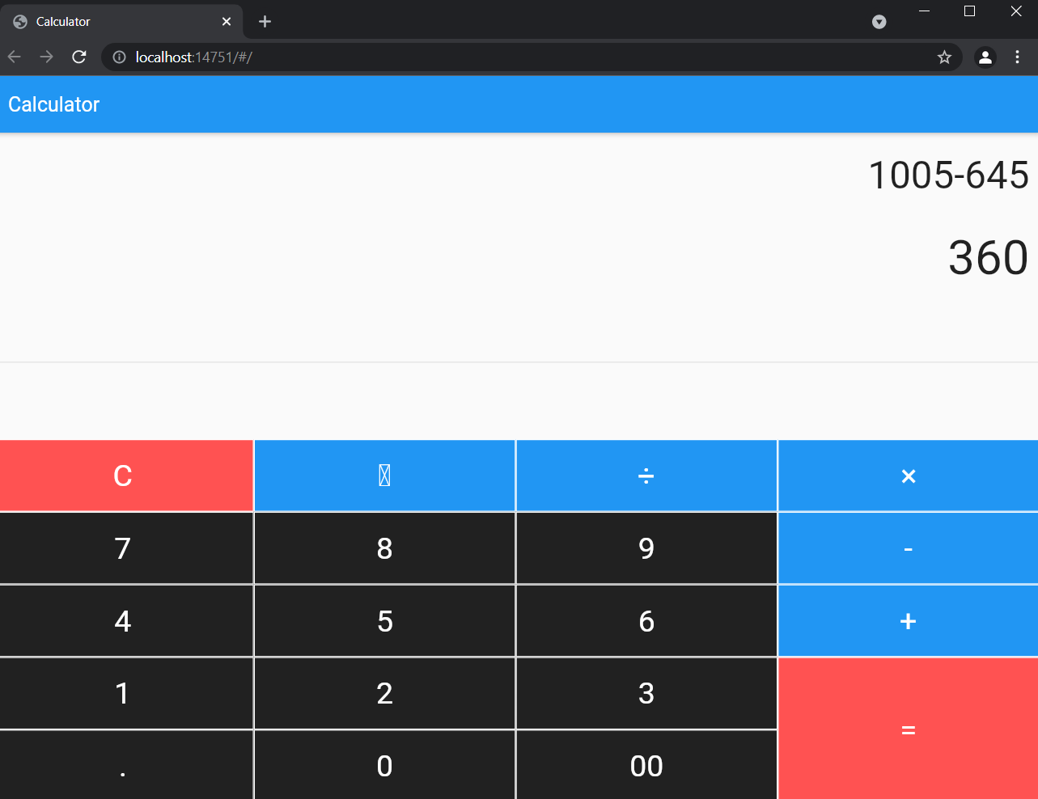

**RESULT:**

Thus the native calculator application using flutter has been created successfully.

**EX NO:04 Develop an Application that draws basic Graphical Primitives on the**

**DATE: 24.08.2021 screen**

**AIM:** To  [write an application that draws basic graphical primitives on the screen.](https://codingconnect.net/android-application-basic-graphical-primitives/)

**CODE:**

**Main.dart**

import 'package:flutter/material.dart';  
  
void main() => runApp(HomePage());  
  
class HomePage extends StatelessWidget {  
 @override  
 Widget build(BuildContext context) {  
 return MaterialApp(  
 theme: ThemeData(  
 brightness: Brightness.dark,  
 accentColor: Colors.*teal*,  
 ),  
 home: Scaffold(  
 appBar: AppBar(  
 title: Text('Custom Shapes'),  
 ),  
 body: Padding(  
 padding: EdgeInsets.all(8.0),  
 child: CustomPaint(  
 painter: ShapesPainter(),  
 child: Container(  
 height: 700,  
 ),  
 ),  
 ),  
 ),  
 );  
 }  
}  
  
class ShapesPainter extends CustomPainter {  
 @override  
 void paint(Canvas canvas, Size size) {  
 final paint = Paint();  
  
 // set the paint color to be white  
 paint.color = Colors.*greenAccent*;  
  
 // Create a rectangle with size and width same as the canvas  
 var rect = Rect.fromLTWH(0, 0, size.width, size.height);  
  
  
 // draw the rectangle using the paint  
 canvas.drawRect(rect, paint);  
  
 paint.color = Colors.*teal*;  
  
 // create a path  
 var path = Path();  
 path.lineTo(0, size.height);  
 path.lineTo(size.width, 0);  
 // close the path to form a bounded shape  
 path.close();  
  
 //canvas.drawPath(path, paint);  
  
 // set the color property of the paint  
 paint.color = Colors.*teal*;  
  
 // center of the canvas is (x,y) => (width/2, height/2)  
 var center = Offset(size.width / 2, size.height / 2);  
  
 // draw the circle with center having radius 75.0  
 canvas.drawCircle(center, 75.0, paint);  
  
 paint.color = Colors.*red*;  
 canvas.drawRect(Offset(100,100) & Size(200,200), paint);  
 paint.color = Colors.*indigo*;  
 canvas.drawRect(Offset(750,350) & Size(200,100), paint);  
  
 }  
  
 @override  
 bool shouldRepaint(CustomPainter oldDelegate) => false;  
}

**OUTPUT:**

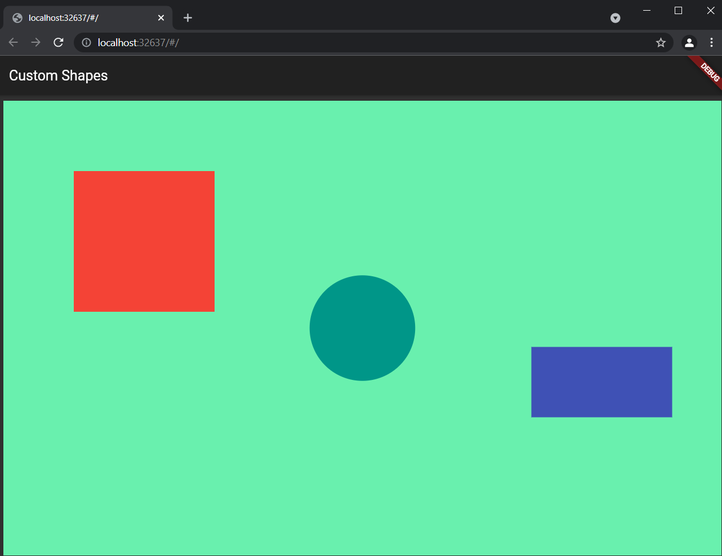

**RESULT:**

Thus the flutter program to draw the basic primitives has been executed successfully.

**EX NO:05 Develop an application that makes use of database.**

**DATE: 31.08.2021**

**AIM:** To develop an application that makes use of database

**CODE:**

**Mainactivity.java**

package com.example.ex05;  
  
import android.app.Activity;  
import android.app.AlertDialog.Builder;  
import android.content.Context;  
import android.database.Cursor;  
import android.database.sqlite.SQLiteDatabase;  
import android.os.Bundle;  
import android.view.View;  
import android.view.View.OnClickListener;  
import android.widget.Button;  
import android.widget.EditText;  
  
public class MainActivity extends Activity implements OnClickListener {  
 EditText Rollno, Name, Marks;  
 Button Insert, Delete, Update, View, ViewAll;  
 SQLiteDatabase db;  
  
 */**  
 * Called when the activity is first created.  
 */* @Override  
 public void onCreate(Bundle savedInstanceState) {  
 super.onCreate(savedInstanceState);  
 setContentView(R.layout.*activity_main*);  
  
 Rollno = (EditText) findViewById(R.id.*Rollno*);  
 Name = (EditText) findViewById(R.id.*Name*);  
 Marks = (EditText) findViewById(R.id.*Marks*);  
 Insert = (Button) findViewById(R.id.*Insert*);  
 Delete = (Button) findViewById(R.id.*Delete*);  
 Update = (Button) findViewById(R.id.*Update*);  
 View = (Button) findViewById(R.id.*View*);  
 ViewAll = (Button) findViewById(R.id.*ViewAll*);  
  
 Insert.setOnClickListener(this);  
 Delete.setOnClickListener(this);  
 Update.setOnClickListener(this);  
 View.setOnClickListener(this);  
 ViewAll.setOnClickListener(this);  
  
 // Creating database and table  
 db = openOrCreateDatabase("StudentDB", Context.*MODE_PRIVATE*, null);  
 db.execSQL("CREATE TABLE IF NOT EXISTS student(rollno VARCHAR,name VARCHAR,marks VARCHAR);");  
 }  
  
 public void onClick(View view) {  
 // Inserting a record to the Student table  
 if (view == Insert) {  
 // Checking for empty fields  
 if (Rollno.getText().toString().trim().length() == 0 ||  
 Name.getText().toString().trim().length() == 0 ||  
 Marks.getText().toString().trim().length() == 0) {  
 showMessage("Error", "Please enter all values");  
 return;  
 }  
 db.execSQL("INSERT INTO student VALUES('" + Rollno.getText() + "','" + Name.getText() +  
 "','" + Marks.getText() + "');");  
 showMessage("Success", "Record added");  
 clearText();  
 }  
 // Deleting a record from the Student table  
 if (view == Delete) {  
 // Checking for empty roll number  
 if (Rollno.getText().toString().trim().length() == 0) {  
 showMessage("Error", "Please enter Rollno");  
 return;  
 }  
 Cursor c = db.rawQuery("SELECT * FROM student WHERE rollno='" + Rollno.getText() + "'", null);  
 if (c.moveToFirst()) {  
 db.execSQL("DELETE FROM student WHERE rollno='" + Rollno.getText() + "'");  
 showMessage("Success", "Record Deleted");  
 } else {  
 showMessage("Error", "Invalid Rollno");  
 }  
 clearText();  
 }  
 // Updating a record in the Student table  
 if (view == Update) {  
 // Checking for empty roll number  
 if (Rollno.getText().toString().trim().length() == 0) {  
 showMessage("Error", "Please enter Rollno");  
 return;  
 }  
 Cursor c = db.rawQuery("SELECT * FROM student WHERE rollno='" + Rollno.getText() + "'", null);  
 if (c.moveToFirst()) {  
 db.execSQL("UPDATE student SET name='" + Name.getText() + "',marks='" + Marks.getText() +  
 "' WHERE rollno='" + Rollno.getText() + "'");  
 showMessage("Success", "Record Modified");  
 } else {  
 showMessage("Error", "Invalid Rollno");  
 }  
 clearText();  
 }  
 // Display a record from the Student table  
 if (view == View) {  
 // Checking for empty roll number  
 if (Rollno.getText().toString().trim().length() == 0) {  
 showMessage("Error", "Please enter Rollno");  
 return;  
 }  
 Cursor c = db.rawQuery("SELECT * FROM student WHERE rollno='" + Rollno.getText() + "'", null);  
 if (c.moveToFirst()) {  
 Name.setText(c.getString(1));  
 Marks.setText(c.getString(2));  
 } else {  
 showMessage("Error", "Invalid Rollno");  
 clearText();  
 }  
 }  
 // Displaying all the records  
 if (view == ViewAll) {  
 Cursor c = db.rawQuery("SELECT * FROM student", null);  
 if (c.getCount() == 0) {  
 showMessage("Error", "No records found");  
 return;  
 }  
 StringBuffer buffer = new StringBuffer();  
 while (c.moveToNext()) {  
 buffer.append("Rollno: " + c.getString(0) + "\n");  
 buffer.append("Name: " + c.getString(1) + "\n");  
 buffer.append("Marks: " + c.getString(2) + "\n\n");  
 }  
 showMessage("Student Details", buffer.toString());  
 }  
 }  
  
 public void showMessage(String title, String message) {  
 Builder builder = new Builder(this);  
 builder.setCancelable(true);  
 builder.setTitle(title);  
 builder.setMessage(message);  
 builder.show();  
 }  
  
 public void clearText() {  
 Rollno.setText("");  
 Name.setText("");  
 Marks.setText("");  
 Rollno.requestFocus();  
 }  
}

**Activity.main.xml**

<?xml version="1.0" encoding="utf-8"?>  
<AbsoluteLayout xmlns:android="http://schemas.android.com/apk/res/android"  
 android:layout_width="match_parent"  
 android:layout_height="match_parent"  
 android:background="#97FAE3">  
  
 <TextView  
 android:layout_width="wrap_content"  
 android:layout_height="wrap_content"  
 android:layout_x="95dp"  
 android:layout_y="22dp"  
 android:text="Student Details"  
 android:textColor="#009688"  
 android:textSize="30sp"  
 android:textStyle="bold" />  
  
 <TextView  
 android:layout_width="wrap_content"  
 android:layout_height="wrap_content"  
 android:layout_x="20dp"  
 android:layout_y="110dp"  
 android:text="Enter Rollno:"  
 android:textColor="#000000"  
 android:textSize="20sp" />  
  
 <EditText  
 android:id="@+id/Rollno"  
 android:layout_width="150dp"  
 android:layout_height="wrap_content"  
 android:layout_x="175dp"  
 android:layout_y="100dp"  
 android:inputType="number"  
 android:textColor="#000000"  
 android:textSize="20sp" />  
  
 <TextView  
 android:layout_width="wrap_content"  
 android:layout_height="wrap_content"  
 android:layout_x="20dp"  
 android:layout_y="160dp"  
 android:text="Enter Name:"  
 android:textColor="#000000"  
 android:textSize="20sp" />  
  
 <EditText  
 android:id="@+id/Marks"  
 android:layout_width="152dp"  
 android:layout_height="wrap_content"  
 android:layout_x="174dp"  
 android:layout_y="198dp"  
 android:ems="10"  
 android:inputType="textPersonName"  
 android:textColor="#000000" />  
  
 <EditText  
 android:id="@+id/Name"  
 android:layout_width="150dp"  
 android:layout_height="wrap_content"  
 android:layout_x="175dp"  
 android:layout_y="150dp"  
 android:inputType="text"  
 android:textColor="#000000"  
 android:textSize="20sp" />  
  
 <TextView  
 android:layout_width="wrap_content"  
 android:layout_height="wrap_content"  
 android:layout_x="20dp"  
 android:layout_y="210dp"  
 android:text="Enter Marks:"  
 android:textColor="#000000"  
 android:textSize="20sp" />  
  
 <Button  
 android:id="@+id/Insert"  
 android:layout_width="150dp"  
 android:layout_height="wrap_content"  
 android:layout_x="25dp"  
 android:layout_y="300dp"  
 android:backgroundTint="#009688"  
 android:text="Insert"  
 android:textSize="20dp" />  
  
 <Button  
 android:id="@+id/Delete"  
 android:layout_width="150dp"  
 android:layout_height="wrap_content"  
 android:layout_x="200dp"  
 android:layout_y="300dp"  
 android:backgroundTint="#009688"  
 android:text="Delete"  
 android:textSize="20dp" />  
  
 <Button  
 android:id="@+id/Update"  
 android:layout_width="150dp"  
 android:layout_height="wrap_content"  
 android:layout_x="25dp"  
 android:layout_y="400dp"  
 android:backgroundTint="#009688"  
 android:text="Update"  
 android:textSize="20dp" />  
  
 <Button  
 android:id="@+id/View"  
 android:layout_width="150dp"  
 android:layout_height="wrap_content"  
 android:layout_x="200dp"  
 android:layout_y="400dp"  
 android:backgroundTint="#009688"  
 android:text="View"  
 android:textSize="20dp" />  
  
 <Button  
 android:id="@+id/ViewAll"  
 android:layout_width="200dp"  
 android:layout_height="wrap_content"  
 android:layout_x="100dp"  
 android:layout_y="500dp"  
 android:backgroundTint="#009688"  
 android:text="View All"  
 android:textSize="20dp" />  
  
</AbsoluteLayout>

**OUTPUT:**

**Insert**

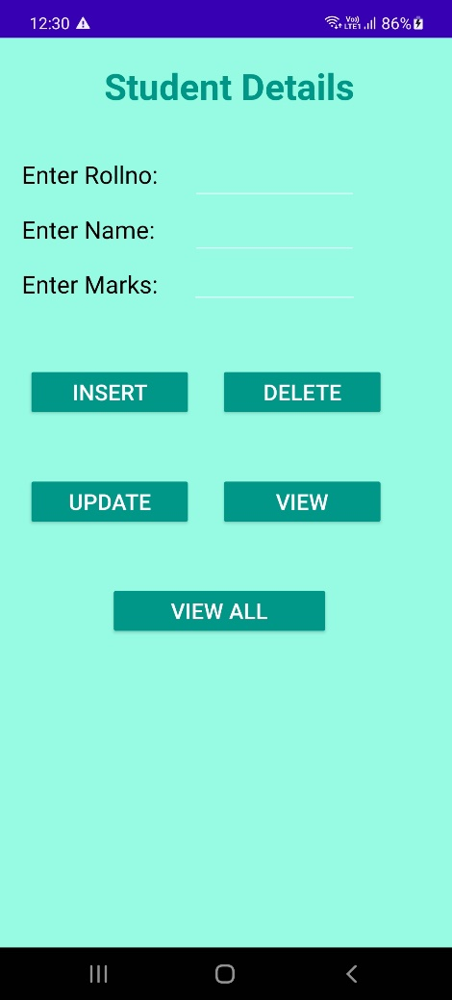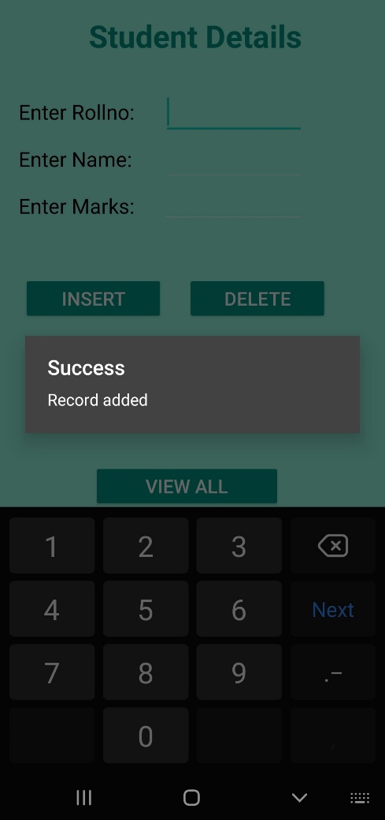

**ViewAll View**

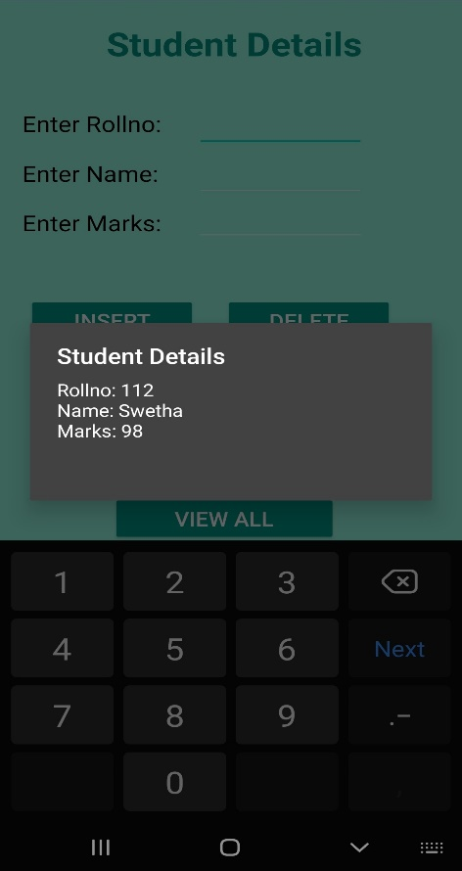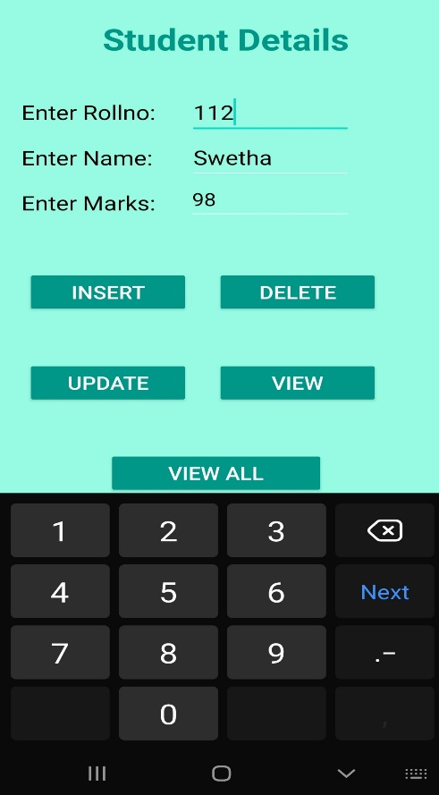

**Update**

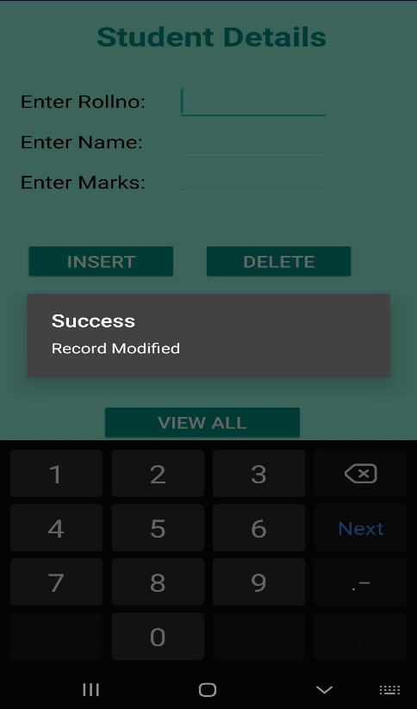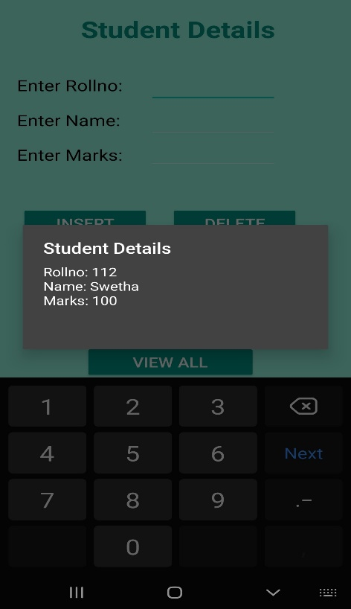

**Delete**

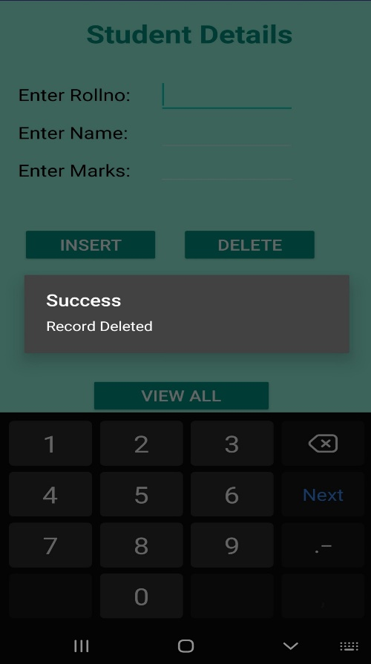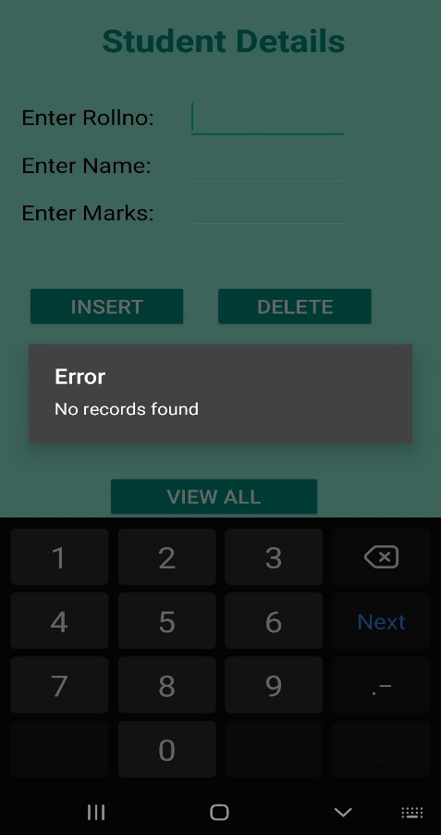

**RESULT:**

Thus the application making use of database has been created successfully.

**EX NO:06 Develop an application that makes use of RSS Feed.**

**DATE: 01.09.2021**

**AIM:** To develop an application that makes use of RSS Feed.

**CODE:**

**Mainactivity.java**

package com.example.ex06;  
  
import android.app.ListActivity;  
import android.content.Intent;  
import android.net.Uri;  
import android.os.AsyncTask;  
import android.os.Bundle;  
import android.view.View;  
import android.widget.ArrayAdapter;  
import android.widget.ListView;  
import org.xmlpull.v1.XmlPullParser;  
import org.xmlpull.v1.XmlPullParserException;  
import org.xmlpull.v1.XmlPullParserFactory;  
import java.io.IOException;  
import java.io.InputStream;  
import java.net.MalformedURLException;  
import java.net.URL;  
import java.util.ArrayList;  
import java.util.List;  
  
public class MainActivity extends ListActivity  
{  
 List headlines;  
 List links;  
  
 @Override  
 protected void onCreate(Bundle savedInstanceState)  
 {  
 super.onCreate(savedInstanceState);  
 new MyAsyncTask().execute();  
 }  
  
 class MyAsyncTask extends AsyncTask<Object,Void,ArrayAdapter>  
 {  
 @Override  
 protected ArrayAdapter doInBackground(Object[] params)  
 {  
 headlines = new ArrayList();  
 links = new ArrayList();  
 try  
 {  
 URL url = new URL("https://codingconnect.net/feed");  
 XmlPullParserFactory factory = XmlPullParserFactory.newInstance();  
 factory.setNamespaceAware(false);  
 XmlPullParser xpp = factory.newPullParser();  
  
 // We will get the XML from an input stream  
 xpp.setInput(getInputStream(url), "UTF_8");  
 boolean insideItem = false;  
  
 // Returns the type of current event: START_TAG, END_TAG, etc..  
 int eventType = xpp.getEventType();  
 while (eventType != XmlPullParser.END_DOCUMENT)  
 {  
 if (eventType == XmlPullParser.START_TAG)  
 {  
 if (xpp.getName().equalsIgnoreCase("item"))  
 {  
 insideItem = true;  
 }  
 else if (xpp.getName().equalsIgnoreCase("title"))  
 {  
 if (insideItem)  
 headlines.add(xpp.nextText()); //extract the headline  
 }  
 else if (xpp.getName().equalsIgnoreCase("link"))  
 {  
 if (insideItem)  
 links.add(xpp.nextText()); //extract the link of article  
 }  
 }  
 else if(eventType==XmlPullParser.END_TAG && xpp.getName().equalsIgnoreCase("item"))  
 {  
 insideItem=false;  
 }  
 eventType = xpp.next(); //move to next element  
 }  
  
 }  
 catch (MalformedURLException e)  
 {  
 e.printStackTrace();  
 }  
 catch (XmlPullParserException e)  
 {  
 e.printStackTrace();  
 }  
 catch (IOException e)  
 {  
 e.printStackTrace();  
 }  
 return null;  
 }  
 protected void onPostExecute(ArrayAdapter adapter)  
 {  
 adapter = new ArrayAdapter(MainActivity.this, android.R.layout.simple_list_item_1, headlines);  
 setListAdapter(adapter);  
 }  
 }  
  
 @Override  
 protected void onListItemClick(ListView l, View v, int position, long id)  
 {  
 Uri uri = Uri.parse((links.get(position)).toString());  
 Intent intent = new Intent(Intent.ACTION_VIEW, uri);  
 startActivity(intent);  
 }  
  
 public InputStream getInputStream(URL url)  
 {  
 try  
 {  
 return url.openConnection().getInputStream();  
 }  
 catch (IOException e)  
 {  
 return null;  
 }  
 }  
}

**activity_main.xml**

<?xml version="1.0" encoding="utf-8"?>  
<LinearLayout xmlns:android="http://schemas.android.com/apk/res/android"  
 android:layout_width="fill_parent"  
 android:layout_height="fill_parent"  
 android:orientation="vertical" >  
  
 <ListView  
 android:id="@+id/listView"  
 android:layout_width="match_parent"  
 android:layout_height="wrap_content" />  
  
</LinearLayout>

**OUTPUT:**

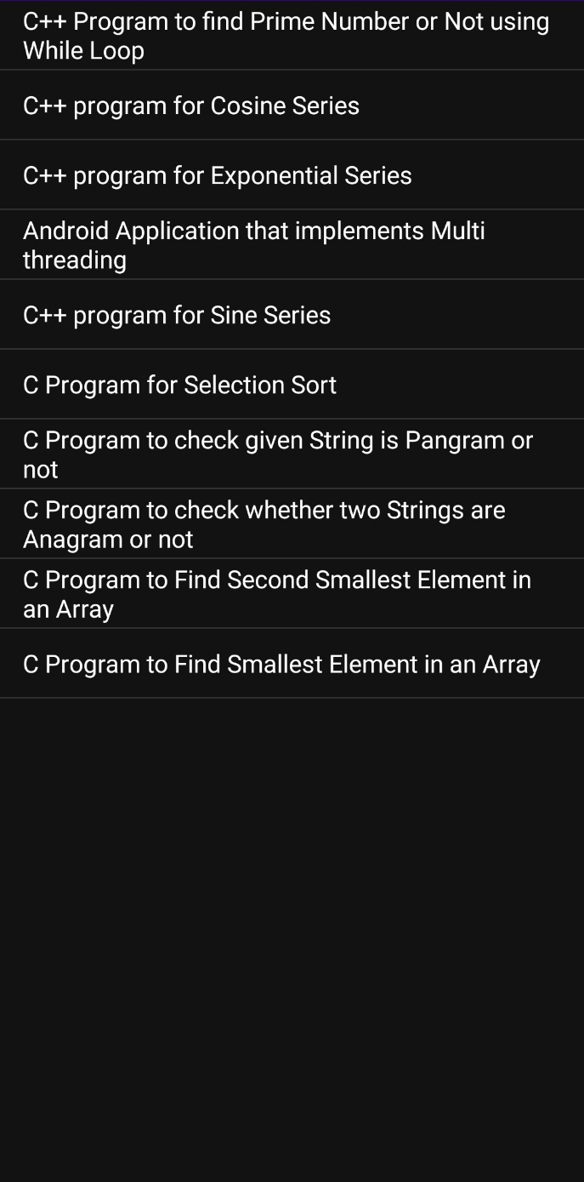

**RESULT:**

Thus the application that uses RSS feed has been created successfully.

**EX NO: 07 Implement an application that implements Multi-threading.**

**DATE: 06/09/21**

**AIM:**

To Implement an application that implements Multi-threading.

**SOURCE CODE:**

**Activity_main.xml**

<?xml version="1.0" encoding="utf-8"?>

<LinearLayout xmlns:android="http://schemas.android.com/apk/res/android"

android:layout_width="match_parent"

android:layout_height="match_parent"

android:orientation="vertical" >

<ImageView

android:id="@+id/imageView"

android:layout_width="250dp"

android:layout_height="250dp"

android:layout_margin="50dp"

android:layout_gravity="center" />

<Button

android:id="@+id/button"

android:layout_width="wrap_content"

android:layout_height="wrap_content"

android:layout_margin="10dp"

android:layout_gravity="center"

android:text="Load Image 1" />

<Button

android:id="@+id/button2"

android:layout_width="wrap_content"

android:layout_height="wrap_content"

android:layout_margin="10dp"

android:layout_gravity="center"

android:text="Load image 2" />

</LinearLayout>

**MainActivity.java**

package com.example.ex7;  
import androidx.appcompat.app.AppCompatActivity;  
import android.os.Bundle;  
import android.view.View;  
import android.widget.Button;  
import android.widget.ImageView;  
public class MainActivity extends AppCompatActivity  
{  
 ImageView img;  
 Button bt1,bt2;  
 @Override  
 protected void onCreate(Bundle savedInstanceState)  
 {  
 super.onCreate(savedInstanceState);  
 setContentView(R.layout.*activity_main*);  
  
 bt1 = (Button)findViewById(R.id.*button*);  
 bt2= (Button) findViewById(R.id.*button2*);  
 img = (ImageView)findViewById(R.id.*imageView*);  
  
 bt1.setOnClickListener(new View.OnClickListener()  
 {  
 @Override  
 public void onClick(View v)  
 {  
 new Thread(new Runnable()  
 {  
 @Override  
 public void run()  
 {  
 img.post(new Runnable()  
 {  
 @Override  
 public void run()  
 {  
 img.setImageResource(R.drawable.*india1*);  
 }  
 });  
 }  
 }).start();  
 } });  
  
 bt2.setOnClickListener(new View.OnClickListener()  
 {  
 @Override  
 public void onClick(View v)  
 {  
 new Thread(new Runnable()  
 {  
 @Override  
 public void run()  
 {  
 img.post(new Runnable()  
 {  
 @Override  
 public void run()  
 {  
 img.setImageResource(R.drawable.*india2*);  
 }  
 }); }  
 }).start();  
 }  
 });  
 }}

**OUTPUT:**

**RESULT:**

Thus an application that implements Multi-threading has been developed and executed.

**EX NO: 08 Develop a native application that uses GPS location information**

**DATE: 13/09/21**

**AIM:**

To develop a native application that uses GPS location information.

**SOURCE CODE:**

**Activity_main.xml:**

<?xml version="1.0" encoding="utf-8"?>  
<androidx.constraintlayout.widget.ConstraintLayout xmlns:android="http://schemas.android.com/apk/res/android"  
 xmlns:app="http://schemas.android.com/apk/res-auto"  
 xmlns:tools="http://schemas.android.com/tools"  
 android:layout_width="match_parent"  
 android:layout_height="match_parent"  
 tools:context=".MainActivity">  
  
 <LinearLayout  
 android:id="@+id/linearLayout"  
 android:layout_width="0dp"  
 android:layout_height="0dp"  
 android:layout_marginStart="1dp"  
 android:layout_marginLeft="1dp"  
 android:layout_marginTop="1dp"  
 android:layout_marginEnd="1dp"  
 android:layout_marginRight="1dp"  
 android:layout_marginBottom="1dp"  
 android:orientation="vertical"  
 app:layout_constraintBottom_toBottomOf="parent"  
 app:layout_constraintEnd_toEndOf="parent"  
 app:layout_constraintStart_toStartOf="parent"  
 app:layout_constraintTop_toTopOf="parent">  
  
 <TextView  
 android:id="@+id/textView2"  
 android:layout_width="match_parent"  
 android:layout_height="30dp"  
 android:text="Latitude" />  
  
 <TextView  
 android:id="@+id/txtlat"  
 android:layout_width="match_parent"  
 android:layout_height="35dp"  
 android:text="" />  
  
 <TextView  
 android:id="@+id/textView4"  
 android:layout_width="match_parent"  
 android:layout_height="35dp"  
 android:text="Longitude" />  
  
 <TextView  
 android:id="@+id/txtlong"  
 android:layout_width="match_parent"  
 android:layout_height="35dp"  
 android:text="" />  
 </LinearLayout>  
</androidx.constraintlayout.widget.ConstraintLayout>

**MainActivity.java:**

package com.example.gps;  
import androidx.annotation.NonNull;  
import androidx.appcompat.app.AppCompatActivity;  
import androidx.core.content.ContextCompat;  
import android.Manifest;  
import android.content.Context;  
import android.content.pm.PackageManager;  
import android.location.Criteria;  
import android.location.Location;  
import android.location.LocationListener;  
import android.location.LocationManager;  
import android.os.Build;  
import android.os.Bundle;  
import android.widget.TextView;  
import android.widget.Toast;  
public class MainActivity extends AppCompatActivity implements LocationListener {  
 LocationManager lmanager;  
 String provider;  
 @Override  
 protected void onCreate(Bundle savedInstanceState) {  
 super.onCreate(savedInstanceState);  
 setContentView(R.layout.activity_main);  
  
 if (Build.VERSION.SDK_INT >= 23) {  
 if (ContextCompat.checkSelfPermission(this, Manifest.permission.ACCESS_FINE_LOCATION) != PackageManager.PERMISSION_GRANTED ||  
 ContextCompat.checkSelfPermission(this, Manifest.permission.ACCESS_COARSE_LOCATION) != PackageManager.PERMISSION_GRANTED) {  
 requestPermissions(new String[]{Manifest.permission.ACCESS_COARSE_LOCATION, Manifest.permission.ACCESS_FINE_LOCATION}, 0);  
 }  
 else init();  
  
 } else {  
 init();  
 }  
 }  
  
 private void init() {  
 lmanager= (LocationManager)getSystemService(Context.LOCATION_SERVICE);  
 Criteria criteria=new Criteria();  
 provider= lmanager.getBestProvider(criteria,false);  
  
 if (ContextCompat.checkSelfPermission(this, Manifest.permission.ACCESS_FINE_LOCATION)!= PackageManager.PERMISSION_GRANTED ||  
 ContextCompat.checkSelfPermission(this, Manifest.permission.ACCESS_COARSE_LOCATION)!= PackageManager.PERMISSION_GRANTED)  
 return;  
  
 if(provider!=null && !provider.equals("")){  
 Location location= lmanager.getLastKnownLocation(provider);  
 lmanager.requestLocationUpdates(provider, 100, 1, this);  
 if(location!=null){  
 onLocationChanged(location);  
 }  
 else{  
 Toast.makeText(getBaseContext(), "Location not available!!", Toast.LENGTH_LONG).show();  
 }  
 }  
 else{  
 Toast.makeText(getBaseContext(), "No Provider found!!", Toast.LENGTH_LONG).show();  
 }  
 }  
  
 @Override  
 public void onRequestPermissionsResult(int requestCode, @NonNull String[] permissions, @NonNull int[] grantResults) {  
 super.onRequestPermissionsResult(requestCode, permissions, grantResults);  
 if (requestCode == 0 && grantResults.length == 2) {  
 init();  
 }  
 else Toast.*makeText*(getBaseContext(), "Required permissions not granted!", Toast.*LENGTH_SHORT*).show();  
 }  
  
 @Override  
 public void onLocationChanged(@NonNull Location location) {  
 TextView T1= (TextView)findViewById(R.id.txtlat);  
 TextView T2= (TextView)findViewById(R.id.txtlong);  
  
 T1.setText(""+ location.getLatitude());  
 T2.setText(""+ location.getLongitude());  
  
 }  
  
 @Override  
 public void onStatusChanged(String provider, int status, Bundle extras) {  
  
 }  
  
 @Override  
 public void onProviderEnabled(@NonNull String provider) {  
 }  
 @Override  
 public void onProviderDisabled(@NonNull String provider) {  
  
 }  
}

**AndroidManifest.xml**

<?xml version="1.0" encoding="utf-8"?>  
<manifest xmlns:android="http://schemas.android.com/apk/res/android"  
 package="com.example.gps">  
 <uses-permission android:name="android.permission.ACCESS_FINE_LOCATION"/>  
 <uses-permission android:name="android.permission.ACCESS_COARSE_LOCATION"/>  
 <uses-permission android:name="android.permission.INTERNET"/>  
  
  
 <application  
 android:allowBackup="true"  
 android:icon="@mipmap/ic_launcher"  
 android:label="@string/app_name"  
 android:roundIcon="@mipmap/ic_launcher_round"  
 android:supportsRtl="true"  
 android:theme="@style/Theme.Gps">  
 <activity  
 android:name=".MainActivity"  
 android:exported="true">  
 <intent-filter>  
 <action android:name="android.intent.action.MAIN" />  
  
 <category android:name="android.intent.category.LAUNCHER" />  
 </intent-filter>  
 </activity>  
 </application>  
  
</manifest>

**OUTPUT:**

**RESULT:**

Thus a native application that uses GPS location information has been developed and executed.

**EX NO: 09 Develop a Android Application that writes data to the SD Card.**

**DATE: 20/09/21**

**AIM:**

To develop a Android Application that writes data to the SD Card.

**SOURCE CODE:**

**MainActivity.java:**

package com.example.sdcard;  
import android.content.Context;  
import android.os.Bundle;  
import android.view.View;  
import android.widget.Button;  
import android.widget.EditText;  
import android.widget.Toast;  
import androidx.appcompat.app.AppCompatActivity;  
import java.io.BufferedReader;  
import java.io.File;  
import java.io.FileInputStream;  
import java.io.FileNotFoundException;  
import java.io.FileOutputStream;  
import java.io.IOException;  
import java.io.InputStreamReader;  
import java.io.OutputStreamWriter;  
public class MainActivity extends AppCompatActivity {  
 EditText editTextFileName,editTextData,e1;  
 Button saveButton,readButton;  
 @Override  
 protected void onCreate(Bundle savedInstanceState) {  
 super.onCreate(savedInstanceState);  
 setContentView(R.layout.activity_main);  
 editTextFileName=findViewById(R.id.editText1);  
 editTextData=findViewById(R.id.editText2);  
 saveButton=findViewById(R.id.button1);  
 readButton=findViewById(R.id.button2);  
 e1 = findViewById(R.id.editText4);  
  
  
//Performing Action on Read Button  
 saveButton.setOnClickListener(new View.OnClickListener(){  
 @Override  
 public void onClick(View arg0) {  
 String filename=editTextFileName.getText().toString();  
 String data=editTextData.getText().toString();  
 FileOutputStream fos;  
 try {  
 fos = openFileOutput(filename, Context.MODE_APPEND);  
//default mode is PRIVATE, can be APPEND etc.  
 fos.write(data.getBytes());  
 fos.close();  
 Toast.makeText(getApplicationContext(),filename + " saved",  
 Toast.LENGTH_LONG).show();  
 } catch (FileNotFoundException e) {e.printStackTrace();}  
 catch (IOException e) {e.printStackTrace();}  
 } });  
//Performing Action on Read Button  
 readButton.setOnClickListener(new View.OnClickListener(){  
 @Override  
 public void onClick(View arg0) {  
 String filename=editTextFileName.getText().toString();  
 StringBuffer stringBuffer = new StringBuffer();  
 try {  
//Attaching BufferedReader to the FileInputStream by the help of InputStreamReader  
 BufferedReader inputReader = new BufferedReader(new InputStreamReader(  
 openFileInput(filename)));  
 String inputString;  
//Reading data line by line and storing it into the stringbuffer  
 while ((inputString = inputReader.readLine()) != null) {  
 stringBuffer.append(inputString + "\n");  
 }  
 } catch (IOException e) {  
 e.printStackTrace(); }  
 Toast.makeText(getApplicationContext(),stringBuffer.toString(),Toast.LENGTH_LONG).show();  
 e1.setText(stringBuffer.toString().trim());  
  
 }  
 }  
 ); }  
}

**Activity_main.xml:**

<?xml version="1.0" encoding="utf-8"?>

<RelativeLayout xmlns:android="http://schemas.android.com/apk/res/android"

xmlns:app="http://schemas.android.com/apk/res-auto"

xmlns:tools="http://schemas.android.com/tools"

android:layout_width="match_parent"

android:layout_height="match_parent"

tools:context=".MainActivity">

<EditText

android:id="@+id/editText1"

android:layout_width="wrap_content"

android:layout_height="wrap_content"

android:layout_alignParentRight="true"

android:layout_alignParentTop="true"

android:layout_marginRight="20dp"

android:layout_marginTop="24dp"

android:ems="10" >

<requestFocus />

</EditText>

<EditText

android:id="@+id/editText2"

android:layout_width="wrap_content"

android:layout_height="wrap_content"

android:layout_alignRight="@+id/editText1"

android:layout_below="@+id/editText1"

android:layout_marginTop="24dp"

android:ems="10" />

<TextView

android:id="@+id/textView1"

android:layout_width="wrap_content"

android:layout_height="wrap_content"

android:layout_alignBaseline="@+id/editText1"

android:layout_alignBottom="@+id/editText1"

android:layout_alignParentLeft="true"

android:text="File Name:" />

<TextView

android:id="@+id/textView2"

android:layout_width="wrap_content"

android:layout_height="wrap_content"

android:layout_alignBaseline="@+id/editText2"

android:layout_alignBottom="@+id/editText2"

android:layout_alignParentLeft="true"

android:text="Data:" />

<Button

android:id="@+id/button1"

android:layout_width="wrap_content"

android:layout_height="wrap_content"

android:layout_alignLeft="@+id/editText2"

android:layout_below="@+id/editText2"

android:layout_marginLeft="5dp"

android:layout_marginTop="16dp"

android:text="save" />

<Button

android:id="@+id/button2"

android:layout_width="wrap_content"

android:layout_height="wrap_content"

android:layout_alignBaseline="@+id/button1"

android:layout_alignBottom="@+id/button1"

android:layout_toRightOf="@+id/button1"

android:text="read" />

<EditText

android:id="@+id/editText4"

android:layout_width="wrap_content"

android:layout_height="wrap_content"

android:hint="Retrived data"

android:layout_alignParentTop="true"

android:layout_alignParentRight="true"

android:layout_marginTop="271dp"

android:layout_marginRight="91dp"

android:ems="10">

<requestFocus />

</EditText>

</RelativeLayout>

**OUTPUT:**

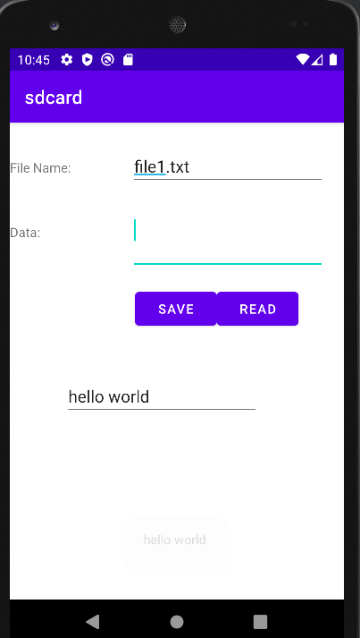

**RESULT:**

Thus Android Application that writes data to the SD Card is developed and executed successfully.

**EX NO: 10 Implement an application that creates an alert upon receiving a message.**

**DATE: 20/09/21**

**AIM:**

To Implement an application that creates an alert upon receiving a message.

**SOURCE CODE:**

**Activity_main.xml:**

<?xml version="1.0" encoding="utf-8"?>  
<LinearLayout xmlns:android="http://schemas.android.com/apk/res/android"  
 android:layout_width="match_parent"  
 android:layout_height="match_parent"  
 android:layout_margin="10dp"  
 android:orientation="vertical">  
 <TextView  
 android:layout_width="wrap_content"  
 android:layout_height="wrap_content"  
 android:text="Message"  
 android:textSize="30sp" />  
 <EditText  
 android:id="@+id/editText"  
 android:layout_width="match_parent"  
 android:layout_height="wrap_content"  
 android:singleLine="true"  
 android:textSize="30sp" />  
 <Button  
 android:id="@+id/button"  
 android:layout_width="wrap_content"  
 android:layout_height="wrap_content"  
 android:layout_margin="30dp"  
 android:layout_gravity="center"  
 android:text="Notify"  
 android:textSize="30sp"/>  
</LinearLayout>

**MainActivity.java:**

package com.example.ex10;  
  
import android.app.Notification;  
import android.app.NotificationManager;  
import android.app.PendingIntent;  
import android.content.Intent;  
import android.os.Bundle;  
  
import android.view.View;  
import android.widget.Button;  
import android.widget.EditText;  
import androidx.appcompat.app.AppCompatActivity;  
public class MainActivity extends AppCompatActivity  
{  
 Button notify;  
 EditText e;  
 @Override  
 protected void onCreate(Bundle savedInstanceState)  
 {  
 super.onCreate(savedInstanceState);  
 setContentView(R.layout.*activity_main*);  
  
 notify= (Button) findViewById(R.id.*button*);  
 e= (EditText) findViewById(R.id.*editText*);  
  
 notify.setOnClickListener(new View.OnClickListener()  
 {  
 @Override  
 public void onClick(View v)  
 {  
 Intent intent = new Intent(MainActivity.this, SecondActivity.class);  
 PendingIntent pending = PendingIntent.*getActivity*(MainActivity.this, 0, intent, 0);  
 Notification noti = new Notification.Builder(MainActivity.this).setContentTitle("New Message").setContentText(e.getText().toString()).setSmallIcon(R.mipmap.*ic_launcher*).setContentIntent(pending).build();  
 NotificationManager manager = (NotificationManager) getSystemService(*NOTIFICATION_SERVICE*);  
 noti.flags |= Notification.*FLAG_AUTO_CANCEL*;  
 manager.notify(1, noti);  
 }  
 });  
 }  
}

**SecondActivity.java:**

package com.example.ex10;  
import android.os.Bundle;  
  
import androidx.appcompat.app.AppCompatActivity;  
public class SecondActivity extends AppCompatActivity {  
 @Override  
 protected void onCreate(Bundle savedInstanceState) {  
 super.onCreate(savedInstanceState);  
 setContentView(R.layout.*activity_second*);  
 }  
}

**activity_second.java:**

<?xml version="1.0" encoding="utf-8"?>  
<LinearLayout xmlns:android="http://schemas.android.com/apk/res/android"  
 android:layout_width="match_parent"  
 android:layout_height="match_parent"  
 android:layout_margin="10dp"  
 android:orientation="vertical">  
  
 <TextView  
 android:layout_width="wrap_content"  
 android:layout_height="wrap_content"  
 android:text="hi"  
 android:textSize="30sp" />  
</LinearLayout>

**OUTPUT:**

**RESULT:**

Thus an application that creates an alert upon receiving a message has been developed and executed successfully.

**EX NO: 11 Write a mobile application that creates an alarm clock.**

**DATE: 04/10/21**

**AIM:**

To Implement a mobile application that creates an alarm clock.

**SOURCE CODE:**

**AndroidManifest.xml:**

<?xml version="1.0" encoding="utf-8"?>  
<manifest xmlns:android="http://schemas.android.com/apk/res/android"  
 package="com.example.ex11">  
  
 <application  
 android:allowBackup="true"  
 android:icon="@mipmap/ic_launcher"  
 android:label="@string/app_name"  
 android:roundIcon="@mipmap/ic_launcher_round"  
 android:supportsRtl="true"  
 android:theme="@style/Theme.Ex11">  
 <activity  
 android:name=".MainActivity"  
 android:exported="true">  
 <intent-filter>  
 <action android:name="android.intent.action.MAIN" />  
  
 <category android:name="android.intent.category.LAUNCHER" />  
 </intent-filter>  
 </activity>  
 <receiver android:name=".AlarmReceiver" >  
 </receiver>  
 </application>  
  
</manifest>

**Activity_main:**

<?xml version="1.0" encoding="utf-8"?>  
<LinearLayout xmlns:android="http://schemas.android.com/apk/res/android"  
 android:layout_width="match_parent"  
 android:layout_height="match_parent"  
 android:orientation="vertical">  
  
 <TimePicker  
 android:id="@+id/timePicker"  
 android:layout_width="wrap_content"  
 android:layout_height="wrap_content"  
 android:layout_gravity="center" />  
  
 <ToggleButton  
 android:id="@+id/toggleButton"  
 android:layout_width="wrap_content"  
 android:layout_height="wrap_content"  
 android:layout_gravity="center"  
 android:layout_margin="20dp"  
 android:checked="false"  
 android:onClick="OnToggleClicked" />  
  
</LinearLayout>

**MainActivity.java:**

package com.example.ex11;  
  
import android.app.AlarmManager;  
import android.app.PendingIntent;  
import android.content.Intent;  
import android.os.Bundle;  
  
import android.view.View;  
import android.widget.TimePicker;  
import android.widget.Toast;  
import android.widget.ToggleButton;  
  
import androidx.appcompat.app.AppCompatActivity;  
  
import java.util.Calendar;  
  
public class MainActivity extends AppCompatActivity  
{  
 TimePicker alarmTimePicker;  
 PendingIntent pendingIntent;  
 AlarmManager alarmManager;  
  
 @Override  
 protected void onCreate(Bundle savedInstanceState)  
 {  
 super.onCreate(savedInstanceState);  
 setContentView(R.layout.*activity_main*);  
 alarmTimePicker = (TimePicker) findViewById(R.id.*timePicker*);  
 alarmManager = (AlarmManager) getSystemService(*ALARM_SERVICE*);  
 }  
 public void OnToggleClicked(View view)  
 {  
 long time;  
 if (((ToggleButton) view).isChecked())  
 {  
 Toast.*makeText*(MainActivity.this, "ALARM ON", Toast.*LENGTH_SHORT*).show();  
 Calendar calendar = Calendar.*getInstance*();  
 calendar.set(Calendar.*HOUR_OF_DAY*, alarmTimePicker.getCurrentHour());  
 calendar.set(Calendar.*MINUTE*, alarmTimePicker.getCurrentMinute());  
 Intent intent = new Intent(this, AlarmReceiver.class);  
 pendingIntent = PendingIntent.*getBroadcast*(this, 0, intent, 0);  
  
 time=(calendar.getTimeInMillis()-(calendar.getTimeInMillis()%60000));  
 if(System.*currentTimeMillis*()>time)  
 {  
 if (calendar.*AM_PM* == 0)  
 time = time + (1000*60*60*12);  
 else  
 time = time + (1000*60*60*24);  
 }  
 alarmManager.setRepeating(AlarmManager.*RTC_WAKEUP*, time, 10000, pendingIntent);  
 }  
 else  
 {  
 alarmManager.cancel(pendingIntent);  
 Toast.*makeText*(MainActivity.this, "ALARM OFF", Toast.*LENGTH_SHORT*).show();  
 }  
 }  
}

**AlarmReceiver.java**

package com.example.ex11;  
  
import android.content.BroadcastReceiver;  
import android.content.Context;  
import android.content.Intent;  
import android.media.Ringtone;  
import android.media.RingtoneManager;  
import android.net.Uri;  
import android.widget.Toast;  
  
public class AlarmReceiver extends BroadcastReceiver  
{  
 @Override  
 public void onReceive(Context context, Intent intent)  
 {  
 Toast.*makeText*(context, "Alarm! Wake up! Wake up!", Toast.*LENGTH_LONG*).show();  
 Uri alarmUri = RingtoneManager.*getDefaultUri*(RingtoneManager.*TYPE_ALARM*);  
 if (alarmUri == null)  
 {  
 alarmUri = RingtoneManager.*getDefaultUri*(RingtoneManager.*TYPE_NOTIFICATION*);  
 }  
 Ringtone ringtone = RingtoneManager.*getRingtone*(context, alarmUri);  
 ringtone.play();  
 }  
}

**OUTPUT:**

**RESULT:**

Thus an application that creates an alarm clock has been developed and executed successfully.