ITA0520 – COMPUTER VISION
ASSIGNMENT 1 – CO1 – SET B
Apply, Compare and Justify Computer Vision Techniques for Smart Greenhouse Crop Imaging Station
Name: Swetha S Register Number: 192521076
Simulation-based implementation report | 50 Marks

Abstract
This report develops a reproducible computer-vision simulation for a smart greenhouse crop-imaging station. Thirty synthetic tray images were generated with controlled changes in illumination, shadows, glare, leaf arrangement and missing planting cells. Ten tasks compare the alternatives specified in Set B, covering presence decisions, processing stages, colour spaces, connectivity, acquisition arrangements, sampling, quantisation, illumination control, imaging workflows and night-time adaptation. Python and OpenCV were used to generate the dataset, process the images, measure execution time and save comparison outputs. The numerical exercises are solved separately and the engineering recommendations are based on the stated greenhouse constraints.

Scope, assumptions and limitations
- All 30 images are synthetic simulations, not photographs captured in a greenhouse. They provide a controlled and reproducible test set when physical camera hardware is unavailable.
- Working images are 640 × 480 to keep CPU execution practical. The scenario's 1280 × 960 camera is treated as the design target; Task 6 explicitly evaluates 640, 1280 and 1920 pixels across a 640 mm field.
- Generated masks are simulation ground truth only. They are not expert annotations and cannot establish field accuracy.
- Camera alternatives in Task 5 and lighting arrangements in Task 8 are software proxies. They are not physical tests of sensor readout, polarising filters or illumination hardware.
- Runtime values are measured on the machine executing the script. They vary with CPU, OpenCV build, operating system and system load.

System scenario and design targets
The greenhouse scenario specifies a 1280 × 960 camera, a 640 mm tray width, a smallest leaf feature of 4 mm, a target frame rate of 15 fps, comparison of 8-bit and 12-bit intensity, and changing daylight. The design must detect missing seedlings without confusing colour correction with presence decisions, maintain useful sampling of leaf tips, and adapt to night-time artificial illumination.

Implementation and reproducibility
The project uses a fixed random seed (2026). Run `python src/run_all.py` after installing the packages in requirements.txt. The script regenerates 30 input images and simulation masks, runs all ten task experiments, writes CSV files, produces representative annotated panels and exports results/summary.json. Each task uses the same generated sample set unless its numerical calculation is independent of image data.
Dataset: 30 samples. Minimum counts required by the question paper are met: Task 1 ≥20, Task 2 ≥25, Task 3 ≥30, Task 4 ≥20, Task 5 ≥25, Task 6 ≥30, Task 7 ≥20, Task 8 ≥25, Task 9 ≥30 and Task 10 ≥20.

Task 1 – Separate seedling presence decisions from colour correction (4 marks)
Candidate A is manual inspection, Candidate B is an image-enhancement dashboard, and Candidate C is an automatic vision decision. The experiment separates a display enhancement from the actual presence decision: CLAHE improves greyscale visibility for review, while an HSV mask and morphological cleanup produce an automatic foreground decision. Manual inspection is represented by the generated mask review proxy because no human annotation study was conducted.
Comparison: manual review can use contextual judgement but is slow and operator-dependent; the enhancement dashboard improves visibility but does not itself decide whether a cell contains a seedling; automatic vision is repeatable and fast but can produce false positives from green tray artefacts or false negatives under glare and colour shifts. A practical system should combine automatic decisions with a review queue for uncertain cells.
Numerical exercise: Detection fraction = detections / inspected frames = 18 / 30 = 0.60 = 60%.
Failure and mitigation: glare can saturate a leaf region and remove useful colour evidence. Use diffuse/polarised illumination where feasible, flag saturated regions, and confirm low-confidence decisions using shape/occupancy evidence. Validate on a separately captured set containing different daylight conditions, plant sizes and empty cells.
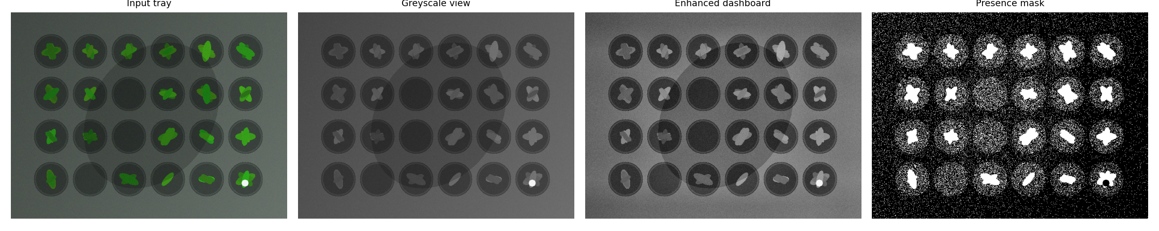

Task 2 – Low/mid/high occupancy pipeline (5 marks)
Candidate A (filter only) is the low-level stage: denoising reduces small intensity fluctuations but does not estimate occupancy. Candidate B segments green regions and measures connected components, providing a mid-level representation. Candidate C adds component measurements and rule-based classification, representing a high-level decision stage. The proposed sequence is denoise → colour segmentation → morphology/component measurement → occupancy classification.
Comparison: filter-only is inexpensive but cannot identify occupied cells; segment-and-measure exposes foreground regions and component sizes but is sensitive to shadows and touching leaves; measure-and-classify provides actionable occupancy estimates but adds thresholds and decision rules that require calibration. False positives can arise from green background objects; false negatives can arise from dark leaves or glare.
Numerical exercise: Total latency = 8 ms + 15 ms + 15 ms = 38 ms/frame. The corresponding ideal throughput is 1000/38 = 26.32 fps, before capture, transfer and display overhead.
Failure and mitigation: adjacent leaves may merge into one component. Use cell-location priors, morphology with conservative kernel sizes and per-cell occupancy checks. Validate on a separate set with overlapping leaves, missing seedlings and different tray positions.
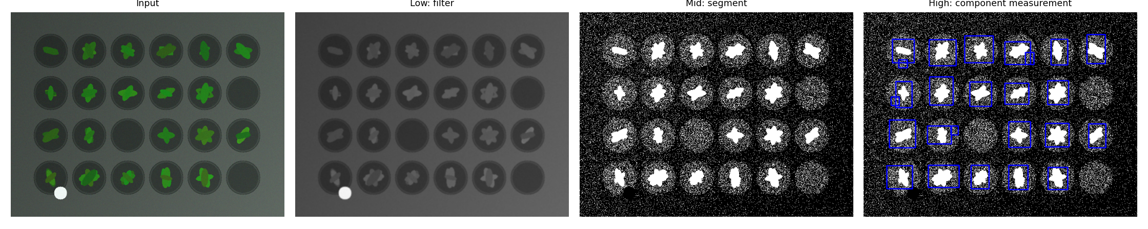

Task 3 – RGB, HSV and greyscale evidence (4 marks)
Greyscale is compact and useful for intensity structure, but discards chromatic evidence that distinguishes green leaves from soil or tray material. RGB preserves colour but each channel changes with illumination and white balance. HSV separates hue from saturation and value, allowing a green-hue range to be tested more directly; however, hue becomes unreliable at very low saturation and under strong colour casts. The experiment records foreground-mask IoU against generated masks as a simulation diagnostic, not as real-world accuracy.
Numerical exercise: For an 800 × 480 frame, 1-channel 8-bit memory = 800 × 480 × 1 byte = 384,000 bytes (375 KiB). For 3-channel 8-bit memory = 800 × 480 × 3 = 1,152,000 bytes (1,125 KiB).
Recommendation: use HSV as the primary green-leaf evidence, supplemented by intensity/shape checks and periodic white-balance calibration. Validate using held-out images across daylight, shadow and wet-leaf conditions.
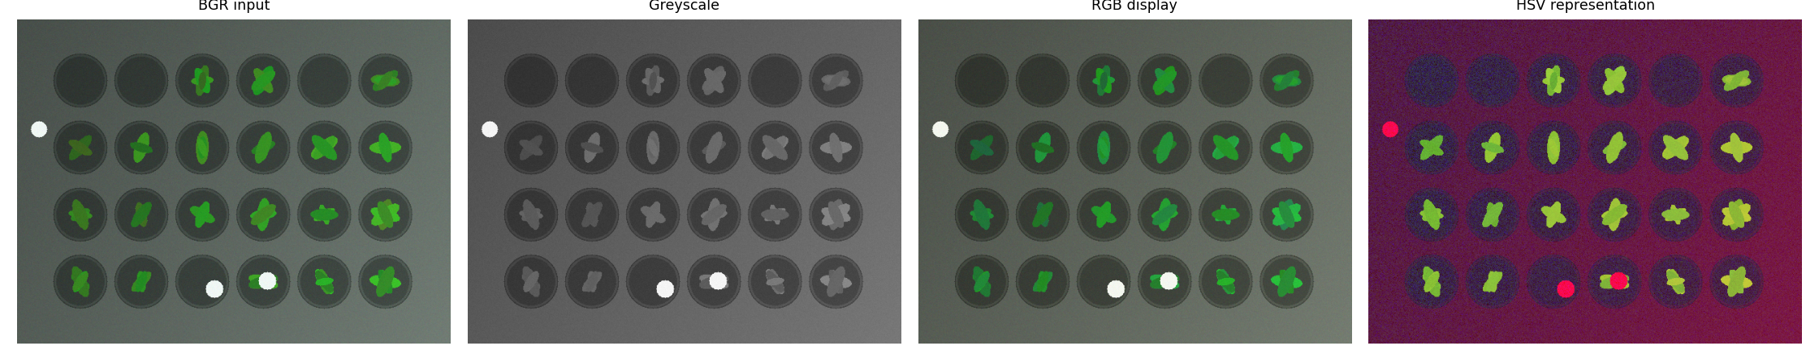

Task 4 – Connectivity without diagonal merging (4 marks)
4-connectivity treats only horizontal and vertical neighbours as connected. 8-connectivity also treats diagonal neighbours as connected. Distance-based grouping joins nearby regions according to a spatial tolerance; it can bridge small gaps but may merge separate seedlings. The experiment applies the three methods to the generated binary masks and records object counts and runtimes.
Numerical exercise: Two pixels touching only at a corner are separate under 4-connectivity and joined under 8-connectivity. For six independent diagonal-only pairs, 4-connectivity counts 12 separate objects while 8-connectivity counts 6 joined objects (a reduction of 6 objects).
Recommendation: use 4-connectivity when the requirement explicitly forbids diagonal merging. If noisy gaps cause over-segmentation, apply carefully limited distance grouping after checking cell boundaries. Validate on masks containing diagonal contacts, touching leaves and small gaps.
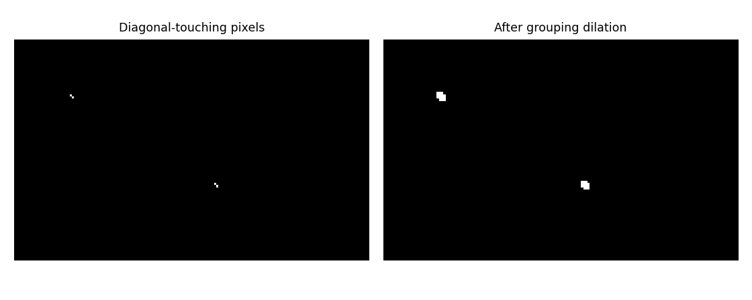

Task 5 – Camera arrangement for glossy wet leaves (5 marks)
Candidate A is rolling-shutter CMOS, B is global-shutter CMOS, and C is line-scan. For a stationary overhead tray, global shutter provides a consistent exposure time across the frame and avoids row-dependent skew during motion. Rolling shutter is often lower-cost but can distort moving leaves or trays. Line-scan can provide high-resolution continuous imaging when the tray moves at a controlled speed, but requires synchronised motion and careful assembly.
The software experiment provides simple acquisition proxies: a row-displacement proxy for rolling shutter, a direct snapshot copy for global shutter, and a repeated scanline proxy for line-scan. These are explanatory simulations, not measurements of physical camera performance. Glossy reflections are primarily addressed through lighting geometry, diffusion and cross-polarisation rather than shutter type alone.
Numerical exercise: blur must decrease from 10 pixels to at most 2 pixels. Required exposure reduction factor = 10 / 2 = 5. Exposure time should be shortened to one-fifth of its original value (an 80% reduction), assuming motion speed is unchanged.
Recommendation: use a global-shutter camera for the overhead station if leaves/trays move during capture, with diffuse cross-polarised lighting to suppress wet-leaf reflections. Validate using moving and stationary trays, wet/dry leaves and varied exposure settings.
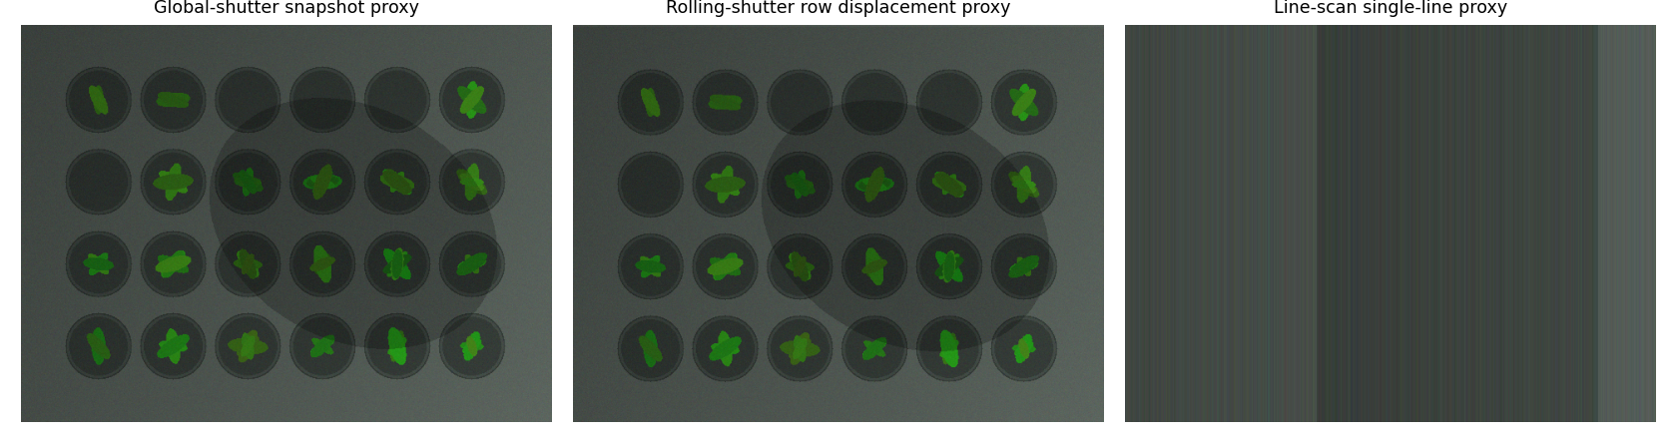

Task 6 – Leaf-tip sampling in the tray field (5 marks)
Sampling determines how many pixels represent a physical feature. The three alternatives compare 640, 1280 and 1920 pixels across a 640 mm field. Higher sampling provides more pixels across a 4 mm leaf but increases data volume and processing cost. The design target should preserve the smallest feature while still meeting the frame-rate budget.
Numerical exercise: Spatial resolution = 1280 pixels / 640 mm = 2 pixels/mm, or 0.5 mm/pixel. A 4 mm leaf spans 4 / 0.5 = 8 pixels at the specified camera resolution. This is above a practical 4-pixel feature target.
Recommendation: 1280 pixels across the field is a balanced baseline for the stated 4 mm target; 1920 pixels offers additional detail at higher bandwidth and compute cost. Confirm with a calibration target and leaf-tip measurements at the edges and centre of the field.
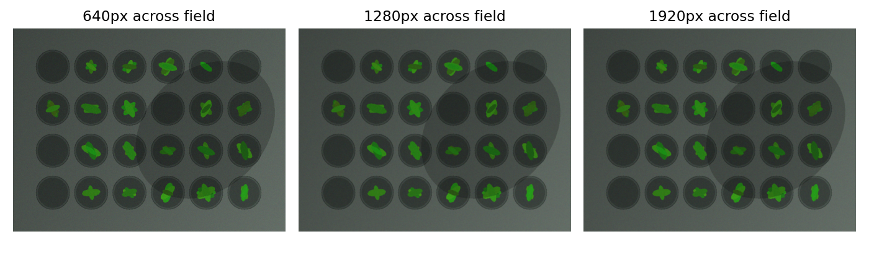

Task 7 – Quantisation under changing daylight (4 marks)
6-bit quantisation provides 64 intensity levels, 8-bit provides 256 levels, and 12-bit provides 4096 levels. More levels preserve finer intensity differences in low-contrast regions, but increase storage and processing requirements. In practice, sensor noise and unstable illumination can limit the benefit of higher bit depth if the acquisition pipeline is not calibrated.
Numerical exercise: 12-bit levels = 2^12 = 4096. Ratio to 6-bit = 4096 / 64 = 64:1.
Recommendation: acquire at 12-bit where the sensor and processing pipeline support it, then normalise/convert for downstream processing as required. Retain 8-bit as a practical baseline and compare leaf contrast after exposure and white-balance stabilisation. Validate under bright, cloudy and shaded conditions.
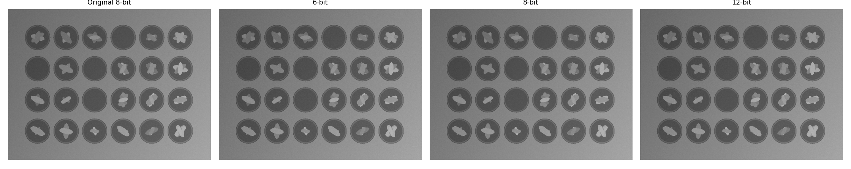

Task 8 – Glare and illumination control (5 marks)
Ambient-only illumination is simplest but is most affected by sunlight changes and specular highlights. Diffuse lighting reduces harsh shadows and reflection intensity by spreading illumination. Controlled polarised lighting, with suitable polarising optics, can suppress specular reflections from wet glossy leaves while preserving more diffuse leaf information. The experiment uses image appearance proxies only; it does not physically model polariser transmission.
Numerical exercise: Relative increase = (new − old) / old × 100 = (100 − 70) / 70 × 100 = 42.86%.
Recommendation: use a fixed diffuse light source and cross-polarised camera/light arrangement where practical, with exposure locked or calibrated. A failure mode is excessive light or polariser misalignment causing dark regions; mitigate with controlled exposure, a calibration patch and a check of illumination uniformity. Validate at multiple tray positions and wetness levels.
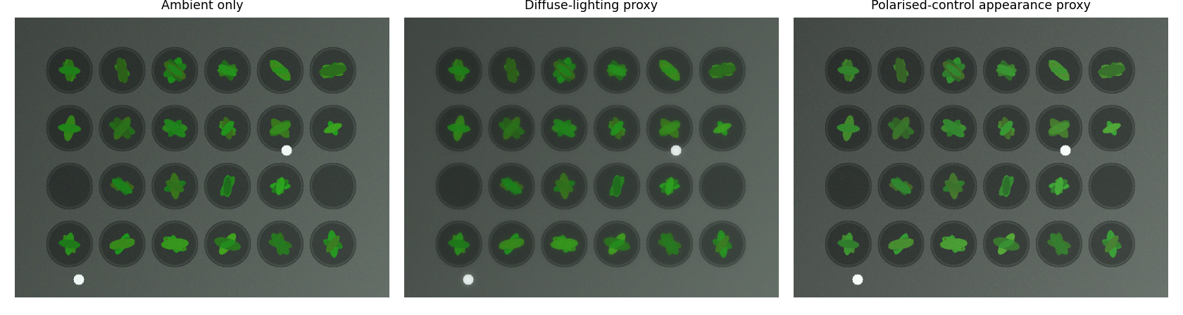

Task 9 – Consistent crop-tray coverage (6 marks)
Candidate A is a single raw camera, B is a calibrated camera with geometric and decision rules, and C is multicamera fusion. A single camera is simple but can suffer from occlusion, perspective variation and uneven illumination. Calibration corrects geometric distortion and supports repeatable tray coordinates. Multicamera fusion can improve coverage and reduce occlusion but increases hardware, synchronisation and processing complexity. The simulation approximates calibration using morphology and approximates a second aligned view using a horizontal flip; this is a software proxy, not a physical multicamera rig.
Numerical exercise: Theoretical maximum frame rate = 1 / 0.045 seconds = 22.22 fps (1000 / 45 ms). This exceeds the 15 fps target in ideal processing-only conditions; camera I/O and other overhead must still be included.
Recommendation: use one calibrated overhead camera if it provides complete tray coverage; add a second view only if real occlusion tests show a measurable benefit. Validate with a calibration grid, tray-edge coverage checks and separate images containing leaves at the borders and corners.
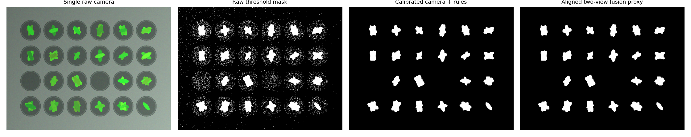

Task 10 – Night-time artificial illumination and validation (8 marks)
Fixed thresholds are easy to implement but can fail when artificial lighting changes colour temperature or brightness. Adaptive calibration estimates image conditions and adjusts processing parameters. A scene-aware model uses additional scene statistics or contextual features to adapt decisions. The simulation darkens and shifts the colour of each sample to represent night illumination, then compares fixed, adaptive and percentile-based scene-aware thresholding.
Numerical exercise: Recall = true positives / actual positives = 42 / 50 = 0.84 = 84%.
Failure and mitigation: a fixed daytime hue/value threshold may miss leaves under warm artificial light. Use a calibration reference, estimate illumination per frame, and monitor confidence/foreground coverage for abrupt changes. Avoid adapting blindly to a frame dominated by non-leaf green objects.
Recommendation: adaptive calibration is the preferred practical starting point; a scene-aware method can be introduced if a sufficiently varied labelled training/validation set is available. Keep a separate validation set captured at night under the intended artificial lights, with different brightness levels, wet leaves, empty cells, overlapping leaves and tray positions. Report precision, recall, false-positive rate, per-cell occupancy error and latency. Do not tune thresholds on the validation set.
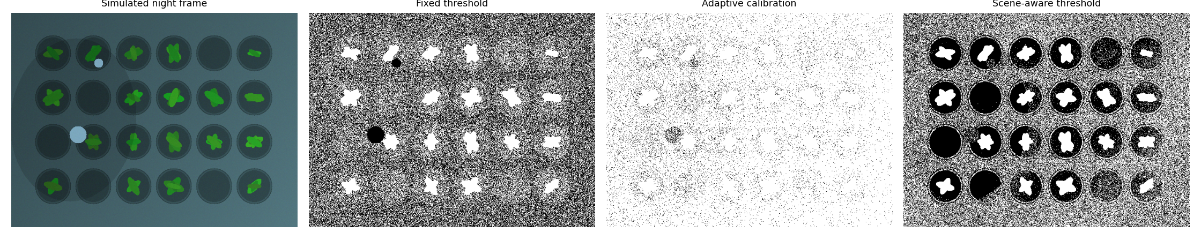

Consolidated numerical answers
Task | Answer
Task 1 | 18/30 = 0.60 = 60%
Task 2 | 8 + 15 + 15 = 38 ms/frame; ideal throughput ≈ 26.32 fps
Task 3 | 384,000 bytes (1 channel); 1,152,000 bytes (3 channels)
Task 4 | Corner-touching pixels: separate in 4-connectivity, joined in 8-connectivity; six independent pairs reduce count by 6
Task 5 | 10/2 = 5; exposure must be one-fifth of original
Task 6 | 2 pixels/mm; 0.5 mm/pixel; 4 mm feature = 8 pixels
Task 7 | 4096 levels; 12-bit has 64 times as many levels as 6-bit
Task 8 | (100−70)/70 × 100 = 42.86%
Task 9 | 1000/45 = 22.22 fps
Task 10 | 42/50 = 0.84 = 84%

Overall engineering recommendation
For a practical greenhouse station, use a calibrated global-shutter overhead camera, diffuse cross-polarised illumination, and 12-bit acquisition where supported. Use HSV-based leaf evidence with conservative morphology and per-cell occupancy rules, while keeping colour enhancement separate from presence decisions. Choose 4-connectivity when diagonal contacts must remain separate. At 1280 pixels across 640 mm, a 4 mm leaf spans 8 pixels, which is a useful sampling margin. Use adaptive night calibration and maintain a held-out validation set. The complete system should be benchmarked end-to-end at the native 1280 × 960 resolution to verify the 15 fps target.

Files and outputs
The accompanying project ZIP includes the Python source, requirements, README, 30 synthetic images and masks, CSV experiment outputs for all tasks, representative image panels, and this report. Runtime measurements should be regenerated on the target machine using the provided script.

References
- ITA0520 – Computer Vision, Assignment 1 – CO1 – Set B, supplied question paper.
- OpenCV documentation: Image Processing and Structural Analysis modules (thresholding, colour conversion, morphology and connected components). https://docs.opencv.org/
- NumPy documentation: array operations and numerical processing. https://numpy.org/doc/

