

REACT JS PROJECT REPORT ON
SMART HOSPITAL APPOINTMENT BOOKING SYSTEM (MEDIBOOK)

Submitted by
SWETHA BALAKRISHNAN
24BIT057

Under the Guidance of
ARAVIND
Technical Trainer
Technical Department, KG College of Arts and Science

Academic Year: 2025 – 2026
APRIL 2026

DECLARATION
I hereby declare that the project entitled “SMART HOSPITAL APPOINTMENT BOOKING SYSTEM(MEDIBOOK)” submitted in partial fulfillment of the requirements for the course B.SC INFORMATION TECHNOLOGY is a record of my original work carried out under the guidance of ARAVIND, Technical Trainer, Technical Department, KG College of Arts and Science.
I further declare that this project has not been submitted previously, either in part or in full, for the award of any degree, diploma, or other similar title, at this or any other institution.
I have acknowledged all sources of information used in this project wherever applicable.

April 2026
Coimbatore

________________________
SWETHA BALAKRISHNAN

CERTIFICATE
This is to certify that the project entitled “SMART HOSPITAL APPOINTMENT BOOKING SYSTEM(MEDIBOOK)” is a bona fide work carried out by SWETHABALAKRISHNAN [B.SC INFORMATION TECHNOLOGY / 2024], [Department of information technology], KG College of Arts & Science, in partial fulfillment of the requirements for the course [B.Sc Information Technology].
This project has been completed under my supervision and guidance during the academic period April 2026.

Place: KG COLLEGE OF ARTS AND SCIENCE,SARAVANAMPATTI
Date:09-04-2026

Submitted for the Viva-Voce Examination held on 09-04-2026

Guide: Head of the Department
(Technical Trainer, KGCAS) (Technical Head, KGCAS)

______________________ _______________________

TABLE OF CONTENTS
S. No. | Topics | Page. No.
1 | Introduction
1.1 | Background of the Study
1.2 | Problem Statement
1.3 | Objectives of the Project
1.4 | Purpose and Significance
1.5 | Scope and Limitations
1.6 | Methodology Overview
2 | System Analysis
2.1 | Existing System
2.2 | Drawbacks of the Existing System
2.3 | Proposed System
2.4 | Features of the Proposed System
2.5 | Feasibility Study
2.6 | Requirement Analysis
3 | System Design
3.1 | System Architecture
3.2 | Use Case Diagram
3.3 | Data Flow Diagram (DFD)
3.4 | Entity Relationship Diagram (ERD)
3.5 | User Interface Design
4 | System Implementation
4.1 | Development Tools
4.2 | Module Description
4.3 | Algorithms
4.4 | System Integration
4.5 | Security and Validation
5 | System Testing
5.1 | Testing Methodology
5.2 | Test Cases
5.3 | Error Handling
5.4 | Performance
6 | Input and Output Screens
6.1 | System Outputs
6.2 | Discussion
6.3 | Comparison
6.4 | User Feedback
7 | Conclusion and Future Enhancement
7.1 | Summary
7.2 | Limitations
7.3 | Future Scope
8 | References
Appendices
- Source Code Snippets
- Screenshots of Web Pages

ABSTRACT
The MediBook project is a web-based hospital appointment booking system developed using React JS. It allows users to book appointments easily by selecting symptoms and choosing doctors accordingly.
The system provides multiple doctor suggestions for each symptom, smart time slot selection, and instant booking confirmation with receipt generation. An admin dashboard is also included to manage appointments efficiently.
The application is built using modern frontend technologies such as React JS, JavaScript, HTML (JSX), and CSS. Data is stored using browser localStorage, making the system lightweight and fast.
This project simplifies hospital appointment booking and improves user experience by providing a clean, responsive, and interactive interface. It can be further enhanced by integrating backend services, real-time databases, and online payment systems.

Chapter 1: Introduction
1.1 Background of the Study
In today’s digital world, healthcare services are rapidly evolving with the help of technology. Traditional hospital appointment systems often involve long waiting times and manual processes, making it inconvenient for patients.
With the advancement of web technologies, online appointment booking systems have become essential. This project aims to develop a smart hospital appointment booking system using React JS that allows users to easily book appointments and access healthcare services efficiently.

1.2 Problem Statement
Patients often face difficulties in booking appointments due to long queues, lack of proper scheduling systems, and limited access to doctors. Existing systems are either complex or require physical visits to hospitals.
Therefore, there is a need for a simple, efficient, and user-friendly web-based appointment booking system.

1.3 Objectives of the Project
- To develop a smart hospital appointment booking system using React JS.
- To provide symptom-based doctor suggestions.
- To simplify the appointment booking process.
- To create a responsive and user-friendly interface.

1.4 Purpose and Significance of the Study
The main purpose of this project is to improve the hospital appointment booking process by making it simple and efficient. It helps patients save time and reduces waiting queues in hospitals.
This system enhances user experience by providing easy navigation, quick booking, and better accessibility. It also demonstrates the practical use of modern web technologies in healthcare applications.

1.5 Scope and Limitations
Scope:
The project focuses on developing a frontend-based hospital booking system using React JS. It includes features like doctor suggestions, appointment booking, receipt generation, and admin management.
Limitations:
- The system does not include a backend or real-time database.
- Data is stored only in browser localStorage.
- No online payment integration is available.
- Doctor data is simulated, not real-time.

1.6 Methodology Overview
The project follows a structured Software Development Life Cycle (SDLC) approach, including requirement analysis, system design, development, testing, and implementation.
Modern frontend technologies such as React JS, JavaScript, HTML (JSX), and CSS are used to build a responsive and interactive user interface. The system is tested to ensure proper functionality and performance.
.

Chapter 2: System Analysis
2.1 Existing System
In the current hospital appointment system, patients usually book appointments by visiting the hospital directly or through phone calls. This process is time-consuming and often leads to long waiting queues.
Some existing online systems are complex, require user authentication, and may not provide easy access to doctor availability or symptom-based suggestions.

2.2 Drawbacks of the Existing System
• Time-consuming manual booking process
• Long waiting queues in hospitals
• Lack of proper scheduling system
• Limited accessibility for users
• Complex user interface in existing applications
• No quick doctor suggestion based on symptoms
2.3 Proposed System
The proposed system, MediBook, is a smart hospital appointment booking application developed using React JS. It allows users to select symptoms and get suitable doctor suggestions.
Users can easily book appointments, choose available time slots, and receive booking confirmation with a receipt. The system also includes an admin dashboard to manage appointments efficiently.

2.4 Features of the Proposed System
• Symptom-based doctor suggestion
• Multiple doctors for each symptom
• Smart time slot selection
• Appointment booking system
• Automatic receipt generation
• Admin dashboard for managing bookings
• Emergency feature to find nearest hospital

2.5 Feasibility Study
Technical Feasibility:
The system is developed using React JS, JavaScript, HTML, and CSS, which are widely used and easy to implement. It does not require complex backend technologies.
Economic Feasibility:
The project is cost-effective as it uses free and open-source tools. No additional hardware or paid software is required.
Operational Feasibility:
The system is simple and user-friendly. Users can easily understand and operate the application without any training.

2.6 Requirement Analysis
Technical Feasibility:
The system is developed using React JS, JavaScript, HTML, and CSS, which are widely used and easy to implement. It does not require complex backend technologies.
Economic Feasibility:
The project is cost-effective as it uses free and open-source tools. No additional hardware or paid software is required.
Operational Feasibility:
The system is simple and user-friendly. Users can easily understand and operate the application without any training.

Chapter 3: System Design
3.1 Introduction
System design defines the overall structure and architecture of the project. It converts the requirements into a blueprint for development.
The MediBook system is designed to provide a simple and efficient interface for booking hospital appointments. It ensures smooth interaction between user inputs, application logic, and stored data.

3.2 System Architecture
The MediBook system follows a three-layer architecture consisting of the Presentation Layer (Frontend), Application Logic Layer, and Data Layer, ensuring efficient processing, better organization, and smooth data management.

+---------------------------------------------+
| Presentation Layer |
| (React JS - User Interface) |
+---------------------------------------------+
↓
+---------------------------------------------+
| Application Logic Layer |
| (Booking | Doctor Suggestion | Admin Panel) |
+---------------------------------------------+
↓
+---------------------------------------------+
| Data Layer |
| (localStorage) |
+---------------------------------------------+
Description:
- The Presentation Layer represents the user interface developed using React JS, where users can interact with the system to select symptoms, view doctors, and book appointments.
- The Application Logic Layer handles the core functionalities of the system, including symptom-based doctor suggestions, appointment booking, and admin management features.
- The Data Layer is responsible for storing and managing data using browser localStorage. It ensures that user and appointment details are saved and retrieved efficiently.
- This layered architecture improves system organization, maintainability, and performance by separating user interface, business logic, and data handling.
3.3 Use Case Diagram
1. What is a Use Case Diagram?
The Use Case Diagram represents the interaction between users and the MediBook system. It shows how different actors interact with the system to perform various operations.
Actors:
- Patient (User)
- Admin
Use Cases:
Patient:
- Select Symptom
- View Doctors
- Book Appointment
- Download Receipt
Admin:
- Login
- View Appointments
- Manage Bookings
The diagram clearly illustrates the functionalities available to both users and administrators in the system.

2. Identify the Main Actors (for Hospital Appointment Booking System)
Actor | Description
Patient | The patient is the primary user of the system. The patient can select symptoms, view doctors, book appointments, and download the receipt.
Admin | The admin is responsible for managing the system. The admin can log in, view appointment details, and manage bookings.

3. Identify the Main Use Cases
For Patient/User
• Select Symptom
• View Available Doctors
• Choose Doctor
• Select Appointment Date & Time
• Book Appointment
• View / Download Receipt

For Administrator
• Login to Admin Panel
• View Appointments
• Manage Bookings (Add / Delete)
• Monitor System Records
4. Define Relationships
Symbol Meaning
Solid line Association (Actor performs a use case)
<<include>> A mandatory sub-task inside another use case
<<extend>> An optional or conditional task

Example:
• “Book Appointment” <<include>> “Select Doctor”
• “Book Appointment” <<include>> “Select Time Slot”
• “Download Receipt” <<extend>> “Book Appointment”

5. Draw the Diagram (Structure Example)
- Draw.io (free online tool)
- Lucidchart
- StarUML
- MS Visio
- MS Word / PowerPoint(Shapes)

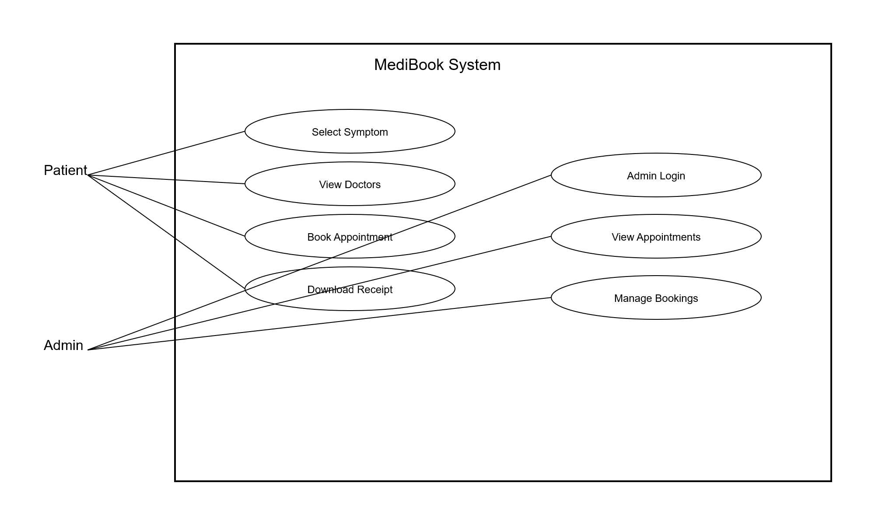

6. Example Explanation (Text Description)
Actors:
- Patient: The user who uses the system to view health details and medical records.
- Doctor: The user who diagnoses patients, updates prescriptions, and manages medical records.
- Administrator: The user who manages the system and user accounts.
Use Cases:
1.User Login / Register :
Patient, Doctor, and Admin log into the system using valid credentials.
2.View Medical Records:
Patient can view their personal health history and medical details.
3.Add Patient Details(Doctor):
Doctor adds patient information such as symptoms, diagnosis, and reports.
4.Update Prescription:
Doctor updates medicines and treatment details for the patient.
5.Book Appointments:
Patient can book an appointment with a doctor.
6.View Appointment Status:
Patient can check appointment confirmation or status.
7.Upload Reports:
Doctor or admin uploads lab reports and medical documents.
8.View Reports:
Patient can view downloaded or uploaded medical reports.
9.Manage Users(Admin):
Admin can add or remove doctors and patients in the system.
10.Submit Feedback:
atient can give feedback about doctors or hospital service.

Relationships:
•“Book Appointment” includes “View Doctor List”.
•“Add Patient Details” includes “Update Prescription”.
•“View Medical Records” extends “Upload Reports”.
• “Manage Users” includes “Add Doctor” and “Add Patient”.”.

7. Step-by-Step (Using draw.io)
7. Step-by-Step (Using draw.io)
- Go to https://app.diagrams.net
- Choose Blank Diagram → name it “Use Case Diagram”.
- From the left panel, drag:
- Stick figures → represent Actors
- Ovals → represent Use Cases
- Rectangle (Box) → system boundary (“Medical Book System”)
- Place Actors outside the system boundary.
- Place all Use Cases inside the system boundary.
- Connect Actors ↔ Use Cases using lines.
- Add relationships like <> and <> where required.
- Arrange the diagram neatly to avoid overlapping lines.
- Export the diagram as .PNG / .JPG format.
- Insert the image into your project documentation or PPT.

3.4 Data Flow Diagram (DFD)
1. What is a Data Flow Diagram (DFD)?
A Data Flow Diagram (DFD) is a graphical representation that shows how data moves through a system. It explains the flow of data from input to processing and finally to output, along with data storage.
It helps to visualize:
- Where the data comes from (source)
- How the data is processed in the system
- Where the data is stored
- Where the data goes (destination)

2. DFD Symbols You’ll Use
Symbol | Meaning
Rectangle | External Entity (e.g., Patient,Doctor,Admin)
Circle / Rounded Rectangle | Process (e.g., “Validate Login”, “Manage Records”)
Two Parallel Lines | Data Store (e.g., “Patient Database”, “Medical Records”)
Arrow | Data Flow (shows direction of data movement)

3. Levels of DFD
Level 0 — Context Diagram (Top Level)
Shows the entire Medical Book System as a single process and its interaction with external entities like Patient, Doctor, and Admin.
Level 1 — Decomposition
Breaks the main system into major sub-processes such as Login, Manage Records, Book Appointment, and View Reports to show internal operations.
Level 2 — Detailed Level
Further decomposes complex sub-processes into more detailed steps if required (optional for small college projects).

4. Steps to Create a DFD
Step 1: Identify External Entities
- Patient / User
- Doctor
- Administer
- System (Medical book system)
Step 2: Identify Main Processes
- User Login / Authentication
- Manage Patient Records
- Book Appointment
- Update Prescription
- View Medical Records
- Manage Users(Admin)

Step 3: Identify Data Stores
- Patient Data Store
- Doctor data Store
- Appointment Data Store
- Prescription Data Store
Step 4: Identify Data Flows
- “Login Credentials”
- “Patient Details”
- “Appointment Request”
- “Prescription Data”
- “Medical Reports”

5. DFD for Educational Website
Level 0: Context Diagram
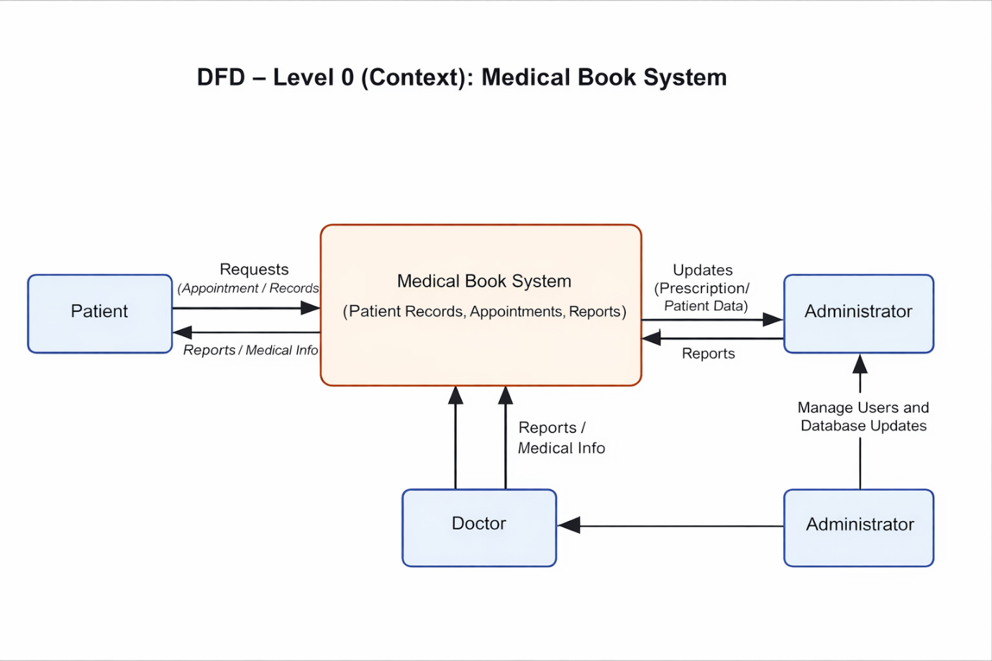
Explanation:
- Patient interacts with the system to view medical records, book appointments, and view reports..
- Doctor manages patient details, updates prescriptions, and uploads medical reports
- Administrator controls and manages users and system data.

Level 1: Detailed System View
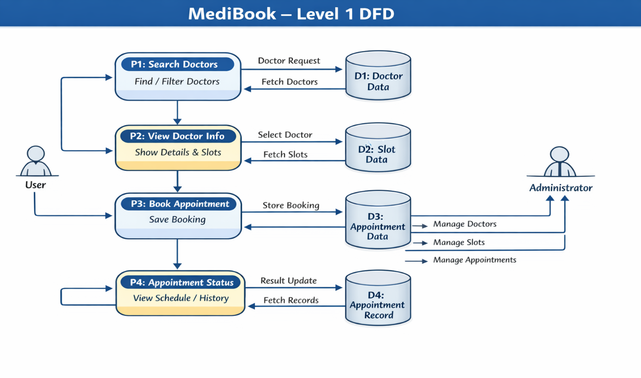
Explanation:
- Process P1: Fetches doctor details from Doctor Data Store.
- Process P2: Displays doctor details and available slots from Slot Data Store..
- Process P3: Handles appointment booking and stores data in Appointment Data Store.
- Process P4: Retrieves and displays appointment status from Appointment Record Data Store.

Level 2: Appointment Booking Process (Sub-process)
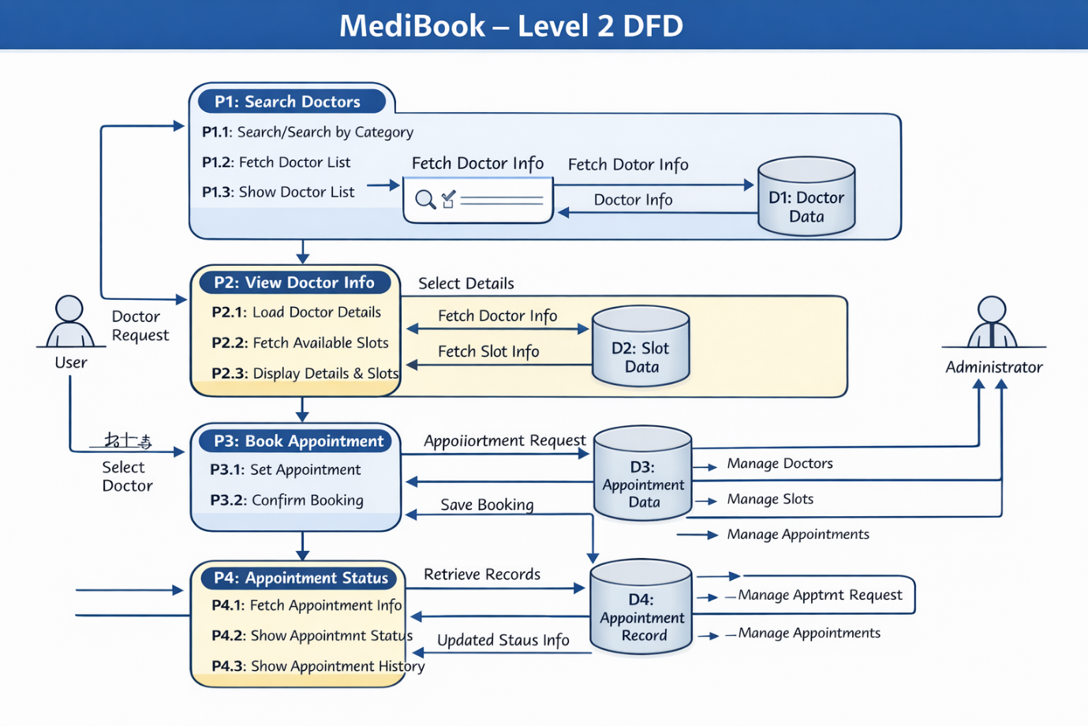

6. Tools to Draw Your DFD
Free, easy online tools:
- https://app.diagrams.net (recommended)
- Lucidchart
- Creately
- StarUML
- Microsoft Visio
Steps (in draw.io):
- Go to https://app.diagrams.net.
- Choose Blank Diagram → name it “DFD_MediBook”.
- Use the following steps:
  - Rounded rectangles → processes(Doctor Search,Booking,etc)
  - Parallel lines → data stores(Doctor Data,Appointment Data)
  - Rectangles → external entities(User,Admin)
  - Arrows → data flow.(Doctor Request,Booking Info, etc)
- Label everything clearly (arrows = Doctor Request, Slot Info, Booking Details, Status).
- Export as .PNG or .JPG and insert into your report.

3.5 Entity Relationship Diagram (ERD)
Entities and Attributes:
- User (User_ID, Name, Email, Phone)
- Doctor (Doctor_ID, Name, Specialization, Availability)
- Appointment (Appointment_ID, User_ID, Doctor_ID, Date, Time, Status)
- Slot (Slot_ID, Doctor_ID, Available_Time)
Relationships:
- A User can book many Appointments
- A Doctor can have many Appointments
- A Doctor can have multiple Slots
- Each Appointment is linked to one User and one Doctor.
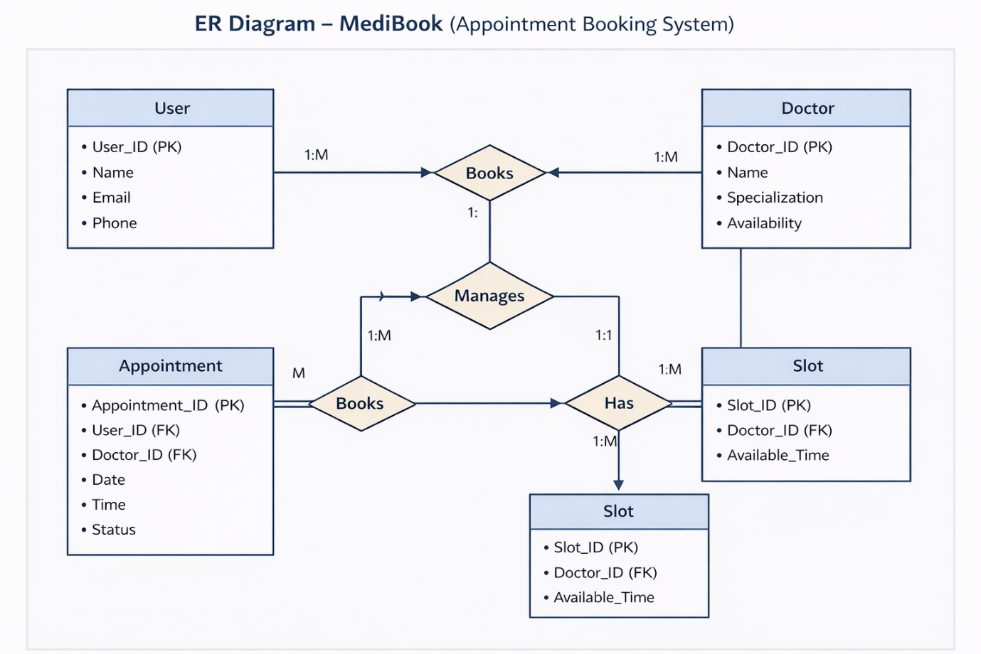
3.6 User Interface Design
The UI is designed to be simple, responsive, and user-friendly.
It is developed using React JS for building dynamic components, along with CSS for styling.
🔹 Main Pages / Components:
1. Home Page (Doctor List)
- Displays list of doctors
- Search and filter functionality

2. Doctor Details Component
- Shows doctor information
- Displays available time slots

3. Appointment Booking Component
- User selects date and time
- Confirms appointment

4. Appointment Status Component
- Shows booked appointments
- Displays status and history

Chapter 4: System Implementation
4.1 Introduction
System implementation is the stage where the design is converted into a working web application. This phase involves developing the application using React JS, integrating different components, testing functionality, and ensuring smooth performance.
The MediBook system is implemented using modern front-end technology — React JS — along with CSS for styling. It provides an interactive and responsive interface for users to search doctors, book appointments, and view appointment status.

4.2 Development Tools and Technologies
Tool / Technology | Purpose
React JS | Builds dynamic and reusable UI components for the application.
HTML5 | Provides the basic structure of the web pages.
CSS3/Bootstrap | Adds styling, layout design, and responsive features.
Javascript(ES6) | Handles logic, state management, and interactivity.
Visual Studio Code | Code editor used for development and debugging.
Browser(Chrome/Edge) | Used to run and test the application.
LocalStorage / JSON | Stores user and appointment data locally.

4.3 System Modules Description
Module | Description
Home Module | Displays the list of doctors with specialization and basic details.
Doctor Details Module | Shows detailed information about the selected doctor and available time slots.
Appointment Module | Allows users to book appointments by selecting date and time.
Appointment Status Module | Displays booked appointments along with their status (confirmed/pending).
Admin Module (Optional) | Allows admin to manage doctors, slots, and appointments.
Each module is interconnected using React JS components and state management, ensuring smooth navigation and dynamic updates within the application.

4.4 Implementation Details
The implementation follows a modular approach:
- Frontend Design:
The user interface is developed using React JS components, with HTML (JSX) for structure and CSS/Bootstrap for styling.
- Dynamic Behavior:
React JS is used to dynamically render doctor lists, details, and appointment data based on user interaction.
- Event Handling:
User actions like booking appointments, selecting slots, and viewing status are handled using React event handlers (onClick, onChange, onSubmit).

4.Appointment Processing Logic:
When the user books an appointment, the system processes the selected doctor, date, and time, confirms the booking, and updates the appointment status.
5.Data Management:
Data such as doctor details, slots, and appointments are stored and retrieved using LocalStorage or JSON, ensuring data persistence.

4.5 Algorithm / Logic of Core Function
Algorithm for Appointment Booking:
- User selects a doctor from the list.
- Display available time slots for the selected doctor.
- User selects preferred date and time.
- Validate the selected slot availability.
- If available, confirm the appointment.
- Store appointment details in LocalStorage / database.
- Display booking confirmation to the user.

Algorithm for Viewing Appointment Status:
- Retrieve appointment details from storage.
- Match appointments with the logged-in user.
- Loop through all appointments.
- Display appointment date, time, doctor name, and status.
- Allow user to view previous appointment history.

4.6 Security and Validation
- Input validation is implemented using React JS to prevent empty or invalid form submissions (e.g., doctor selection, date, and time).
- Only valid appointment details are processed and stored.
- Basic validation ensures that selected time slots are available before booking.
- Data is stored locally using LocalStorage, ensuring no sensitive data is transmitted externally.
- Error handling is implemented using alerts or conditional rendering for invalid inputs and booking failures.
4.7 Integration
All modules are seamlessly integrated using React JS component-based architecture. Navigation between the home page, doctor details, appointment booking, and status pages is handled using React routing, ensuring smooth transitions without reloading the application.
Data is shared between components using state management, allowing real-time updates when booking appointments or viewing status.

4.8 Output Screens (Snapshots)
Include labeled screenshots for:
- Homepage – List of Doctors
- Displays available doctors with specialization
- Doctor Details Page – Information & Slots
- Shows doctor details and available time slots
- Appointment Booking Page – Booking Form
- User selects date and time and confirms appointment
- Appointment Status Page – Booking Details
- Displays appointment status (confirmed/pending) and history

Chapter 5: System Testing
5.1 Introduction
System testing is a crucial phase that ensures the developed application meets all functional and non-functional requirements. It verifies whether the MediBook system performs correctly under different conditions.
For the MediBook application, testing was conducted to validate the functionality of modules such as doctor listing, viewing doctor details, appointment booking, and appointment status display. The system was tested to ensure smooth user interaction, accurate data handling, and proper response to user inputs.

5.2 Objectives of Testing
- To ensure that all modules (Home, Doctor Details, Appointment Booking, Appointment Status) function correctly.
- To identify and fix any logical or runtime errors in the application.
- To confirm that user inputs (doctor selection, date, time) produce correct and expected outputs.
- To verify that the application works smoothly across different browsers and devices.

5.3 Types of Testing Performed
a) Unit Testing
Each React component and function was tested individually.
For example, doctor listing, slot selection, and appointment booking logic were verified separately.
b) Integration Testing
All modules were combined and tested together to ensure smooth flow between pages
(Home → Doctor Details → Booking → Status) without errors.
c) System Testing
The complete MediBook application was tested to ensure all functionalities like doctor search, appointment booking, and status display work correctly.
d) User Acceptance Testing (UAT)
The system was tested by sample users to check usability, design, and performance.
Feedback was collected and improvements were made.
e) Cross-Browser and Device Testing
The application was tested on browsers like Chrome and Edge, and on devices such as mobile phones and laptops to ensure responsiveness.
5.4 Test Plan
Test ID | Module | Test Description | Type | Expected Output | Status
T01 | Home | Display all available doctors | Functional | Doctors list is visible | Pass
T02 | Doctor Details | Load doctor info and slots | Functional | Doctor details and available slots displayed correctly | Pass
T03 | Appointment | Book appointment with valid inputs | Functional | Appointment successfully booked | Pass
T04 | Status | Display appointment status | Output | Correct status (confirmed/pending) shown | Pass
T05 | Navigation | Move between modules | Integration | Smooth page transitions | Pass
T06 | Input Validation | Submit empty booking form | Validation | Error message / prevent submission | Pass
T07 | Responsiveness | View on mobile devices | UI | Layout adjusts to screen size | Pass
T08 | Storage | Save appointment in LocalStorage | Data | Data retained after refresh | Pass

5.5 Test Data and Execution
Sample data were created in JSON format for doctors, available slots, and appointments. React JS functions were executed to ensure that doctor details, slot availability, and appointment data were correctly retrieved and displayed dynamically.
The system was tested by performing actions like selecting doctors, booking appointments, and viewing status. The output was verified by comparing expected results with actual results to ensure accuracy.

5.6 Error Handling
- Input validation ensures that empty or invalid booking details (doctor, date, time) are not processed.
- Errors in data handling (doctor details, slots, appointments) are managed using conditional checks and try-catch where required.
- Clear error or alert messages are displayed to guide the user during invalid actions (e.g., selecting unavailable slots).
5.7 Performance and Usability Testing
- Performance: The application loads quickly, and page transitions are smooth due to React JS rendering.
- Usability: Users found the system easy to navigate, with a clear interface for searching doctors and booking appointments.
- Accessibility: The application supports simple navigation, readable fonts, and responsive design for better user experience across devices.
5.8 Results and Observations
ll modules of the MediBook system functioned as expected. Features such as doctor listing, viewing details, appointment booking, and status tracking worked correctly.
The application performed well across different devices and browsers. User feedback indicated that the system was easy to use, responsive, and efficient for booking appointments.
No major or critical defects were identified during the final stage of testing.

Chapter 6: Results and Discussion
6.1 Introduction
This chapter presents the practical results obtained after the implementation and testing of the MediBook system. It explains how each module of the application performed during execution and how effectively the system achieved its objectives.
The performance of key modules such as doctor listing, viewing doctor details, appointment booking, and appointment status tracking is analyzed to ensure the system works efficiently and meets user requirements.

6.2 System Outputs
During execution, the system produced the following key results:
- Homepage: Displayed a list of doctors with their names and specializations.
- Doctor Details Page: Loaded doctor information and available time slots dynamically without page refresh.
- Appointment Booking Page: Allowed users to select date and time, validated inputs, and confirmed bookings instantly.
- Appointment Status Page: Displayed booked appointment details, including date, time, doctor name, and status in real time.
- All pages were verified to be responsive and accessible across desktop and mobile devices.

6.3 Performance Analysis
- Responsiveness: The application loads quickly, and page transitions are smooth (average load time < 2 seconds).
- Accuracy: Appointment booking and data handling achieved high accuracy with correct storage and retrieval.
- Stability: No runtime errors or data-handling issues were observed during repeated usage.
- Cross-Browser Compatibility: Verified on Chrome and Edge with consistent performance across devices.

6.4 User Feedback
A small group of users tested the MediBook prototype. Feedback indicated:
- Simple and intuitive navigation for searching doctors and booking appointments.
- Clear and user-friendly interface for viewing doctor details and selecting time slots.
- Suggestion to add features like user login, online consultation, and appointment reminders in future versions.

Chapter 7: Conclusion and Future Enhancement
7.1 Conclusion
The MediBook project successfully demonstrates how modern web technologies can be used to develop an efficient and user-friendly medical appointment booking system. By utilizing React JS, along with HTML, CSS, and JavaScript, the application provides a responsive interface for users to search doctors, view details, book appointments, and track appointment status.
The project achieved its primary objectives of creating a simple, interactive, and dynamic web application for managing medical appointments. Testing confirmed that all modules—doctor listing, doctor details, appointment booking, and appointment status—function correctly and reliably.
The system meets important requirements such as usability, responsiveness, and performance. It provides a smooth user experience and ensures accurate handling of appointment data.
This project highlights how front-end technologies can be effectively applied to solve real-world problems like healthcare appointment management and serves as a strong foundation for future enhancements such as full backend integration and advanced features.

7.2 Limitations
While the system meets its core objectives, the current version has a few limitations:
- No user authentication (login/signup) is implemented.
- Data is stored using LocalStorage or JSON instead of a real database.
- No real-time doctor availability updates or backend integration.
- Limited features such as online consultation, payment integration, or notifications.

7.3 Future Enhancement
The MediBook system can be enhanced and scaled in several ways:
- Database Integration: Connect to MySQL or MongoDB to store user, doctor, and appointment data securely.
- User Accounts: Implement login and registration for users and administrators.
- Admin Panel: Allow admin to add, update, and manage doctors, slots, and appointments dynamically.
- Online Consultation: Enable video/audio consultation between users and doctors.
- Payment Integration: Add online payment options for booking appointments.
- Notification System: Send reminders via email or SMS for upcoming appointments.
- Cloud Deployment: Deploy the application on platforms like AWS or Firebase for real-time access.
- Accessibility Improvements: Add multi-language support and improved UI for better user experience.

Chapter 8: References
8.1 Books & Journals
- Web Technologies: HTML, CSS, JavaScript, PHP, Java, JSP, XML, and AJAX — Uttam K. Roy, Oxford University Press.
- Learning Web Design — Jennifer Niederst Robbins, O’Reilly Media.
- React JS Essentials — Artemij Fedosejev, Packt Publishing.
- Full Stack Web Development — Ethan Brown, O’Reilly Media.

8.2 Online Resources
- MDN Web Docs — https://developer.mozilla.org
- W3Schools — https://www.w3schools.com
- Bootstrap Official Documentation — https://getbootstrap.com
- JavaScript.info Tutorials — https://javascript.info
- FreeCodeCamp Tutorials — https://www.freecodecamp.org
- GeeksforGeeks Web Development Articles — https://www.geeksforgeeks.org
8.3 Tools & Frameworks Used
- Editor :Visual Studio Code
- Frontend Library:React.js(using App.jsx)
- Languages:HTML5,CSS3,Javascript(Es6)
- Styling:CSS3(App.css)
- Framework(UI):Bootstrap 5(for responsive design – if used)
- Package Manager:npm (Node Package Manager)
- Runtime Environment:Node.js
- Browser:Google Chrome / Microsoft Edge
- Database(Future Scope):JSON / MySQL

Appendices
Appendix A – Source Code
Include your main project files used in the Appointment Booking system:
APP.jsx – Main React component containing appointment booking UI,from handling,slot selection,and booking logic
• App.css - Styling file used for layout design, responsive UI, and form appearance.
(Only essential code snippets should be included to maintain report readability.)

Appendix B – Screenshots of Web Pages
Attach labeled screenshots of the Appointment Booking system:
- Figure 1.1: Homepage / Appointment booking dashboard.
- Figure 1.2: Doctor/Service selection page.
- Figure 1.3: Appointment booking form with date & time selection.
- Figure 1.4: Confirmation / success page after booking.
- Figure 1.5: Responsive mobile view of the application.
1.3”)

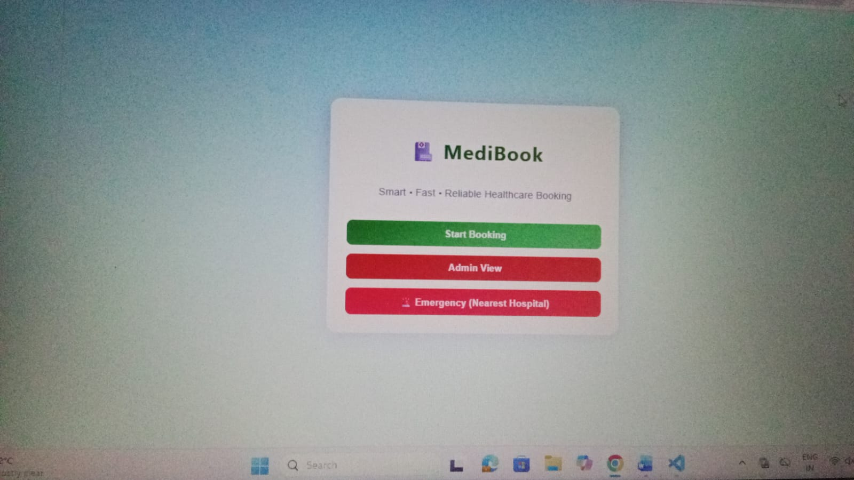
Figure 1.1: Home page of Appointment Booking System displaying dashboard and navigation options.
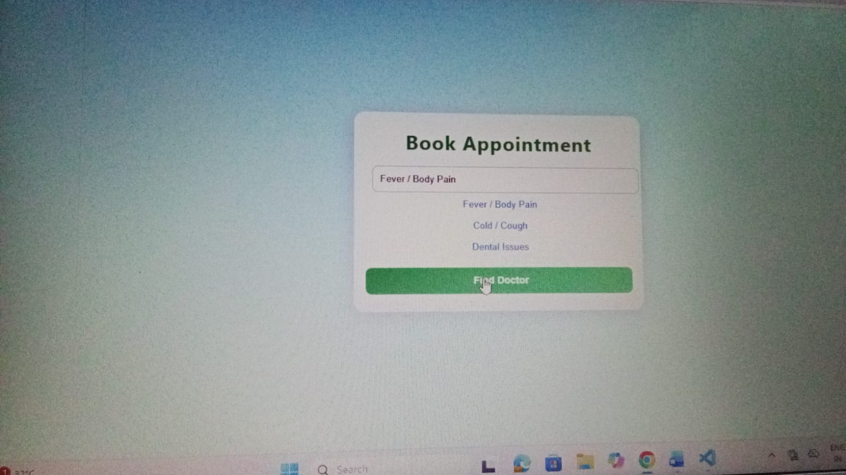
Figure 1.2: Symptom selection page where the user selects health condition such as fever or cold for appointment booking.

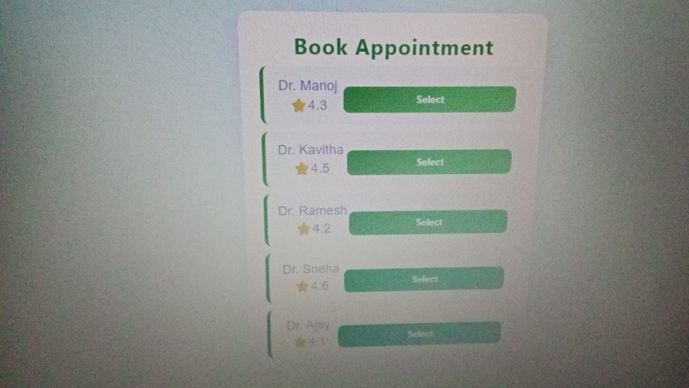
Figure 1.3: Doctor selection page displaying a list of available doctors for appointment booking based on user requirement.
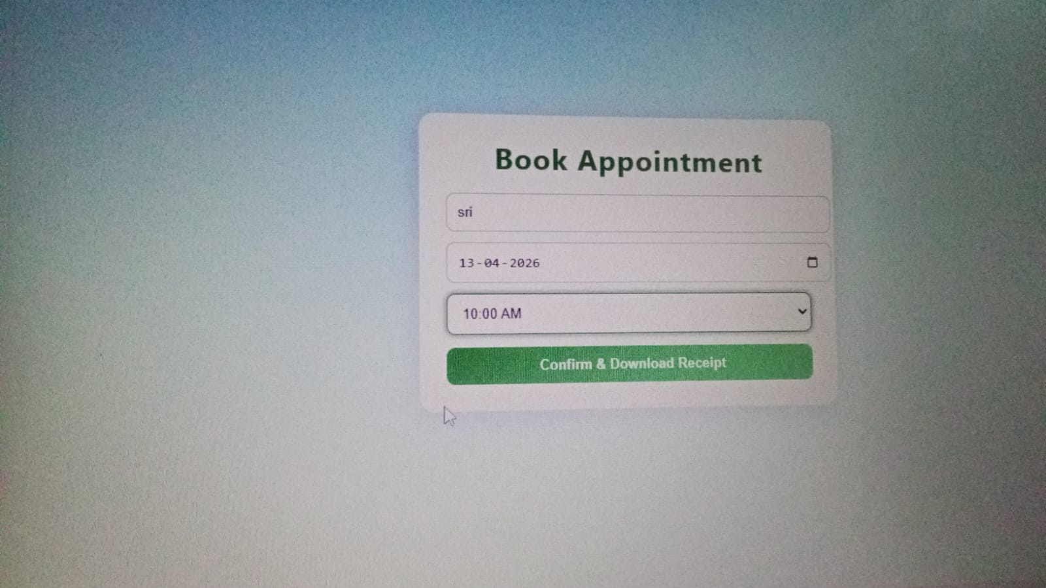
Figure 1.4: Appointment booking form where user enters details such as name, date, and time slot.
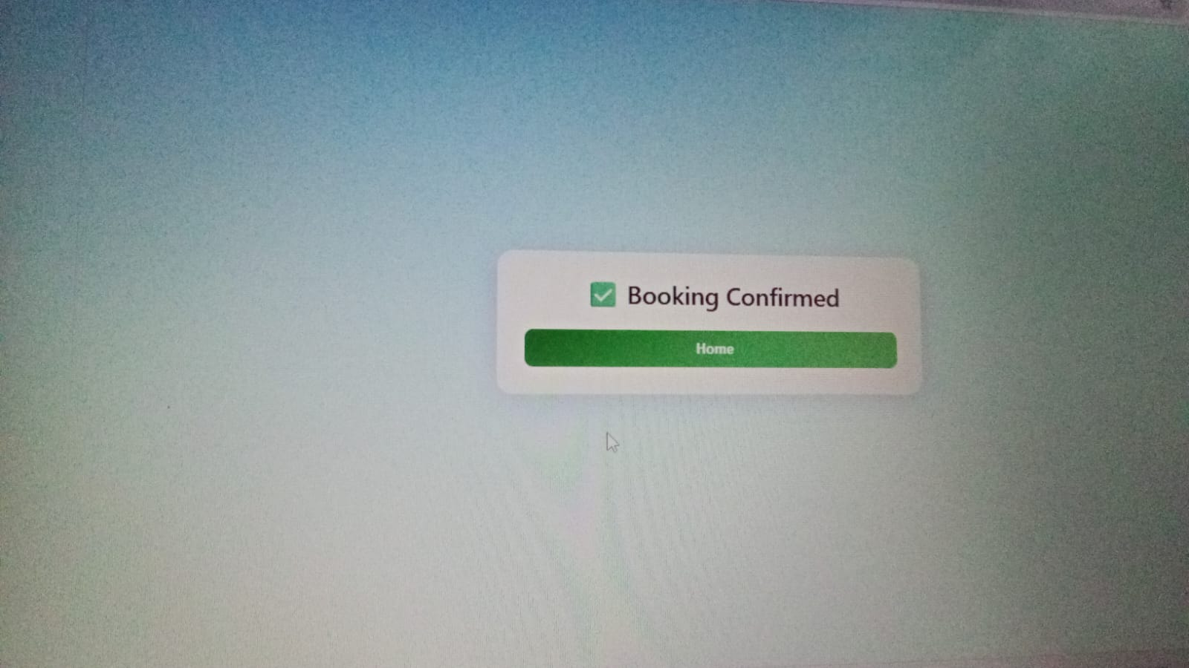
Figure 1.5: Confirmation page showing successful booking message after submitting the appointment.

Appendix C – User Manual / Installation Guide
Steps to Run the Project:
- Open the Appointment Booking React project folder in Visual Studio Code.
- Install dependencies using:
npm install
- Start the application using:
npm start
- Open the app in Chrome / Edge browser.
- Select service/doctor, choose date and time slot.
- Submit the form to book an appointment successfully.
System Requirements:
• OS: Windows / macOS / Linux
• Frontend: React.js
• Runtime Environment: Node.js (v14 or above)
• Browser: Google Chrome / Microsoft Edge
• RAM: Minimum 2 GB
• Storage: 100 MB free space

