TOOLS USED TO DRAW FLOWCHART
- Smart Draw – Good Tool to draw and understand but can’t save the file in system it can be used free for upto 7 days after that we must pay to use them
- Canva – A user friendly tool also enables to view in mobile using the app can be saved in any format. Without even subscription all the features were available.
- Diagrams.net – The diagrams can be saved and also in any destination you want it to be. But the Output Wasn’t precise and not in single page the saved diagrams open up to the website
- Lucidchart - The diagrams can be directly stored into the system and has every feature also easy to use. It Require to pay after some uses
- Visme – The tool is used for flowchart animation and content creating and in teaching, But more tools are available when you pay for them.
- Zenflowchart – The diagrams can be directly stored into the system and has every features also easy to use. But it restricted to use more than 20 shapes on using the 21st shape it must be paid
- Visual Paradiagram – Visual paradiagram is explicitly designed for flowchart drawing, It is also paid one to use but In complex algorithm cases it is the best
- Creatly – This tool is used to design Unified Modeling Language (UML) and flowcharts
- Google Draw – All the features are available and they are directly stored in the Drive.
EXP.NO: 1-A STUDENT GRADE ANALYSIS
DATE :21/11/22

AIM:
To draw flowchart and write algorithm for the following problem.

ALGORITHM:
STEP 1: Start.
STEP 2: Get the Number of students (N)
STEP 3: Assign i = 0.
STEP 4: Check for the condition i < N.
4.1: If True, Get Name, Roll.no and Marks m1, m2, m3, m4, m5.
4.2: Calculate Total = m1 + m2 + m3 + m4 + m5 and Average = Total / 5
4.3: Display Name and Roll Number.
4.4: Check for condition avg >= 30 and avg < 50.
4.4.1: If True Display the message your grade is c" and increase i value by 1.
4.5: Check for condition avg > 50 and avg < 80
4.5.1: If True Display the message "You grade is B" and increase i value by 1.
4.6: Check for the condition avg > 80 and avg ≤ 100
4.6.1: If True Display the message. "Your grade is A" and increase i value by 1.
4.7: Check for the condition avg < 30
4.7.1: If True Display the message "Your grade is D".
STEP 5: If False, go to step 9
STEP 9: Stop.

FLOWCHART:

RESULT:
Thus, the algorithm and the flowchart is given for the problem.

EXP.NO: 1(B) CALCULATE WEIGHT OF STEEL ROD
DATE:21.11.2022

AIM:
To draw flowchart and write algorithm for calculating the weight of a steel Rod.

ALGORITHM:
STEP 1: Start.
STEP 2: Get the number of Iron nods.
STEP 3 Initialize the value I and weight as 0.
STEP 4: Chock for the condition i = n.
4.1: of true, get the diameter of the rod.
4.2: Calculate the weight-unit-weight using the formula d*2 /162 = W
4.3: Calculate the weight using the formula.
No. of rods x weight - Tw
4.4: Calculate total weight = TW+W.
4.5: Increment the value of i by 1 go to step 4.
4.1: If false display the total weight.
STEP 5: Stop

FLOWCHART:
RESULT:
Thus the flowchart and the algorithm is written for the given problem.

EXP.NO: 1-C
DATE :21/11/22 CALCULATING ELECTRIC BILL

AIM:
To draw flowchart and write algorithm for calculating the electric bill.

ALGORITHM:
STEP 1: Start.
STEP 2:Get the no of units consumed=units
STEP 3:if units<=100
STEP 4:energy charge=0,fixed charge=0,duty charge=0
STEP 5:if units<=200
STEP 6:energy =04.5*(Units-100),fixed charge=20,duty charge=8
STEP 7:if units<=500
STEP 8:energy charge=3.5*(Units-100),fixed charge=30,duty charge=4.8
STEP 9:if units>>800,energy charge=4.5*(400)+6.0*(Units-500),fixed charge=75,duty charge=100
STEP 10:Stop

FLOWCHART:
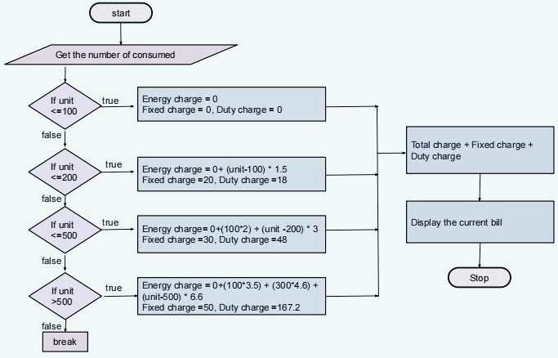

RESULT:
Thus the flowchart and the algorithm is written for the given problem.

EXP.NO: 1-D
DATE :29/11/22

CALCULATE ELECTRIC CURRENT IN 3 PHASE A/C CIRCUIT

AIM:
To draw flowchart and write algorithm. to- calculate electrical current in 3 phase AC circuit.

ALGORITHM:
STEP 1: Start
STEP 2: Get value of pf (power factor)
STEP 3: Get value of Current (I).
STEP 4: Get value of voltage (V)
STEP 5: Calculate P using the formula P= √3*pf*I*V.
STEP 6: Display the value of P.
STEP 7: Stop

FLOWCHART:

RESULT:
Thus, the flowchart and the algorithm is written for the problem.
EXP.NO: 1-E
DATE :29/11/22
CALCULATE WEIGHT OF A MOTORBIKE

AIM:
To draw flowchart and write algorithm for calculating weight of a motorbike.

ALGORITHM:
STEP 1: Start.
STEP 2: Get gross vehicle weight Rating GVWR
STEP 3: Get Dry weight (DW)
STEP 4: Get Fuel weight (FW)
STEP 5: Get Raider weight (RW)
STEP 6: Get Passenger weight (PW)
STEP 7: Calculate Total weight = DW+FW+RW+PW
STEP 8: Get Load.
STEP 9: Calculate safe weight. GVWR-Load-weight.
STEP 10: Check the condition safe weight >=0.
10.1: If true, print the message “You have a safe load and you can drive" go to stop.
10.2: If false, print the message "Reduce the load and then drive”.
10.2.1: Go to step 8.
STEP 11: Stop

FLOWCHART:
RESULT:
Thus, the flowchart and the algorithm is written for the problem.
EXP.NO: 1-F
DATE :29/11/22
RETAIL SHOP

AIM:
To draw the flowchart and write the algorithm for the retail shop billing.

ALGORITHM:
STEP 1: Start
STEP 2: Get the Bill number.
STEP 3: Get costumer name, Address, and Ph.no.
STEP 4: Get the value of total No. of Items purchased.
STEP 5: Initialize the values for i =0, Total =0 and. subtotal =0.
STEP 6: Check if condition
6.1: If true, get Item name, Price, Quantity and the discount.
6.2: Calculate the subtotal = Qty * Price - Discount
6.3: Calculate the total = Total + Subtotal.
6.4: Increment the value of i and go to step 6.
STEP 7: of false, get the GST value.
STEP 8: Calculate Total bill amount. Total fast/100.
STEP 9: Display the Total-bill-amount,
STEP 10: Stop.

RESULT:
Thus the algorithm and the flowchart is written for the given program.

FLOWCHART:
RESULT:
Thus the algorithm and flowchart written for the given problem.

EXP.NO: 1-G
DATE :21/11/22
SINE SERIES.

AIM:
To draw flowchart and write algorithm for the sine series.

ALGORITHM:
STEP 1: Start.
STEP 2: Get the value of x.
STEP 3: Initialize the values of 1=1, sine =0 and import moth.
STEP 4: Get the value of N.
STEP 5: Check weather value do i less than N
5.1: If condition is true, convent a to radians and adding it to y.
5.1.1: Let value of s be (-1) to the power i
5.1.2: Now calculate the series using the formula.
Sine = sine + ((y**2* i +1))/ math factorial (21+4) S.
5.1.3: Increment value of i by 1.
5.2 of condition is false display sine.
STEP 6: stop.

FLOWCHART:

RESULT:
Thus the algorithm and flowchart written for the given problem.

