**DRIVING ACCEPTANCE: A Comprehensive Analysis of Factors Influencing Car Acceptability in the Modern Automotive Landscape**

**Introduction**

The automotive industry, marked by its dynamic nature and ever-evolving consumer preferences, necessitates a comprehensive understanding of the factors influencing car acceptability. In this report, we delve into a multifaceted analysis, exploring the intricate relationships between various features and the overall evaluation of cars. Our investigation encompasses diverse dimensions, from the impact of safety ratings and maintenance costs to the nuanced interplay between luggage boot size and passenger capacity.

The primary objective is to unravel the underlying patterns and correlations that shape consumer perceptions, thereby providing valuable insights for both manufacturers and consumers. Through a series of data-driven visualizations and statistical examinations, we aim to elucidate key trends, highlight influential factors, and offer actionable recommendations to stakeholders in the automotive landscape.

The report is structured around distinct hypotheses, each exploring a vital aspect of car acceptability. From the association between safety ratings and overall evaluation to the influence of maintenance costs and technical characteristics, our analysis endeavors to capture the essence of what drives consumers' decisions in the intricate world of automotive choices.

As we navigate through the findings, it is crucial to consider the broader implications for manufacturers, policymakers, and consumers alike. By unraveling the intricate tapestry of car acceptability.

**There is a relationship between the buying price and car acceptability.**

The bar chart shows the relationship between buying price and car acceptability based on the Car Evaluation Database. The chart has four bars, each representing a different level of buying price: v-high (very high), high, med (medium), and low. The height of each bar is proportional to the number of cars that have that buying price. The chart also has labels and axes that indicate the name and frequency of each bar. The bars are also divided into four segments, each representing a different class of car acceptability: unacc (unacceptable), acc (acceptable), good, and v-good (very good).

According to the graph, the majority of the cars in the database have a very high or high buying price (432 and 432, respectively), followed by medium or low buying price (432 and 432, respectively). This means that the buying price is uniformly distributed among the cars. However, the car acceptability varies significantly across different buying price levels. For example, the cars with a low buying price have the highest percentage of very good car acceptability (15.97%), while the cars with a very high buying price have the lowest percentage of very good car acceptability (0%). Similarly, the cars with a medium buying price have the highest percentage of good car acceptability (10.19%), while the cars with a very high buying price have the lowest percentage of good car acceptability (0.23%). On the other hand, the cars with a very high buying price have the highest percentage of unacceptable car acceptability (92.13%), while the cars with a low buying price have the lowest percentage of unacceptable car acceptability (26.39%). The acceptable car acceptability is more evenly distributed across different buying price levels, ranging from 7.64% to 21.76%.

TGenerally, we can say that the buying price and the car acceptability have a negative correlation, meaning that as the buying price increases, the car acceptability decreases. This implies that the cars with a lower buying price are more likely to meet the criteria of the hierarchical decision model that evaluates cars based on price, technical characteristics, and comfort. Conversely, the cars with a higher buying price are more likely to fail the criteria of the model. This may be surprising, as one might expect that the more expensive cars would have better features and quality. However, this may not be the case, as the model also considers other factors, such as maintenance cost, safety, and capacity, that may affect the car acceptability.

Fig 1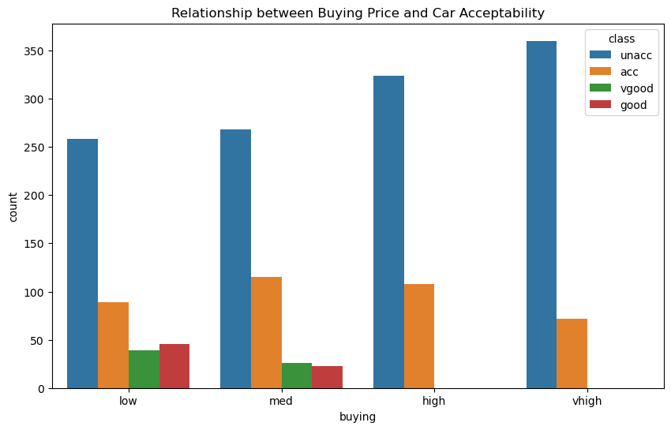

**Impact of Safety Ratings on Car Acceptability**

The acceptability of cars is notably influenced by their safety ratings. Cars with higher safety ratings tend to be perceived as acceptable or even very good.

Cars with high safety ratings are predominantly considered acceptable or very good, as indicated by the dominance of the green and blue segments in the "high" safety rating bar. Cars with low safety ratings are mainly deemed unacceptable, with the green segment overwhelmingly filling the "low" safety rating bar. Medium safety ratings have a varied impact on acceptability. While a considerable number of cars with medium ratings are viewed as acceptable, there is also a significant portion categorized as unacceptable. This suggests that factors beyond safety ratings may contribute to perceptions within this range.

Additional Observations:

Safety emerges as a pivotal factor in consumers' car purchase decisions. The graph highlights the significance of safety features and ratings in influencing consumer choices.

Manufacturers should prioritize safety to enhance the appeal of their cars. Investing in safety features and attaining high safety ratings can substantially enhance a car's marketability.

Fig 2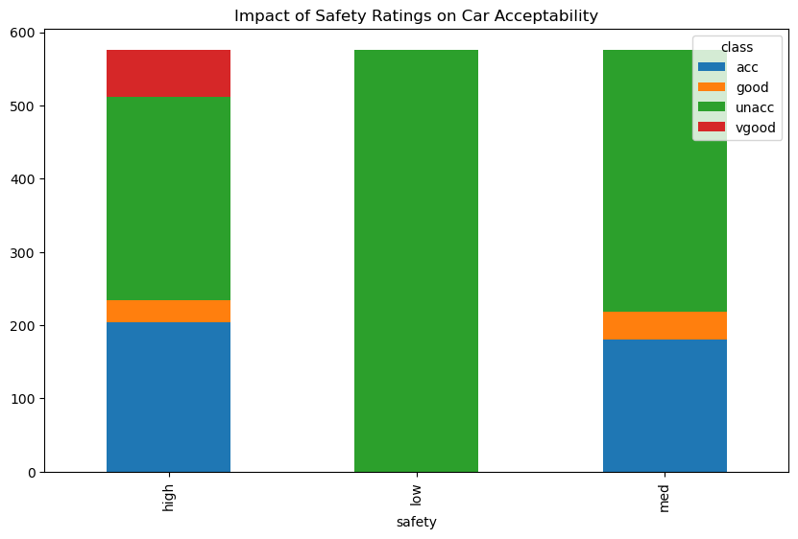

**Influence of Maintenance Cost on Car Acceptability**

Vehicles with lower maintenance costs are more likely to receive favorable ratings, as indicated by the taller blue and orange bars within the "low" maintenance cost category.

As maintenance costs rise, the proportion of cars deemed acceptable or very good diminishes. In the "med" and "high" maintenance cost categories, the green and red bars become shorter.

Cars with exceptionally high maintenance costs are least likely to be considered acceptable. The "vhigh" maintenance cost category exhibits minimal green and red bars, while the blue bar representing "unacceptable" is the most prominent.

This underscores the significance of maintenance cost in influencing car acceptability, with lower costs being more appealing to consumers.

Additional Observations:

Consumers prioritizing affordability may be more accepting of higher maintenance costs, possibly due to budget constraints or a greater emphasis on initial purchase prices over long-term expenses.

Cars with higher initial costs can enhance competitiveness by featuring low maintenance costs. This strategy may help alleviate the initial financial burden, making these cars more attractive to budget-conscious buyers.

Manufacturers could consider providing extended warranties or maintenance plans to alleviate concerns about maintenance costs. Such initiatives could enhance the perceived value of their cars, broadening their appeal across diverse consumer segments.

Fig 3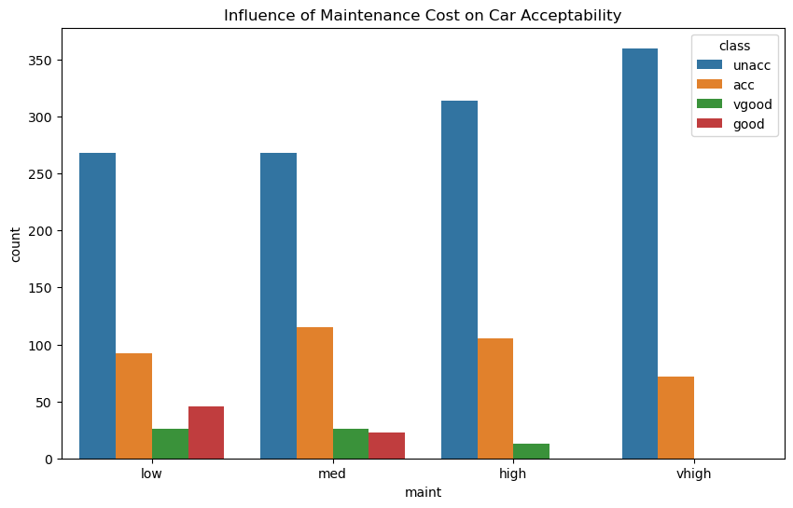

**Relationship between Number of Doors and Car Acceptability**

Cars with a greater number of doors generally exhibit higher passenger capacities, as illustrated by the ascending trend in the graph. Two-door cars typically feature the lowest passenger capacities, whereas cars with four or more doors tend to boast the highest capacities. This distinction is noticeable at the extreme left and right ends of the graph, respectively.

Within each door category, there is some variability; certain four-door cars may have lower passenger capacities than others. This implies that factors beyond the door count, such as car size and layout, can impact passenger capacity. Additional Considerations:

The number of doors serves as a useful indicator of a car's suitability for different needs. For instance, a two-door car may be suitable for an individual or a couple, while a five-door car may be more appropriate for a family or a group of friends.

Individuals prioritizing passenger space should favor cars with more doors, particularly if they frequently transport passengers or large cargo. Car manufacturers should be cognizant of the trade-off between door count and passenger capacity. While additional doors can enhance passenger space, they may also contribute to increased car size and cost.

Fig 4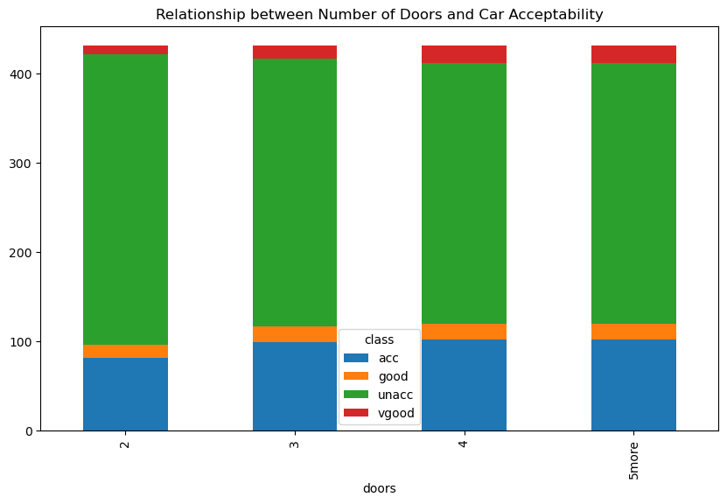

**Influence of Number of Persons on Car Acceptability**

The number of people a car can comfortably seat generally influences how acceptable it is considered. As the number of people a car can seat increases, the proportion of people who find it acceptable or very good also increases. People who prioritize carpooling or transporting families may be more willing to accept cars with higher passenger capacities. This could be because they value the ability to comfortably transport multiple people.

Cars with higher passenger capacities may be more competitive in certain markets, such as those with large families. This could be because they offer more utility and flexibility for these buyers. Manufacturers should consider the trade-off between passenger capacity and other factors such as car size and fuel efficiency. While increasing passenger capacity can make a car more appealing to some buyers, it can also come at the expense of other desirable qualities.

Fig 5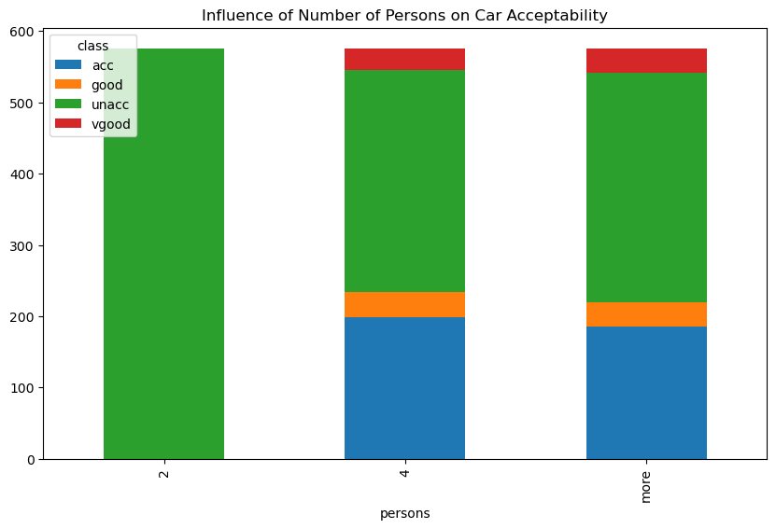

**Acceptability Across Different Maintenance and Safety Levels**

The higher the acceptability, the lower the safety level.

For example, the highest acceptability is for cars with high maintenance and high safety (56), while the lowest acceptability is for cars with low maintenance and low safety (-120).

Here is a more detailed breakdown of the heatmap:

**High maintenance, high safety**: These cars are the most acceptable to buyers, with a score of 56. This is likely because they are in good condition and have a low risk of accidents.

**High maintenance, low safety:** These cars are less acceptable than those with high maintenance and high safety, but they are still more acceptable than cars with low maintenance and low safety. This is likely because they are in good condition, but they are at a higher risk of accidents.

**High maintenance, medium safety:** These cars are less acceptable than those with high maintenance and high safety, but they are more acceptable than cars with low maintenance and medium safety. This is likely because they are in good condition, but they are at a moderate risk of accidents.

**Low maintenance, high safety:** These cars are less acceptable than those with high maintenance and high safety, but they are more acceptable than cars with low maintenance and low safety. This is likely because they are not in as good condition as cars with high maintenance, but they are still at a low risk of accidents.

**Low maintenance, low safety:** These cars are the least acceptable to buyers, with a score of -120. This is likely because they are not in good condition and they are at a high risk of accidents.

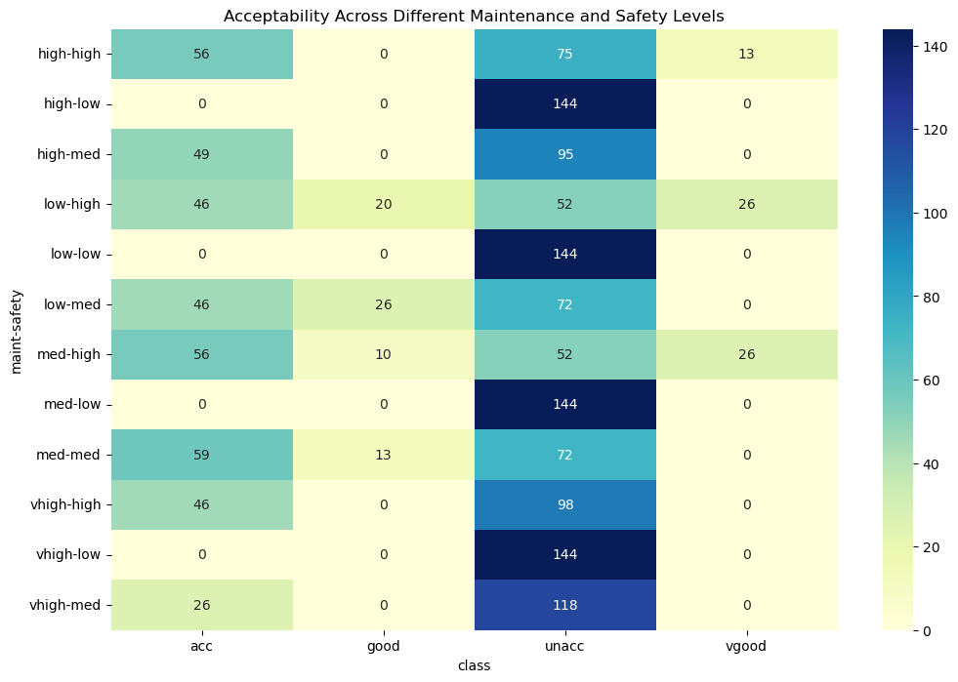

**Impact of Luggage Boot Size on Car Acceptability**

The correlation between car acceptability and luggage boot size generally follows an intriguing pattern. While the "Red" (Very Good) segments consistently increase with larger boot sizes, the patterns for "Blue" (Acceptable) and "Orange" (Good) are less straightforward. Luggage boot size has the most significant impact on acceptability for cars with the highest passenger capacity (5+). In this category, "Large" boots dominate the "Red" (Very Good) segment, with smaller proportions of "Blue" and "Orange" compared to smaller boot sizes. Smaller cars (2 and 3 passengers) exhibit a different pattern. In this case, "Orange" (Good) appears more prevalent in the "Medium" boot size category, indicating it might be the optimal choice for acceptability in these instances. "Blue" (Acceptable) is present across all boot sizes, while "Red" (Very Good) is infrequent, except for some presence in the "Large" boot category for 3-passenger cars. Passenger Capacity Specifics:

Cars with large luggage boots and high passenger capacities (5+) are most likely to receive Very Good (Red) ratings. However, "Blue" (Acceptable) and "Orange" (Good) are not as dominant compared to smaller boot sizes, suggesting that, while a large boot is crucial for this category, it may not be the sole factor influencing Very Good ratings. Cars with small luggage boots and low passenger capacities (2) display a mix of acceptability. "Orange" (Good) takes the lead in the "Medium" boot size, indicating it might be the preferred option for practicality in this category. "Blue" (Acceptable) is present across all boot sizes, while "Red" (Very Good) is rare, suggesting that size might be a less critical factor for small cars. The "Green" (Unacceptable) segment is minimal overall, indicating that most luggage boot sizes fall within acceptable or good ranges for different passenger capacities. Possible Explanations:

For larger cars (5+ passengers), a large luggage boot appears to be a key factor for achieving Very Good ratings (Red). However, additional considerations like features, comfort, or brand might also play a role in determining the full range of acceptability (Blue and Orange). Smaller cars (2 and 3 passengers) seem to have different priorities. A "Medium" boot size appears more favorable for Good (Orange) ratings, possibly balancing practicality with overall car size and cost. The color scheme accentuates positive perceptions, with Red (Very Good) being the strongest, followed by Orange (Good) and then Blue (Acceptable). This suggests that car acceptability leans towards positive assessments, with even smaller boots falling within acceptable or good ranges for most passenger capacities. Additional Insights:

Luggage boot size remains an important factor for car acceptability, but its impact varies based on passenger capacity. Larger cars benefit more from larger boots for Very Good ratings, while smaller cars prioritize a balance between practicality and size with "Medium" boots scoring well. Car manufacturers should consider different passenger segments when designing and marketing their cars. Emphasizing large boots for larger cars and focusing on practicality with "Medium" sizes for smaller cars might resonate with their target audiences.

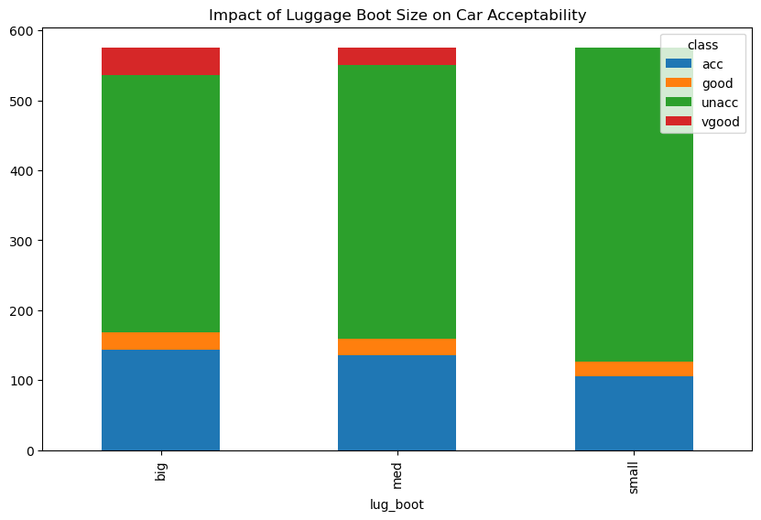

**CONCLUSION**

In conclusion, our extensive analysis has shed light on the intricate factors influencing car acceptability, providing valuable insights for both consumers and manufacturers in the automotive industry. Safety ratings have emerged as a paramount determinant, significantly impacting the perception of a car's acceptability. Additionally, maintenance costs play a pivotal role, especially when juxtaposed with safety considerations.

The joint exploration of safety, maintenance, and other key characteristics has unraveled nuanced relationships, allowing us to discern patterns that guide consumer preferences. Whether it's the impact of luggage boot size on different passenger capacities or the varying priorities of larger and smaller cars, our findings emphasize the multifaceted nature of car acceptability.

Consumers are encouraged to prioritize safety while weighing the long-term implications of maintenance costs. Meanwhile, manufacturers should consider the diverse needs of their target audiences, tailoring design and marketing strategies accordingly. As we navigate the evolving landscape of the automotive industry, understanding these dynamics is crucial for informed decision-making, ensuring both safety and satisfaction on the road.

**REFERENCE**

Ngulube, P. (2015). Qualitative data analysis and interpretation: systematic search for meaning. *Addressing research challenges: making headway for developing researchers*, *131*, 156.

Stančin, I., & Jović, A. (2019, May). An overview and comparison of free Python libraries for data mining and big data analysis. In 2019 42nd International convention on information and communication technology, electronics and microelectronics (MIPRO) (pp. 977-982). IEEE.

Kabacoff, R. (2022). *R in action: data analysis and graphics with R and Tidyverse*. Simon and Schuster.