**For Larger Screens**

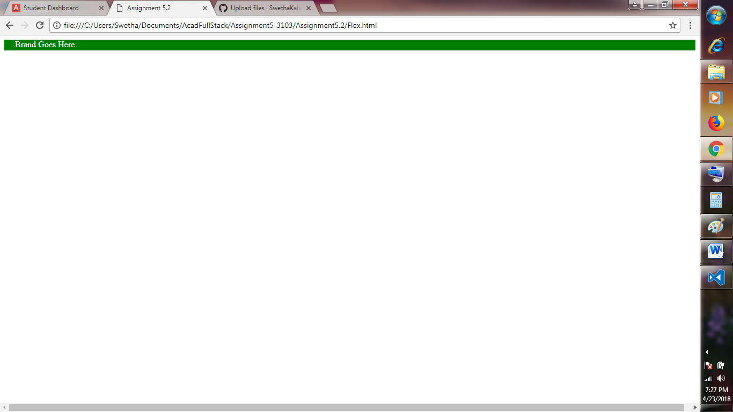

**For Small Screens When Width is reduces and @media query is applied**

