1. **From Head Section**

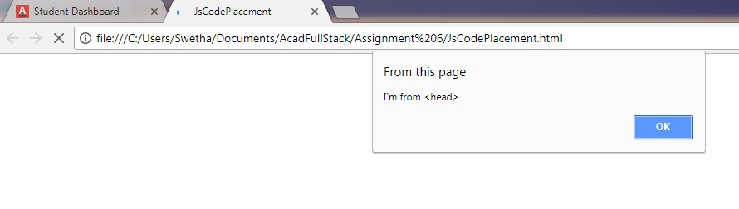

1. **From Body Section**

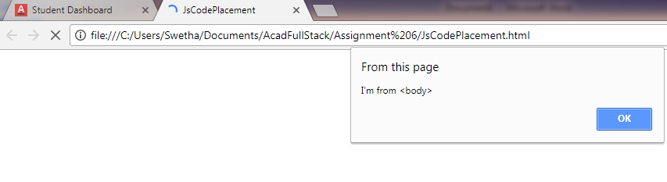

1. **From external file script src in body**

