1. http:// <http://localhost:3000/protfolio>



1. http:// [http://localhost:3000](http://localhost:3000/protfolio)

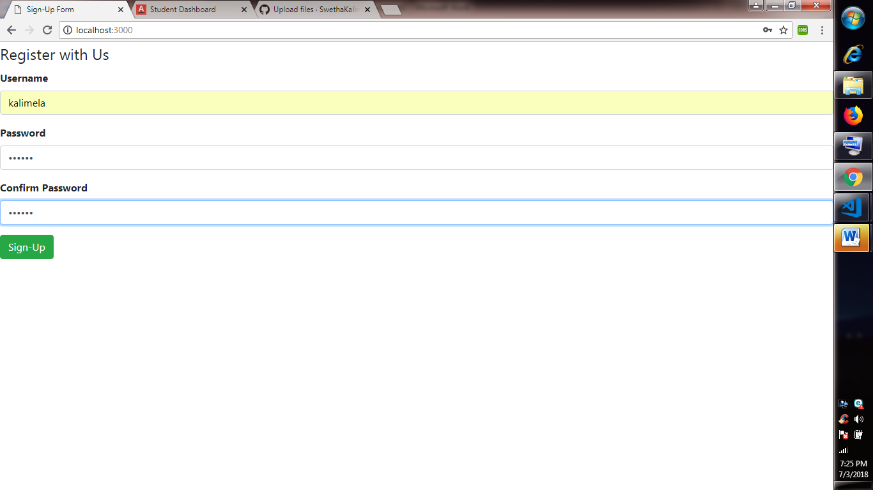

1. On clicking signup

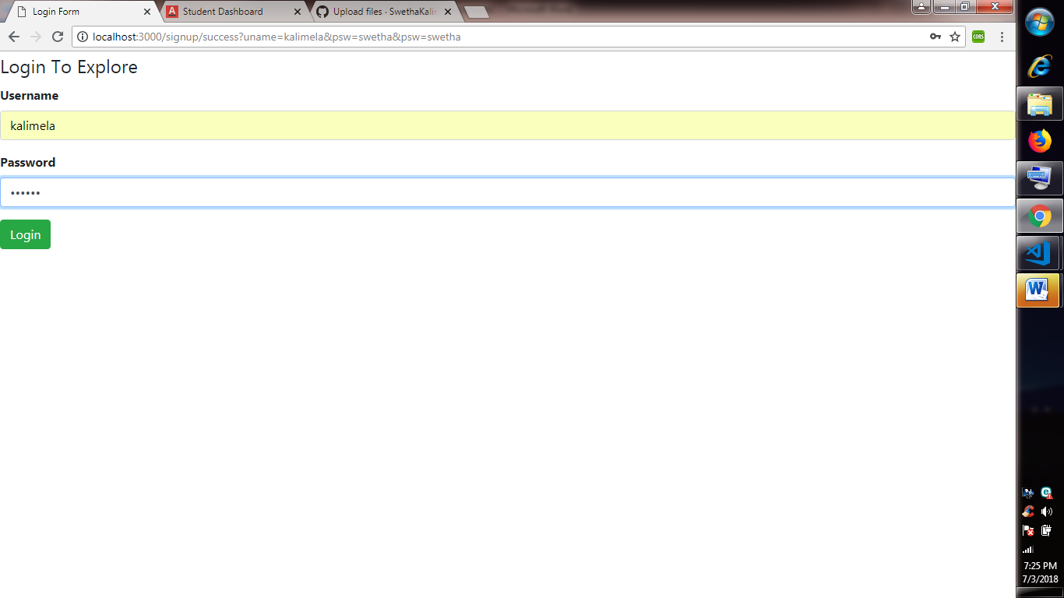

1. On clicking login

