|--- **App.js [*The App Root Component*]**

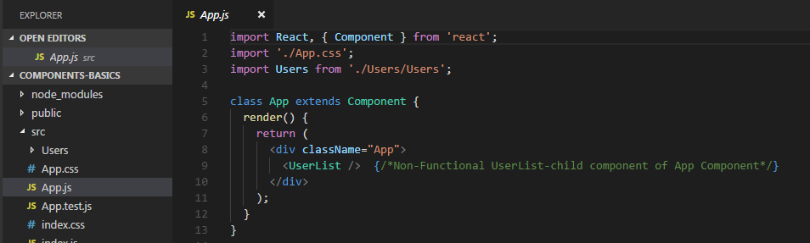

|--- **App.js [*Child Class Component in the App Root Component*]**

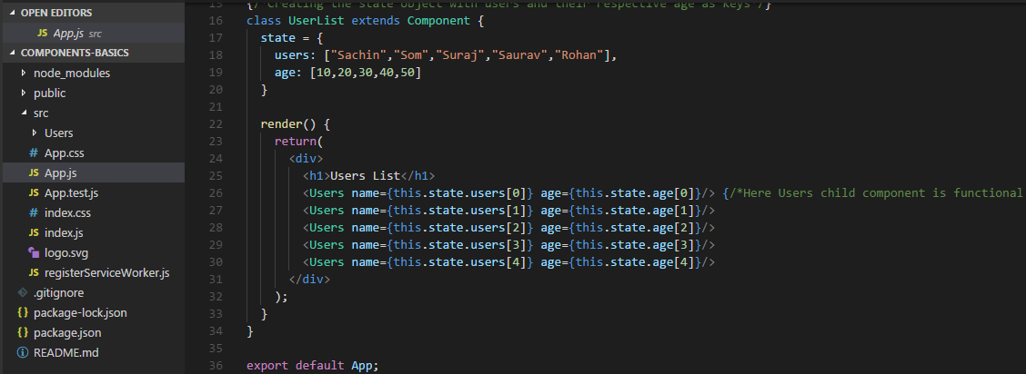

**|--Src**

**|__Users**

**|--Users.js [*Functional Child Component to the UserList Non-Functional Component*]**

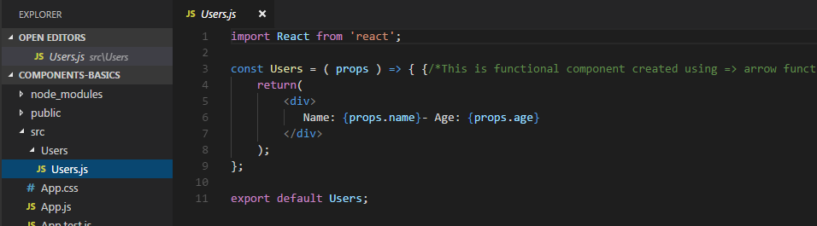

**Output**

