1. **Checking if node and npm are installed in my system. Please refer screen shot below.**

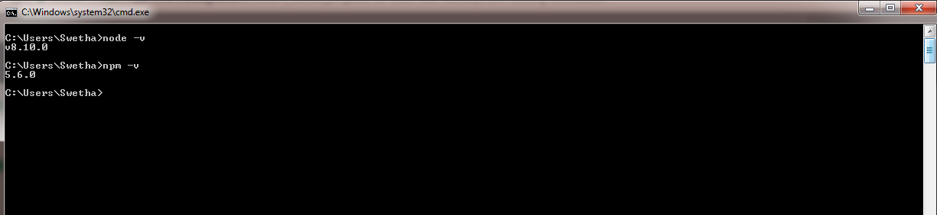

1. **Creating a new project/folder in VSC**

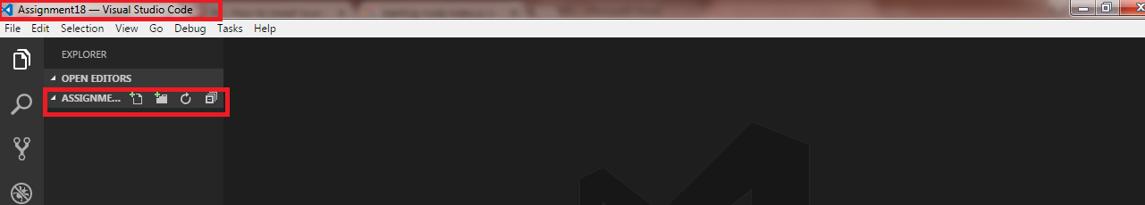

1. **Creating “package.json” with command npm init**

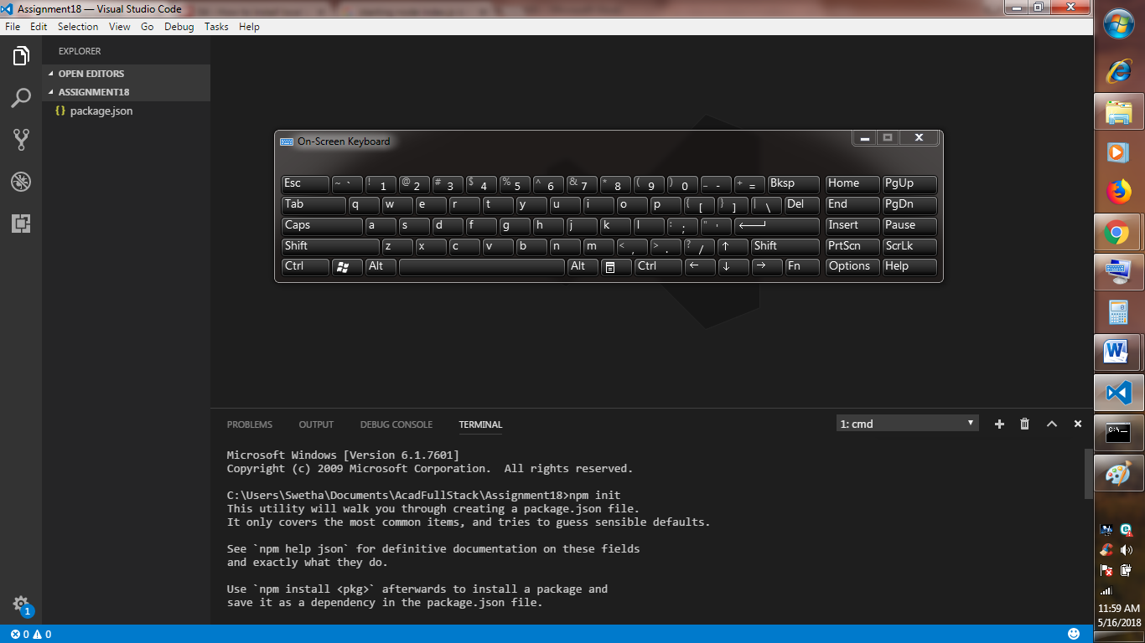

1. **To run the Project**

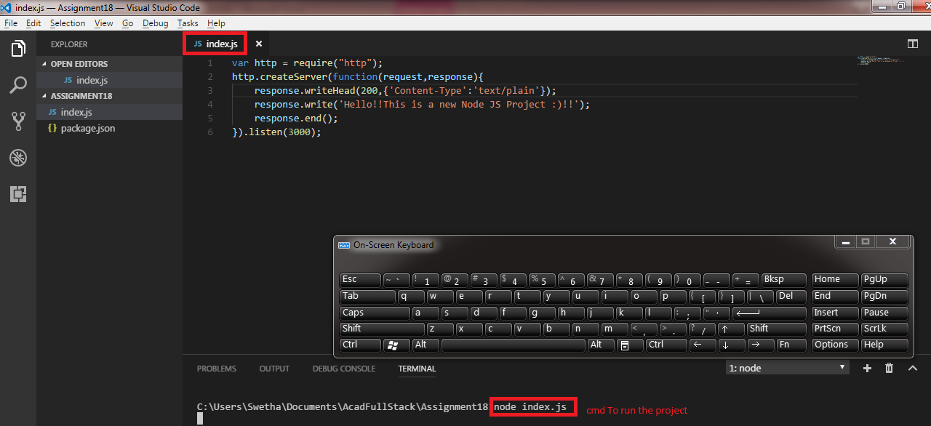

1. **Output** [**http://localhost:3000**](http://localhost:3000) **see below image**

