Assignment4

Swetha

3/14/2022

a.Use only the numerical variables (1 to 9) to cluster the 21 firms. Justify the various choices made in conducting the cluster analysis, such as weights for different variables, the specific clustering algorithm(s) used, the number of clusters formed, and so on.

#Loading the Required packages  
library(flexclust)

## Warning: package 'flexclust' was built under R version 4.1.3

## Loading required package: grid

## Loading required package: lattice

## Loading required package: modeltools

## Loading required package: stats4

library(cluster)

## Warning: package 'cluster' was built under R version 4.1.3

library(tidyverse)

## Warning: package 'tidyverse' was built under R version 4.1.3

## -- Attaching packages --------------------------------------- tidyverse 1.3.1 --

## v ggplot2 3.3.5 v purrr 0.3.4  
## v tibble 3.1.6 v dplyr 1.0.8  
## v tidyr 1.2.0 v stringr 1.4.0  
## v readr 2.1.2 v forcats 0.5.1

## Warning: package 'readr' was built under R version 4.1.3

## Warning: package 'forcats' was built under R version 4.1.3

## -- Conflicts ------------------------------------------ tidyverse_conflicts() --  
## x dplyr::filter() masks stats::filter()  
## x dplyr::lag() masks stats::lag()

library(factoextra)

## Warning: package 'factoextra' was built under R version 4.1.3

## Welcome! Want to learn more? See two factoextra-related books at https://goo.gl/ve3WBa

library(FactoMineR)

## Warning: package 'FactoMineR' was built under R version 4.1.3

library(ggcorrplot)

## Warning: package 'ggcorrplot' was built under R version 4.1.3

#loading the data  
getwd()

## [1] "C:/Users/mercy/OneDrive/Desktop/FML/Assignment4"

setwd("C:/Users/mercy/OneDrive/Desktop/FML/Assignment4")  
Info<- read.csv("Pharmaceuticals.csv")  
# I am selecting columns from 3 to 11 and storing the data in variable Info1  
Info1 <- Info[3:11]  
# Using head function to display the first 6 rows of data  
head(Info1)

## Market_Cap Beta PE_Ratio ROE ROA Asset_Turnover Leverage Rev_Growth  
## 1 68.44 0.32 24.7 26.4 11.8 0.7 0.42 7.54  
## 2 7.58 0.41 82.5 12.9 5.5 0.9 0.60 9.16  
## 3 6.30 0.46 20.7 14.9 7.8 0.9 0.27 7.05  
## 4 67.63 0.52 21.5 27.4 15.4 0.9 0.00 15.00  
## 5 47.16 0.32 20.1 21.8 7.5 0.6 0.34 26.81  
## 6 16.90 1.11 27.9 3.9 1.4 0.6 0.00 -3.17  
## Net_Profit_Margin  
## 1 16.1  
## 2 5.5  
## 3 11.2  
## 4 18.0  
## 5 12.9  
## 6 2.6

summary(Info1)

## Market_Cap Beta PE_Ratio ROE   
## Min. : 0.41 Min. :0.1800 Min. : 3.60 Min. : 3.9   
## 1st Qu.: 6.30 1st Qu.:0.3500 1st Qu.:18.90 1st Qu.:14.9   
## Median : 48.19 Median :0.4600 Median :21.50 Median :22.6   
## Mean : 57.65 Mean :0.5257 Mean :25.46 Mean :25.8   
## 3rd Qu.: 73.84 3rd Qu.:0.6500 3rd Qu.:27.90 3rd Qu.:31.0   
## Max. :199.47 Max. :1.1100 Max. :82.50 Max. :62.9   
## ROA Asset_Turnover Leverage Rev_Growth   
## Min. : 1.40 Min. :0.3 Min. :0.0000 Min. :-3.17   
## 1st Qu.: 5.70 1st Qu.:0.6 1st Qu.:0.1600 1st Qu.: 6.38   
## Median :11.20 Median :0.6 Median :0.3400 Median : 9.37   
## Mean :10.51 Mean :0.7 Mean :0.5857 Mean :13.37   
## 3rd Qu.:15.00 3rd Qu.:0.9 3rd Qu.:0.6000 3rd Qu.:21.87   
## Max. :20.30 Max. :1.1 Max. :3.5100 Max. :34.21   
## Net_Profit_Margin  
## Min. : 2.6   
## 1st Qu.:11.2   
## Median :16.1   
## Mean :15.7   
## 3rd Qu.:21.1   
## Max. :25.5

# The variables are measured in different weights throughout the rows, we will scale the data in Info1 and save the scaled data in the Info2 dataframe. I am Calculating the distance between the rows of data and visualizing the distance matrix using get_dist and fviz_dist functions which are available in factoextra package.

Info2 <- scale(Info1)  
row.names(Info2) <- Info[,1]  
distance <- get_dist(Info2)  
fviz_dist(distance)

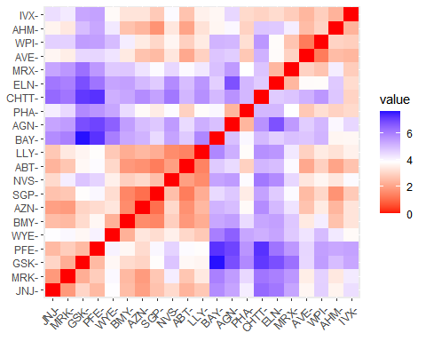

# Now I am creating the correlation Matrix and I am printing to check the correlation among major variables

corr <- cor(Info2)  
ggcorrplot(corr, outline.color = "grey50", lab = TRUE, hc.order = TRUE, type = "full")

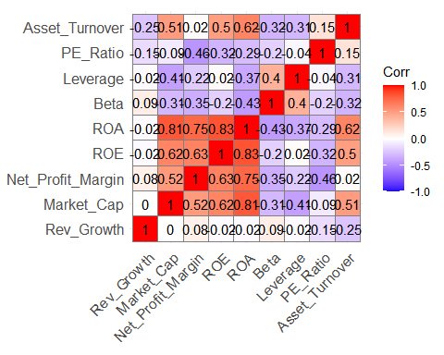

#The Correlation Matrix reveals that ROA, ROE, Net Profit Margin, and Market Cap is high. By using Principal Component Analysis I am finding out weightage of major variables in the data set. Here I am assuming best number of cluster is 5.

pca <- PCA(Info2)

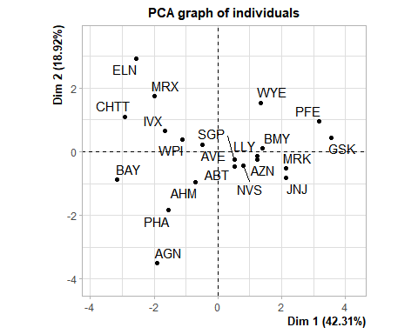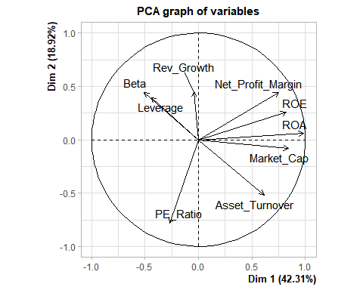

var <- get_pca_var(pca)  
fviz_pca_var(pca, col.var="contrib",  
 gradient.cols = c("grey","yellow","purple","red","blue"),ggrepel = TRUE ) + labs( title = "PCA Variable Variance")

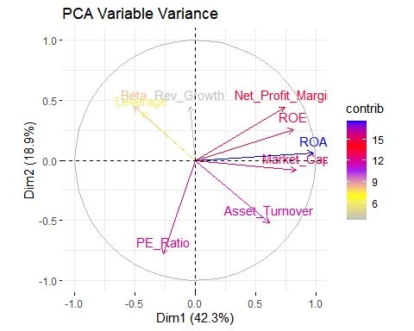

We may deduce from PCA Variable Variance that ROA,ROE, Net Profit Margin, Market Cap, and Asset Turnover contribute over 61% to the two PCA components/dimensions (Variables)and I am using elbow method to find optimal number of customers.

set.seed(10)  
wss <- vector()  
for(i in 1:10) wss[i] <- sum(kmeans(Info2,i)$withinss)  
plot(1:10, wss , type = "b" , main = paste('Cluster of Companies') , xlab = "Number of Clusters", ylab="wss")

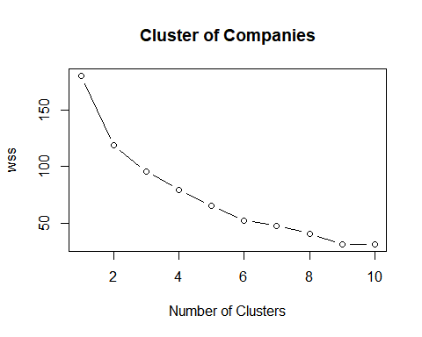

wss

## [1] 180.00000 118.56934 95.99420 79.21748 65.61035 52.67476 47.66961  
## [8] 41.12605 31.81763 31.57252

I got the same number as assumed. Optimal cluster is at 5 . ## Silhouette Method Finding best number of clusters.

fviz_nbclust(Info2, kmeans, method = "silhouette")

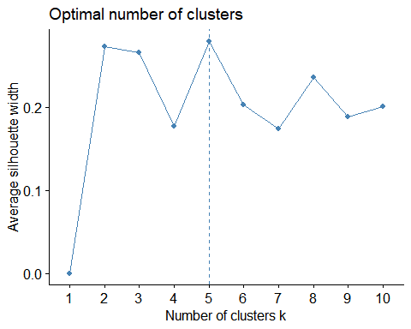

Here also the idealnumber of clusters is 5. Using k-means algorithm to cluster with 5.

set.seed(1)  
k5 <- kmeans(Info2, centers = 5, nstart = 25) # k = 5, number of restarts = 25  
k5$centers

## Market_Cap Beta PE_Ratio ROE ROA Asset_Turnover  
## 1 -0.76022489 0.2796041 -0.47742380 -0.7438022 -0.8107428 -1.2684804  
## 2 -0.43925134 -0.4701800 2.70002464 -0.8349525 -0.9234951 0.2306328  
## 3 -0.03142211 -0.4360989 -0.31724852 0.1950459 0.4083915 0.1729746  
## 4 -0.87051511 1.3409869 -0.05284434 -0.6184015 -1.1928478 -0.4612656  
## 5 1.69558112 -0.1780563 -0.19845823 1.2349879 1.3503431 1.1531640  
## Leverage Rev_Growth Net_Profit_Margin  
## 1 0.06308085 1.5180158 -0.006893899  
## 2 -0.14170336 -0.1168459 -1.416514761  
## 3 -0.27449312 -0.7041516 0.556954446  
## 4 1.36644699 -0.6912914 -1.320000179  
## 5 -0.46807818 0.4671788 0.591242521

k5$size

## [1] 4 2 8 3 4

fviz_cluster(k5, data = Info2)

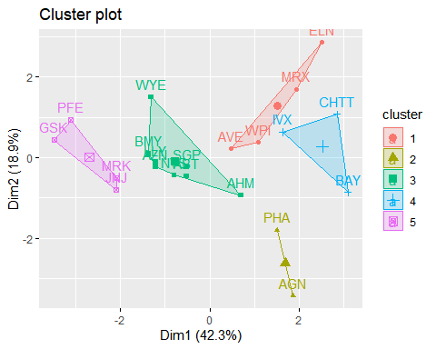

#kmeans clustering, using Manhattan Distance

set.seed(1)  
k51 = kcca(Info2, k=5, kccaFamily("kmedians"))  
k51

## kcca object of family 'kmedians'   
##   
## call:  
## kcca(x = Info2, k = 5, family = kccaFamily("kmedians"))  
##   
## cluster sizes:  
##   
## 1 2 3 4 5   
## 7 3 6 3 2

#Using predict function.  
clusters_index <- predict(k51)  
dist(k51@centers)

## 1 2 3 4  
## 2 2.150651   
## 3 3.513242 4.146567   
## 4 3.878726 4.246051 3.388339   
## 5 3.018500 3.737739 5.124420 6.043691

image(k51)  
points(Info2, col=clusters_index, pch=19, cex=0.3)

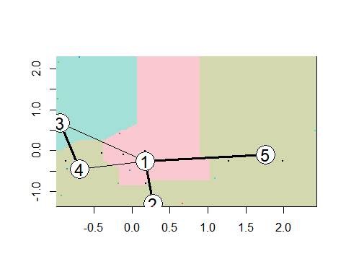

b.Interpret the clusters with respect to the numerical variables used in forming the clusters Using Kmeans method to calculate Mean.

Info1 %>% mutate(Cluster = k5$cluster) %>% group_by(Cluster) %>% summarise_all("mean")

## # A tibble: 5 x 10  
## Cluster Market_Cap Beta PE_Ratio ROE ROA Asset_Turnover Leverage  
## <int> <dbl> <dbl> <dbl> <dbl> <dbl> <dbl> <dbl>  
## 1 1 13.1 0.598 17.7 14.6 6.2 0.425 0.635  
## 2 2 31.9 0.405 69.5 13.2 5.6 0.75 0.475  
## 3 3 55.8 0.414 20.3 28.7 12.7 0.738 0.371  
## 4 4 6.64 0.87 24.6 16.5 4.17 0.6 1.65   
## 5 5 157. 0.48 22.2 44.4 17.7 0.95 0.22   
## # ... with 2 more variables: Rev_Growth <dbl>, Net_Profit_Margin <dbl>

clusplot(Info2,k5$cluster, main="Clusters",color = TRUE, labels = 2,lines = 0)

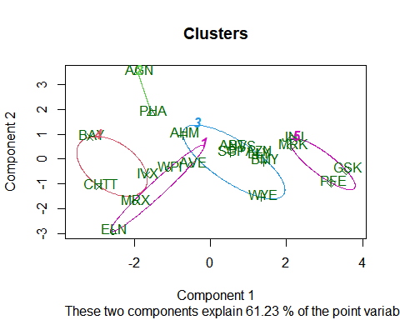

Companies are categorized into different clusters as follows:

Cluster 1: ELN, MRX, WPI and AVE Cluster 2: AGN and PHA Cluster 3: AHM,WYE,BMY,AZN, LLY, ABT, NVS and SGP Cluster 4: BAY, CHTT and IVX Cluster 5: JNJ, MRK, PFE and GSK From the means of the cluster variables , we can say that, Cluster 1 has the fastest revenue growth, the highest Net Profit Margin, and the lowest PE ratio. It can be purchased or held in reserve..Cluster 2 PE ratio is very high Cluster 3 has average risk Cluster 4 Though it has a good PE ratio, it carries a very high risk , very very high leverage and low Net Profit margin , making it very risky to own. Revenue growth is also very low.Cluster 5 has a high market capitalization, return on investment, return on assets, asset turnover, and net profit margin. With a low PE ratio, the stock price is moderately valued and hence can be purchased and held revenue growth of 18.5% is good.

c.Is there a pattern in the clusters with respect to the numerical variables (10 to 12)? (those not used informing the clusters) #plotting clusters against the variables to check for any patterns

Info3 <- Info[12:14] %>% mutate(Clusters=k5$cluster)  
ggplot(Info3, mapping = aes(factor(Clusters), fill =Median_Recommendation))+geom_bar(position='dodge')+labs(x ='Clusters')

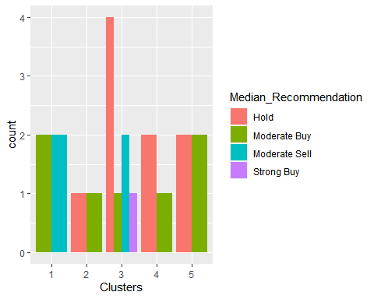

ggplot(Info3, mapping = aes(factor(Clusters),fill = Location))+geom_bar(position = 'dodge')+labs(x ='Clusters')

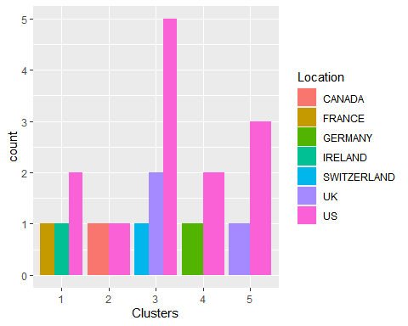

ggplot(Info3, mapping = aes(factor(Clusters),fill = Exchange))+geom_bar(position = 'dodge')+labs(x ='Clusters')

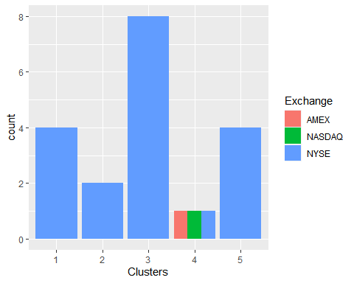

–>.Clusters and the variable Median Recommendation appear to follow a pattern. –>Except for the fact that the bulk of the clusters/companies are listed on the NYSE and are based in the United States, there appears to be no discernible pattern among the clusters, locations, or exchanges.

d.Provide an appropriate name for each cluster using any or all of the variables in the dataset. Cluster 1: Best Buying Cluster 2: Highly Risky Cluster 3: Go for it Cluster 4: Very Risky or Runaway Cluster 5: Ideal to Own