MAHCINE LEARNING-ASSIGNMENT5

Github link:

Zoom video link:

Question 1:Principle component analysis

A : Apply PCA on CC dataset.

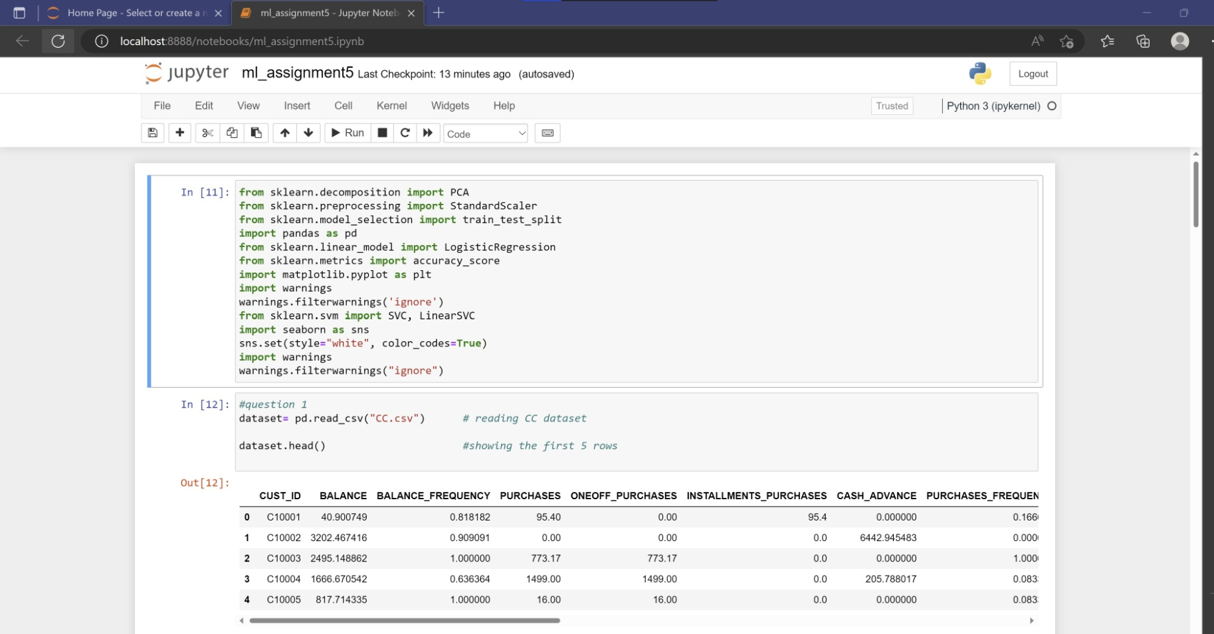

Importing the CC dataset nd showing the first five rows using head( ).

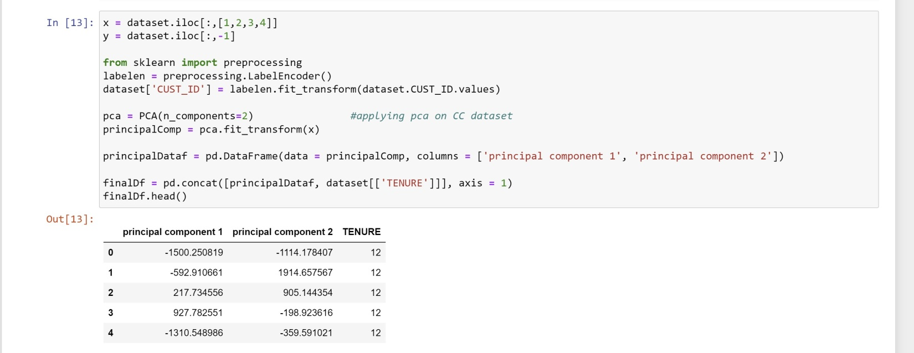

Applying pca on the CC dataset.

B :Applying kmeans algorithm on the pca result and reporting the performance:

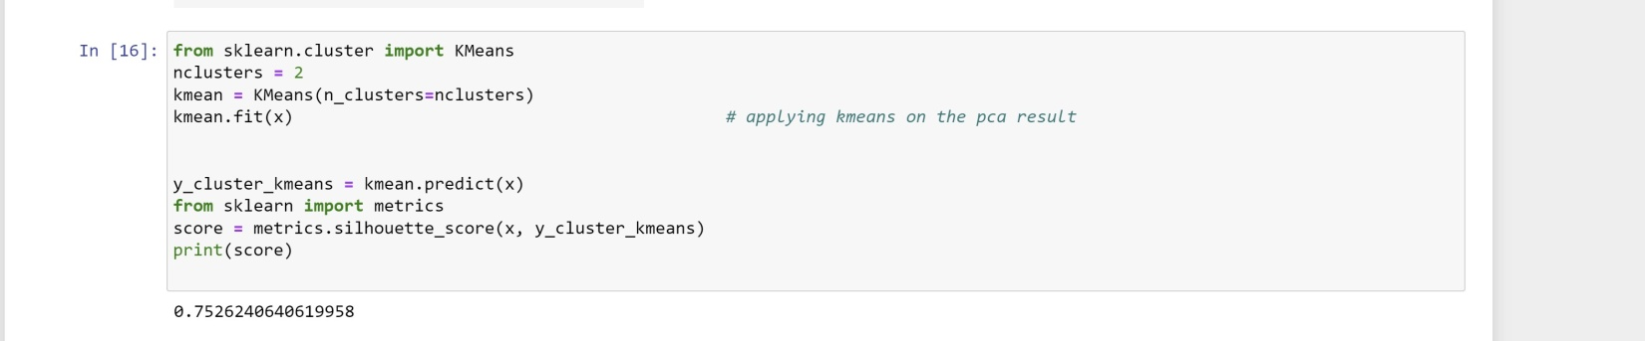 after applying kmeans we got the silhouette score as 0.75.If the silhouette is near to 1 it is said that the object is well mached with its own group and well separated from it’s the neighbhouring cluster.

C: performing scaling along with PCA and the kmeans and reporting the performance

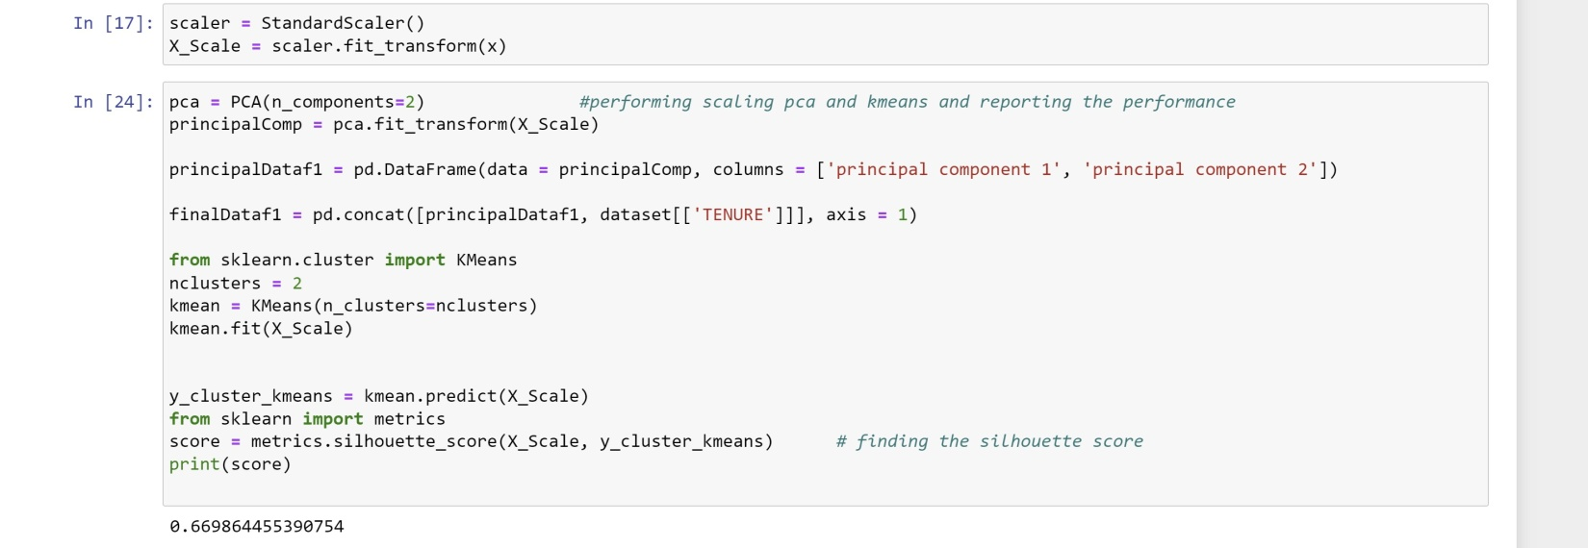

QUESTION 2:

A: Performing scaling

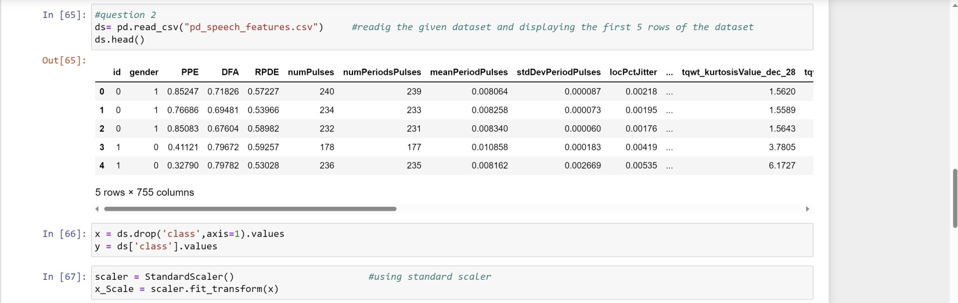

Here we read the given data file pd_speech_features and use head() to show the first five rows of the dataset.

Then we use standard scaler and perform the scaling .

B: Apply PCA with k=3

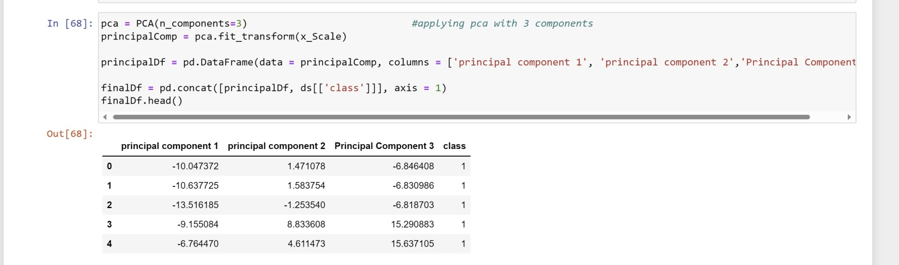

Applying pca with k=3 as shown above.

C: Using SVM to report the performance :

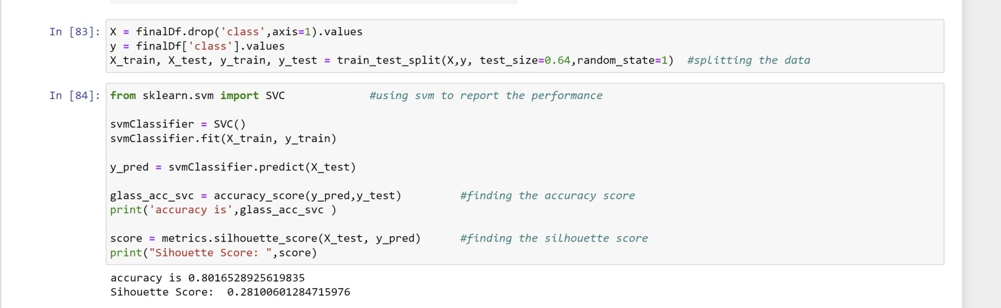

Here by using the svmclassifier we have found the accuracy as well as the silhouette score.

QUESTION 3:

Applying linear discriminant analysis on the iris dataset to reduce the dimensionality of the data to k=2 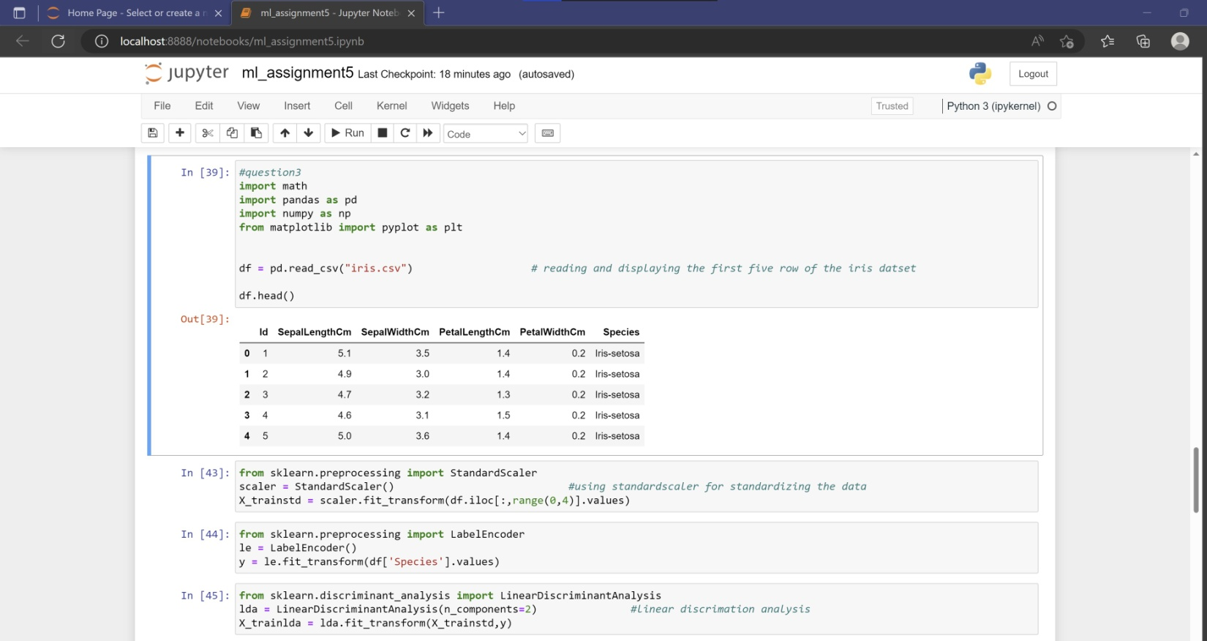

Importing the iris dataset and showing the first five rows by using head().

Then using standardscaler and labelencoder and then applying linear discriminant analysis on the iris dataset.

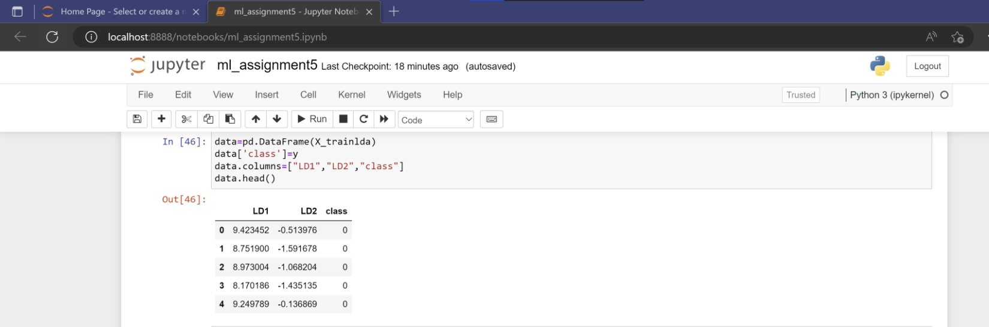

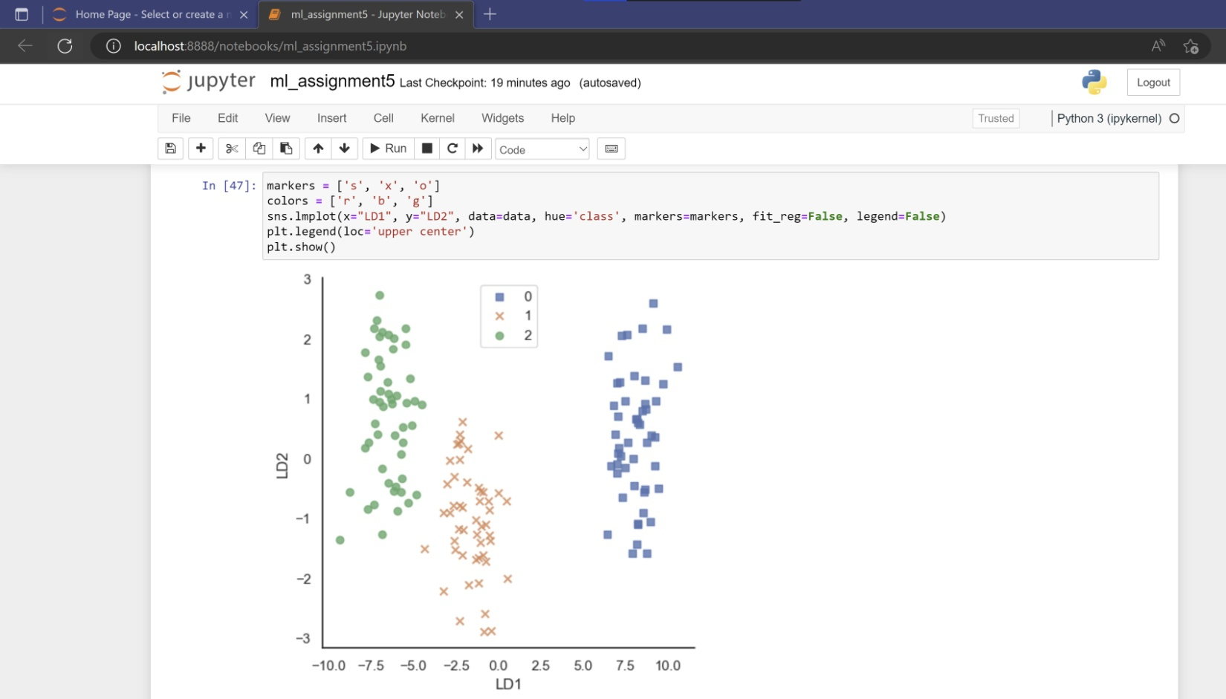

QUESTION 4: The difference between PCA and LDA.

