1.Show Databases:

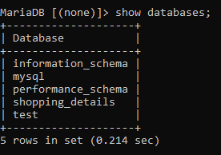

2.Create Database:

C:\Users\Swetha\Desktop\Dbms\1.PNG

3.Use Database:

C:\Users\Swetha\Desktop\Dbms\2.PNG

4.Create Table:

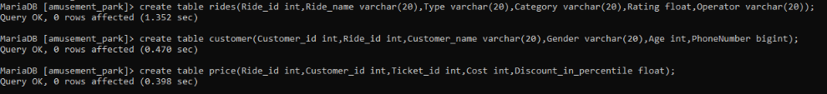

5.Show Tables present in the database amusement_park:

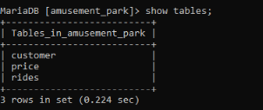

6.Insert records into the table rides:

C:\Users\Swetha\Desktop\Dbms\5.PNG

7. a.Select data from the table rides:

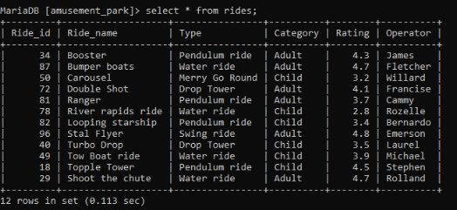

7.b.Select data from the table customer:

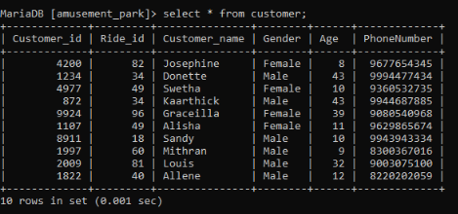

7.c.Select data from the table price:

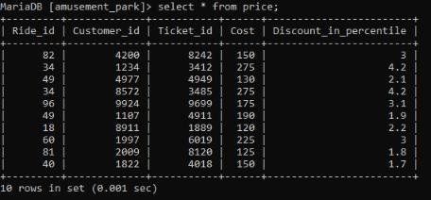

8.Select ridename and type from the table rides:

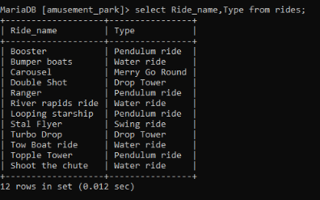

9.Sort the Age of customers in decending order using the keyword group by desc:

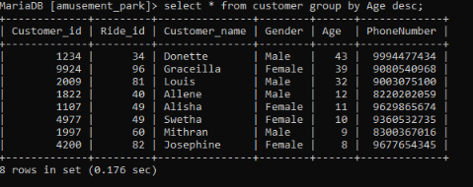

10.Order the rides based on the type using the keyword order by:

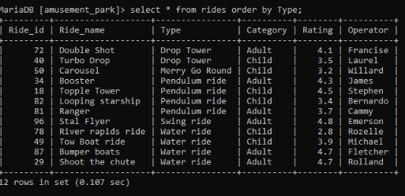

11.Display the average age of the customers:

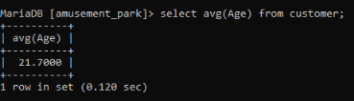

12.Dispaly the maximum rating of rides:

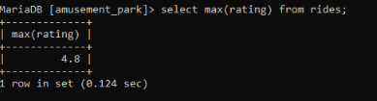

13.Display the minimum cost from the table price:

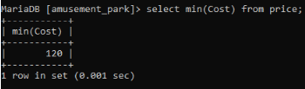

14.Display the sum of cost from the table price:

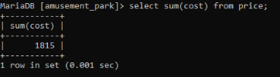

15.Display the count of rides from the table rides:

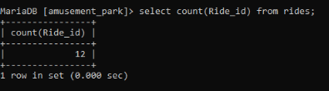

16.Display the count and the type of ride group by having count of ride name greater than 3:

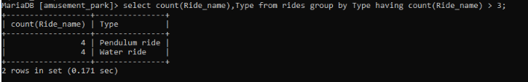

17.Display the distinct type of rides:

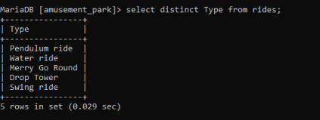

18.Display the count od distinct type of rides:

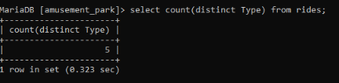

19.Display the customer id and name from the table customer where age is greater than 12 and gender is female:

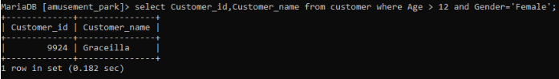

20.Display the ride names from the table rides whose rating is between 3.1 and 5.0:

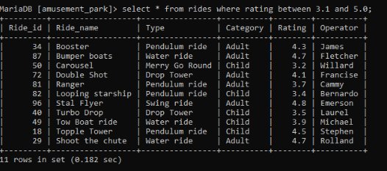

21.Display the ride names starting with t:

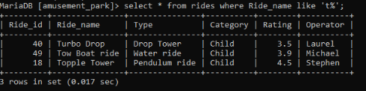

22.Display the ride names whose type is Water ride and Drop Tower:

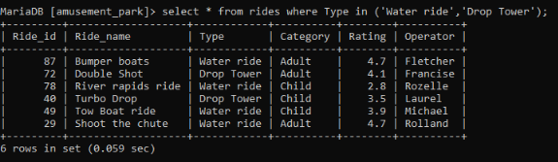

23.Display the rides whose type is Pendulum ride and the rating is greater than 4.0 using logical operator and:

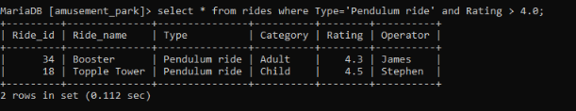

24.Display the cost of tickets whose price is less than 170 or the discount in percentile is less than 3.5 using logical operator or:

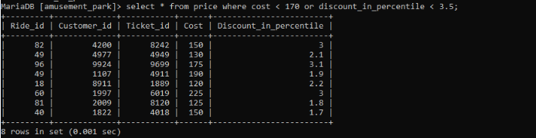

25.Display the customer details whose age is less than 12 using where or:

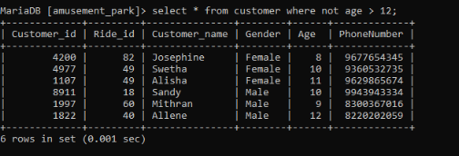

26.Add new column to the table price named total:

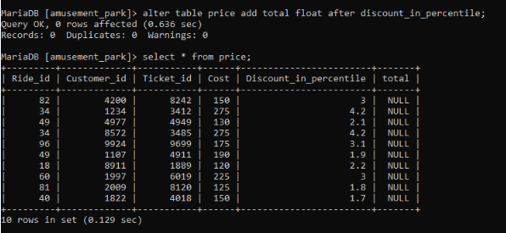

27.Delete the column total from the table price:

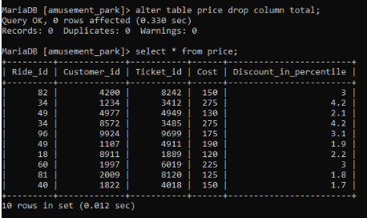

28.Display the description of the table customer:

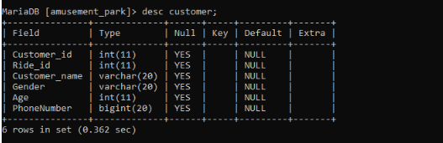

29.Update the customer table and set customer_id to 8572 where customer name is Kaarthick:

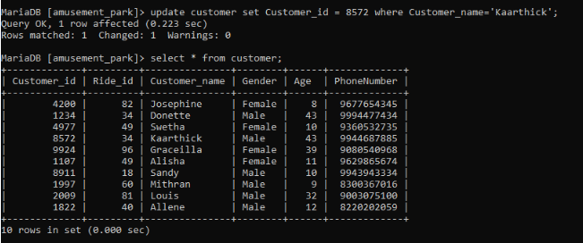

30.Delete the row from customer table whose customer id is 9924:

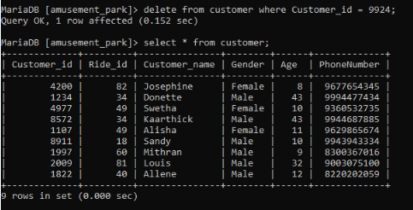

31.Display first 5 rows from the table rides:

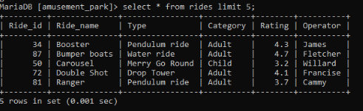

32.Display customer names from the customer table ending with a:

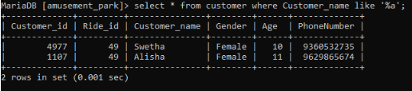

33. Display customer names from the customer table that contains a subtring ‘ne’:

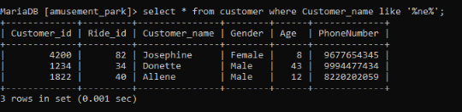

34.Display the ride names from the table rides which has the second letter has o:

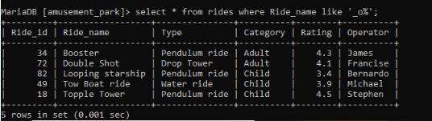

35.Display the ride names from the table rides that does not start with the letter b:

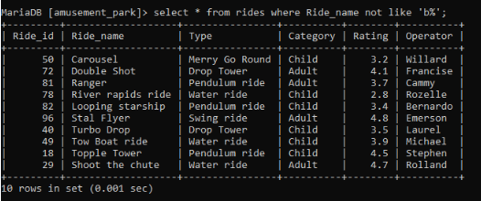

36.Rides that has rating between 3.5 and 4.5 and does not belong to the type Pendulum ride and Water ride:

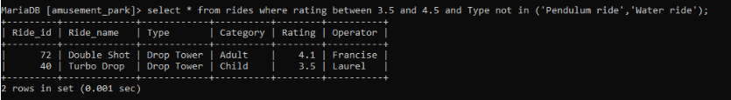

37.Add primary key Ride_id to the table rides:

C:\Users\Swetha\Desktop\Dbms\38.PNG

38.Calculate variance of age from the table customer:

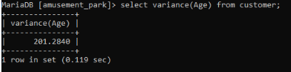

39.Calculate standard deviation of age from the table customer:

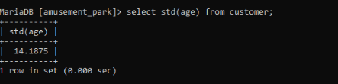

40.Concatenate and display the customer name and gender from the table customer

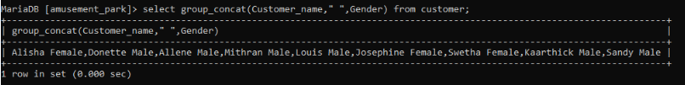

41.Calculate bit_xor of rating from the table rides:

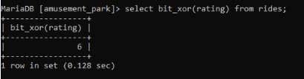

42.Find the length of the ride name whose ride id is 34:

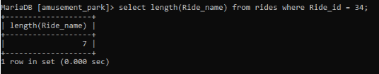

43.Find the length of all the ride names from the table rides:

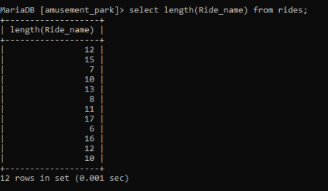

44.Extract 5 characters from right from the rides whose rating is greater than 3.5:

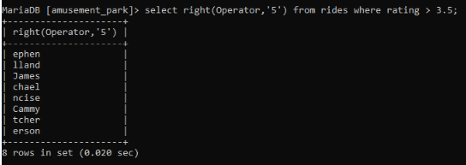

45. Extract 5 characters from left from the rides whose rating is greater than 3.5:

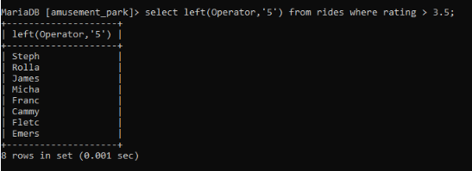

46.Find the position of the character e in the string customer name from the table customers:

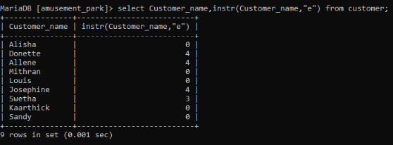

47.Insert ‘thosh’ and replace the last 2 characters of the customer name whose customer id is 8911

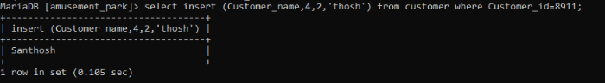

48.Format the ratings of the rides to a zero decimal places:

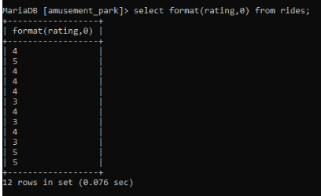

49.Find swetha from the set of customer names from the table customers:

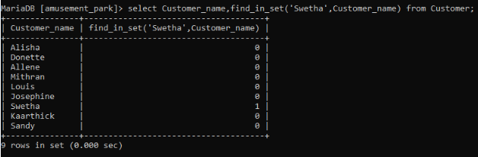

50.Display the names of customers in upper case:

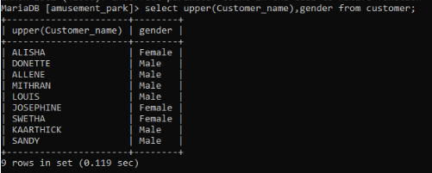

51.Display the names of customer in upper case and gender in lower case from the table customer:

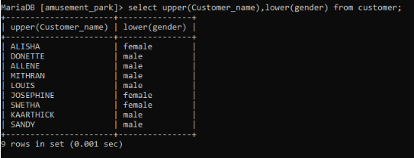

52.Locate 45 from the list of phone numbers of the customers from the table customer:

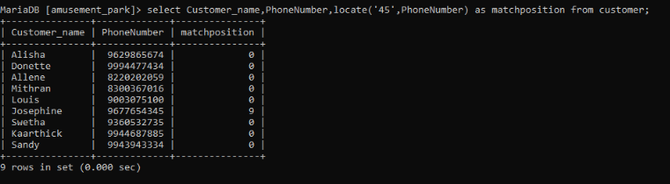

53.Perform right padding to 20 characters with the string 00:

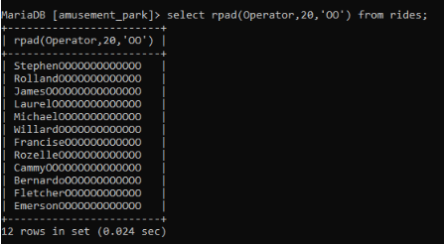

54.Extract 4 characters from the 5th position of the customer name from the table customer:

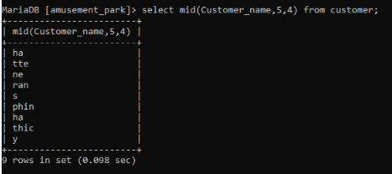

55. Perform left padding to 20 characters with the string 00

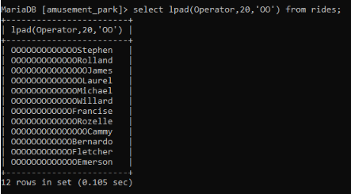

56.Replace the child category as kids in the table rides:

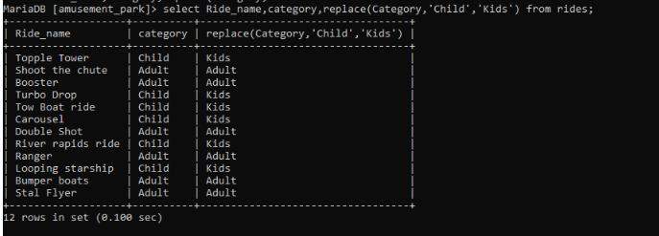

57. Find the position of the character e in the string customer name from the table customers:

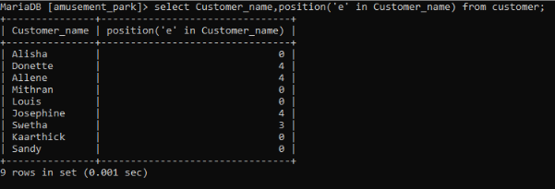

58.Repeat the operator name from the table rides thrice:

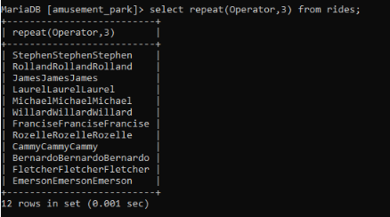

59.Display the reverse of ride names from the table rides:

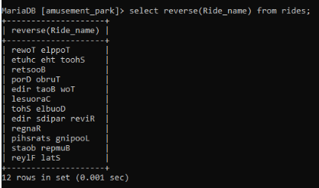

60.Form a substring of 5 characters using the customer name from the character 2 :

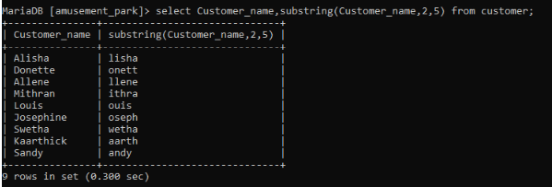

61.Compare the ride name Booster with the ride whose ride id is 34:

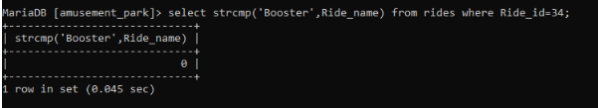

62.Perform ceiling of rating in the table rides:

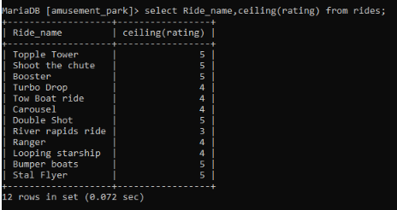

63.Perform floor of discount in percentile in the table price:

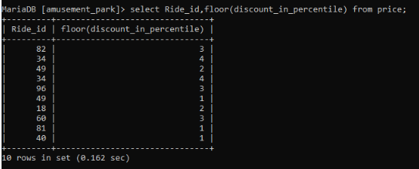

64.Calculate the log of cost from the table price:

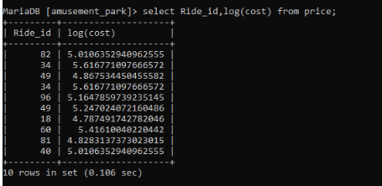

65.Calculate the natural logarithm of cost from the table price:

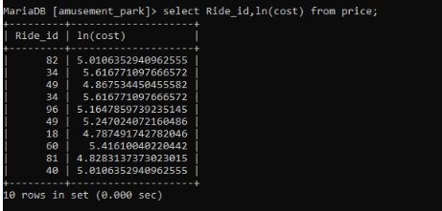

66.Calculate the square root of cost from the table price:

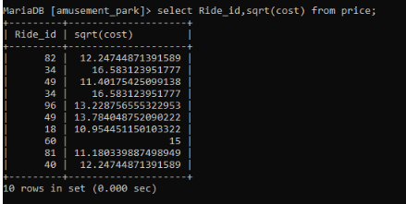

67. Rank the ride names based on the rating of the rides(dense rank):

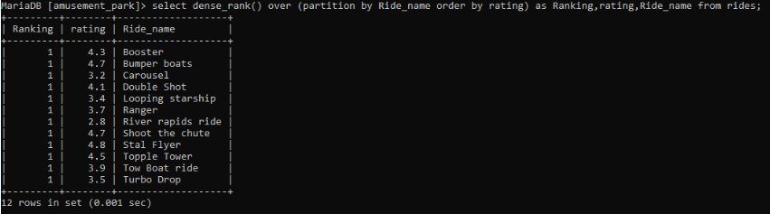

68. Rank the ride names based on the rating of the rides(rank):

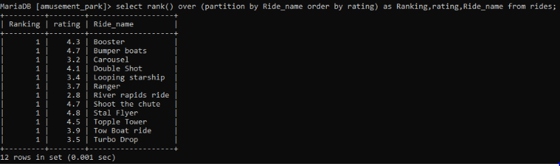

69. Rank the ride names based on the rating of the rides and row number:

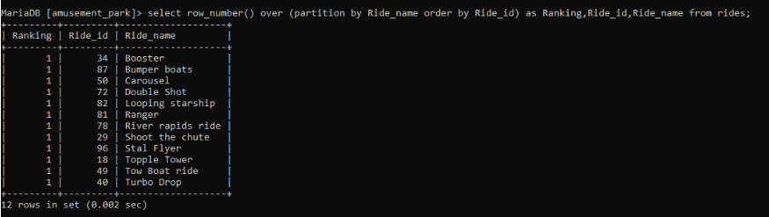

70.Update the customer’s phone number whose name is swetha:

C:\Users\Swetha\Desktop\Dbms\71.PNG

71.Alter the table price and modify ticket_id as unique:

C:\Users\Swetha\Desktop\Dbms\72.PNG

72.Display customer name and gender from the table customer:

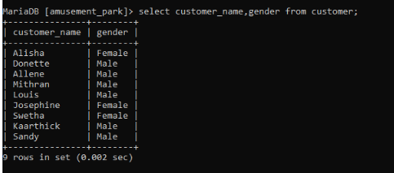

73.Display the customer names from the table customer whose gender is male:

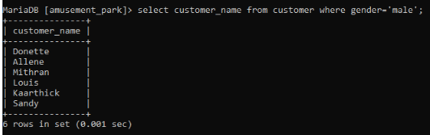

74.Display the substring_index of the ride name whose ride id is 49:

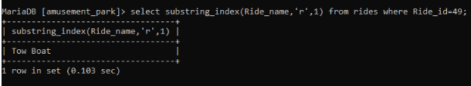

75.Calculate the absolute value of the discount in percentile from the table price:

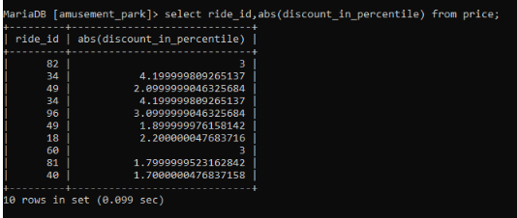

76. Calculate acos of discount in percentile from the table price:

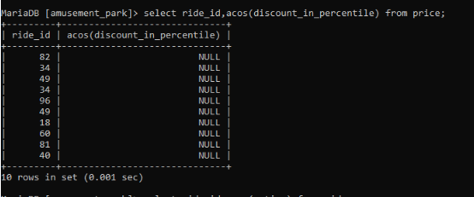

77. Calculate atan of rating from the table rides:

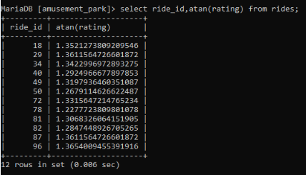

78.Calculate atan2 of discount in percentile and cost from the table price:

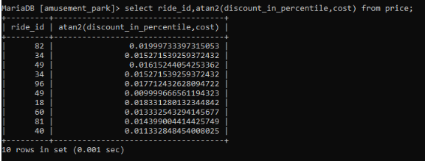

79. Calculate cos of rating from the table rides:

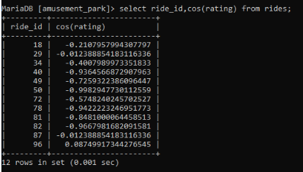

80. Calculate cot of rating from the table rides:

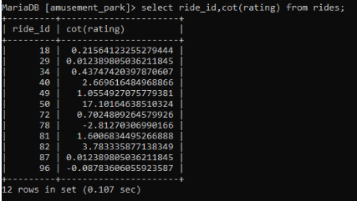

81. Calculate degrees of rating from the table rides:

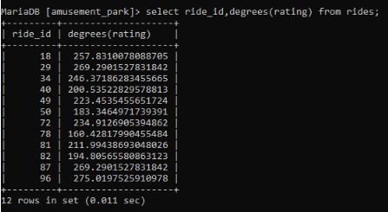

82.Calculate the discount amount from the cost and discount in percentile from the table price:

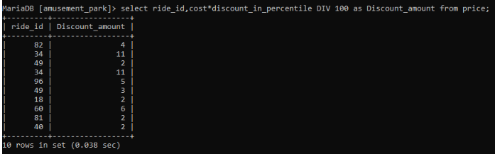

83.Calculate the exponential value of rating from the table rides:

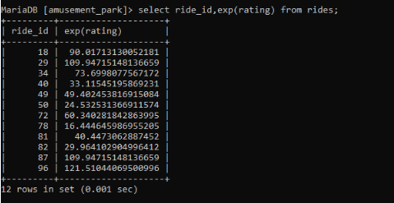

84.Find the customer whose age is maximum from the list of customers:

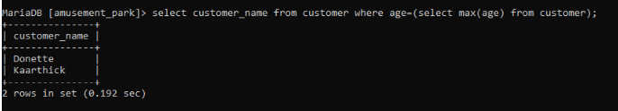

85.Rename the table customer to customer_details:

C:\Users\Swetha\Desktop\Dbms\86.PNG

86.Display customers whose age is greater than 12 and the gender is male:

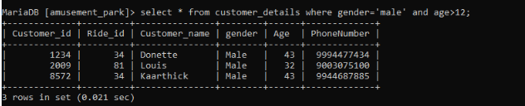

87.Display the ride id with the maximum price:

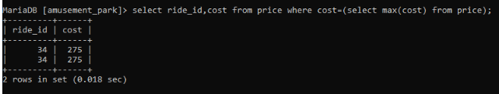

88.Alter the table customer_details and check whether age is greater than 5:

C:\Users\Swetha\Desktop\Dbms\89.PNG

89.Display the first three ride names and rating orderd by rating in the descending order:

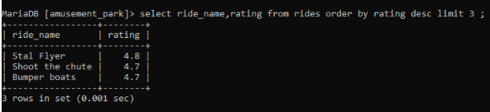

90.Display the customer name whose age is less than 12 using the keyword some:

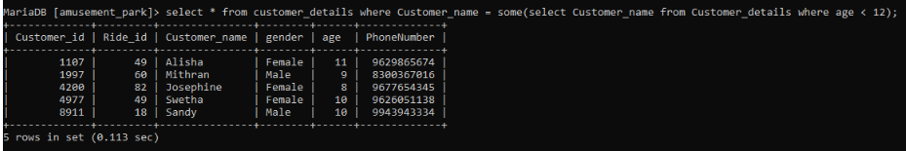

91.Find the day of the specified date:

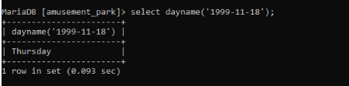

92.Delete the database test:

C:\Users\Swetha\Desktop\Dbms\93.PNG

93.Display the version of the maria db:

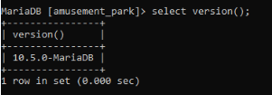

94.Display the current database in use:

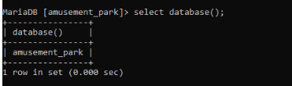

95.Display the current user:

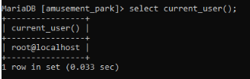

96.Display the current time stamp:

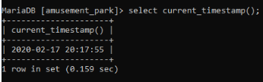

97.Display the date from the given date format:

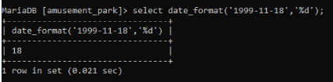

98.Display the current time:

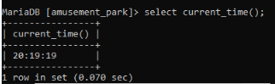

99.Display the current date:

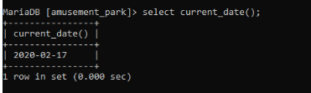

100.Return 3 spaces using the space function for the ride name with ride id of 34:

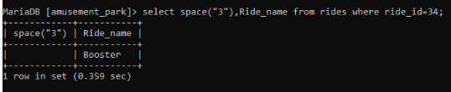

101.Find the length of ride name whose ride id is 34:

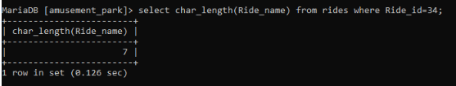

102.Return the ascii value of s using ascii function:

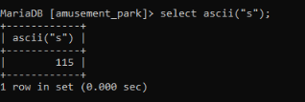

103. Users that have been created in MariaDB as well as information about these Users:

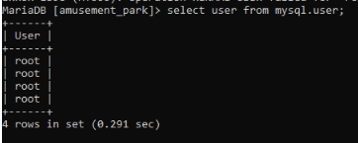

104.Alter the table rides and modify ridename to varchar(25) not null:

C:\Users\Swetha\Desktop\Dbms\105.PNG

105.Find the ride id whose cost is greater than 100 using keyword any:

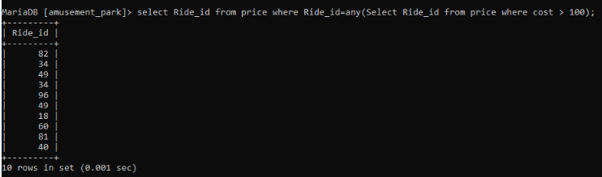

106. Find the ride id whose cost is less than 200 using keyword any:

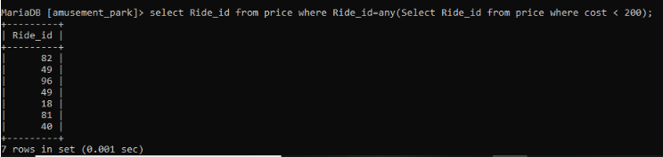

107.Display the rides of type pendulum using the keyword exists:

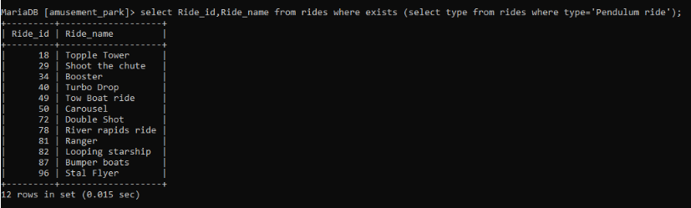

108.Display the ride id and ride name whose type is pendulum having the count of ride id is greater than 1:

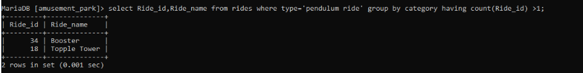

109.Perform inner join and combine the ride names and the customer names :

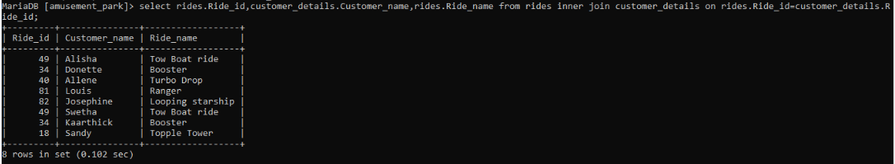

110.Perform left join and combine the customer details and the price tables:

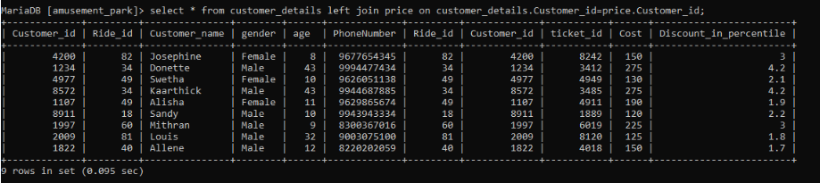

111. Perform right join and combine the customer details and the price tables:

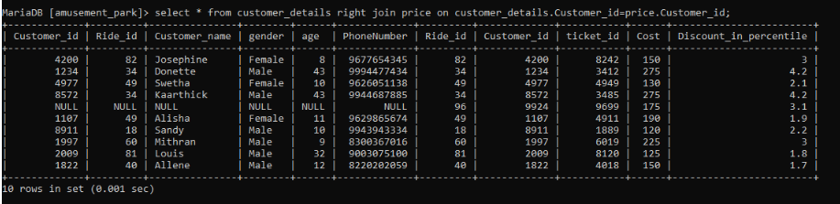

112.Alter the table rides and drop the primary key:

C:\Users\Swetha\Desktop\Dbms\113.PNG

113.Display the customer name and id whose phone number is 9677654345:

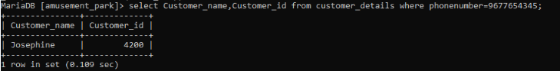

114.Display the union all of ride id’s present in the rides table and the customer details table:

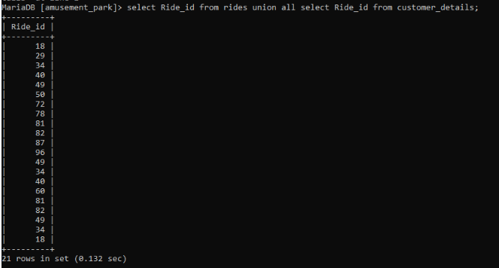

115. Display the intersection of ride id’s present in the rides table and the customer details table:

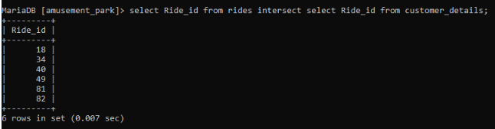

116. Display the union of ride id’s present in the rides table and the customer details table:

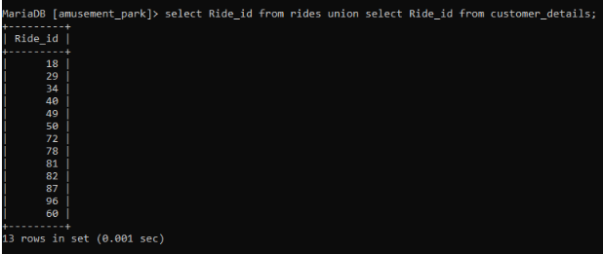

117.Field value:

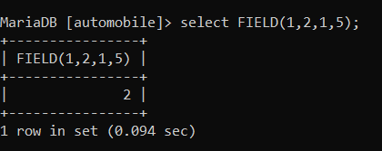

118.Find_in-Set  function returns the position of a string in a comma-delimited string list:

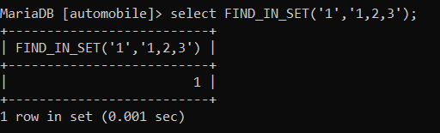

119. Find_in-Set  function returns the position of a string in a comma-delimited string list:

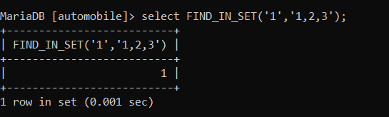

120. Simulate a row number for the details entered:

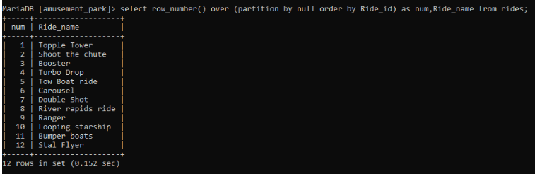

121.Delete the customer detail whose id is 4200:

C:\Users\Swetha\Desktop\Dbms\119.PNG

122.Delete column ticket id from the table price:

C:\Users\Swetha\Desktop\Dbms\120.PNG

123.Display the customer name whose phone number ends with the number 5:

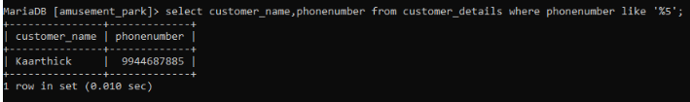

124.Display the content from the table customer details where customer name is null:

C:\Users\Swetha\Desktop\Dbms\122.PNG

125. Change the column name temporarily:

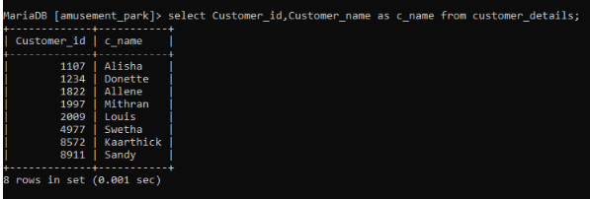

126.Display the customer names from the customer details table in descending order:

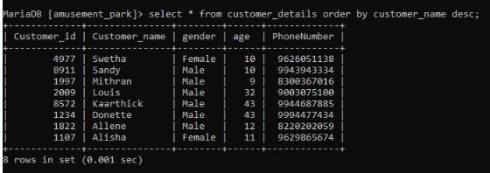

127.Display the rides that belong to the category adult:

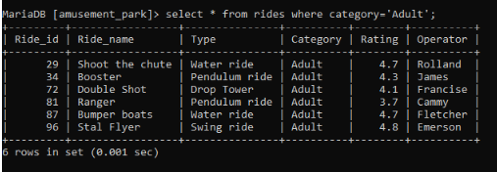

128.Perform inner join of ride name and cost from the table rides and price:

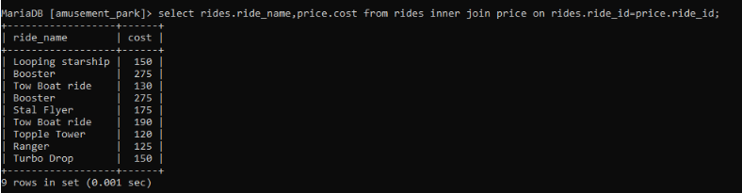

129. Search for the particular name

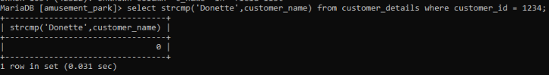

130.Create table history:

C:\Users\Swetha\Desktop\Dbms\129.PNG

131.Display the content of the table history:

C:\Users\Swetha\Desktop\Dbms\130.PNG

132.Truncate table history:

C:\Users\Swetha\Desktop\Dbms\131.PNG

133.Drop table history:

C:\Users\Swetha\Desktop\Dbms\132.PNG

134.Create view pay_details:

C:\Users\Swetha\Desktop\Dbms\133.PNG

135.Display pay_details:

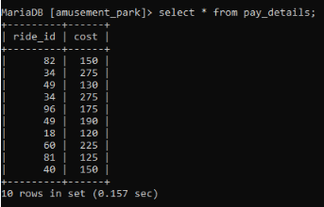

136.Drop view pay_details:

C:\Users\Swetha\Desktop\Dbms\135.PNG

137.Display the content of pay_details:

C:\Users\Swetha\Desktop\Dbms\136.PNG

138.Display the type and the count of rides grouped by type ordered in descending order:

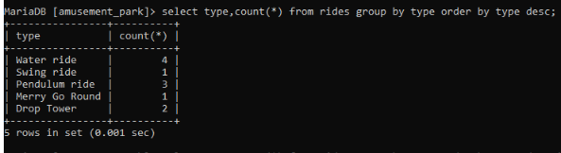

139. Display the type and the count of rides grouped by type ordered in descending order is not null:

C:\Users\Swetha\Desktop\Dbms\138.PNG

140. Display the type and the count of rides grouped by type in descending order whose rating is greater than 3.0:

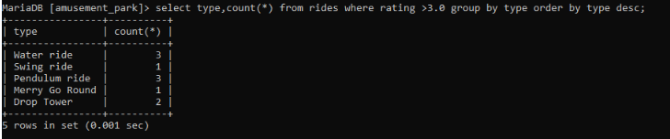

141. Display the type and the count of rides grouped by type in descending order whose rating is between 3.0 and 4.5:

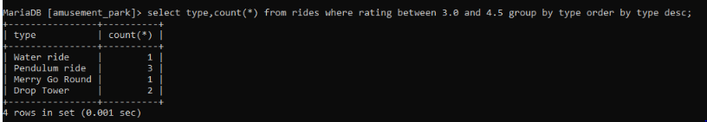

142. Display the ride name and the count of rides where the type is pendulum ride:

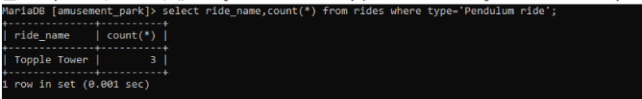

143.Display the customer details where the gender is female and the phone number ends with 4 or the age is less than 12 or the age is between 30and 40:

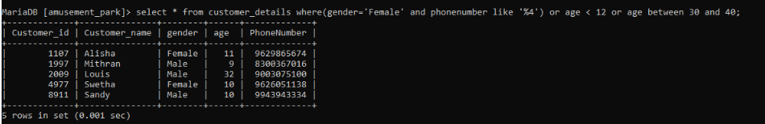

144. Calculate the average age of customers:

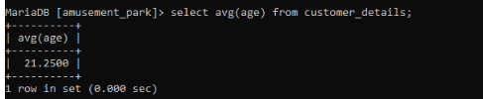

145.Average age of customer assigned to @avg_age:

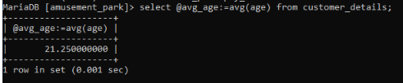

146.Display the list of customers whose age is greater than that of the average age:

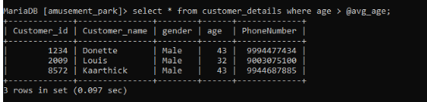

147.Display the ride name and the category count group by ride name: 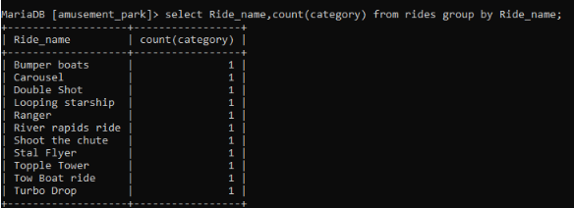

148.Display the type and the count of rides and the type is null and grouped by type in descending order whose rating is between 3.0 and 4.5:

C:\Users\Swetha\Desktop\Dbms\141.PNG

149.Display the category count where the category is adult:

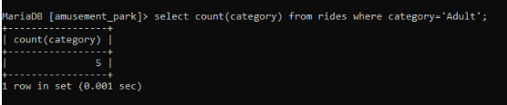

150. Display the customer details where the gender is female and the phone number ends with 4 or the age is less than 12 and the phone number is not null:

