**BLOOD BANK MANAGEMENT SYSTEM**

**AIM:**

**SCHEMA:**

donor(did,dname,age,sex,bloodtype);

recipient(rid,rname,age,sex,bloodtype);

blood(bankid,bloodtype,donor,recipient,quantity,did,rid);

bank(bankid,bname,address,city,state,);

**THE TABLES IN THIS SYSTEM ARE:**

* **DONOR:**

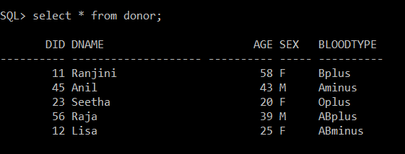

* **RECEPIENT:**

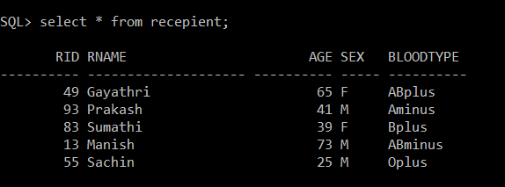

* **BLOOD:**

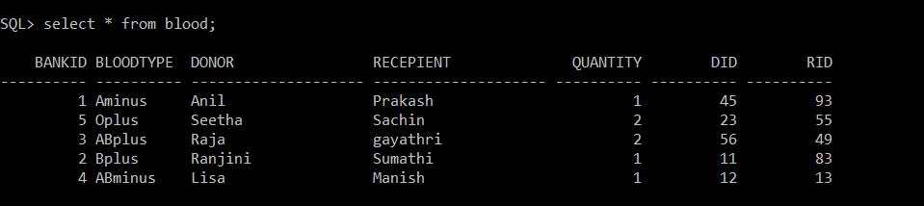

* **BANK:**

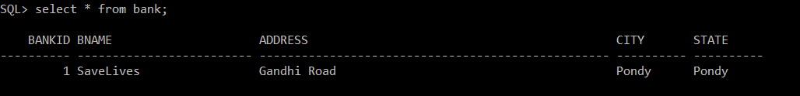

**PROCEDURES:**

1. **Question:** Insert a record into the table bank with entries (1,’SaveLives’,’Gandhi Road’,’Pondy’,’Pondy’)

**Procedure:**

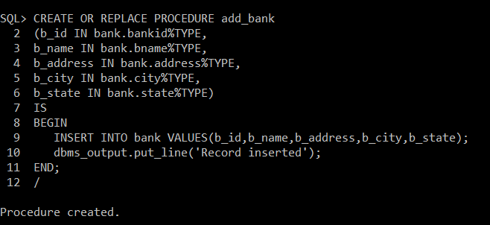

**Execution:**

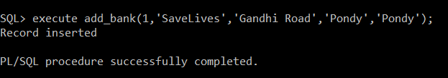

**OUTPUT:**

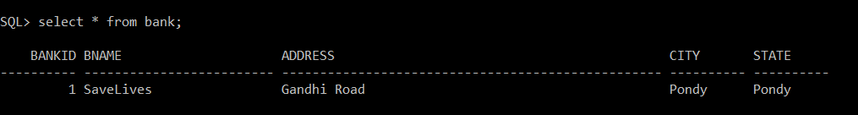

1. **Question:** Update the age of a donor named “Ranjini” from 58 to 59.

**Procedure:**

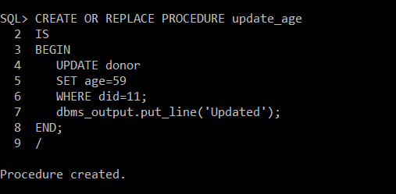

**Execution:**

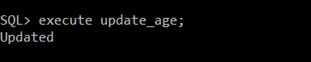

**OUTPUT:**

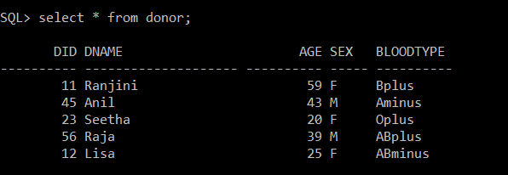

**FUNCTIONS:**

1. **Question:** Calculate the total quantity of blood available.

**Function:**

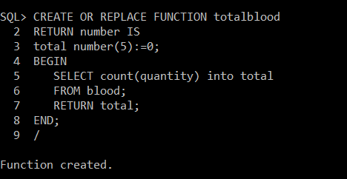

**Execution and Output:**

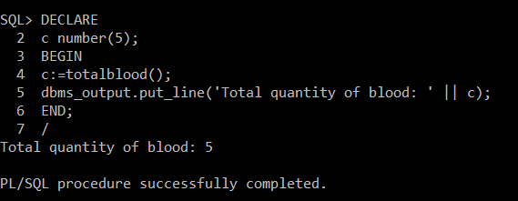

1. **Question:** To find the maximum age from the recipients.

**Function:**

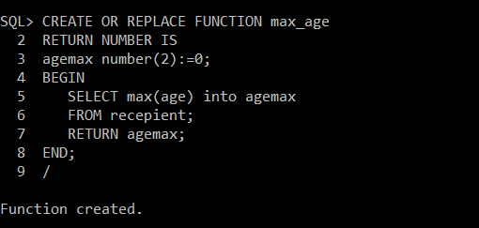

**Execution and Output:**

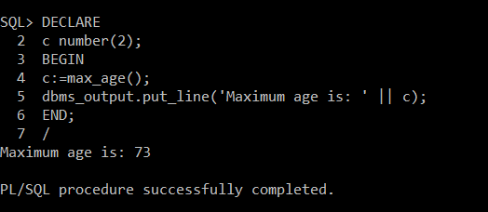

**CURSORS:**

1. **Question:** Create an explicit cursor to display all the records in the table Recepient.

**Explicit Cursor Code:**

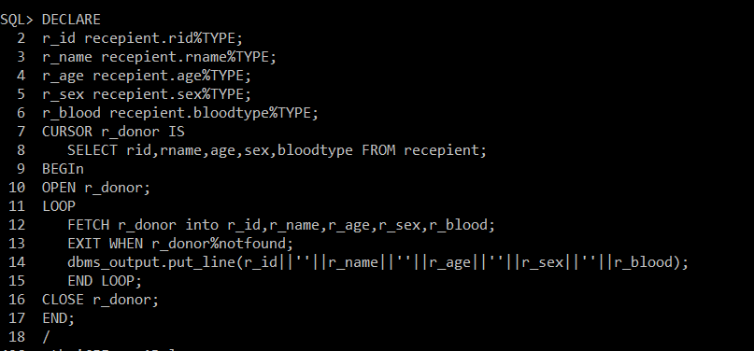

**Output:**

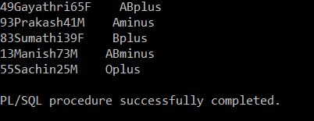

1. **Question(By implicit cursor):** Update all the quantities of blood by 5.

**Implicit Cursor Code:**

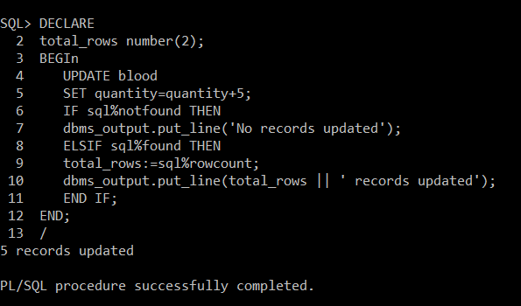

**Output:**

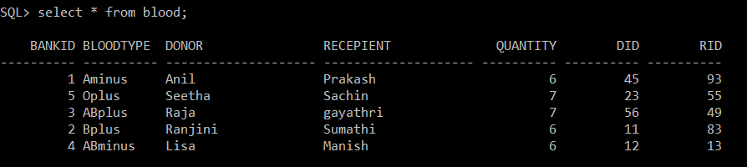

**TRIGGERS:**

1. **Question:** Create a trigger that lets us know that a record has been inserted after the insertion is successful.

**Trigger:**

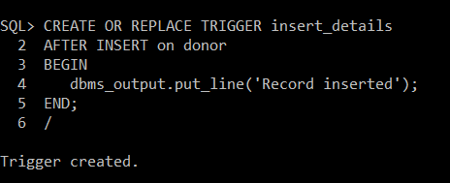

**Output:**

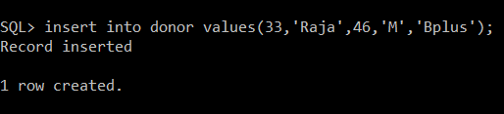

1. **Question:** Add a record to a table only if the time is between 9:00 AM and 6:00 OM.

**Trigger:**

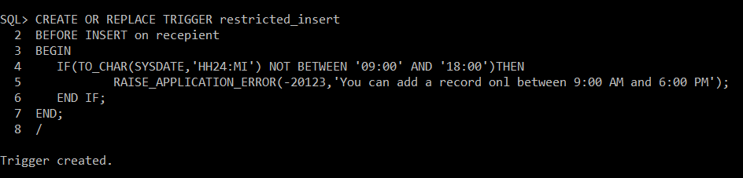

**Output:**



**PACKAGE:**

**1. Question:** Create a package with two procedures add_sample and edit_sample

**Procedure:**

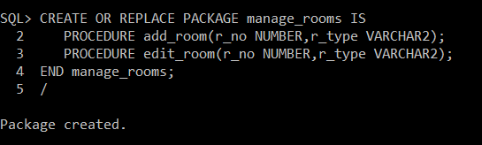

**Defining body of the package:**

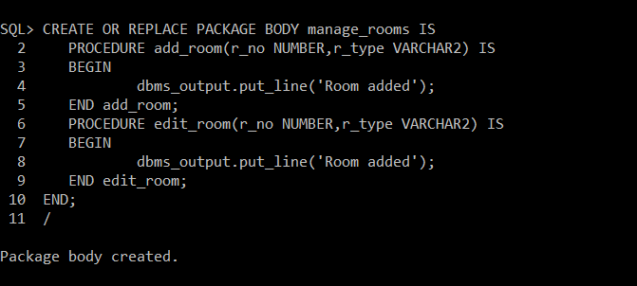

**Output:**

