SAILOR

Create Database boatride

C:\Users\Swetha\Desktop\Dbms\2.db2.PNG

Create Tables sailor,boats and ride



Insert values into the tables sailor,boats and ride

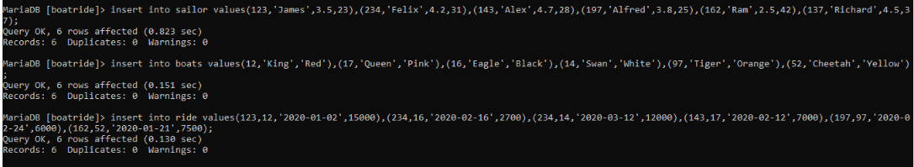

Display the data inside the table sailor

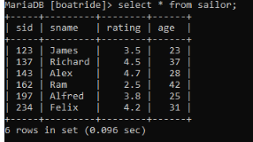

Display the data inside the table boats

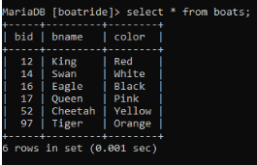

Display the data inside the table ride

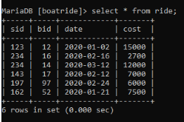

1. Print the name of the boats which costs greater than 5000

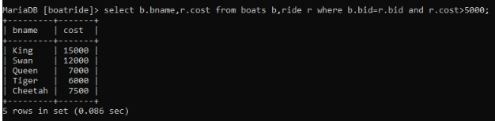

2. Print the name of the sailor and boat who travelled on 2020-02-12

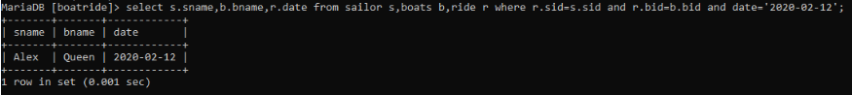

3.Display the boat id,boat name and sailor name ordered by rating in descending order:

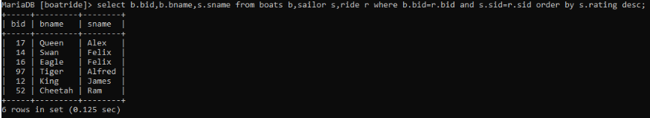

4.Display the colour of the boat which went for ride more number of times

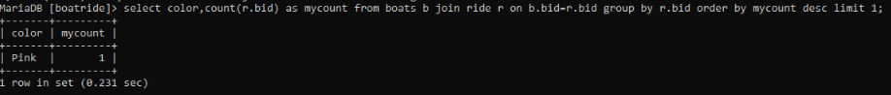

5.Display the boat id,sailor name and age who ride the boat coloured red:

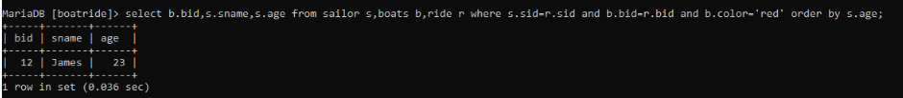

6. . Find all rides (display date, sailor sids and names, and boat bids and names) for rides made during the month of February 2020:

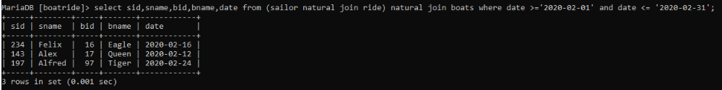

7. Display the cost of sailor James who went ride on 2020-01-02:



8. Display the sailor name where the date=2020-01-02 and the boat colour is red:

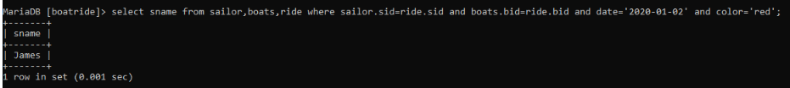

9. Display the sailor id,boat name and cost that their rating is in descending order:

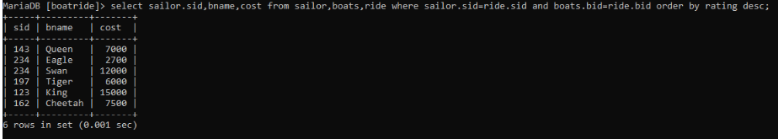

10.Dispaly the sailor name and boat name which went for the ride on 12th March 2020

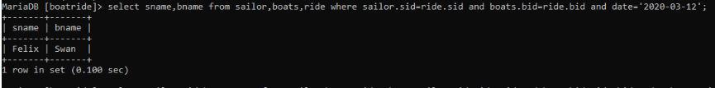

11.Print boat name,sailor name,date and color of the boat ride minimum number of times:



12. Toatl cost made by a particular boat:

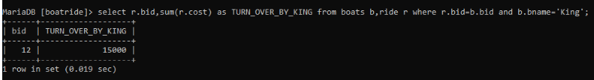

13. Display the sailor name and boat name who went for the ride on a particular date:

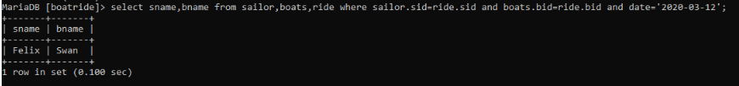

14. Find sailor id,sailor name,rating,age with the second lowest rating:

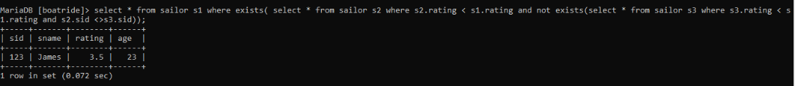

15.Print sailor id,sailor name and boat id ride by them:

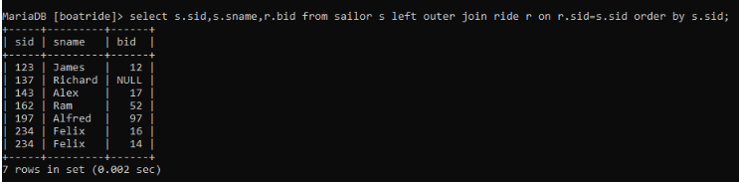

16.Find the sailor name and age of the youngest sailor:

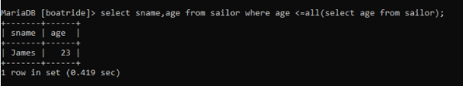

17. Find the name of the sailor who ride in the boat number 17:

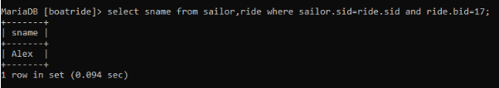

18. List the sid, sname, and rating of each sailor along with the bids and names of the boats sorted in descending order by rating and in ascending order by boat name: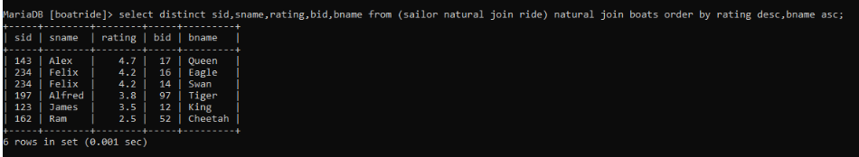

19.Find the sailor name and the ratings of sailor whose rating is nearly equal to some sailor named James:

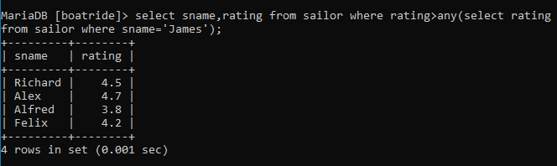

20.Display the sailor name and date of the ride made by the sailor with the highest rating:

