Software engineering for AI

techniques

Lab assignment

NAME: SWETHA.K

REG NO: 192124060

DAY: 3

11.Draw a Class diagram for Online Voting System using CASE tools

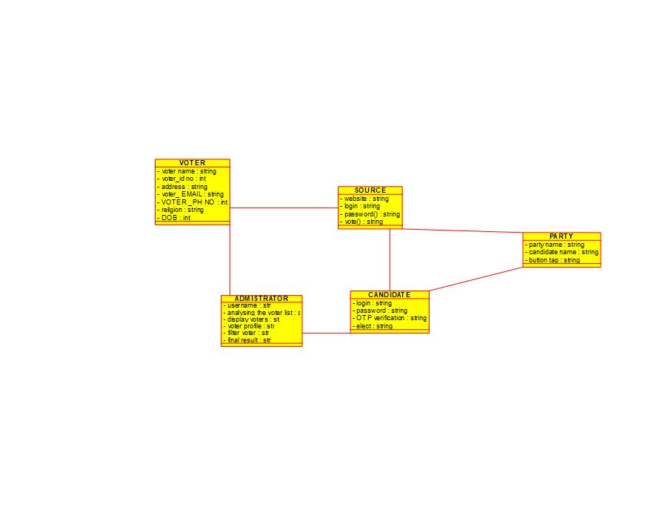

12.Draw a Class diagram for Library Management System using CASE tools.

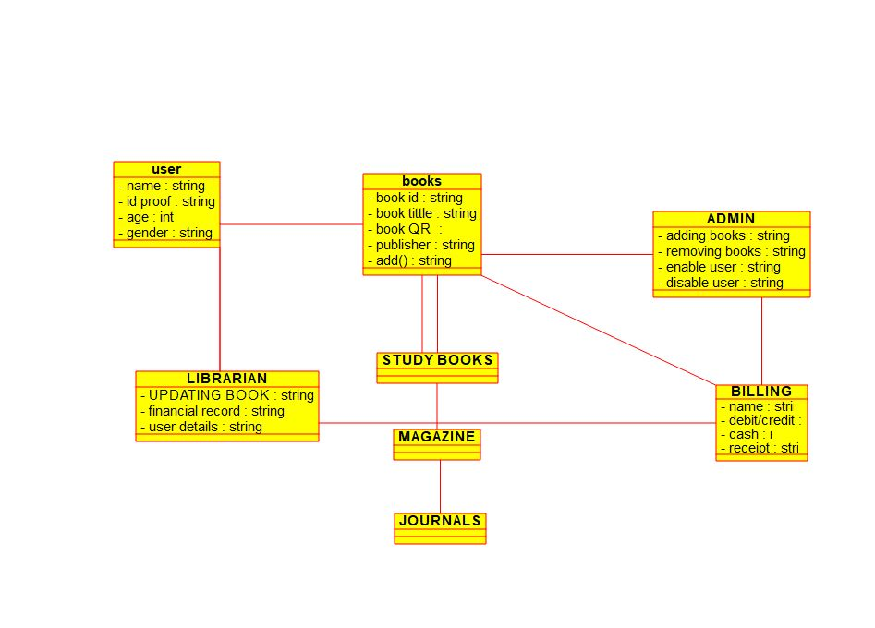

13.Draw a Class diagram for Online Shopping system using CASE tools.

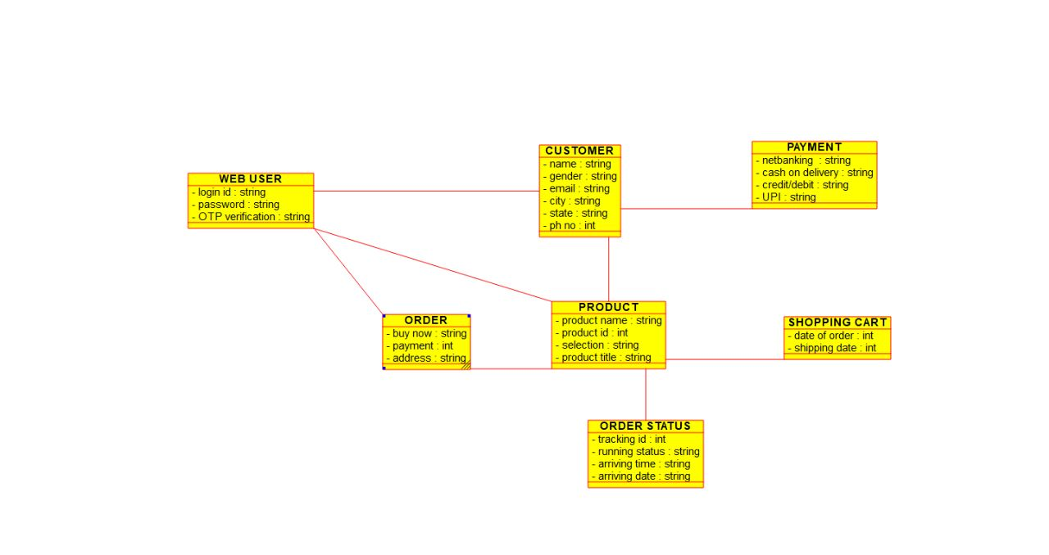

14.Draw a Class diagram for Online Railway Reservation System using CASE tools.

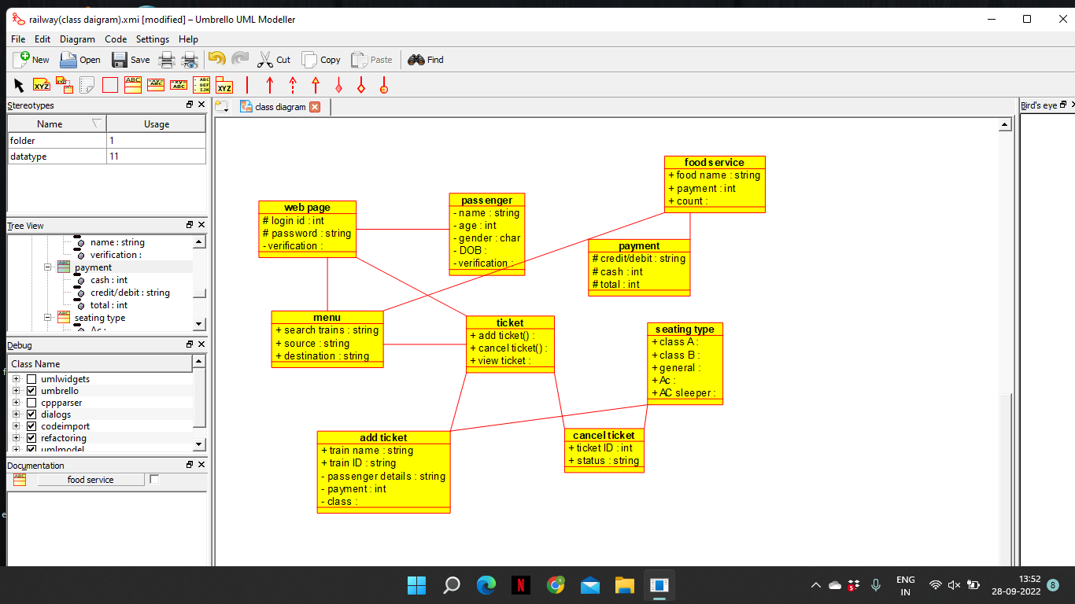

15.Draw a Activity diagram for Online Voting System using CASE tools

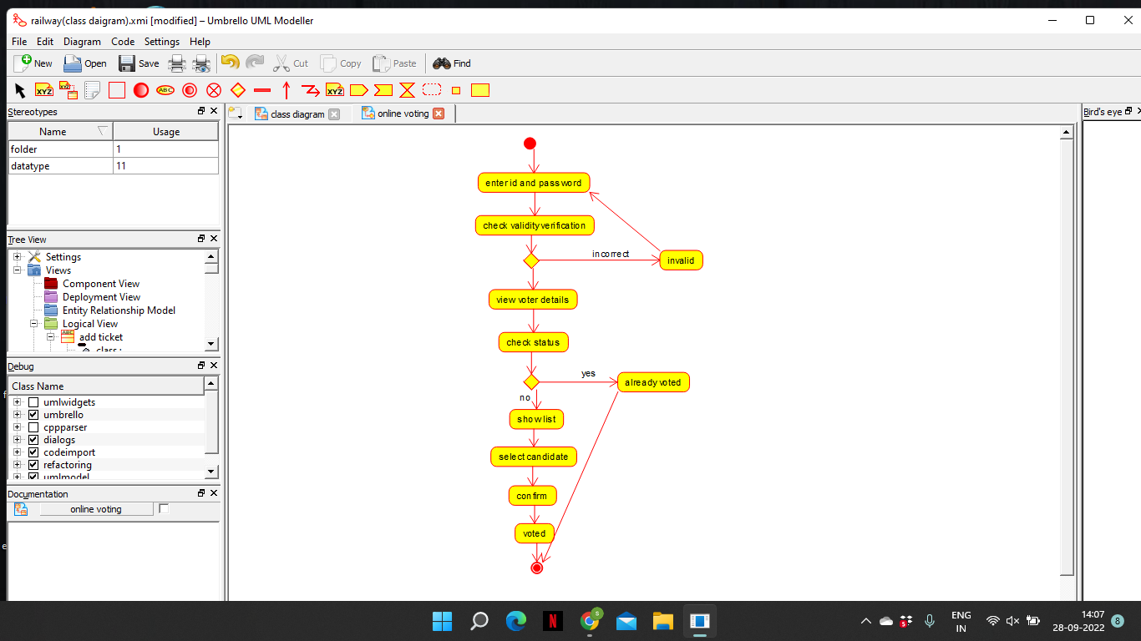

16.Draw a Activity diagram for Library Management System using CASE tools.

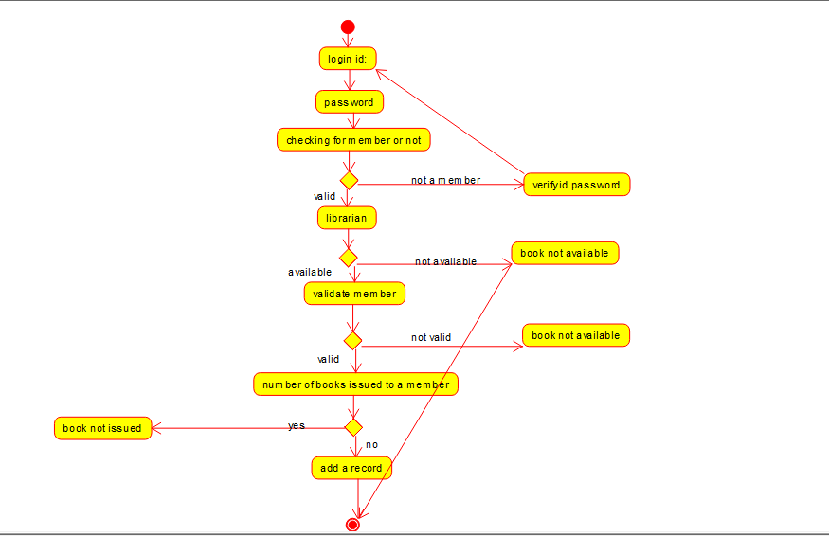

17.Draw a Activity diagram for Online Shopping system using CASE tools.

