IOT PROJECT—PHASE 5

PROJECT NAME—AIR QUALITY MONITORING

Problem Definition:

The problem is to create an effective IoT (Internet of Things) air quality monitoring system that accurately measures and reports air quality data in real-time. This system should address the growing concerns about air pollution and its impact on public health and the environment.

Design Thinking Approach:

1. Empathize:

- Understand the needs of potential users, such as individuals, communities, and environmental agencies, who require air quality data.

- Conduct surveys, interviews, and observations to gather insights into their preferences and pain points regarding air quality monitoring.

2. Define:

- Clearly define the problem statement, considering the user needs and environmental goals.

- Identify key metrics for air quality, such as PM2.5, PM10, CO2, NO2, and O3 levels, that need to be monitored.

3. Ideate:

- Brainstorm innovative solutions for monitoring air quality using IoT technology.

- Consider various sensor types, data transmission methods, and data visualization techniques.

- Explore potential partnerships with environmental organizations or government agencies for data sharing and collaboration.

4. Prototype:

- Develop a prototype IoT device that can measure air quality using selected sensors.

- Create a user-friendly interface, such as a mobile app or web dashboard, for users to access real-time air quality data.

- Ensure the device is energy-efficient and can operate in various environmental conditions.

5. Test:

- Pilot the IoT air quality monitoring system in a real-world environment to collect data and assess its functionality.

- Gather user feedback and make necessary improvements to the system’s hardware and software based on user input.

6. Implement:

- Deploy the IoT air quality monitoring system in target locations, such as urban areas, industrial zones, and sensitive ecological regions.

- Collaborate with local authorities and environmental agencies to integrate the system into their pollution control efforts.

7. Evaluate:

- Continuously monitor and evaluate the system’s performance, data accuracy, and user satisfaction.

- Implement updates and enhancements based on ongoing feedback and emerging technology trends.

8. Iterate:

- Use a feedback loop to iterate on the design and functionality of the IoT air quality monitoring system.

- Stay informed about advancements in sensor technology and data analytics to improve the system over time.

By following this design thinking approach, you can create an IoT air quality monitoring system that addresses the problem effectively and meets the needs of both individuals and environmental stakeholders.

Innovation in IoT (Internet of Things) air quality monitoring can involve:

1-Sensor Technology: Develop more accurate and affordable sensors to measure various air pollutants such as PM2.5, PM10, VOCs, CO2, and ozone. Miniaturization and integration of multiple sensors into a single device can be a focus.

2-Connectivity: Enhance connectivity options, like 5G and low-power networks (e.g., NB-IoT), to ensure seamless data transmission from remote monitoring devices to central servers.

3-Data Analytics: Employ advanced data analytics and machine learning algorithms to process and interpret the collected air quality data in real-time, allowing for better predictive modeling and actionable insights.

4-Mobile Apps: Create user-friendly mobile apps that provide real-time air quality information and personalized health recommendations based on location and individual sensitivities.

5-Integration with Smart Devices: Enable IoT air quality monitors to integrate with smart home devices like thermostats and air purifiers for automatic adjustments based on air quality conditions.

6-Environmental Mapping: Develop interactive maps or platforms that aggregate data from multiple IoT sensors, allowing users to visualize air quality at a city-wide or regional scale.

7-Sustainability: Design IoT devices with energy-efficient components and consider renewable power sources like solar panels for sustainability.

8-Public Awareness: Promote public awareness through educational campaigns and community engagement, encouraging people to take proactive steps in reducing air pollution.

10-Regulatory Compliance: Ensure that IoT air quality monitoring systems comply with local and international regulations and standards to maintain data accuracy and credibility.

11-Open Data Access: Facilitate open access to air quality data to encourage research, innovation, and the development of new solutions by third-party developers and researchers.

These innovations can help improve air quality monitoring and contribute to a healthier and more sustainable environment.

To start building your IOT air quality monitoring system, you can follow these steps:

Choose IOT Devices: Select appropriate sensors for measuring air quality parameters like pollution levels and particulate matter. Common sensors for this purpose include gas sensors, dust sensors, and temperature/humidity sensors.

Hardware Setup: Connect the selected sensors to your IOT device (e.g., Raspberry Pi, Arduino, or a specialized IoT board). Ensure that the connections are correctly established and the sensors are powered.

Install Necessary Software: Set up the development environment on your IoT device. This typically includes installing Python and any libraries required to interface with the sensors. For instance, you might use libraries like Adafruit CircuitPython for sensor integration.

Write Python Script: Develop a Python script on the IOT device to collect data from the sensors. This script should read sensor values at regular intervals and store them in variables.

Data Transmission: Use IOT protocols like MQTT, HTTP, or WebSocket to send the collected data to your chosen data-sharing platform. This could be a cloud service or a local server. Make sure you have the necessary credentials and configurations for the data transfer.

Data Validation and Quality Checks: Implement data validation and quality checks in your Python script to ensure the collected data is accurate and within expected ranges. You can set up threshold values for alerts.

Error Handling: Implement error-handling mechanisms in your script to manage any unexpected issues, such as network outages.

Data Visualization: You can consider building a dashboard or a data visualization interface to monitor the air quality data in real-time. There are various tools and platforms available for this purpose.

Testing and Calibration: Test your system thoroughly to ensure the accuracy and reliability of data. Calibration may be necessary for some sensors to ensure accurate readings.

Security: Ensure that your data transmission is secure. Use encryption and authentication mechanisms to protect your data during transmission.

Scaling and Expansion: As your project progresses, you may want to add more sensors, improve the data storage and analysis capabilities, and possibly integrate machine learning for predictive analytics.

Remember that building an IoT system can be a complex process, so it’s essential to plan and document each step carefully. Also, keep in mind any power requirements and data usage costs, especially if you’re using a cloud-based data-sharing platform.

Developing a Python script for an IoT device to send collected data to a data sharing platform typically involves using communication protocols and APIs relevant to the platform you’re sending data to. Below is a general example of how you can create a Python script to send data from an IoT device to a data sharing platform. Please note that the specifics will depend on the platform you’re using.

Assuming you want to send data using HTTP (RESTful API) to a generic data sharing platform, you can use libraries like requests to make HTTP requests. Here’s an example script:

Import requests

Import json

# Define the data to send

Data_to_send = {

“sensor_id”: “12345”,

“temperature”: 25.5,

“humidity”: 50.2,

“timestamp”: “2023-10-18T14:30:00Z”

}

# Define the API endpoint and authentication (if required)

Api_url = <https://yourdataplatform.com/api/endpoint>

Api_key = “your_api_key” # Replace with your API key

# Set headers (if required)

Headers = {

“Content-Type”: “application/json”,

“Authorization”: f”Bearer {api_key}”

}

# Convert data to JSON

Data_json = json.dumps(data_to_send)

# Send the data to the platform

Try:

Response = requests.post(api_url, data=data_json, headers=headers)

# Check the response

If response.status_code == 200:

Print(“Data sent successfully!”)

Else:

Print(f”Failed to send data. Status code: {response.status_code}”)

Except Exception as e:

Print(f”An error occurred: {str€}”)

In this script:

Replace data_to_send with the data collected by your IoT device.

Set api_url to the API endpoint provided by your data sharing platform.

If your platform requires authentication, set api_key and provide the necessary headers.

Convert the data to JSON format using json.dumps().

Send the data to the platform using the requests.post() method.

Make sure to install the requests library if you haven’t already by running pip install requests.

Replacing data_payload with the actual data collected by your IoT device is a critical step in the Python script. This is where you format the sensor data into a structured JSON object that can be sent to your data-sharing platform’s API. Here’s how you can do it:

Read Sensor Data: Use the appropriate code to read data from your sensors. The specific code to read sensor data depends on the type of sensors you’re using and the libraries or modules available for them. Make sure that you’ve correctly initialized and configured your sensors earlier in the script.

Format Data Payload: Create a JSON object (dictionary in Python) that contains the sensor data you want to send. This should match the data format expected by your data-sharing platform. For example, if you have sensors for pollution levels and particulate matter, your data payload might look like this:

Python

Copy code

Sensor_data = {

“timestamp”: time.time(),

“pm2.5”: sensor_readings_pm25, # Replace with actual PM2.5 data

“co2”: sensor_readings_co2, # Replace with actual CO2 data

# Add other sensor data as needed

}

Ensure that you replace “sensor_readings_pm25” and “sensor_readings_co2” with the actual variables or values obtained from your sensors. The “timestamp” should represent the time when the data was collected.

Add Additional Sensor Data: If you have more sensors measuring other parameters (e.g., temperature, humidity, GPS coordinates), add them to the sensor_data dictionary as necessary.

Send Data: Finally, send the sensor_data to your data-sharing platform’s API using the requests.post method, as shown in the previous example.

Here’s a more concrete example of how to replace data_payload with actual sensor data:

Python

Copy code

# Read sensor data

Sensor_readings_pm25 = sensor.read_pm25() # Replace with actual reading code

Sensor_readings_co2 = sensor.read_co2() # Replace with actual reading code

# Format data payload

Sensor_data = {

“timestamp”: time.time(),

“pm2.5”: sensor_readings_pm25,

“co2”: sensor_readings_co2,

# Add other sensor data as needed

}

Make sure that you’ve correctly read and formatted data from your sensors to match the requirements of your data-sharing platform. The exact structure and content of sensor_data may vary depending on the platform’s API specifications, so refer to their documentation for any specific formatting requirements.

Setting the api_url variable to the correct API endpoint is a crucial step in configuring your IoT air quality monitoring system. The api_url variable should point to the URL where your data-sharing platform’s API is hosted. Below are the details you need to consider when setting this variable:

API Endpoint URL: You will need to obtain the API endpoint URL from your data-sharing platform provider. This URL is typically provided when you set up an account or register your IoT project on the platform. It should look something like:

Arduino

Copy code

<https://api.example.com/your-data-endpoint>

Replace <https://api.example.com/your-data-endpoint> with the actual URL provided by your data-sharing platform.

Authentication: If your data-sharing platform requires authentication, you’ll need to include this information in the request headers. Common authentication methods include using API keys, OAuth tokens, or other forms of authentication. Make sure to set up the authentication headers in the script correctly, as shown in the previous example. Replace “Bearer YourAccessToken” with your actual authentication token.

Here's how you can set api_url in your Python script with the correct API endpoint:

Python

Copy code

Api_url = <https://api.example.com/your-data-endpoint> # Replace with your actual API endpoint URL

Remember that this URL is specific to the data-sharing platform you’re using, and it should be provided by the platform’s documentation

Convert the data to JSON format using json.dumps().

Json.dumps() is a Python function that converts data into a JSON (JavaScript Object Notation) format. It’s often used to serialize data, making it easy to store or transmit. To use it, you'll need to import the json module in Python. Here’s a basic example:

Python

Copy code

Import json

Data = {

“name”: “John”,

“age”: 30,

“city”: “New York”

}

Json_data = json.dumps(data)

In this example, the data dictionary is converted into a JSON formatted string and stored in the json_data variable. This string can then be saved to a file, sent over a network, or used in various ways to work with structured data.

Send the data to the platform using the requests.post() method.

To send data to a platform using the requests.post() method in Python, you’ll need to provide the necessary information and parameters in the request. Here are the details:

Import the requests library:

Make sure you have the requests library installed. If not, you can install it using pip:

Python

Copy code

Pip install requests

Import the library in your Python script:

Python

Copy code

Import requests

Define the URL of the platform you want to send data to:

Python

Copy code

url = ‘https://your-platform-url.com/api/endpoint’

Prepare the data you want to send. This can be in JSON format, form data, or other suitable formats:

For JSON data:

Python

Copy code

Data = {

‘key1’: ‘value1’,

‘key2’: ‘value2’,

}

For form data:

Python

Copy code

Data = {

‘param1’: ‘value1’,

‘param2’: ‘value2’,

}

Send the POST request with the data:

Python

Copy code

Response = requests.post(url, data=data)

Check the response from the platform:

Python

Copy code

If response.status_code == 200:

# Request was successful

Print(‘Data sent successfully’)

Else:

# Request failed

Print(‘Failed to send data. Status code:’, response.status_code)

Remember to replace ‘https://your-platform-url.com/api/endpoint’ with the actual URL of the platform you want to send data to and adapt the data format to what the platform expects. Additionally, you may need to provide headers, authentication, or other specific parameters depending on the platform’s API documentation.

Certainly, you can use web development technologies to create a platform for displaying real-time air quality data from IoT devices. Here’s a high-level overview of the steps you can follow:

1. **Front-end Development:**

- Create a user interface using HTML for displaying air quality data.

- Style the interface using CSS to make it user-friendly and visually appealing.

- Use JavaScript to handle real-time data updates and user interactions.

2. **Back-end Development:**

- Set up a server to receive data from IoT devices. You can use technologies like Node.js or Python.

- Implement APIs to handle incoming data, store it in a database, and serve it to the front end.

3. **Database Integration:**

- Choose a database system (e.g., MySQL, MongoDB) to store air quality data.

- Design the database schema to efficiently store and retrieve data.

4. **Real-Time Data Integration:**

- Use web sockets (e.g., WebSocket API) to establish a real-time connection between IoT devices and the platform.

- When IoT devices send data, the server should push it to connected clients in real-time.

5. **User Authentication (Optional):**

- Implement user authentication if you want to restrict access to the platform.

- You can use libraries like Passport.js for authentication.

6. **Testing:**

- Thoroughly test the platform to ensure it can receive, process, and display real-time air quality data accurately.

7. **Deployment:**

- Deploy the platform to a web server or cloud platform for public or private access.

8. **Scalability and Security:**

- Plan for scalability, especially if the number of IoT devices and users grows.

- Implement security measures to protect the platform and data.

9. **Documentation:**

- Create documentation for the platform, including how to use it, the data format, and API endpoints.

10. **Maintenance:**

- Regularly update and maintain the platform to ensure it remains functional and secure.

Remember to adapt and refine your development process based on the specific requirements and technologies you’re using for your project. Good luck with your data-sharing platform development!

Creating a real-time air quality data platform involves several steps. Here’s a high-level overview using HTML, CSS, and JavaScript:

**Data Source**: Find a reliable source for real-time air quality data, such as an API from a weather or environmental agency.

**HTML Structure**: Create the basic HTML structure for your platform. This might include a header, content area, and a container for displaying the data.

```html

<!DOCTYPE html>

<html>

<head>

<title>Real-Time Air Quality</title>

</head>

<body>

<header>

<h1>Real-Time Air Quality Platform</h1>

</header>

<div id=”data-container”>

<!—Air quality data will be displayed here (

</div>

<script src=”script.js”></script>

</body>

</html>

```

**CSS Styling**: Use CSS to style your platform. You can define the layout, fonts, colors, and overall design.

```css

Body {

Font-family: Arial, sans-serif;

Background-color: #f0f0f0;

Margin: 0;

Padding: 0;

}

Header {

Background-color: #007BFF;

Color: white;

Text-align: center;

Padding: 20px;

}

#data-container {

Margin: 20px;

Padding: 20px;

Background-color: white;

Border-radius: 5px;

Box-shadow: 0 0 5px rgba(0, 0, 0, 0.2);

}

```

**JavaScript**: Use JavaScript to fetch real-time air quality data from the API and update the content on your platform.

```javascript

// Replace with the actual API endpoint

Const apiUrl = ‘https://api.example.com/air-quality’;

Async function fetchAirQualityData() {

Try {

Const response = await fetch(apiUrl);

Const data = await response.json();

// Update the data container with the fetched information

Document.getElementById(‘data-container’).innerHTML = `

<h2>Current Air Quality</h2>

<p>Location: ${data.location}</p>

<p>PM2.5: ${data.pm25} µg/m³</p>

<p>PM10: ${data.pm10} µg/m³</p>

<p>NO2: ${data.no2} µg/m³</p>

`;

} catch (error) {

Console.error(‘Error fetching air quality data’, error);

}

}

// Fetch data initially and then update it at regular intervals (e.g., every 5 minutes)

fetchAirQualityData();

setInterval(fetchAirQualityData, 300000);

```

**Deployment**: Host your platform on a web server. You can use a service like GitHub Pages, Netlify, or your own web hosting.

**Testing and Optimization**: Test your platform, ensure it works across different browsers, and optimize it for performance.

**User Interface Enhancements**: Consider adding interactive features, charts, or maps for a better user experience.

**Documentation**: Provide clear instructions on how to use your platform and the source of the air quality data.

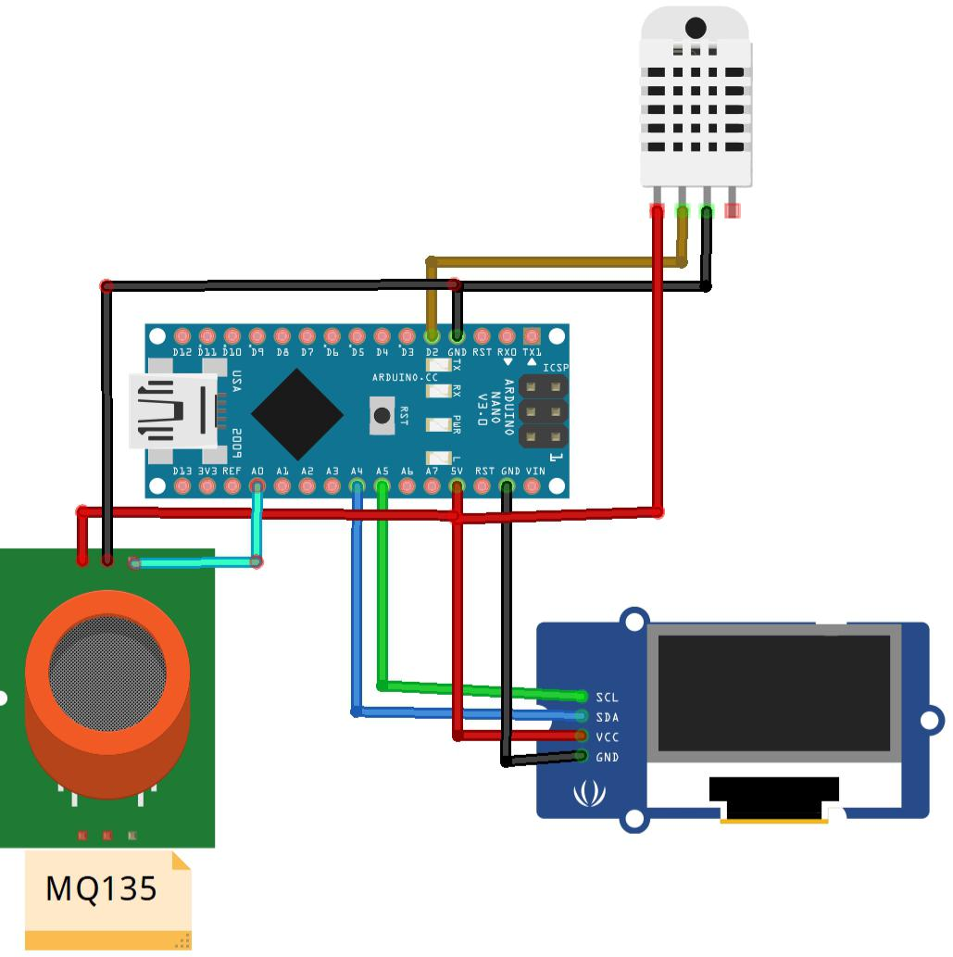

By

SWETHA R

923321106044

ECE 3rd year