|  |
| --- |
|  |
|  |
|  |
|  |
|  |
|  |
|  |

**FLOOD MONITORING**

**AND EARLY WAERING SYSTEM**

**SUBMITTED BY;**

**SWETHA.R**

**au812921106036**

**swetharenga1705@gmail.com**

INNOVATION:

**DATA COLLECTION**

There are few places on Earth where people need not be concerned about flooding. Any place where rain falls is vulnerable, although rain is not the only impetus for flood.

A flood occurswhen water overflows or inundates land that's normally dry. This can happen in a multitude of ways. Most common is when rivers or streams overflow their banks. Excessive rain, a ruptured dam or levee, rapid ice melting in the mountains, or even an unfortunately placed beaver dam can overwhelm a river and send it spreading over the adjacent land, called a floodplain.

Coastal flooding occurs when a large storm or tsunami causes the sea to surge inland. According to reports from the World Meteorological Organization (2009), approximately 70% of all disasters occurring in the world are related to hydro-meteorological events. Among the disasters, flooding probably is one of the most severe disasters affecting the people across the globe.

India is the worst flood affected country in the world after Bangladesh and accounts for onefifth of global death count due to floods. Nearly 75 percent of the total Indian rainfall is concentrated over a short monsoon season of four months (June-September).

As a result, the rivers witness a heavy discharge during these months, leading to widespread floods. About 40 million hectares of land in the country is liable to floods according to National Flood Commission, and an average of 18.6 million hectares of land is affected annually.

**EARLY WARNING SYSTEM :**

“The set of capacities needed to generate and disseminate timely and

meaningful warning information to enable individuals, communities and

organizations threatened by a hazard to prepare and to act appropriately and

in sufficient time to reduce the possibility of harm or loss.”

(UNISDR,2009)Early Warning System (EWS) evolved about 2 to 3 decades ago. The needs for EWS started to arise in 1970s and 1980s when the prolonged droughts and famines in the West African Sahel and in the Horn of Africa occurred. Since its early development, EWS started to be used for

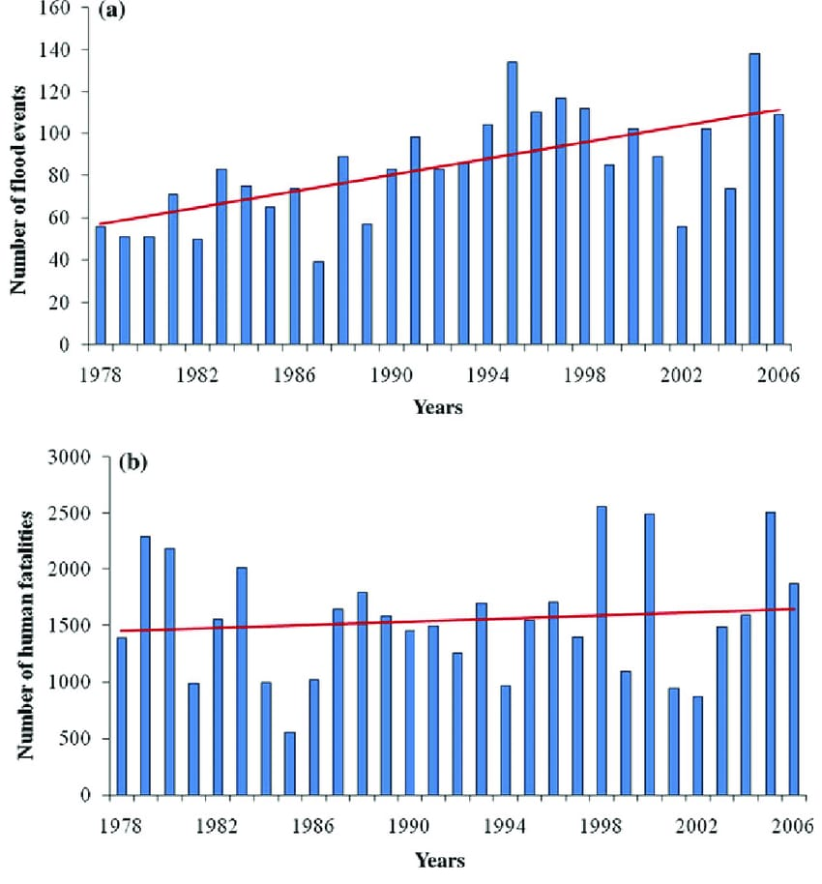

**Area affected,population affected and human lives Iost. A comparative analysis:**

