**PROGRAM:-**

import java.io.File;

import java.io.IOException;

import jxl.Cell;

import jxl.CellType;

import jxl.Sheet;

import jxl.Workbook;

import jxl.read.biff.BiffException;

public class connect {

private String inputFile;

public void setInputFile(String inputFile) {

this.inputFile = inputFile;

}

publicvoid read() throwsIOException{

File inputWorkbook = newFile(inputFile);

Workbook w;

try {

w = Workbook.getWorkbook(inputWorkbook);

// Get the first sheet

Sheet sheet = w.getSheet(0);

for(intj= 0;j<sheet.getColumns();j++){

for (inti=0;i<sheet.getRows(); i++) {

Cell cell = sheet.getCell(j,i);

CellTypetype = cell.getType();

if(type == CellType.LABEL) {

System.out.println("I got a label " + cell.getContents());

}

if(type == CellType.NUMBER) {

System.out.println("I got a number " + cell.getContents());

}

}

}

} catch(BiffExceptione) {

e.printStackTrace();

}

}

publicstaticvoid main(String[] args) throwsIOException {

connecttest= new connect();

test.setInputFile("F:\\Book1.xls");

test.read();

}

}

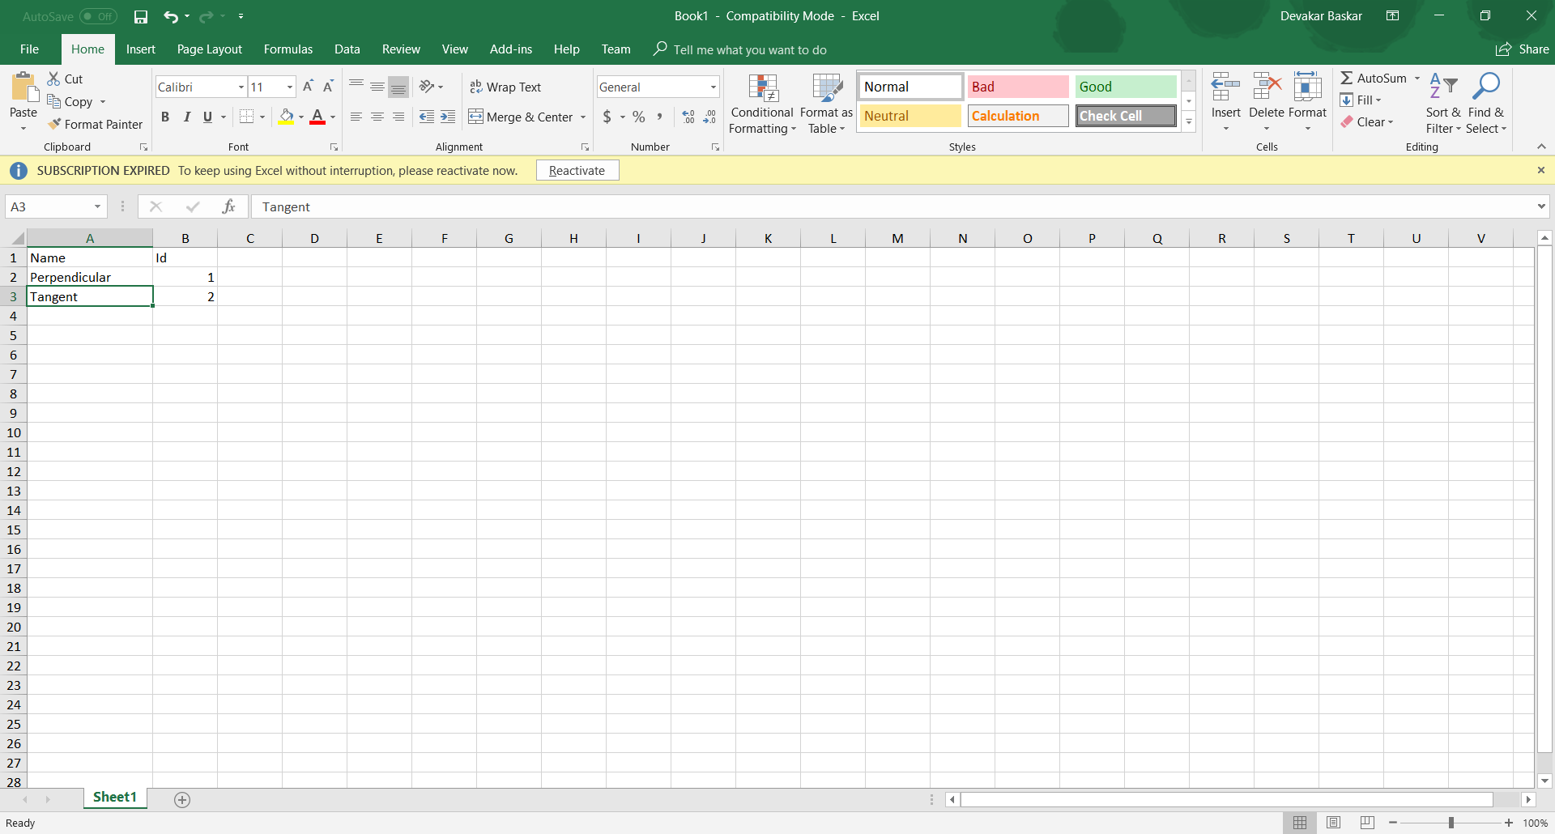

**OUTPUT:-**

