**PROGRAM:-**

importjava.sql.*;

public class accessconnect {

publicstaticvoid main(String[] args)

{

try

{

Connection conn=DriverManager.getConnection("jdbc:ucanaccess://C:\\Users\\admin\\eclipse-workspace\\enumsam\\Socket\\src\\Theatre1.mdb");

Statement stment = conn.createStatement();

String qry = "SELECT * FROM Hurricane";

ResultSet rs = stment.executeQuery(qry);

while(rs.next())

{

String id = rs.getString("Seat") ;

String fname = rs.getString("Availablity");

System.out.println("Seat no="+id +"\t" +"Availablity=" +fname +"\n");

}

}

catch(Exception err)

{

System.out.println(err);

}

//System.out.println("HasithSithila");

} }

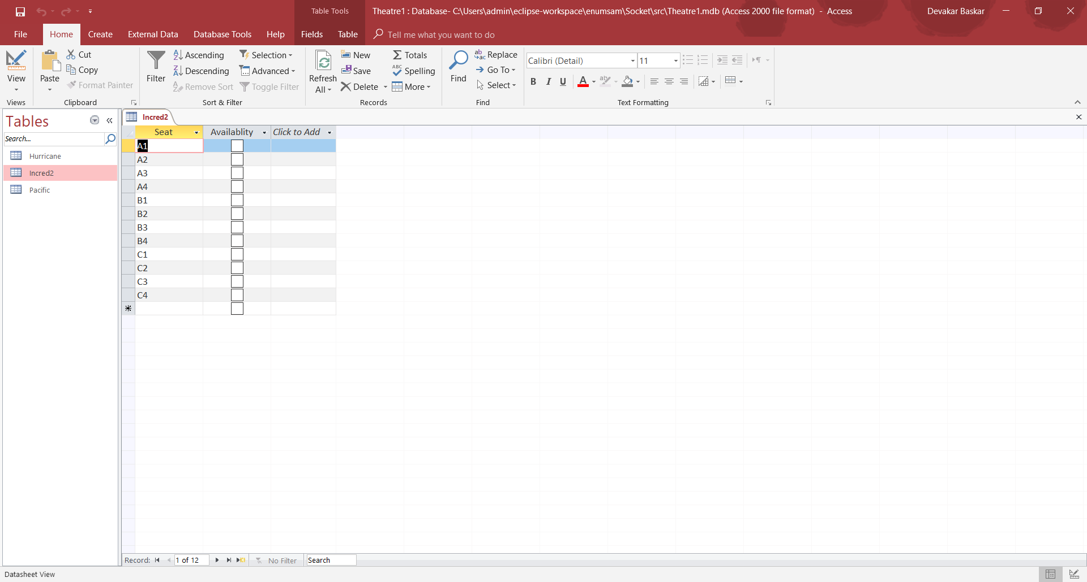

**OUTPUT:-**

