**PROGRAM:-**

import java.sql.*;

public class mysql_db

{

void display()

{

try

{

Class.forName("com.mysql.jdbc.Driver");

Connection connect = DriverManager.getConnection("jdbc:mysql://localhost:3306/mysql_database","root","");

Statement stmt = connect.createStatement();

ResultSet res = stmt.executeQuery("select * from book");

while(res.next())

{

int id = res.getInt("Book_ID");

String title = res.getString("Book_Title");

String a = res.getString("Author");

String p = res.getString("Publications");

Float cost = res.getFloat("Price");

System.out.println("\nID : " + id);

System.out.println("Title : " + title);

System.out.println("Author : " + a);

System.out.println("Publications : " + p);

System.out.println("Price : " + cost);

}

connect.close();

}

catch(Exception e)

{

System.out.println("Error : " + e);

}

}

public static void main(String args[])

{

mysql_db m = new mysql_db();

m.display();

}

}

**DATABASE:-**

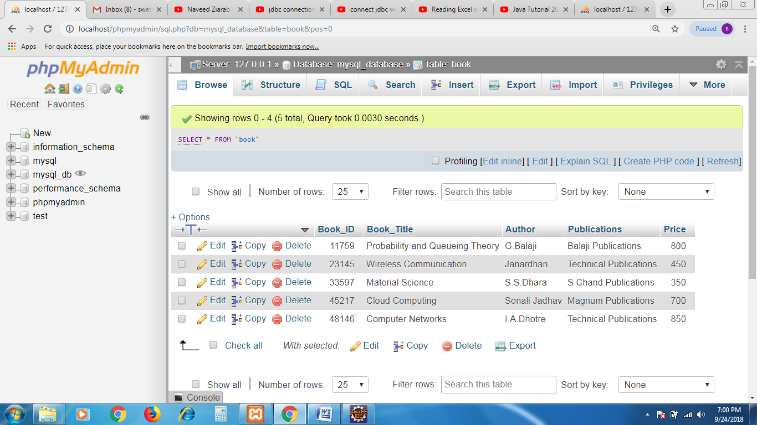

**OUTPUT:-**

