**HEART DISEASE**

**PREDICTION USING MACHINE LEARNING**

**A PROJECT REPORT**

***Submitted by***

**HARIKRISHNAN G(922319104012)**

**MOHAMMED ANAS N(922319104019)**

**PAVITHRA T(922319104025)**

**SWETHA S(922319104039)**

***in partial fulfilment for the award of the degree***

***of***

**BACHELOR OF ENGINEERING**

**IN**

**COMPUTER SCIENCE AND ENGINEERING**



**UNIVERSITY COLLEGE OF ENGINEERING DINDIGUL**

**DINDIGUL -624 622.**

**ANNA UNIVERSITY: CHENNAI 600 025**

**MAY 2023**

**ANNA UNIVERSITY: CHENNAI 600 025**

**BONAFIDE CERTIFICATE**

Certified that this project “**Heart Disease Prediction Using Machine Learning ”** is the bonafide work of “**HARIKRISHNAN G(922319104012)**,**MOHAMMEDANAS.N(922319104019)**,**PAVITHRA T(922319104024),SWETHA S(922319104039)**” Who carried out the project under my supervision.

|  |  |
| --- | --- |
| **SIGNATURE**  Dr. A. POOBALAN ,  PROJECT GUIDE,  Assistant Professor,  Department of Computer Science &  Engineering,  University College of Engineering  Dindigul. | **SIGNATURE**  Dr. M.VINOTH KUMAR ,  SUPERVISOR,  Assistant Professor,  Department of Computer Science &  Engineering,  University College of Engineering  Dindigul . |

Submitted for the project Viva-voce held at University College of Engineering Dindigul on……………………………………………….......

**INTERNAL EXAMINER EXTERNAL EXAMINER**

**ACKNOWLEDGEMENT**

Firstly, we would like to thank the Lord Almighty for his benevolence and blessings that has given us the strength to complete this project.

We express our sincere gratitude to our Dean/Principal Dr.Sutha M.E., Ph.D., for providing us with plethora of resources, which enhances the quality of learning.

We express our sincere thanks to Dr.M.Vinoth Kumar M.E., M.B.A., PhD, Professor and Head of the Department, Computer science and Engineering, for providing necessary facilities to carry out the project work.

We would like to express our deep sense of gratitude to our guide and Project Coordinator Dr.A.POOBALAN Assistant Professor, Senior Grade Department of Computer science and Engineering, for his stimulating guidance, help and encouragement in the study, design and implementation of our project which enabled us to complete it successfully.

Also, we wish to thank all the faculty members of our department and our friends for rendering their support.

**TABLE OF CONTENTS**

|  |  |  |
| --- | --- | --- |
| **CHAPTER**  **NO.** | **TITLE** | **PAGE**  **NO.** |

**ABSTRACT i**

**LIST OF FIGURES ii**

**LIST OF TABLES iii**

**LIST OF ABBREVIATIONS iv**

**1 INTRODUCTION**

1.1 General Introduction 1

**2 LITERATURE SURVEY**

2.1 Improving Heart Disease Prediction using

Constrained Association Rules 12

2.2 Predicting Survival Causes After Out of

Hospital Cardiac Arrest using Data

Mining Method 12

2.3 Mining Bio Signal Data: Coronary Artery

Disease Diagnosis using Linear and

Nonlinear 13

2.4 Associative Classification Approach for

Diagnosing Cardiovascular Disease 14

2.5 Intelligent Heart Disease Prediction

System using CANFIS and Genetic Algorithm

**3 PROBLEM STATEMENT**

3.1 Problem Definition 18

3.2 Existing System

3.2.1 Disadvantages

3.3 Proposed System

3.3.1 Advantages

3.4 Feasibility Study 2

3.4.1 Economical Feasibility

3.4.2 Technical Feasibility

3.4.3 Social Feasibility

**4 SYSTEM REQUIREMENTS**

4.1 Hardware Requirements 21

4.2 Software Requirements 21

4.3 Software Description 21

**5 SYSTEM DESIGN**

5.1 Input Design

5.2 Output Design

5.3 Database Design

**6 SYSTEM DIAGRAMS**

6.1 Architecture Diagram 29

6.2 Data Flow Diagram 29

6.3 UML Diagram 30

6.3 Sequence Diagram 30

6.4 Activity Diagram 31

6.5 Class Diagram 32

**7 SYSTEM IMPLEMENTATION**

7.1 Modules of the project 34

7.2 Module Description 34

**8 SYSTEM TESTING**

8.1 Unit Testing

8.2 Integration Testing

8.3 Validation Testing

8.4 White Box Testing

8.5 Black Box Testing

**9 EXPERIMENTAL RESULTS**

9.1 Screenshots 38

**10 RESULTS AND GRAPHS**

**11 CONCLUSION AND FUTURE ENHANCEMENT**

11.1 Conclusion 49

11.2 Future Enhancement 49

**APPENDIX (Source code)**

**REFERENCES**

**ABSTRACT**

Heart Attack is a term that assigns a large number of medical conditions related to heart. The key to Heart (Cardiovascular) diseases to evaluate large scores of data sets, compare information that can be used to predict, Prevent, Manage such as Heart attacks. Heart Disease is mainly because of stress, family backgrounds, High blood Pressure, etc… Data analytics is used to incorporate world for its valuable use to controlling, contravasting and Manage a large data sets. It can be applied with an much success to predict, prevent, Managing a Cardiovascular Diseases. To solve this we aims to implement the Data Analytics based on SVM and Genetic Algorithm to diagnosis of heart diseases. This result reveal the Genetic Algorithm as best optimized Prediction Models.

**LIST OF FIGURES**

|  |  |  |  |
| --- | --- | --- | --- |
|  | **FIGURE NO.** | **DESCRIPTION OF FIGURE** | **PAGE NO** |
|  | 6.1 | Architecture Diagram | 23 |
|  | 6.2 | Data Flow Diagram | 24 |
|  | 6.3 | UML Diagram |  |
|  |  | 6.3.1. Use Case Diagram | 26 |
|  |  | 6.3.2. Sequence Diagram | 27 |
|  |  | 6.3.3. Activity Diagram | 28 |
|  |  | 6.3.4. Class Diagram | 29 |

**LIST OF TABLES**

|  |  |  |  |  |
| --- | --- | --- | --- | --- |
|  | **TABLE NO** | | **DESCRIPTION OF FIGURE** | **PAGE NO.** |
|  | | 5.3.1. | Download | 22 |
|  | | 5.3.2. | Registration | 22 |
|  | | 5.3.3. | Upload | 22 |

**LIST OF ABBREVIATIONS**

|  |  |
| --- | --- |
| WWW | World Wide Web |
| ULR | Unsupervised Label Refinement |
| SBFA | Search-Based Face Annotation |
| CBIR | Content-Based Image Retrieval |
| CBA | Clustering-Based Approximation |
|  |  |
|  |  |
|  |  |

**1. INTRODUCTION**

**1.1 GENERAL OVERVIEW**

Heart diseases are often used in exchange for cardiovascular diseases. These kinds of diseases mainly refer to the conditions of blocked

or narrowed blood vessels, resulting in a stroke, chest pain or angina,

and heart attack. Other kinds of heart conditions, such as those affecting the rhythm, valve, or muscle of the heart, are other types of heart

diseases. On the other hand, machine learning is crucial for determining

whether anyone has suffered from heart disease. In either case, if these

are predicted ahead of time, doctors would have a much easier time

gaining crucial information for treating and diagnosing patients. Heart

disease is mainly an incorrect symptom of coronary artery disease. It is

also known as a cardiac disease; therefore, it is not with cardiovascular

disease, which is any blood vessel disease.

Python is a programming language with a high level of objectoriented abstraction with a spirited, energetic collection of building

options and quick development cycles. As per Loku et al. [1] analysis, it

is regarded as one of the safest programming languages with numerous

applications in the medical field. Furthermore, it is regarded as a

well-liked and well-accepted programming language with applications

traversing over AI-based software developments and several other web

applications. As per the suggestion of Mathur [2], the python framework is used easily for creating a desktop or web-based application.

As per the depiction of Guleria and Sood [3], with the application of

python programming in the health care sectors, especially for detecting heart diseases, clinicians and institutions can provide better and

improvised outcomes for the patients through scalable and dynamic

applications. However, the coding packages and libraries used in this

project are Pandas, Matplotlib, IPython, Numpy, Python, SciPy, and

many others.

Cardiovascular Disease (CVD), commonly referred to as heart disease, encompasses a wide range of conditions that affect the heart, with the two most common conditions being ischemic heart diseases and strokes. The World Health Organization lists the most significant behavioural risk factors for CVD as maintaining an unhealthy diet, a sedentary lifestyle, tobacco use, and excessive consumption of alcohol. Prolonged exposure to these risk factors can present itself as an initial sign of CVD, which include elevated blood pressure, elevated blood glucose, raised blood lipids, and obesity. Warning signs listed by the American Heart Association include having one or more of the following: shortness of breath, persistent coughing or wheezing, swelling of the ankles and feet, constant fatigue, lack of appetite, and impaired thinking [1]. Moreover, Coronavirus may cause heart disease [2]–[4]. Efficient early diagnosis can substantially reduce the risk and global burden of CVD by initiating treatment rapidly to prevent further health deterioration. Thus, there is an urgent need to develop machine learning models that can predict the probability of developing CVD depending on the risk factors present. Recently, machine learning models have successfully lent a hand in diverse cases in the medical field [5]. They have been effective in analyzing, evaluating, and predicting different medical conditions [6]. In this paper, we are proposing a machine learning approach to predict the presence of cardiovascular diseases in patients based on major health data.

We thus propose to collect relevant data pertaining all elements related to our field of study, train the data as per the proposed algorithm of machine learning and predict how strong is there a possibility for a patient to contract a heart disease. For the purpose of patients entering data, we suggest to make use of the easily available sensors in watches and cell phones to measure the simple fact

**2 LITERATURE SURVEY**

**2.1 Improving Heart Disease Prediction using Constrained Association Rules**

**Author:** Carlos Ordonez, Technical Seminar Presentation, University of Tokyo, 2019.

**Methodology: Constrained Association Rules** .

**Advantages:** The heart disease can be predicted with some basic attributes taken from the patient and in their work have introduced a system that includes the characteristics of an individual human being based on totally 13 basic attributes like sex, blood pressure, cholesterol and others to predict the likelihood of a patient getting affected by heart disease.

**Disadvantage:** The data mining classification algorithms such as Decision Tree, Naive Bayes, and Neural Network are utilized to make predictions and the results are analysed on Heart disease database.

* 1. **Predicting Survival Causes After Out of Hospital Cardiac Arrest using Data Mining Method**

**Author:** Franck Le Duff, CristianMunteanb, Marc Cuggiaa and Philippe Mabob , Studies in Health Technology and Informatics, Vol. 107, No.2, pp. 1256-1259, 2019.

**Methodology: Data Mining Method**

**Advantages:** This paper have done a research work involving five hundred and thirty-three patients who had suffered from cardiac arrest and they were integrated in the analysis of heart disease probabilities. They performed classical statistical analysis and data mining analysis using mostly Bayesian networks.

**Disadvantage:** This paper have proposed a method that uses least squares support vector machine (LS-SVM) utilizing a binary decision tree for classification of cardiotocogram to find out the patient condition..

**2.3 Mining Bio Signal Data: Coronary Artery Disease Diagnosis using Linear and Nonlinear Features of HRV**

**Author:** Heon Gyu Lee, Ki Yong Noh and Keun Ho Ryu, Proceedings of International Conference on Emerging Technologies in Knowledge Discovery and Data Mining, pp. 56-66, 2019

**Methodology: Linear and Nonlinear Features of HRV**

**Advantages:** They have carried out various experiments on linear and non-linear features to estimate several classifiers, e.g., Bayesian classifiers, CMAR, C4.5 and SVM. Based on their experiments, SVM outperformed the other classifiers. Noh, et al. suggested a classification method which is an associative classifier that is constructed based on the efficient FPgrowth method.

**Disadvantage:** This paper have performed a work on prediction of survival of Coronary heart disease (CHD) which is a challenging research problem for medical society. They also used 10-fold cross-validation methods to determine the impartial estimate of the three prediction models for performance comparison purposes.

**2.4 Associative Classification Approach for Diagnosing Cardiovascular Disease**

**Author:** Kiyong Noh, HeonGyu Lee, Ho-Sun Shon, Bum Ju Lee and Keun Ho Ryu, Intelligent Computing in Signal Processing and Pattern Recognition, Vol. 345, pp. 721-727, 2019.

**Methodology:** Diagnosing Cardiovascular Disease

**Advantages:** The performance of the proposed CANFIS model was evaluated in terms of training performances and classification accuracies. Finally, their results show that the proposed CANFIS model has great prospective in predicting the heart disease.

**Disadvantage:** This paper have proposed a new work in which the heart disease is identified and predicted using the proposed Coactive Neuro-Fuzzy Inference System (CANFIS).

**2.5Intelligent Heart Disease Prediction System using CANFIS and Genetic Algorithm**

**Author:** Latha Parthiban and R. Subramanian, International Journal of Biological, Biomedical and Medical Sciences, Vol. 3, No. 3, pp. 1-8, 2019.

**Methodology:** Prediction System using CANFIS and Genetic Algorithm

**Advantages:** This paper have done a work using, one partition clustering algorithm (K-Means) and one hierarchical clustering algorithm (agglomerative). K-means algorithm has higher effectiveness and scalability and converges fast when production with large data sets.

**Disadvantage:** Hierarchical clustering constructs a hierarchy of clusters by either frequently merging two smaller clusters into a larger one or splitting a larger cluster into smaller ones. Using WEKA data mining tool, they have calculated the performance of k-means and hierarchical clustering algorithm on the basis of accuracy and running time.

|  |  |  |  |
| --- | --- | --- | --- |
| **TITLE** | **YEAR** | **ADVANTAGES** | **DISADVANTAGES** |
| 1. Predicting Survival Causes After Out of Hospital Cardiac Arrest using Data Mining Method | Franck Le Duff, CristianMunteanb, Marc Cuggiaa and Philippe Mabob , Studies in Health Technology and Informatics, Vol. 107, No.2, pp. 1256-1259, 2019. | This paper have done a research work involving five hundred and thirty-three patients who had suffered from cardiac arrest and they were integrated in the analysis of heart disease probabilities. They performed classical statistical analysis and data mining analysis using mostly Bayesian networks. | This paper have proposed a method that uses least squares support vector machine (LS-SVM) utilizing a binary decision tree for classification of cardiotocogram to find out the patient condition.. |

|  |  |  |  |
| --- | --- | --- | --- |
| **TITLE** | **YEAR** | **ADVANTAGES** | **DISADVANTAGES** |
| 1. Mining Bio Signal Data: Coronary Artery Disease Diagnosis using Linear and Nonlinear Features of HRV | Heon Gyu Lee, Ki Yong Noh and Keun Ho Ryu, Proceedings of International Conference on Emerging Technologies in Knowledge Discovery and Data Mining, pp. 56-66, 2019 | They have carried out various experiments on linear and non-linear features to estimate several classifiers, e.g., Bayesian classifiers, CMAR, C4.5 and SVM. Based on their experiments, SVM outperformed the other classifiers. Noh, et al. suggested a classification method which is an associative classifier that is constructed based on the efficient FPgrowth method. | This paper have performed a work on prediction of survival of Coronary heart disease (CHD) which is a challenging research problem for medical society. They also used 10-fold cross-validation methods to determine the impartial estimate of the three prediction models for performance comparison purposes. |

|  |  |  |  |
| --- | --- | --- | --- |
| **TITLE** | **YEAR** | **ADVANTAGES** | **DISADVANTAGES** |
| 1. Associative Classification Approach for Diagnosing Cardiovascular Disease | Kiyong Noh, HeonGyu Lee, Ho-Sun Shon, Bum Ju Lee and Keun Ho Ryu, Intelligent Computing in Signal Processing and Pattern Recognition, Vol. 345, pp. 721-727, 2019. | The performance of the proposed CANFIS model was evaluated in terms of training performances and classification accuracies. Finally, their results show that the proposed CANFIS model has great prospective in predicting the heart disease. | This paper have proposed a new work in which the heart disease is identified and predicted using the proposed Coactive Neuro-Fuzzy Inference System (CANFIS). |

|  |  |  |  |
| --- | --- | --- | --- |
| **TITLE** | **YEAR** | **ADVANTAGES** | **DISADVANTAGES** |
| 1. Intelligent Heart Disease Prediction System using CANFIS and Genetic Algorithm | Latha Parthiban and R. Subramanian, International Journal of Biological, Biomedical and Medical Sciences, Vol. 3, No. 3, pp. 1-8, 2019. | This paper have done a work using, one partition clustering algorithm (K-Means) and one hierarchical clustering algorithm (agglomerative). K-means algorithm has higher effectiveness and scalability and converges fast when production with large data sets. | Hierarchical clustering constructs a hierarchy of clusters by either frequently merging two smaller clusters into a larger one or splitting a larger cluster into smaller ones. Using WEKA data mining tool, they have calculated the performance of k-means and hierarchical clustering algorithm on the basis of accuracy and running time. |

**3. SYSTEM ANALYSIS**

**3.1 PROBLEM DEFINITION**

The major challenge in heart disease is its detection. There are instruments available which can predict heart disease but either they are expensive or are not efficient to calculate chance of heart disease in human. Early detection of cardiac diseases can decrease the mortality rate and overall complications. However, it is not possible to monitor patients every day in all cases accurately and consultation of a patient for 24 hours by a doctor is not available since it requires more sapience, time and expertise. Since we have a good amount of data in today’s world, we can use various machine learning algorithms to analyze the data for hidden patterns. The hidden patterns can be used for health diagnosis in medicinal data.

**3.2 EXISTING SYSTEM**

* The World Health Organization (WHO) has estimated that 12 million deaths occur worldwide, every year
* due to the Heart diseases.
* About 25% deaths in the age group of 25-69 year occur because of heart diseases. In urban areas, 32.8%.
* deaths occur because of heart ailments, while this percentage in rural areas is 22.9.
* Over 80% of deaths in world are because of Heart disease. WHO estimated by 2030, almost 23.6 million.
* The diagnosis of diseases is a significant and tedious task in medicine.

**3.2.1. DISADVANTAGES OF EXISTING SYSTEM**

* Limited accuracy: Although heart disease prediction systems can provide valuable insights into the likelihood of developing heart disease, their accuracy is not always perfect. False positives and false negatives can occur, which can lead to unnecessary or delayed medical interventions.
* Limited data: Heart disease prediction systems rely on input data to make predictions. However, the quality and quantity of input data can affect the accuracy of the system. In some cases, there may be limited data available, which can reduce the accuracy of the system.
* Lack of interpretability: Some heart disease prediction systems may use complex machine learning algorithms that are difficult to interpret. This can make it challenging for medical professionals to understand the underlying factors that contribute to the predicted risk of heart disease.

**3.3 PROPOSED SYSTEM**

Advanced machine learning algorithms: Advanced machine learning algorithms such as deep learning can be used to improve the accuracy of heart disease prediction models. These algorithms can be trained on large datasets to identify complex patterns and relationships between different risk factors and heart disease.

Integration with electronic health records (EHR): Heart disease prediction systems can be integrated with EHR systems to access a patient's medical history, lifestyle, and other relevant health data. This can improve the accuracy of predictions by providing a more comprehensive view of the patient's health.

Explainable AI: To address the lack of interpretability in some heart disease prediction systems, explainable AI techniques can be used. These techniques enable the system to provide explanations for its predictions, allowing medical professionals to understand the factors that contribute to a patient's risk of heart disease.

Personalized risk assessment: Heart disease prediction systems can be personalized to account for individual risk factors such as genetics, age, and lifestyle. This can improve the accuracy of predictions and enable more targeted interventions to prevent or treat heart disease.

Continuous monitoring: Heart disease prediction systems can be designed to continuously monitor a patient's health and provide real-time updates on their risk of developing heart disease. This can enable early detection and intervention, leading to better outcomes for the patient..

**3.3.1. ADVANTAGES OF PROPOSED SYSTEM**

* Improved accuracy: Advanced machine learning algorithms and personalized risk assessments can improve the accuracy of heart disease predictions, leading to earlier detection and better outcomes for patients.
* Better integration with healthcare systems: Integration with electronic health records can provide a more comprehensive view of a patient's health and enable better coordination between healthcare providers.

**3.4 FEASIBILITY STUDY**

The feasibility of the project is analyzed in this phase and business proposal is put forth with a very general plan for the project and some cost estimates. During system analysis the feasibility study of the proposed system is to be carried out. This is to ensure that the proposed system is not a burden to the company. For feasibility analysis, some understanding of the major requirements for the system is essential.

Three key considerations involved in the feasibility analysis are

**3.4.1 ECONOMICAL FEASIBILITY**

**3.4.2 TECHNICAL FEASIBILITY**

**3.4.3 SOCIAL FEASIBILITY**

**3.4.1 ECONOMICAL FEASIBILITY**

An organization makes good investment on the system. So, they should be worthful for the amount they spend in the system. Always the financial benefit and equals or less the cost of the system, but should not exceed the cost.

* The cost of investment is analyzed for the entire system
* The cost of Hardware and Software is also noted.
* Analyzing the way in which the cost can be reduced

Every organization wants to reduce there cost but at the same time quality of the Service should also be maintained. The system is developed according the estimation of the cost made by the concern. In this project, the proposed system will definitely reduce the cost and also the manual work is reduced and speed of work is also increased.

**3.4.2 TECHNICAL FEASIBILITY**

The Technical feasibility is the study of the software and how it is included in the study of our project. Regarding this there are some technical issues that should be noted they are as follows:

* Is the necessary technique available and how it is suggested and acquired?
* Does the proposed equipment have the technical capacity to hold the data required using the new system?
* Will the system provide adequate response that is made by the requester at an periodic time interval
* Can this system be expanded after this project development
* Is there a technique guarantees of accuracy, reliability in case of access of data and security

The technical issues are raised during the feasibility study of investigating our System. Thus, the technical consideration evaluates the hardware requirements, software etc. This system uses JSP as front end and Oracle as back end. They also provide sufficient memory to hold and process the data. As the company is going to install all the process in the system it is the cheap and efficient technique.

This system technique accepts the entire request made by the user and the response is done without failure and delay. It is a study about the resources available and how they are achieved as an acceptable system. It is

an essential process for analysis and definition of conducting a parallel assessment of technical feasibility.

Though storage and retrieval of information is enormous, it can be easily handled by Oracle. As the oracle can be run in any system and the operation does not differ from one to another. So, this is effective.

**3.4.3 SOCIAL FEASIBILITY**

Proposed project will be beneficial only when they are turned into an information system and to meet the organization operating requirements. The following issues are considered for the operation:

* Does this system provide sufficient support for the user and the management?
* What is the method that should be used in this project?
* Have the users been involved in the planning and development of the projects?
* Will the proposed system cause any harm, bad result, loss of control and accessibility of the system will lost?

Issues that may be a minor problem will sometimes cause major problem in the operation. It is the measure of how people can able to work with the system. Finding out the minor issues that may be the initial problem of the system. It should be a user-friendly environment. All these aspect should be kept in mind and steps should be taken for developing the project carefully.

Regarding the project, the system is very much supported and friendly for the user. The methods are defined in an effective manner and proper conditions are given in other to avoid the harm or loss of data. It is designed in GUI interface, as working will be easier and flexible for the user.

**4. SYSTEM REQUIREMENTS**

**4.1. HARDWARE REQUIREMENTS**

The below Hardware Specifications were used in both Server and Client machines when developing.

Processor : Intel(R) Core(TM) i3

Processor Speed : 3.06 GHz

RAM : 2 GB

Hard Disk Drive : 250 GB

CD-ROM Drive : Sony

Monitor : “17” inches

Keyboard : TVS Gold

Mouse : Logitech

**4.2. SOFTWARE REQUIREMENTS**

The below Software Specifications were used in both Server and Client machines when developing.

**SERVER**

Operating System : Windows 7

Technology Used : Microsoft ASP.NET

Database : SQL Server

Database Connectivity : ActiveX Data Object (ADO)

Web Server : Internet Information Server

Browser : Internet Explorer 6.0

**CLIENT**

Operating System : Windows 7

Browser : Internet Explorer 6.0

**4.3 . SOFTWARE DESCRIPTION**

**FEATURE OF ASP.NET**

ASP.NET, the next version of ASP, is a programming Framework that is used to create enterprise – class web applications. The enterprise class web applications are accessible on a global basis loading to efficient information management. However, the advantages that ASP.NET offers make it more than just next version of ASP.NET.

ASP.NET is integrated with visual studio.Net, which provides a GUI designer, a rich toolbox and a fully integrated debugger. This allows the development of applications in a what you see is what you get (WYSIWYG) MANNER.

The .NET Framework is a common environment for building, deploying, and running Web Services and Web Applications. The .NET Framework contains common class libraries - like ADO.NET, ASP.NET and Windows Forms - to provide advanced standard services that can be integrated into a variety of computer systems.

The .NET Framework is language neutral. Currently it supports C++, C#, Visual Basic, JScript (The Microsoft version of JavaScript) .The new Visual Studio.NET is a common development environment for the new .NET Framework. It provides a feature-rich application execution environment, simplified development and easy integration between a number of different development languages.

**Unique Features Of .Net Environment**

1. Internet Inside
2. Common Language support
3. Common Class Libraries
4. Common Language Runtime
5. Garbage Collection.
6. Cross Language Reference
7. Web Services

**INTERNET INFORMATION SERVICE 6.0**

IIS 6.0 has strong support for more programming to take place on the server, to allow the new Web Applications to run in any browser on any platform.

**ASP.NET**

* ASP.NET is a server side scripting technology that enables scripts (embedded in web pages) to be executed by an Internet server.
* ASP.NET is a Microsoft Technology
* ASP.NET stands for Active Server Pages
* ASP.NET is a program that runs inside IIS
* IIS stands for Internet Information Services
* IIS comes as a free component with Windows 2008
* IIS is also a part of the Windows NT 4.0 Option Pack
* The Option Pack can be downloaded from Microsoft PWS is a smaller - but fully functional - version of IIS PWS can be found on your Windows 95/98 CD.
* ASP.NET 3.0 is the latest version of ASP.NET, but there will never be an ASP.NET 4.0 version.
* ASP.NET is the next generation ASP.NET, but it's not an upgraded version of ASP.NET. ASP.NET is an entirely new paradigm for server-side ASP.NET script
* ASP.NET is a part of the new .NET (dotnet) Framework. Microsoft spent three years rewriting ASP.NET from the ground up, and ASP.NET is not fully backward compatible with ASP.NET 3.0.
* ASP.NET has better language support, a large set of new controls and XML based components, and better user authentication.
* ASP.NET provides increased performance by running compiled code.
* ASP.NET code is not fully backward compatible with ASP.NET.
* ASP.NET is a server side programming language.
* ASP.NET is an object oriented programming language.
* Active Server Pages - ASP.NET
* ASP.NET is the latest version of ASP.NET. It includes Web Services to link applications, services and devices using HTTP, HTML, XML and SOAP.

**NEW IN ASP.NET**

1. New Language Support
2. Programmable Controls
3. Event Driven Programming
4. XML Based Components
5. User Authentication
6. User Accounts and Roles
7. High Scalability
8. Compiled Code
9. Easy Configuration
10. Easy Deployment
11. Includes ADO .NET

**WEB SERVICES**

* Web services are small units of code
* Web services are designed to handle a limited set of tasks
* Web services use XML based communicating protocols
* Web services are independent of operating systems
* Web services are independent of programming languages .
* .NET Web Services
* Web services are small units of code built to handle a limited task.
* Small Units of Code
* Web services are small units of code designed to handle a limited set of tasks.

**XML BASED WEB PROTOCOLS**

Web services use the standard web protocols HTTP, XML, SOAP, WSDL, and UDDI.

**HTTP**

HTTP (Hypertext Transfer Protocol) is the World Wide Web standard for communication over the Internet.

**XML**

XML (extensible Markup Language) is a well-known standard for storing, carrying, and exchanging data.

**SOAP**

Simple Object Access Protocol is a lightweight platform and language neutral Communication protocol that allows programs to communicate via standard Internet HTTP

**WSDL**

WSDL (Web Services Description Language) is an XML-based language used to define web services and to describe how to access them.

**UDDI**

Universal Description, Discovery and Integration is a directory service where businesses can register and search for web services. UDDI is a public registry, where one can publish and inquire about web services.

**INDEPENDENT OF OPERATING SYSTEM**

Since web services use XML based protocols to communicate with other systems, web services are independent of both operating systems and programming languages.

An application calling a web service will always send its requests using XML, and get its answer returned as XML. The calling application will never be concerned about the operating system or the programming language running on the other computer.

**BENEFITS OF WEB SERVICES**

1. Easier to communicate between applications.
2. Easier to distribute information to more consumers.
3. Rapid development.
4. Web services make it easier to communicate between different applications.
5. They also make it possible for developers to reuse existing web services.
6. Instead of writing new ones.

**5.2. INTRODUCTION TO SQL SERVER**

The database component of Microsoft® SQL Server™ 2008 is a Structured Query Language (SQL)–based, scalable, relational database with integrated Extensible Markup Language (XML) support for Internet applications. Each of the following terms describes a fundamental part of the architecture of the SQL Server 2008 database component:

**DATABASE**

A database is similar to a data file in that it is a storage place for data. Like a data file, a database does not present information directly to a user; the user runs an application that accesses data from the database and presents it to the user in an understandable format.

Database systems are more powerful than data files in that data is more highly organized. In a well-designed database, there are no duplicate pieces of data that the user or application must update at the same time. Related pieces of data are grouped together in a single structure or record, and relationships can be defined between these structures and records.

When working with data files, an application must be coded to work with the specific structure of each data file. In contrast, a database contains a catalog that applications use to determine how data is organized. Generic database applications can use the catalog to present users with data from different databases dynamically, without being tied to a specific data format.

A database typically has two main parts: first, the files holding the physical database and second, the database management system (DBMS) software that applications use to access data. The DBMS is responsible for enforcing the database structure, including:

* Maintaining relationships between data in the database.
* Ensuring that data is stored correctly, and that the rules defining data relationships

are not violated.

* Recovering all data to a point of known consistency in case of system failures.

**RELATIONAL DATABASE**

Although there are different ways to organize data in a database, relational databases are one of the most effective. Relational database systems are an application of mathematical set theory to the problem of effectively organizing data. In a relational database, data is collected into tables (called relations in relational theory).

A table represents some class of objects that are important to an organization. For example, a company may have a database with a table for employees, another table for customers, and another for stores. Each table is built of columns and rows (called attributes and tuples in relational theory). Each column represents some attribute of the object represented by the table. For example, an Employee table would typically have columns for attributes such as first name, last name, employee ID, department, pay grade, and job title. Each row represents an instance of the object represented by the table. For example, one row in the Employee table represents the employee who has employee ID 12345. When organizing data into tables, you can usually find many different ways to define tables. Relational database theory defines a process called normalization, which ensures that the set of tables you define will organize your data effectively.

**SCALABLE**

SQL Server 2008 supports having a wide range of users access it at the same time. An instance of SQL Server 2008 includes the files that make up a set of databases and a copy of the DBMS software. Applications running on separate computers use a SQL Server 2008 communications component to transmit commands over a network to the SQL Server 2008 instance. When an application connects to an instance of SQL Server 2008, it can reference any of the databases in that instance that the user is authorized to access. The communication component also allows communication between an instance of SQL Server 2008 and an application running on the same computer. You can run multiple instances of SQL Server 2008 on a single computer.

SQL Server 2008 is designed to support the traffic of the largest Web sites or enterprise data processing systems. Instances of SQL Server 2008 running on large, multiprocessor servers are capable of supporting connections to thousands of users at the same time.

Although SQL Server 2008 is designed to work as the data storage engine for thousands of concurrent users who connect over a network, it is also capable of working as a stand-alone database directly on the same computer as an application. The scalability and ease-of-use features of SQL Server 2008 allow it to work efficiently on a single computer without consuming too many resources or requiring administrative work by the stand-alone user. The same features allow SQL Server 2008 to dynamically acquire the resources required to support thousands of users, while minimizing database administration and tuning. The SQL Server 2008 relational database engine dynamically tunes itself to acquire or free the appropriate computer resources required to support a varying load of users accessing an instance of SQL Server 2008 at any specific time. The SQL Server 2008 relational database engine has features to prevent the logical problems that occur if a user tries to read or modify data currently used by others.

**STRUCTURED QUERY LANGUAGE**

To work with data in a database, you have to use a set of commands and statements (language) defined by the DBMS software. Several different languages can be used with relational databases; the most common is SQL. The American National Standards Institute (ANSI) and the International Standards Organization (ISO) define software standards, including standards for the SQL language. SQL Server 2008 supports the Entry Level of SQL-92, the SQL standard published by ANSI and ISO in 1992. The dialect of SQL supported by Microsoft SQL Server is called Transact-SQL (T-SQL). T-SQL is the primary language used by Microsoft SQL Server applications.

**EXTENSIBLE MARKUP LANGUAGE**

XML is the emerging Internet standard for data. XML is a set of tags that can be used to define the structure of a hypertext document. XML documents can be easily processed by the Hypertext Markup Language, which is the most important language for displaying Web pages.

Although most SQL statements return their results in a relational, or tabular, result set, the SQL Server 2008 database component supports a FOR XML clause that returns results as an XML document. SQL Server 2008 also supports XPath queries from Internet and intranet applications. XML documents can be added to SQL Server databases, and the OPENXML clause can be used to expose data from an XML document as a relational result set.

**5. SYSTEM DESIGN**

**5.1. INPUT DESIGN**

The input design is the link between the information system and the user. It comprises the developing specification and procedures for data preparation and those steps are necessary to put transaction data in to a usable form for processing can be achieved by inspecting the computer to read data from a written or printed document or it can occur by having people keying the data directly into the system. The design of input focuses on controlling the amount of input required, controlling the errors, avoiding delay, avoiding extra steps and keeping the process simple. The input is designed in such a way so that it provides security and ease of use with retaining the privacy. Input Design considered the following things:

* What data should be given as input?
* How the data should be arranged or coded?
* The dialog to guide the operating personnel in providing input.
* Methods for preparing input validations and steps to follow when error occur.

**OBJECTIVES**

1. Input Design is the process of converting a user-oriented description of the input into a computer-based system. This design is important to avoid errors in the data input process and show the correct direction to the management for getting correct information from the computerized system.
2. It is achieved by creating user-friendly screens for the data entry to handle large volume of data. The goal of designing input is to make data entry easier and to be free from errors. The data entry screen is designed in such a way that all the data manipulates can be performed. It also provides record viewing facilities.
3. When the data is entered it will check for its validity. Data can be entered with the help of screens. Appropriate messages are provided as when needed so that the user will not be in maize of instant. Thus the objective of input design is to create an input layout that is easy to follow
   1. **OUTPUT DESIGN**

A quality output is one, which meets the requirements of the end user and presents the information clearly. In any system results of processing are communicated to the users and to other system through outputs. In output design it is determined how the information is to be displaced for immediate need and also the hard copy output. It is the most important and direct source information to the user. Efficient and intelligent output design improves the system’s relationship to help user decision-making.

1. Designing computer output should proceed in an organized, well thought out manner; the right output must be developed while ensuring that each output element is designed so that people will find the system can use easily and effectively. When analysis design computer output, they should Identify the specific output that is needed to meet the requirements.
2. Select methods for presenting information.
3. Create document, report, or other formats that contain information produced by the system.

The output form of an information system should accomplish one or more of the following objectives.

* Convey information about past activities, current status or projections of the
* Future.
* Signal important events, opportunities, problems, or warnings.
* Trigger an action.
* Confirm an action.

**5.3. DATABASE DESIGN**

**PatientRegistration**

|  |  |  |  |
| --- | --- | --- | --- |
| **Field Name** | **Data Type** | **Constraint** | **Description** |
| Id | Int | Primary Key | Patient id |
| Userid | Varchar(50) | Primary key | User id |
| Firstname | Varchar(50) | Not null | Patient name |
| Email | Varchar(100) | Not null | Patient mail id |
| Password | Varchar(50) | Not null | Patient password |
| Mobileno | Varchar(15) | Not null | Patient mobile no |
| Dob | Date | Not null | Date of birth |
| Age | Int | Not null | Patient age |
| Gender | Varchar(10) | Not null | Patient gender |

**PatientAppointment**

|  |  |  |  |
| --- | --- | --- | --- |
| **Field Name** | **Data Type** | **Constraint** | **Description** |
| Id | Int | Primary Key | Patient id |
| Name | varchar(50) | Not null | Patient name |
| Email | varchar(100) | Not Null | Patient mail id |
| Date | Date | Not null | Appointment date |
| Message | Varchar(250) | Not null | Message to patient |

**6. SYSTEM ARCHITECTURE**

**6.1. SYSTEM ARCHITECTURE**

A system architecture or systems architecture is the computational design that defines the structure and/or behavior of a system.

An architecture description is a formal description of a system, organized in a way that supports reasoning about the structural properties of the system. It defines the system components or building blocks and provides a plan from which products can be procured, and systems developed , that will work together to implement the overall system.

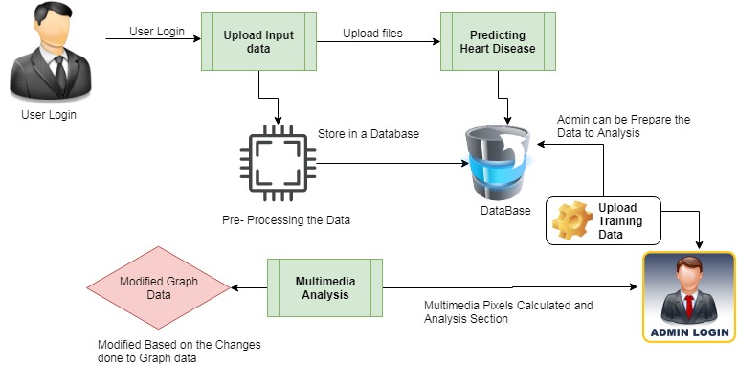

**6.2.** DATA FLOW DIAGRAM

**User**

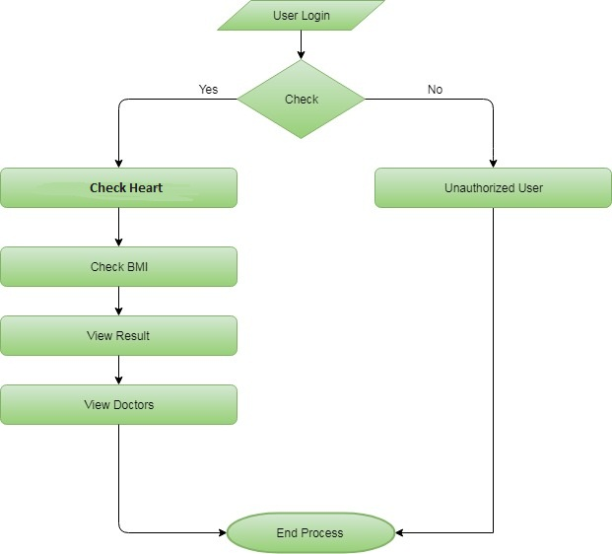

**Admin**

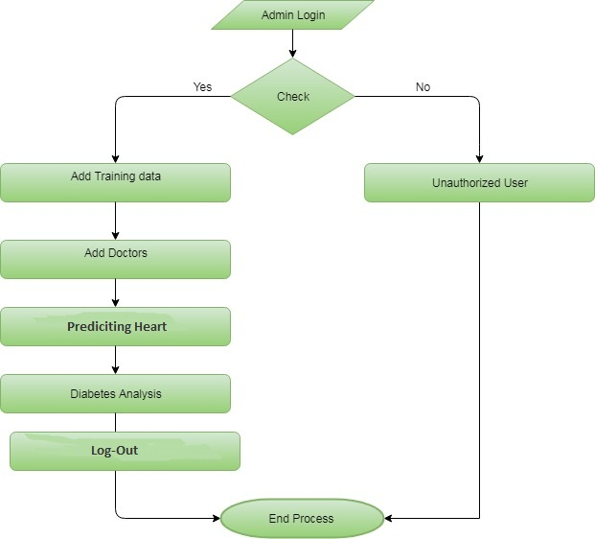

**6.3. UML DIAGRAM**

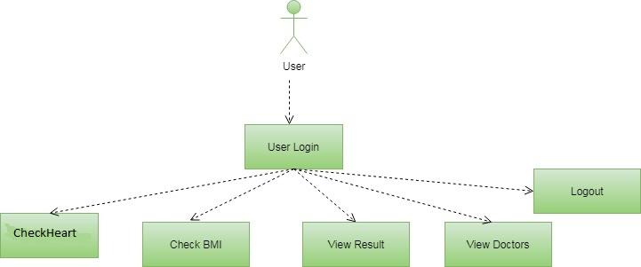**User**

**Admin**

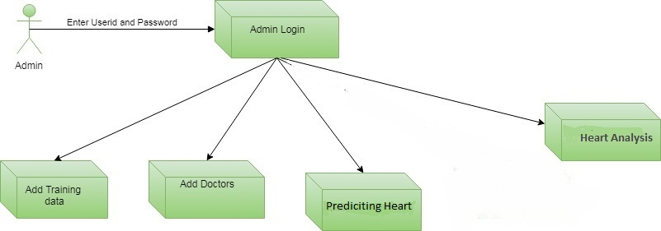

**6.3 SEQUENCE DIAGRAM**

**User**

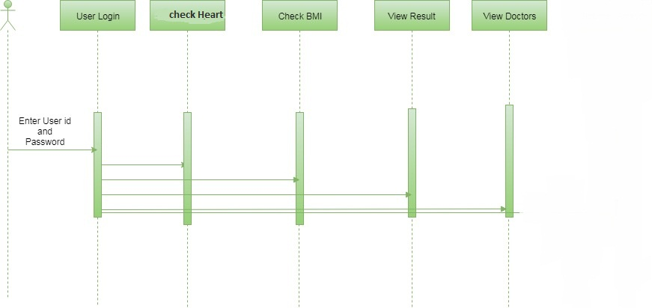

**Admin**

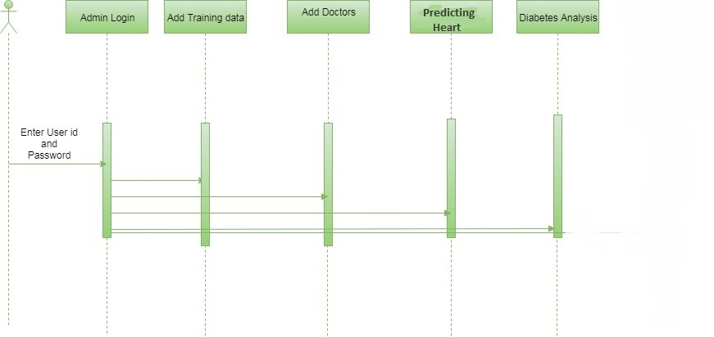

**6.4 ACTIVITY DIAGRAM**

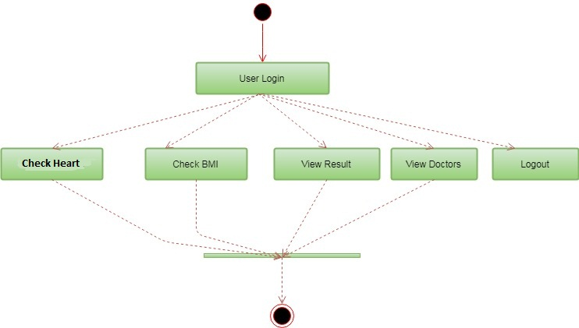

**6.5 CLASS DIAGRAM**

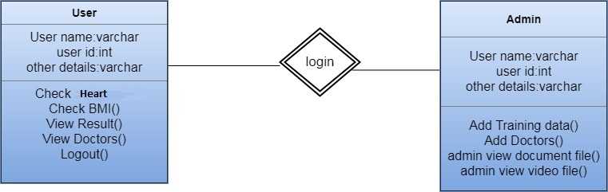

1. **SYSTEM IMPLEMENTATION**

Implementation is the stage in the project where the theoretical design is turned into a working system. The most critical stage is achieving a successful system and in giving confidence on the new system for the users, what it will work efficient and effectively. It involves careful planning, investing of the current system, and its constraints on implementation, design of methods to achieve the change over methods.

The implementation process begins with preparing a plan for the implementation of the system. According to this plan, the activities are to be carried out in these plans; discussion has been made regarding the equipment, resources and how to test activities.

The coding step translates a detail design representation into a programming language realization. Programming languages are vehicles for communication between human and computers programming language characteristics and coding style can profoundly affect software quality and maintainability. The coding is done with the following characteristics in mind.

* Ease of design to code translation.
* Code efficiency.
* Memory efficiency.
* Maintainability.

The user should be very careful while implementing a project to ensure what they have planned is properly implemented. The user should not change the purpose of project while implementing. The user should not go in a roundabout way to achieve a solution; it should be direct, crisp and clear and up to the point.

Implementation is the stage of the project when the theoretical design is turned out into a working system. Thus it can be considered to be the most critical stage in achieving a successful new system and in giving the user, confidence that the new system will work and be effective.

The implementation stage involves careful planning, investigation of the existing system and it’s constraints on implementation, designing of methods to achieve changeover and evaluation of changeover methods.

* 1. **MODULES OF THE PROJECT**
* Upload Training Data
* Data Pre- Processing
* Predicting Heart Disease
* Graphical Representations

**7.2 MODULES DESCRIPTION**

**1. Upload Training Data:**

The process of rule generation advances in two stages. During the first stage, the SVM model is built using training data During each fold, this model is utilized for predicting the class labels The rules are evaluated on the remaining 10% of test data for determining the accuracy, precision, recall and F-measure. In addition, ruleset size and mean rule length are also calculated for each fold of cross-validation.

**2. Data Pre- Processing:**

Heart disease data is pre-processed after collection of various records. The dataset contains a total of 303 patient records, where 6 records are with some missing values. Those 6 records have been removed from the dataset and the remaining 297 patient records are used in pre-processing. The multiclass variable and binary classification are introduced for the attributes of the given dataset.

**3. Predicting Heart Disease:**

The training set is different from test set. In this study, we used this method to verity the universal applicability of the methods. In k-fold cross validation method, the whole dataset is used to train and test the classifier to Heart Stoke.

**4. Graphical Representations:**

The analyses of proposed systems are calculated based on the approvals and disapprovals. This can be measured with the help of graphical notations such as pie chart, bar chart and line chart. The data can be given in a dynamical data.

1. **SYSTEM TESTING**

System Testing is an important stage in any system development life cycle. Testing is a process of executing a program with the intention of finding errors. The importance of software testing and its implications with respect to software quality cannot be overemphasized. Software testing is a critical element of software quality assurance and represents the ultimate review of specification, design and coding. A good test case is one that has a high probability of finding a yet undiscovered error.

The purpose of testing is to discover errors. Testing is the process of trying to discover every conceivable fault or weakness in a work product. It provides a way to check the functionality of components, sub assemblies, assemblies and/or a finished product It is the process of exercising software with the intent of ensuring that the Software system meets its requirements and user expectations and does not fail in an unacceptable manner. There are various types of test. Each test type addresses a specific testing requirement.

Testing is the set of activities that can be planned in advance and conducted systematically. Different test conditions should be thoroughly checked and the bugs detected should be fixed. The testing strategies formed by the user are performed to prove that the software is free and clear from errors. To do this, there are many ways of testing the system’s reliability, completeness and maintainability.

The important phase of software development is concerned with translating the design specification into the error-free source code. Testing is carried out to ensure that the system does not fail, that it meets the specification and it satisfies the user. The system testing was carried out in a systematic manner with a test data containing all possible combinations of data to check the features of the system. A test data was prepared for each module, which took care of all the modules of the program.

System Testing is an important stage where the system developed is tested with duplicate or original data. It is a process of executing a program with the intent of finding an error. It is a critical process that can consume fifty percent of the development time.

The following are the attributes of good test:

* A good test is not redundant.
* A good test should be "best of breed".
* A good test should be neither simple nor too complex.

**8.1. UNIT TESTING**

In the unit testing the analyst tests the program making up a system. The software units in a system are the modules and routines that are assembled and integrated to perform a specific function. In a large system, many modules on different levels are needed.

Unit testing can be performed from the bottom up starting with the smallest and lowest level modules and proceeding one at a time. For each module in a bottom-up testing, a short program executes the module and provides the needed data.

# 8.2. INTEGRATION TESTING

Integration testing is a systematic technique for constructing the program structure while conducting test to uncover errors associate with interfacing. Objectives are used to take unit test modules and built program structure that has been directed by design.

The integration testing is performed for this Project when all the modules where to make it a complete system. After integration the project works successfully.

# 8.3. VALIDATION TESTING

Validation testing can be defined in many ways, but a simple definition is that can be reasonably expected by the customer. After validation test has been conducted, one of two possible conditions exists.

* The functions or performance characteristics confirm to specification and are accepted.
* A deviation from specification is uncovered and a deficiency list is created.

Proposed system under consideration has been tested by using validation testing and found to be working satisfactorily.

For example, in this project validation testing is performed against module. This module is tested with the following valid and invalid inputs for the field id.

##### 8.4. WHITE BOX TESTING

White box testing, sometimes called glass-box testing is a test case design method that uses the control structure of the procedural design to derive test cases. Using white box testing methods, the software engineer can derive test cases that

* Guarantee that all independent paths with in a module have been exercised at least once.
* Exercise all logical decisions on their true and false sides.
* Execute all loops at their boundaries and with in their operational bounds and
* Exercise internal data structure to assure their validity.

For example in this project white box testing is performed against patient module. Without entering text if we apply it displays the message “First add record then save it” else it should be saved.

##### 8.5. BLACK BOX TESTING

This method treats the coded module as a black box. The module runs with inputs that are likely to cause errors. Then the output is checked to see if any error occurred. This method cannot be used to test all errors, because some errors may depend on the code or algorithm used to implement the module.

**9 EXPERIMENTAL RESULTS**

**9.1 SCREENSHOTS**

**Home Page**



**Patient Appointment**

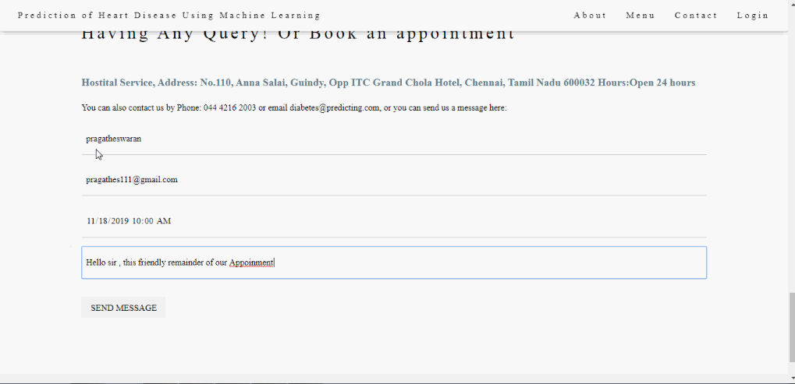

**Patient Registration**

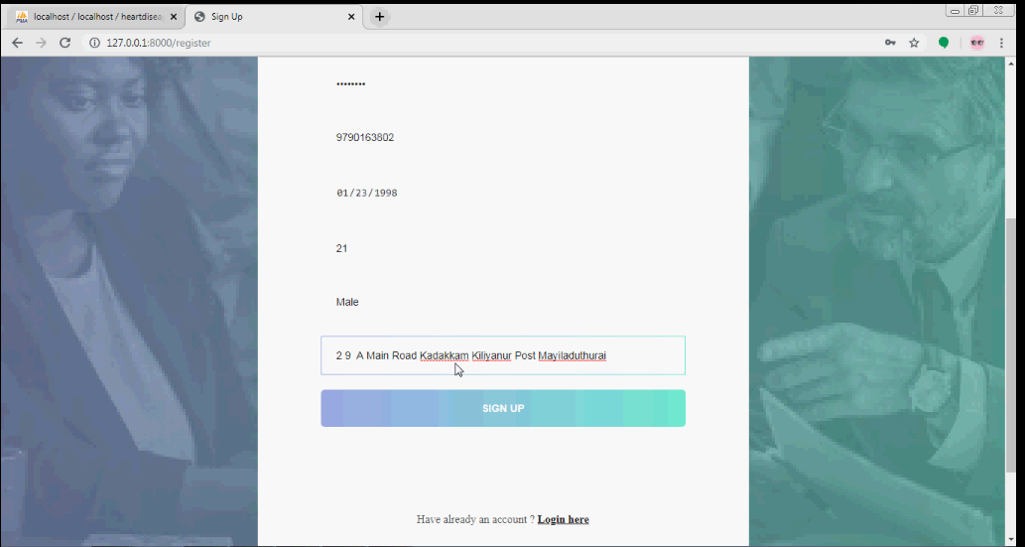

**Patient Login**

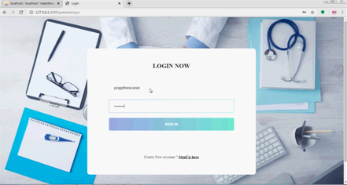

**Patient Page**

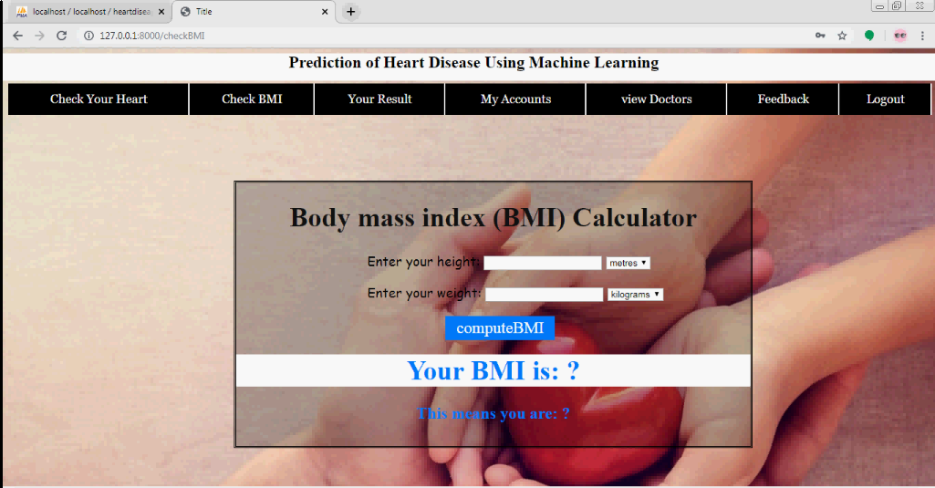

**Account Details**

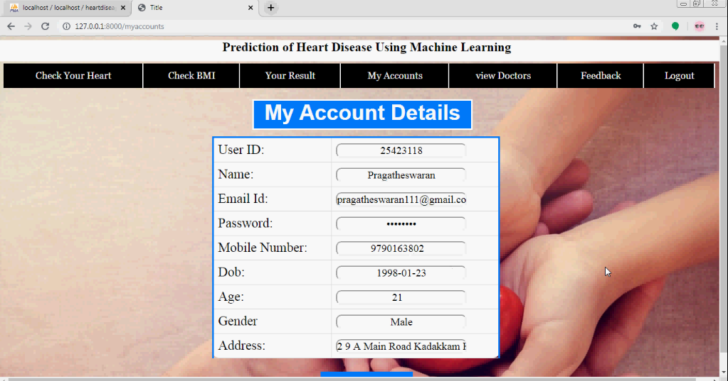

**View Doctor Details**

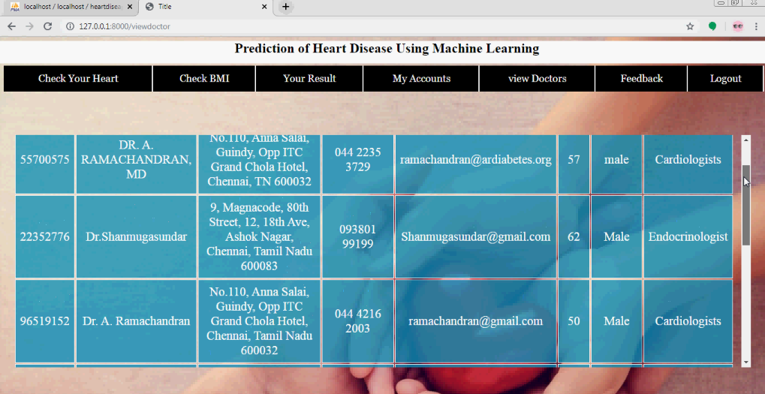

**Predict Risk**

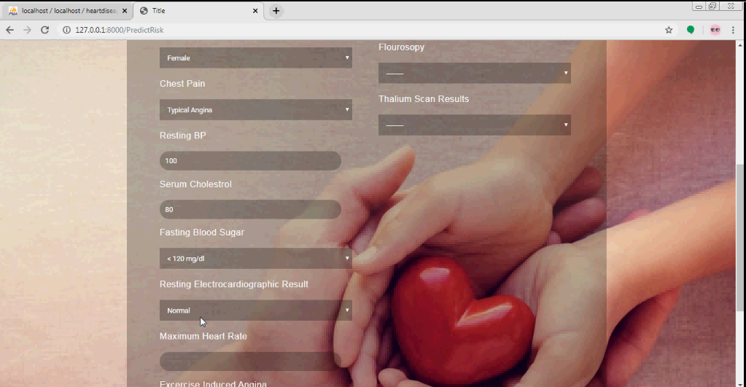**View Patient Review**

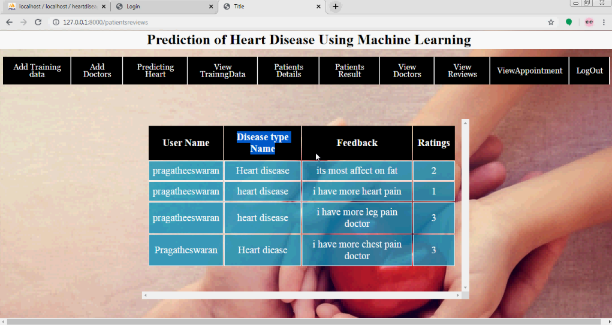**Upload Training Data**

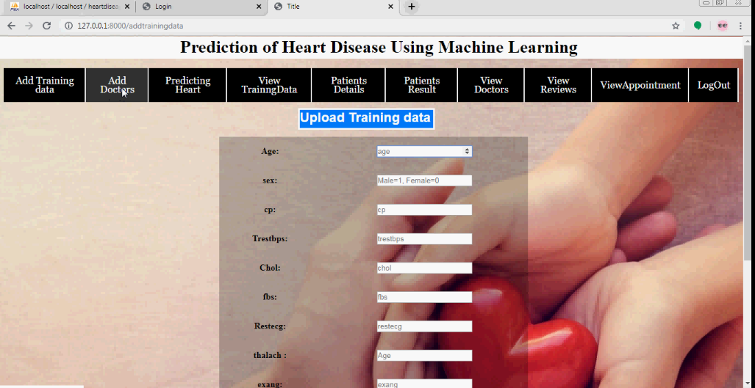

**View Training Data**

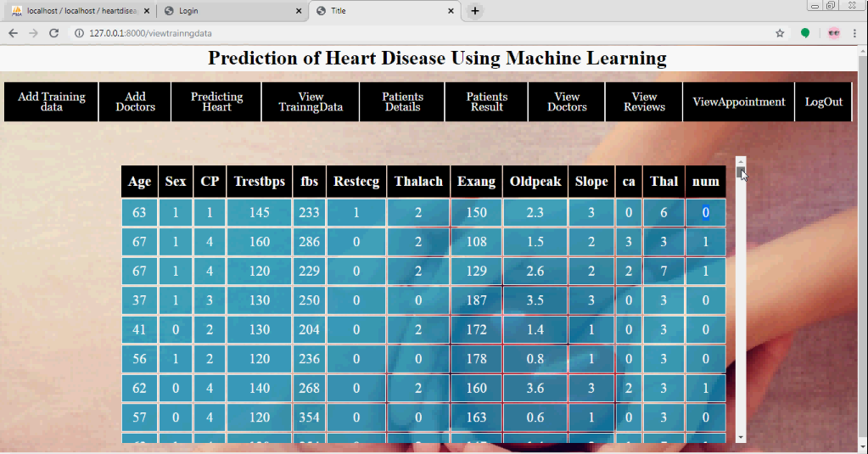**Add Doctors**

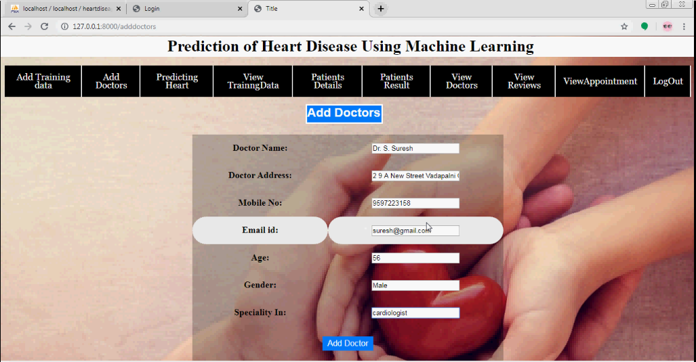

**10 RESULTS AND GRAPHS**

**Result**

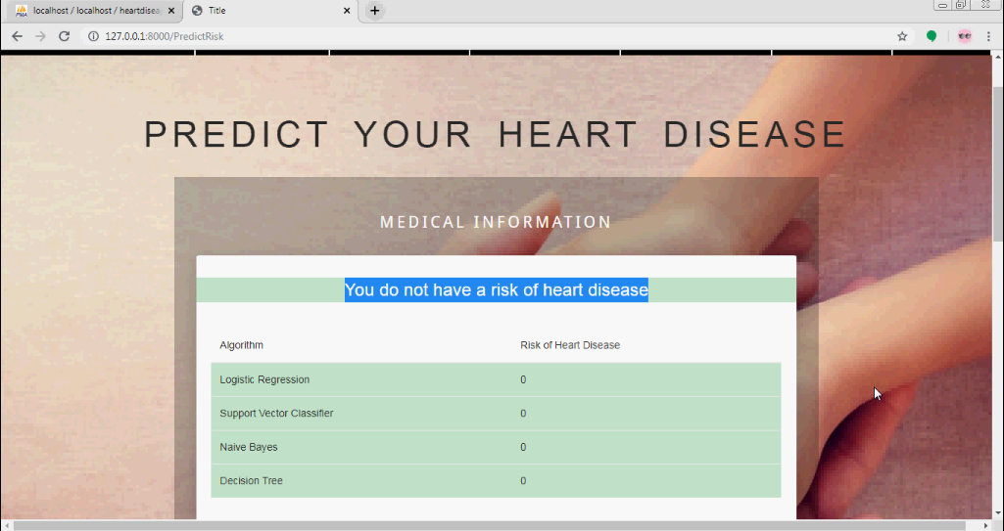

**View Graph**

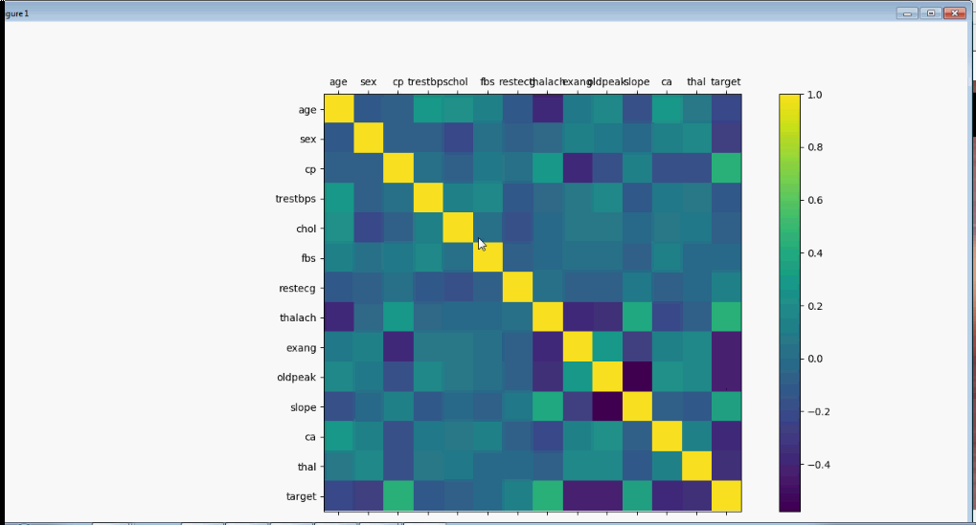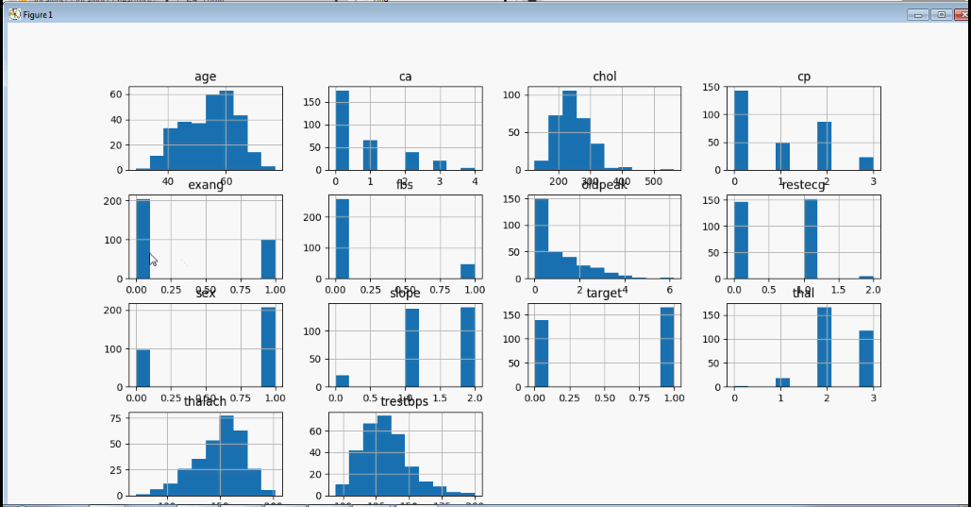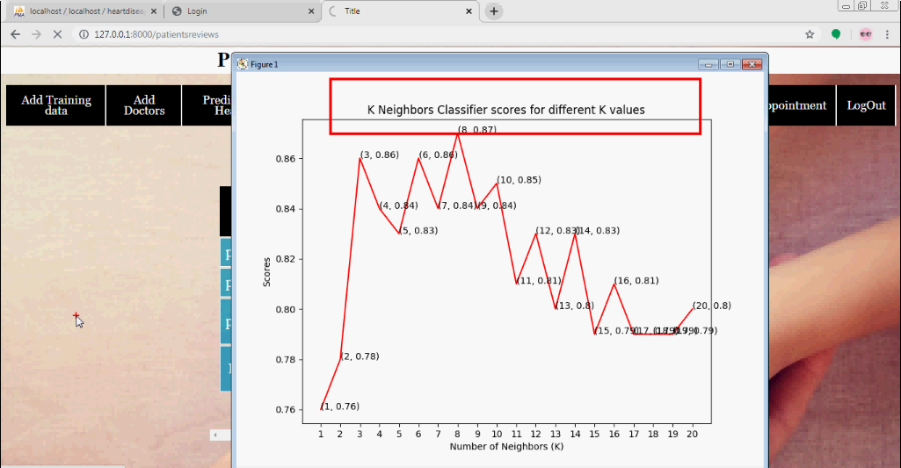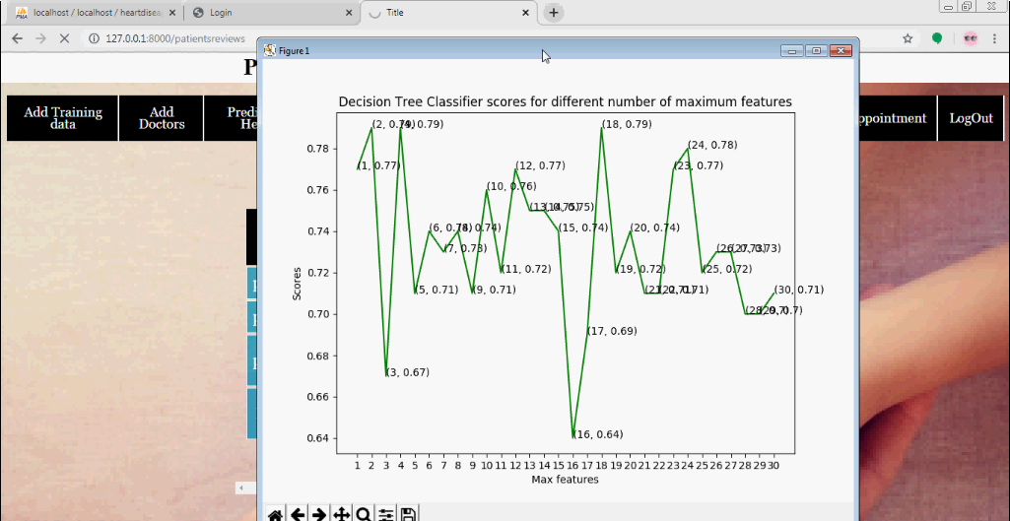



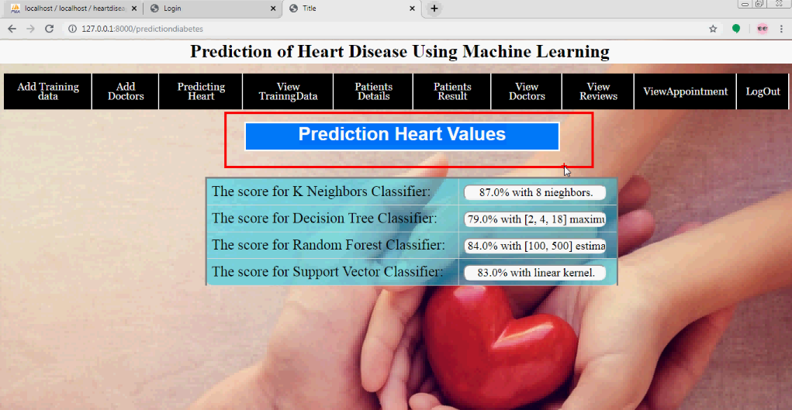

**11. CONCLUSION**

Identifying the processing of raw healthcare data of heart information will help in the long term saving of human lives and early detection of abnormalities in heart conditions. Machine learning techniques were used in this work to process raw data and provide a new and novel discernment towards heart disease. Heart disease prediction is challenging and very important in the medical. However, the mortality rate can be drastically controlled if the disease is detected at the early stages and preventative measures are adopted as soon as possible. Further extension of this study is highly desirable to direct the investigations to real-world datasets instead of just theoretical approaches and simulations. The proposed hybrid HRFLM approach is used combining the characteristics of Random Forest (RF) and Linear Method (LM). HRFLM proved to be quite accurate in the prediction of heart disease. The future course of this research can be performed with diverse mixtures of machine learning techniques to better prediction techniques. Furthermore, new feature selection methods can be developed to get a broader perception of the significant features to increase the performance of heart disease prediction.

**FUTURE ENHANCEMENT**

In future we can be made to produce an impact in the accuracy of the Decision Tree and Bayesian Classification for additional improvement after applying genetic algorithm in order to decrease the actual data for acquiring the optimal subset of attribute that is enough for heart disease prediction.

The automation of heart disease prediction using actual real time data from health care organizations and agencies which can be built using big data. They can be fed as a streaming data and by using the data, investigation of the patients in real time can be prepared.

**APPENDIX -1.2**

**CODING**

from django.db import models

# Create your models here.

class Add_Doctors_Details(models.Model):

doctorID = models.CharField(max_length=100)

doctorname = models.CharField(max_length=100)

doctoraddress = models.CharField(max_length=500)

mobileno = models.CharField(max_length=20)

emailid = models.CharField(max_length=100)

doctorage = models.IntegerField()

doctorgender = models.CharField(max_length=100)

speciality = models.CharField(max_length=200)

class predicting_value(models.Model):

kneighborstraing = models.CharField(max_length=1000)

decisiontree = models.CharField(max_length=1000)

randomtesting = models.CharField(max_length=1000)

svmtrining = models.CharField(max_length=1000)

class Addtrainingdatas(models.Model):

age= models.IntegerField()

sex= models.IntegerField()

cp= models.IntegerField()

trestbps= models.IntegerField()

chol= models.IntegerField()

fbs= models.IntegerField()

restecg= models.IntegerField()

thalach= models.IntegerField()

exang= models.IntegerField()

oldpeak= models.CharField(max_length=200)

slope = models.IntegerField()

ca= models.IntegerField()

thal = models.IntegerField()

num = models.IntegerField()

from django.shortcuts import render,redirect

from django.db.models import Count

# Create your views here.

from patients.models import UserRegistration,Feeback_Model,Check_Diabetes,patientsappoinment

from doctors.models import Add_Doctors_Details,Addtrainingdatas,predicting_value

import pandas as pd

import numpy as np

from sklearn.linear_model import LogisticRegression

from sklearn.tree import DecisionTreeClassifier

from sklearn.ensemble import RandomForestClassifier

from sklearn.ensemble import GradientBoostingClassifier

from sklearn.svm import SVC

from sklearn.preprocessing import MinMaxScaler

from sklearn.neural_network import MLPClassifier

from sklearn.preprocessing import StandardScaler

from sklearn.preprocessing import MinMaxScaler as Scaler

from sklearn.neighbors import KNeighborsClassifier

from sklearn.naive_bayes import GaussianNB

from sklearn.svm import LinearSVC

from sklearn.tree import DecisionTreeRegressor

from sklearn import model_selection

from sklearn.model_selection import GridSearchCV

import numpy as np

import pandas as pd

import matplotlib.pyplot as plt

from matplotlib import rcParams

from matplotlib.cm import rainbow

import warnings

warnings.filterwarnings('ignore')

from sklearn.model_selection import train_test_split

from sklearn.preprocessing import StandardScaler

from sklearn.neighbors import KNeighborsClassifier

from sklearn.svm import SVC

from sklearn.tree import DecisionTreeClassifier

from sklearn.ensemble import RandomForestClassifier

def adminlogin(request):

if request.method =="POST":

username = request.POST.get('username')

password = request.POST.get('password')

if username =='admin' and password == 'admin':

return redirect('patientsdetails')

return render(request,'admins/adminlogin.html')

def patientsdetails(request):

ted = UserRegistration.objects.all()

return render(request, 'admins/patientsdetails.html',{'objects':ted})

def adddoctors(request):

if request.method=="POST":

doctorID = request.POST.get('doctorID')

doctorname = request.POST.get('doctorname')

doctoraddress = request.POST.get('doctoraddress')

mobileno = request.POST.get('mobileno')

emailid = request.POST.get('emailid')

doctorage = request.POST.get('doctorage')

doctorgender = request.POST.get('doctorgender')

speciality = request.POST.get('speciality')

Add_Doctors_Details.objects.create(doctorID=doctorID,doctorname=doctorname,doctoraddress=doctoraddress,mobileno=mobileno,emailid=emailid,doctorage=doctorage,doctorgender=doctorgender,speciality=speciality)

return render(request,'admins/adddoctors.html')

def adminviewdoctors(request):

Opj = Add_Doctors_Details.objects.all()

return render(request, 'admins/adminviewdoctors.html',{'objects':Opj})

def patientsreviews(request):

Opj = Feeback_Model.objects.all()

return render(request, 'admins/patientsreviews.html',{'objects':Opj})

def addtrainingdata(request):

Result = ''

Normal = []

Prediabetes = []

T2Diabetes = []

Result = 'Result'

if request.method=="POST":

age = request.POST.get('age')

sex = request.POST.get('sex')

cp = request.POST.get('cp')

trestbps = request.POST.get('trestbps')

chol = request.POST.get('chol')

fbs = request.POST.get('fbs')

restecg = request.POST.get('restecg')

thalach = request.POST.get('thalach')

exang = request.POST.get('exang')

oldpeak =request.POST.get('oldpeak')

slope = request.POST.get('slope')

ca = request.POST.get('ca')

thal = request.POST.get('thal')

num = request.POST.get('num')

**REFERENCE**

Good Teachers are worth more than thousand books, we have them in Our Department

**References Made From:**

[1] Carlos Ordonez, “Improving Heart Disease Prediction using Constrained Association Rules”, Technical Seminar Presentation, University of Tokyo, 2004.

[2] Franck Le Duff, CristianMunteanb, Marc Cuggiaa and Philippe Mabob, “Predicting Survival Causes After Out of Hospital Cardiac Arrest using Data Mining Method”, Studies in Health Technology and Informatics, Vol. 107, No.2, pp. 1256-1259, 2004.

[3] W.J. Frawley and G. Piatetsky-Shapiro, “Knowledge Discovery in Databases: An Overview”, AI Magazine, Vol. 13, No. 3, pp. 57-70, 1996.

[4] Heon Gyu Lee, Ki Yong Noh and Keun Ho Ryu, “Mining Bio Signal Data: Coronary Artery Disease Diagnosis using Linear and Nonlinear Features of HRV”, Proceedings of International Conference on Emerging Technologies in Knowledge Discovery and Data Mining, pp. 56-66, 2007.

[5] Kiyong Noh, HeonGyu Lee, Ho-Sun Shon, Bum Ju Lee and Keun Ho Ryu, “Associative Classification Approach for Diagnosing Cardiovascular Disease”, Intelligent Computing in Signal Processing and Pattern Recognition, Vol. 345, pp. 721-727, 2006.

[6] Latha Parthiban and R. Subramanian, “Intelligent Heart Disease Prediction System using CANFIS and Genetic Algorithm”, International Journal of Biological, Biomedical and Medical Sciences, Vol. 3, No. 3, pp. 1-8, 2008.

[7] Niti Guru, Anil Dahiya and Navin Rajpal, “Decision Support System for Heart Disease Diagnosis using Neural Network”, Delhi Business Review, Vol. 8, No. 1, pp. 1-6, 2007.

[8] Sellappan Palaniappan and Rafiah Awang, “Intelligent Heart Disease Prediction System using Data Mining Techniques”, International Journal of Computer Science and Network Security, Vol. 8, No. 8, pp. 1-6, 2008.