# *USER GUIDE*

*A*

*Mini Project Report*

*Submitted in partial fulfilment of the*

*Requirements for the award of the Degree of*

**BACHELOR OF ENGINEERING**

IN

**INFORMATION TECHNOLOGY**

By

SWETHA SAI DAKUPATI - 1602-19-737-093

AKSHITHA REDDY - 1602-19-737-065



**Department of Information Technology**

**Vasavi College of Engineering (Autonomous)**

**(Affiliated to Osmania University)**

**Ibrahimbagh, Hyderabad-31**

**2020**

**Vasavi College of Engineering (Autonomous)**

**(Affiliated to Osmania University)**

**Hyderabad-500 031**

**Department of Information Technology**



**DECLARATION BY THE CANDIDATE**

We, SWETHA SAI DAKUPATI AND AKSHITHA REDDY **,** bearing hall ticket number, 1602-19-737-093 and 1602-19-737-065, hereby declare that the project report entitled “USER GUIDE” Department of Information Technology, Vasavi College of Engineering, Hyderabad, is submitted in partial fullfilment of the requirement for the award of the degree of **Bachelor of Engineering** in **Information Technology**

This is a record of bonafide work carried out by me and the results embodied in this project report have not been submitted to any other university or institute for the award of any other degree or diploma.

SWETHA SAI DAKUPATI - 1602-19-737-093

AKSHITHA REDDY - 1602-19-737-065

(Faculty In-Charge) (Head,Dept of IT)

**ACKNOWLEDGEMENTS**

The satisfaction that accompanies the successful completion of this project would not be in  complete without the mention of the people who made it possible, without whose constant  guidance and encouragement would have made efforts go in vain. We consider ourselves  privileged to express gratitude and respect towards all those who guided us through the  completion of this project.

We convey thanks to my project guide Mrs.Prasanna, Assistant Professor of Information Technology Department for  providing encouragement, constant support and guidance which was of a great help to  complete this project successfully.

Last but not the least, we wish to thank our parents for financing our studies in this  privileged Vasavi College of Engineering as well as for constantly encouraging us to learn  Engineering. Their personal sacrifice in providing this opportunity to learn Engineering is  gratefully acknowledged.

Sincerely,

Swetha Sai Dakupati - 1602-19-737-093

Akshitha Reddy-1602-19-737-065

**ABSTRACT**

Our project is “USER GUIDE”. In our busy times of our work, we forget some of the things which are important, that things might include passwords, bank account details and our day to day transactions .This project will help us out in that. The main idea of our project is to create a private space for a user to store his personal information like bank transaction details , passwords of various websites and accounts securely.

Also, every student requires guidance from their seniors or alumni for getting jobs and for planning future but not everyone could confidently reach out them . So, we want to provide a platform where seniors or any person could post their experiences or the knowledge they have, as public which could help out their juniors.

**TABLE OF CONTENTS**

|  |  |
| --- | --- |
| **TOPIC** | **PAGE NUMBER** |
| **INTRODUCTION** | **6** |
| **TECHNOLOGY** | **8** |
| **PROPOSED WORK** | **9** |
| **RESULTS** | **36** |
| **ADDITIONAL KNOWLEDGE ACQUIRED** | **47** |
| **CONCLUSION AND FUTURE WORK** | **48** |
| **REFERENCES** | **49** |

**INTRODUCTION**

**ABOUT THE PROJECT**

“USER GUIDE” is a console based C Project which stores the personal information of the user and displays the information which user posts as public to the guest. This program is run by any user who has an account or can create it and add, delete, view their personal information which is stored securely and allows them to login to their account only if the password is correct .And, anyone can login as a guest to view public information of registered users in read only mode.

**PURPOSE**

Every student has dreams and aspirations, but in the way to reach them they face many hurdles, they might need help and support. They might require further guidance to proceed in life. Their seniors or alumni of their streams can guide them and explain what mistakes they did and how did they correct them, which can help these juniors in reaching their goals. User Guide helps these juniors in taking guidance from their seniors.

Also, in our busy schedule we create various accounts which include passwords, and forget them after a while because of which we might lose whole data. Sometimes we might even skip the events or get delayed with our work.

We spend the much money in a month without noticing and at last we might fall short of money, if we note down the money spent every day ,than in the future days of that month we can use it efficiently.

So, to find a solution to solve all these problems we want to create a user friendly source where he can store all his data like passwords of various accounts, dates of the events, his monthly savings and transactions.

**REGISTERED USERS**

If it is a new user he have to set username and password to become registered user else the registered users can login using their username ,password.

If username and password is correct then the registered users account gets displayed with all his information. If password is incorrect error message is displayed.

There are mainly 7 modules for registered users:

* To write into public files.
* To store passwords
* To view your stored passwords
* To store details of user’s monthly transactions
* To display details of user’s stored monthly transactions
* To set remainders
* To display remainders

**GUEST USER-**

Guest does not require to create an account he can view the information of the user he wants and exit

**TECHNOLOGY**

All computer software needs certain hardware components or other software components  resources to be present. In order for computers to used efficiently these are the primary  prerequisites. There are two different categories of this section.

**a. Software Requirements:**

Software requirements mainly share out with defining the software resource  requirements that need to be installed on a computer to provide optimal functioning of  a particular application. These conditions are not included in the software installation  package and need to be installed separately.

In order to use User Guide the following are the prerequisites, a. Operating System – Windows 7 and above

b. C Compiler – GNU Compiler

c. Editor – Any basic editor is preferable (Example: Notepad++)

**b. Hardware Requirements:**

Hardware requirements refer to the common set requirements defined by any  operating system or software application and are usually the physical computer  resources. In this section we basically deal with primary memory, secondary memory,  processing power.

In order to use User guide one should have the following,

a. Processor - Intel Core i5 and above

b. Memory – 4GB Ram

**PROPOSED WORK**

1. **Design**

User Case Diagrams and descriptions for all the use cases

1. **USE CASE DIAGRAM**

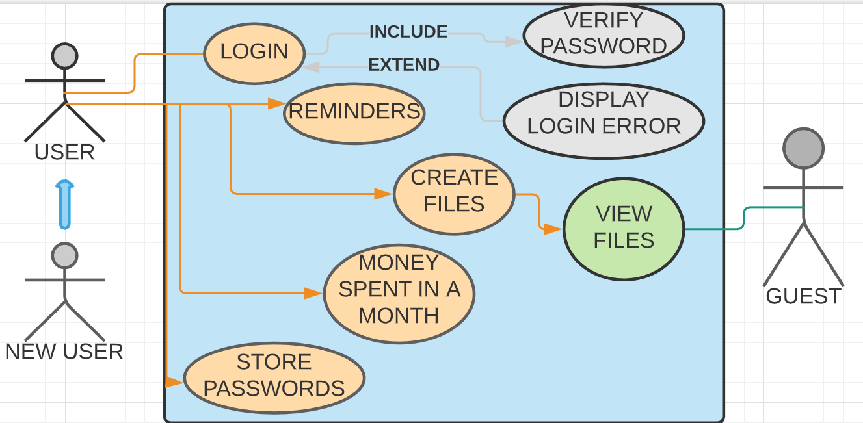

1. **FLOWCHARTS-**

START

STOP

NO

ERROR MESSAGE

YES

DISPLAYS HIS PUBLIC FILE

DOES ANY USER EXISTS WITH THAT NAME

ENTER NAME OF THE USER TO VIEW HIS FILE

2

IF 1 - GUEST LOGIN

IF 2 - CREATES AN ACCOUNT

YES

YES

ERROR

IF 3 - VERIFIES REGISTER USERS EMAILID AND PASSWORD

NO

YES

IS INPUT 1 OR 2 OR 3?

TAKE INPUR 1 OR 2 OR 3

3

3

2

NO

YES

NO

YES

NO

NO

DISPLAY that month’s events and 9 OPTIONS TO CHOOSE

DISPLAYS 9 OPTIONS TO CHOOSE

YES

IS EMAILID AND PASSWORD CORRECT

STOP

IF 9 IS ENTERED

LOGIN ERROR

ENTER EMAILID AND PASSWORD

EMAILID ALREADY EXISTS MESSAGE DISPLAYS

DOES SAME EMAILID EXIST BEFORE

SETS EMAILID AND PASSWORD

**The 9 options diplayed to the registered users are**

**1 -To write into a file**

If a users enters 1 ,a file opens where he can write all his experiemces of life so that guests can view

**2 - To store passwords**

If a user enters 2,on reentering his account password again he can store website name and password.

**3 - To view stored passwords**

If a user enters 3,on reentering his account password and by entering website or bank name he can view its password.

**4 - To store monthly transactions**

If a user enters 4,by entering the month number he can store his income and expenditures of that month.

**5 - To view his savings**

If a user enters 5,by entering the month number he can view details of his savings and expenditures and all details of his transactions of that month.

**6 - To set reminders**

If user enters 6 ,by entering the month number ,he can store all the events of that entered month.

**7 - To view reminders**

If a user enters 7,by entering the month number ,he can view his events of that month.

**8 - To delete reminders**

If a user enters 8,by entering the month number,he can delete any event of the entered month.

**9 - To exit**

If a user enters 9 ,the program terminates.

**b . IMPLEMENTATION**

**//LIBRARARIES USED IN THIS PROJECT**

#include<stdio.h>

#include<conio.h>

#include<stdlib.h>

#include<string.h>

#include<time.h>

typedef struct Data{

char user_name[20],pwd[20];

}Data;

Data d;//our user data

**//FUNCTIONS OF USER GUIDE**

int isFileExists();

void Read_password();

void display_reminders();

void Write_Transactions(char mon[4]);

void Read_Transactions();

void Read_Reminders(char mon[3]);

void set_Reminder(char mon[3]);

void credit_debit_month(int n);

void writepwd();

void searchpwd();

void choices();

void view();

void writework();

int write_Check_Password(int n);

void signin();

void signup();

int check_date(int m,int y);

void deleteline(char mon[3]);

int main(){

system("COLOR 31");

int user;

printf("\n\n******************************************************************************\n");

printf("\t\t\t WELCOME TO USER GUIDE\n");

printf("*******************************************************************************\n");

printf("******************************************************************************\n");

printf("\t\t\t\tENTER:\n\t\t\t1.If you are a guest\n\t\t\t2.To create an account.\n\t\t\t3.To Login.\n");

printf("*******************************************************************************\n ");

scanf("%d",&user);

switch(user){

case 1: printf("\nGive the username of the person to view his text:");

scanf("%s",d.user_name);

view();

break;

case 2: signup();

break;

case 3: signin();

break;

default:printf("\nSorry! We don't have any service of that kind.\n");

}

return 0;

}

**//CHECKING FOR ITS USER NAME AS FILE IF ITS EXISTING RETURN 1\**

int isFileExists(){

FILE *fp;

**//READING IS NULL WHEN THE FILE HAS NO CONTENTS I.E; NOT CREATED FP IS NULL;**

if((fp=fopen(d.user_name,"r"))==NULL)

return 0;

//**ELSE NEED TO CLOSE THE EXISTING FILE AND RETURN TRUE**

fclose(fp);

return 1;

}

**//TO STORE USER'S MONTHLY TRANSACTIONS**

void Write_Transactions(char mon[4]){

FILE *fp;

char c,file[100];

//MAKING THE FILE NAME AS USERNAME MON

strcpy(file,d.user_name);

strcat(file,mon);

fp=fopen(file,"a");

printf("\n Give data in the form of your PURPOSE : AMOUNT only.\n And press CTRL^Z to stop giving data\n");

while((c=getchar())!=EOF){

putc(c,fp);

}

system("cls");

fclose(fp);

}

**//TO STORE PASSWORDS OF THE USER**

void writepwd(){

FILE *fp;

int i;

char c,file[100];

//MAKING THE FILE NAME AS USERNAMEPWD.CSV

strcpy(file,d.user_name);

strcat(file,"pwd.csv");

system("cls");

printf("For security reasons you need to verify yourself again.\n");

Read_password();

if(write_Check_Password(0)){

fp=fopen(file,"a");

printf("\n Give data in the form of website : password only.\n Press CTRKL^Z to stop giving your data\n");

while((c=getchar())!=EOF){

if(c==':') putc(',',fp);

else putc(c,fp);

}

fclose(fp);

printf("\nThank you for storing your passwords.\n");

}

**//IF WRONG PASSWORDS ENTERED**

else printf("\nWrong password.");

}

**//SEARCHING FOR A PASSWORD TO WEBSITE ASKED BY THE USER IN THE FILE HE STORED IT**

void searchpwd(){

FILE *fp;

int i,cnt=0;

char check[500],c,key[100],file[100];

strcpy(file,d.user_name);

strcat(file,"pwd.csv");

printf("For security reasons you need to verify yourself again.\n");

Read_password();

//IF FILE IS SET BUT NOT GIVEN DATA TO IT

if(write_Check_Password(0)){

if((fp=fopen(file,"r"))==NULL){

printf("\nFirst give some data to the file to search\n");

return;

}

printf("\n Give name of the web to search for its password:");

scanf("%s",key);

while((c=getc(fp))!=EOF){

if(c==',' && (strcmp(check,key))==0){

printf("\n%s:",key);

cnt=1;

while((c=getc(fp))!='\n')

putchar(c);

break;

}

else strncat(check,&c,1);

if(c=='\n') strcpy(check,"");

}

//IF USER ASKS FOR SOMETHING HE NOT STORED

if(cnt==0) printf("\n Can't find relevent web in your file.\n");

fclose(fp);

}

else printf("\nWrong password.");

}

int check_date(int m,int y){

if(m >=1 && m<=12 && y>0) return 1;

else return 0;

}

**//CHOICES TO THE USER**

void choices(){

int choice,mon,y;

char year[4];

display_reminders();

char m[3],date[4];

do{

printf("\n ENTER \n 1.To write to your file.\n 2.To store passwords.\n 3.To search for a password.\n 4.To store your transactions.\n 5.To get your transactions\n 6.To read reminder.\n 7.To set your reminders. \n 8.to delete any reminder. \n 9.To quit.\n");

scanf("%d",&choice);

switch(choice){

case 1: //TO WRITE IN THE FILE

writework();

//SHOWING HIM HIS FILE CONTENTS

printf("Your file contains");

view();

break;

case 2: writepwd();

break;

case 3: searchpwd();

break;

case 4: printf("Enter mon-year in the form ofmm/yy to store your transactions in that month:");

scanf("%d/%d",&mon,&y);

if(check_date(mon,y)){

sprintf(date,"%02d-%02d",mon,y);

Write_Transactions(date);

}

else printf("\nGiven month or year not found in calender.");

break;

case 5: Read_Transactions();

break;

case 6: printf("\n Give the month of your events you want to view in the form of \"xx\" \n");

scanf("%s",m);

Read_Reminders(m);

break;

case 7: printf("\n Give the month of your event you want to view in the form of \"xx\" \n");

scanf("%s",m);

set_Reminder(m);

break;

case 8:printf("\n Give the month of your events you want to delete in the form of \"xx\" \n");

scanf("%s",m);

deleteline(m);

break;

case 9: printf("\n Exiting....\n");

break;

default:printf("\nChoose correctly");

}

}while(choice!=9);

}

//IF FILE EXISTS READING FROM IT TO PRINT

void view(){

system("cls");

//AGAIN CHECKING FOR FILE EXISTS BECAUSE GUEST HAS NO LOGIN AND CANNOT CHECK FOR THE FILE GIVEN BY HIM IN LOGIN

system("COLOR F0");

if(!isFileExists()){

printf("\nOpps! Person with user name \"%s\" is not found in our data .Try again.\n",d.user_name);

return;

}

FILE *fp;

int cnt=0;

fp=fopen(d.user_name,"r");

char c,p[100];

//READING PASSWORD BECAUSE WE CAN'T PRINT IT FROM THE FILE

fscanf(fp,"%s",p);

//TO READ THE '\N' FROM THE FILE TO READ THE CONTENTS FROM IT

fgetc(fp);

while((c=getc(fp))!=EOF){

cnt=1;

printf("%c",c);

}

fclose(fp);

**//IF THE USER HAS CREATED AN ACCOUNT THEN HIS PASSWORD WILL BE IN THE FILE BUT IF WE DIDN'T YET CHOOSE WRITE SOMETHING THEN THIS IS PRINTED**

if(cnt==0) printf("\nWaiting for %s to give the data.\n",d.user_name);

//system("cls");

}

**//TO WRITE IN FILE**

void writework(){

FILE *fp;

fp=fopen(d.user_name,"a");

char c;

printf("\n Start writing the file. Once you finish give CTRL^Z.\n");

while((c=getchar())!=EOF){

fputc(c,fp);

}

fclose(fp);

system("cls");

}

**//WRITING PASSWORD TO FILE AND CHECKING IF THE PASSWORD IS CORRECT OR NOT**

int write_Check_Password(int n){

//WRITING TO FILE

if(n==1){

FILE *fp;

fp=fopen(d.user_name,"w");

fprintf(fp,"password:%s\n",d.pwd);

fclose(fp);

return 1;

}

//CHECKING IF PASSWORD IS CORRECT OR NOT

else{

FILE *fp;

fp=fopen(d.user_name,"r");

char fpwd[100];

fscanf(fp,"password : %s",fpwd);

fclose(fp);

if((strcmp(d.pwd,fpwd))==0) return 1;

else return 0;

}

}

**//NEW USER LOGIN TO CREATE AN ACCOUNT**

void signin(){

int i;

char c;

system("cls");

system("COLOR E5");

printf("\nEnter your username:");

scanf("%s",d.user_name);

if(!isFileExists()){

printf("\nOpps! you're a new user.Try to create an account.");

return;

}

Read_password();

int check=write_Check_Password(0);

if(!check){

printf("\n Try again wrong password.");

return;

}

choices();

}

**//TO CREATE A NEW ACCOUNT**

void signup(){

int i;

char c;

system("cls");

system("COLOR F6");

printf("\nHeartly, Welcome new user.\n");

printf("\nEnter username:");

scanf("%s",d.user_name);

//UNTIL USER GIVES HIS USERNAME AS A NON EXISTING ONE WE TAKE INPUT

while(1){

if(isFileExists()){

printf("\nOpps! One of our users already has this username. \n Please give another name to your account:\n");

scanf("%s",d.user_name);

}

else

break;

}

Read_password();

write_Check_Password(1);

choices();

}

**//READING PASSWORD**

void Read_password(){

int i;

char c;

printf("\nEnter a password:");

for(i=0;;i++){

c=getch();

if(c==' ' || c=='\r'){

d.pwd[i]='\0';

break;

}

d.pwd[i]=c;

printf("* ");

}

}

void credit_debit_month(int n){

FILE *fp;

long long int amt,credit=0,debit=0;

int i,mon,y;

char str[1000],date[4],file[1000];

printf("Enter mon-year in the form ofmm/yy:");

scanf("%d/%d",&mon,&y);

//checking if correct date is entered or not

if(check_date(mon,y)){

sprintf(date,"%02d-%02d",mon,y);

strcpy(file,d.user_name);

strcat(file,date);

fp=fopen(file,"r");

if(fp==NULL) printf("\n Store something to print it.\n");

while((fgets(str,1000,fp))!=NULL){

if((strcmp(str,"\n"))==0) continue;

for(i=1;str[i-1]!=':';i++){}

amt=atoi(str+i);

if(amt>0) credit+=amt;

else debit+=amt;

}

if(n==1) printf("\n As per our records your total amount you received in %d/%d is %ld.",mon,y,credit);

else if(n==2) printf("\n As per our records total amount you spent in %d/%d is %ld.",mon,y,(debit));

else if(n==3){

printf("\n As per our records your savings in %d/%d is %ld.",mon,y,(credit+debit));

if((credit+debit)>0) printf("\n Great! you have been profit in this month.");

else if((credit+debit)<0) printf("\n Sorry you have spent much in this month.");

else printf("\n Cool! your in no loss your savings are 0.");

}

else printf("\n We don't have service of this kind.");

fclose(fp);

}

else printf("\n Given %d/%d not found in calendar.",mon,y);

}

**//PRINTING OUR USER'S MONTHLY TRANSACTIONS**

void Read_Transactions(){

system("COLOR F0");

int n;

printf("\n Enter \n 1. To get the total amount you received in a month.\n 2. To get total amount you spent in a month. \n 3.To get your savings in a month.\n ");

scanf("%d",&n);

credit_debit_month(n);

}

void Read_Reminders(char mon[3]){

FILE *fp;

char c,file[100];

strcpy(file,d.user_name);

strcat(file,mon);

fp=fopen(file,"r");

if(fp==NULL) printf("\n There is no reminder for this month.\n");

while((c=getc(fp))!=EOF){

if(c==',') printf(":");

else printf("%c",c);

}

fclose(fp);

printf("\nThank you.");

}

**//displaying reminders based on current date at the start**

**void display_reminders(){**

**system("COLOR C0");**

**char mon[3];**

**int m;**

**time_t now;**

**time(&now);**

**struct tm *local=localtime(&now);**

**m=local->tm_mon+1;**

**itoa(m,mon,10);**

FILE *fp;

char c,file[100];

strcpy(file,d.user_name);

strcat(file,mon);

fp=fopen(file,"r");

if(fp==NULL)

printf("\n There are no events in this month.\n");

else{

printf("\nThese are your events in this month\n");

while((c=getc(fp))!=EOF){

if(c==',') printf(":");

else printf("%c",c);

}

}

fclose(fp);

}

void set_Reminder(char mon[3]){

FILE *fp;

char c,file[100];

//MAKING THE FILE NAME AS USERNAMEMON

strcpy(file,d.user_name);

strcat(file,mon);

fp=fopen(file,"a");

printf("\n Give data in the form of your date:event only.And press CTRKL^Z to stop giving data\n");

while((c=getchar())!=EOF){

if(c==':') putc(',',fp);

else putc(c,fp);

}

system("cls");

fclose(fp);

}

void deleteline(char mon[3]){

FILE *fp, *fileptr2;

char ch;

int delete_line, temp = 1;

char c,file[100];

strcpy(file,d.user_name);

strcat(file,mon);

fp=fopen(file,"r");

if(fp==NULL) printf("\n There is no reminder for this month.\n");

while((c=getc(fp))!=EOF){

if(c==',') printf(":");

else printf("%c",c);

}

rewind(fp);

printf(" \n Enter line number of the remainder to be deleted:");

scanf("%d", &delete_line);

//open new file in write mode

fileptr2 = fopen("replica.c", "w");

ch = getc(fp);

while (ch != EOF)

{

ch = getc(fp);

if (ch == '\n')

temp++;

//except the line to be deleted

if (temp != delete_line)

{

//copy all lines in file replica.c

putc(ch, fileptr2);

}

}

fclose(fp);

fclose(fileptr2);

remove(file);

//rename the file replica.c to original name

rename("replica.c", file);

printf("\n The remainders of the month after being modified are as follows:\n");

fp = fopen(file, "r");

ch = getc(fp);

while (ch != EOF)

{

printf("%c", ch);

ch = getc(fp);

}

fclose(fp);

}

1. **USER TEST CASES**

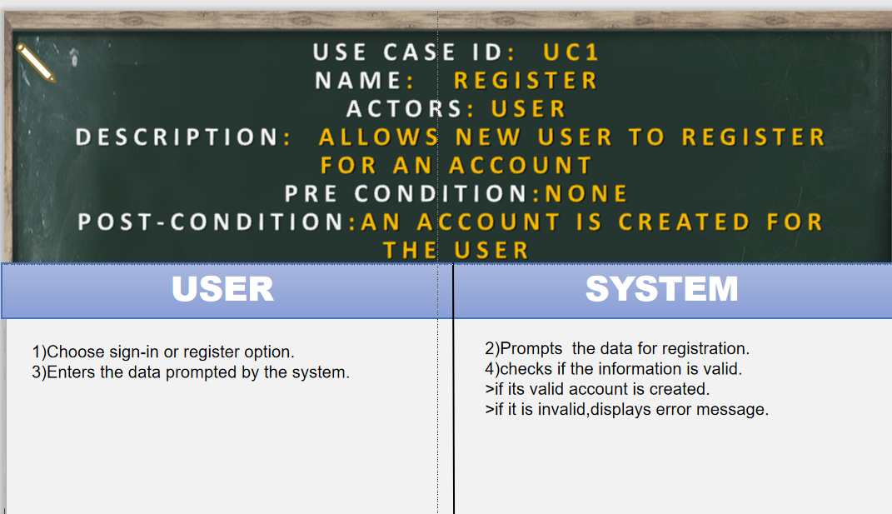

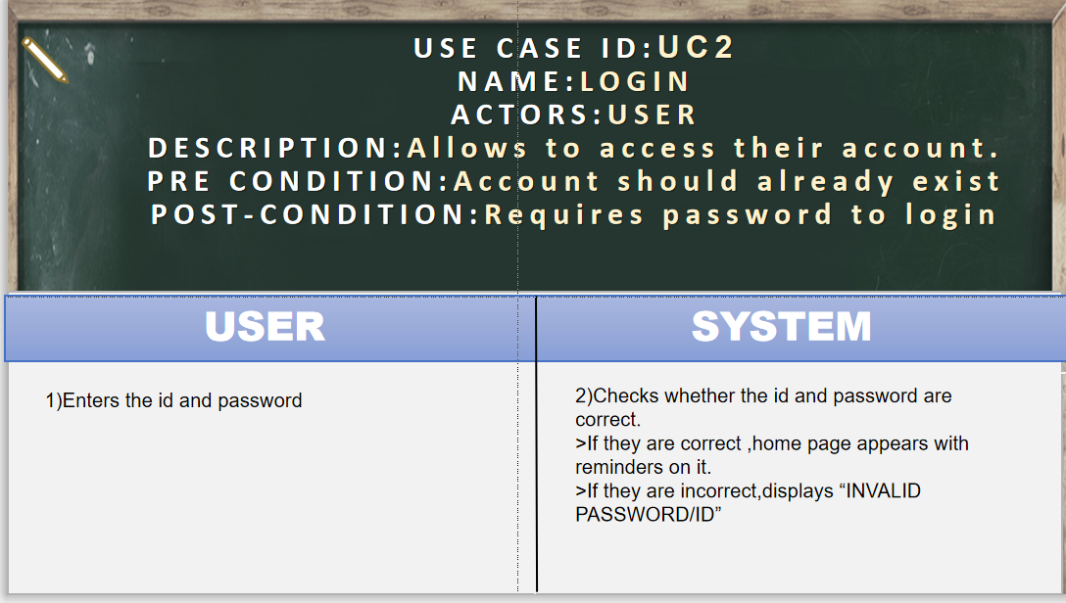

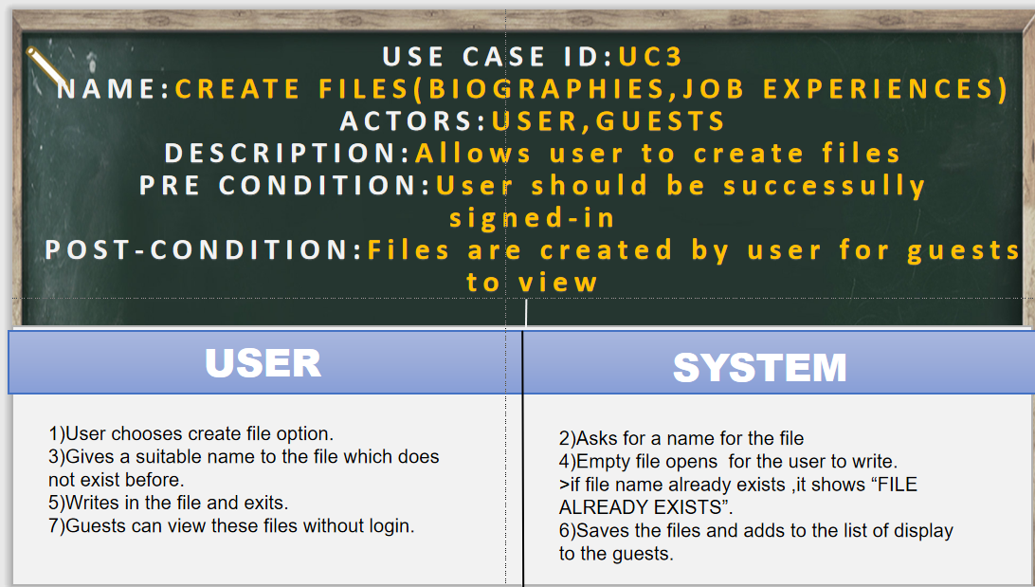

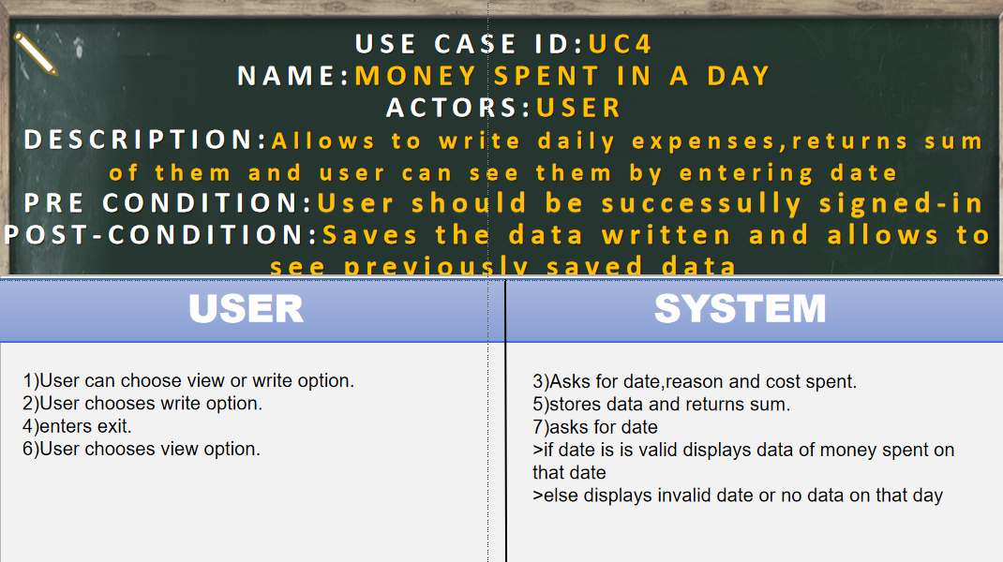

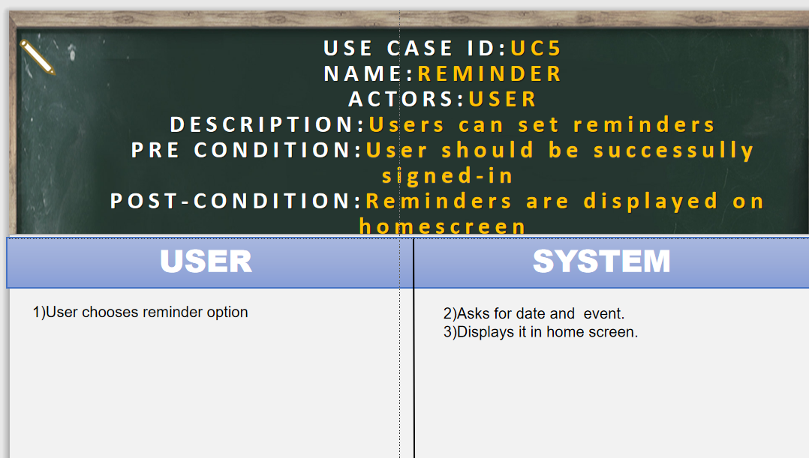

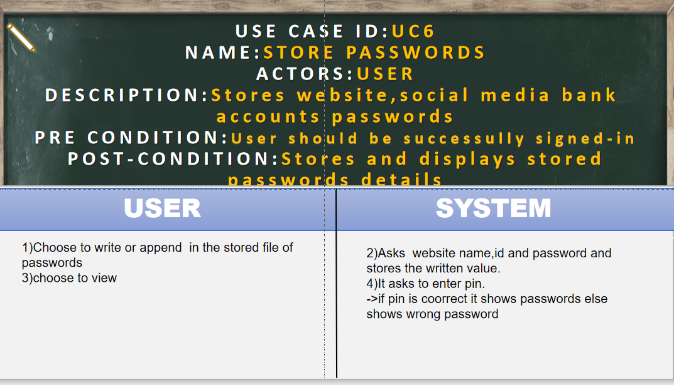

**RESULTS**

//LOGGING IN TO CREATE ACCOUNT AND SET USERNAME AND PASSWORD

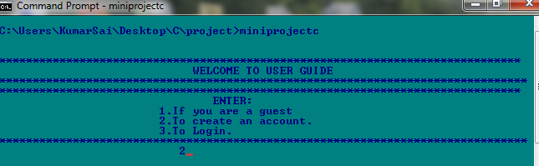

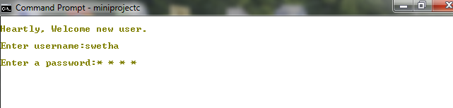

//TO WRITE INTO PUBLIC FILE

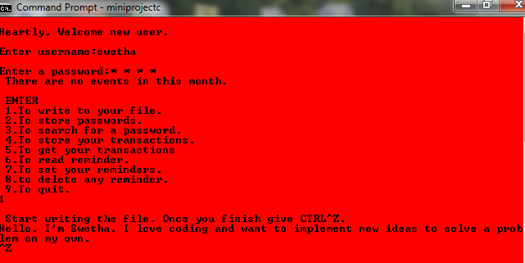

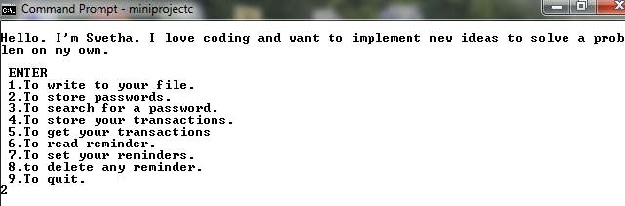

//STORING PASSWORDS

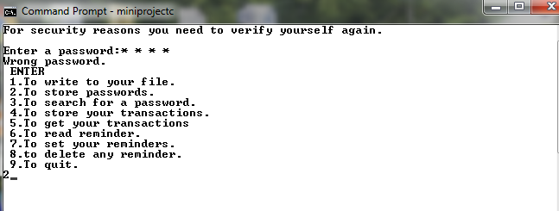

//TO SEARCH FOR A WEDSITE’S PASSWORD BY ENTERING 3

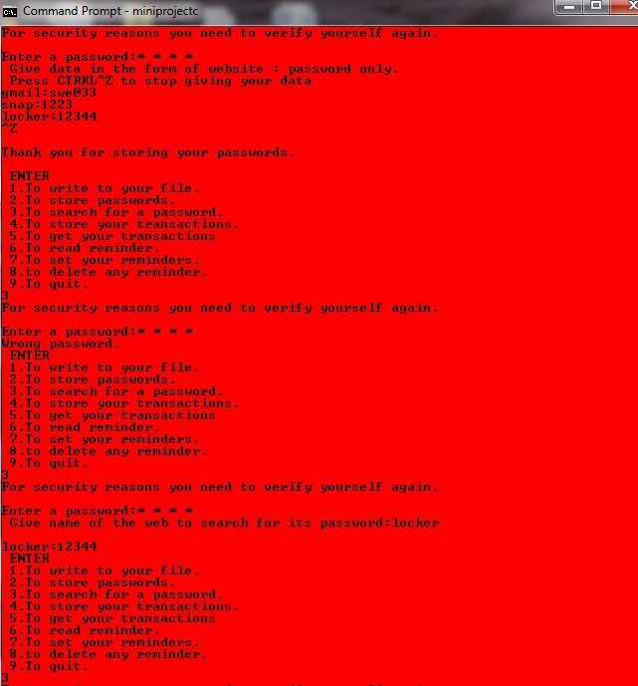

//ENTERED 4 TO STORE TRANSACTIONS(‘-‘ IF USED AND’+’ IF CREDITTED)

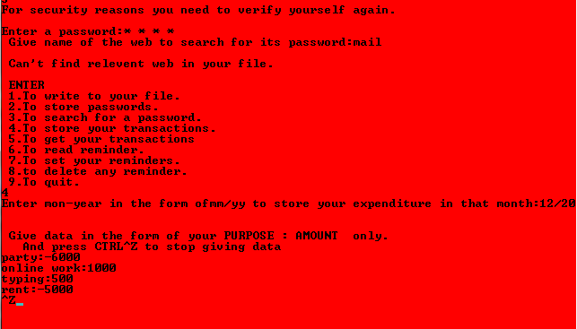

//GETTING DEATILS OF THE MONTHS’S TRANSACTIONS BY ENTERNING 5

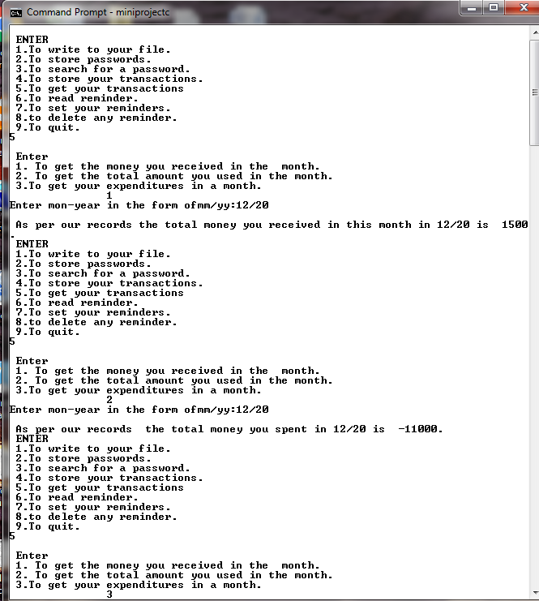

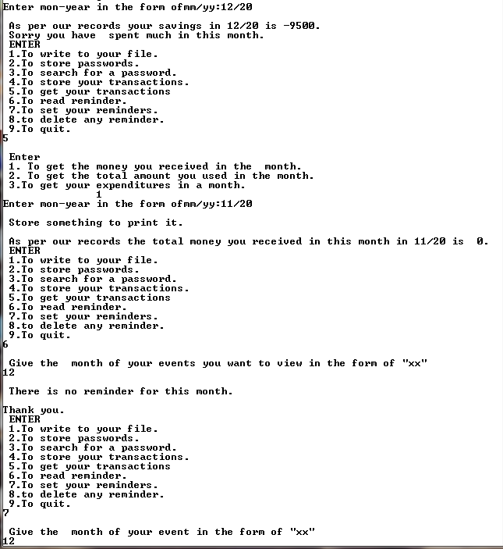

//SETTING REMINDERS

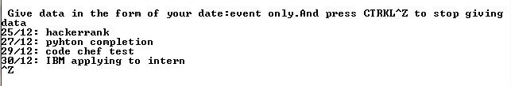

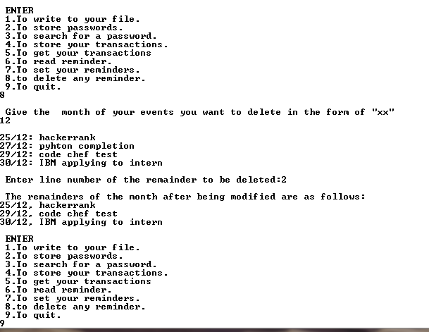

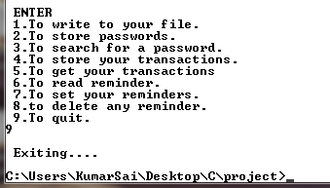

//WHEN A REGISTERED USER LOGS IN INTO HIS ACCOUNT



//WHEN A REGISTERED USER LOGS IN, ALL HIS REMINDERS IN THAT MONTH ARE DISPLAYED

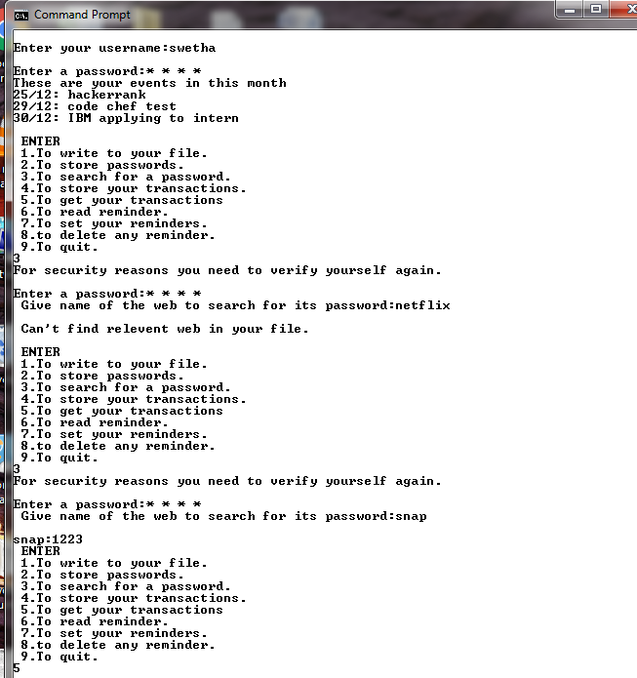

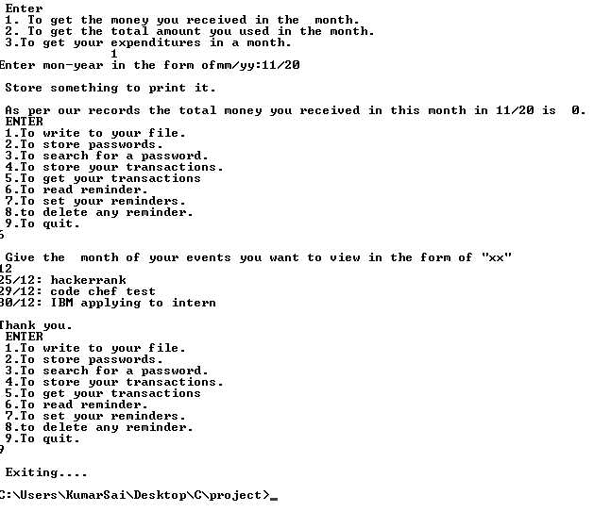

//IF GUEST REQUESTS FOR AN UNKNOWN USER

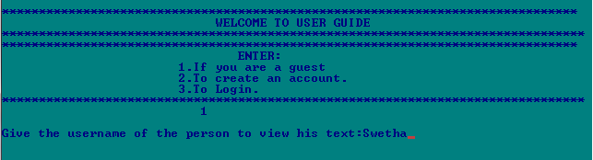

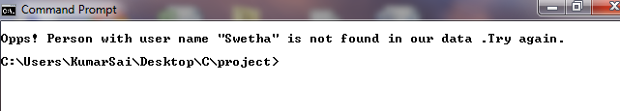

//IF A REGISTERED USER DIDN’T YET SHARE HIS EXPERIENCES

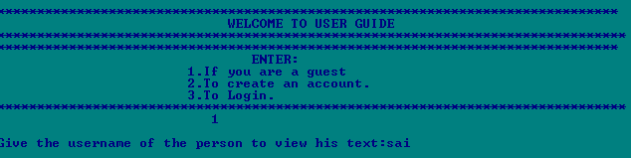

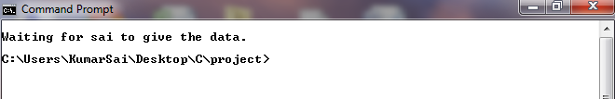

//IF YOU’RE A GUEST AND ASK FOR A REGISTERED USER WHO HAS SHARED HIS EXPERIENCES WITH US

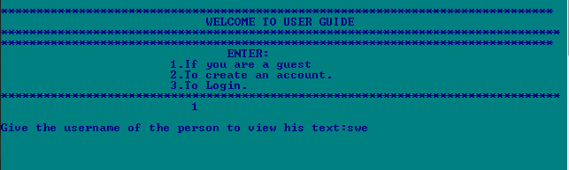

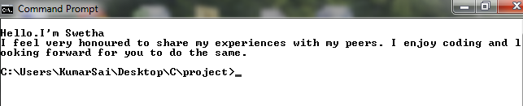

**What was the additional learning apart from the course programming for problem solving relate the ideas that you have gained implementing this mini-project?**

As a result of implementing this c project we got to learn different libraries such as ‘conio.h’ and ‘time.h’. We were able to use the knowledge of files and execute in real-time application. We learnt about the basic graphics of c that is displaying various font colors and background colors. We also learnt reading and writing files from csv files. We, even explored the ‘time.h’ and ‘conio.h’ libraries for achieving a look and feel of an actual window application by constructing reminder function.

Also, we have further improved our knowledge in file-handling because of the vast amount of data manipulation we have done using text files.

Other than this, we have learnt the value of team spirit and have understood the intention behind working in teams. We have learnt to be team players.

**CONCLUSION AND FUTURE WORK**

Conclusion of the proposed system is based on user’s need. The system is developed in considering all issues related to all users which are included in this system. Based on the result of this research it can be concluded. It helps users to store all their private information securely, it helps them to write, delete, store, append and view their data which are organized properly which makes users to find their information easily. It would be useful for most of the people as everyone face this problem of forgetting things.

In future, we would like to make this project an application that would be accessible to everyone so that they store their information in a secure and organized manner. We would also like to implement few more features like making a calender type table so that users can schedule their weekly or monthly plans to complete their works or preparations before exams.

In future public files will also be organized in such a way that every stream of people can get guidance from their alumni and seniors of the same stream. The files can be distinguished as IAS aspirants ,IIT aspirants, Doctors and if possible we’ll try to bring in contact between them virtually through chat .

**REFERENCES**

**Stackoverflow(for debugging errors)**

**Geeksforgeeks**

[**www.Tutorials.com**](http://www.Tutorials.com)

[**www.Programiz.com**](http://www.Programiz.com)

[**www.quora.com**](http://www.quora.com)

**THE END**