**How-To Guide for Using the Co-Morbidity Application**

**Step 1:** Open a patient’s chart.

* On the left menu panel, click on the Co-Morbidity link.

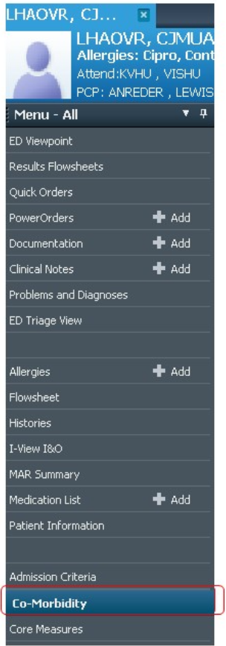

**Step 2:** If the patient has applicable results that are available, comorbidities will display in the **Computed CoMorbidities/Clinical Conditions** section.

* To validate the clinical indicators, hover over the text to display the values and the rules.

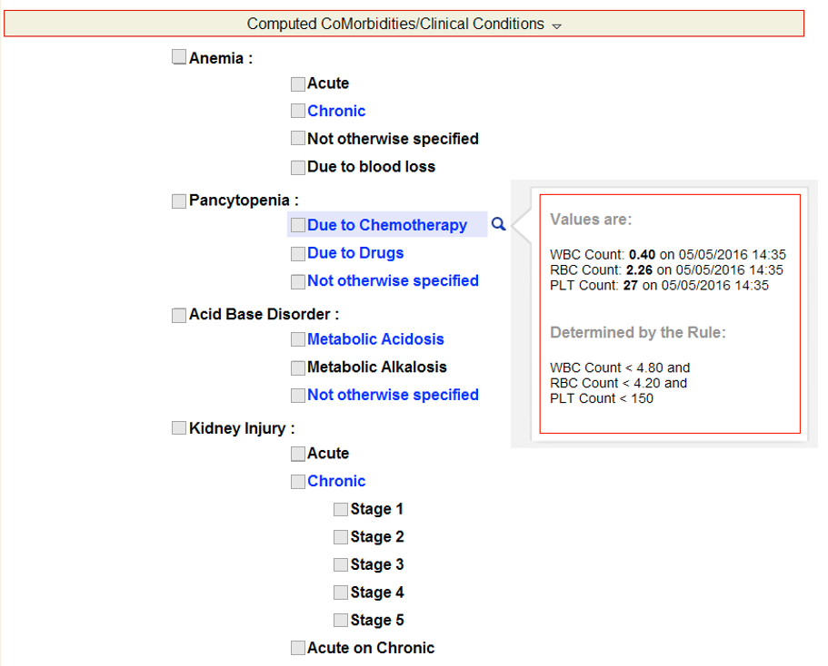

**Step 3:** Select comorbidities by clicking the checkbox next to it.

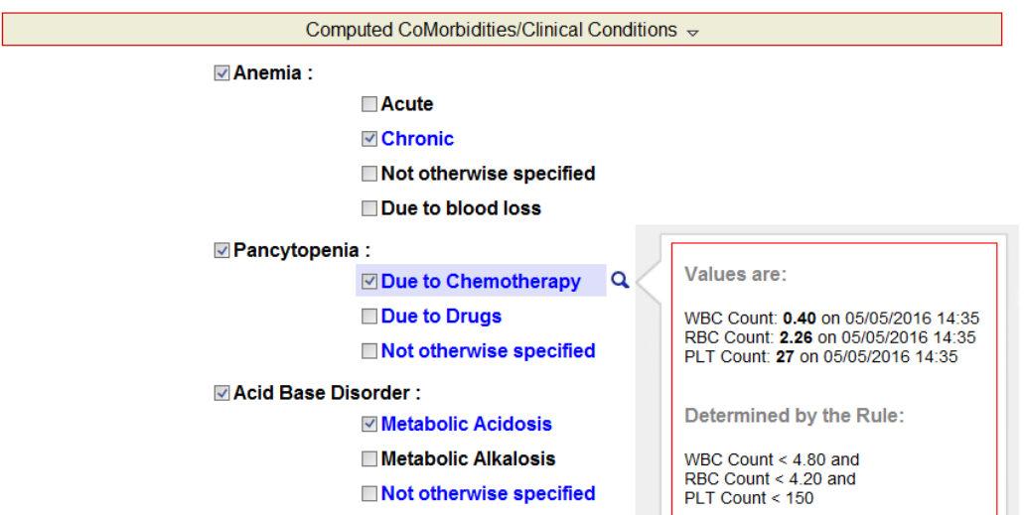

* Scroll through and validate other comorbidities and clinical conditions, if applicable.

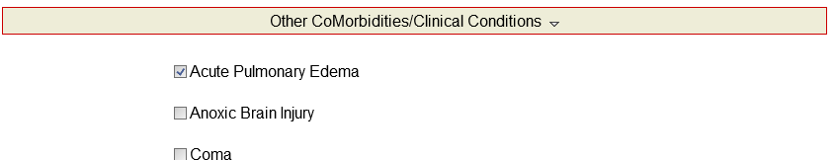

**Step 4:** When complete click on the COMMIT icon on the top of the application.

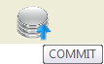

**Step 5:** Pull the Comorbidities into a PowerNote.

* Open a PowerNote and navigate to the **Impression and Plan** section.
  + Under **Diagnosis code search**, click on **OTHER.**

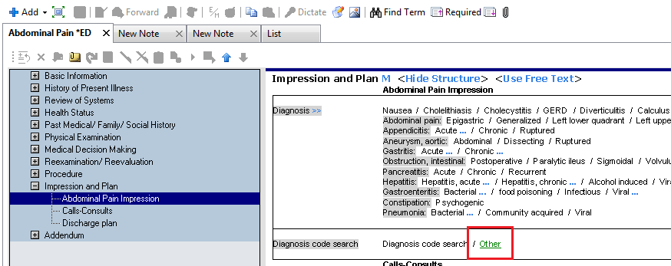

* Click on the Insert Template icon on the box that comes up.

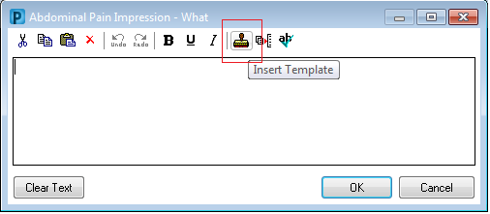

* Double-click on the **\*Co-Morbidities** template name on the Select Templates window.

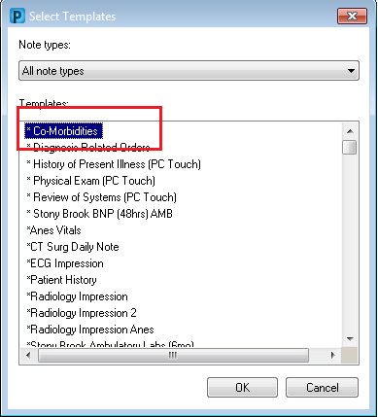

* Review and make edits if necessary. Then click **OK** to insert into the note.

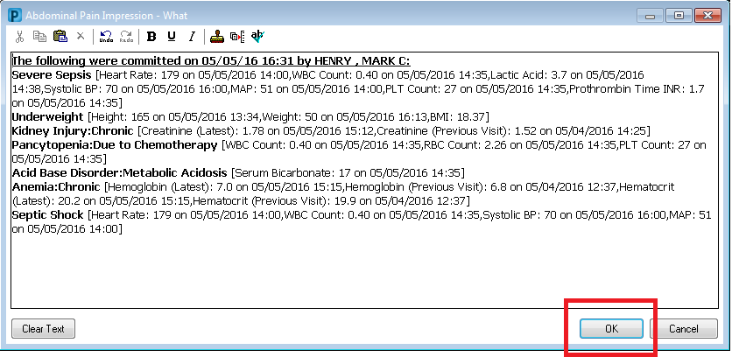

* If the application is run at a later time on the same encounter, the **Previously Committed CoMorbidities/Clinical Conditions** section will be available.
  + The date & time and the provider who committed the comorbidities will be displayed.
  + You can view the results that were available at the time that the comorbidity was committed by hovering over the text.

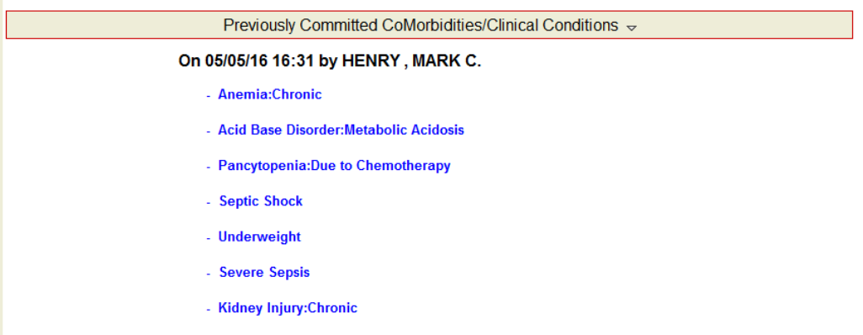

**Help Notes:** If at any time you need help on using the application or if you wish to view the rules on how the comorbidities are computed, you can click on the HELP icon on the top of the application.

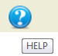

* This will open the help window.

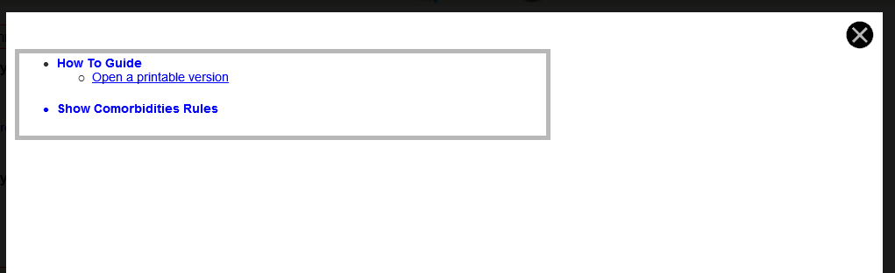

* Click on the **How To Guide** link and it will open **A Quick “How To” Guide** on the right side of the help window.

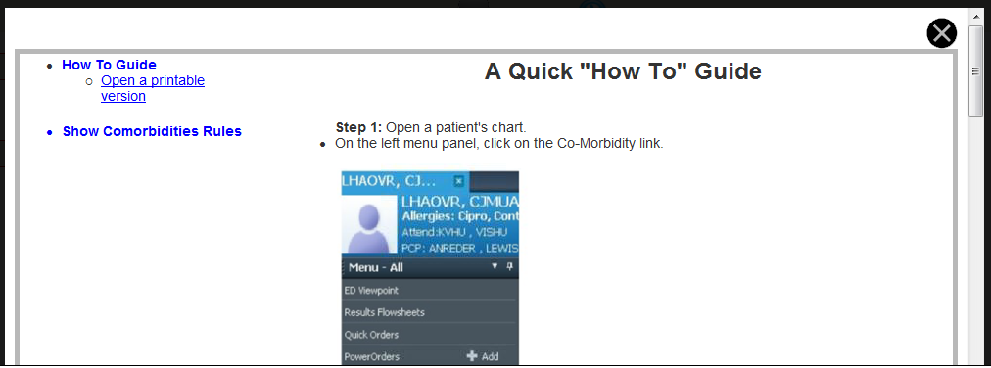

* Click on the **Open a printable version** to open a Microsoft Word document of the How To Guide.
  + A box will come up with a prompt to **Open**, **Save**, or **Cancel.**
  + Click **Open** to open the Word document in a printer-friendly format.

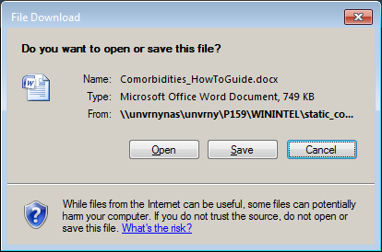

* Click on the **Show Comorbidities Rules** to display the list of comorbidities.
  + Click on any comorbidity to display the rules for that comorbidity on the right side.

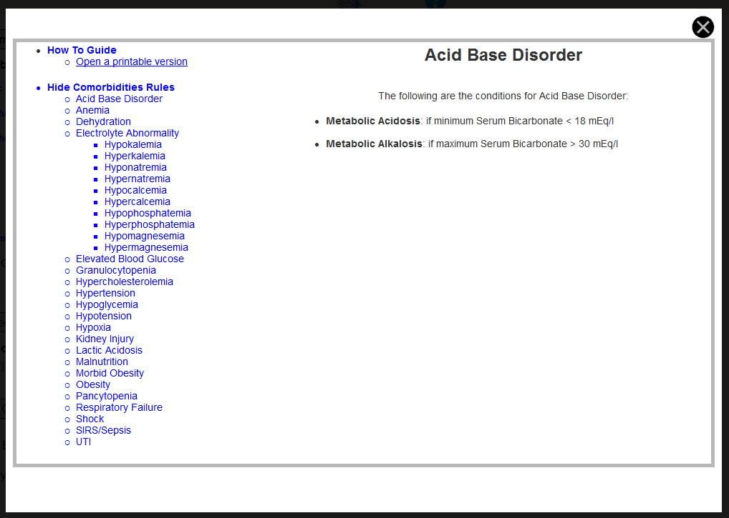

* When done, click on the Close Help icon on the top right of the help window and you will be taken back to the application.

