|  |
| --- |
| Comorbidities - ECG and Radiology  Documentation for the project  State University of New York at Stony Brook  Department of Computer Science  May 16, 2017 |

|  |
| --- |
| Table of Contents  **Abstract**3  **Project Access Instructions**3  **Flow Chart**12  **Detailed Functionality**12  Radiology.js 12  ECG.js 15  **Conclusion**17  **Future Work**17  **Links**17  Code Repository 17 |

# Abstract

Comorbidities are diagnosed using a set of rules that compare certain lab dictionary values against assigned threshold limits. In this project, the functionality was extended to include comorbidities derived from Radiology and EKG reports. The comorbidities in EKG and Radiology reports can be indicated by the presence of certain terms or phrases. A list of such terms and phrases (referred to as ‘search terms’) was prepared for various comorbidities. The reports were parsed to detect the search terms and the corresponding comorbidities were generated for display. A snippet of the report’s contents appears on hovering over the comorbidity to allow the doctors to make more informed decisions. The mouse-over display also includes links to the original reports and in the case of EKG, the images for EKG tracing. The parsing logic also includes basic connotation detection on search terms to present better results.

# Project Access Instructions

* 1. Connect to [ipsecvpn.uhmc.sunysb.edu](https://ipsecvpn.uhmc.sunysb.edu) using Cisco Anyconnect Security Mobility Client. Enter “iramakris” and “Dcba@@52” for the username and password fields respectively.

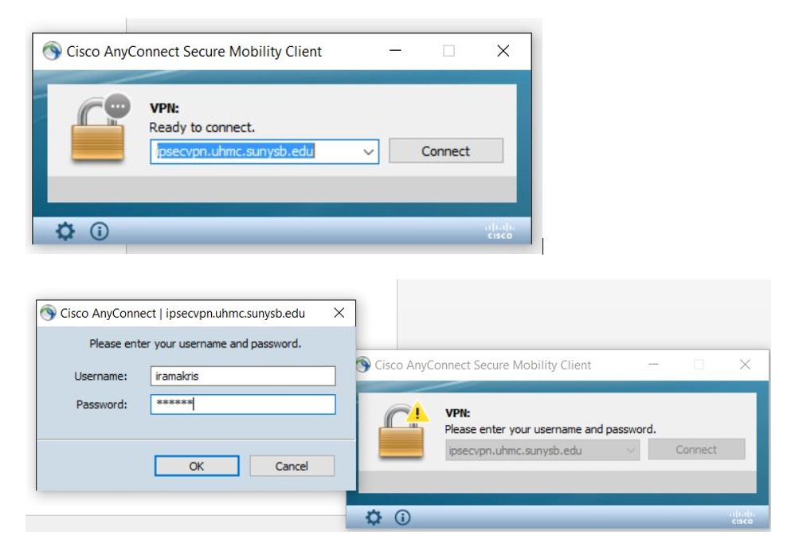

* 1. A Cisco AnyConnect dialog box appears that asks us to connect to Stony Brook Medicine VPN Connection. Click “Accept”.

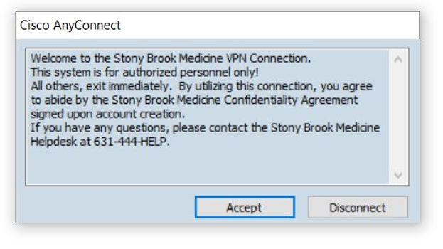

* 1. On the browser, enter the url: [https://uhmc-ctx-web.uhmc.sunysb.edu/Citrix/](https://uhmc-ctx-web.uhmc.sunysb.edu/Citrix/XenApp/auth/silentDetection.aspx)

[XenApp/auth/silentDetection.aspx](https://uhmc-ctx-web.uhmc.sunysb.edu/Citrix/XenApp/auth/silentDetection.aspx) A login prompt appears. Enter “iramakris” and “Dcba@@52” in the username and password fields respectively again to login into the application.

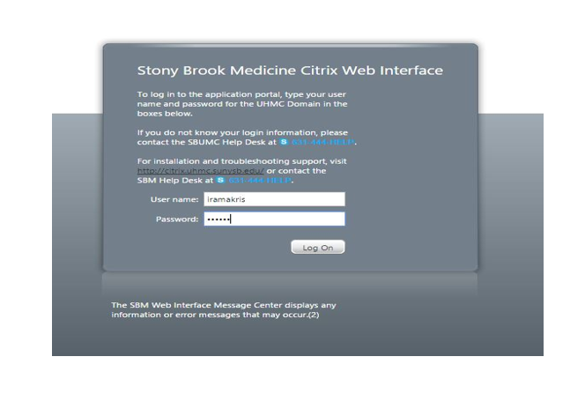

* 1. Click on the Cerner C159 folder.

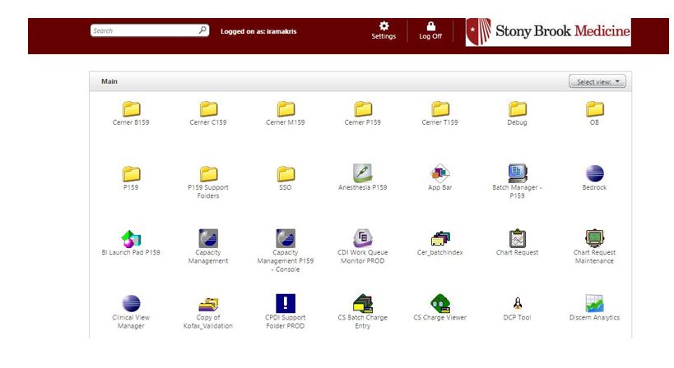

* 1. Click on the FirstNet C159 folder to gain access to the patient list.

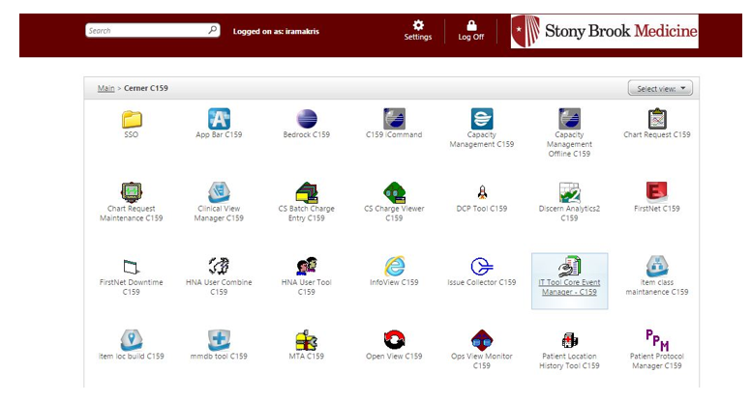

* 1. A launch.ica citrix receiver application gets downloaded. Click on it to run it. Make sure that the citrix receiver is running in the background.

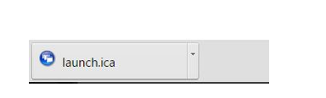

* 1. When prompted for username and password again on the C159 domain, enter “iramakris” and “ivfirstnet18” respectively to login (If you can’t login using the username and password, please don’t try more than 2 times, and contact professor for help).

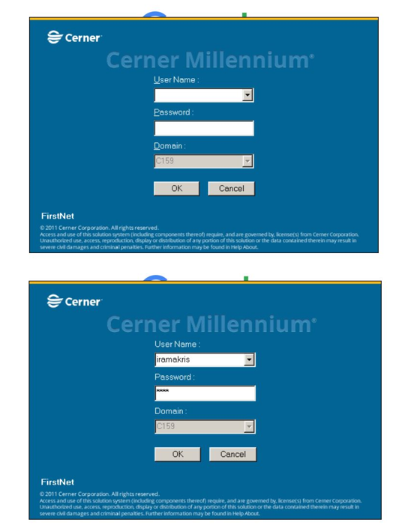

* 1. Enter “no” if asked to be checked in as an available provider.

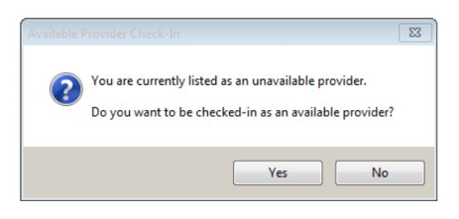

* 1. Click on the “patient list” column in the taskbar to gain the list of patients.

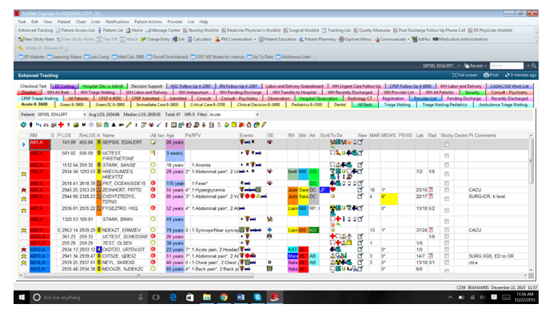

* 1. Once the patients list appears, click on 04L8-ED Acute Care. A list of patients shows up. Click on any patient whose details are to be accessed.

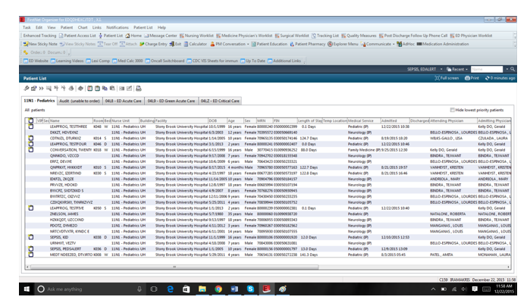

* 1. All the details associated to the patient is available. Double click on any patient record. Go to the Co-Morbidity (Radiology) folder, which is the last folder on the left hand side list of all available folders. If the encounter id being searched is not found among the list, go to the search icon at the top right of the screen. Type in the required encounter id as the “Account #” and search.

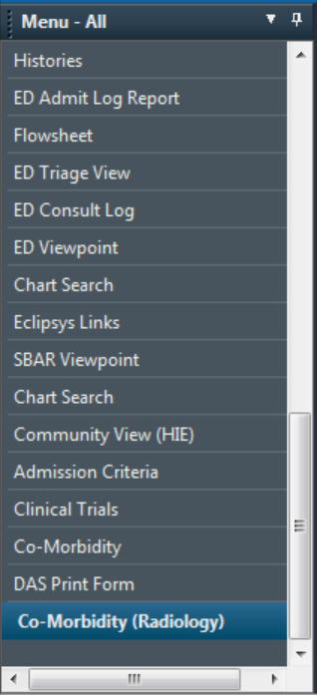

* 1. The various sections show the Computed Comorbidities present, Comorbidities from EKG and Comorbidities from Radiology Report. For example:

Encounter id: 70038372086

.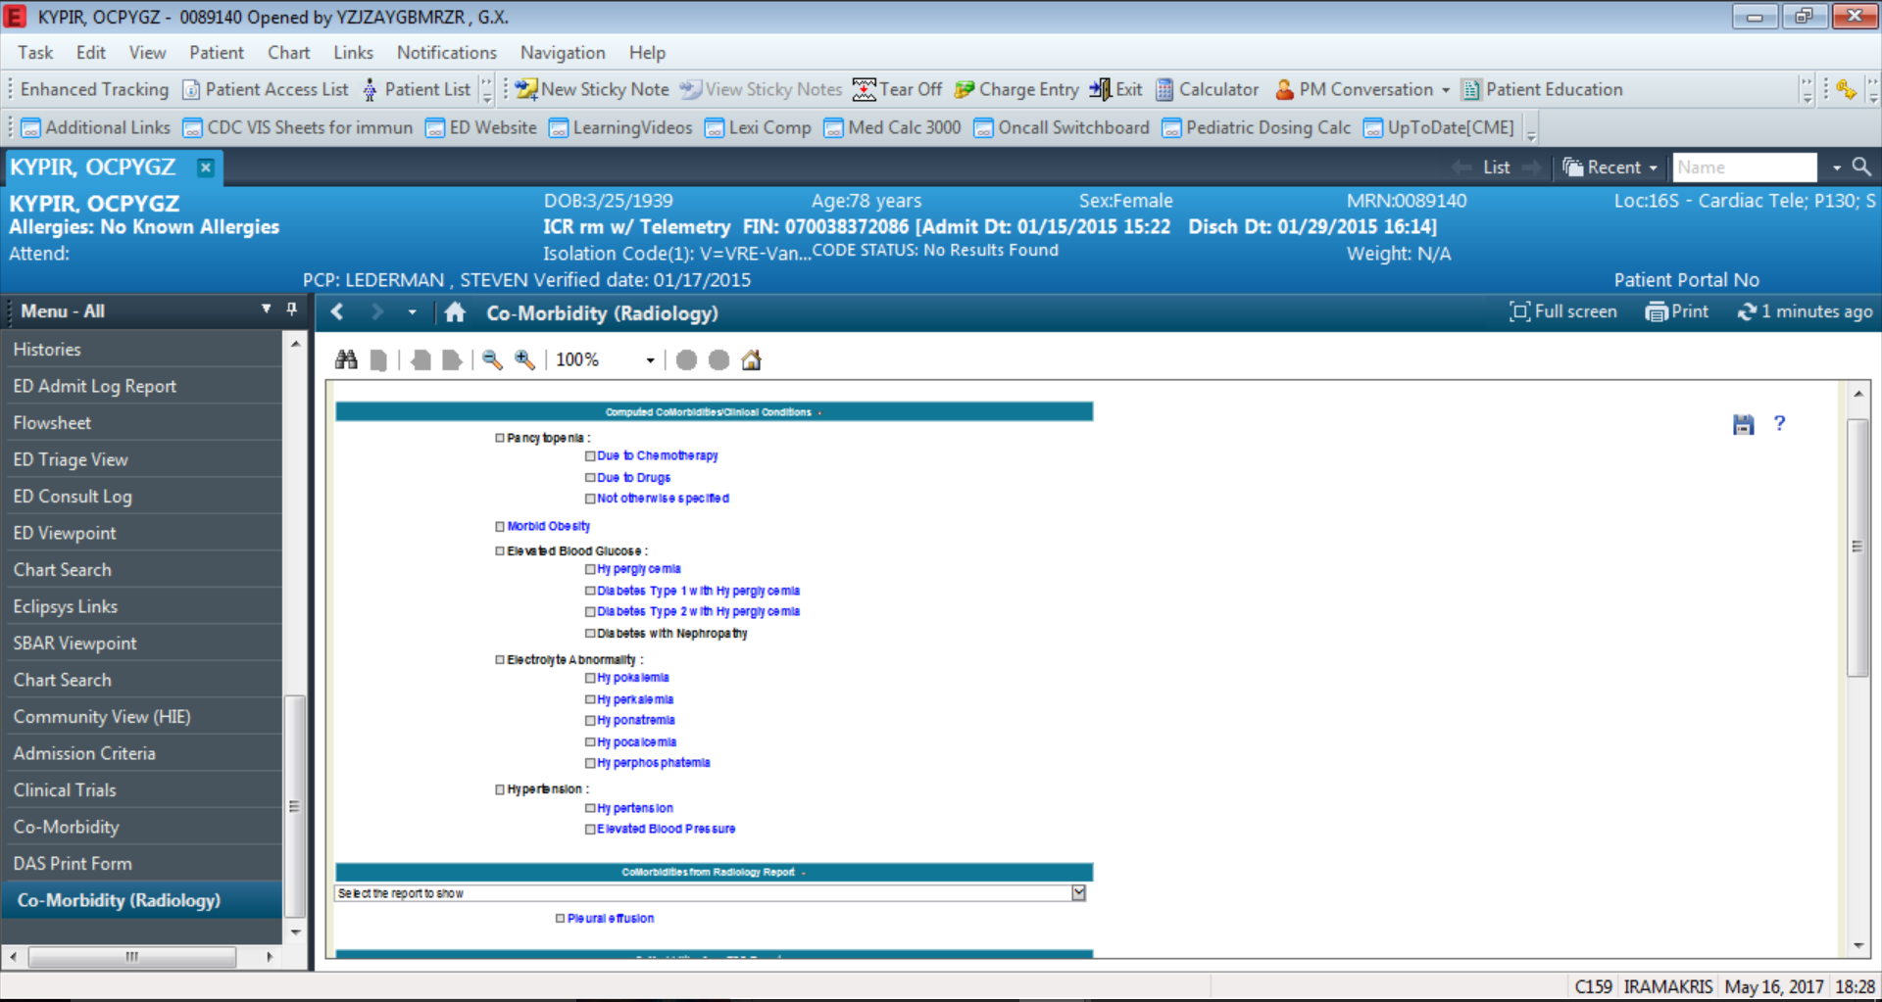

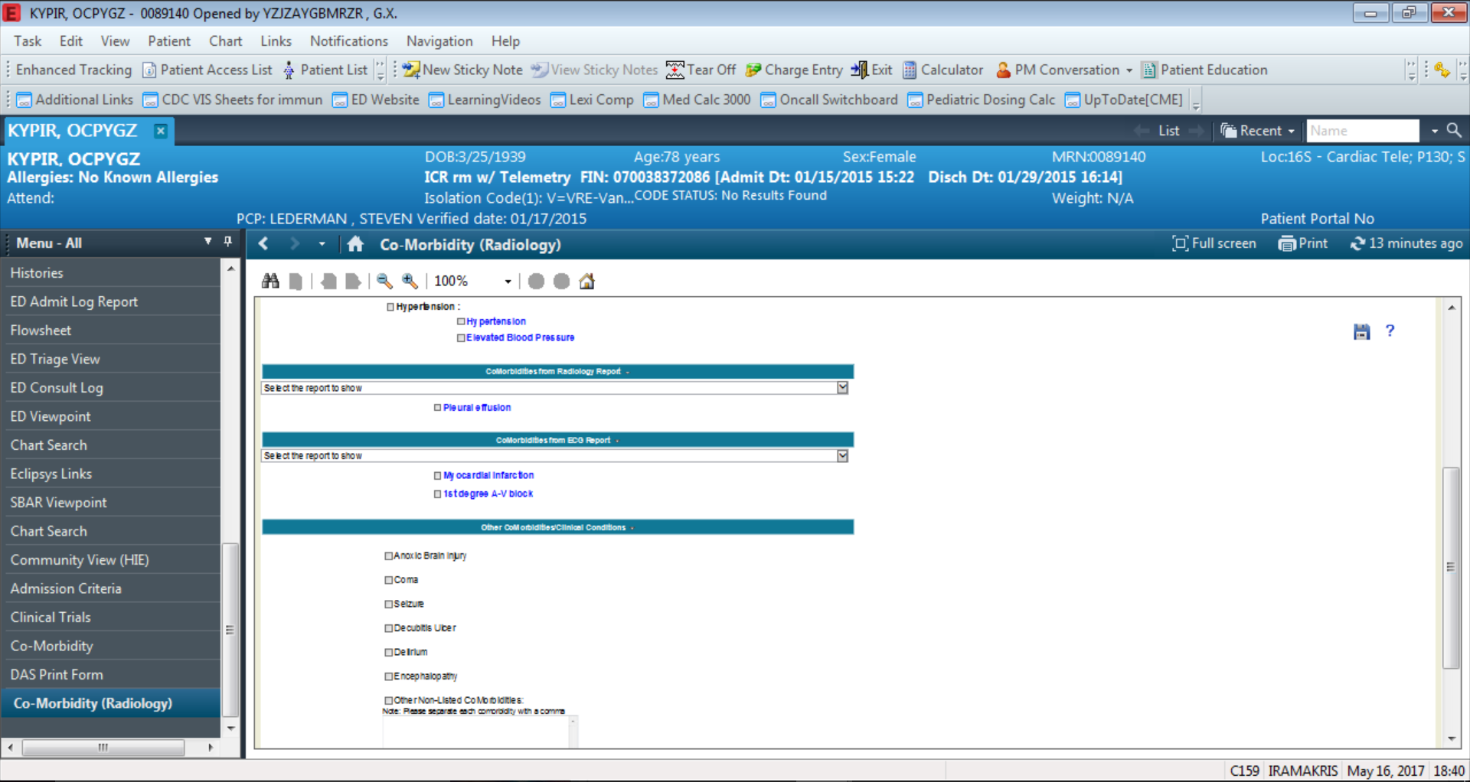

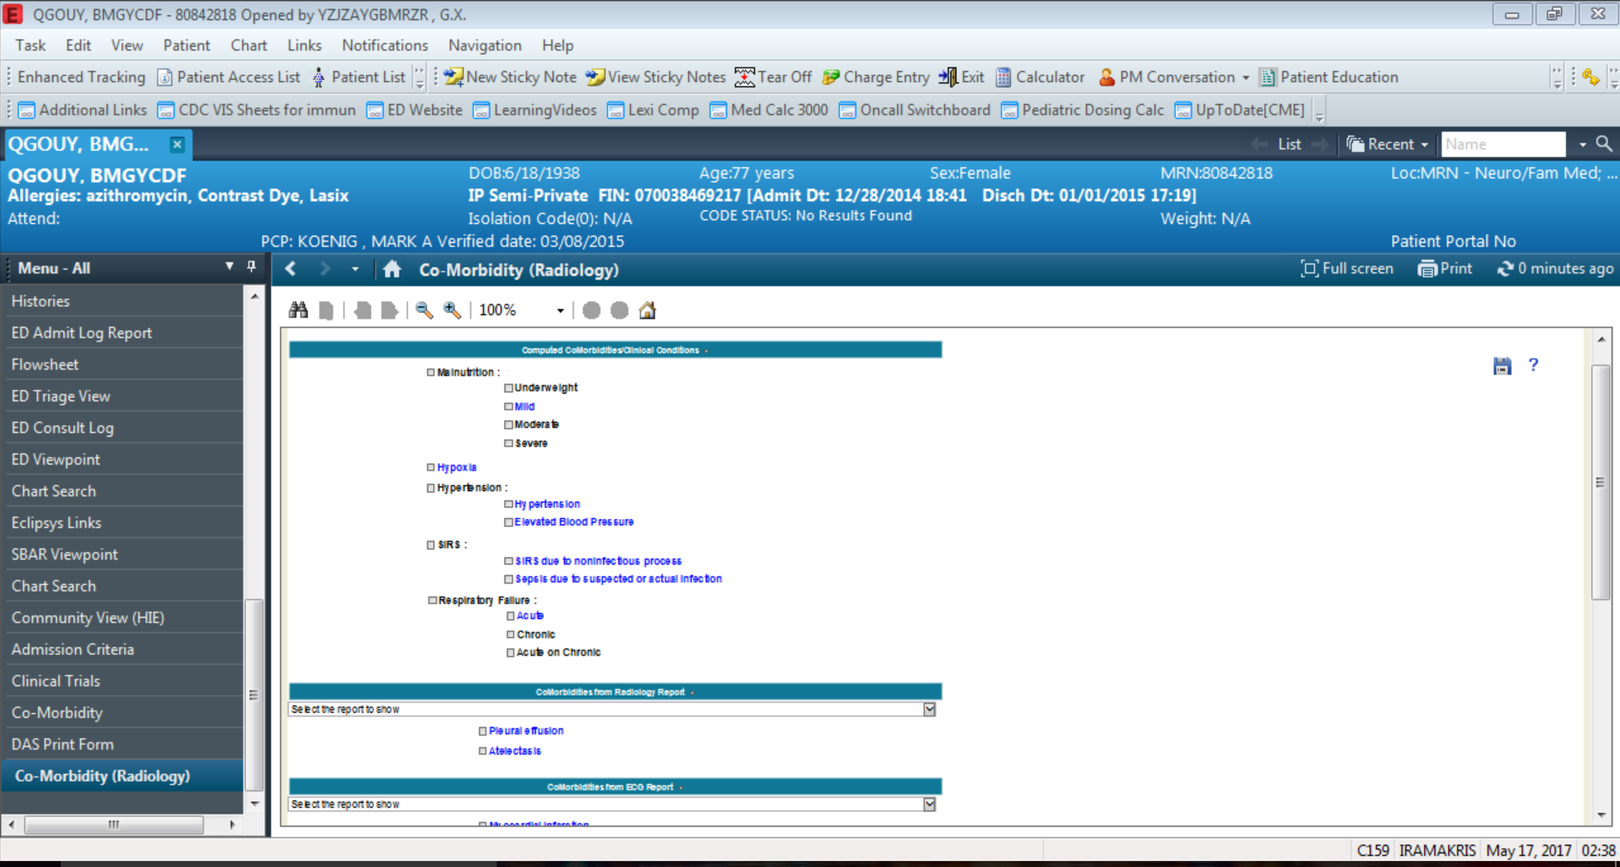

* 1. Hovering over any of the comorbidities shows the lab values, as well as the rule which was used to determine that this comorbidity is present.

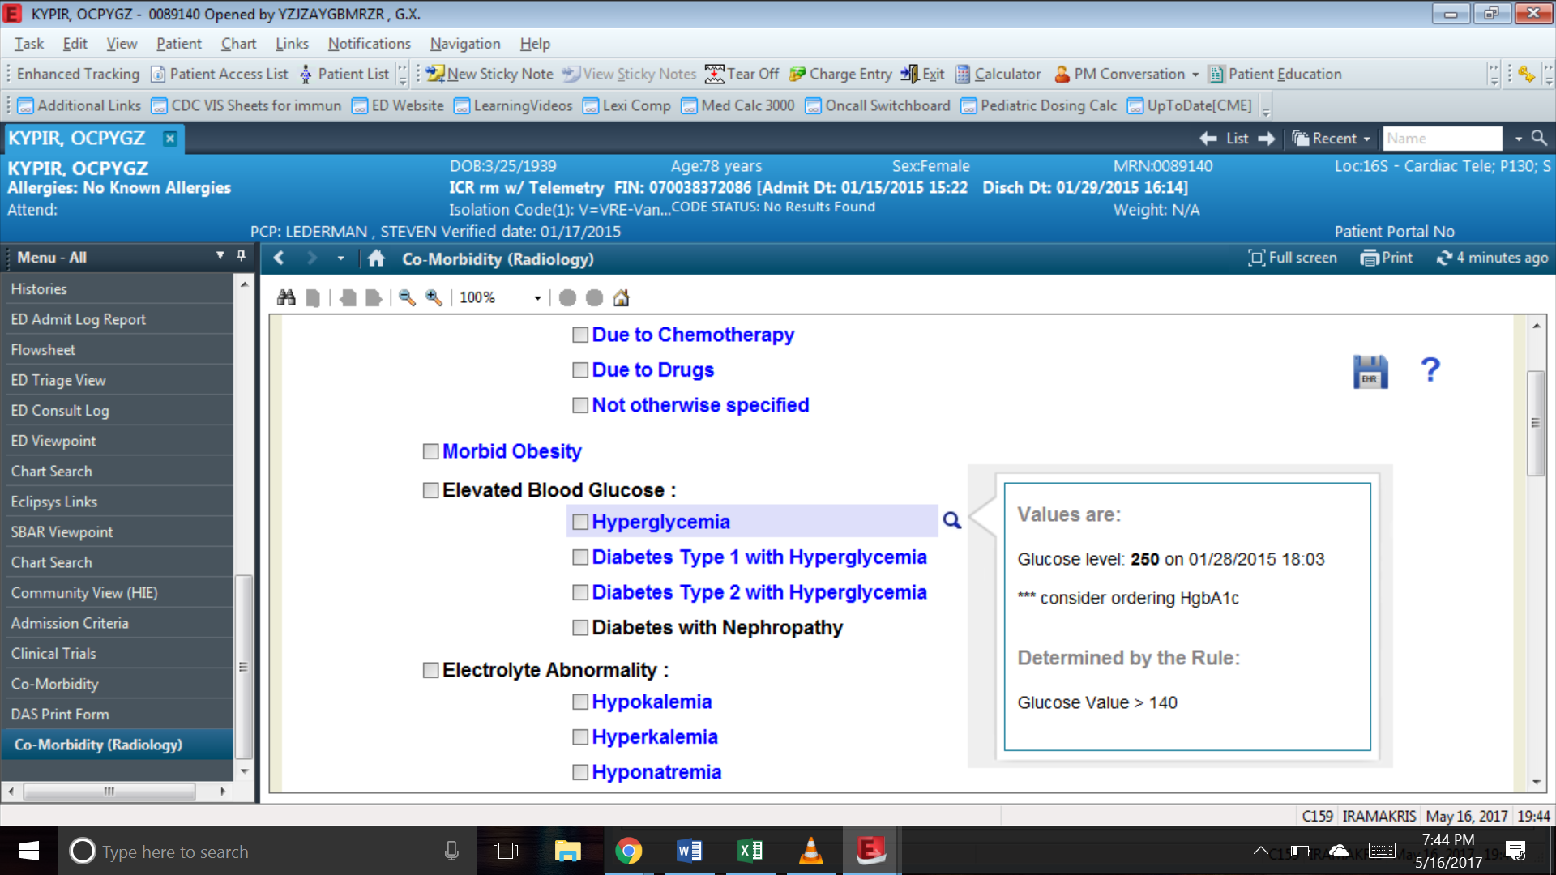

* 1. Check the ones that are appropriate (ones that need to be committed).

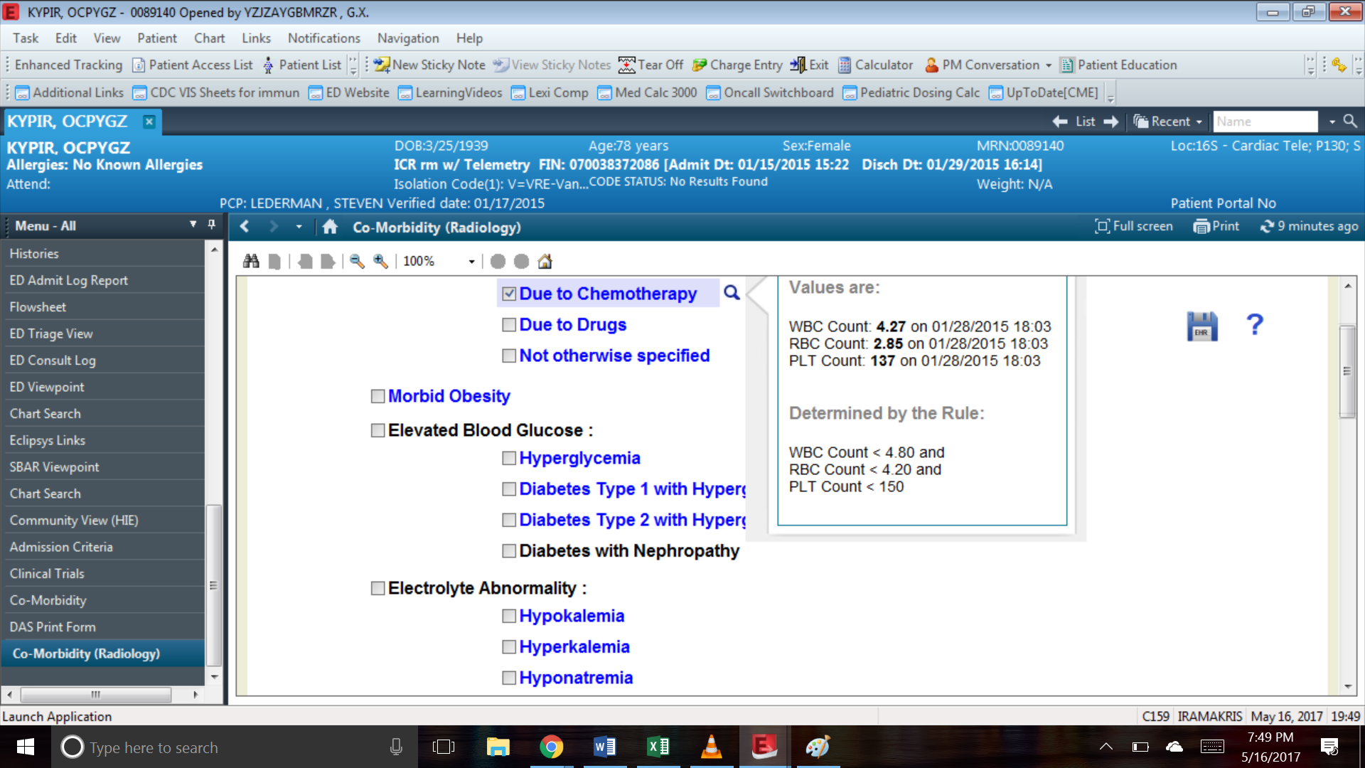

* 1. Click on the Save icon to commit the selection. The comorbidity committed will appear under a separate banner called Previously Committed Comorbidities.

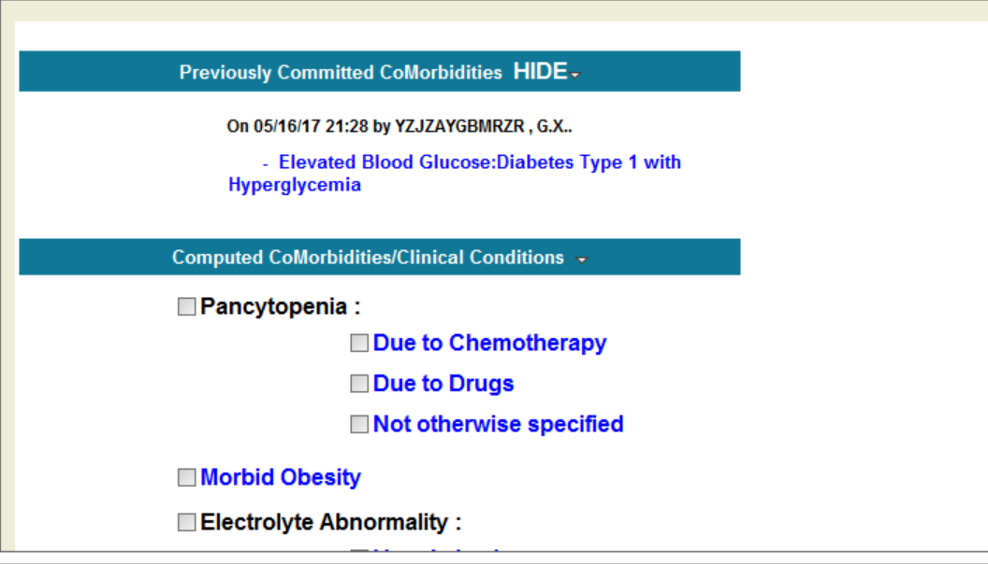

# Flow Chart

[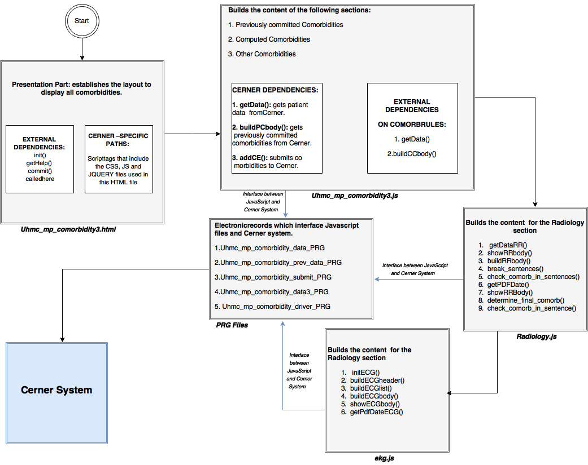](https://www.draw.io/#G0B9VNcKdpEvp_a0J2eVhNQzc5U0k)

# Detailed Functionality

## Radiology.js

This script is responsible for the parsing of Radiology reports and detecting the comorbidities present. This script invokes functions that parse the contents of Radiology reports in their entirety. Along with functions that generate displays for the comorbidities detected and the associated reports, the functions that perform the actual parsing and the detection of positive/negative connotations are defined here. It looks for search terms in categories : “Chest” , “Head, Brain”, “ECG” and “Abdomen”. The following are some of the important functions in this script :-

* **initRR(loadData):**

The initialization function for this script, it performs three important tasks:-

1. It sets up the rest of the functionality for Radiology report parsing and comorbidity detection by invoking buildRRlist(), buildRRheader() and showRRbody().
2. It invokes initECG(), the initialization function for ECG script.
3. It invokes getDataRR() which fetches the reports for further analysis.

* **buildRRheader():**

This function sets up and builds the header (i.e., the banner) that displays the text “Comorbidities from Radiology Report”.

* **buildRRlist():**

The buildRRlist function creates the drop-down list (using <select> tag) of Radiology reports that were fetched for the patient. The list displays the item - ‘No report’ if no Radiology reports were fetched.

* **buildRRbody():**

This is the core function that displays the comorbidities detected in the Radiology reports. It provides the following functionality:-

1. The contents of the Radiology reports are passed onto the functions - determine_final_comorb() and check_comorb_in_sentences(). These functions have been described later in this section. This step is performed for report contents under both ‘Impressions’ and ‘Findings’.
2. The result of the functions invoked above is a list of comorbidities that are present on a per-report basis. If no comorbidities are present then, the rest of the functionality described below does not apply and the display is left blank
3. The list of comorbidities will have no duplicates within
4. The list of comorbidities is setup for display along with checkboxes. The checkboxes can be ticked to commit the comorbidities.
5. For every comorbidity present, a small preview window is shown on mouse-over. This preview window shows the contents of the report that were parsed for search terms. This window disappears on mouse-out.
6. The text within the preview window has the highlighted search term corresponding to that comorbidity. The highlighting is done according to the following logic :- If no associated negative connotation is present, the first occurrence of the search term in a sentence gets highlighted. In cases where the search term is associated with both positive and negative connotation, then the search term with the positive connotation gets highlighted.
7. The links - Link to Report and the button Show Report are provided in the preview window. The links invoke JavaScript functions via the PRG file that show the original report for Radiology. However, it should be noted that this viewing windows uses a Cerner-specific viewer. The ‘Show Report’ button is used to view the report contents on the same page as described under showPDF() later in this section.

* **getDataRR():**

1. getDataRR() is responsible for issuing requests to the Cerner backend for EKG and Radiology report data.
2. The function issues a Cerner specific XMLCcl request to the Cerner backend. The PRG file uhmc_mp_comorbidity3_data can be examined to understand the response.
3. As a response, the data received is converted into JSON format, an array of objects with the fields - title, contents and link to report (for Radiology), title, contents, link to report and link to ECG tracing (for EKG).
4. The JSON is segregated on the basis of title - ECG or Radiology and various structures are populated in this function to store the content received.

* **showPDF():**

1. This function is invoked on clicking the ‘Show Report; button that is available through the preview window that appears on mouseover on the list of comorbidities present.
2. The showPDF sets the selection in the drop down list of the reports to the comorbidity and its associated report.
3. Moreover, it displays the important sections of the report contents. The search terms are highlighted in this section as well. The highlighting is done according to the following logic :- If no associated negative connotation is present, the first occurrence of the search term in a sentence gets highlighted. In cases where the search term is associated with both positive and negative connotation, then the search term with the positive connotation gets highlighted.
4. This function is used by both the Radiology and ECG scripts. The functionality is similar in both the cases with the observable difference being the extra ‘Link to ECG Tracing’ in the case of ECG.

* **transform_report():**

This function is applicable only to Radiology reports and is used to separate out the title, findings and impression from the report contents. This is done since impressions and findings are parsed separately when checking for comorbidities.

* **getPdfDate():**

It breaks the entire content into separate sentences. Then sentences are then split by "Electronically Signed On" so as to return the date on the report. The date of the report is extracted in this function. This date is used by buildRRbody() and buildRRlist().

* **showRRbody():**

Invoked from the initializing function, this in turn invokes buildRRbody().

* **determine_final_comorb():**

The method checks for each search term in all the sentences of the report. If the entire search term is present in the sentence , then the corresponding search object from the search terms json array is added to the return array object. The search terms are no longer split into individual words before a search in the report contents.

* **check_comob_in_sentences():**

The method checks if a given comorbidity (passed as argument) is present in the sentences (also passed as argument).

1. If the comorbidity is present ONLY in negative connotation, it is not considered(not pushed to be printed).
2. If the comorbidity is present in ONLY positive connotation, the comorbidity is not considered (not pushed to be displayed as present).
3. If the comorbidity is not found in the sentences at all, it is not considered (not pushed to be printed).
4. If it is determined to be present in a negative connotation associated with the comorbidity AS WELL AS a positive connotation, the comorbidity is pushed (to be displayed as present).

## ECG.js

This script is responsible for the parsing of EKG reports and detecting the comorbidities present. This script invokes functions that parse the contents of EKG reports in their entirety. However, this is mainly involved in generating displays for the comorbidities detected and the associated reports. The following are some of the important functions in this script :-

* **initECG():**

The initialization function for this script, it is invoked from Radiology.js - initRR(). It invokes buildECGheader(), buildECGlist() and showECGbody() that set up the banners, drop-down menus for reports and the display associated with comorbidities present (if any).

* **buildECGheader():**

This function sets up and builds the header (i.e., the banner) that displays the text “Comorbidities from ECG Report”.

* **buildECGlist():**

The buildECGlist function creates the drop-down list (using <select> tag) of EKG reports that were fetched for the patient. The list displays the item - ‘No report’ if there were no EKG reports fetched.

* **buildECGbody():**

The core function in this script, it performs the following :-

1. The contents of the EKG report are passed onto the functions - determine_final_comorb() and check_comorb_in_sentences(). These functions have been described under Radiology.js
2. The result of the functions invoked above is a list of comorbidities that are present on a per-report basis. If no comorbidities are present then, the rest of the functionality described below does not apply and the display is left blank
3. The list of comorbidities is setup for display along with checkboxes. The checkboxes can be ticked to commit the comorbidities.
4. For every comorbidity present, a small preview window is shown on mouse-over. This preview window shows the contents of the report that were parsed for search terms. This window disappears on mouse-out.
5. The text within the preview window has the highlighted search term corresponding to that comorbidity. The highlighting is done according to the following logic :- If no associated negative connotation is present, the first occurrence of the search term in a sentence gets highlighted. In cases where the search term is associated with both positive and negative connotation, then the search term with the positive connotation gets highlighted.
6. The links - Link to Report, Link to ECG Tracing and the button Show Report are provided in the preview window. The links invoke JavaScript functions via the PRG file that show the original report for ECG and the associated ECG tracing images. It should be noted however that both these viewing windows use Cerner-specific viewer and the Muse system respectively. The ‘Show Report’ button is used to view the report contents on the same page.

* **showECGbody():**

Invoked from the initializing function, this in turn invokes buildECGbody().

* **getPdfDateECG():**

It breaks the entire content into separate sentences. Then sentences are then split by "Confirmed by" and "on" so as to return the date on the report. The date of the report is extracted in this function. This date is used by buildECGbody() and buildECGlist().

# Conclusion

The comorbidity detection in EKG and Radiology reports has been successfully implemented and demonstrated. EKG and Radiology reports were parsed and checked for search terms that indicated comorbidities. The positive or negative connotations of the search terms were also taken into account during detection of comorbidities. The codebase has been tested against report data for several patient records and is currently in use on production servers. Several modifications were made to the codebase and the current system is stable and provides the required functionalities.

# Future Work

In the future we hope to implement the following in our application:

* The current system detects comorbidities from ECG and Radiology reports, we will enhance and extend the functionality of the system to check and display the comorbidities from Echo reports as well to detect comorbidities like Pericardial Effusion, Ejection Fraction, Cardiomyopathy etc.
* We wish to improve the existing logic to detect the correct comorbidity even if the comorbidity itself is observed in a report of a different category. For example, if a chest abnormality is observed in a head CT, (since a head CT image contains some part of the chest), the radiologist reports the abnormality. Currently this will be considered under the category “Head” or “Brain” (since the actual report is a head CT) but we wish to modify the code to that it recognizes this case as a comorbidity of the “Chest” category.

# Links

### Code Repository

Path: [**SBComorbidity**](https://bitbucket.org/hbusireddy/sbcomorbidity/src/f310b4af66f0?at=master)**/[cernerrulebuilder](https://bitbucket.org/hbusireddy/sbcomorbidity/src/f310b4af66f0/cernerrulebuilder/?at=master)/Comorbidity_Radiology/**

**at** [**https://bitbucket.org/ hbusireddy/sbcomorbidity**](https://bitbucket.org/)