10/7/2018

Stephen White

**Wikipedia Contribution**

CS 499: Open Source Software

Instructor: Igor Steinmacher

I made a contribution to the wiki page on Computer Science at the following link:

(<https://en.wikipedia.org/wiki/Computer_science#Programming_Paradigms>)

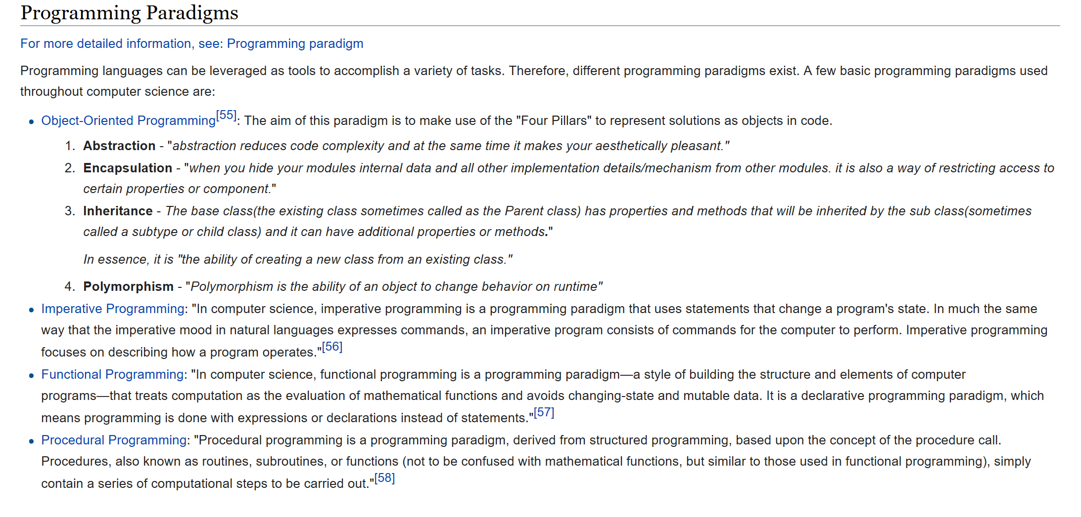My contribution was aimed at introducing visitors to four basic programming paradigms (Object-Oriented, Imperative, Functional, and Procedural). I provided external links for users to learn more about the topics, but I figured a small section on programming paradigms would be a good addition to the computer science page! It appears that my addition has been accepted as of this time (it may be going through review), but below is a screenshot of my addition!