Age Prediction Analysis

Kevin Wall
Emerging Technologies - Computer Science Masters
Full Sail Univeristy
Winter Park, FL, USA
kpwall@student.fullsail.edu

Abstract— Explored is a lightweight real-time age prediction application that works with both live webcam input and static images. The system uses a Haar Cascade classifier to detect faces and a pre-trained deep neural network, implemented through OpenCV’s DNN module, to estimate age ranges. Testing showed that the system can reliably detect frontal faces and provide reasonable age group estimates under typical indoor conditions. Although the accuracy of age prediction can vary in less ideal scenarios, the results demonstrate that real-time age estimation can be achieved efficiently on consumer-grade hardware. This project highlights the balance between performance, simplicity, and accuracy, and serves as a foundation for further exploration in lightweight computer vision applications
Keywords— Object detection, face recognition, Haar Cascade, MobileNet-SSD, OpenCV, real-time detection, age estimation, tkinter, consumer hardware

Introduction
Face Detection is widely used across the world in forms of security and analysis. Coming in all shapes and sizes from CCTV Cameras to grocery store self-checkout kiosks, face detection systems help identify human presence and improve system efficiency. For example, kiosks can enter sleep mode when no human is detected and activate when someone enters the frame, conserving electricity [1]. Security systems can track who comes in and leaves a premise in case of illegal activities to help police solve incidents and crimes if they occur.
While the detection of faces can be a bit easier to solve, age prediction can be a bit more difficult. Ascertaining the age of someone through a photograph can be challenging due to many factors such as lighting, shadows, facial orientation, and image quality. To address these challenges, a lightweight application capable of detecting faces and estimating age in real-time is proposed.
In this work, I implement a basic real-time age detection application that can analyze both static images and live webcam feeds. The system detects faces using a Haar Cascade algorithm and predicts the age using a pre-trained Caffe deep neural network model. The application demonstrates that lightweight, real-time face detection and age estimation can be achieved on standard hardware with limited system resources.

Related Works
Face detection studies have been conducted in the past with studies on Haar Cascade classifiers and Deep Learning algorithms using convolutional neural networks (CNNs) [2]. Haar Cascade remains popular for real-time applications due to how inexpensive for computing it is and the ease of implementing it. As modern hardware becomes increasingly more expensive, cost-effective solutions that can run on consumer grade equipment.
Age estimation from facial images is much more challenging since it often uses deep learning models that are trained on much larger data sets than what face models are trained on. Typically these models use categorical grouping to help classify ages in a range instead of estimating an exact age. Caffe models like age_net are used for practical applications with the ease of implementation and performance benefits.

System Design
The application is designed to use the webcam if one is present and give users an option to alternate and analyze images stored locally on their device. This helps users switch between a live and static scenario which can help fine tune model predictions.
The system architecture is divided into three primary components, implemented across three Python files: main.py, detection.py, and gui.py. By abstracting the functionality we can improve maintainability, allowing the detection logic to perform isolated logic from the user interface.
The core processing logic resides in detection.py. This class is responsible for acquiring input from the webcam or loading images from the disk, processing the frames, detecting faces, and performing an age estimation based on that input. Face detection is handled using a Haar Cascade model, which operates on a grayscale version of the input to identify facial regions. Once a face is detected, the corresponding image region is passed to the age estimation model, which predicts an age range using pre-trained deep neural network weights. The detection module returns annotated frames containing bounding boxes and age labels.
The graphical user interface (GUI) is implemented in gui.py using the tkinter module. The GUI provides user controls for switching between webcam and locally saved images while also being responsible for displaying the processed video frames. The GUI uses updated frames from the detection module, showing real-time visualization. Detected faces are highlighted with bounding boxes, and estimated age ranges are rendered as text overlays above each detected face.

Face Detection Method
Face detection operates on image frames captured from either a live webcam feed or a loaded image from the disk. Input frames are initially represented in BGR color format as provided by OpenCV. Prior to detection, each frame is converted to grayscale to reduce computational complexity and improve detection stability.
Face detection is performed using a Haar Cascade classifier trained on frontal face features; e.g. nose, eyes, mouth. The classifier scans the grayscale image at multiple scales and locations to identify regions that match predefined Haar-like feature patterns associated with human faces. A cascade structure is used to quickly discard non-face regions, allowing the system to operate quickly in real-time scenarios.

Detection accuracy is influenced by factors such as scale variation, minimum neighbor thresholds, lighting conditions, and facial orientation. In this project, parameters were selected to balance detection sensitivity while reducing the chances for false-positives.

Age Estimation
Age estimation is performed using a pre-trained deep neural network model loaded through OpenCV’s DNN module. The model is based on the Caffe framework and is designed to classify facial images into predefined age ranges rather than predicting an exact numerical age.
For each detected face, the corresponding image region is extracted from the original frame and resized to a fixed resolution of 227 x 227 pixels. The face image is then converted into a blob which age_net will be able to utilize in estimating the ages of the detected faces.
The model outputs probabilities across eight age categories:
- 0-2
- 4-6
- 8-12
- 15-20
- 25-32
- 38-43
- 48-53
- 60-100
The age group with the highest probability score is selected as the final prediction and displayed on GUIs output frame. Using categorical age ranges improves estimation counts and reduces prediction errors caused by ambiguity between closely related ages.

Implementation Details
The application was created in Python using OpenCV for computer vision operations and tkinter for the GUI. The OpenCV library is used for video capture, image preprocessing, face detection, and neural network. The tkinter module provides a lightweight framework for rendering video frames and handling user interaction.
Real-time processing is achieved by continuously capturing frames from the webcam and passing them through the detection pipeline. Frames denoted with bounding boxes and age labels are returned to the GUI module for display. The system is designed to operate on consumer-grade hardware without reliance on specialized equipment.

Experimental Results
The system was evaluated using both live webcam input and static images under typical indoor lighting conditions. The face detection module successfully identified frontal faces in real time, with consistent bounding box placement across consecutive frames. Age estimation results were generally stable across frames, although minor fluctuations were observed due to lighting changes and facial movement.
Static image testing demonstrated reliable face detection and age classification when faces were clearly visible and well-lit. These results indicate that the system is capable of performing real-time age estimation with acceptable accuracy for non-critical applications.
File | Results
File | Name | Age (when taken) | Age Range Estimation
W_AP1 | Kevin Wall | 22 | 25-32
W_AP2 | Chris Pratt | 35 | 25-32
W_AP3 | Morgan Freeman | 76 | 38-43
W_AP4 | Tom Hanks | 48 | 38-43
W_AP5 | Princess Diana | 52 | 8-12

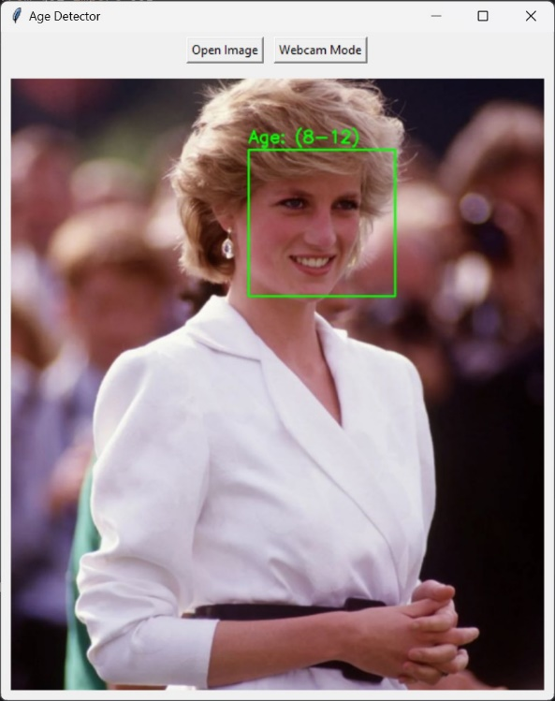
- Princess Diana on her 52nd Birthday [3].
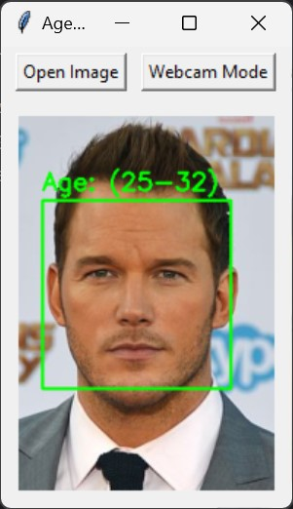
- Chris Pratt at the Guardians of the Galaxy Premier [4].

Limitations and Future Work
While the system successfully detects faces and estimates age in real time, the accuracy of age prediction was not always consistent. Variations in lighting, shadows, and facial orientation often affected models estimates, particularly when faces were viewed at an angle or under uneven lighting conditions. In some cases, these factors caused the age estimation to fluctuate between adjacent age ranges. This behavior shows that visual age estimation can be difficult when relying solely on facial appearance.
Another limitation of this project is the reliance on a pre-trained age estimation model. Since the model was not trained or fine-tuned on a custom dataset, its predictions are constrained by the quality, diversity, and bias present in the original training data. Additionally, the small number of test images and limited testing scenarios restrict the ability to fully evaluate the model’s overall accuracy and generalization capabilities.
Future work could focus on improving detection by replacing the Haar Cascade detector with a deep-learning-based face detection approach that better handles non-frontal faces and occlusions. Age estimation accuracy could also be improved by incorporating more advanced models trained on larger and more diverse datasets or by fine-tuning an existing model using additional training samples. Further niche enhancements may include improving GUI responsiveness and adding performance metrics to better evaluate system accuracy under varying conditions.

Conclusion
This project demonstrated the development of a lightweight real-time age prediction application capable of processing both live webcam input and static images. By combining a Haar Cascade-based face detection approach with a pre-trained deep neural network for age estimation, the system provides a practical example of how facial analysis techniques can be implemented efficiently on consumer-grade hardware.
Although the system has limitations in accuracy under certain conditions, it successfully illustrates the trade-offs between performance, simplicity, and computational cost. The results show that real-time face detection and age estimation can be achieved without requiring high end, complex, or specialized hardware. Overall, this project served as a strong foundation for age detection implementation and further experimentation with computer vision applications.

References
- L. Huefner, “The Business Benefits of Facial Recognition Kiosks | KIOSK,” KIOSK Information Systems, Oct. 09, 2023. https://kiosk.com/facial-recognition-kiosk/
- S. Shaban, R. P. Singh, and Dr. M. Mehra, “Age and Gender Prediction using Caffe Model and OpenCV,” International Journal of Innovative Research in Computer Science & Technology, pp. 15–21, Jan. 2022, doi: https://doi.org/10.55524/ijircst.2022.10.1.4.
- Glamour.com, 2025. https://media.glamour.com/photos/569632b5d9dab9ff41b532ec/master/w_1600 (accessed Dec. 14, 2025).
- C. to, “Chris Pratt,” Wikipedia.org, Jan. 17, 2015. https://sco.wikipedia.org/wiki/Chris_Pratt#/media/File:Chris_Pratt_-_Guardians_of_the_Galaxy_premiere_-_July_2014_(cropped).jpg (accessed Dec. 14, 2025).
- Gettyimages.com, 2025. https://media.gettyimages.com/id/150316969/photo/tom-hanks-readers-digest-june-1-2005.jpg?s=2048x2048&w=gi&k=20&c=4p2YydmwAISxm5pNgYBwu4mqAzI1DPMtVfxe1xebBOM= (accessed Dec. 14, 2025).
- Nocookie.net, 2025. https://static.wikia.nocookie.net/nowyouseeme/images/5/53/Morgan_Freeman.jpeg/revision/latest?cb=20250308153121 .

