GPT Chatbot Analysis

Kevin Wall
Emerging Technologies - Computer Science Masters
Full Sail Univeristy
Winter Park, FL, USA
kpwall@student.fullsail.edu

Abstract— .
Keywords—

Introduction
Chatbots have become an important tool for automating communication and providing quick access to information. Consumer websites are more commonly featuring chatbots to try and help users find the product they are looking for. This project aims to build a chatbot that can understand user questions, provide accurate responses, and offer a simple, interactive interface. The goal is to create a system that is both effective and safe for users, while being flexible enough to handle a variety of prompts.

System Overview
The chatbot is built as a web service using FastAPI [1], providing real-time responses via the REST API. The main components are:

Web Interface and Request Handling
Users interact with the chatbot through a locally hosted HTML page. Messages are sent to the /chat endpoint as JSON, including the text and a session ID. Each session keeps track of the conversation history for multi-turn dialogue. A default session is provided to keep user prompt stored locally.

Conversation Management
Conversations are stored in memory using a dictionary keyed by session ID. Each session starts with a prompt by the user and stores both user inputs and assistant responses for later context/retrieval.

Input Validation and Safety
User messages are filtered through a safety module before being sent to the language model to prevent harmful or inappropriate content. Content like Social Security Numbers, Phone Numbers, and passwords are filtered out.

NLP and Custom Tools
The assistant uses the OpenAI GPT API [2] for generating responses. It can also call external tools, such as getting weather in the United States of America, looking up a knowledge base, or retrieving global population data. Tool outputs are included in the conversation and returned to the user seamlessly.

Logging and Metrics
All interactions are logged to a JSON file, including user and assistant messages, latency, token usage, cost, and tool calls. This supports debugging, evaluation, and performance monitoring.

Performance
Asynchronous calls are used for I/O-bound tools to reduce response time. Overall, the modular design allows easy addition of new tools, safety checks, or interface updates.
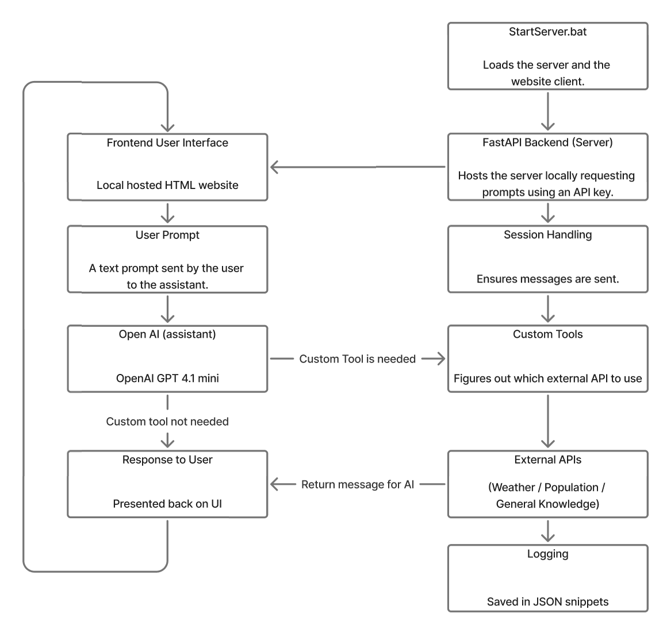
- A high level system diagram of the proposed chatbot.

Tools and Implementation
The chatbot is implemented in Python and uses several libraries and modules:

General Modules & Libraries
- FastAPI: Runs server logic regarding API requests and user prompts.
- HTML/CSS/JavaScript: Local website (127.0.0.1:8000) acting as an interface for the chatbot.
- OpenAI API: GPT-4.1-mini
- JSON Logging: metrics like latency and prompts are saved in JSON format.

Custom Helper Modules
- tools.py defines functions for tasks such as retrieving weather or population data.
- customlog.py handles logging of conversation turns, latency, token usage, and tool calls.
- customsafety.py validates and filters user messages to prevent unsafe content.

Evaluation
The chatbot was tested with 30 questions using PyTest [3]. Prompts covering greetings, factual knowledge, tool-based prompts, follow-ups, numerical reasoning, small talk, and unsafe or invalid requests were used due to how common they are and can be easily verified.
For tool-based prompts like weather and population, the chatbot was able to identify locations within the United States of America regarding weather, and globally for any population request if the location was given. General knowledge questions were attempted and often answered by the model, and follow-up questions used the conversation history effectively [4].
Unsafe or malicious inputs, such as hacking instructions or bomb-making prompts, were blocked by the safety filter. Invalid or nonsensical prompts were handled gracefully, with the chatbot providing fallback responses or posting the prompted errors instead of crashing. Often crashes would be caused by prompts the chatbot was unable to solve or answer given the toolset in 30 seconds. A timeout was set for this reason to ensure that the chatbot would answer quickly if possible.
Everyday questions, like fun facts, simple math, jokes, and common knowledge, were answered as best and fitting as possible. Overall, the evaluation showed the chatbot performs reliably, safely, and consistently across a wide range of prompts, with proper use of tools and context handling.

Safety and Ethical Considerations
The chatbot includes multiple safeguards to ensure safe and responsible usage from any user. All user prompts are passed through a validation method, which blocks unsafe or harmful content. This includes words related to hacking, violence, or explicit language. Unsafe messages result in a clear error response and are never sent to the model.
Sensitive information such as credit card numbers, API keys, or social security numbers is automatically redacted using regular expressions before being processed. This helps prevent the exposure of private data, even if accidentally. Regular expressions were used in varying formats to cover a wide range of potential “hacks” [5].
Invalid, nonsensical, or malicious prompts are handled safely by using fallback messages provided instead of processing them. This prevents crashes or unintended behavior. The system does not store sensitive personal data beyond the conversation logs used for metrics and debugging. When logging occurs, it uses the filtered messages to ensure privacy.

Error Analysis
Upon reviewing the unit test results, the main source of errors was caused by external API failures, unknown prompts, or missing data. With external APIs, timeouts or unavailable data caused errors for some weather or population prompts. For unknown prompts returning a safe fallback message was used which happened mainly when it could not process the prompt or the prompt was out-of-scope. Some general knowledge questions could not be answered fully, which lead to responses like “Sorry, I don’t know.”
Despite these issues, the safety system consistently blocked unsafe content, and all errors were handled gracefully without crashing the server. Logging helped in tracking latency, tool usage, and prompts, which can be used to improve future iterations, performance, and reliability.
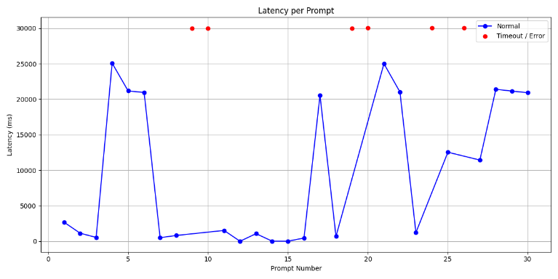
- Latency per prompt given. Red datapoints indicate an error or timeout.
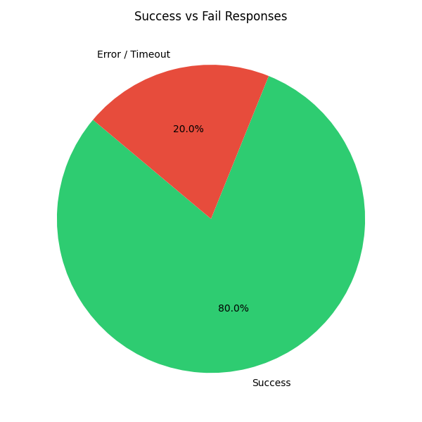
- Pie chart showcasing prompts responses being a success or error/timeout.

Discussion
The test results show several points about the chatbots’ performance and potential areas for improvement. The system demonstrates strong reliability for regular prompts and shows effective handling and proper use of custom tools. Latency analysis indicates that most standard prompts are processed quickly, but external API calls introduce variability, especially for prompts that are unobtainable like international weather.
While the safety mechanisms prevent unsafe content from being processed, the strict filtering can occasionally reject ambiguous prompts that users may not intend to give similar information. Timeout errors reveal a dependency on third-party APIs that could potentially be fixed by using a local database for non-modern requests like historical figures. Additionally, the chatbot performs better on structured questions than on vague or random prompts.
The chatbot performs effectively within the defined scope, but extending it to improve error recovery, and refine prompt interpretation could further enhance the user’s experience.

Conclusion
This project shows that creating a safe and flexible chatbot is possible by using a modular setup with custom tools and metric logging. The bot can answer everyday questions and stay safe by filtering sensitive content and automatically removing any secrets it encounters.
Overall, the chatbot works well across many types of prompts, though there are still a few limitations. When outside APIs don’t respond as expected or when user prompts are unclear it can become an issue presenting information the user requested. In the future, the chatbot could be improved by adding broader global weather support, responding clearer when errors appear via fallback responses, and enhancing language understanding for even smoother conversations.
By using custom tools, real-time logging, and safety checks, this chatbot project has the potential to be used for more advanced and responsible conversational AI systems.

References
- “FastAPI,” fastapi.tiangolo.com. https://fastapi.tiangolo.com
- OpenAI, “OpenAI Platform,” Openai.com, 2024. https://platform.openai.com/docs/overview
- Pytest, “pytest: helps you write better programs — pytest documentation,” docs.pytest.org, 2015. https://docs.pytest.org/en/stable/
- “Python Testing with pytest, Second Edition,” Pragprog.com, 2022. https://pragprog.com/titles/bopytest2/python-testing-with-pytest-second-edition/
- L. Weidinger et al., “Ethical and social risks of harm from Language Models,” arXiv:2112.04359 [cs], Dec. 2021, Available: https://arxiv.org/abs/2112.04359

