Drone Pathfinding Analysis

Kevin Wall
Emerging Technologies - Computer Science
Full Sail Univeristy
Winter Park, FL, USA
kpwall@student.fullsail.edu

Abstract— Drones have become essential tools in fields like agriculture and military operations, but for them to be truly effective, they need to navigate complex, changing environments on their own. This paper looks at how we can use the A* Pathfinding algorithm to help drones find their way across terrain that changes in real time, like rising water or unexpected obstacles. Using Python and libraries like pygame and noise, a simulation was created where a drone must adjust its path based on dynamic terrain. The A* algorithm helps the drone choose the most efficient route, factoring in the cost of different types of terrain and constantly recalculating the path if new obstacles appear. The results show that A* Pathfinding can effectively guide drones around obstacles and to their destination, if a clear path exists.
Keywords— A* Pathfinding, Python, Perlin noise, Dynamic Environments, Terrain Analysis

Introduction
The usage of drones have been drastically increasing in recent years. From military tools and land surveyors to crop analysis and videography, drones have helped advance multiple fields in how data is collected. By giving humans a perspective that would ultimately be unobtainable since we do not possess flight, drones allow us to analyze sights from above and monitor areas with more ease.
Unmanned Aerial Vehicles (UAVs) have been notably used for farming and militaristic purposes. Farmers use UAVs, also called drones, to spray crops, transport produce, monitor livestock, and measure farm health [1]. Among the rise in drone usage, computer vision (CV) frameworks have been utilized in identifying varying visual inputs [2] and processing for potential targets. The military trying to analyze potential hidden bases or threats would be a common use case of UAVs.
While drones are commonly controlled by an operator, it is useful to have drones autonomously and dynamically calculate a path to follow. Terrain can shift rapidly and unexpectedly due to various unpredictable weather patterns causing previously known paths to no longer be available. Trees can be fallen over blocking a road, By creating a drone that is able to analyze the terrain while finding an efficient path that doesn't consume energy haphazardly can be critical depending on the operation/situation.

Setup

Tools and Modules
The following tools and modules were used to develop and integrate this research project.
- Python 3.13 Interpreter
- PyCharm IDE
- Modules:
  - pygame
  - noise
  - numpy
  - heapq

Terrain
Functionality was split between a few classes to help modularize and maintain the project when expanding features. Starting with generating an environment, a square grid of terrain cells was created with attributes capturing the cost, color, and if it was walkable or not. By using Perlin noise, I was able to easily generate terrain with a recognizable pattern and seed the generation to reproduce results. When sampling a point in the noise, the resulting value dictated what type of cell it would be. Lower values resulted in water and deep sea whereas higher values resulted in higher land like sand, grass, and rocks. Water based terrain was labeled as non-walkable since real-world drones have electrical components and would help mitigate damage during the retrieval period.

Visualizing
While constructing the terrain with various types of environments was simple, visualizing the environment, destination markers, flight path, and drone itself would be crucial in order to test and analyze the results. In the environment stage, colors were already assigned to the grid which would be drawn into the pygame window using rectangles dynamically calculated for the windows dimensions [3]. Having the flight path and destination markers contrast the environment helps show where the path is calculated and where it changes to. Potentially using different shapes to denote markers could be more beneficial in a future implementation.

Data Collection
A path is generated using the A* Pathfinding Algorithm each cycle of the program. While computationally expensive at larger scales, the program is kept to a grid size of 150 and should at maximum be expanded to 250. Any larger grids result in instability and longer cycle completion times. Within the simulation, mouse inputs are used to create destination markers to calculate the path. If a path is not detected or is unable to be generated, the path will not display. If a path is able to be generated, it will be shown and updated every cycle, showing a rectangle emulating a drone along the path.
While travelling, the drone recalculates its surroundings to ensure the path is still viable since water can rise and fall affecting travel costs and estimates. To the drone, the environment is fully observable since it is passed the entire map at the beginning of the step, similar to how Google Maps uses satellites and stored environment paths to ensure a route is still viable [4]. Items being tracked are the path cost and if the drone has reached the destination. I found that 100% of the time, if a path was available, the drone would reach the destination. Often the algorithm preferred grass terrain to travel on since it has the lowest heuristic weight to it meaning the cheapest terrain.
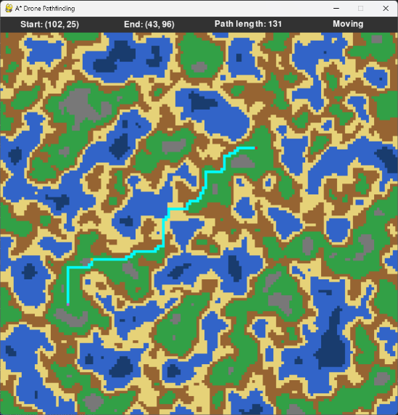
- A viable path was found and the drone is actively moving along it.
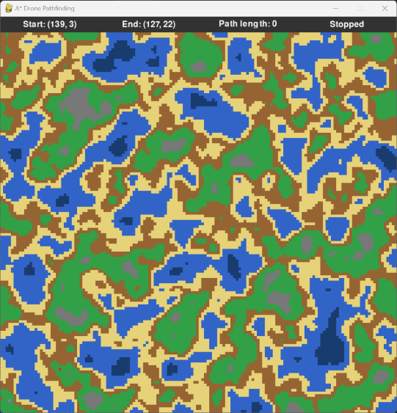
- A path was not able to be calculated since water blocks the bottom right corner where an END destination marker was placed.

Analysis and results
The A* Pathfinding algorithm was implemented due to it's effective use of path weight and heuristic costs. The algorithm calculates expands upon Dijkstra's algorithm by estimating the cost to reach the target from the current point while also adding in the accumulated costs of reaching the current cell.
When new obstacles appear, the drone will move to the closest walkable cell that is along the path, if one is not found it will backtrack along the path and recalculate the route again. The drone only needs to reroute when a previously recorded cell is then consumed by water making it unwalkable. Across multiple simulations, the A* pathfinding algorithm produced paths that avoided high-cost and non-walkable terrain. The drone preferred for low-cost terrain and adapted to dynamic water environment.

Discussion
This implementation was a success in recalculating paths to avoid dynamic obstacles and reach the desired goal. Improving the simulation to have better visual improvements, more realistic environments (trees, rivers, mountains, animals, other UAVs), and reduced computation time spent will be ideal for a future iteration. This implementation shows prospective insight into how drones can be used in the modern world to navigate through difficult environments.
The only scenarios in which the drone failed to reach it's destination was when the destination itself was unrouteable. This implementation is similar to real world drones by having them fly over solid terrain for safety and retrieval while being different by not having a person navigate the drone. In a future version, taking into account energy as an active element to track could help find more insights into what decisions the drone can start to make.
Overall, this project was insightful with demonstrating how AI systems, typically associated with chatbots or urban planning, can be effectively used in pathfinding scenarios. With regards to the nature of the environment where movement costs fluctuate over time, the importance of AI in real-world applications and simulations such as drone navigation are showcased in detail.

References
- B. Belton and L. Baldiga, “Agricultural drones are taking off globally, saving farmers time and money,” Oct. 2025, doi: https://doi.org/10.64628/aai.4nmw6vkqc.
- V. Reddy, H. Madan, N. Khatri, Antar, and K. Shridhar Patnaik, “Autonomous UAV Navigation using Deep Learning-Based Computer Vision Frameworks: A Systematic Literature Review,” Array, pp. 100361–100361, Aug. 2024, doi: https://doi.org/10.1016/j.array.2024.100361.
- Pygame, “Pygame Front Page — pygame v2.0.0.dev15 documentation,” www.pygame.org. https://www.pygame.org/docs/
- J. claude adjanohoun, “How Google Maps Finds the Shortest Path: A* Algorithm Explained in JavaScript.,” Medium, Jan. 22, 2025. https://medium.com/@johnadjanohoun/how-google-maps-finds-the-shortest-path-a-algorithm-explained-in-javascript-054b46ee7bf5L

